Supplementary Information for Data Collection.

Data Sources: https://trace.ncbi.nlm.nih.gov/Traces/index.html?view=study&acc=SRP166020
Raw data used in this project:
5moU 100% modified samples-fast5 file :https://sra-pub-src-1.s3.amazonaws.com/SRZ190756/LUC_5mou_dRNA_fast5.tar.gz.1
normal unmodified samples-fast5 file: https://sra-pub-src-1.s3.amazonaws.com/SRZ190757/LUC_normal_dRNA_fast5.tar.gz.1

Figure S1. A demonstration of the generated feature matrix
Under the general workflow, the feature extraction and primary performance comparison process is developed into two broad categories, the first one considers the 5mer as a unit passing through the pore and taking all the twenty feature columns of four signal numerical features respective to five positions in specific 5-mers in the dataset (denoted as “all_RF”, “all_SVM”, “all_XG”); the second one considers the middle position as the target for 5mou modification thus only takes signal features of the middle position in each 5-mer (denoted as “mid_RF”, “mid_SVM”, “mid_XG”); the third one considers the middle and one neighbouring position surrounding it, resulted in 15 feature columns（denoted as “midn_RF”, “midn_SVM”, “midn_XG”. The subdivision of the “all_model” category will be compared in the next section using specific 5-mers that are sampled from 5-mers respective to different AUC values.

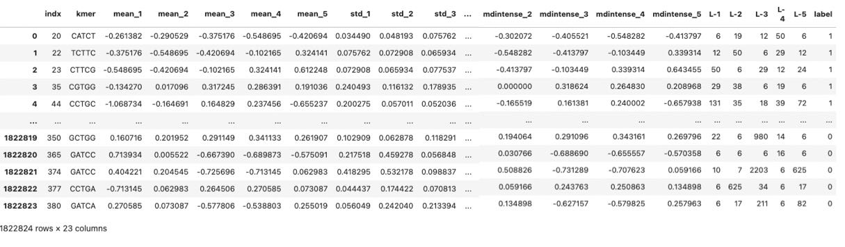

Detailed information regarding the code and data for this framework are available on the GitHub repository(https://github.com/JiayiLi21/NanoML-5moU/tree/main)

Figure S2 Mann-Whitney non-parametric test results for AGTTC and TGTGC in terms of 20 signal features
1. AGTTC results
1. (a) AGTTC dataset: Signal features in the first position
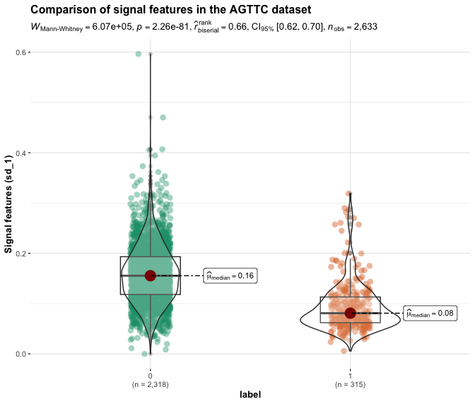
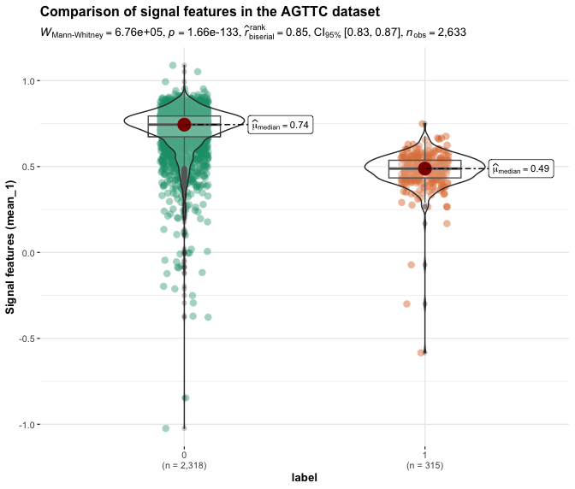

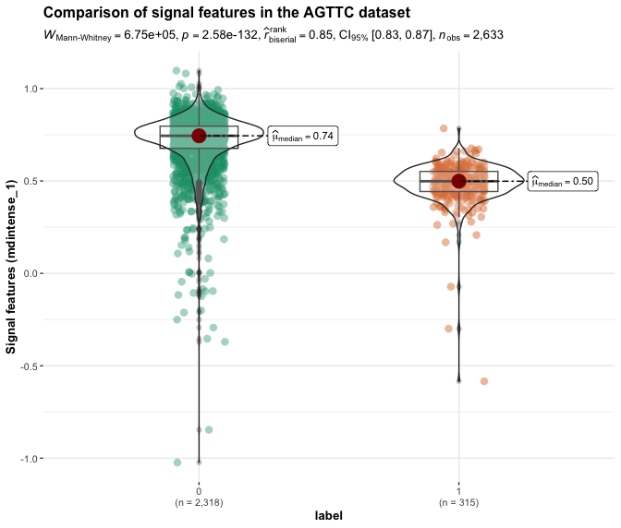
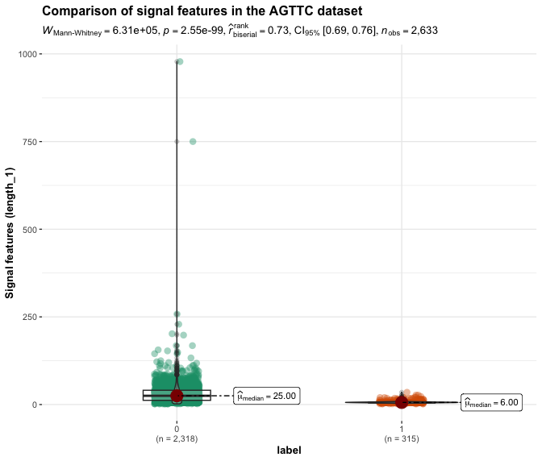

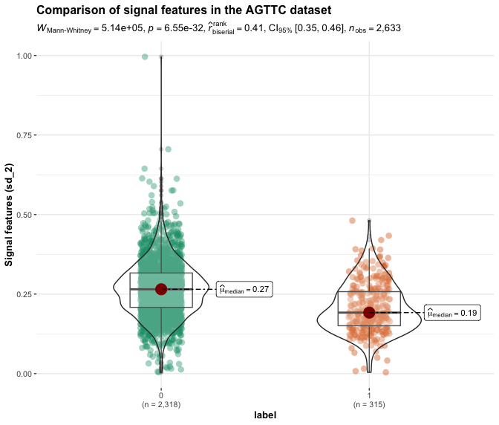
Figure S2
1. (b) AGTTC dataset: Signal features in the second position
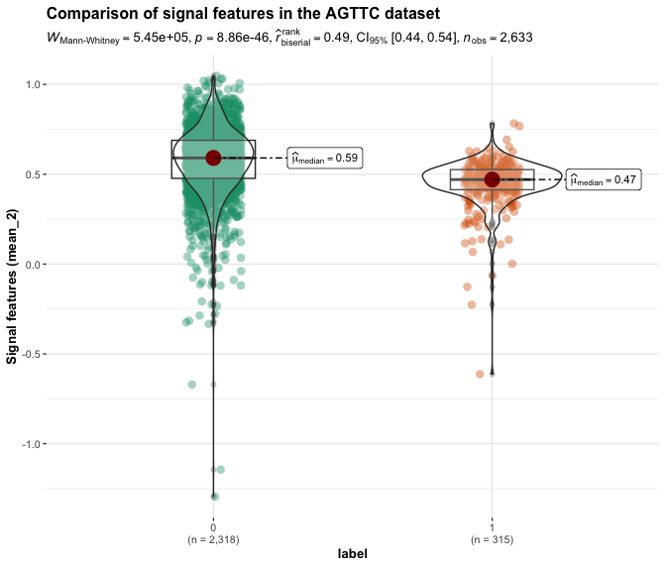

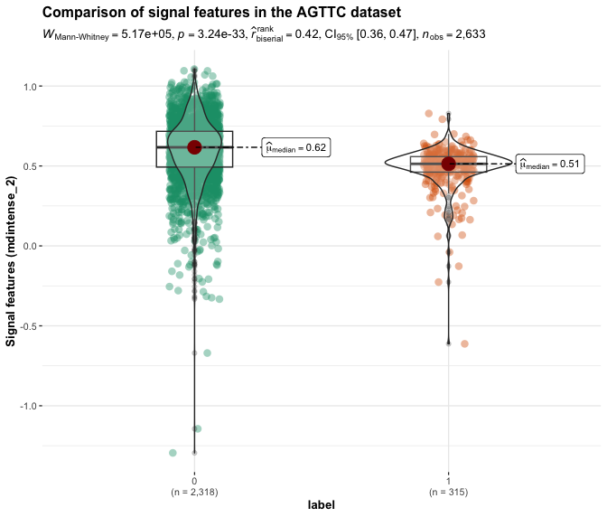
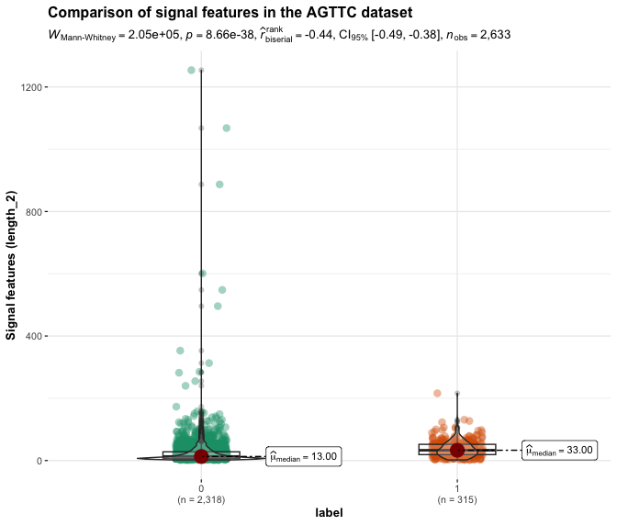

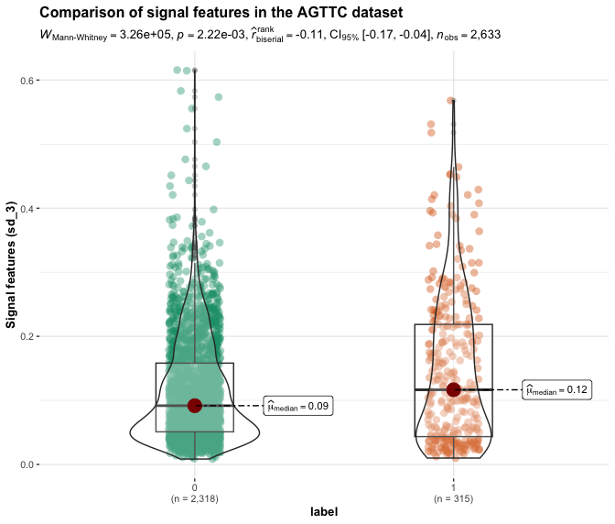
Figure S2
1. (c) AGTTC dataset: Signal features in the third position
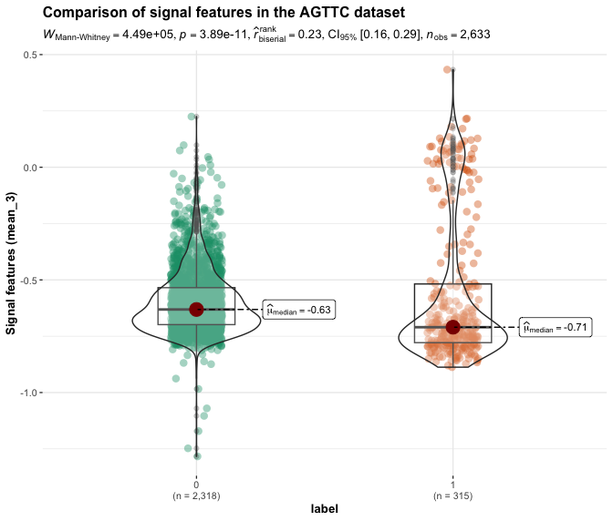

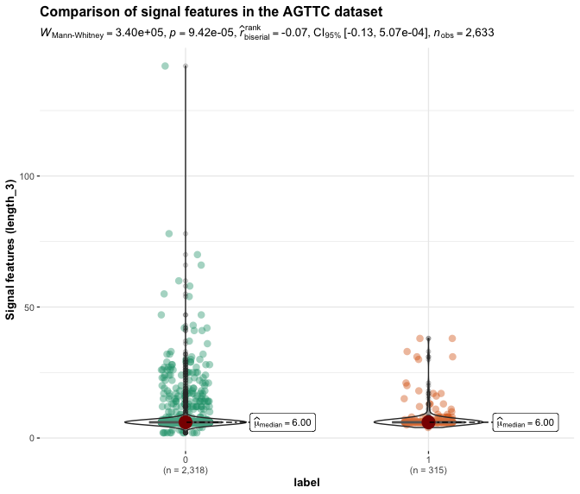
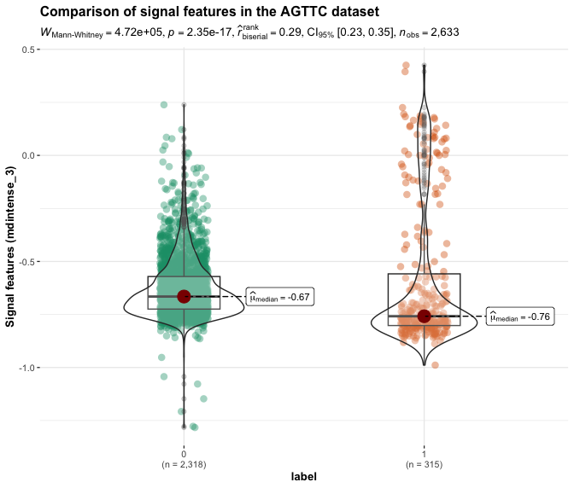

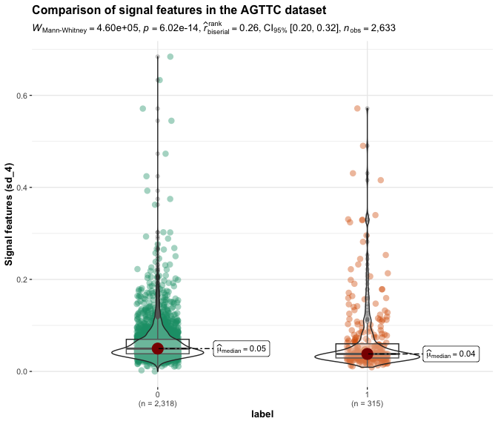
Figure S2

1.(d) AGTTC dataset: Signal features in the fourth position
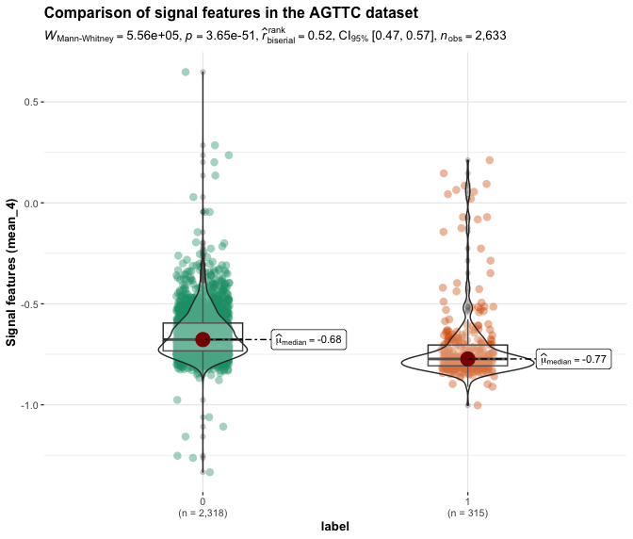

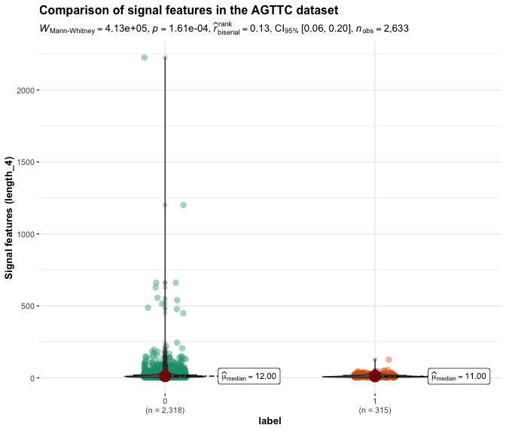

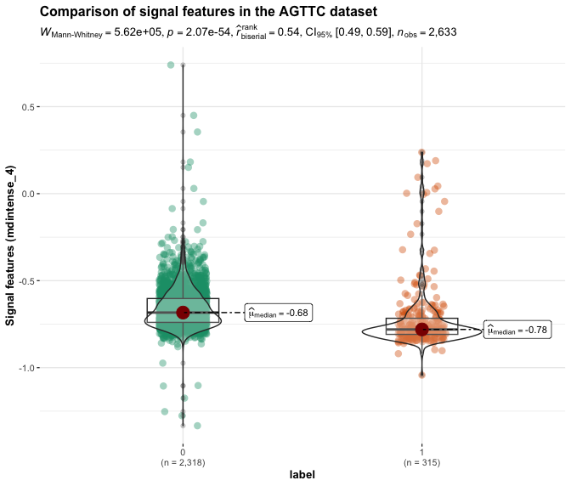

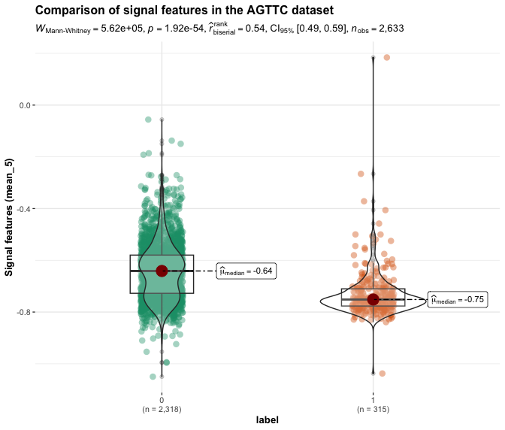
Figure S2-1.(e) AGTTC dataset: Signal features in the fifth position

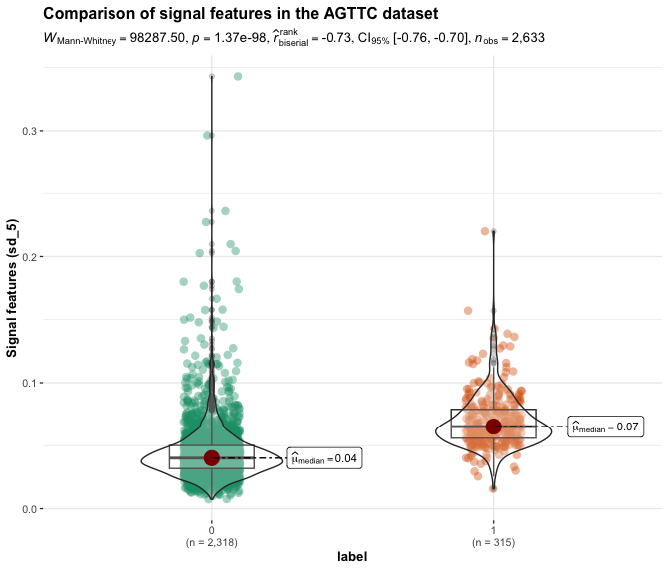

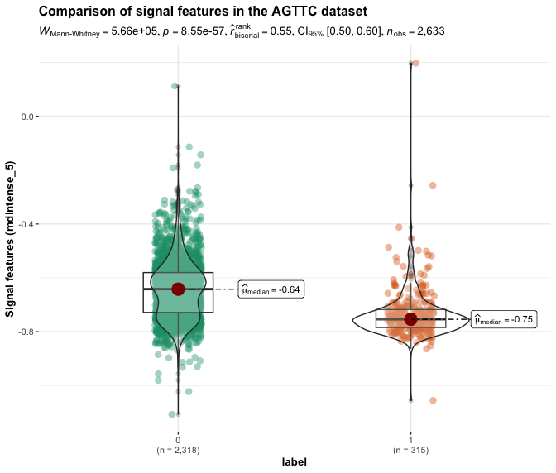

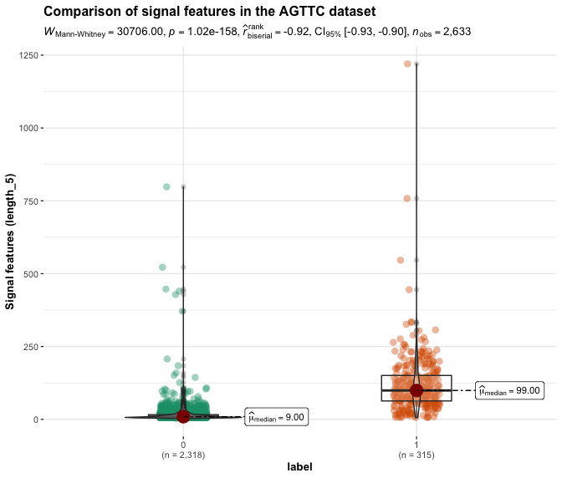

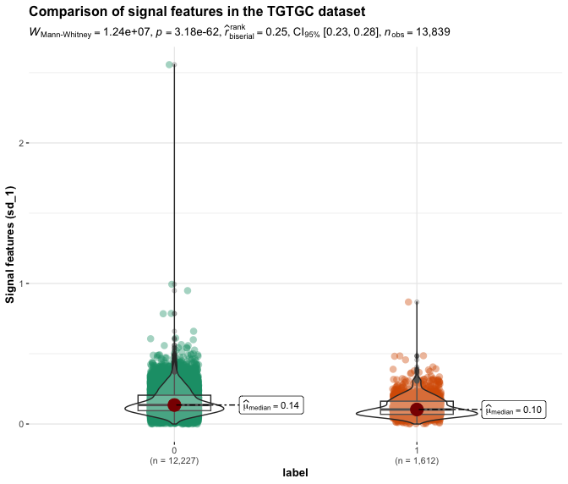
Figure S2 - 2. TGTGC result
2. (a) TGTGC dataset: Signal features in the first position
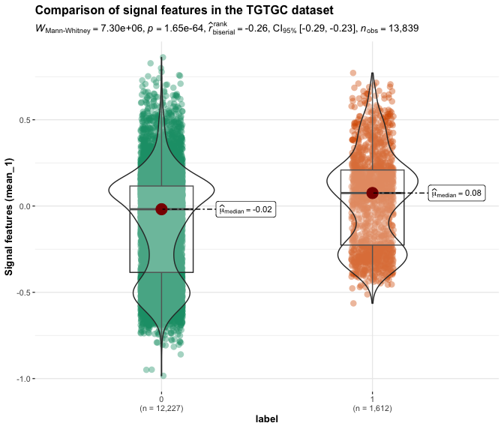

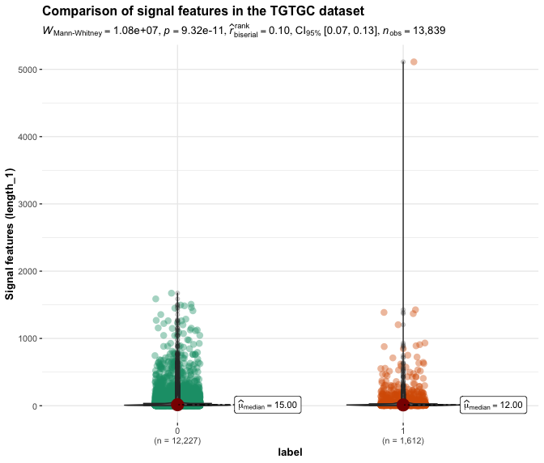
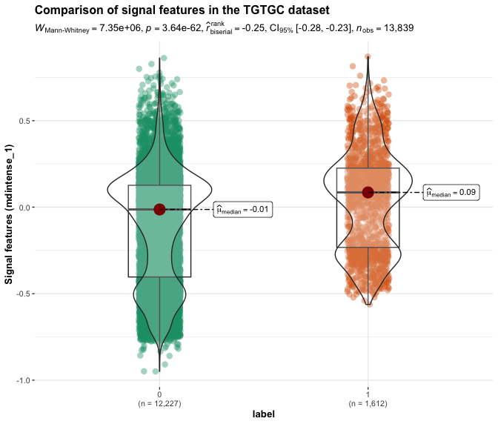

Figure S2 - 2.(b) TGTGC dataset: Signal features in the second position
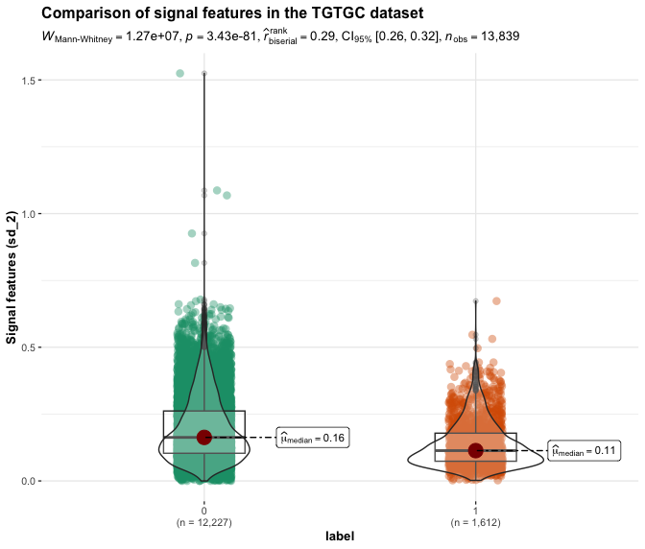
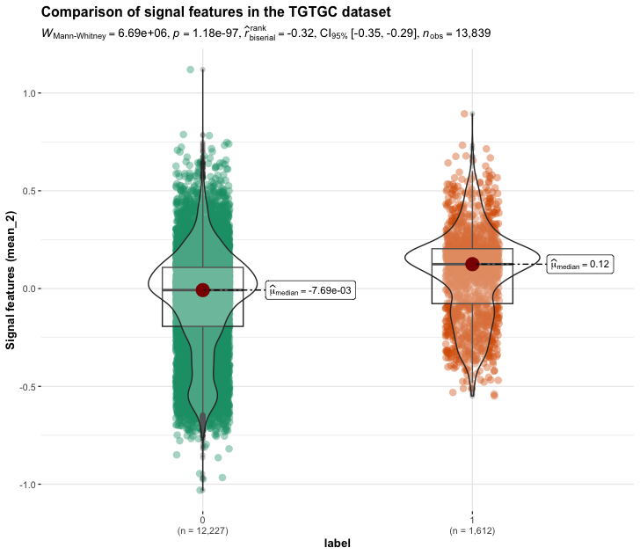

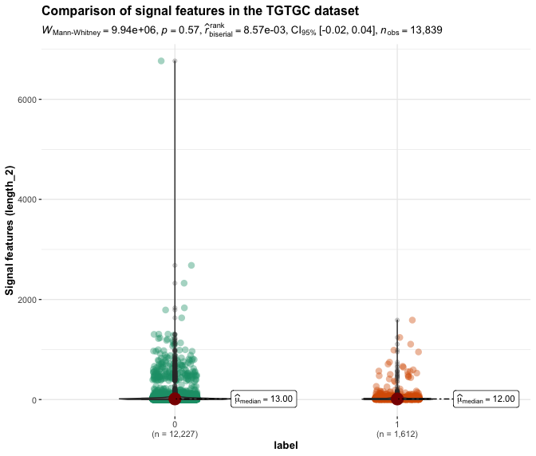
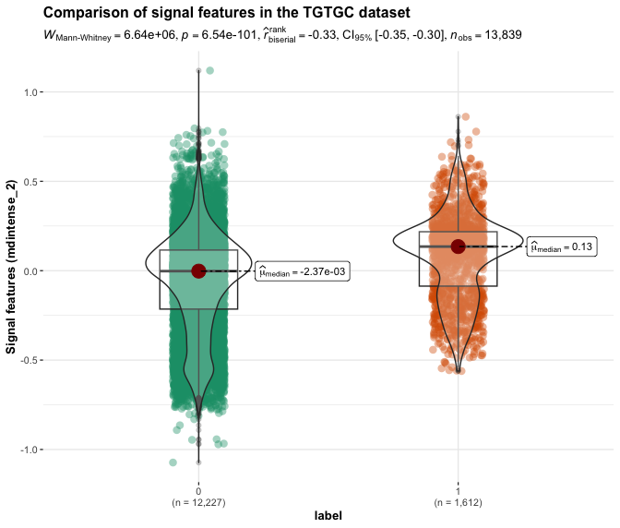

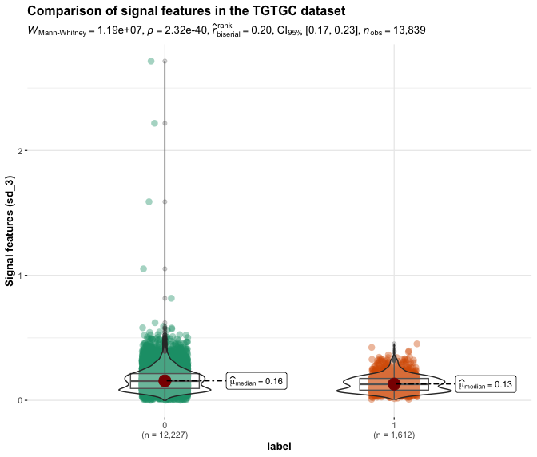
Figure S2 2. (c) TGTGC dataset: Signal features in the third position
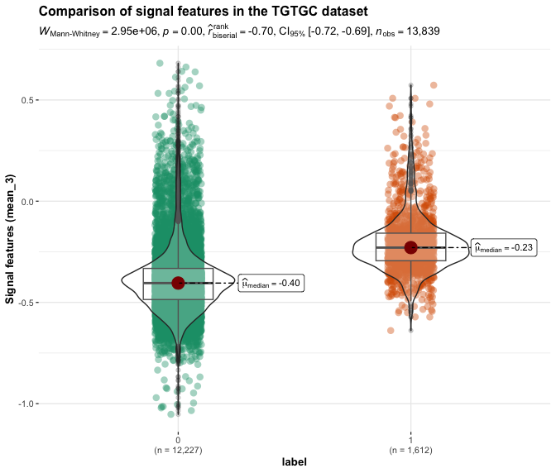

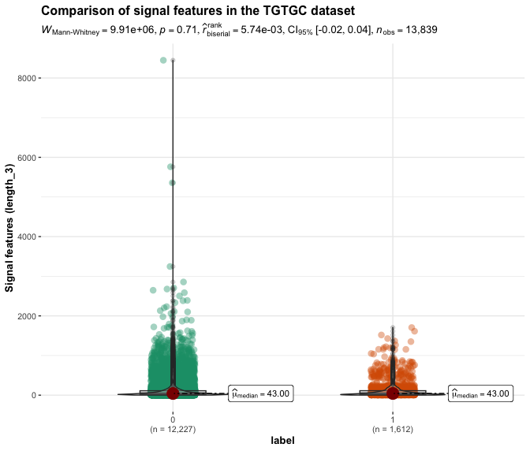
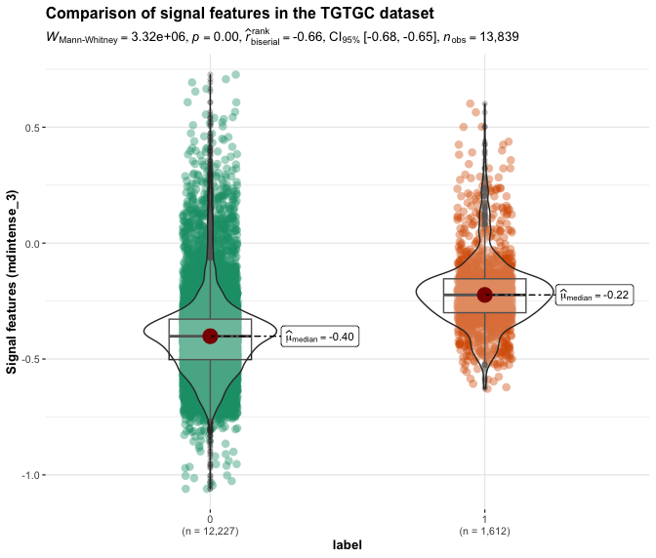

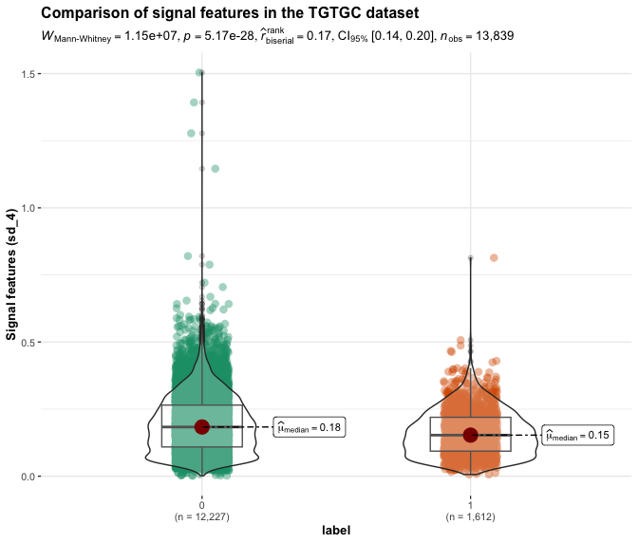
Figure S2 -2.(d) TGTGC dataset: Signal features in the fourth position
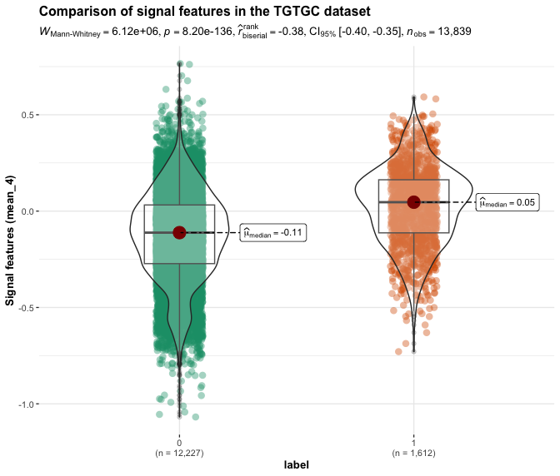

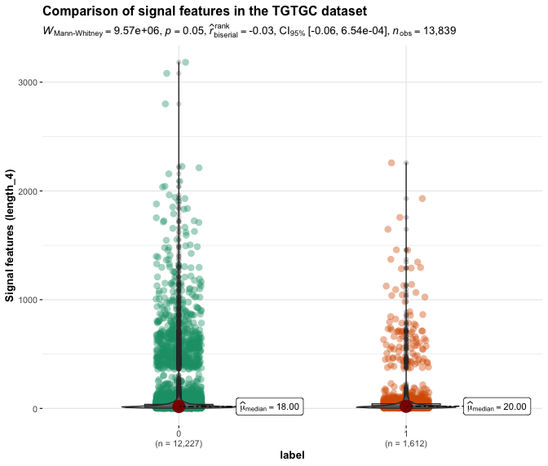
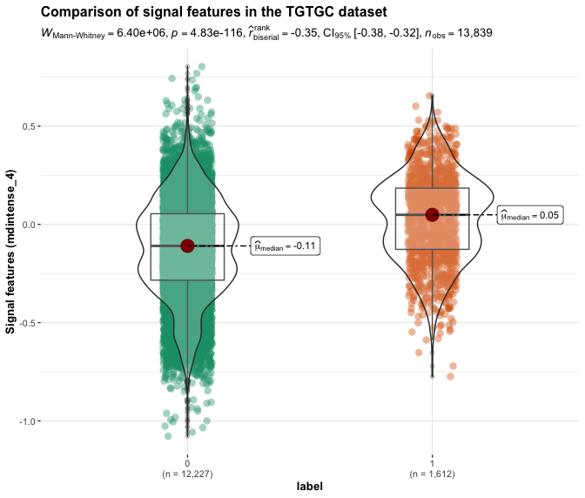

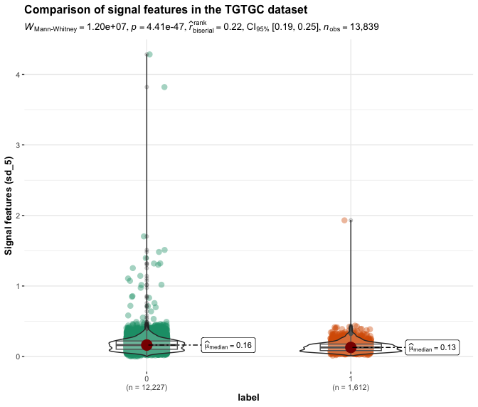
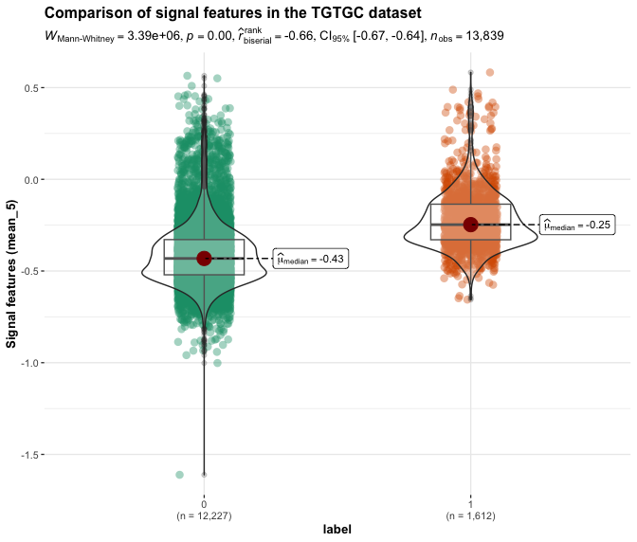
Figure S2 - 2.(e) TGTGC dataset: Signal features in the fifth position

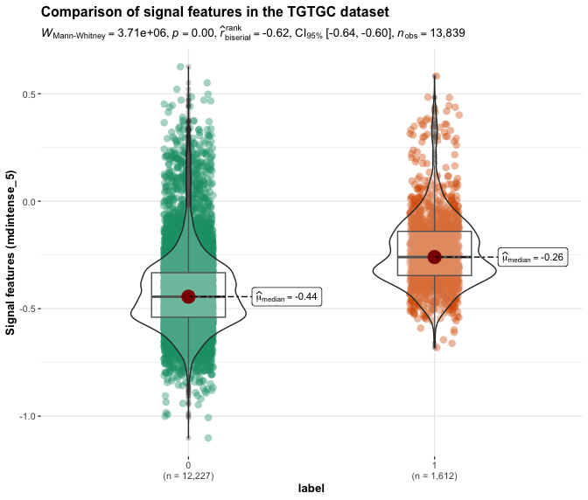

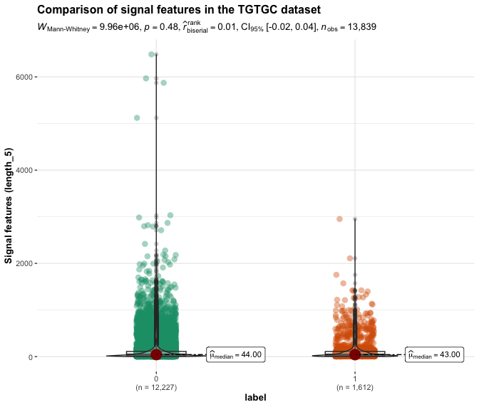

Figure S3. The feature contribution of the XGBoost model is visualized by the SHAP function.

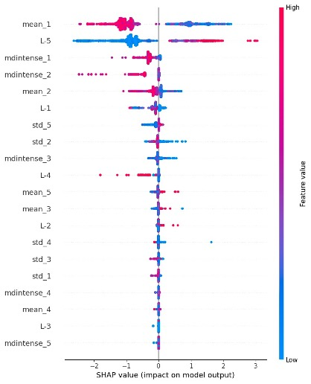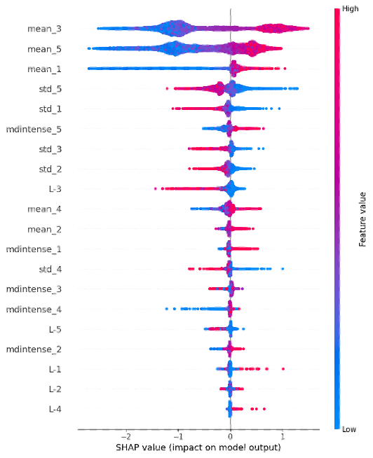
- Results of the AGTTC dataset (b) Results of the TGTGC dataset

