Supplementary Materials for
Hyperbolic exciton polaritons in a van der Waals magnet
Francesco L. Ruta*, Shuai Zhang*, Yinming Shao, Samuel Moore, Swagata Acharya, Zhiyuan Sun, Siyuan Qiu, Johannes Geurs, Brian S.Y. Kim, Matthew Fu, Daniel G. Chica, Dimitar Pashov, Xiaodong Xu, Di Xiao, Milan Delor, X-Y. Zhu, Andrew J. Millis, Xavier Roy, James C. Hone, Cory R. Dean, Mikhail I. Katsnelson, Mark van Schilfgaarde, D. N. Basov*
Correspond to: *f.ruta@columbia.edu, *sz2822@columbia.edu, *db3056@columbia.edu
Table of Contents pg(s)
 | Materials and Methods  - Single crystal growth  - Stacking and transfer  - Fourier transform infrared spectroscopy  - Scanning near-field optical microscopy  - Ab initio quasiparticle GW theory  - Finite difference time domain simulations | 1  1  2  3  3  4
 | Supplementary Figures  - Far-field infrared spectroscopy with b-axis polarization  - Far-field infrared spectroscopy with a-axis polarization  - Fitting c-axis dielectric constant to near-field data  - Im r_{p} in complex-k space  - Hyperbolic surface polaritons  - Rabi splitting in complex-ω electrodynamics  - Fourier analysis of near-field amplitude data  - Geometrical corrections to the in-plane wavevector  - Temperature and thickness dependence of hyperbolic exciton polaritons  - Atomic force microscopy of CrSBr microcrystals  - Temperature dependence of exciton spectral weight  Supplementary Tables  - Lorentz and Tauc-Lorentz oscillators initial model parameters  Supplementary Notes | 5  6  6  9  11  13  14  15  16  16  17  5
1 | Polaritons near the light cone  - Reflection from biaxial slab  - Note on maxima of Im r_{p}  - Hyperbolic polariton modes | 7-8  8  9-10
2 | Coupled excitons and waveguide modes | 11-12
3 | Geometrical correction to the in-plane wavevector | 15
 | Supplementary References | 18
Materials and Methods

Single crystal growth
High quality CrBr₃ was synthesized from chromium powder (1.78 g, 34.2 mmol, 99.94%, −200 mesh, Alfa Aesar) and elemental bromine (8.41 g, 52.6 mmol, 99.99%, Sigma-Aldrich) with one end of the tube maintained at 1000°C and the other at 50 °C via water bath to prevent the tube from exploding from bromine overpressure. Chromium (0.174 g, 3.35 mmol), sulfur (0.196 g, 6.11 mmol, 99.9995%, Alfa Aesar), and CrBr₃ (0.803 g, 2.75 mmol) were then loaded into a 12.7 mm outside-diameter, 10.5 mm inside-diameter fused silica tube. The tube was evacuated to a pressure of ~30 mTorr and flame sealed to a length of 20 cm. The tube was placed into a computer-controlled, two-zone, tube furnace. The source side was heated to 850°C in 24 hours, allowed to soak for 24 hours, heated to 950°C in 12 hours, allowed to soak for 48 hours, and then cooled to ambient temperature in 6 hours. The sink side was heated to 950°C in 24 hours, allowed to soak for 24 hours, heated to 850°C in 12 hours, allowed to soak for 48 hours, and then cooled to ambient temperature in 6 hours. The crystals were cleaned by soaking in 1 mg mL⁻¹ of CrCl₂ (anhydrous, 99.9%, Strem Chemicals) aqueous solution for 1 hour at ambient temperature. After soaking, the solution was decanted and the crystals were thoroughly rinsed with deionized water and acetone. Residual sulfur residue was removed by washing with warm toluene.

Stacking and transfer
At cryogenic temperatures, CrSBr contaminated s-SNOM tips during scanning. To overcome this, we encapsulated CrSBr with a thin (<10 nm) hexagonal boron nitride (hBN) layer^{M1}. Exfoliated hBN is picked up using the standard dry-transfer technique. A polycarbonate (PC) film draped over a polydimethylsiloxane (PDMS) dome is gently pressed down onto the crystal at 130 °C. As the PC cools to 100 °C, the crystal is lifted from an SiO₂/Si substrate and adheres to the polymer. The hBN/PC film is then pressed onto an exfoliated CrSBr crystal following the same temperature protocol. To reduce CrSBr adhesion to the SiO₂, thereby ensuring hBN picks up the CrSBr, the SiO₂/Si chip is first treated with liquid 1-dodecanol at 160 °C for 5-10 minutes. Residual 1-dodecanol is then washed away with isopropyl alcohol (IPA) several times. Next, the hBN/CrSBr stack is transferred to a SiO₂/Si chip prepatterned with ~200 x 200 um gold pads. The PC temperature is slowly raised to 190 °C before delaminating from the PDMS dome onto the chip. The PC is then removed, leaving the finished stack, by rinsing with chloroform and IPA several times at 15 seconds each step. Finally, the heterostructures were cleaned of any remaining polymer residue by contact mode scanning in a Bruker Dimension atomic force microscope.

Fourier transform infrared spectroscopy
Reflectance spectra of CrSBr flakes were measured using a Bruker Hyperion 2000 microscope connected to a Bruker Vertex 80 V FTIR spectrometer. A tungsten halogen lamp was used as a light source covering a frequency range of 0.5 to ~2.5 eV. Linearly polarized light was focused on the sample using a 15X objective and the aperture size was set to be smaller than the sample dimensions. Reflectance spectra in the visible range are normalized to an optically thick silver layer (170 nm) on the substrate and recorded with a silicon detector.
Dielectric function fitting was performed with a multilayer model consisting of a CrSBr thin flake with thickness d on top of a 90-nm-thick SiO₂ layer on a semi-infinite silicon substrate. The dielectric function of the SiO₂ layer is extracted from the measured reflectance using variational dielectric function (VDF) fitting in the RefFit package^{M2}. The b-axis dielectric response of CrSBr as a function of frequency was initially parameterized by a combination of Lorentz oscillators
$$\begin{aligned}ε\left(ω\right)=ε_{∞}+\frac{f}{ω_{0}^{2}-ω^{2}-iγω} \#(M1)\end{aligned}$$
and Tauc-Lorentz oscillators
$$\begin{aligned}ε_{2}\left(ω\right)=\sum_{i}{\frac{A_{i}}{ω}}\frac{ω_{i}γ_{i}{\left(ω-ω_{g,i}\right)}^{2}}{{\left(ω^{2}-ω_{i}^{2}\right)}^{2}+γ_{i}^{2}ω^{2}}Θ\left(ω-ω_{g,i}\right), \#(M2)\end{aligned}$$
$$ε_{1}\left(ω\right)=\frac{2}{π}\int_{0}^{∞}{\frac{ω^{'}ε_{2}(ω^{'})}{ω^{'2}-ω^{2}}} dω^{'} (M3)$$
Here, $ω_{0},$ $f$, and $γ$ are the oscillator frequency, oscillator strength and linewidth of the Lorentz oscillator, respectively. $ε_{∞}$ is the high-frequency dielectric permittivity. Tauc-Lorentz oscillators were used to better describe the asymmetric lineshape of the excitonic resonances in CrSBr. In Equation M2, $ω_{i}$, $A_{i}$, $ω_{g,i}$, and $γ_{i}$ describe the center frequency, height, onset frequency, and width of the Tauc-Lorentz oscillator, respectively. $Θ(x)$ is a step function and the real part of the dielectric function $ε_{1}\left(ω\right)$ is obtained from Kramers-Kronig relations (Equation M3). Using the multi-oscillator model as a starting point (Table S1), reflectance spectra for b-axis responses of CrSBr were further refined with VDF fitting in the RefFit package^{M2}.
Spectral weight was defined in this work by the following expression:
$$SW=\frac{h^{2}c}{π^{2}ε_{0}}\int_{ω_{min}}^{ω_{max}}{σ_{1}(ω)dω} (M4)$$
where $σ_{1}\left(ω\right)=Re\left(icωε_{0}\left(1-ε\left(ω\right)\right)\right)=cωε_{0}ε_{2}(ω)$ is the real part of the optical conductivity. The integrated spectral range was from 1.24-1.55 eV (10,000-12,500 ${cm}^{-1}$). Spectral weight values were normalized such that the $SW\left(T=10 K\right)=1.0$.
Scanning near-field optical microscopy
For room temperature measurements, a Neaspec neaSNOM near-field microscope was used with an M Squared SolsTiS continuous-wave Ti-sapphire laser. PtIr-coated NanoWorld Arrow tips with 75 kHz resonance frequencies were used. For low temperature measurements, we used a home-built cryogenic near-field microscope also with an M Squared SolsTiS. Ag-coated TERS tips (OMNI TERS-SNC-Ag) from AppNano were used in the cryo-system. The signal localized under the apex of the tip is isolated in the backscattered signal by demodulation at the 1st-5th tip tapping harmonics. Pseudoheterodyne detection was employed whereby backscattered light is interfered with light from a vibrating mirror and only signal from interference sidebands was collected^{M3}. Temperature measurements were performed with a silicon diode sensor (Lakeshore DT-670) fixed underneath the sample holder receiver.

Ab initio quasiparticle GW theory
Electronic structure and excitonic properties are calculated within a self-consistent diagrammatic extension of quasiparticle self-consistent GW theory (QSG$W$)^{M4} called QSG$\hat{W}$. In contrast to conventional GW methods, QSGW modifies the charge density and is justified by a variational principle^{M5}. On the other hand, QSG$\hat{W}$^{M6} iteratively updates G, the self-energy ($Σ$), and the screened Coulomb interaction (W) until all quantities self-consistently converge to desired accuracies. Within QSG$\hat{W}$, W includes vertex corrections (ladder diagrams) by solving a Bethe–Salpeter equation. Crucially, our QSG$\hat{W}$ methods are fully self-consistent in both $Σ$ and the charge density^{M7}. Our results are thus parameter-free and have no starting point bias. QSGW and QSG$\hat{W}$ cycles are iterated until the root mean square change in $Σ_{0}$ reaches ${10}^{-5}$ Ry. A $2×2×2$ supercell of the $Cr_{2}Br_{2}S_{2}$ formula unit with six atoms per unit cell was used (48 atoms total with 48 interstitial sites added to augment the basis with floating orbitals). In paramagnetic calculations, local spin orientations are arranged in a quasirandom configuration that mimics the most relevant radial correlation functions of a true random structure. An objective function composed of 480 pair and 384 triplet functions is minimized, following the approach of Ref. M8. The objective function contained 16 pairs and 24 triplets per Cr site. This corresponds to three shells of Cr neighbors whose length ranged between 0.41 and 0.71 lattice constants, and all triplets whose sum of lengths did not exceed 1.37 lattice constants. The two-particle excitonic Hamiltonian that is solved self-consistently to compute both $Σ$ and excitonic eigenvalues and eigenfunctions, contained 104 valence bands and 36 conduction bands.

Finite difference time domain simulations
Simulations of the electric fields of hyperbolic exciton polaritons were performed with the Ansys Lumerical finite difference time domain (FDTD) solver for Maxwell’s equations (https://www.lumerical.com/products/fdtd/). We used a point dipole source positioned 20 nm above the top surface of a finite-thickness CrSBr slab and polarized along the z direction. Electric field monitors were placed on the top surface and cross-section. The boundary conditions were set to the perfectly matched layer option.

[M1] D. Hu, C. Luo, L. Kang, M. Liu, Q. Dai, Few-layer hexagonal boron nitride as a shield of brittle materials for cryogenic s-SNOM exploration of phonon polaritons, Applied Physics Letters 120 (2022) 161101
[M2] A.B. Kuzmenko, Kramers-Kronig constrained variational analysis of optical spectra, Review of Scientific Instruments 76 (2005) 083108
[M3] N. Ocelic, A. Huber, R. Hillenbrand, Pseudoheterodyne detection for background-free near-field spectroscopy, Applied Physics Letters 89 (2006) 101124
[M4] M. van Schilfgaarde, T. Kotani, S. Faleev, Quasiparticle self-consistent GW theory, Physical Review Letters 96 (2006) 226402
[M5] S. Ismail-Beigi, Justifying quasiparticle self-consistent schemes via gradient optimization in Baym-Kadanoff theory, Journal of Physics: Condensed Matter 29 (2017) 385501
[M6] B. Cunningham, M. Grüning, D. Pashov, M. van Schilfgaarde, QSG$\hat{W}$: quasiparticle self-consistent GW with ladder diagrams in W (2023) arXiv:2302.06325

[M7] S. Acharya, D. Pashov, A. N. Rudenko, M. Rösner, M. van Schilfgaarde, M. I. Katsnelson, Importance of charge self-consistency in first-principles description of strongly correlated systems, npj Computational Materials 7 (2021) 208

[M8] A. Zunger, S.-H. Wei, L. G. Ferreira, J. E. Bernard, Special quasirandom structures, Physical Review Letters 65 (1990) 353
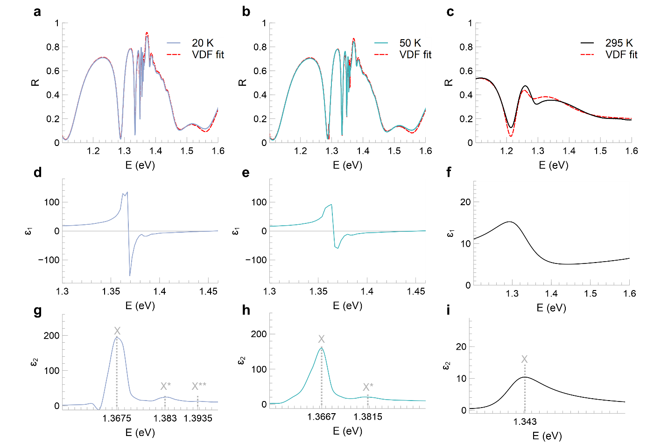
Figure S1: Far-field infrared spectroscopy with b-axis polarization. Far-field reflectance spectra from Fourier transform infrared spectroscopy along the b-axis for, a, 20 K, b, 50 K, c, 295 K. d-f, corresponding real dielectric functions (ε₁) obtained from variational dielectric function (VDF) fitting. Linewidths are orders of magnitude lower at cryogenic temperatures, and d has a larger oscillator strength than e (Table S1). g-i, corresponding imaginary dielectric functions (ε₂) obtained from VDF fitting (solid lines). Three peaks in g are the exciton (X) at E=1.3675 eV and two sidebands (X*, X**) at E=1.383 and 1.3935 eV, respectively. X and X* are observed in h at E=1.3667 and 1.3815 eV, respectively. Only X is observed in i peaked at E=1.343 eV.

Table S1: Lorentz and Tauc-Lorentz oscillators initial model parameters.
T (K) | Type | ε∞ | ω_{g,i} (cm⁻¹) | ω₀ | ω_{i} (cm⁻¹) | f (cm⁻²) | A_{i} (cm⁻¹) | $γ |$ $γ_{i}$ (cm⁻¹)
295 | Lorentz | 3.41 | 9349.4 | 12391104 | 2218.8
 | Tauc-Lorentz | 9559.56 | 10637.25 | 855097.98 | 982.25
 | Tauc-Lorentz | 12979.33 | 11656.99 | 6963112.86 | 1480.71
50 | Lorentz | 3.1 | 11307.76 | 22188621.83 | 341.91
 | Tauc-Lorentz | 10689.97 | 11007.05 | 9443575.64 | 46.06
 | Tauc-Lorentz | 13456.81 | 14135.51 | 2381064.29 | 495.51
 | Tauc-Lorentz | 15824.97 | 13875.94 | 10633893.2 | 1142.09
20 | Lorentz | 2.67 | 11316.49 | 28553206 | 373.14
20 | Tauc-Lorentz | 10779.76 | 11024.22 | 17284378.15 | 28.97
20 | Tauc-Lorentz | 13493.87 | 14185.4 | 2701528.49 | 458.6
20 | Tauc-Lorentz | 15734.46 | 13329.45 | 9155736.47 | 2047.61
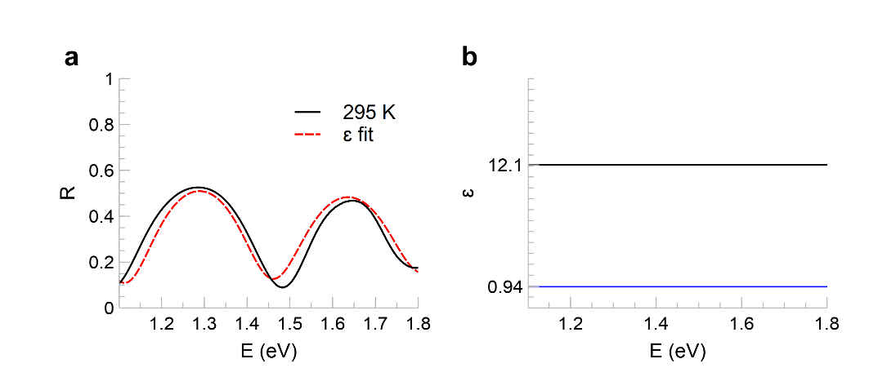
Figure S2: Far-field infrared spectroscopy with a-axis polarization. a, Far-field reflectance spectrum from Fourier transform infrared spectroscopy polarized along the CrSBr a-axis at room temperature (black). Dielectric function fit (red dashed line) using a complex dielectric constant. b, extracted a-axis dielectric constant is $ε_{a}$=12.1+0.94j.

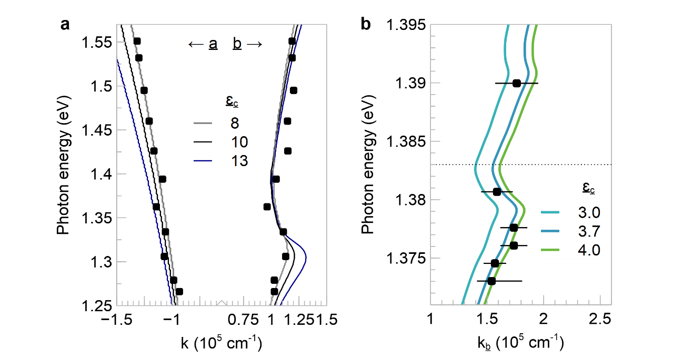
Figure S3: Fitting c-axis dielectric constant to near-field data. a, waveguide mode dispersions for various values of $ε_{c}$, the out-of-plane dielectric constant. $ε_{c}=8$ is the best-fit value for room-temperature a-axis near-field data (black squares, k < 0). $ε_{c}=8$ also fits b-axis near-field data (k > 0) well, but these data were not considered during least-squares fitting. b, hyperbolic exciton polariton dispersions for various values of $ε_{c}$. $ε_{c}=3.7$ is the best-fit value for 20 K near-field data on a 107 nm sample (black squares). For 50 K, we use the waveguide mode in Fig. 3e to extract $ε_{c}=4.5$.
Supplementary Note S1: Polaritons near the light cone

- Reflection from biaxial slab

CrSBr is orthorhombic and thus biaxial. For calculating the complex reflection coefficients of p- and s-polarized light, $r_{p}\left(ω,k\right)$ and $r_{s}\left(ω,k\right)$, respectively, at arbitrary orientations, we employ a general 4x4 propagation matrix formalism^{S1-S2}. The CrSBr dielectric tensor $\overset{⃡}{ε}$ can be written for any arbitrary orientation by rotating its basis. In this work, we only rotate the basis in-plane (to compute isofrequency contours in Fig. 4a) and so only one parameter $ϕ$ is necessary:

$${\overset{⃡}{ε}}^{'\left(ω\right)}=R^{-1}\left(ϕ\right)\overset{⃡}{ε}\left(ω\right)R\left(ϕ\right) (S1)$$

$$R=\left[\begin{matrix}\cos{ϕ} & \sin{ϕ} & 0 \\ -\sin{ϕ} & \cos{ϕ} & 0 \\ 0 & 0 & 1\end{matrix}\right] (S2)$$

Maxwell's curl equations in an arbitrary anisotropic medium can be written in the form of a first-order system of differential equations (in SI units):

$$\frac{∂Ψ}{∂z^{'}}= iΔΨ (S3)$$

where $Ψ={\left[\begin{matrix}\sqrt{ε_{0}}E_{x} & \sqrt{μ_{0}}H_{y} & \sqrt{ε_{0}}E_{y} & \sqrt{μ_{0}}H_{x}\end{matrix}\right]}^{T}$and the components of the $Δ$-matrix are as follows when the xz plane is the plane of incidence:

$$Δ=\frac{ω}{c}\left[\begin{matrix}-ε_{zx}^{'}kc/{ωε}_{zz}^{'} & 1-k^{2}c^{2}/ω^{2}ε_{zz}^{'} & -ε_{zy}^{'}kc/ωε_{zz}^{'} & 0 \\ ε_{xx}^{'}-ε_{xz}^{'}ε_{zx}^{'}/ε_{zz}^{'} & -ε_{xz}^{'}kc/ωε_{zz}^{'} & ε_{xy}^{'}-ε_{xz}^{'}ε_{zy}^{'}/ε_{zz}^{'} & 0 \\ 0 & 0 & 0 & 1 \\ ε_{yx}^{'}-ε_{yz}^{'}ε_{zx}^{'}/ε_{zz}^{'} & ε_{yz}^{'}kc/ωε_{zz}^{'} & ε_{yy}^{'}-k^{2}c^{2}/ω^{2}-ε_{yz}^{'}ε_{zy}^{'}/ε_{zz}^{'} & 0\end{matrix}\right] (S4)$$

where $k$ and $ω$ are the in-plane momentum and frequency of light, respectively. The general solution to the system of differential equations in Equation S3 that gives the electromagnetic field components after traveling a distance $d$ inside the medium is:

$$Ψ\left(z^{'}+d\right)=e^{iΔd}Ψ(z^{'}) (S5)$$

The matrix $P\left(d\right)=e^{iΔd}$ is called the propagation matrix. To evaluate the exponential of $Δ$, we compute its eigenvalues $\{k_{zi}\}$ and eigenvectors $V$.

$$P\left(d\right)=V\left[\begin{matrix}e^{ik_{z1}d} & 0 & 0 & 0 \\ 0 & e^{ik_{z2}d} & 0 & 0 \\ 0 & 0 & e^{ik_{z3}d} & 0 \\ 0 & 0 & 0 & e^{ik_{z4}d}\end{matrix}\right]V^{-1} (S6)$$

Finally, $r_{p}\left(ω,k\right)$ and $r_{s}\left(ω,k\right)$ can be calculated from the continuity requirements at the interfaces. The incident and exit media have isotropic refractive indices of $n_{i}=1$ and $n_{t}$, respectively.

$$r_{p}\left(ω,k\right)=\frac{A_{+}D_{-}-B_{-}C_{+}}{B_{-}C_{-}-A_{-}D_{-}}, r_{s}\left(ω,k\right)=\frac{A_{-}D_{+}-B_{+}C_{-}}{B_{-}C_{-}-A_{-}D_{-}} (S7)$$
where:
$$A_{+,-}=n_{t}P_{12}-\cos{γ_{t}}P_{22}±\cos{γ_{i}}(n_{t}P_{11}-\cos{γ_{t}}P_{21})$$
$$B_{+,-}=\left(n_{t}P_{13}-\cos{γ_{t}}P_{23}\right)± \cos{γ_{i}}(n_{t}P_{14}- \cos{γ_{t}}P_{24})$$
$$C_{+,-}=\left(n_{t}\cos{γ_{t}}P_{32}-P_{42}\right)±\cos{γ_{i}}(n_{t}\cos{γ_{t}}P_{31}-P_{41})$$
$$D_{+,-}=\left(n_{t}\cos{γ_{t}}P_{33}-P_{43}\right)±\cos{γ_{i}}(n_{t}\cos{γ_{t}}P_{34}-P_{44})$$

and $\cos{γ_{i,t}}=\sqrt{1-{\left(kc/n_{i,t}ω\right)}^{2}}$ are cosines of the angles of incidence and transmission, accordingly. $r_{s}\left(ω,k\right)$ will be used to calculate TE₀ mode momenta in Fig. S9.

- Note on maxima of $Im r_{p}$

When dissipation ($Im k$) is large, as in Fig. 4c, $\max{Im r_{p}}$ may no longer be a good indicator of poles. Consider $r_{p}(k)$ at fixed $ω$ that is non-holomorphic at $k=k_{p}$ but analytic on $0<\left|k-k_{p}\right|<z$ with Laurent series:

$$r_{p}\left(k\right)=\sum_{n=1}^{∞}{\frac{b_{n}}{{\left(k-k_{p}\right)}^{n}}}+\sum_{m=0}^{∞}{a_{m}{\left(k-k_{p}\right)}^{m}} (S8)$$

We plot $Im r_{p}$ from Fig. 4c in complex-$k$ space with true dissipation (Fig. S4a) and reduced dissipation (Fig. S4b). Note in Fig. S4b, the pole resembles a simple pole with real coefficient (i.e. Im $b_{1}≈0 and b_{n>1}≈0$, inset of Fig. S4b), such that $\operatorname{argmax}{Im r_{p}(k)}≈k_{p}$. When larger losses are introduced, $k_{p}$ begins to deviate from a simple pole with real coefficient (Fig. S4a). Either Im $b_{1}$ or $b_{n>1}$ are now non-negligible. Thus, the usual $Im r_{p}$ heuristics for poles are invalid. For this reason, computed dispersions may not necessarily align with maxima of $Im r_{p}$ in all figures.
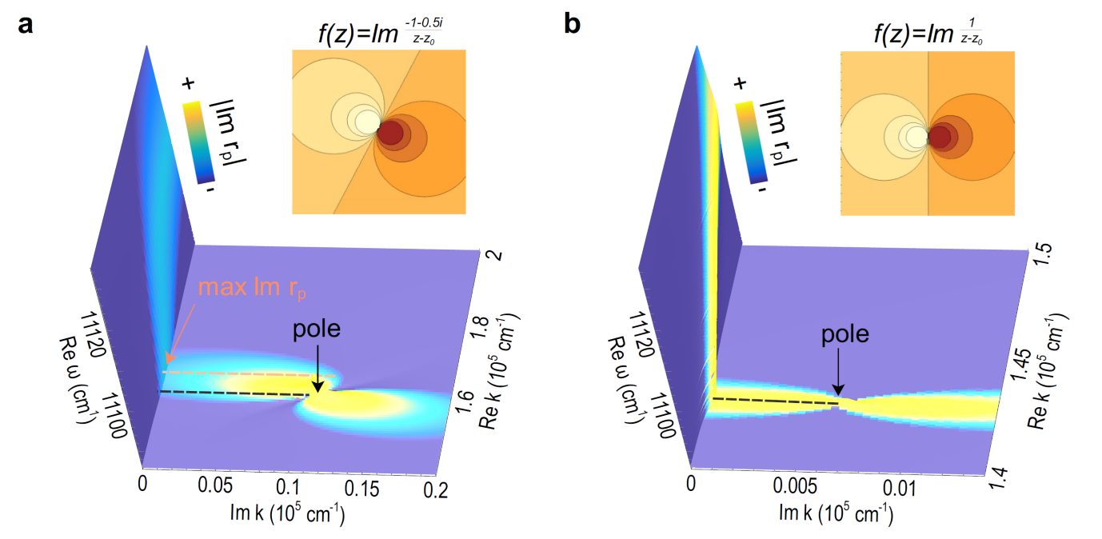
Figure S4: Im r_{p} in complex-k space. Imaginary part of the p-polarized reflection coefficient $r_{p}$ in complex-k space at fixed photon energy E=1.375 eV with a, experimental and, b, artificially reduced dissipation. $\max{Im r_{p}}$ does not align with the complex pole of $r_{p}$ when dissipation is large in a. With reduced dissipation in b, however, the pole resembles a simple pole with real coefficient (inset) at approximately $\max{Im r_{p}}$.

- Hyperbolic polariton modes

When we consider an orientation where the CrSBr dielectric tensor $\overset{⃡}{ε}$ is diagonal, e.g. when the principal b- and c-axes are aligned to the xz axes, $r_{p}$ simplifies the to a familiar form:
$$r_{p}\left(ω,k\right)=\frac{r_{01}+r_{12}e^{2ik_{z}d}}{1-{r_{01}r}_{21}e^{2ik_{z}d}} (S9)$$
where:
$r_{uv}=\frac{Q_{v}-Q_{u}}{Q_{v}+Q_{u}}, Q_{u}=\frac{ε_{x}^{u}}{k_{z}^{u}}$, and $k_{z}=\sqrt{\frac{ε_{x}}{ε_{z}}\left(k_{m}^{2}-k^{2}\right)}$.
$d$ is the thickness of the slab and $k_{0}=ω/c$ is the momentum of vacuum photons. Now consider a geometry where substrate and superstrate are both vacuum. Equation S9 further simplifies and we get a simple condition for the polariton modes of the slab:

$$r_{01}^{2}=e^{-2ik_{z}d}, r_{01}=\frac{\sqrt{k_{0}^{2}-k^{2}}∓\sqrt{\frac{1}{ε_{x}ε_{z}}\left(k_{m}^{2}-k^{2}\right)}}{\sqrt{k_{0}^{2}-k^{2}}±\sqrt{\frac{1}{ε_{x}ε_{z}}\left(k_{m}^{2}-k^{2}\right)}} (S10)$$
We discuss the hyperbolic case where $ε_{x}ε_{z}<0$. We observe that the fundamental hyperbolic mode is a surface mode when its dispersion is between the vacuum light cone $k_{0}$ and material light cone $k_{m}=\sqrt{ε_{z}}k_{0}$ by the following argument. Neglecting dissipation ($Im k=0$), one has
$$\begin{matrix}Im r_{01}=0 & { k}_{0}≤k≤k_{m} \\ Im r_{01}≠0 & k>k_{m}\end{matrix} (S11)$$

Therefore, to satisfy Equation S10 as $k$ varies in the range $k_{0}≤k≤k_{m}$, $k_{z}$ must be purely imaginary since $r_{01}^{2}$ is purely real. That is to say, the polariton is a surface mode. When $k>k_{m}$, the solution for $k_{z}$ becomes complex since $r_{01}$ can in general be complex, meaning the mode will have some oscillatory out-of-plane component like a typical bulk hyperbolic polariton. Furthermore, expanding the positive branch of $r_{01}^{2}$ and $e^{-i2k_{z}d}$ about $k_{m}$:

$$r_{01}^{2}≈1+4\sqrt{\frac{k_{m}^{2}-k^{2}}{\left(-ε_{x}ε_{z}\right)\left(k^{2}-k_{0}^{2}\right)}}, e^{-i2k_{z}d}≈1+2d\sqrt{\frac{-ε_{x}}{ε_{z}}\left(k_{m}^{2}-k^{2}\right)} (S12)$$

As we move slightly left to $k<k_{m}$, we see that both $r_{01}^{2}$ and $e^{-i2k_{z}d}$ are increasing from 1 since $-ε_{x}ε_{z}$ and $\frac{-ε_{x}}{ε_{z}}>0$. Moreover, $r_{01}^{2}→+∞$ as $k→\sqrt{\frac{1-\frac{1}{ε_{x}}}{1-\frac{1}{ε_{x}ε_{z}}}}k_{0}≡k^{*}$ and clearly $k_{0}<k^{*}<k_{m}$. Thus, as we move farther below $k_{m}$, $r_{01}^{2}$ must increase rapidly while $e^{-i2k_{z}d}$ grows comparatively slowly. If the lefthand slope of $r_{01}^{2}$ is smaller than that of $e^{-i2k_{z}d}$ at $k_{m}$, then these functions must intersect at some point (Fig. S5b). By comparing derivatives of Equation S10, we can solve for the frequency range where this is true:

$${|ε}_{x}\left(ω\right)|≥{\left(πωd\sqrt{ε_{z}-1}\right)}^{-1} (S13)$$

In the range of frequencies satisfying Equation S13, a solution to Equation S10 must exist for $k^{*}<k<k_{m}$, and by the arguments following Equation S11 it must be a surface mode. Saturation of the bound in Equation S13 corresponds to crossing of the material light cone. Thus, when Equation S13 is not satisfied, the fundamental mode still exists, but as a bulk mode at $k>k_{m}$.

Suppose now the dielectric function is a single Lorentz oscillator (Equation M1) with $γ=0$. Then $ε_{x}→-∞$ as $ω→ω_{0}$ from above. So $k^{*}→k_{0}$ and $e^{-i2k_{z}d}$ diverges immediately below $k_{m}$, and we have $k\left(ω_{0}\right)→k_{0}$ for the surface mode as illustrated in Fig. S5a. Meanwhile, higher-order modes with $k>k_{m}$ always have $r_{01}^{2}→1$ as $ω→ω_{0}$ and the self-oscillation condition is simply $\frac{nπ}{d}$=$\sqrt{\frac{-ε_{x}}{ε_{z}}\left(k^{2}-k_{m}^{2}\right)}$. The righthand side will always diverge unless $k=k_{m}$ for all mode orders $n$, thus forcing $k\left(ω_{0}\right)→k_{m}$.

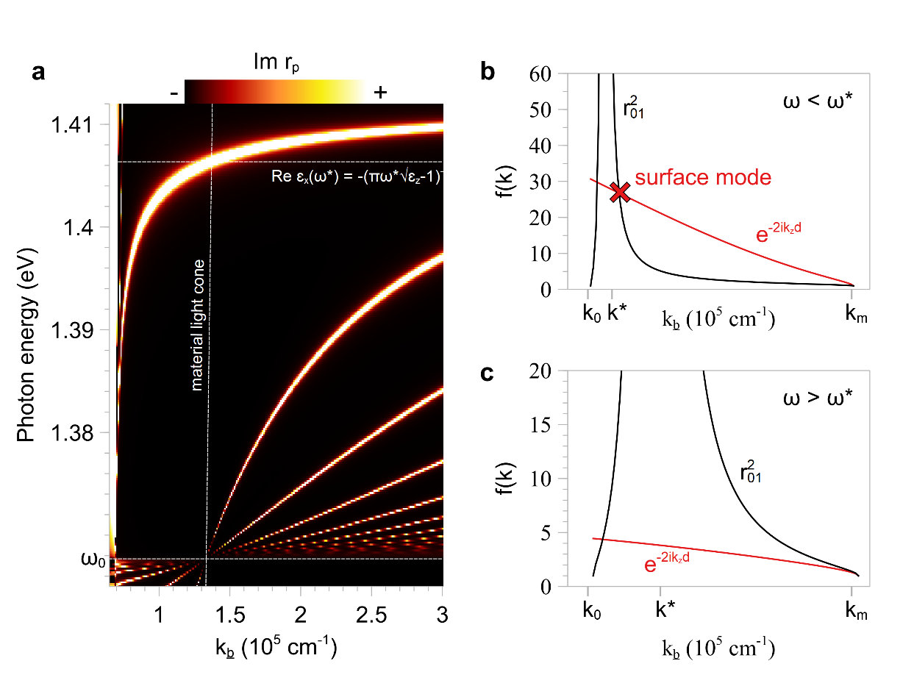
Figure S5: Hyperbolic surface polaritons. a, hyperbolic polariton dispersion of a toy suspended anisotropic material with a single in-plane Lorentz oscillator dielectric function in the near-infrared. The fundamental mode is a surface mode with $k\left(ω_{0}\right)→k_{0}$ inside the material light cone and a bulk mode outside, crossing the material light cone at $ω^{*}$ when ${Re ε}_{x}\left(ω^{*}\right)=-{\left(πω^{*}d\sqrt{ε_{z}-1}\right)}^{-1}$. Higher-order modes are always bulk modes with $k\left(ω_{0}\right)→k_{m}$. b, below $ω^{*}$, the two terms in Equation S10 intersect between $k^{*}$ and $k_{m}$, corresponding to a surface mode solution. The initial slope of the exponential term is higher than that of $r_{01}^{2}$, but $r_{01}^{2}$ diverges at $k^{*}$. c, above $ω^{*}$, the two terms do not intersect above $k^{*}$ because the initial slope of the exponential term is smaller.

Supplementary Note S2: Coupled excitons and waveguide modes

Coupling between excitons and light is often understood within the framework of the coupled oscillator model. In two-dimensional quantum well structures with mirrors, the self-oscillation condition for polaritons can be mapped analytically to a coupled oscillator model by making a near-resonance assumption^{S3}. In waveguide geometries, however, the self-oscillation condition cannot similarly be cast analytically into a coupled oscillator model and the exciton and “cavity mode” cannot be neatly decoupled into individual oscillators
A more general calculation for Rabi splitting energies involves computing the separation between complex-ω poles^{S4} of Equation S9. Complex-ω electrodynamics represent time-decaying electric fields^{S5}, while our experiments probe spatially-decaying standing waves. Complex-ω electrodynamics do not represent our particular experiments, but are nonetheless physical and can be probed directly via other methods. Unlike complex-k solutions, complex-ω eigenvalues are homotopic to the coupled oscillator model and provide an unambiguous value for the Rabi splitting energy. In Fig. S6, we search complex-$ω$ space for zeros of $χ^{2}=|{\left.​1-{r_{01}r}_{21}e^{2ik_{z}d}\right|}^{2}$. To enforce zero-detuning, a real value for k can be chosen such that $Im ω_{+}=Im ω_{-}$ when $Re ω_{+}≠Re ω_{-}$ (strong coupling); or $Re ω_{+}=Re ω_{-}$ when $Im ω_{+}≠Im ω_$ (weak coupling). If the dielectric function can be expressed as a single oscillator, then $Im ω_{+}=Im ω_{-}=-γ/4$ at zero detuning in the strong coupling regime. We obtain Rabi splitting energies of $Δω=ω_{+}-ω_{-}=226 meV$ using the 295 K dielectric function and d=117 nm, k=$1.1222×{10}^{5} {cm}^{-1}$ (Fig. S6a) and $Δω=163 meV$ using the 20 K dielectric function and d=107 nm, k=$1.05×{10}^{5} {cm}^{-1}$ (Fig. S6b). Reduced scattering rates at low temperature typically increase $Δω$, but other features of $\overset{⃡}{ε}$ change simultaneously, particularly $ε_{z}$, leading to complicated temperature dependence. Finally, we plot complex-ω solutions for different detuning (Re k) in Figs. S6c and S6d, showing that they coincide approximately with dispersions of split waveguide modes in the Im $r_{p}$ loss function.
The coupling strength $κ$ is only a parameter of the coupled oscillator model and is not well-defined in the generalization described above. Nonetheless, discussions on $κ$ are prevalent in the literature and so we will use common definitions of $κ$ to compare exciton polaritons in CrSBr to those in other materials. Within the framework of the coupled oscillator model, we can obtain $κ$ from $Δω$ via:
$$κ=\frac{1}{2}\sqrt{{\left(Δω\right)}^{2}+\frac{1}{4}{\left(γ_{ex}-γ_{ph}\right)}^{2}}≈\frac{Δω}{2} (S14)$$
Since the CrSBr dielectric function is not described by a single Lorentzian, the exciton scattering rate $γ_{ex}$ is ambiguous, but we will anyways select the linewidth of the first Tauc-Lorentz oscillator in Table S1 (122 meV at 295 K and 3.6 meV at 20 K). The photon scattering rate $γ_{ph}$ is difficult to estimate well, so we adopt the common but unjustified practice of looking at the linewidth of the waveguide mode without exciton in the Im $r_{p}$ loss function^{S6} (~70 meV). Using these numbers for $γ_{exc}$ and $γ_{ph}$, we have $κ=114$ meV at 295 K and 83 meV at 20 K. One frequently used condition for strong coupling, although again somewhat arbitrary, compares $κ$ to the average of scattering rates^{S7}:
$$κ>\frac{γ_{ex}+γ_{ph}}{2} (S15)$$
By this metric, all of our experiments are performed within the strong coupling regime.

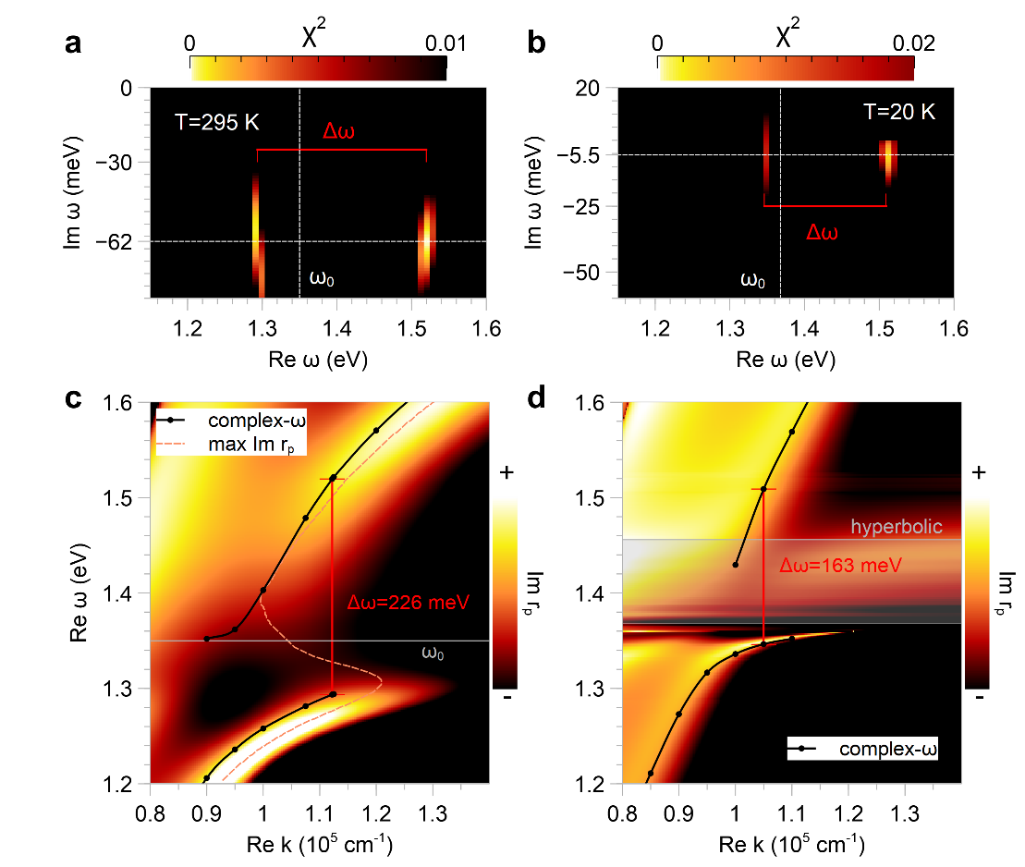
Figure S6: Rabi splitting in complex-ω electrodynamics. Complex-ω poles of Equation S9 show Rabi splitting energies at zero detuning ($Im ω_{+}=Im ω_{-}$) of a, 226 meV for Fig. 2 sample at 295 K and, b, 163 meV for Fig. 4 sample at 20 K. Complex-ω poles at different detuning approximately match split waveguide mode dispersions from, c, Fig. 2 and, d, Fig. 4 Im $r_{p}$ loss functions.

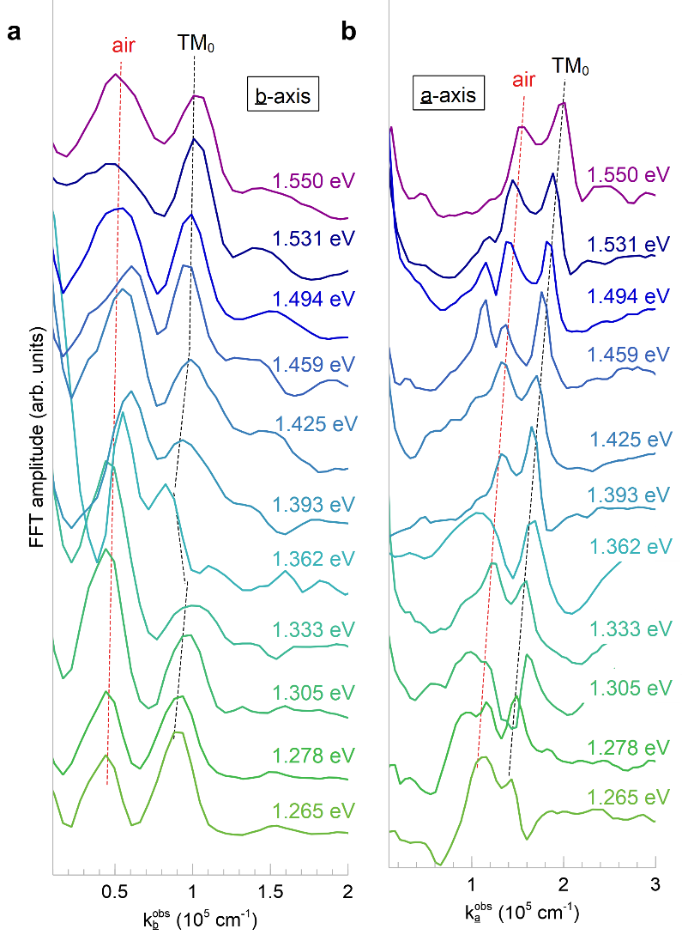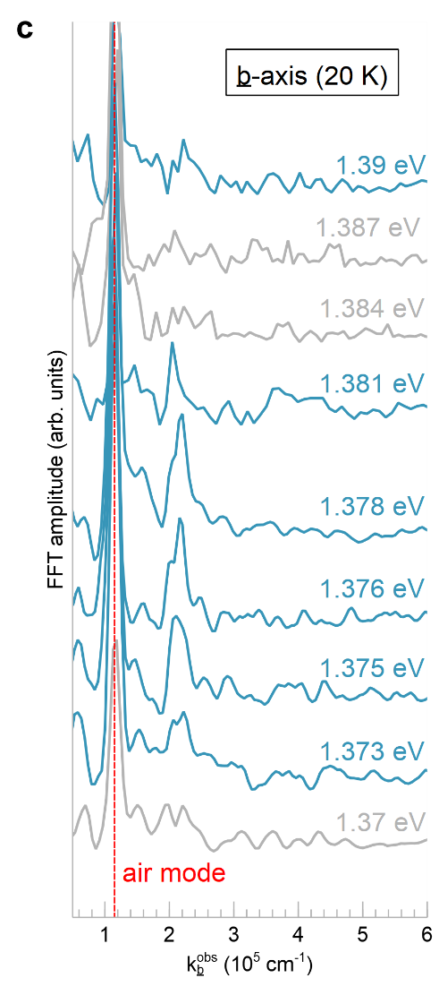
Figure S7: Fourier analysis of near-field amplitude data. Fourier transforms of line profiles shown in, a, Fig. 2c and, b, Fig. 2d. Peak locations after geometrical correction correspond to plotted data points in Fig. 2e. Red dashed line traces air mode peaks and black dashed line traces TM₀ waveguide mode peaks. A backbending dispersion is observed near the exciton energy (~1.35 eV) only along the b-axis. c, Fourier transforms of T=20 K near-field profiles. Blue peak positions are plotted in Fig. 4c.

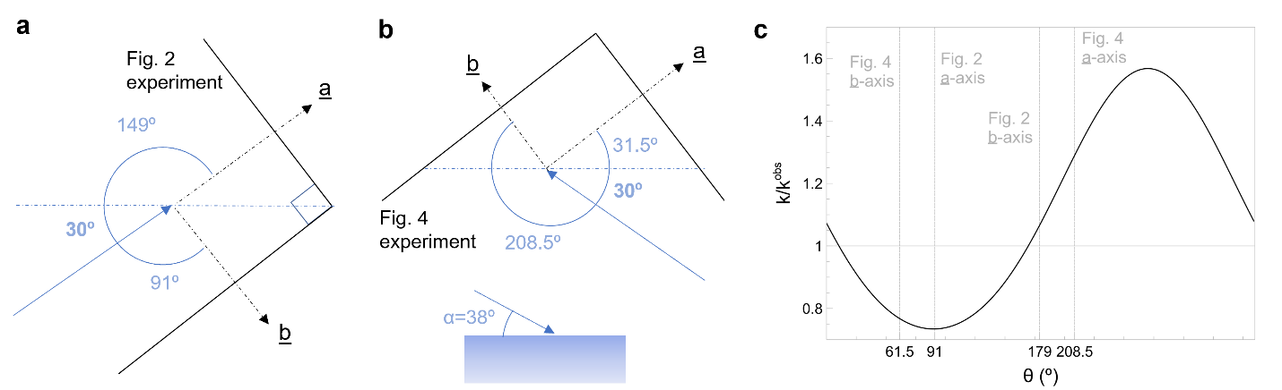
Figure S8: Geometrical correction to the in-plane wavevector. a, schematic of sample geometry in the room-temperature near-field microscope (Fig. 2 experiment) detailing the in-plane direction θ of incident light (blue arrow) relative to sample edges (solid black lines). b, similar schematic for Fig. 4 sample in the cryogenic microscope. Inset shows light incident at an out-of-plane angle $α=38°$ for Fig. 2 and $32.5°$ for Fig. 4. Fig. 3 sample configuration is $θ=90°, α=32.5°$. c, ratio of true wavevector to observed wavevector for different θ with E=1.376 eV and k=1.67$×$10⁵ cm⁻¹. Relevant θ are marked with dashed gray lines.

Supplementary Note S3: Geometrical correction to the in-plane wavevector

Relative to mid-infrared polaritons, the in-plane wavevector of near-infrared exciton polaritons k is close to the momentum of free-space light k₀=ω/c. Modes launched by the s-SNOM tip thus tend to transmit through sample edges and outcouple to the far-field. Fringes in s-SNOM images are interferograms of edge-transmitted modes and light backscattered from the tip, which follow different paths back to the detector. Analysis of s-SNOM fringes must account for this path difference by applying a geometrical correction to extracted momenta^{S8}:
$\frac{k}{k^{obs}}=\frac{k-k_{0}\sin\left(β-θ\right)\cos{α}}{k\cos{β}}$ (S16)
$β≡\arcsin\left(\frac{k_{0}}{k}\cos{α}\cos{θ}\right)$ (S17)
where $k^{obs}$ is the observed momentum extracted from Fourier analysis, $α=38°$ is the out-of-plane incident angle^{S9}, and $θ$ is the in-plane incident angle relative to the sample edge parallel. Given $k^{obs}$ and $θ$, one can solve Equations S16 and S17 self-consistently to obtain $k$. Figs. S8a and S8b detail $θ$ for sample orientations used in Figs. 2 and 4, respectively. Fig. S8c plots ${k/k}^{obs}$ for fixed energy and true momentum.

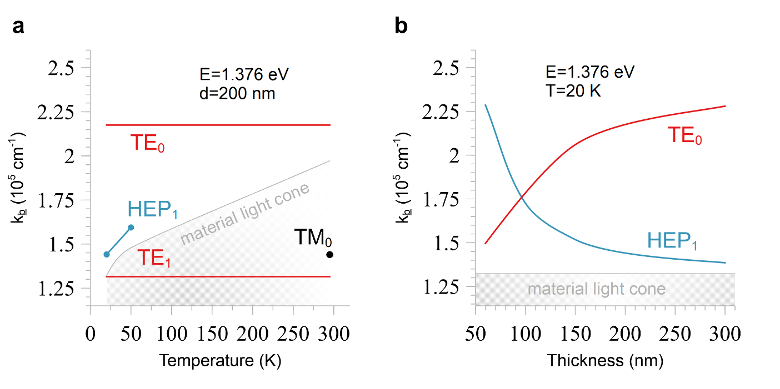
Figure S9: Temperature and thickness dependence of hyperbolic exciton polaritons. Calculated, a, temperature and, b, CrSBr slab thickness dependence of n=1 hyperbolic exciton polariton (HEP₁) and fundamental transverse electric waveguide mode (TE₀) using far-field optical constants (assuming a-axis is not temperature-dependent) and c-axis dielectric constants from Fig. S3.
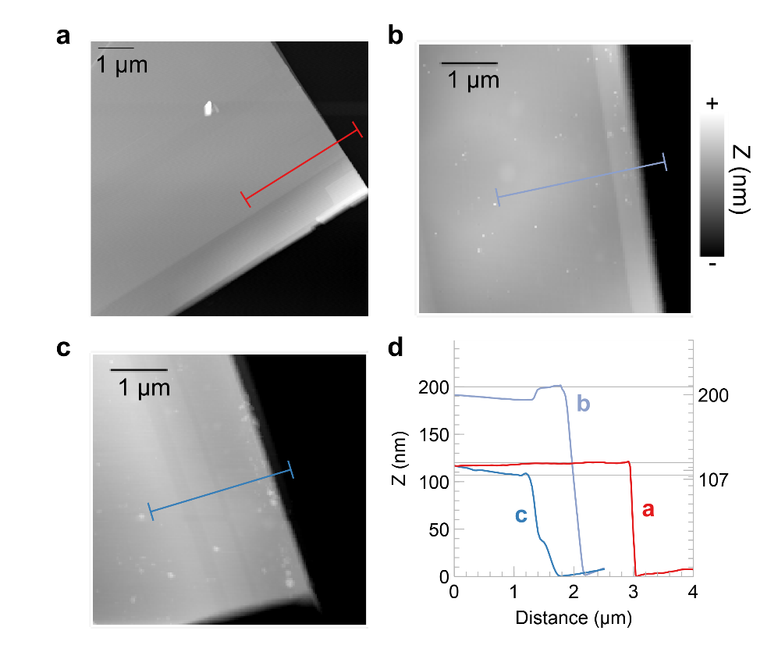
Figure S10: Atomic force microscopy of CrSBr microcrystals. Atomic force microscopy topography images of CrSBr samples in, a, Fig. 2, b, Fig. 3 and, c, Fig. 4. d, line profiles along the corresponding color-coded lines in topography images used to measure thicknesses of 117 nm, 200 nm, and 107 nm for samples in Figs. 2,3, and 4, accordingly.

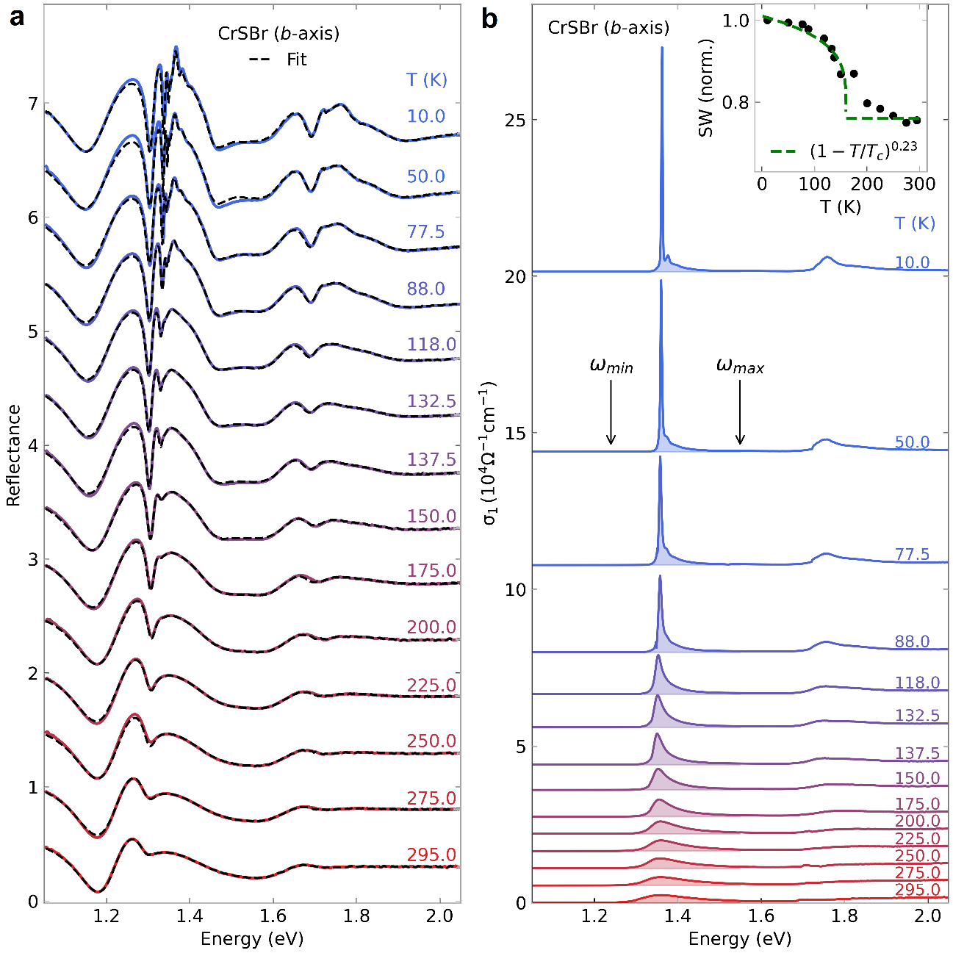
Figure S11: Temperature dependence of exciton spectral weight. a, reflectance spectra polarized along the b-axis of a bulk 297-nm-thick CrSBr microcrystal at temperatures T=10-295 K. Variational dielectric function fits are black dashed lines. b, corresponding real optical conductivities $σ_{1}$. Filled areas correspond to areas of integration between $ω_{min}$ and $ω_{max}$ used to calculate the exciton spectral weight. Inset shows exciton spectral weight (SW) as a function of temperature. Fitting a power law (green dashed line) yields a critical exponent of $0.23$.
Supplementary References

[S1] R.M.A. Azzam, N.M. Bashara, Ellipsometry and Polarized Light (North-Holland: New York, 1977)
[S2] I. Abdulhalim, Analytic propagation matrix method for linear optics of arbitrary biaxial layered media, Journal of Optics A: Pure and Applied Optics 1 (1999) 646-653
[S3] V. Savona, L.C. Andreani, P. Schwendimann, A. Quattropani, Quantum well excitons in semiconductor microcavities: unified treatment of weak and strong coupling regimes, Solid State Communications 93 (1995) 733-739
[S4] A. Bylinkin, et al., Real-space observation of vibrational strong coupling between propagating phonon polaritons and organic molecules, Nature Photonics 15 (2021) 197-202

[S5] A. Archambault, T.V. Teperik, F. Marquier, J.J. Greffet, Surface plasmon Fourier optics, Physical Review B 79 (2009) 195414

[S6] Y. Luan, H Zobeiri, X. Wang, E. Sutter, P. Sutter, Z. Fei, Imaging anisotropic waveguide exciton polaritons in tin sulfide, Nano Letters 22 (2022) 1497-1503

[S7] P. Törmä, W.L. Barnes, Strong coupling between surface plasmon polaritons and emitters: a review, Reports on Progress in Physics 78 (2015) 013901

[S8] A.J. Sternbach, et al., Femtosecond exciton dynamics in WSe₂ optical waveguides, Nature Communications 11 (2020) 3567

[S9] D. Hu, et al., Probing optical anisotropy of nanometer-thin van der Waals microcrystals by near-field imaging, Nature Communications 8 (2017) 1471

