Extended Data for

Politicization Undermines Trust in Institutions, Even Among the Ideologically Aligned Public

Item E1. Associations Between Ideological Congruence (Between Participant and Institution) and Politicization on Trust for All 40 Institutions in Study 1

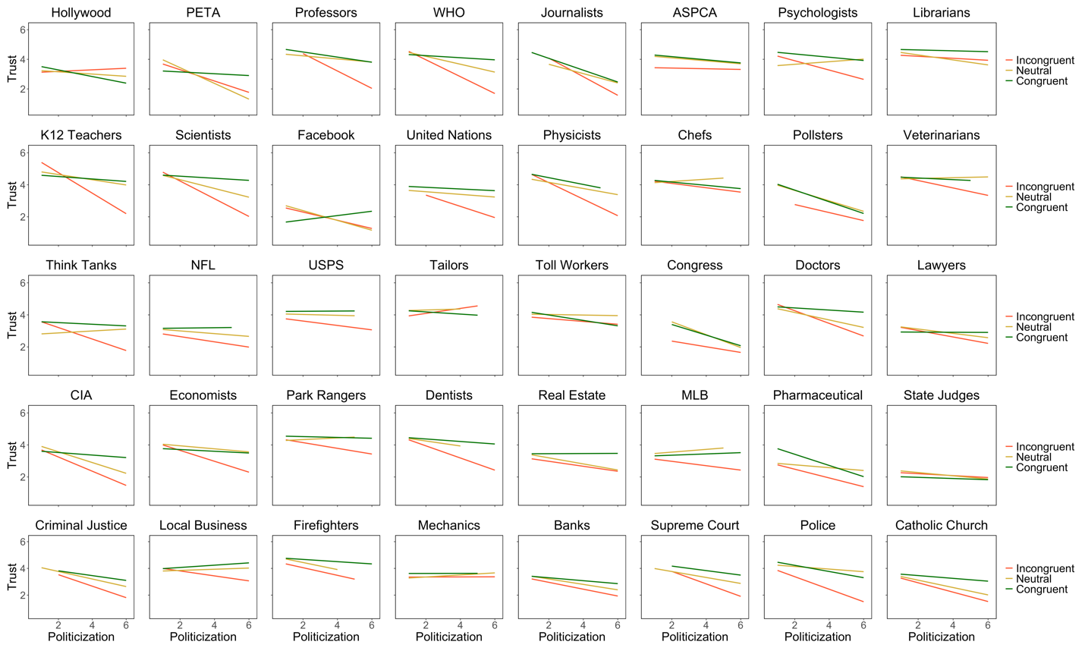

Note. Congruent = participant views the institution as slanted in the same direction of their own self-reported ideology. Incongruent = participant views the institution as slanted in the opposite direction of their own self-reported ideology. Neutral = either the participant is centrist or views the institution as ideologically balanced. Institutions are sorted from the institution perceived as slanted furthest left (Hollywood, top left) to the institution perceived as slanted furthest right (Catholic Church, bottom right).

Item E2. Associations Between Ideological Congruence (Between Participant and Institution) and Politicization on Trust and Support/Deference in Studies 2a (Panel A) and 2b (Panel B)

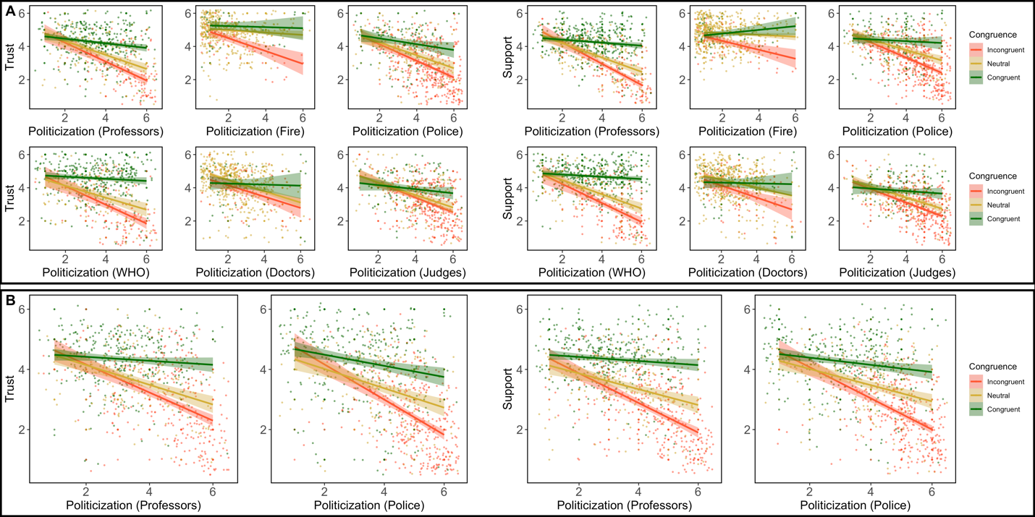
Note. Congruent = participant views the institution as slanted in the same direction of their own self-reported ideology. Incongruent = participant views the institution as slanted in the opposite direction of their own self-reported ideology. Neutral = either the participant is centrist or views the institution as ideologically balanced. The wide error bars for the congruent and incongruent subjects in the doctor and firefighter ratings reflect the small number of subjects who rated these institutions as having an ideological slant. Because of this, the positive slope between perceived politicization and deference toward (ideologically balanced) firefighters among ideologically congruent participants may be unreliable.
Item E3. ANOVAs Testing the Experimental Effects of Politicization in Study 3

Outcome |  |  |  |  |  |  | Simple
Condition | n | M | SD | F | p | η² | (vs. control)
Trust Get Outdoors |  |  |  | 126.96 | <.001 | .294
Biden | 202 | 3.89 | 1.23 |  |  |  | <.001
Control | 208 | 4.61 | 0.88
Trump | 202 | 2.73 | 1.44 |  |  |  | <.001
Support/Defer Get Outdoors |  |  |  | 157.40 | <.001 | .341
Biden | 202 | 3.85 | 1.12 |  |  |  | <.001
Control | 208 | 4.55 | 0.67
Trump | 202 | 2.77 | 1.20 |  |  |  | <.001
Trust All Rangers |  |  |  | 20.85 | <.001 | .064
Biden | 200 | 4.35 | 1.01 |  |  |  | .077
Control | 208 | 4.58 | 0.86
Trump | 201 | 3.93 | 1.19 |  |  |  | <.001
Support/Defer All Rangers |  |  |  | 43.94 | <.001 | .127
Biden | 200 | 4.09 | 1.02 |  |  |  | <.001
Control | 208 | 4.61 | 0.66
Trump | 201 | 3.73 | 1.12 |  |  |  | <.001
Note. Simple refers to simple effects in contrast to the control condition.

Item E4. Interactions Between Participant Ideology and Dummy-Coded Conditions in Study 3

 |  |  |  |  |  | 95% CI |  | Semipartial
 | B | SE | Beta | t | p | Low | High | r
Trust Get Outdoors
(Constant) | 4.61 | 0.08 |  | 61.17 | <.001 | 4.46 | 4.76
Participant Ideology | -0.09 | 0.08 | -0.07 | -1.25 | .211 | -0.24 | 0.05 | -.039
Trump Dummy | -1.81 | 0.11 | -0.60 | -16.79 | <.001 | -2.02 | -1.60 | -.518
Biden Dummy | -0.71 | 0.11 | -0.23 | -6.54 | <.001 | -0.92 | -0.49 | -.202
Trump x Ideology | 0.92 | 0.11 | 0.38 | 8.67 | <.001 | 0.71 | 1.13 | .267
Biden x Ideology | -0.24 | 0.11 | -0.09 | -2.22 | .027 | -0.46 | -0.03 | -.068
Defer Get Outdoors
(Constant) | 4.56 | 0.06 |  | 71.05 | <.001 | 4.43 | 4.68
Participant Ideology | -0.06 | 0.06 | -0.05 | -0.91 | .362 | -0.18 | 0.07 | -.027
Trump Dummy | -1.73 | 0.09 | -0.65 | -18.88 | <.001 | -1.91 | -1.55 | -.561
Biden Dummy | -0.70 | 0.09 | -0.26 | -7.65 | <.001 | -0.88 | -0.52 | -.227
Trump x Ideology | 0.75 | 0.09 | 0.35 | 8.25 | <.001 | 0.57 | 0.92 | .245
Biden x Ideology | -0.30 | 0.09 | -0.13 | -3.20 | .001 | -0.48 | -0.12 | -.095
Trust All Rangers
(Constant) | 4.58 | 0.07 |  | 65.14 | <.001 | 4.44 | 4.72
Participant Ideology | -0.07 | 0.07 | -0.07 | -1.06 | .289 | -0.21 | 0.06 | -.041
Trump Dummy | -0.64 | 0.10 | -0.28 | -6.34 | <.001 | -0.83 | -0.44 | -.246
Biden Dummy | -0.22 | 0.10 | -0.10 | -2.22 | .027 | -0.42 | -0.03 | -.086
Trump x Ideology | 0.26 | 0.10 | 0.14 | 2.62 | .009 | 0.07 | 0.46 | .102
Biden x Ideology | -0.16 | 0.10 | -0.09 | -1.61 | .107 | -0.36 | 0.04 | -.063
Defer All Rangers
(Constant) | 4.62 | 0.06 |  | 71.73 | <.001 | 4.49 | 4.74
Participant Ideology | -0.11 | 0.06 | -0.11 | -1.74 | .082 | -0.24 | 0.01 | -.065
Trump Dummy | -0.87 | 0.09 | -0.41 | -9.51 | <.001 | -1.05 | -0.69 | -.353
Biden Dummy | -0.52 | 0.09 | -0.24 | -5.62 | <.001 | -0.70 | -0.34 | -.208
Trump x Ideology | 0.21 | 0.09 | 0.12 | 2.36 | .019 | 0.04 | 0.39 | .088
Biden x Ideology | -0.24 | 0.09 | -0.13 | -2.58 | .010 | -0.42 | -0.06 | -.096

Item E5. MANOVA Table and Data Visualization of Interactions Between Candidate Preference and Condition in Study 3

Outcome
Effect | F | df | p
Trust Get Outdoors
Condition | 83.38 | 2, 599 | <.001
Vote | 6.20 | 2, 599 | .002
Condition x Vote | 27.71 | 4, 599 | <.001
Support/Defer Get Outdoors
Condition | 106.25 | 2, 599 | <.001
Vote | 5.03 | 2, 599 | .007
Condition x Vote | 37.73 | 4, 599 | <.001
Trust All Rangers
Condition | 11.38 | 2, 599 | <.001
Vote | 3.69 | 2, 599 | .025
Condition x Vote | 6.33 | 4, 599 | <.001
Support/Defer All Rangers
Condition | 35.42 | 2, 599 | <.001
Vote | 8.02 | 2, 599 | <.001
Condition x Vote | 9.35 | 4, 599 | <.001

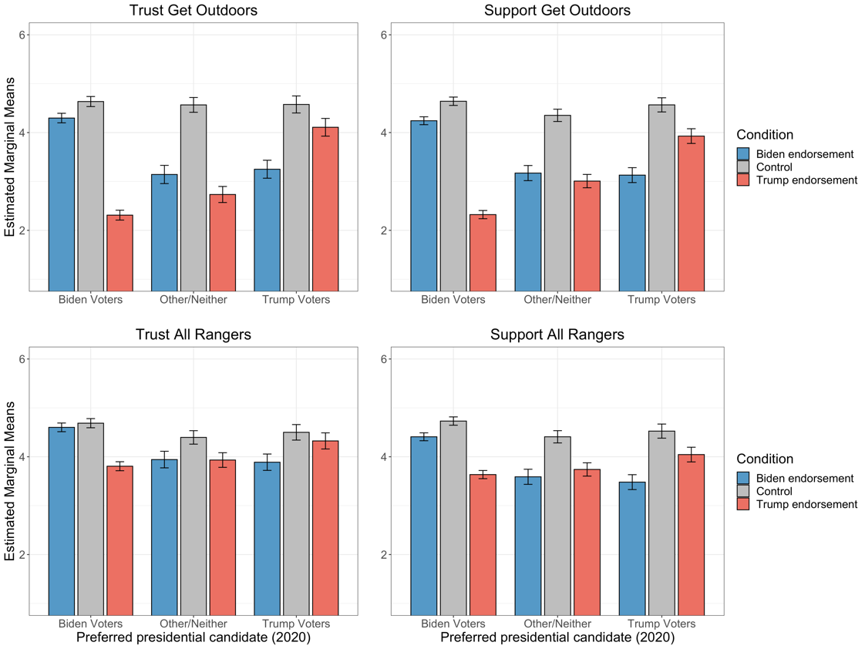

Note: Error bars represent SEs of estimated marginal means.

Item E6. Descriptives for All Primary Variables in Study 4
 |  | Slant |  | Politicization |  | Trust |  |  | Skepticism
 | n | M | SD | M | SD | M | SD |  | M | SD
Women's and Gender Studies | 441 | 19.28 | 19.74 | 4.62 | 1.31 | 3.71 | 1.70 |  | 3.92 | 1.97
Political Science | 437 | 45.08 | 19.20 | 4.43 | 1.31 | 3.33 | 1.45 |  | 4.67 | 1.58
Ethnic Studies | 437 | 27.59 | 20.21 | 4.11 | 1.36 | 3.68 | 1.52 |  | 4.30 | 1.57
Religious Studies | 437 | 64.94 | 19.28 | 4.09 | 1.37 | 3.34 | 1.47 |  | 4.74 | 1.59
Criminal Justice | 441 | 51.43 | 19.07 | 3.95 | 1.26 | 3.76 | 1.48 |  | 3.76 | 1.80
Social Work | 437 | 30.47 | 19.45 | 3.92 | 1.37 | 3.94 | 1.50 |  | 4.00 | 1.49
Business | 441 | 60.41 | 17.01 | 3.79 | 1.28 | 3.68 | 1.45 |  | 3.54 | 1.73
Economics | 441 | 56.68 | 17.42 | 3.77 | 1.25 | 3.93 | 1.37 |  | 3.42 | 1.72
Environmental Science | 436 | 28.74 | 19.54 | 3.76 | 1.43 | 4.13 | 1.62 |  | 3.76 | 1.51
Education | 441 | 37.15 | 19.69 | 3.75 | 1.46 | 4.05 | 1.55 |  | 3.51 | 1.84
Sociology | 437 | 34.30 | 18.66 | 3.73 | 1.36 | 3.73 | 1.41 |  | 4.14 | 1.48
Public Health | 441 | 38.85 | 18.36 | 3.56 | 1.39 | 4.10 | 1.48 |  | 3.29 | 1.75
History | 441 | 45.83 | 18.19 | 3.55 | 1.37 | 4.11 | 1.40 |  | 3.54 | 1.76
Philosophy | 437 | 37.50 | 19.08 | 3.52 | 1.38 | 3.80 | 1.43 |  | 4.28 | 1.46
Psychology | 441 | 36.66 | 18.00 | 3.32 | 1.47 | 3.96 | 1.48 |  | 3.56 | 1.78
Communications | 437 | 42.74 | 16.07 | 3.21 | 1.37 | 3.75 | 1.31 |  | 3.80 | 1.43
Art and Art History | 436 | 32.81 | 19.34 | 3.14 | 1.45 | 4.04 | 1.44 |  | 3.60 | 1.47
English Language and Literature | 441 | 37.37 | 18.43 | 3.13 | 1.42 | 4.25 | 1.42 |  | 2.84 | 1.64
Earth and Planetary Sciences | 441 | 36.71 | 17.79 | 2.96 | 1.43 | 4.56 | 1.47 |  | 2.70 | 1.63
Anthropology | 437 | 39.17 | 17.41 | 2.86 | 1.45 | 4.03 | 1.40 |  | 3.61 | 1.42
Foreign Languages and Literatures | 441 | 36.79 | 16.23 | 2.81 | 1.36 | 4.21 | 1.39 |  | 2.67 | 1.60
Nursing | 441 | 44.44 | 14.78 | 2.72 | 1.36 | 4.62 | 1.40 |  | 2.47 | 1.54
Biology | 437 | 42.41 | 16.78 | 2.71 | 1.37 | 4.48 | 1.39 |  | 3.28 | 1.39
Music | 437 | 36.59 | 17.91 | 2.62 | 1.39 | 4.21 | 1.43 |  | 3.29 | 1.34
Information Technology | 441 | 47.24 | 15.23 | 2.62 | 1.38 | 4.43 | 1.33 |  | 2.69 | 1.65
Computer Science | 437 | 46.96 | 15.60 | 2.41 | 1.39 | 4.57 | 1.32 |  | 3.08 | 1.33
Engineering | 440 | 52.87 | 14.06 | 2.35 | 1.32 | 4.75 | 1.27 |  | 2.29 | 1.45
Physics | 441 | 44.94 | 16.21 | 2.34 | 1.35 | 4.81 | 1.39 |  | 2.37 | 1.53
Chemistry | 437 | 45.96 | 14.83 | 2.27 | 1.32 | 4.60 | 1.35 |  | 3.03 | 1.31
Mathematics | 437 | 49.58 | 15.40 | 2.14 | 1.36 | 4.77 | 1.39 |  | 2.95 | 1.28

Note. For Slant, Red to White to Blue indicates increasing levels of perceived left-leaning ideology.
For all other variables, Red = Top tertile of politicization, bottom tertile of trust, and top tertile of skepticism. Yellow = Middle tertile for all variables, Green = Bottom tertile of politicization, top tertile of trust, and bottom tertile of skepticism.

Item E7. Interactions Between Ideological Congruence (Between Participant and Discipline) and Perceived Politicization on Trust in Study 4

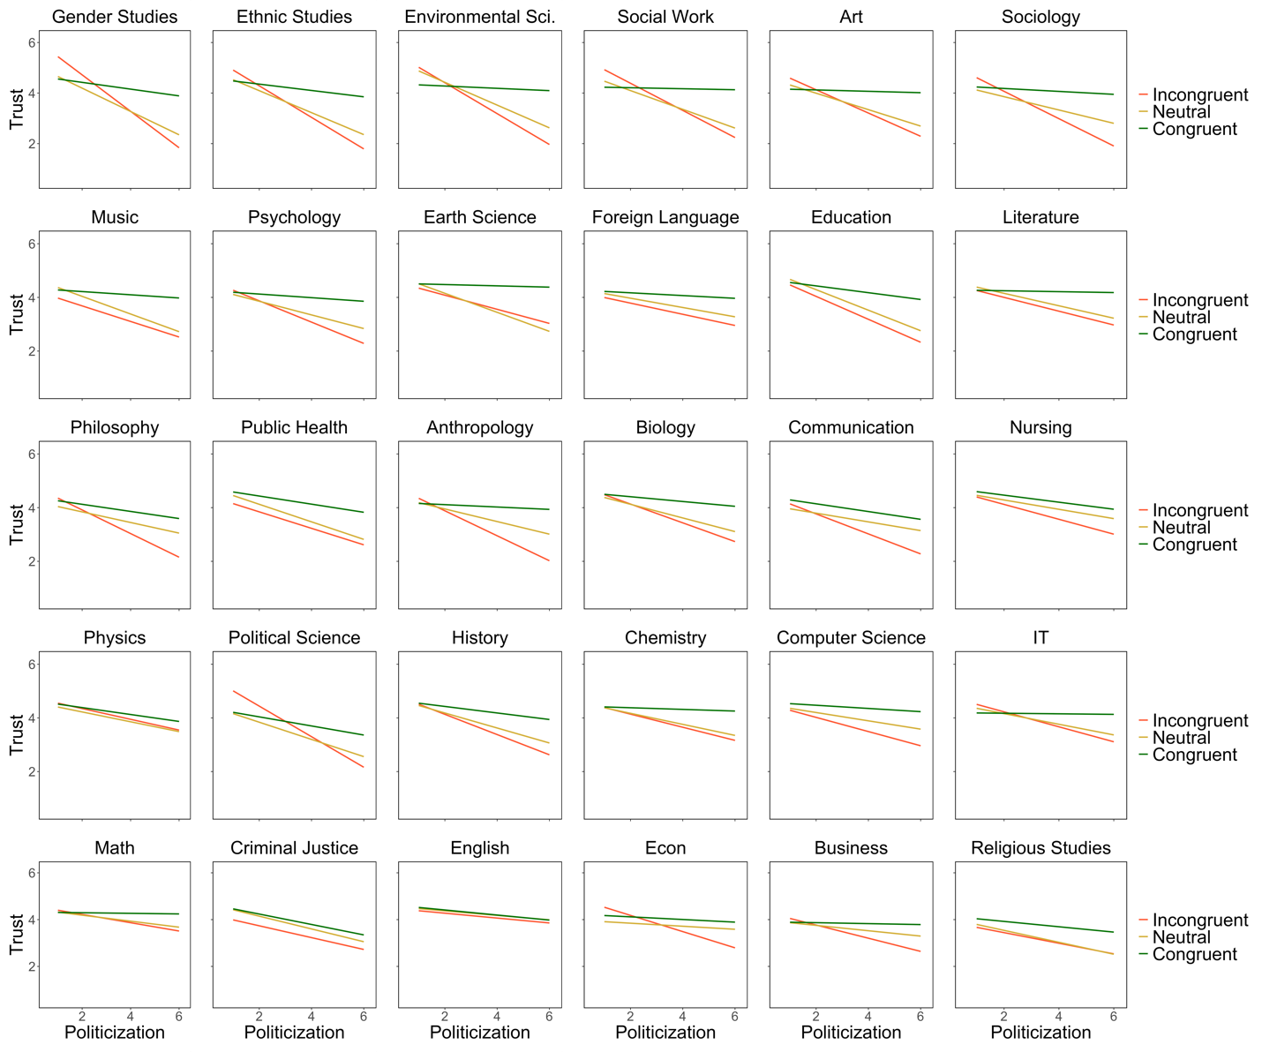

Item E8. MANOVA Table Testing the Experimental Effects of Politicization in Study 5
Outcome |  |  |  |  |  |  | Simple
Condition | n | M | SD | F | p | η² | (vs. control)
Trust EconPA |  |  |  | 27.84 | <.001 | .09
Depoliticization | 198 | 4.17 | 1.08 |  |  |  | 1.00
Control | 202 | 4.03 | 1.04
Democrat Polit. | 203 | 3.41 | 1.24 |  |  |  | <.001
Republican Polit. | 203 | 3.26 | 1.44 |  |  |  | <.001
Politicization All Economists |  |  |  | 10.56 | <.001 | .04
Depoliticization | 198 | 3.8 | 1.26 |  |  |  | 1.00
Control | 202 | 3.74 | 1.18
Democrat Polit. | 203 | 4.25 | 1.05 |  |  |  | <.001
Republican Polit. | 203 | 4.21 | 1.15 |  |  |  | <.001
Trust All Economists |  |  |  | 7.66 | <.001 | .03
Depoliticization | 198 | 3.77 | 1.04 |  |  |  | 1.00
Control | 202 | 3.89 | 1.00
Democrat Polit. | 203 | 3.42 | 1.08 |  |  |  | <.001
Republican Polit. | 203 | 3.58 | 1.10 |  |  |  | 0.020
Skepticism All Economists |  |  |  | 9.87 | <.001 | .04
Depoliticization | 198 | 3.65 | 1.22 |  |  |  | 1.00
Control | 202 | 3.61 | 1.20
Democrat Polit. | 203 | 4.06 | 1.10 |  |  |  | <.001
Republican Polit. | 203 | 4.11 | 1.27 |  |  |  | <.001
Note. Simple refers to simple effects in contrast to the control condition.

Item E9. Table and Data Visualization of Interactions Between Experimental Conditions and Participant Ideology in Study 5
 |  |  |  |  |  | 95% CI |  | Semipartial
 | B | SE | Beta | t | p | Low | High | r
Trust EconPA
(Constant) | 4.03 | .08 |  | 50.24 | <.001 | 3.87 | 4.19
Participant Ideology | 0.00 | .08 | .00 | 0.01 | .995 | -0.16 | 0.16 | .000
Depolit Dummy | 0.12 | .11 | .04 | 1.07 | .284 | -0.10 | 0.35 | .034
Democrat Dummy | -0.62 | .11 | -.21 | -5.49 | <.001 | -0.85 | -0.40 | -.174
Republican Dummy | -0.82 | .11 | -.28 | -7.25 | <.001 | -1.05 | -0.60 | -.230
Depolit X Ideoloy | -0.31 | .12 | -.11 | -2.58 | .010 | -0.54 | -0.07 | -.082
Democrat X Ideology | -0.40 | .12 | -.15 | -3.44 | <.001 | -0.63 | -0.17 | -.109
Republican X Ideology | 0.61 | .11 | .26 | 5.56 | <.001 | 0.39 | 0.82 | .176
Trust All Economists
(Constant) | 3.89 | .07 |  | 53.03 | <.001 | 3.75 | 4.04
Participant Ideology | 0.01 | .08 | .01 | 0.09 | .927 | -0.14 | 0.15 | .003
Depolit Dummy | -0.13 | .10 | -.05 | -1.24 | .217 | -0.33 | 0.08 | -.042
Democrat Dummy | -0.47 | .10 | -.19 | -4.52 | <.001 | -0.67 | -0.27 | -.155
Republican Dummy | -0.33 | .10 | -.13 | -3.17 | .002 | -0.53 | -0.13 | -.109
Depolit X Ideoloy | -0.12 | .11 | -.05 | -1.08 | .280 | -0.33 | 0.10 | -.037
Democrat X Ideology | -0.28 | .11 | -.13 | -2.60 | .009 | -0.48 | -0.07 | -.089
Republican X Ideology | 0.22 | .10 | .11 | 2.21 | .027 | 0.03 | 0.42 | .076
Skepticism All Economists
(Constant) | 3.61 | .08 |  | 43.53 | <.001 | 3.45 | 3.78
Participant Ideology | 0.12 | .08 | .10 | 1.46 | .146 | -0.04 | 0.29 | .050
Depolit Dummy | 0.05 | .12 | .02 | 0.39 | .695 | -0.19 | 0.28 | .013
Democrat Dummy | 0.45 | .12 | .16 | 3.86 | <.001 | 0.22 | 0.68 | .132
Republican Dummy | 0.50 | .12 | .18 | 4.26 | <.001 | 0.27 | 0.73 | .145
Depolit X Ideoloy | 0.14 | .12 | .05 | 1.12 | .262 | -0.10 | 0.38 | .038
Democrat X Ideology | 0.29 | .12 | .12 | 2.40 | .016 | 0.05 | 0.52 | .082
Republican X Ideology | -0.17 | .11 | -.08 | -1.53 | .126 | -0.40 | 0.05 | -.052

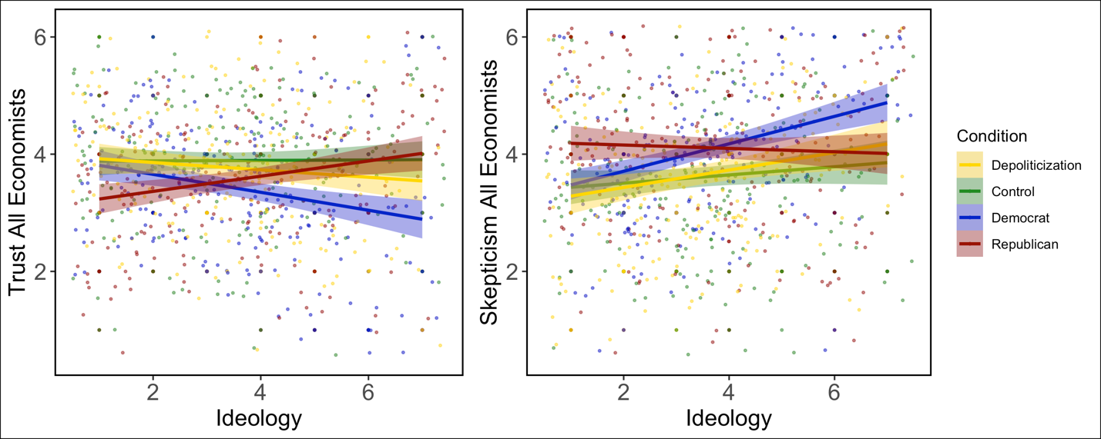
Note. Refer to Figure 5 in the main text to see a similar plot for Trust EconPA.

