Supplementary Fig. 1 PR2-plot analysis
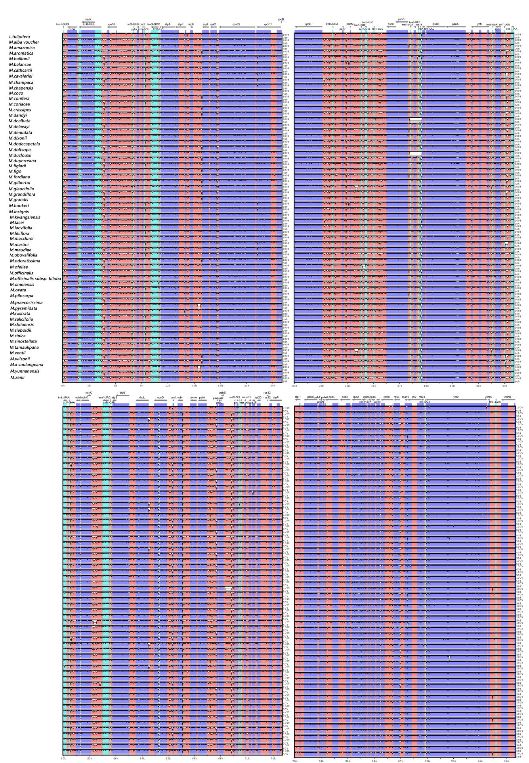
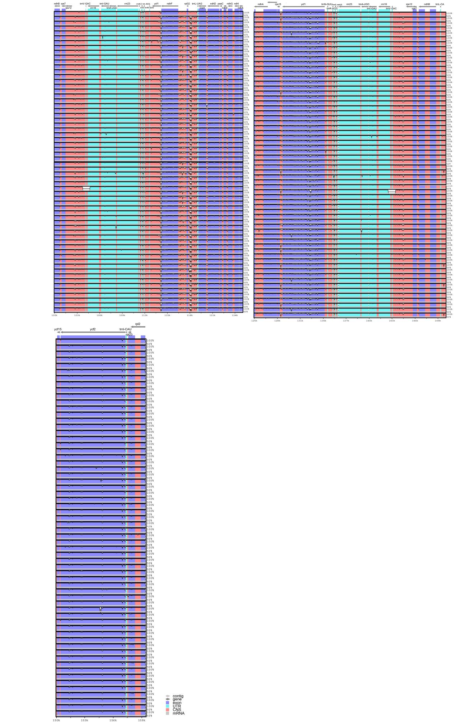
Supplementary Fig. 2 Differences in Chloroplast Genome Sequences of Magnoliaceae Plants

