Supplementary information

A nanovaccine with dual toll-like receptor agonists based on CaP mineralized PLGA nanoparticle for preventing HPV infections

Yongjie Chi^{1,2, ‡}, Chengcheng Jia^{1,3, ‡}, Weiting Zhong^{4, ‡}, Zhu Yang ^{1,2}, Ocean Cheung⁵, Yu Lu⁶, Yanping Zhao^{4,*}, Hongjun Wang^{4,*}, Jianping Chen^{3,*}, and Lianyan Wang ^{1,2,*}

Supplementary Experimental Section

Materials: PVA-217 (Poly (vinyl alcohol)), 1700 DP, 88.5% DH) was purchased from Kuraray (Tokyo, Japan). PLGA (poly (D, L-lactic-co-glycolic acid), 75/25, Mw≈13 kDa) was purchased from Lakeshore Biomaterials (Birmingham, AL, USA). Shirasu porous glass (SPG) membrane was purchased from SPG Technology Co. Ltd. (Sadowara, Japan). The National Engineering Research Center for Biotechnology (Beijing, China) offered premix membrane emulsification apparatus (FMEM-500M). Beijing Health Guard Biotechnology Inc. provided the HPV16 L1 pentamer antigen. Imject™ Alum Adjuvant was obtained from Thermo scientific. RPMI 1640 medium and fetal bovine serum (FBS) were purchased from Gibco (Carlsbad, CA, USA). Phosphate buffered saline was purchased from Hyclone (Logan, UT). Nile red was purchased from Thermo scientific. DAPI and Lyso-Tracker Green was purchased from Solarbio.

Evaluation of release behavior: Briefly, a sufficient amount of PLGA vaccine particles (10 mg) were dispersed in PBS (pH 7.4) solution. The whole system was placed in a 37 °C environment and shaken continuously at 150 rpm using a shaker. The supernatant was collected at regular intervals, and R848, Poly (I:C) and antigens were detected by HPLC system and ELISA, respectively.

Biocompatibility analysis: Briefly, bone marrow-derived stem cells were extracted from the femur and tibia of mice and cultured in 1640 complete medium containing 20 ng mL⁻¹ GM-CSF and 10 ng mL⁻¹ IL-4 for 7 days to generate BMDCs. After the harvested BMDCs were cultured in 96-well plates for 24 h, different concentrations of drugs or particles were added and co-cultured for 24 h. CCK-8 was used to detect the activity of DCs.

Evaluation of cellular phagocytosis behavior: Briefly, bone marrow-derived stem cells were extracted from the femur and tibia of mice and cultured in 1640 complete medium containing 20 ng mL⁻¹ GM-CSF and 10 ng mL⁻¹ IL-4 for 7 days to generate BMDCs. After the harvested BMDCs were cultured in Confocal dishes 24h, PLGA, PLGA-CaP and PLGA-CaP-HPV16 particles stained with Nile red were added. After co-culture for 4 h, lysosomes and nuclei were stained with Lyso-Tracker Green and DAPI, respectively. Subsequently, it was observed under a laser confocal microscope.

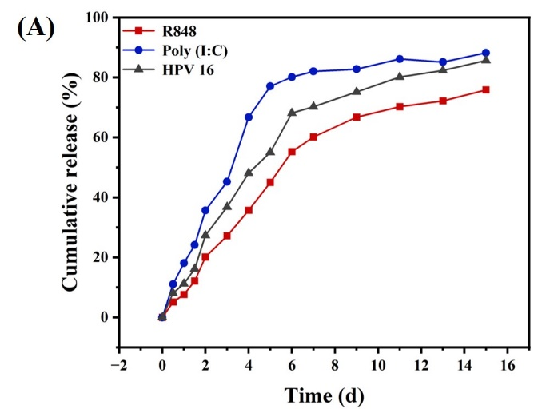
Figure S1. Evaluation of release behavior of different components of the vaccine, PLGA-CaP(R848)-Poly (I:C)-HPV 16.

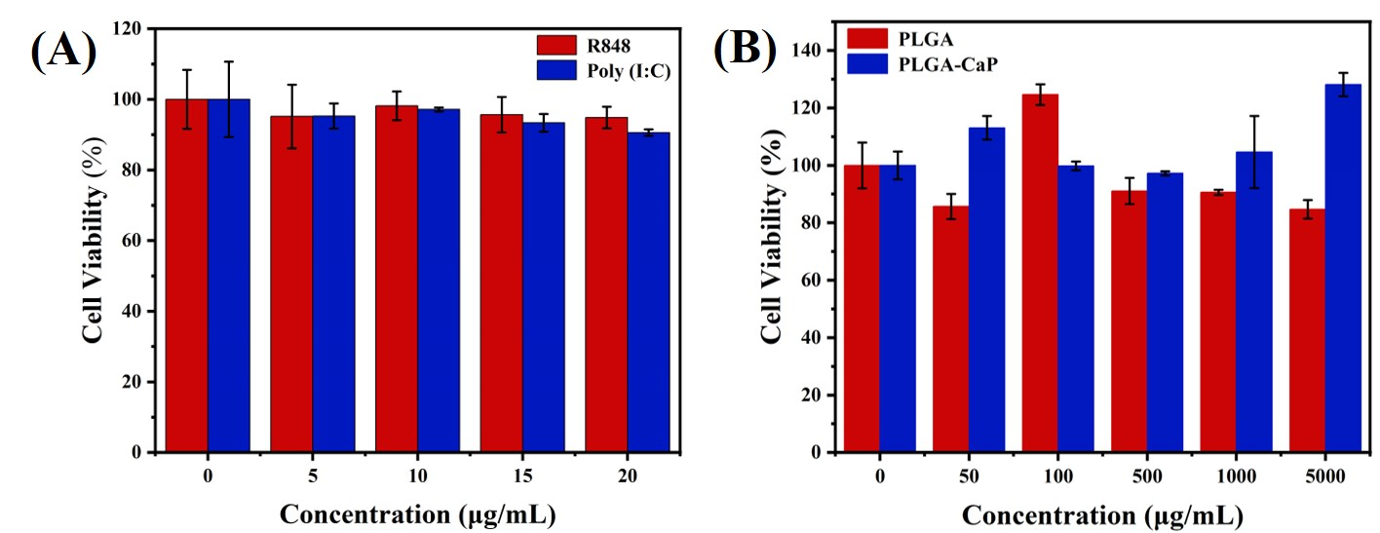
Figure S2. Biocompatibility of different drugs or nanoparticles, R848, Poly (I:C), PLGA and PLGA-CaP. Dendritic cells (extracted from mouse bone marrow) were incubated with different concentration of drugs or particles for 24 hours to evaluate the cell viability by CCK-8.

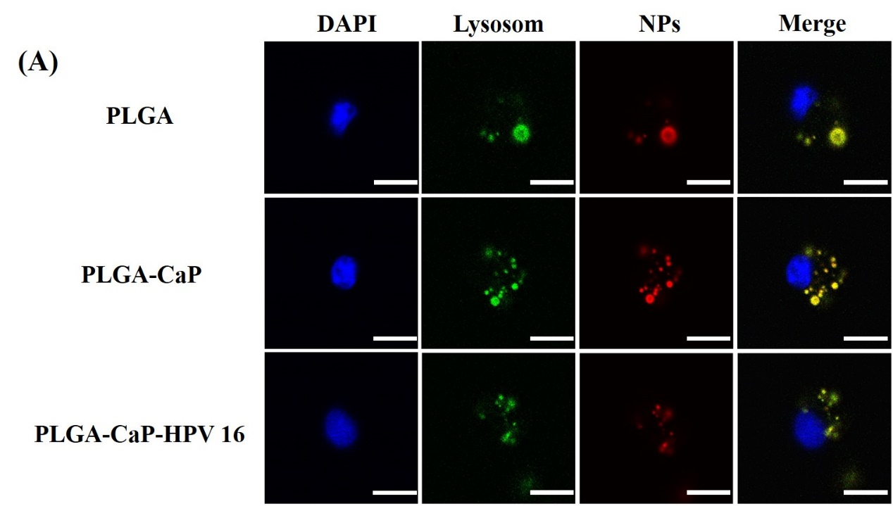
Figure S3. Confocal imaging analysis of the phagocytic behavior of dendritic cells on different nanoparticles. DAPI, Blue,nucleus; Green, lysosome; Red, Nanoparticles. Scale bar = 10 μm.

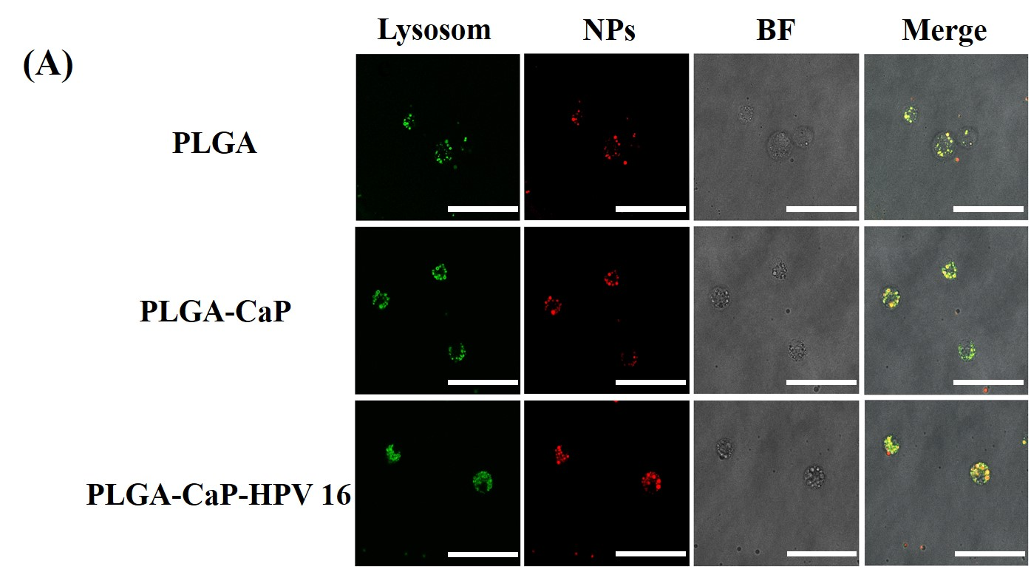
Figure S4. Confocal imaging analysis of the phagocytic behavior of dendritic cells on different nanoparticles. Green, lysosome; Red, Nanoparticles; BF, Bright field. Scale bar = 50 μm.

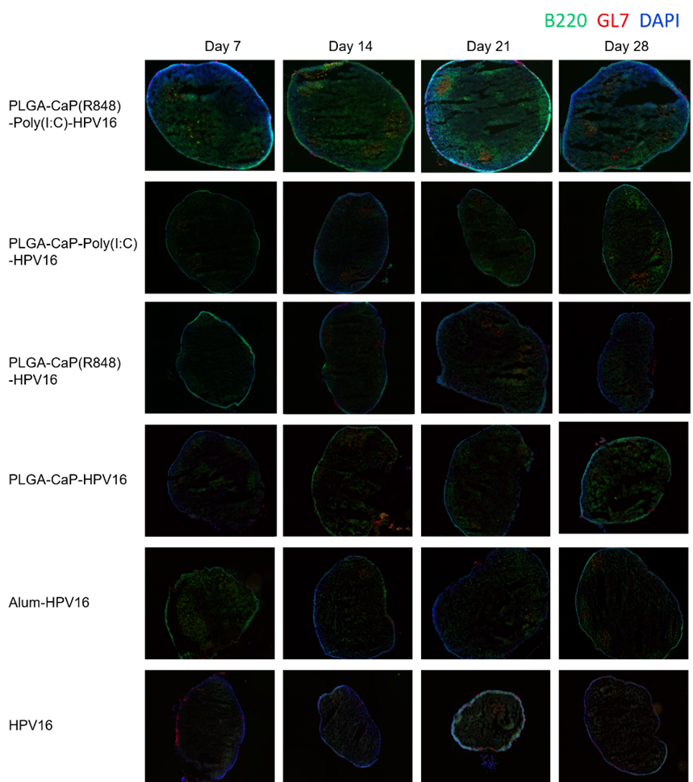
Figure S5. The most representative complete lymph node image of 4-6 lymph nodes in each treatment condition at each time point. BALB/c mice were immunized with the indicated adjuvants and antigen. Draining popliteal lymph nodes were excised at indicated time points, fixed, sectioned and stained for germinal centers (GL-7, red; B220, green, and DAPI, blue).

