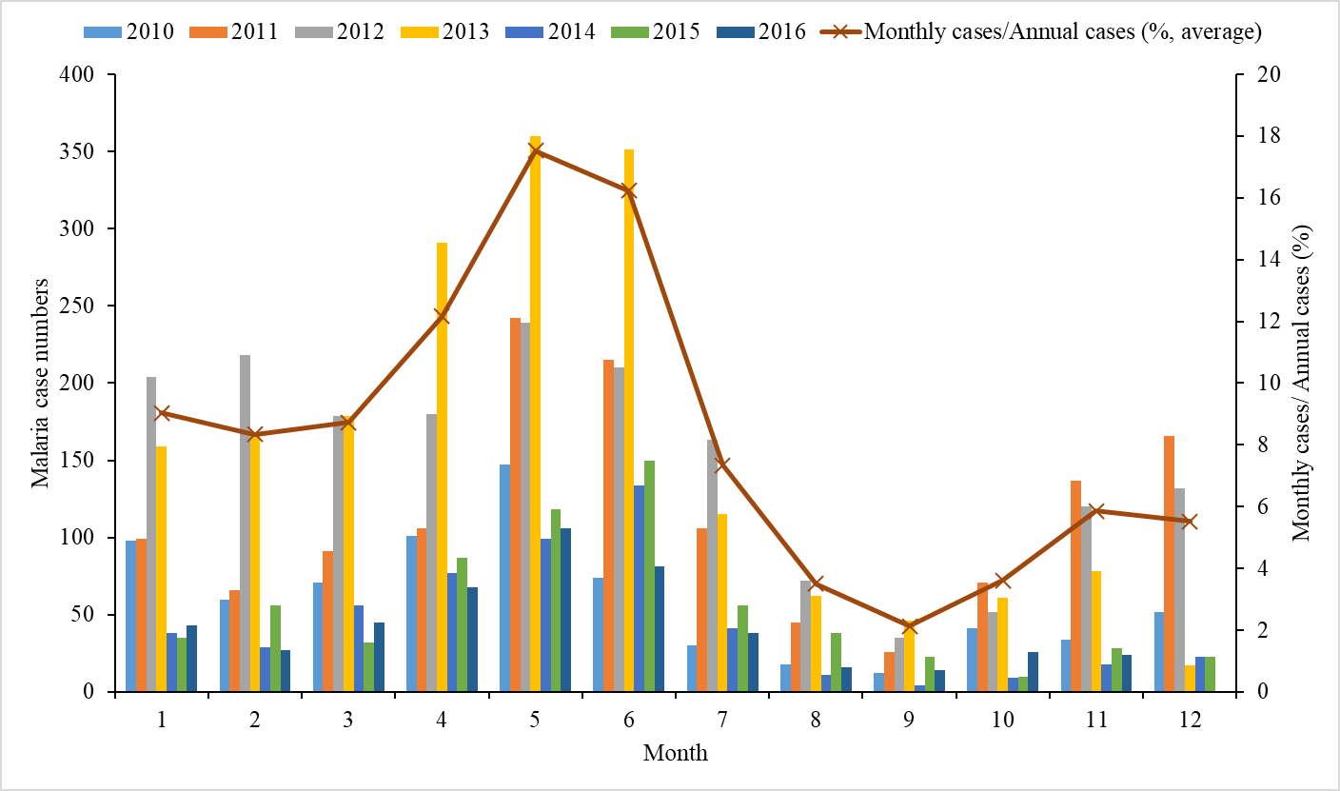

Figure S1. Monthly malaria cases in HAM from 2010 to 2016.
Endemic season is defined as the period with average monthly cases accounted for more than 10% of annual cases in this study, which is from April to June.

(A) K1 family (9 haplotypes)
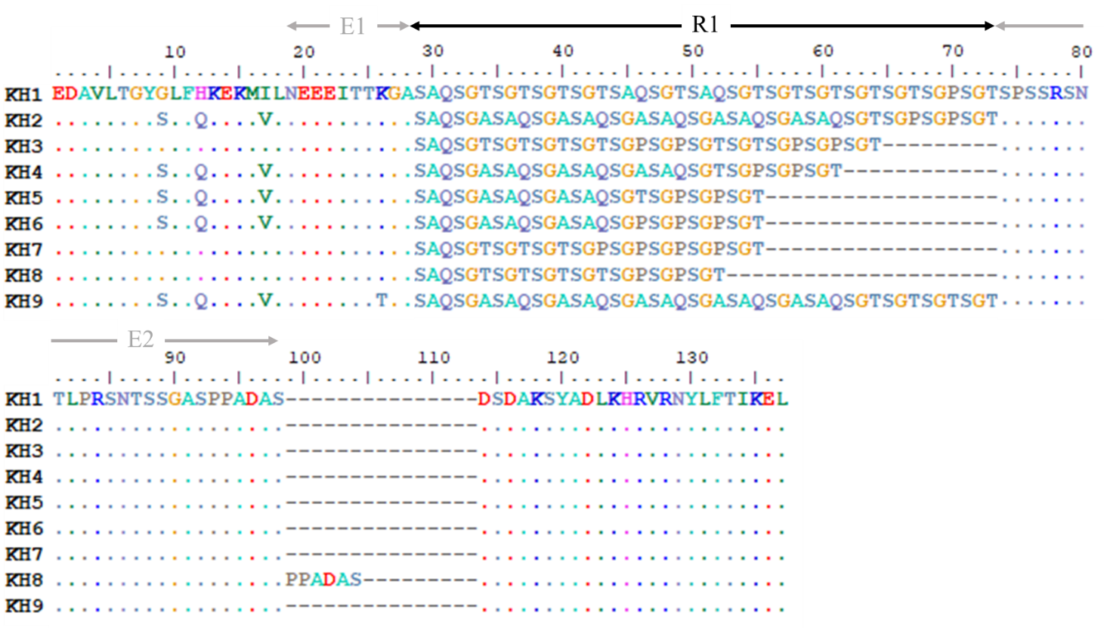

(B) MAD20 family (8 haplotypes)
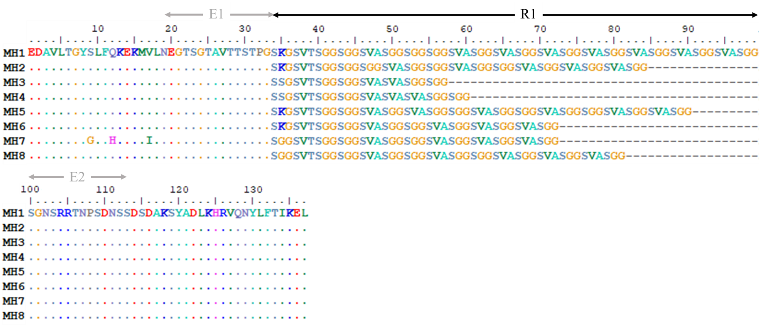

(C) RO33 family (4 haplotypes)
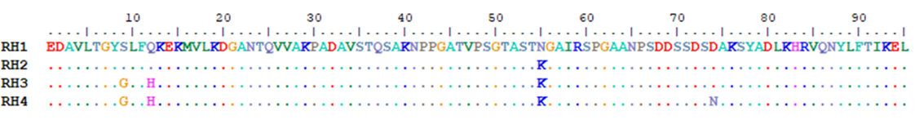

Figure S2. Sequence alignment of MSP1 haplotypes.
E1 and E2 are the family-specific regions, and R1 is the tri-peptide repetitive region in K1 and MAD20 allelic families. The RO33 block 2 region is an unique sequence without tandem repeats.

(A) 3D7/IC family

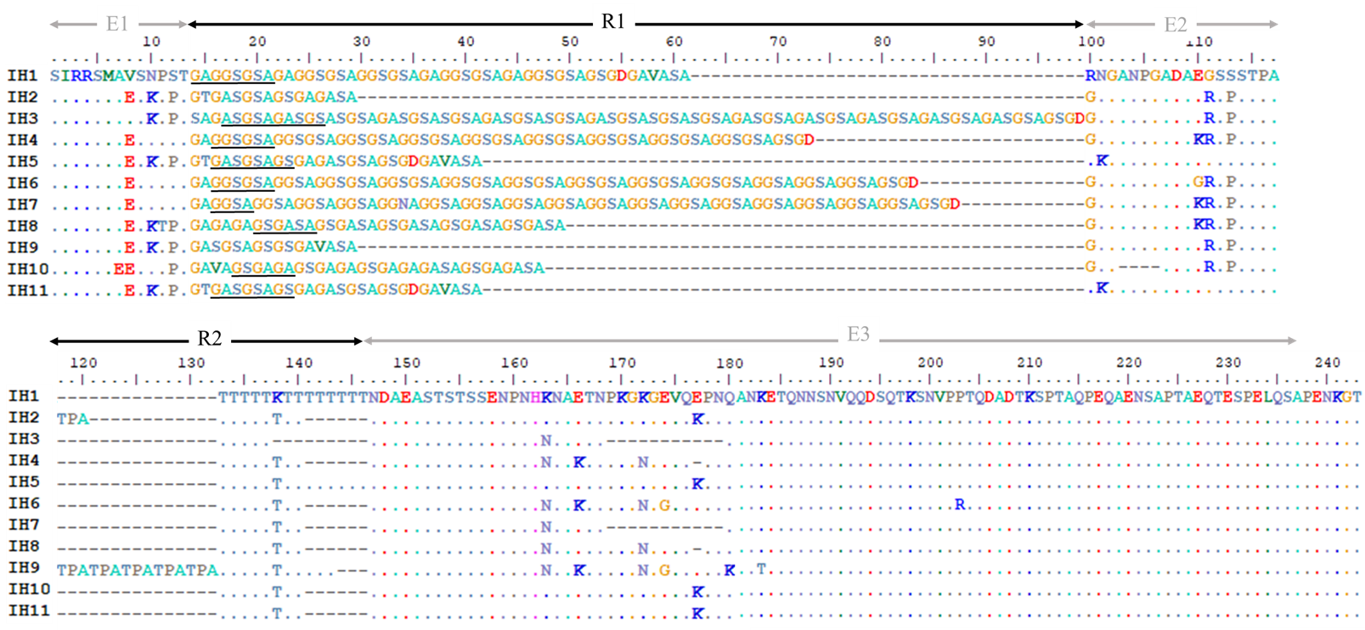

(B) FC27 family
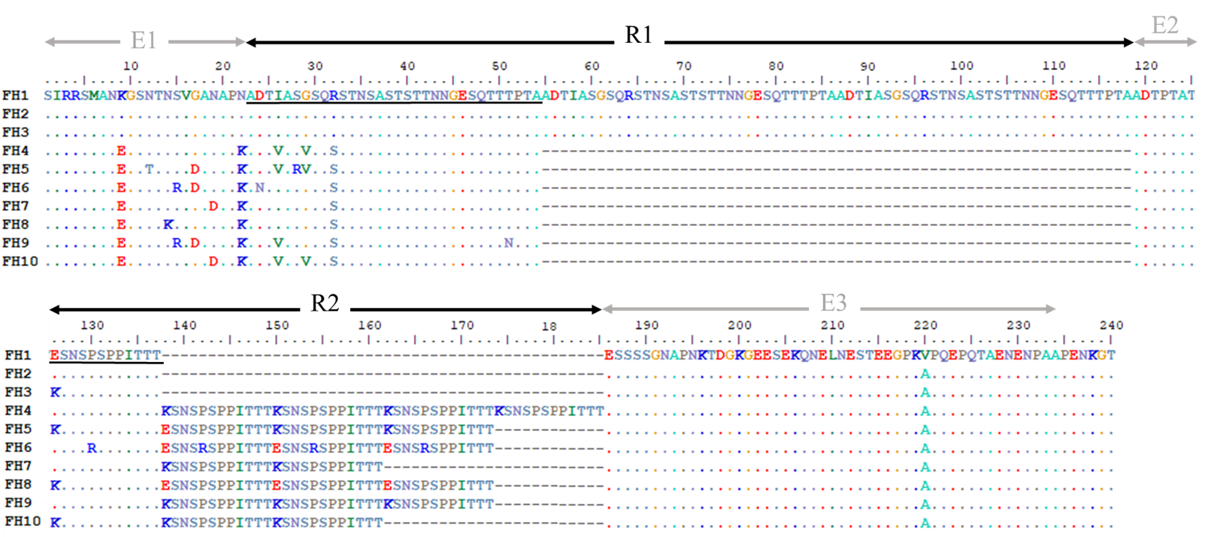

Figure S3. Sequence alignment of MSP2 haplotypes.
The family-specific regions are E1-E3, and the two tandem repetitive regions are R1 and R2 shown in the graph. Each repeat unit in R1 and R2 is underlined.

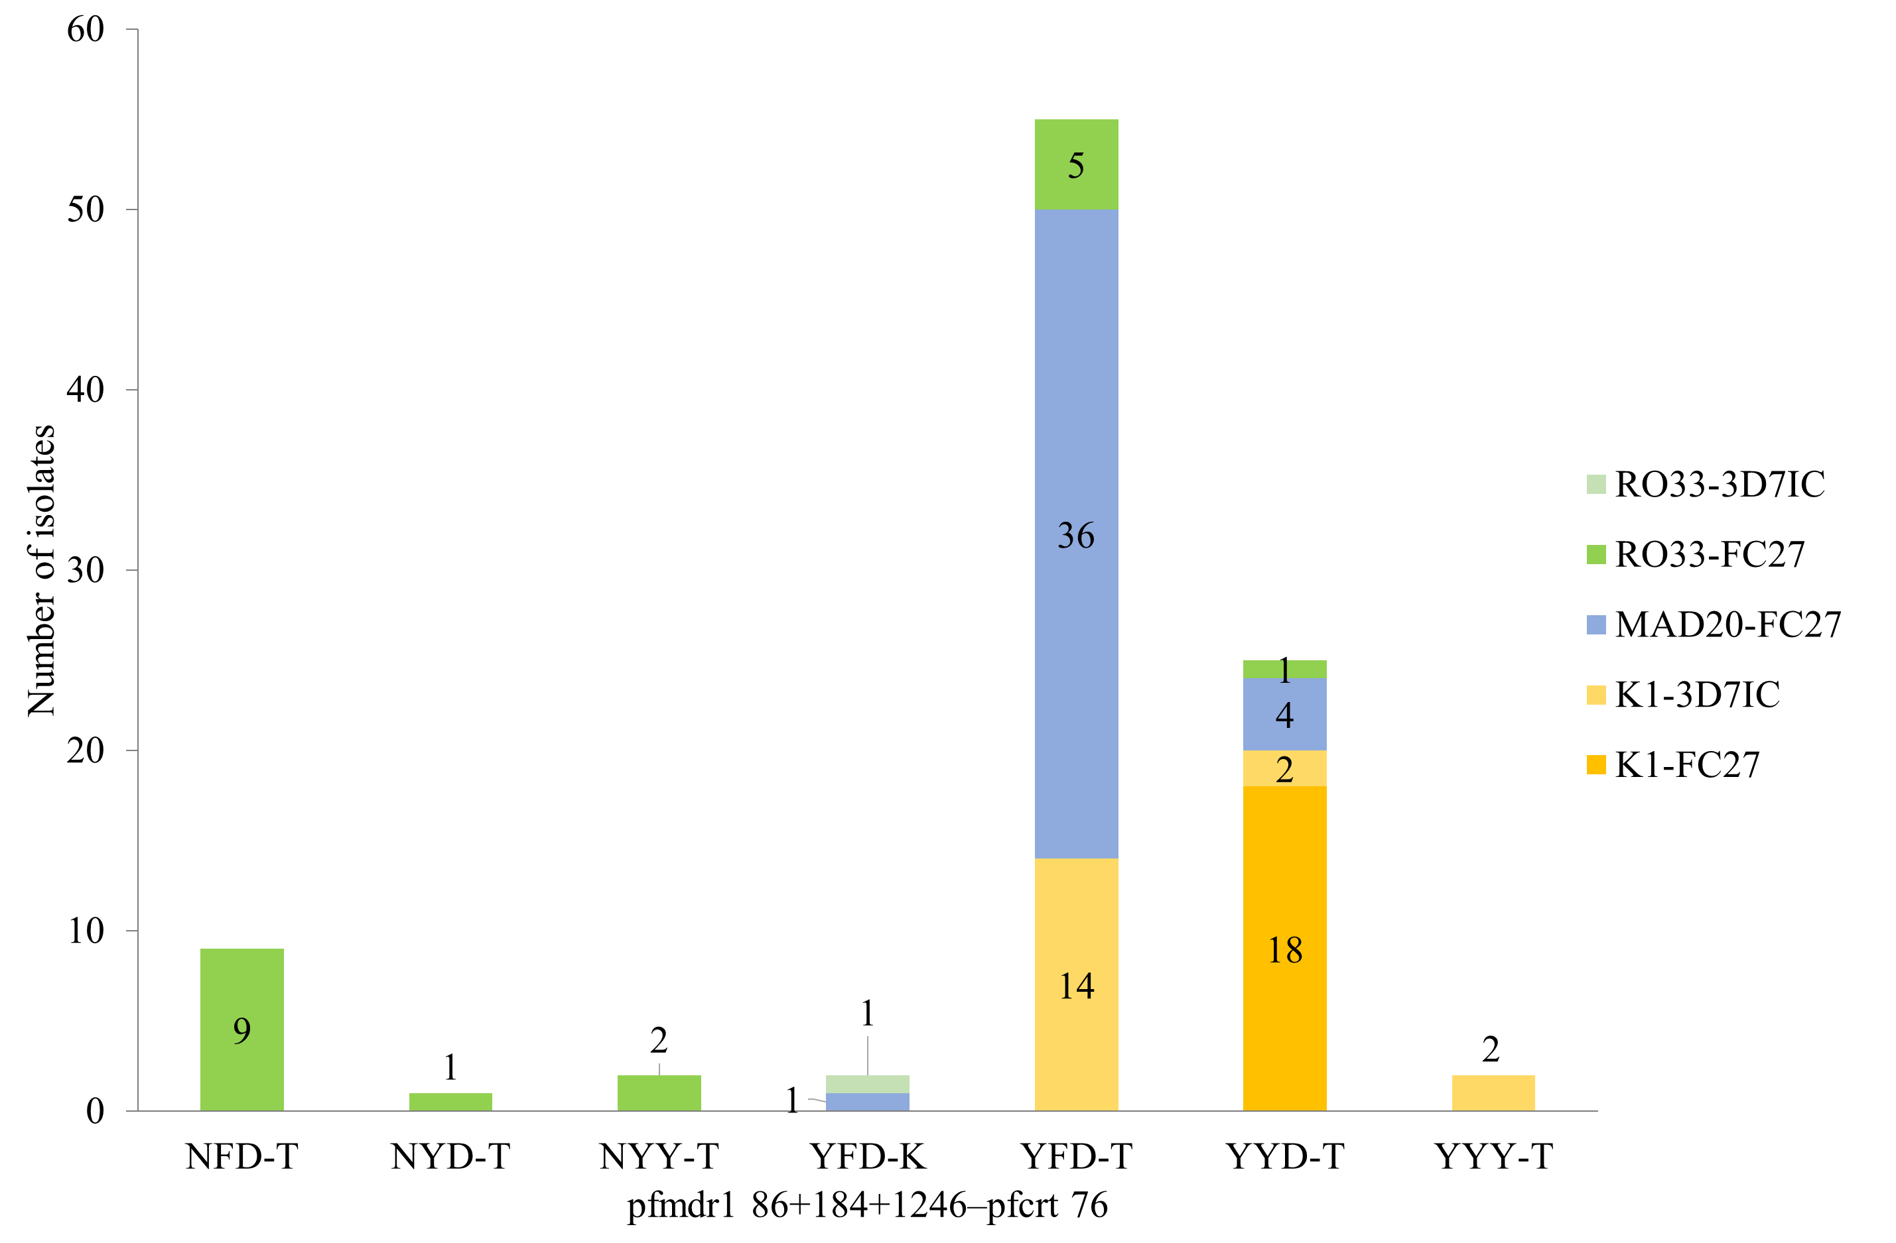
Resistance to AQ
Resistance to LF
pfmdr1 86+184+1246-pfcrt 76

Figure S4. Polymorphisms of pfmdr1-pfcrt and MSP1-MSP2 in 96 DBS samples.
A total of 96 samples (day 0 and day R) were successfully genotyped for all the genetic markers, including msp1, msp2, pfmdr1, and pfcrt. The x-axis shows the combined haplotypes of pfmdr1 N86Y+Y184F+D1246Y-pfcrt K76T. Bars in different colors indicate different groupings of MSP1-MSP2 allelic types, and number of isolates is shown in the bars. LF = lumefantrine, AQ = amodiaquine

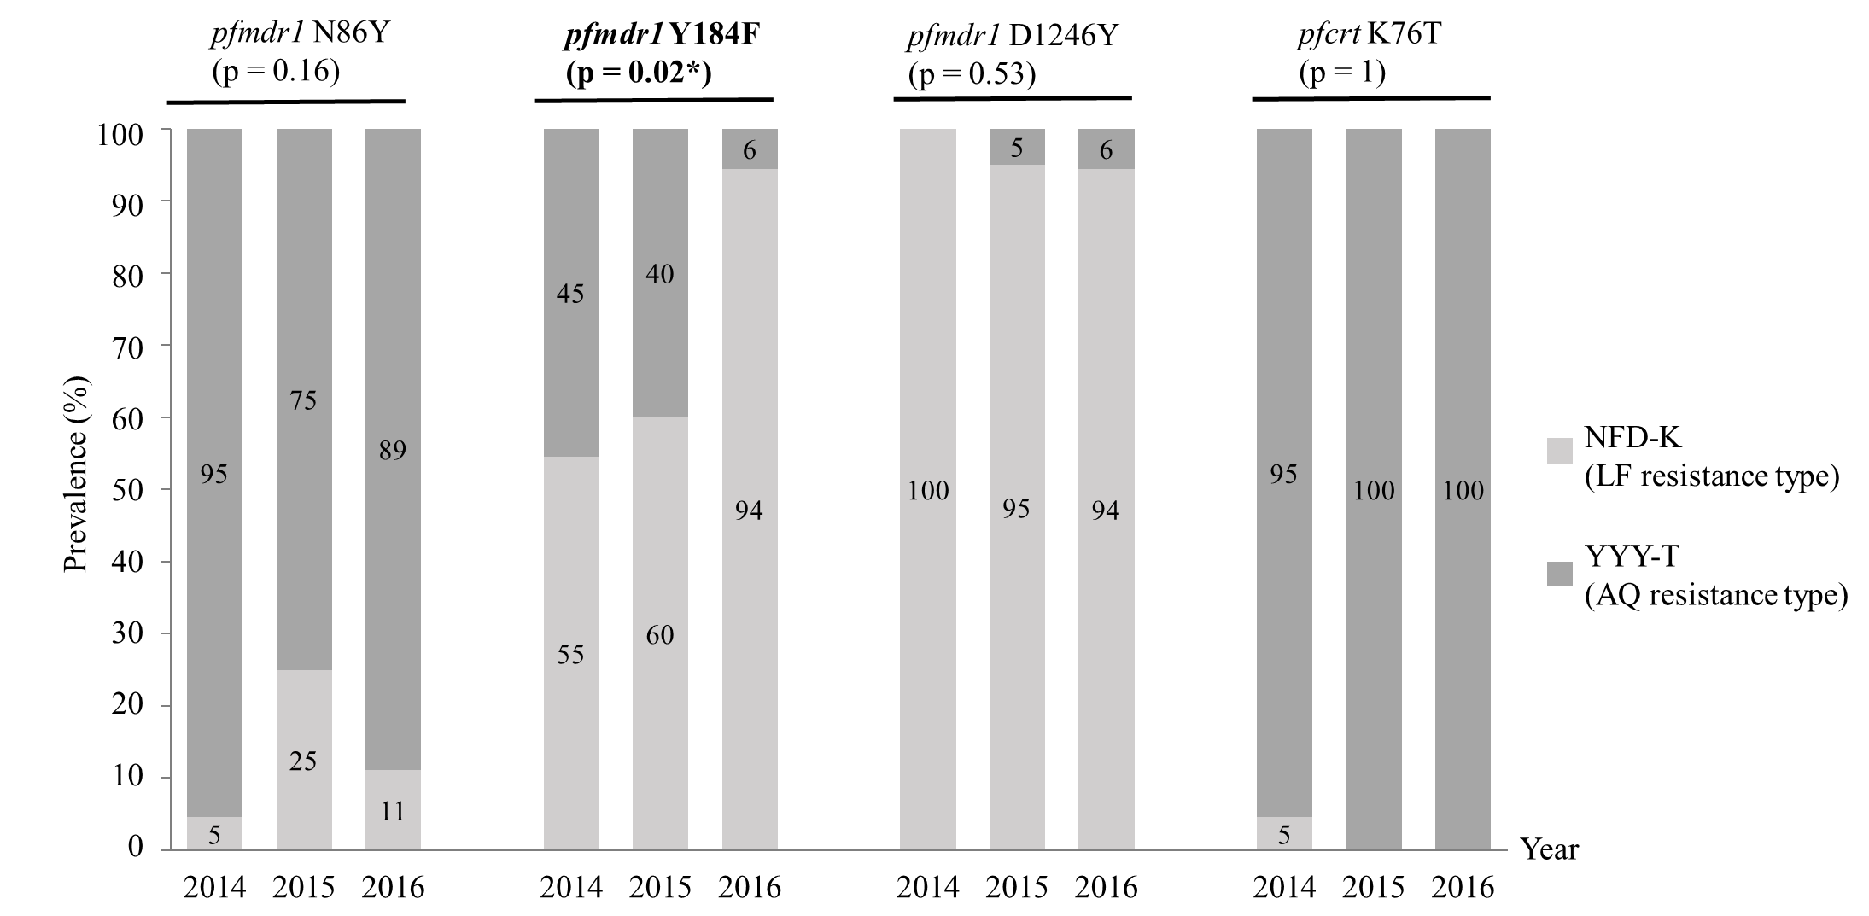

Figure S5. Temporal changes in pfmdr1 and pfcrt polymorphisms in 60 pre-treatment samples from 2014 to 2016.
The figures show temporal changes of pfmdr1 and pfcrt polymorphisms in 60 pre-treatment samples, of which 22 samples are collected from 2014, 20 samples are collected from 2015, and 18 samples are collected from 2016. Comparisons among groups were tested by Fisher’s exact test, and significant p-values are shown in bold type. Values in the bar graph are prevalence (%).

(A)

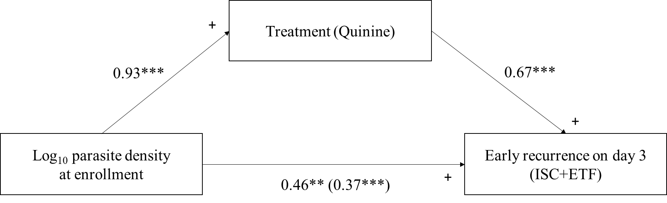

(B)

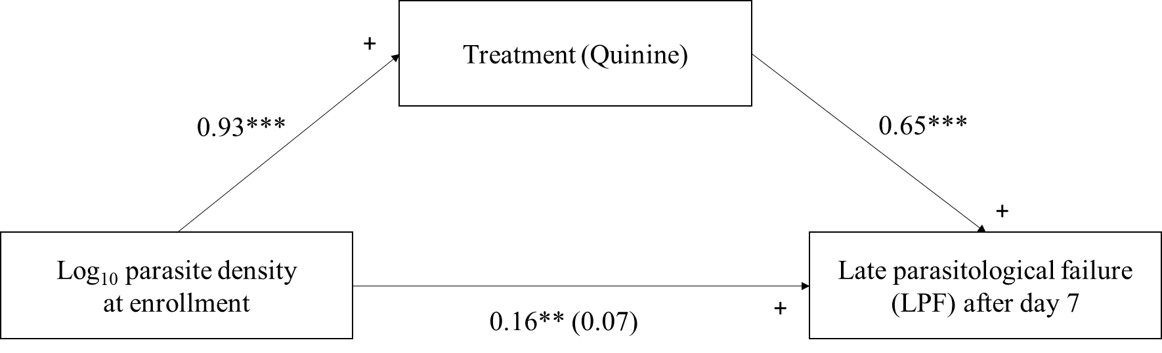

Figure S6. Results from the mediation analyses.
Figure (A) tests the mediation pathway of parasite density→ treatment selection (Quinine or not)→ early recurrence on day 3 (including insufficient clearance and early treatment failure) after controlling other predictive factors in the model. Figure B tests the mediation pathway for the outcome of late parasitological failure after day 7. The effect of infective parasite density on recurrence is partially mediated by the treatment selection of quinine. The direct effect of parasite density to early and late recurrence without considering treatment selection is significant, and the coefficient is 0.46 in A pathway (p < 0.001), and 0.16 in B pathway (p = 0.009). Parasite density at enrollment has significant effect on treatment selection (coefficient = 0.93, p < 0.001), which patients with higher parasite density at enrollment has higher probability to be treated by quinine. When treatment selection is considered as a mediator, the indirect effect for parasite density to “early” recurrence is still significant (p < 0.001) and the indirect effect was 0.46-0.37 = 0.09; however, the effect of parasite density to “late” recurrence is no longer significant (p = 0.28) after considering treatment selection.
**p < 0.01, ***p < 0.001, + means positive effect (coefficient).

