Supplementary materials
S1. Variations of individual provisioning response before and after parental removal of biparental nests in Chinese penduline tits. (a) Total feeding frequency (male + female = blue dots) before the experiment and feeding frequency by the remaining parent (red dots = remaining females; green dots = remaining males); (b) the feeding frequency of the remaining parent before and after partner removal (red dots = female feeding frequency before and after the male was removed; green dots = male feeding frequency before and after the female was removed. Each dot indicates the feeding frequency from one nest).

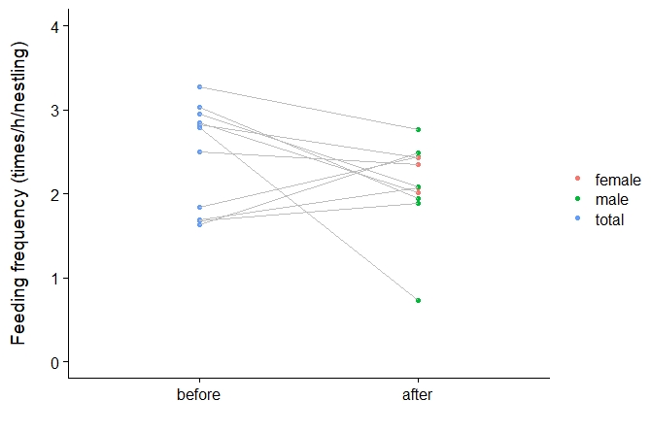
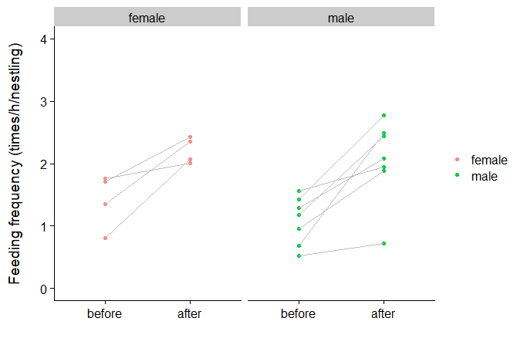
(b)
(a)

S2. Variations of individual brooding response before and after parental removal of biparental nests in Chinese penduline tits. (a) Total brooding duration (male + female = blue dots) before the experiment and brooding duration by the remaining parent (red dots = remaining females; green dots = remaining males); (b) the brooding duration of the remaining parent before and after partner removal (red dots = female brooding duration before and after the male was removed; green dots = male brooding duration before and after the female was removed. Each dot indicates the brooding duration from one nest).
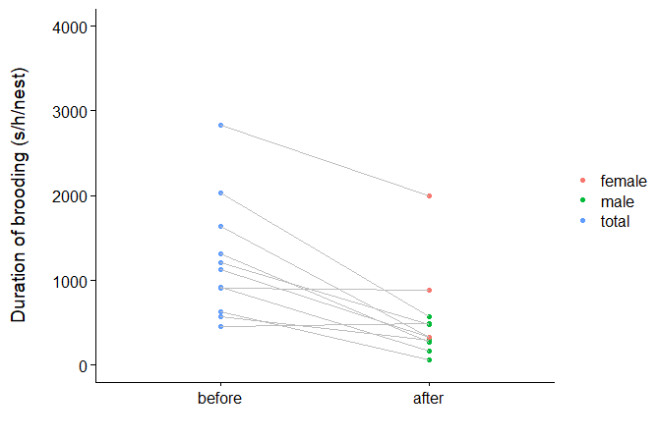
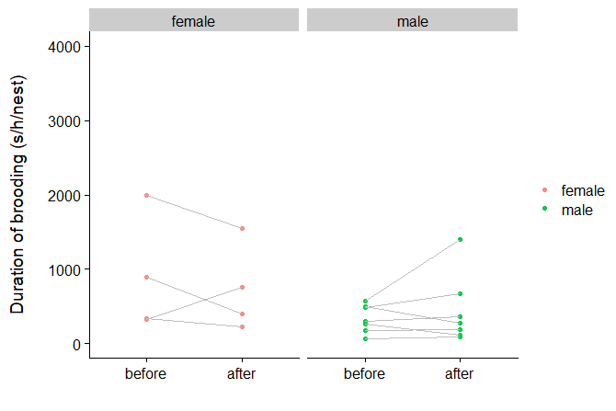
(a)
(b)

