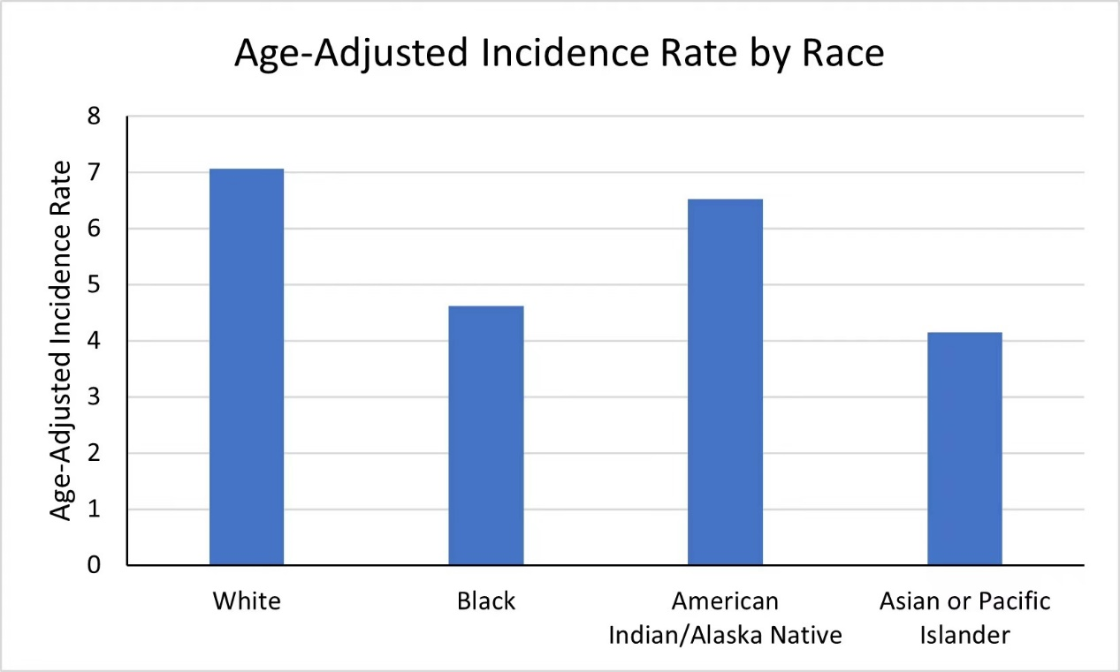

Supplementary figure 1: Age-adjusted incidence rate of ccRCC by race (from 2000 to 2017)

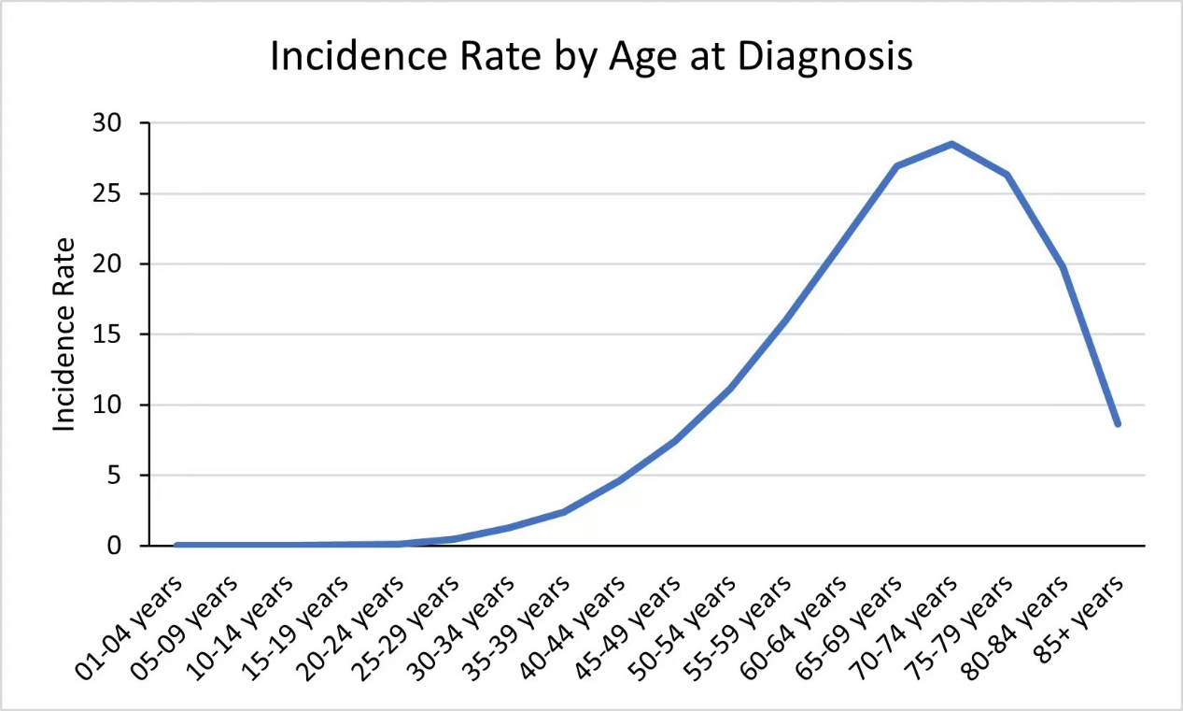
Supplementary figure 2: Age-adjusted incidence rate of ccRCC by age at diagnosis (from 2000 to 2017)

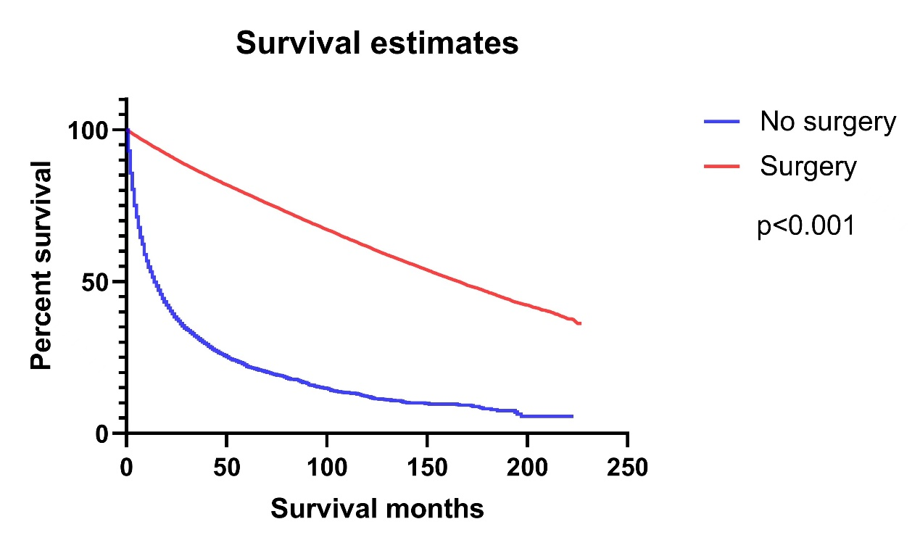
Supplementary figure 3: Kaplan–Meier curves of survival rates in patients with ccRCC according to the surgical treatment

