Online Supplementary Materials
For Figures

The study of whether acquired Mendelian diseases are the origin of Alzheimer’s disease from viral respiratory diseases.

Corresponding author: science@research.re.kr

Fig. S1. The flow of subjects randomized with anti-Alzheimer drugs (AADs) and the prevalence of viral respiratory diseases (VRDs) on Sorok Island
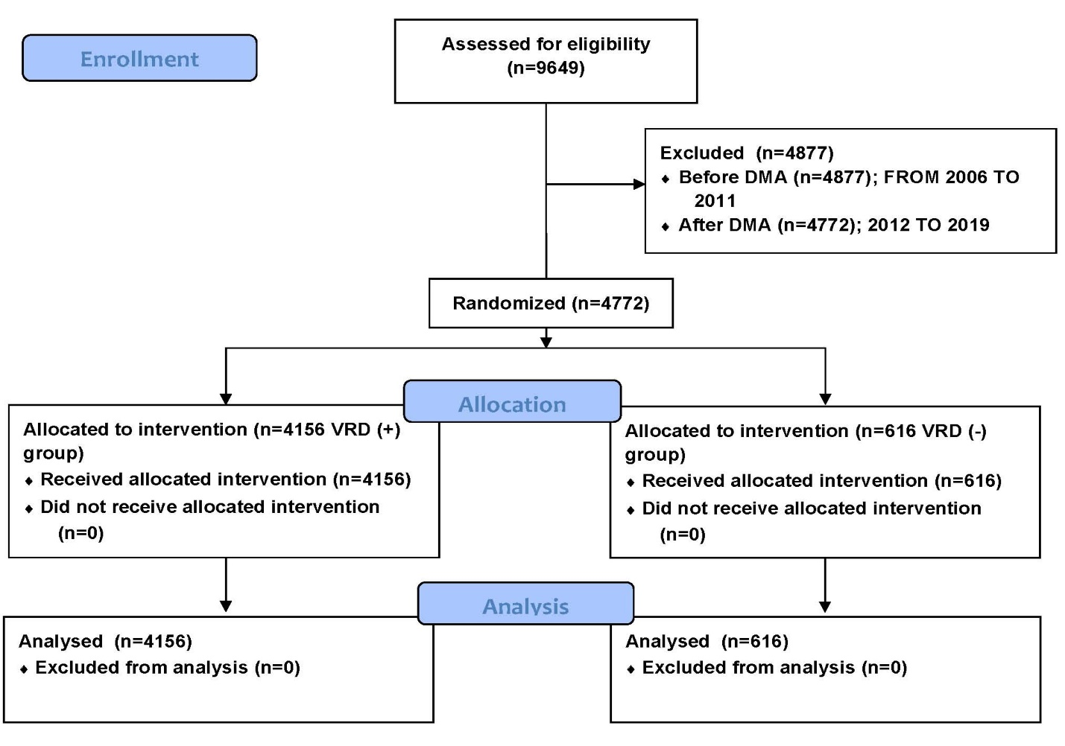

Fig. S2. T1:T2 on Sorok Island from 2012 to 2019.
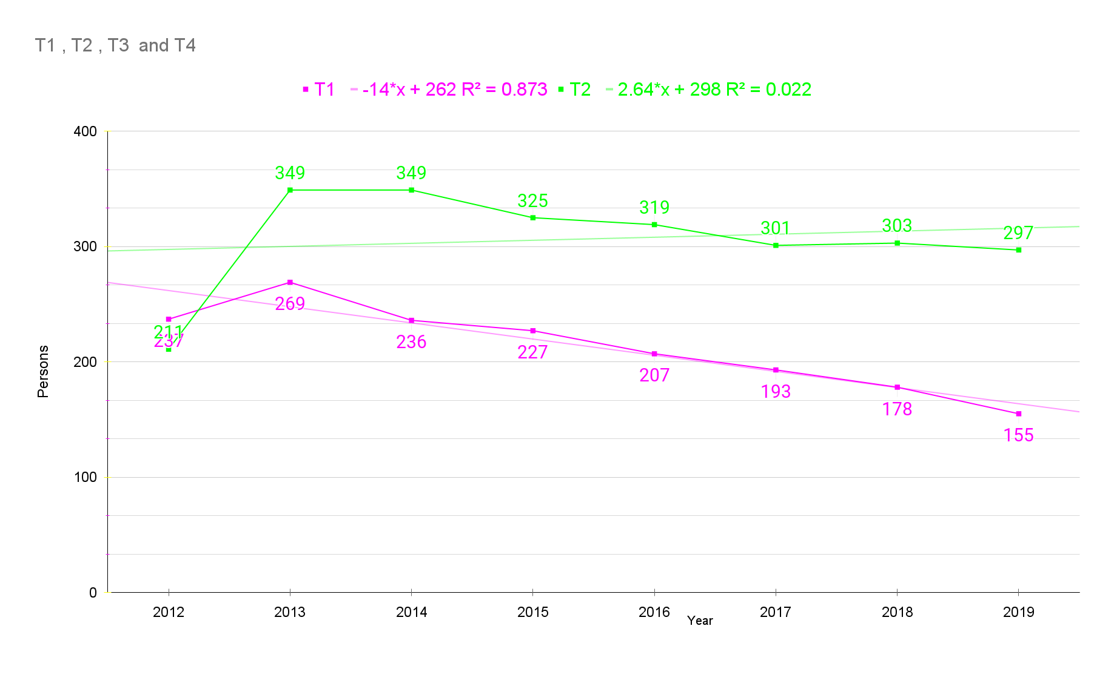

Fig. S3. T1:T3 on Sorok Island from 2012 to 2019.
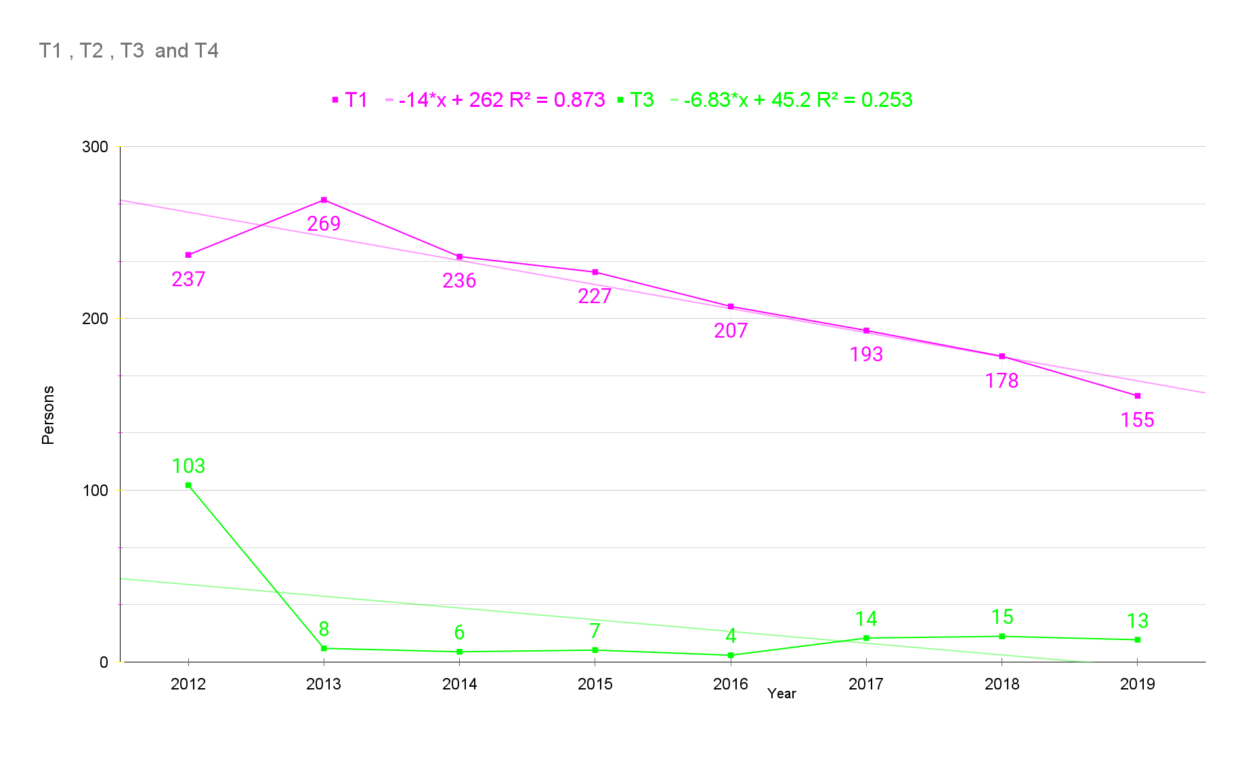

Fig. S4. T1:T4 on Sorok Island from 2012 to 2019.
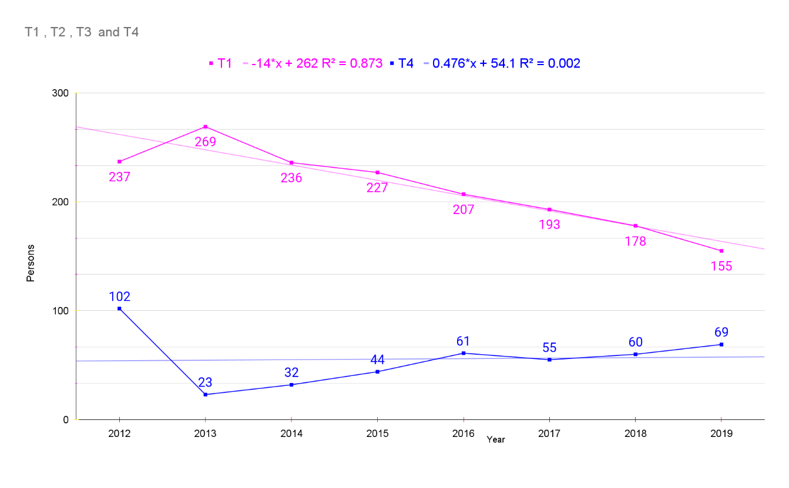

Fig. S5. T2:T3 on Sorok Island from 2012 to 2019.
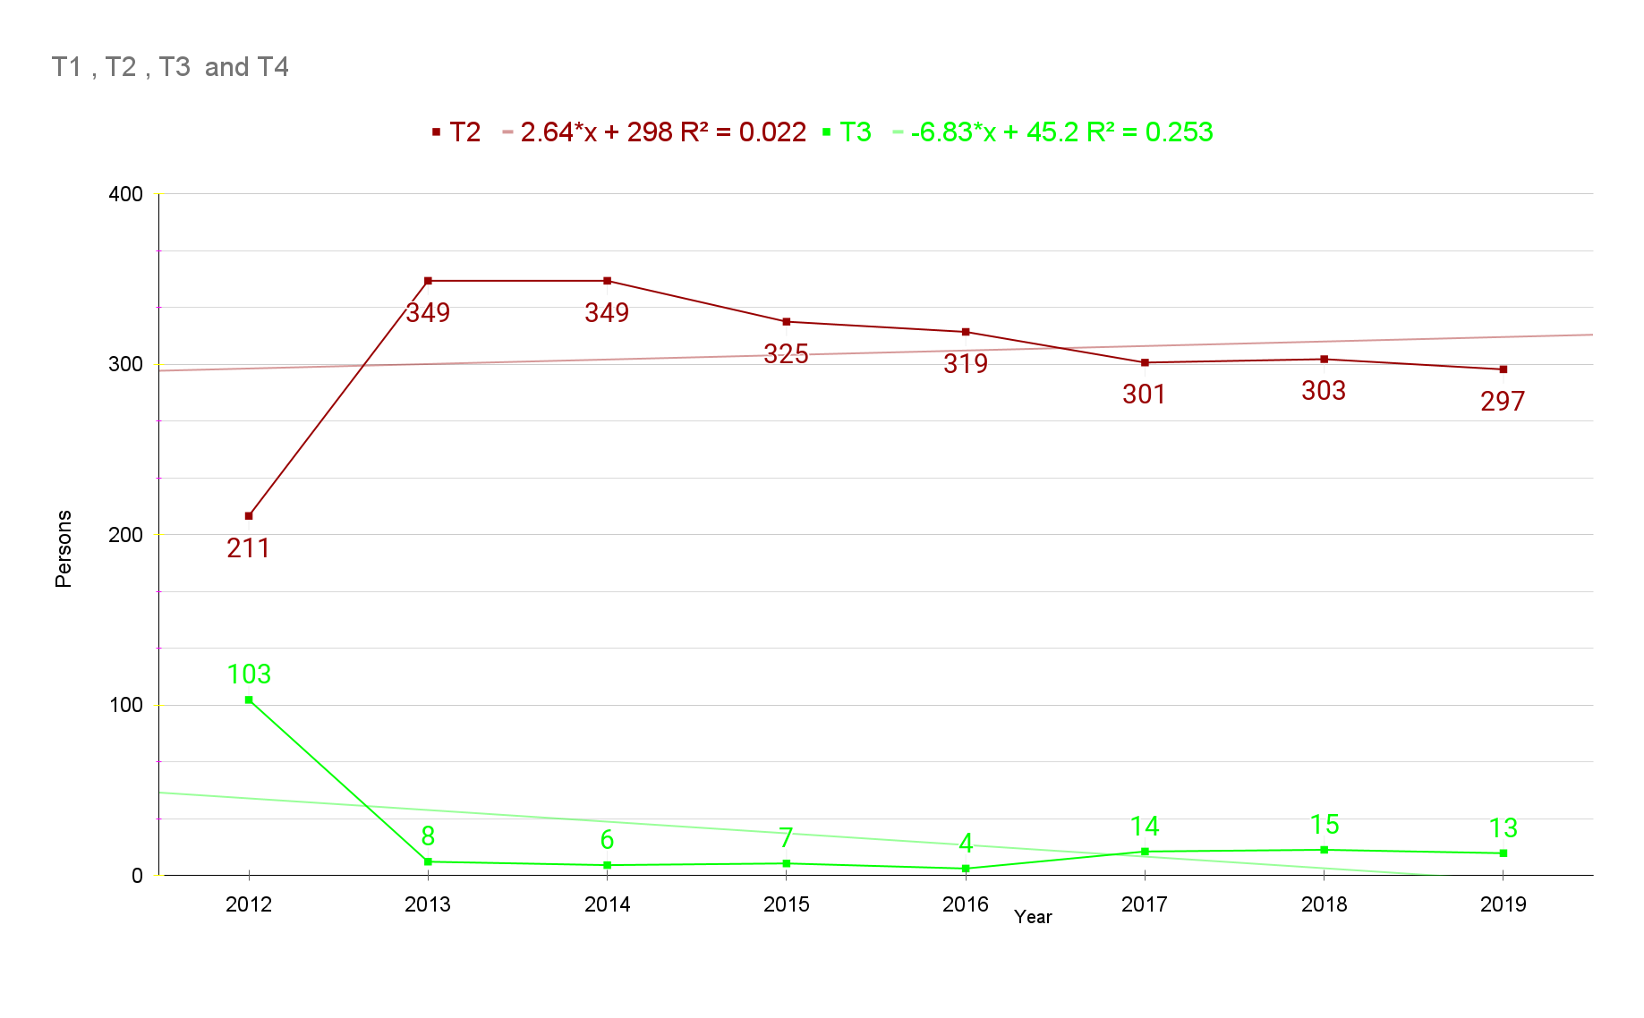

Fig. S6. T2:T4 on Sorok Island from 2012 to 2019.
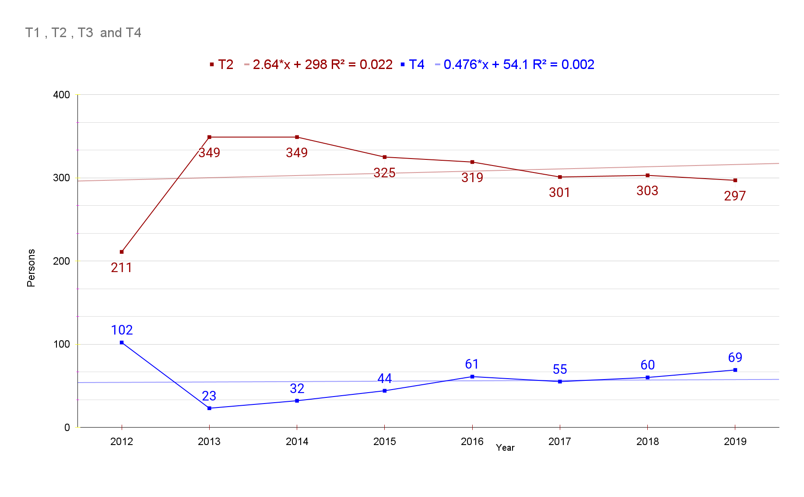

Fig. S7. Life expectancy on Sorok Island

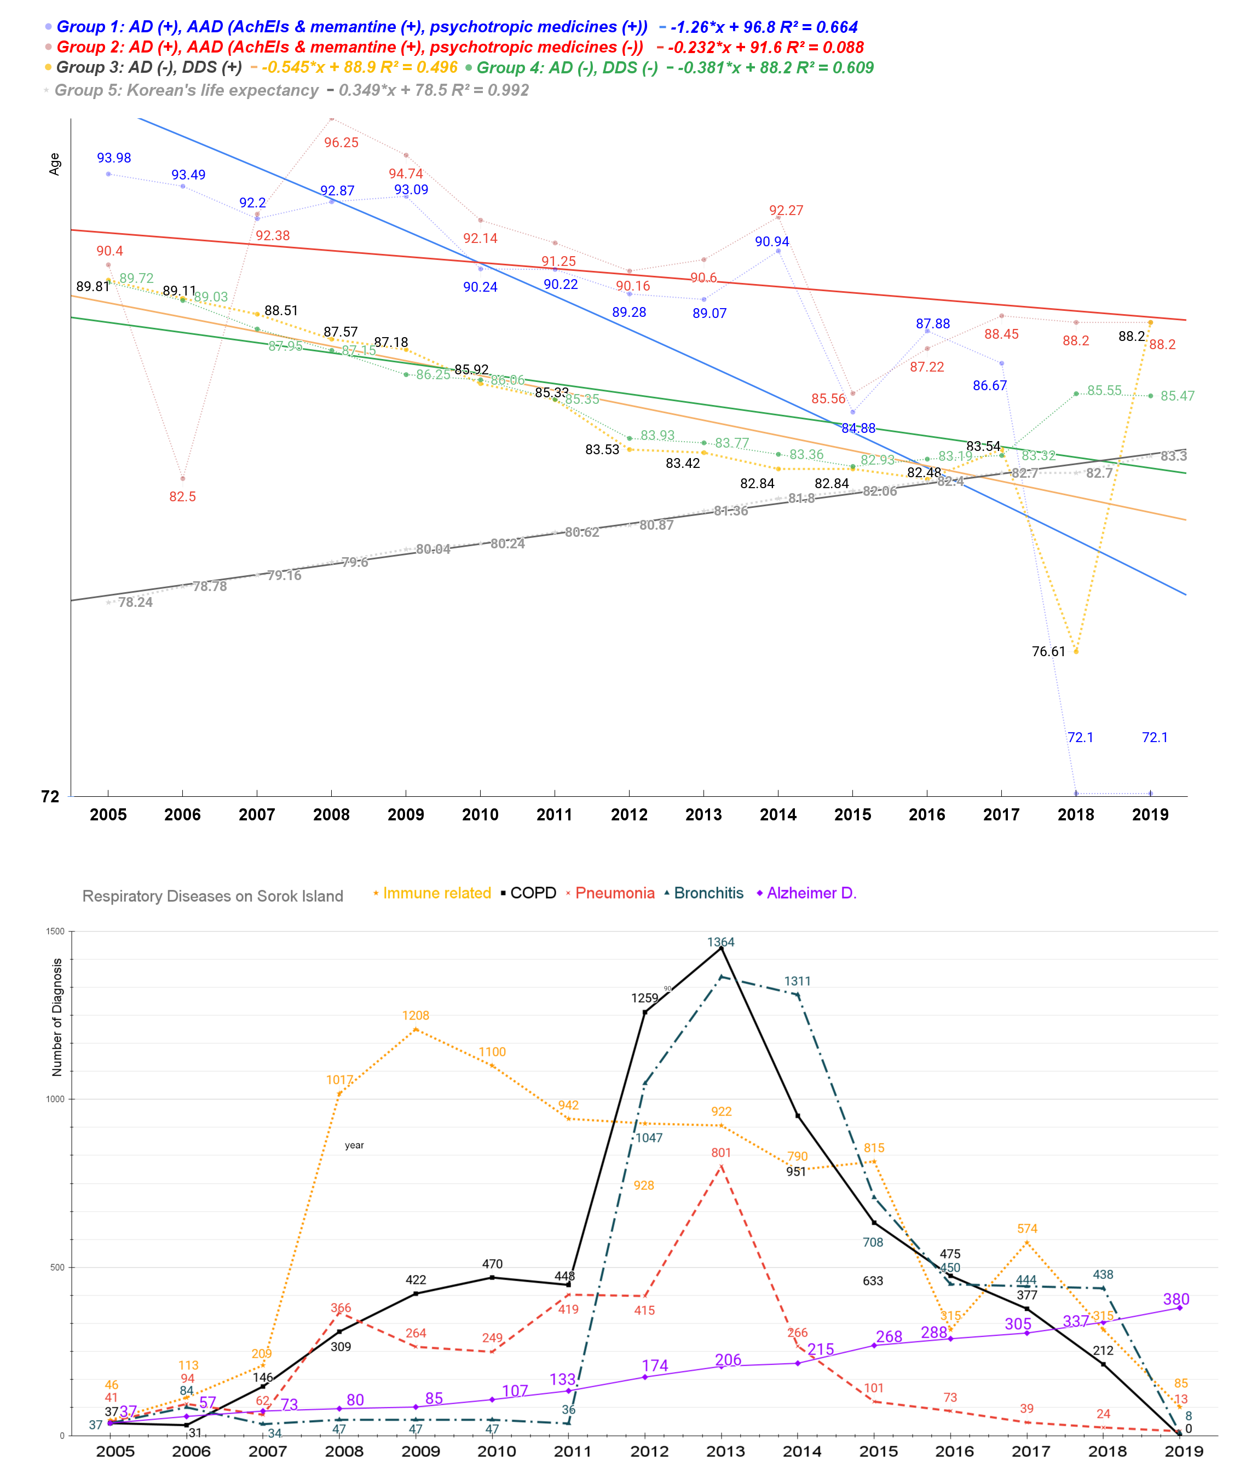
Group 1 and group 2 were Alzheimer’s disease diagnosed (+) populations. Both are prescribed (+) acetylcholine esterase inhibitors (AchEIs) and memantine. In addition, group 1 was only prescribed psychotropic medicines. Group 3 and group 4 were Alzheimer’s disease undiagnosed (-) populations. Group 3 was only dapsone-prescribed (+), and group 4 was dapsone-unprescribed (-). A gradual trend in life expectancy can be identified when observing a time series of 15 years (2005-2019) ¹. The group using AchEIs had a higher life expectancy than those not using them. The life expectancy of the entire Korean population is gradually increasing ². Immune-related inflammatory diseases showed a sharp increase in prevalence from 2008 to 2015, and COPD increased slowly from 2008 to 2011, rapidly increasing in 2012 and 2013. Acute bronchitis quickly rose from 2012 to 2014, and pneumonia increased sharply in 2013 compared to previous years ³. AD has increased continuously since 2005 ².

References
1 Lee, J. H., Kanwar, B., Lee, C. J., Sergi, C. & Coleman, M. D. Dapsone is an anticatalysis for Alzheimer’s disease exacerbation. iScience, doi:10.1016/j.isci.2022.104274 (2022).
2 Lee, J. H. The listed, delisted, and sustainability of therapeutic medicines for dementia patients: the study is specific to South Korea. Naunyn Schmiedebergs Arch Pharmacol 395, 535-546, doi:10.1007/s00210-022-02209-3 (2022).
3 Lee, J. H. et al. Bronchitis, COPD, and pneumonia after viral endemic of patients with leprosy on Sorok Island in South Korea. Naunyn-Schmiedeberg's Archives of Pharmacology, doi:10.1007/s00210-023-02407-7 (2023).

