Supplementary Materials: Increasing the ratio of red to blue light as supplemental light improves growth, photosynthesis, and yield of cut roses
Supplementary Materials
Figure S1. Effect of different ratios of R and B light spectrum as supplemental light on PIABS (Performance index for the photochemical activity) (A), ABS/RC (The specific energy fluxes per RC for energy absorption) (B), TRo/RC (Trapped energy flux (leading to QA reduction) per RC) (C), ETo/RC (Electron transport flux (further than QA-) per RC) (D) and DIo/RC (Electron transport flux (further than QA-) per RC) (E) of two rose cultivars (ʻSamuraiʼ and ʻUtopiaʼ). Supplemental light recipies including 90% R: 10% B (R90B10), 80% R: 20% B (R80B20), 70% R: 30% B (R70B30) and a treatment without supplemental light (Control) was used. Each column is representative of mean value of six replicates plus SEM. Significance at the 0.05, 0.001 and 0.0001 probability levels are indicated by *, *** and ****, respectively, Figure S2. Several quantitative and qualitative factors are influential in the marketability of rose shoots, which increases the economic efficiency. In the above figure, a comprehensive study of the effect of different ratios of red and blue light spectrum as supplementary light 90% red: 10% blue (R90B10), 80% red: 20% blue (R80B20), 70% red: 30% blue (R70B30) and without light Supplement (Control) on the reproduction characteristicsof two cultivars of roses.

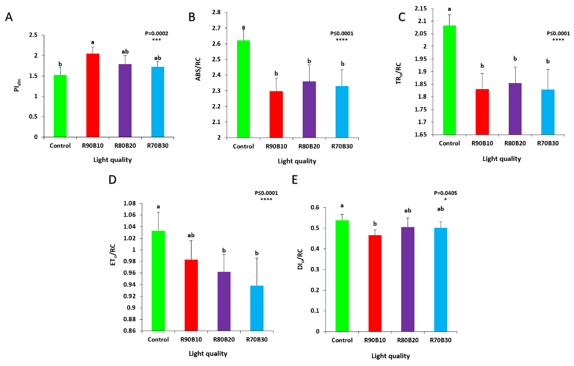
Figure S1. Effect of different ratios of R and B light spectrum as supplemental light on PI_{ABS} (Performance index for the photochemical activity) (A), ABS/RC (The specific energy fluxes per RC for energy absorption) (B), TR_{o}/RC (Trapped energy flux (leading to Q_{A} reduction) per RC) (C), ET_{o}/RC (Electron transport flux (further than Q_{A}⁻) per RC) (D) and DI_{o}/RC (Electron transport flux (further than Q_{A}⁻) per RC) (E) of two rose cultivars (ʻSamuraiʼ and ʻUtopiaʼ). Supplemental light recipies including 90% R: 10% B (R90B10), 80% R: 20% B (R80B20), 70% R: 30% B (R70B30) and a treatment without supplemental light (Control) was used. Each column is representative of mean value of six replicates plus SEM. Significance at the 0.05, 0.001 and 0.0001 probability levels are indicated by *, *** and ****, respectively.

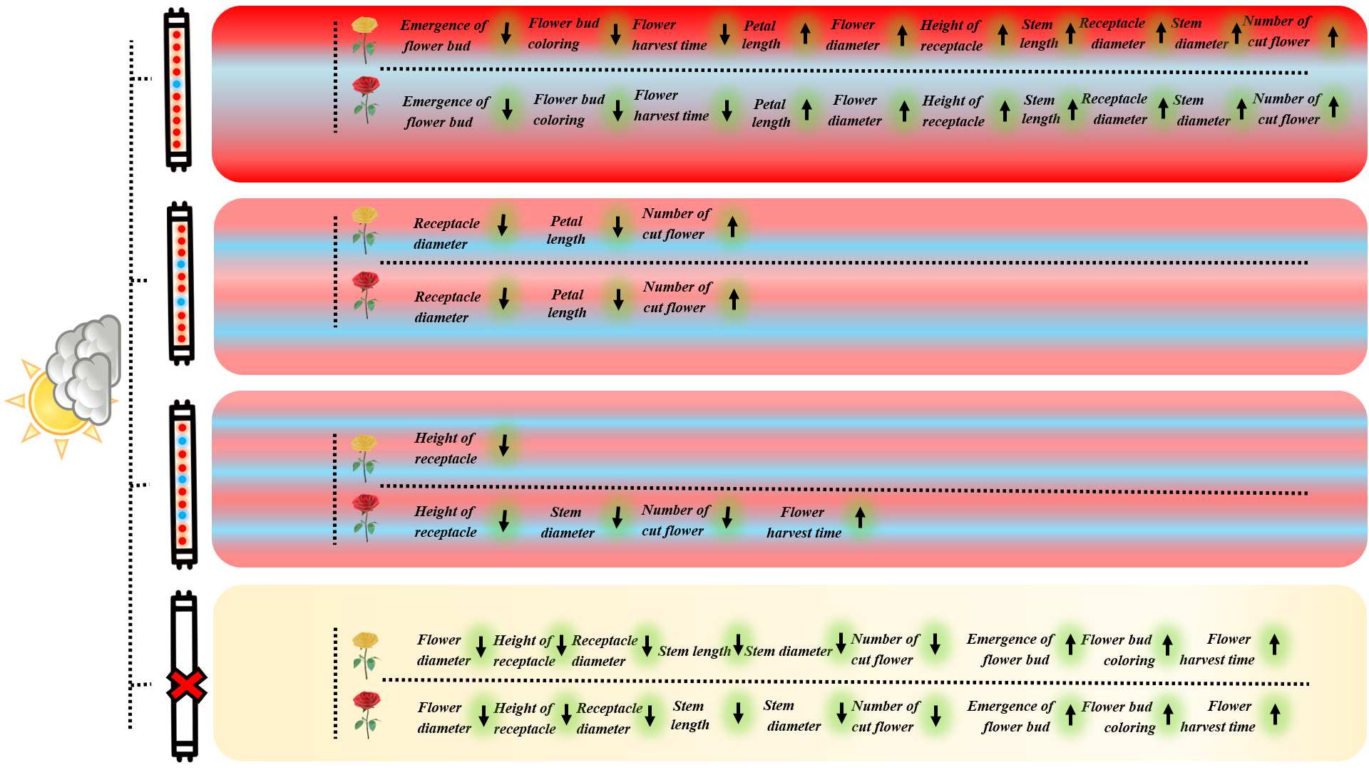
Figure S2. Several quantitative and qualitative factors are influential in the marketability of rose shoots, which increases the economic efficiency. In the above figure, a comprehensive study of the effect of different ratios of red and blue light spectrum as supplementary light 90% red: 10% blue (R90B10), 80% red: 20% blue (R80B20), 70% red: 30% blue (R70B30) and without light Supplement (Control) on the reproduction characteristicsof two cultivars of roses.

