Table 2. Description of the land use and land cover (LULC) classes
Sl. No. | Class | Class Description | Sample
1 | Agricultural land | Area covered by different croplands such as annual or seasonal crops | 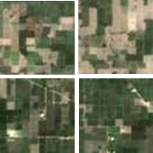
2 | Builtup | Area covered by human settlements and commercial buildings | 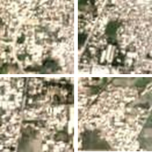
3 | Forest | Area covered by dense as well as sparse trees | 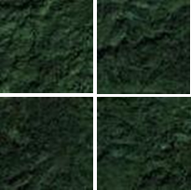
4 | Waterbody | Area covered by water including flowing and stagnant water bodies as well as barren coastal areas | 