Trimatch comparison of the prognosis of hypochloremia, normolchloremia and hyperchloremia in patients with septic shock
SUPPLEMENTAL MATERIAL

Table.S1 Baseline characteristics at the time of ICU admission among original cohort group
Variables | Normal group | Low group | High group | P value
Variables | N=2289 | N=470 | N=967 | P value
Race (%) |  |  |  | 0.441
White | 1526(66.7) | 299(63.6) | 635(65.7)
Black | 184 (8.0) | 46 (9.8) | 93(9.6)
Others | 579 (25.3) | 125(26.6) | 239(24.7)
Gender = M (%) | 1270(55.5) | 286(60.9) | 467(48.3) | <0.001
Hospital-acquired AKI(%) | 1820(79.5) | 421(89.6) | 743(76.8) | <0.001
Age (%) |  |  |  | <0.001
> 60 | 1387 (60.60) | 222 (47.23) | 599 (61.94)
<=60 | 902 (39.40) | 248 (52.77) | 368 (38.06)
Hospital mortality (%) | 731(31.9) | 199(42.3) | 281(29.1) | <0.001
Vasoactive (%) | 1690(73.8) | 335(71.3) | 767(79.3) | <0.001
HR (mean (SD)) | 97.87 (21.74) | 95.84 (19.76) | 98.16 (21.25) | 0.126
MAP (mean (SD)) | 76.07 (15.74) | 74.38 (15.27) | 75.26 (16.31) | 0.079
Lactate (mean (SD)) | 2.61 (1.40) | 2.59 (1.39) | 2.66 (1.44) | 0.611
pH (mean (SD)) | 7.33 (0.11) | 7.33 (0.13) | 7.30 (0.12) | <0.001
pO2 (mean (SD)) | 57.72 (21.79) | 55.31 (21.23) | 59.08 (21.92) | 0.023
Urine output (mean (SD)) | 1384.11 (965.19) | 1172.98 (1004.38) | 1425.58 (999.80) | <0.001
Hb (mean (SD)) | 10.35 (2.20) | 10.29 (2.36) | 10.28 (2.09) | 0.662
PLT (mean (SD)) | 188.79 (102.16) | 182.69 (105.79) | 182.72 (95.84) | 0.212
RDW (mean (SD)) | 15.87 (2.62) | 16.51 (2.83) | 15.65 (2.52) | <0.001
Creatinine (mean (SD)) | 1.48 (0.85) | 1.77 (0.98) | 1.44 (0.81) | <0.001
Potassium (mean (SD)) | 4.15 (0.69) | 4.26 (0.83) | 3.98 (0.67) | <0.001
Sodium (mean (SD)) | 137.03 (4.02) | 132.08 (4.75) | 142.04 (3.80) | <0.001
Sofa (mean (SD)) | 3.08 (2.75) | 3.82 (3.31) | 3.05 (2.49) | <0.001
ALB(mean (SD)) | 2.78 (0.61) | 2.98 (0.71) | 2.55 (0.58) | <0.001
RRT (%) | 115( 5.0) | 77(16.4) | 34( 3.5) | <0.001
Ventilation (%) | 301(13.1) | 48(10.2) | 149(15.4) | 0.022
Liver disease (%) |  |  |  | <0.001
Yes | 521 (22.8) | 182 (38.7) | 173 (17.9)
No | 1768 (77.2) | 288 (61.3) | 794 (82.1)
Congestive heart failure (%) |  |  |  | <0.001
Yes | 777(33.9) | 195(41.5) | 247(25.5)
No | 1512(66.1) | 275(58.5) | 720(74.5)
Chronic kidney disease (%) |  |  |  | <0.001
Yes | 560(24.5) | 154(32.8) | 207(21.4)
No | 1729(75.5) | 316(67.2) | 760(78.6)
ICU mortality (%) | 500 (21.8) | 145 (30.9) | 207 (21.4) | <0.001

Table.S2 Multivariate regression of original cohort
Parameters | OR | CI |  | P value
Parameters | OR | 2.5% | 97.5% | P value
Low group | 1.519 | 1.111 | 2.071 | 0.008
High group | 0.832 | 0.671 | 1.031 | 0.094
Race
Black | 0.854 | 0.579 | 1.238 | 0.413
Others | 1.380 | 1.120 | 1.699 | 0.002
age> 60 | 2.083 | 1.699 | 2.560 | <0.001
Lactate | 1.109 | 1.039 | 1.184 | 0.002
pH | 0.414 | 0.168 | 1.022 | 0.055
pO2 | 1.009 | 1.004 | 1.013 | <0.001
Anuria | 0.635 | 0.331 | 1.182 | 0.160
Oliguria | 0.198 | 0.107 | 0.356 | <0.001
RDW | 1.101 | 1.064 | 1.140 | <0.001
Creatinine | 0.997 | 0.888 | 1.118 | 0.962
Liver disease | 1.665 | 1.323 | 2.094 | <0.001

Table.S3 Multivariate regression of KNN cohort
Parameters | OR | CI |  | P value
Parameters | OR | 2.5% | 97.5% | P value
Low group | 1.357 | 1.083 | 1.697 | 0.008
High group | 0.851 | 0.713 | 1.016 | 0.075
Race
Black | 0.948 | 0.717 | 1.245 | 0.704
Others | 1.409 | 1.189 | 1.669 | <0.001
age> 60 | 1.809 | 1.540 | 2.129 | <0.001
Lactate | 1.154 | 1.092 | 1.220 | <0.001
pH | 0.308 | 0.154 | 0.615 | 0.001
pO2 | 1.009 | 1.005 | 1.013 | <0.001
Anuria | 0.854 | 0.569 | 1.273 | 0.442
Oliguria | 0.299 | 0.207 | 0.429 | <0.001
RDW | 1.124 | 1.093 | 1.157 | <0.001
Creatinine | 1.034 | 0.940 | 1.137 | 0.485
Liver disease | 1.855 | 1.550 | 2.218 | <0.001

Table.S4 Multivariate regression of Match cohort
Parameters | OR | CI |  | P value
Parameters | OR | 2.5% | 97.5% | P value
Low group | 1.357 | 1.158 | 2.167 | 0.004
High group | 0.851 | 0.772 | 1.469 | 0.699
Race
Black | 1.253 | 0.781 | 1.983 | 0.340
Others | 1.445 | 1.077 | 1.935 | 0.013
age> 60 | 1.597 | 1.217 | 2.103 | <0.001
Lactate | 1.093 | 0.987 | 1.211 | 0.087
pH | 0.409 | 0.104 | 1.609 | 0.199
pO2 | 1.004 | 0.997 | 1.011 | 0.246
Anuria | 1.069 | 0.571 | 1.986 | 0.834
Oliguria | 0.363 | 0.209 | 6.211 | <0.001
RDW | 1.119 | 1.069 | 1.170 | <0.001
Creatinine | 1.087 | 0.936 | 1.261 | 0.273
Liver disease | 1.913 | 1.436 | 2.552 | <0.001

Figure.S1 Demographic and clinical feature selection using the least absolute shrinkage and selection operator (LASSO) binary logistic regression model.

Figure.S2 The detail of the missing value.
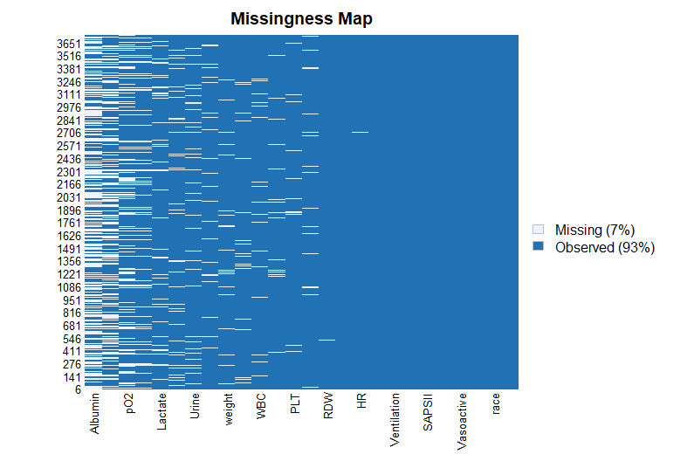

Figure.S3 The Receiver-operating characteristics (ROC) curve of the chloridion model and SOFA. The predictive value of hypopchloremia were calculated by using ROC analysis. The result showed that hypopchloremia had moderate predictive power (AUC = 0.789), and hypopchloremia had better predictive power than SOFA score (AUC = 0.576).

