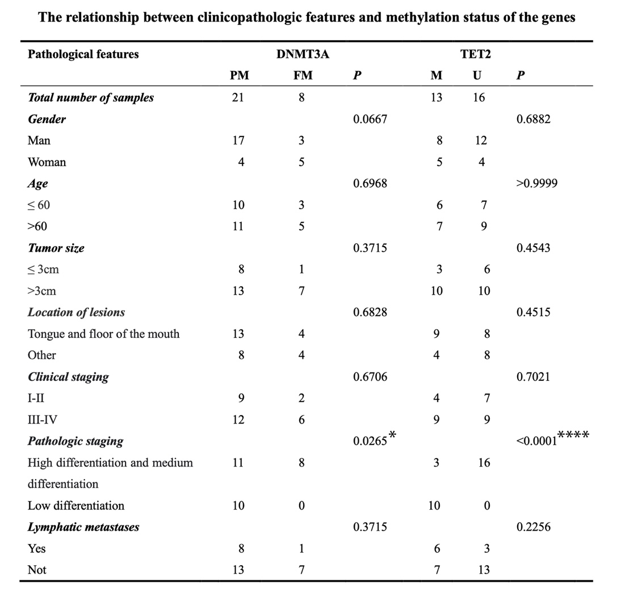
Table 1 Relationship between clinicopathologic features and methylation degrees of DNMT3A and TET2 (PM, partially methylated; FM, fully methylated; M, methylated; U, unmethylated)

