Table. 1 Developing COS process based on the COMET COS-STAD.
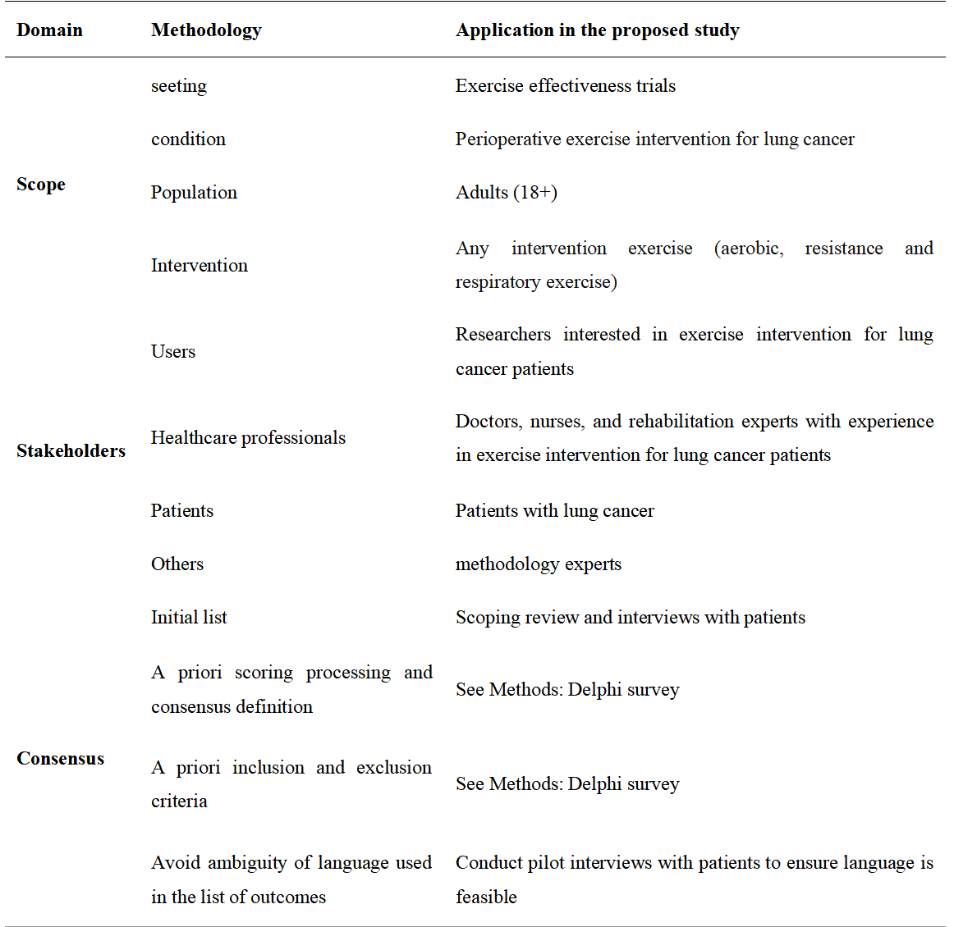

TABLE 2 Pre-selected open-ended questions
