Supplementary Material
Supplementary Material 1. Tuckey Test of Breed effect resulting from the mixed models analysis for the four different resilience indicators.
Traits | Breed Contrast | Estimate | SE | t.ratio | p.value
Lag1 | DR - LR | -0.015 | 0.021 | -0.732 | 0.746
Lag1 | DR - LW | -0.015 | 0.021 | -0.722 | 0.752
Lag1 | LR - LW | 0.000 | 0.021 | 0.016 | 1.000
LnVar | DR - LR | 0.215 | 0.231 | 0.929 | 0.626
LnVar | DR - LW | 0.176 | 0.230 | 0.765 | 0.726
LnVar | LR - LW | -0.038 | 0.233 | -0.165 | 0.985
MaxArea | DR - LR | -0.011 | 0.161 | -0.067 | 0.998
MaxArea | DR - LW | -0.089 | 0.160 | -0.558 | 0.843
MaxArea | LR - LW | -0.078 | 0.162 | -0.483 | 0.880
SumMin | DR - LR | 0.040 | 0.194 | 0.208 | 0.977
SumMin | DR - LW | -0.170 | 0.192 | -0.885 | 0.652
SumMin | LR - LW | -0.210 | 0.195 | -1.077 | 0.532

Supplementary Material 2: PERMANOVA analysis for the effect each of the systematic effect of the Breed and Room on the host microbiota composition
Effect | DF | SumOfSqs | Pr(>F)
Breed | 2 | 50359 | 0.000999
Room | 7 | 25601 | 0.000999

Supplementary Material 3. Barplot illustrating the absolute value of the log fold change (LFC) abundances for the ten most significantly abundant KEGG pathways, for the indicators of natural logarithm of residual variance (LnVar) and area under the curve for periods with consecutive negative errors (MaxArea). KEGG pathways, with positive LFC are represented by yellow bars, while those with negative LFC are represented by light-blue bars.
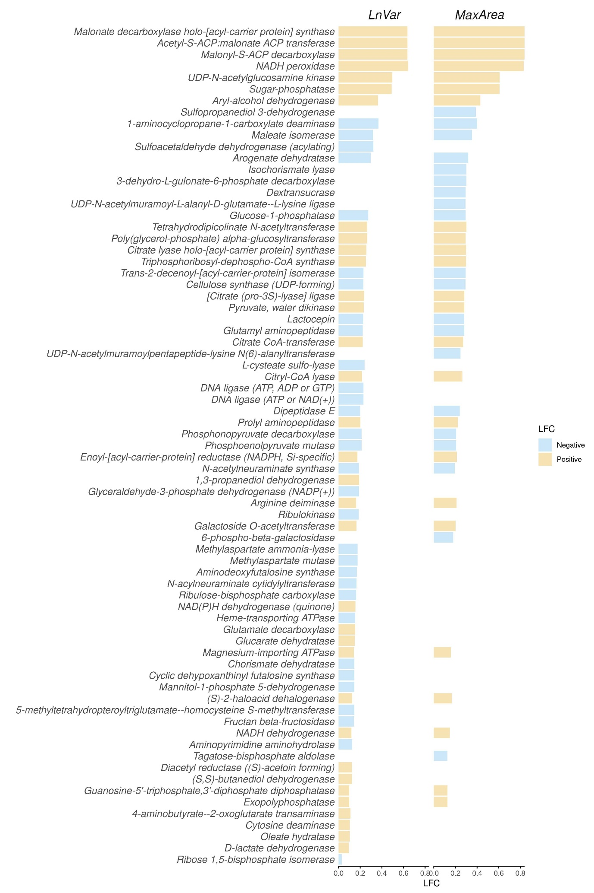
Supplementary Material 4. PERMANOVA analysis for the effect each of the four resilience phenotypes expressed in class on microbial composition. The four phenotype was lag of one day of residual (Lag1), natural logarithm of residual variance (LnVar), area under the curve for periods with the largest consecutive negative errors (MaxArea), and sum of residual's local minima (SumMin).
Indicator | SumSq | F | Pr(>F)
Lag1 | 2798 | 1.4636 | 0.027
LnVar | 3523 | 1.8317 | 0.002
MaxArea | 2852 | 1.5293 | 0.015
SumMin | 2301 | 1.2156 | 0.1388

Supplementary Material 5. Inverse Simpson alpha diversity in class was assessed for the four resilience indicator were Lag of one day of residual (A), natural logarithm of residual variance (B) area under the curve for periods with largest consecutive negative errors (c), sum of residual’s local minima (d).The x-axis represents the resilience classes: Lower (L), Medium (M) as the control group, and Higher (H). Above the plot, the p-values of the Kolmogorov-Smirnov test between the classes are reported above the box-plot
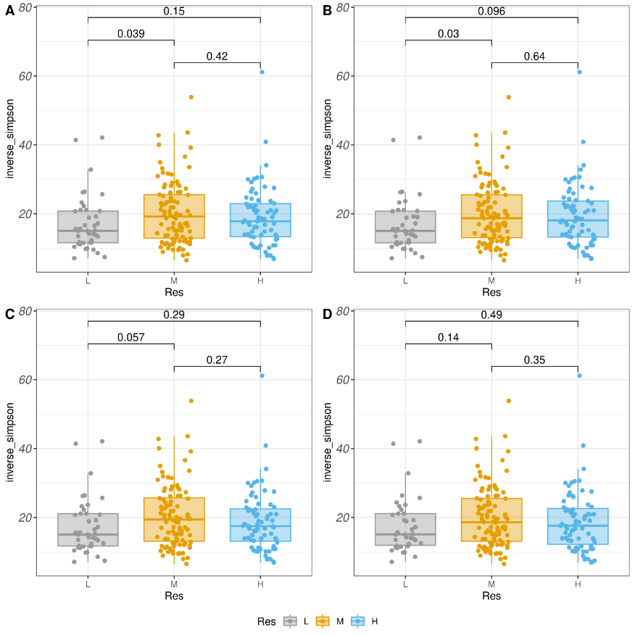
Supplementary Material 6. Heatmap illustrating the absolute value of the log fold change (LFC) abundances for the significantly abundant Kegg pathways, with the indicators of natural logarithm of residual variance (LnVar) and area under the curve for periods with consecutive negative errors (MaxArea). The ASVs are grouped based on the genera to which they belong. The x-axis represents the LFC when comparing the resilient animals class with control groups (lfc_L), and the higher resilient animals class with control groups (lfc_H).

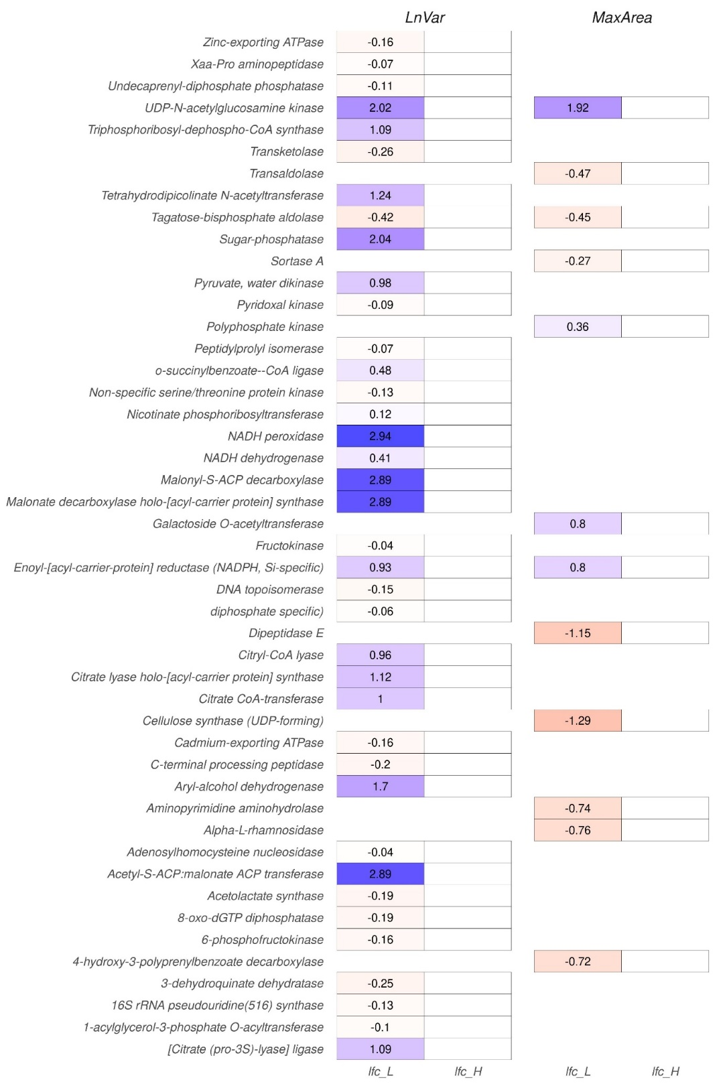

Supplementary Material 7. Description of data editing
An initial quality control for the single visit was performed by adapting the line guidance proposed in
Caesy (2005), to our data, in short:
- Visits with consumption ≥ 2000g and occupation time ≥ 3600s were removed.
- Visits with consumption ≥ 0g and ≤ 50g and feeding rate (consumption/occupation) ≥ 500(g/d) were removed.
- Visit with consumption greater than 50g and feeding rate ≥ 170(g/s) removed.
- Visit with feeding rate equal to zero if occupancy ≥ 500(g/s) removed.
- Visit with feeding rate ≤ 2(g/s) were removed.
- Visit with head and forward weight (defined bellow) difference of feed consumption ≤ -0.1 and ≥ mean + 3sd were removed
- Visit with head and forward time (defined bellow) difference 0 were removed .
Leading weight: difference is the entrance weight of following visit minus exit weight of present visit.
Following weight: difference is entrance weight of present visit minus exit weight of preceding visit
Leading time: difference is the entrance time of following visit minus exit time of present visit;
Following time: difference entrance time of present visit minus exit time of preceding visit .
After that, a total 444,867 visit records remain ( 728 animal).Then, for each animal and for each day, we calculated the Daily feed consumption; sum of daily feed consumption for each animal (FCD).
Supplementary Material 8. Number of animals(n) per each resilience traits, number of animals per each class are equal among resilience indicator
Class | n
H | 24
L | 15
M | 30

