Supplementary information for:
Drought hubs in the equatorial oceans drive global drought propagation

Tejasvi Chauhan¹, Vikram Chandel², Subimal Ghosh^{1,2*}

Department of Civil Engineering, Indian Institute of Technology Bombay, India
- Interdisciplinary Programme in Climate Studies, Indian Institute of Technology Bombay, India

*Corresponding Author. Email: subimal@iitb.ac.in

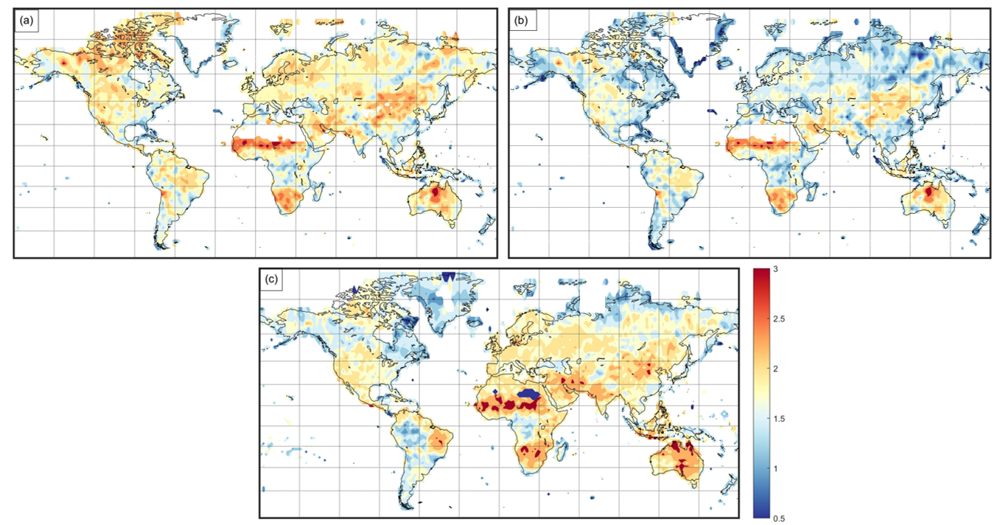
Figure S1: Degree centrality (DC, log₁₀) of grids from complex networks (CN) showing synchronisation between drought onsets on land using drought indices sc-PDSI ((a) without correcting overestimation with latitude, (b) corrected for overestimation with latitude (methods)) and SPI-12 (c, corrected for overestimation with latitude) from CRU dataset. The masked land regions (Sahara and Greenland) in S1(a,b) had not data available for sc-PDSI.

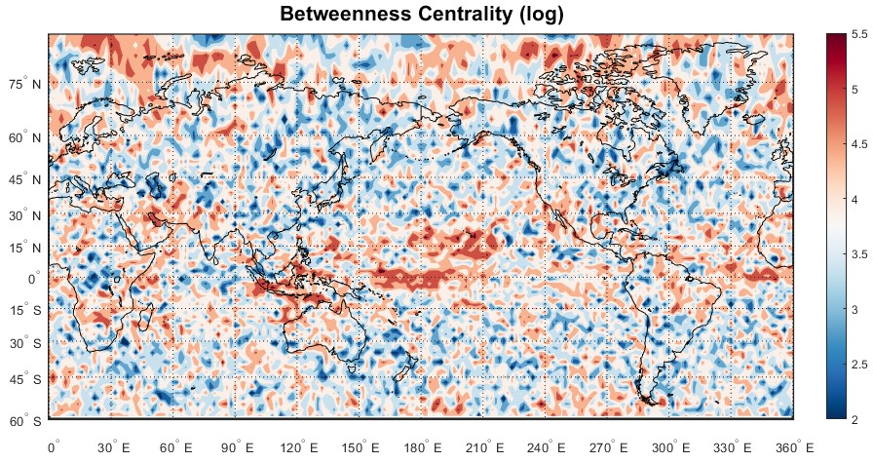
Figure S2: Betweenness centrality (BC) of grids from complex networks (CN) of synchronisation between drought onsets.

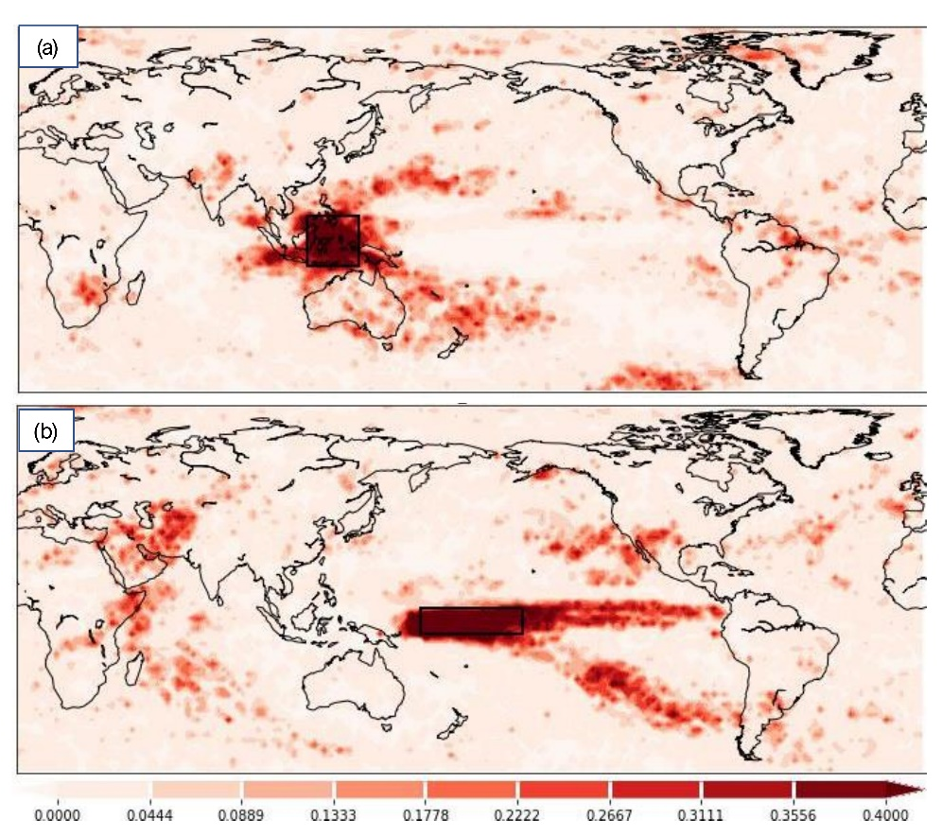
Figure S3. Connections of drought onsets from Maritime continent (a) and eastern central Pacific Ocean (b). Both maritime continent and Pacific Ocean can simultaneously impact multiple land regions indicating a possibility of confounding behaviour.

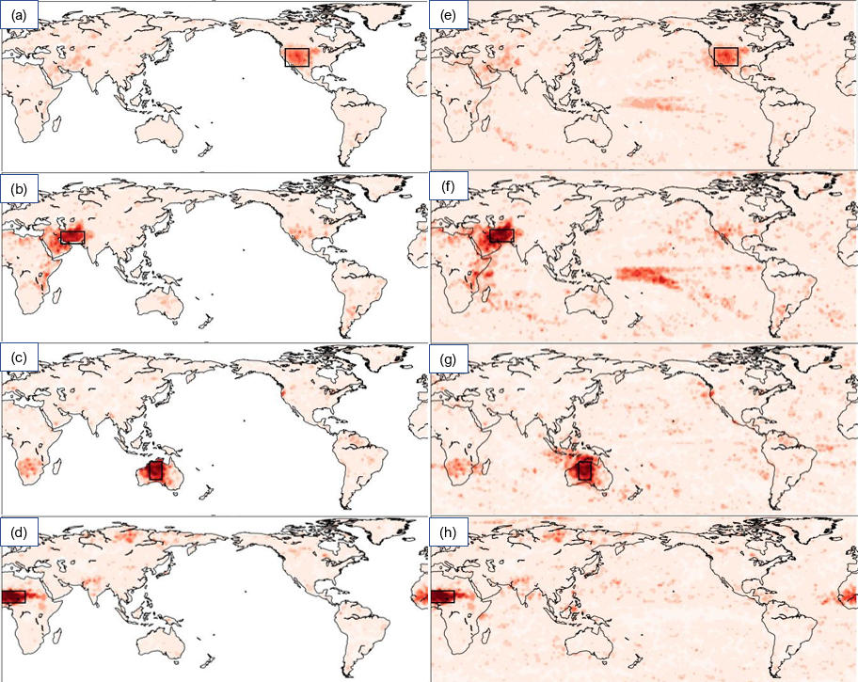
Figure S4: Grids connected to various land hubs when considering land only (a-d) against when including drought onsets on Ocean surface (e-h). Area considered to compute the connected grid has been marked in each subplot.

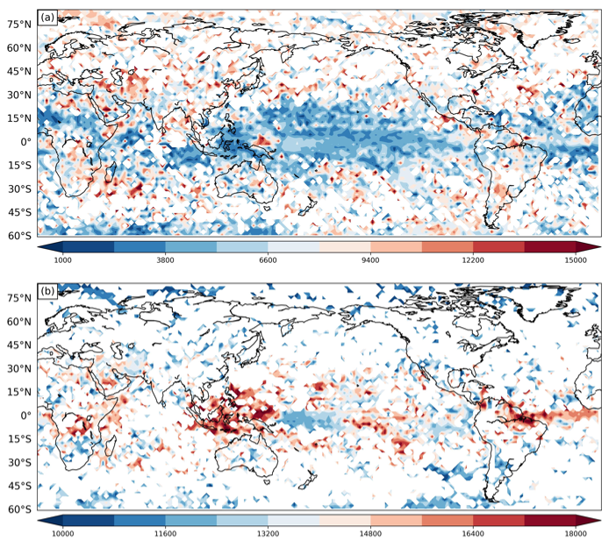
Figure S5: shows the mean synchronization distance (MSD, methods) of links generated using event synchronization after removing all links with distances less than 1000 km (a), and 10000 km (b). The right panels show the variation of mean MSD along the latitude. MSD is computed only for those links which were found statistically significant at 90% confidence (methods). The Figure shows that the equatorial regions have the farthest drought teleconnections. The maritime continent is the biggest hub having the farthest teleconnections followed by the Atlantic Ocean, South America, the western Indian Ocean, and the equatorial region of Africa.

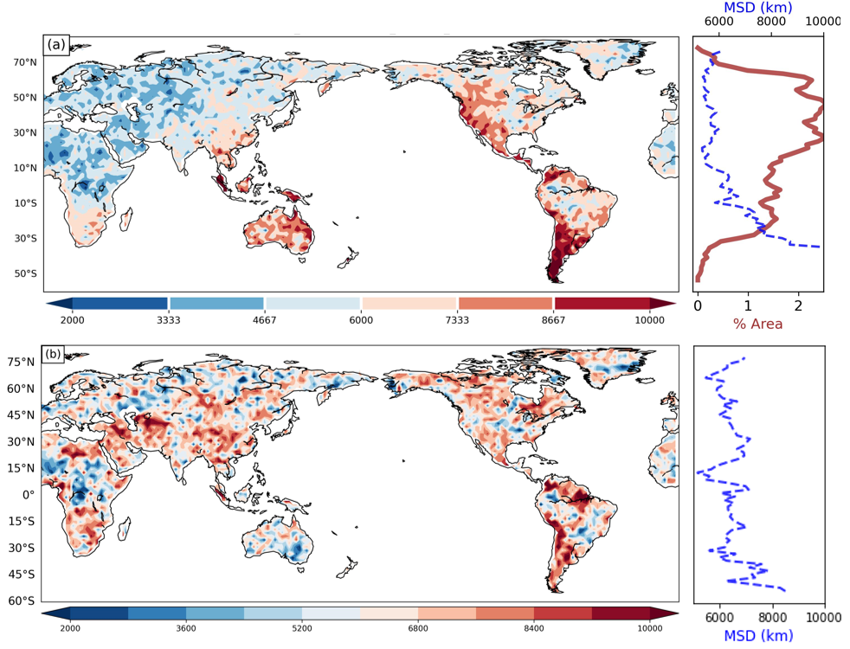
Figure S6: Mean synchronisation distance (MSD) of land regions when computed from a CN generated only land grids (a) and using both land and ocean regions (b). Right panels (blue curve) show variation of average MSD with latitude. Right Panel (red curve) shows percentage land area varying with latitude.

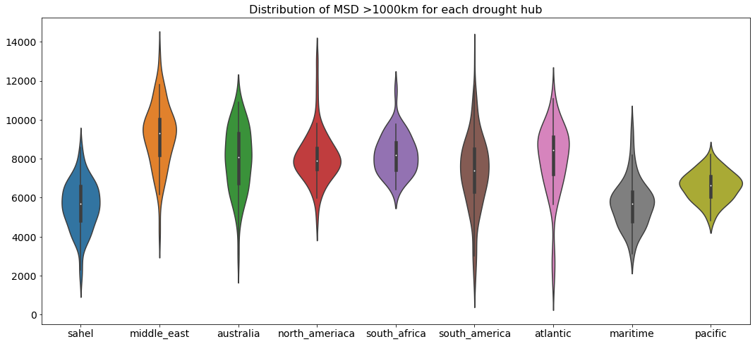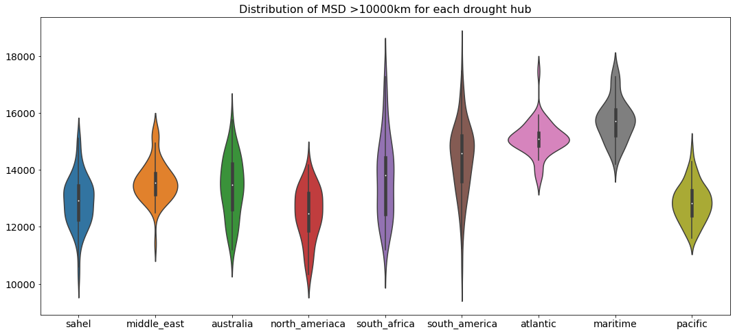
(b)
(a)

Figure S7: Violin plots showing distribution of MSD from each drought hub considering thresholds of 10000km (a) and 1000km (b).

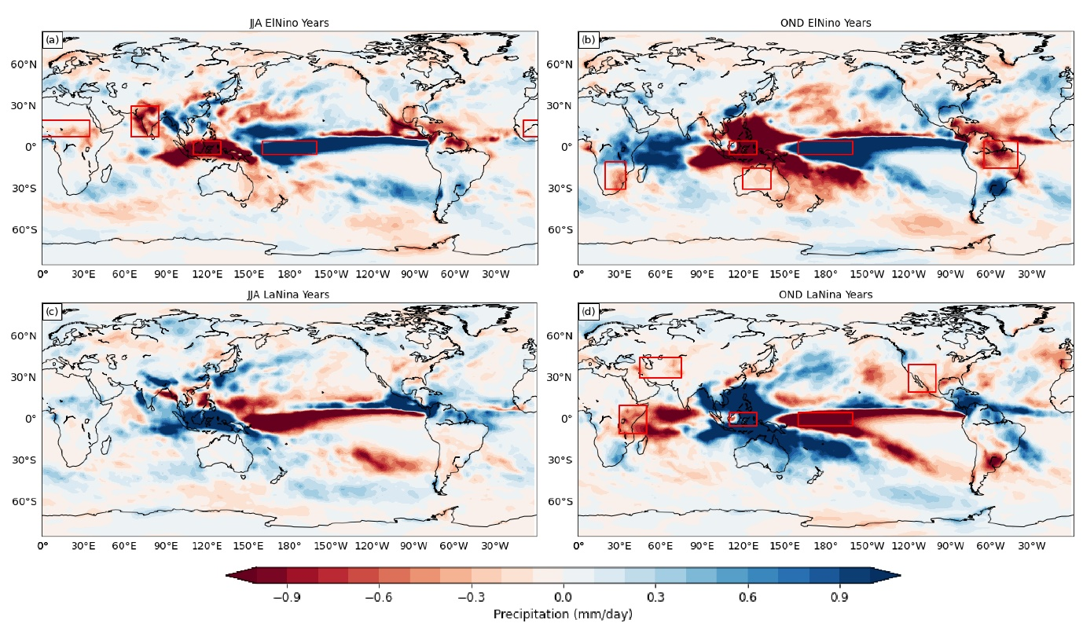
Figure S8: Global precipitation anomalies during boreal Summers (JJA) and boreal Winters (OND) for El Nino (a, b) and La Nina (c, d) years.

