Supplementary Materials for
Fabricating a hepatocyte-targeted fullerene derivative as a new lipid droplet regulator

Table-of-contents

Supplementary Methods 2

Supplementary Figures 17

Supplementary References 21

Supplementary Methods
Preparation of nanomaterials
Cerium oxide, Zinc oxide, graphene oxide, gold nanoparticles, silver nanoparticles, Fe₃O₄, nanodiamonds were obtained from Nanjing XFNANO Materials Tech Co Ltd. Fullerol was prepared according the literature. C₆₀ toluene solution was mixed with 50% NaOH aqueous solution. After addition of 40% TBAH (Tetrabutylammonium hydroxide), the reaction was stirred for 24 h at room temperature. Then the supernatant was removed, and the precipitate was washed with methanol. Finally, the crude product was dialyzed against deionized water to remove impurities.

Preparation of different fullerene derivatives
F1, F2, F3, F4, F5, F6, F7, F8 were respectively prepared according to methods reported^{1,2,3,4,5,6}.

Synthesis of C₇₀[C(COOH)₂]₄ (QF70)
QF70 was prepared by classical Bingel method. Briefly, 1, 8-diazabicyclo [5.4.0] undec-7-ene (DBU, 365 μL, 2.38 mmol) was added to a solution of C₇₀ (100 mg, 0.119 mmol) in toluene (100 mL) under argon atmosphere. Then diethyl bromomalonate (405 μL, 2.38 mmol) was added. The reaction was stirred for 4 h at room temperature to get C₇₀[C(COOC₂H₅)₂]₄ crude product. After purification by column chromatography, QF70 was finally acquired by hydrolysis of C₇₀[C(COOC₂H₅)₂]₄ in toluene solution of NaH under argon atmosphere at 80℃.

Synthesis of QF70-FITC
QF70 (5 mg, 3.46 μmol) and Hatu (2.63 mg, 6.92 μmol) were added to 1 mL DMF. After stirring for 30 min, FITC-NH₂ (2.4 mg, 6.92 μmol) was added to the above solution. The reaction was carried out for another 4 h at room temperature. The resulting product was dialyzed against deionized water for 3 days.

Synthesis of QF70-Gd-DTPA
Gd-DTPA-aminoethanol: DTPA (20 mg, 0.05 mmol) and a few drops of triethylamine were added to 2 mL DMF. After stirring for 30 min at 55 ℃, 2-aminoethanol (6.1 mg, 0.1 mmol) and Hatu (38 mg, 0.1 mmol) were added. The mixture was stirred for 4 h at room temperature. Then GdCl₃ (11.86 mg, 0.05 mmol) was added. The reaction was continued for another 12 h. Collect the precipitate and dried under vacuum.
QF70-Gd-DTPA: QF70 (10 mg, 6.92 μmol), NHS (1 mg, 10 μmol), DCC (2 mg, 10 μmol) were dissolved in 2 mL DMF, the solution was stirred for 3 h on ice bath. Then Gd-DTPA-aminoethanol (5.92 mg, 0.01 mmol) was added and stirred for 24 h. The crude product was dialyzed against deionized water to remove impurities.

Synthesis of QF70-biotin
QF70 (10 mg, 6.92 μmol) and Hatu (5.26 mg, 13.84 μmol) were added to 2 mL DMF. After stirring for 30 min, biotin-PEG-NH₂ (5.78 mg, 13.84 μmol) was added to the above solution. The resulting solution was stirred for another 4 h at room temperature, followed by dialyzing against deionized water.

Characterizations of QF70
The molecular weights of fullerene derivatives were confirmed by MALDI-TOF (AB SCIEX 5800MALDITOF); UV-Vis spectra were obtained by using a UV-2550 spectrophotometer (Shimadzu); Thermal analysis of QF70 was performed on a Mettler-Toledo TGA2/DSC3 apparatus; XPS spectra were carried out on thermo ESCALAB250Xi; The hydrodynamic diameters of QF70 in deionized water, PBS buffer, 5% HSA aqueous solution and artificial gastric acid were tested by Zetasizer Nano ZSP; Transmission electron microscopy (TEM) images of QF70 were captured with a JEOL JEM-2100; AFM images were recorded on (SPM-9700HT), with mica used as the substrate of QF70.

Raman spectroscopy
The Raman spectra were measured by LabRAM HR Evolution spectrometer with 532 nm excitation laser. SiO₂ was adopted as substrate.

Cell culture
Human Huh7 hepatocyte were purchased from the Type Culture Collection of the Chinese Academy of Sciences, Shanghai, China. The cells were cultured in DMEM supplemented with 10% FBS (Thermo Fisher Scientific, Madison, WI, USA) and 1% penicillinstreptomycin

Male C57BL/6J mice, aged 6-8 weeks, were employed for the isolation of Mouse primary hepatocytes and Kupffer cells using a two-step collagenase perfusion technique. Primary hepatic stellate cells (HSCs) were obtained from male C57BL/6J mice aged 16 weeks. The mice were anesthetized with pentobarbital sodium, and their livers were completely digested by perfusion with collagenase type IV solution (17104019 Gibco). The liver was dissected, finely chopped, and strained through a 70 μm cell strainer. Following a 2-minute centrifugation at 50 g, Kupffer cells were isolated in the upper aqueous phase, while hepatocytes were retained in the cell pellet. The Kupffer cells were subsequently purified using a 50% Percoll solution (17089101 GE Healthcare Life Sciences UK). In the context of hematopoietic stem cells (HSCs), the cell suspension underwent centrifugation at a force of 580 g, followed by further enrichment through the utilization of 29% Nycodenz density gradient centrifugation. The hepatocytes were subsequently seeded onto plates coated with collagen and cultured in a standard medium composed of DMEM (C11995500BT; Gibco) supplemented with 10% FBS (10099-141; Gibco) and 1% penicillin-streptomycin (15140-122; Gibco) within a 5% CO₂ incubator maintained at a temperature of 37°C.

Antibodies
PLIN2 (15294-1-AP) and LAMP2 (66301-1-lg) antibodies were bought from Proteintech, while Flag antibodies were acquired from Cell Signaling Technology. Actin (AC026) antibodies were obtained from ABclonal, and CD11b (BM3925) antibodies from Boster. All primary antibodies were diluted 1:1,000 unless specified. Jackson Laboratory(Bar Harbor, ME, USA) provided the secondary antibodies Peroxidase AffiniPure goat anti-rabbit-lgG(H+L) (111-035-003) and goat anti-mouse-IgG(H+L) (115-035-003).

FT-IR spectroscopy
After fully vacuum drying, the FT-IR spectra of samples were obtained with Thermo FTIR5700 by classical KBr pellet approach.

CCK8 assay
Hepatocytes were seeded in 96-well plates (1x10⁴ cells per well). After treatment with different nanomaterials (200 μg/mL) for 24 h, cells was further incubated with CCK8 (0.5 mg/mL) according to manufacturer's protocol. Then OD450 was obtained with a multifunctional microplate reader.

Apoptosis analysis
The cell apoptosis induced by nanoparticles was detected by flow cytometry analysis. Briefly, hepatocytes were seeded on six-well plates. After incubation with nanomaterials (200 μg/mL) for 24 h, cells were collected and stained with annexin V-FITC and propidium iodide according to protocol. The fluorescene was evaluated by a FACS flow cytometer (CytoFLEX, Beckman Coulter). The gating strategy is as follows: surviving cells (Annexin V- and PI-), early apoptotic cells (Annexin V+ and PI-), and late apoptotic cells (Annexin V+ and PI+).

IL6/TNFα promoter luciferase assay
Hepatocytes were seeded in 24-well plates (3x10⁴/well) and cultured overnight. Then cells were transfected with IL6 or TNFα luciferase reporter plasmids, and Renilla luciferase plasmid as control for 12 h. After further treatment with PA (0.5 mM) and various nanoparticles (100 μg/mL), The cells were harvested for luciferase activity detection, according to a dual-luciferase reporter system (E1960, Promega, WI, USA) .

Nile red staining
After paraformaldehyde fixation, Lipid accumulaiton in cells were labeled with Nile red (1 μM in PBS) for 15 min. Subsequently, the nucleus was stained with DAPI.

Effects of nanoparticles on lipid accumulation in hepatocytes:
Hepatocytes were seeded on six-well plates. After preincubation with nanomedicine (100 μg/mL) for 3 h, the cells were further stimulated with PA/OA (0.5 mM/1 mM) for 12 h combined with nanomedicine. After wash with PBS, the cells were collected and used for Nile red staining.

Effects of different fullerene derivatives on lipid accumulation in hepatocytes:
Hepatocytes were seeded on six-well plates. After preincubation with fullerene derivatives (50 μg/mL) for 3 h, the cells were further stimulated with PA/OA (0.2 mM/0.4 mM) for 12 h combined with fullerene derivatives. After wash with PBS, the cells were collected and used for Nile red staining.

Uptake of nanoparticles
Hepatocytes were seeded in 96-well plates (1x10⁴ cells per well). After incubation with different nanomaterials (100 μg/mL) for 3 h, the cell culture supernatants was collected and detected by UV spectrometry (450 nm). The ratio of (OD_{0h}-OD_{3h})/OD_{0h} was defined as the uptake rate.

Molecular dynamics (MD) simulation
PM6 and B3LYP were employed to optimize all structures. The former was utilized as a preliminary step to expedite the computational process⁷, while the latter, specifically B3LYP/3-21g* and B3LYP/6-31g*, was employed for final refinement. It is noteworthy that the final optimizations were executed utilizing the B3LYP/6-31g* method exclusively, the /6-31g* basis set comprises atomic orbitals up to quadruple-zeta quality and polarization functions on all atoms. The calculations were performed utilizing the Gaussian 09 quantum chemical program package.

The Gromacs2016.4 package and Charmm36 force field^{8,9}, along with CHARMMGUI¹⁰, were utilized to conduct simulations. The monomeric fullerene underwent molecular dynamics simulations within a water/DPPC system at 298 K. The simulation box contained SPC water molecules and was neutralized with Na+ and Cl- ions. Energy minimization was performed using the steepest descent method. The fullerene was positioned at different distances from the center of the bilayer and restrained harmonically to allow for solvent and lipid equilibration, followed by 5 ns simulations in DOPC (and two more in DPPC) for a total simulation time of 90 ns. Properties of the DOPC membrane were calculated from lipid systems, and trajectory visualization and analysis were performed using VMD software¹¹.

Subcellular distribution of QF70
Hepatocytes were seeded in 10 cm dishes. After incubation with QF70-biotin (100 μM) for different time (6 h, 12 h, 24 h), the cells were collected and homogenized. Next, subcellular fractions were enriched by differential centrifugation method according to literature. Finally, the specific amount of QF70-biotin in each organelle were determined by Biotin-quantitation Kit (E-IR-R501, Elabscience, USA).

3T3-L1 differentiation
Two days after seeding, 3T3-L1 cells were exposed to differentiation reagent (DMEM with 10% FBS, 1 μg/mL insulin, 0.25 μM dexamethasone, 0.5 mM IBMX, and 2 μM rosiglitazone) for another two days. Then the culture medium was replaced with DMEM containing insulin only until the end of the differentiation. On the seventh day, 3T3-L1 cells can be cultured in routine medium.

Cells transmission electron microscopy (TEM)
Primary hepatocytes or 3T3-L1 were exposed to QF70 (100 μM) for 3 hours. Then the cells were fixed in 2.5% glutaraldehyde, followed dehydration, epon embedding, resin sectioning. Finally, the cellular ultrastructure was observed by TEM (HT7700, Exalens).

Confocal fluorescence imaging
Cellular uptake of QF70:
Hepatic parenchymal cells, hepatic stellate cells (HSCs), and Kupffer cells were respectively isolated from mouse liver as previously described. Then cells were seeded in special microscope dish, and incubated with QF70-FITC (100 μM) for different times. After staining with DAPI, images were collected by a laser scanning confocal microscopy. Observation of QF70 uptake by 3T3-L1 were performed using similar steps as above.

Co-localization of QF70 with lysosomes:
Hepatic parenchymal cells or 3T3-L1 were seeded in special microscope dish. After treatment with QF70-FITC (60 μM) for 3 h, the cells were stained with LysoTracker and labeled with hoechst. The pictures were taken by a confocal microscope.

Co-localization of QF70 with PLIN2：
Hepatic parenchymal cells were seeded on confocal dishes and cultured overnight. Subsequently, cells were stimulated with PA/OA (0.2 mM/0.4 mM) for 12 h. After incubation with QF70-FITC (60 μM) for 3 h, the cells were fixed with 4% paraformaldehyde for 30 min, followed by permeabilization in 0.5% Triton X-100, blocking in 6.5% BSA. Then PLIN2 primary antibody was added and incubated overnight at 4℃. After washing in PBS, the cells were treated with a secondary antibody (A11034, Invitrogen, Carlsbad, CA, USA) for another 1 h (protected from light). Finally, confocal pictures were taken after sealing containing DAPI.

Co-localization of PLIN2 with LAMP2:
Influence of QF70 on the colocalization of PLIN2 and lysosome was studied by double immunofluorescence. In brief, hepatocytes were seeded on confocal dishes. After adherent growth, cells were stimulated with PA/OA (0.2 mM/0.4 mM) for 12 h. Then experimental groups were treated with QF70 (60 μM) for 3 h, while control groups were treated with saline. Next, the cells were fixed with 4% paraformaldehyde, permeabilized in 0.5 % Triton X-100, and blocked in 6.5% BSA. Last, the cells were incubated with a mixture of PLIN2 (Proteintech Group, 15294-1-AP) and LAMP2 (Proteintech Group, 66301-1-Ig), and subsequent mixture of secondary antibodies (A11034, Invitrogen, Carlsbad, CA, USA; A11036, Invitrogen, Carlsbad, CA, USA). Co-localization analyses were captured with confocal microscopy.

Animals and treatment
The animal protocols utilized in this study underwent rigorous examination and approval by both the Animal Care and Use Committee of the Renmin Hospital of Wuhan University and the Institutional Animal Care and Use Committee of the Institute of Model Animals of Wuhan University. Our commitment to upholding ethical standards in animal treatment is exemplified through our rigorous adherence to the Guidelines for the Care and Use of Laboratory Animals, established by the National Academy of Sciences and disseminated by the National Institutes of Health. In accordance with the utmost principles of ethical conduct, we ensured the exclusion of any form of abuse or punishment in our study.

ob/ob: At the onset of the study, 4 weeks ob/ob mice were allocated into two groups, the vehicle group and the QF70 group. After 2 weeks for acclimation, the mice were subjected to daily oral administration of either 100 mg/kg QF70 or vehicle for a duration of 8 weeks.

Fatty liver model: For a duration of 24 weeks, Male C57BL/6J mice were fed a HFD, containing 20% protein, 60% fat, and 20% carbohydrates (#D12492, Huafukang Bioscience in Beijing, China), while control mice were fed an NC diet (D12450B, Research Diets in New Brunswick, NJ, USA), which consisted of 18.3% protein, 10.2% fat, and 71.5% carbohydrates. At 8th week, mice were randomly assigned to either the vehicle or QF70 group, and orally administered 100 mg/kg QF70 or vehicle daily for 16 weeks.

NASH model of mouse: Male mice on C57BL/6J background, 8 weeks old and weighing 24-27 g, were selected for the experiments. A mouse model of NASH was induced by feeding the mice a HFHC diet consisting of 14% protein, 42% fat, 44% carbohydrates, and 0.2% cholesterol (#TP 26304, TrophicDiet in Nantong, China) for 16 weeks, while controls were fed a NC diet (D12450B, Research Diets in New Brunswick, NJ, USA) with 18.3% protein, 10.2% fat, and 71.5% carbohydrates. After 4 weeks, mice were randomly assigned to either vehicle or QF70 group, and orally administered 100 mg/kg QF70 or vehicle daily for 12 weeks.

NASH model of nonhuman primates: A total of eight cynomolgus monkeys, all males and aged between 13 and 15 years, were obtained from Topgene Biotechnology located in Guangzhou, China. The acquisition procedure strictly complied with the relevant laws and regulations of the People's Republic of China, and was duly authorized by both the Department of Forestry in Hubei Province and the Department of Forestry in Guangdong Province. All monkeys included in this study underwent local quarantine inspection and met the relevant standards. After starting on a HFHC diet for 4 weeks, consisting of lard (10%), sucrose (15%), cholesterol (1%), corn flour (14.5%), and wheat flour (14.5%) provided by Beijing Keao Xieli Feed Co., Ltd. in Beijing, China, the monkeys were categorized into vehicle and QF70 groups (n=4 males/group). QF70 (17.5 mg/kg) and vehicle were administered orally on a daily basis. Physical examinations and liver biopsies were conducted every 4 weeks, while MRI scans were performed at 0th, 4th and 16th week.

Biodistribution of QF70 in mice
After oral administration of QF70-Gd-DTPA (0.4 mmol/kg), the mice were sacrificed at different times (0 h, 0.5 h, 1 h, 3 h, 6 h, 12 h, 24 h, 72 h, 168 h). The tissues and blood were collected and weighted. Then all samples were digested in concentrated HNO₃ overnight. After filtration and dilution, the concentrations of Gd³⁺ was determined by ICP-MS (PQ-MS).

Fluorescence imaging
After oral administration of QF70-FITC (0.4 mmol/kg), the mice were sacrificed at 24 h. The tissues and organs (heart, lung, liver, spleen, pancreas, subcutaneous fat, kidney, epididymis fat, brown fat, skeletal muscle) were collected. Then fluorescence images were captured with fluorescent imaging equipment (IVIS SPECTRUM, excitation wavelength: 495 nm; emission wavelength: 519 nm).

MRI imaging of mice liver
The mice were orally administered with QF70-Gd-DTPA at a dosage of 0.4 mmol Gd³⁺/kg. T1 imaging was performed at different times on a 3T Siemens Medical Systems (T_{R} = 520 ms, T_{E} = 11 ms, FOV =10 × 10 cm, acquisition matrix = 256 × 256, slice thickness = 2 mm).

Biochemical analysis
Serum ALT, AST, ALP, HDL, LDL, LDH, TG, TC, CREA, UREA, BUA, CK and CKMB were detected using a biochemical analyzer (ADVIA 2400, Siemens, USA). TG and TC in cells and liver tissues were measured by (Wako, 290-63701 and 294-65801). All the analyses were performed according to the manufacturer's instructions.

Histopathology assessment
H&E and Oil red O staining were performed to assess lipid accumulation in tissue. Picrosirius red (PSR) staining was carried out to quantify cardiac fibrosis. F4/80 (MCA497, AbD Serotec) and CD11b (BM3925, Boster) immunofluorescence was performed to evaluate liver inflammation. Pathological pictures were taken using a digital pathology platform (Aperio Versa 200). Quantitative analysis was performed by Image-Pro Plus.

GTT and ITT
Both insulin tolerance tests (ITT) and glucose tolerance tests (GTT) were performed in ob/ob obese mice. Mice were fasted for 18 h before tests. For GTT, blood samples were collected at 0, 15, 30, 60, 120 min after glucose injection (1 g/kg, intraperitoneally); For ITT, blood samples were obtained at 0, 15, 30, 60, 120 min after insulin injection (0.75 U/kg, intraperitoneally).

qPCR
RNA was extracted and transcribed to cDNA with a Transcriptor First-Strand cDNA Synthesis Kit. Quantitative realtime PCR was conducted with SYBR Green (#04896866001) using a LightCycler480 II (Roche). The primers were shown in Table S1.

RNAseq
Total RNA was extracted from tissues or cells using TRIzol reagent, followed by Quality assessment with an Agilent RNA Nano Kit. Library preparation was constructed by the MGIEasy RNA Library Prep Kit according to the manufacturer's instructions. Briefly, mRNA fragmentation was performed after mRNA purification. Then, the mRNA fragments were reverse-transcribed into cDNA. Subsequently, ligation and PCR amplification were carried out. Afterwards, pooling, purification and digestion was performed to get resulting libraries. RNA-seq analysis were performed on a BGIseq-500 (MGI Tech Co.)

MRI imaging of monkey liver
In-phase/opposite-phase T1-weighted imaging (T1WI) were performed to assess the fat fraction in monkey livers. Before anesthesia, macaques were fasted for 12 h. Then imaging data were collected on a 3 T Siemens Medical Systems. The imaging parameters for TIWI MRI included a field of view spanning 224 mm, slice thickness of 3 mm, 25 slices, repetition time of 1590.0 ms, a 20-degree flip angle, and an ISO voxel size of 0.5 x 0.5 x 3.0 mm. The in-phase T1 imaging had an echo time of 2.66 ms and the opp-phase MRI had an echo time of 3.67 ms. Finally, Fat distribution of liver were characterized by pseudocolor images using MATLAB.

Pull-down and IP assay
Hepatocytes were seeded in 10 cm cell culture dish. After preincubation with QF70-biotin or biotin (60 μM) for 3 h, the cells were further stimulated with PA/OA (0.2 mM/0.4 mM) for 16 h, incubated with QF70-biotin or biotin treatment. The dish was then washed with precooled PBS, and 1 mL immunoprecipitation buffer (20 mM Tris-HCl, 150 mM NaCl, 1 mM EDTA and 1% Triton X-100) containing protease inhibitor cocktail tablets (04693132001, Roche) and phosphatase inhibitor tablets (4906837001, Roche) was added and left for 30 minutes. The lysates were centrifuged at 15,000 rpm for 10 minutes at 4 °C to remove cellular debris. The supernatants were then incubated with Streptavidin Agarose Resins (#20353, Thermo) at 4°C for 4 hours, followed by 3 washes in cold immunoprecipitation wash buffer (20 mM Tris-HCl, 300 mM NaCl, 1 mM EDTA and 1% Triton X-100). The protein complex was then pulled down and boiled in SDS loading buffer for 10 minutes before being subjected to Mass spectrometry analysis, or Western blot analysis with the indicated primary and corresponding secondary antibodies, as mentioned previously.

Isothermal titration calorimetry (ITC)
Binding affinities of QF70 to different proteins were evaluated by ITC (NANO ITC, TA). QF70 and the purified proteins were both dissolved in buffer (20 mM Tris buffer, pH=8.5). Degassing treatment was performed for all solutions before test. All tests were performed at 25℃. QF70 solution was titrated into protein solution in 25 2 μL-injection every 180 s with stirring speed of 300 rpm. Data were analysed based on independent interaction model using Nano Analyze software.

Western blot analysis
Protein from cell samples was directly extracted with RIPA lysis buffer (65 mM Tris-HCl pH 7.5, 150 mM NaCl, 1 mM EDTA, 1% NP-40, 0.5% sodium deoxycholate, 0.1% SDS, and protease inhibitor cocktail tablets), while protein from tissue samples need to be grinded using a TissueLyser (Tissuelyser-24, Jingxin). After quantification with BCA Protein Assay Kit (23225, Thermo Fisher Scientific), the protein samples were isolated by 10% SDS-PAGE gels, and transferred to PVDF membranes (0.45 μm). Then PVDF was blocked with 5% skim milk, followed by incubation with corresponding primary and secondary antibodies. The protein visualization were conducted with a ChemiDoc MP Imaging System. β-Actin was adopted as control.

Effects of nanomedicine on PLIN2 expression of Lipid droplet in hepatocytes:
Hepatocytes were seeded in 10 cm dishes. After preincubation with nanomedicine (100 μg/mL) for 3 h, the cells were further stimulated with PA/OA (0.5 mM/1 mM) for 12 h combined with nanomedicine. Then cells were harvested and lipid droplets (LDs) were isolated according to the literature. The PLIN2 of LDs was determined by WB.

Change in PLIN2 expression in hepatocytes during stimulation by palmitate and oleate:
Hepatic parenchymal cells were seeded on six-well plates and cultured overnight. After stimulation with PA/OA (0.2 mM/0.4 mM) at 6/12/24 h, the cells were collected and processed for WB to evaluate the expression of PLIN2.

Change in PLIN2 expression during 3T3-L1 differentiation:
3T3-L1 cells were seeded on six-well plates and cultured for two days. After exposed to differentiation reagent at 1/2/3/4/5/6/7 day, the cells were harvested. Then the PLIN2 content was determined by WB.

Effects of QF70 on PLIN2 expression in hepatocytes:
Hepatic parenchymal cells were seeded on six-well plates. After preincubation with QF70 (60 μM) for 3 h, the cells were further stimulated with PA/OA (0.2 mM/0.4 mM) for 12 h, as well as QF70 treatment. After wash with PBS, the cells were collected and used for WB assay.

Effects of QF70 on PLIN2 contents of lysosomes in hepatocytes:
Similar to the procedure above, after preincubation with QF70 (60 μM), the cells were further treated with PA/OA (0.2 mM/0.4 mM) combined with QF70 for 12 h. Subsequently, cells were lysed and lysosomes was harvested by differential centrifugation method according to literature. Then lysosome-enriched fractions were processed for WB assay.

Effects of QF70 on flag-PLIN2 expression in hepatocytes-PLIN2 KO transfected with PLIN2-WT or PLIN2-mut:
Hepatocytes-PLIN2 KO cells were seeded on six-well plates. After transfected with flag, flag-PLIN2 mut or flag-PLIN2 plasmid, the cells were further treated with QF70 (60 μM) and stimulated with PA/OA (0.2 mM/0.4 mM) as described above. The cells were collected and processed for WB to evaluate the expression of flag-PLIN2.

Docking of PLIN2 and QF70
The structure of PLIN2 protein was constructed by molecular dynamics (MD) simulations. An typical isomer of QF70 was selected for calculation, followed by further optimization based on energy minimization and MD. We carried out protein-ligand docking employing AutoDock Vina (48), setting the search space to encompass a 25 Å × 25 Å × 25 Å area centered on the ion binding site. Subsequently, we identified the complex structure featuring the most favorable free energy for further analysis. The evaluation of ligand-rounding residue interactions in KDM1A was accomplished using the MMPBSA module (49) within AMBER 16 (50).

Statistical analysis
The data were presented as means ± SD. The statistical significance was evaluated by Student's t-test or ANOVA in SPSS software (version 19.0). P＜0.05 are identified as significant differences. *P < 0.05, **P < 0.01,***P < 0.001.

Supplementary Figures
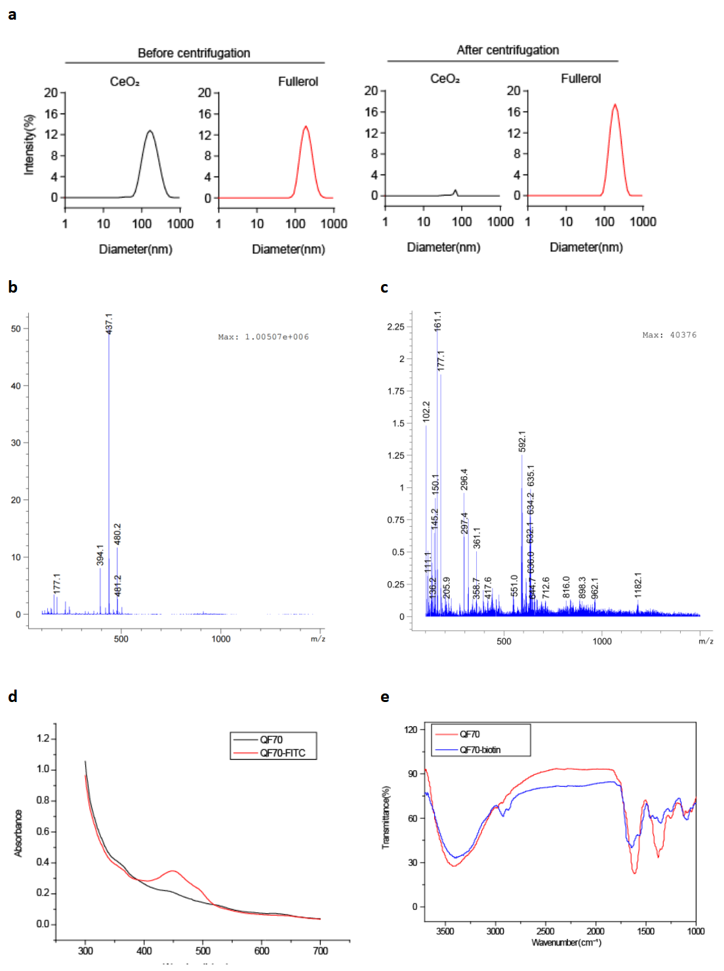
Fig. S1. Characterization of different compounds. (a) Particle size distribution before and after centrifugation determined by DLS. (b) MS of DTPA-ethanolamine. (c) MS of Gd-DTPA-ethanolamine. (d) UV spectrum of QF70 and QF70-FITC. (e) Fourier-transform infrared spectroscopy of QF70 and QF70-biotin.

Fig. S2. Schematic representation of F1',F2',F3',F4',F5',F6',F7',F8'.

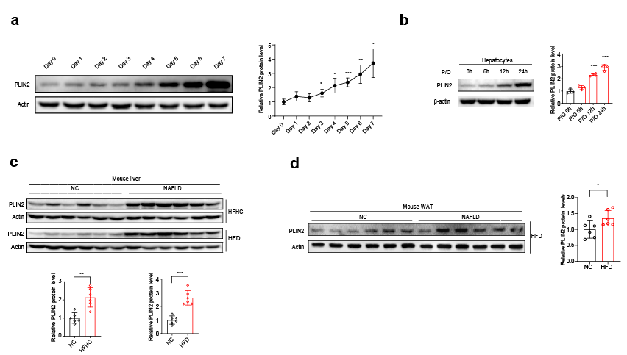
Fig. S3. PLIN2 expression in different cells and tissues. (a) Western blots and quantification of PLIN2 expression of 3T3-L1 at different time points during differentiation. (b) Western blots and quantification of PLIN2 expression of hepatocytes treatment with palmitic acid (0.2 mM PA) and oleic acid (0.4 mM OA) for different hours. (c) Western blots and quantification of PLIN2 expression in liver between NC group and HFHC/HFD group. (d) Western blots and quantification of PLIN2 expression in WAT between NC group and HFD group.

Table S1. Primers
Gene | Species | Sequence5’-3’
IL-6 | mouse | F:TCTGCAAGAGACTTCCATCCAGTTGC  R:AGCCTCCGACTTGTGAAGTGGT
CCL-2 | mouse | F:TACAAGAGGATCACCAGCAGC  R:ACCTTAGGGCAGATGCAGTT
Cebpα | mouse | F:GCGGGAACGCAACAACATC  R:GTGTCCAGTTCACGGCTCAG
Acox-1 | mouse | F:GTCTCCGTCATGAATCCCGA  R:TGCGATGCCAAATTCCCTCA
Lcad | mouse | F:CAAACGTCTGGACTCCGGTT  R:TCCGTGGAGTTGCACACATT
PPARα | mouse | F:TATTCGGCTGAAGCTGGTGTAC  R:CTGGCATTTGTTCCGGTTCT
PdgfRα | mouse | F:CGTTCAAGACCAGCGAGTTTA  R:CCTTGGGGACGGTCAAAGT
SCD1 | mouse | F:TCTTCCTTATCATTGCCAACACCA  R:GCGTTGAGCACCAGAGTGTATCG
PPARγ | mouse | F:ATTCTGGCCCACCAACTTCGG  R:TGGAAGCCTGATGCTTTATCCCCA
MCAD | mouse | F:GAAGCCACGAAGTATGCCCT  R:TAGTAAGTGTTCCGGCGACC
TNFα | Human | F:TGGCGTGGAGCTGAGAGATA  R:TGATGGCAGAGAGGAGGTTG
CXCL-8 | Human | F:CACTGCGCCAACACAGAAAT  R:ATGAATTCTCAGCCCTCTTCAAA
SCD-1 | Human | F:GCCCCTCTACTTGGAAGACGA  R:AAGTGATCCCATACAGGGCTC
PPARγ | Human | F:GGGATCAGCTCCGTGGATCT  R:TGCACTTTGGTACTCTTGAAGTT
ACADM | Human | F:GGAAGCAGATACCCCAGGAAT  R:AGCTCCGTCACCAATTAAAACAT
ACOX1 | Human | F:TGGCCGCTATGATGGGAATG  R:CAGTGACTTCAGGTGCTTGT

Table S2. Physical parameters of macaques
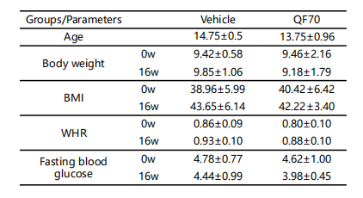
Table S3. Blood routine tests of macaques

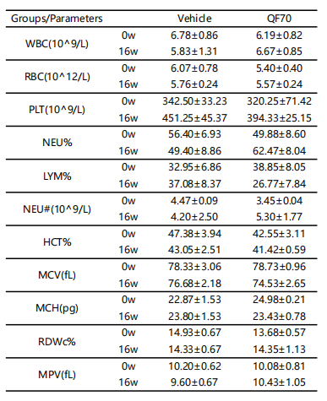

Supplementary References
1. Xing, G. et al. Influences of Structural Properties on Stability of Fullerenols. J Phys Chem B 108, 11473-11479 (2004).
2. Liu, Q. et al. Protective effect of C70-carboxyfullerene against oxidative-induced stress on postmitotic muscle cells. ACS Appl Mater Interfaces 5, 4328-4333 (2013).
3. Zhou, Y. et al. Amino acid functionalized gadofullerene nanoparticles with superior antitumor activity via destruction of tumor vasculature in vivo. Biomaterials 133, 107-118 (2017).
4. Li, Z. et al. Preparation and characterization of fullerene (C60) amino acid nanoparticles for liver cancer cell treatment. Journal of nanoscience and nanotechnology 14, 4513-4518 (2014).
5. Zhou, Y. et al. Amino acid modified [70] fullerene derivatives with high radical scavenging activity as promising bodyguards for chemotherapy protection. Sci Rep 8, 16573 (2018).
6. Hu, Z. et al. Protective effect of a novel cystine C(60) derivative on hydrogen peroxide-induced apoptosis in rat pheochromocytoma PC12 cells. Chemico-biological interactions 167, 135-144 (2007).
7. Stewart, J.J. Optimization of parameters for semiempirical methods V: modification of NDDO approximations and application to 70 elements. J Mol Model 13, 1173-1213 (2007).
8. Abraham, M.J. et al. GROMACS: High performance molecular simulations through multi-level parallelism from laptops to supercomputers. SoftwareX 1-2, 19-25 (2015).
9. Miyamoto, S. & Kollman, P.A. Settle: An analytical version of the SHAKE and RATTLE algorithm for rigid water models. 13, 952-962 (1992).
10. Jo, S., Kim, T., Iyer, V.G. & Im, W. CHARMM-GUI: a web-based graphical user interface for CHARMM. Journal of computational chemistry 29, 1859-1865 (2008).
11. Humphrey, W., Dalke, A. & Schulten, K. VMD: visual molecular dynamics. Journal of molecular graphics 14, 33-38, 27-38 (1996).

