SUPPLEMENTARY FIGURES
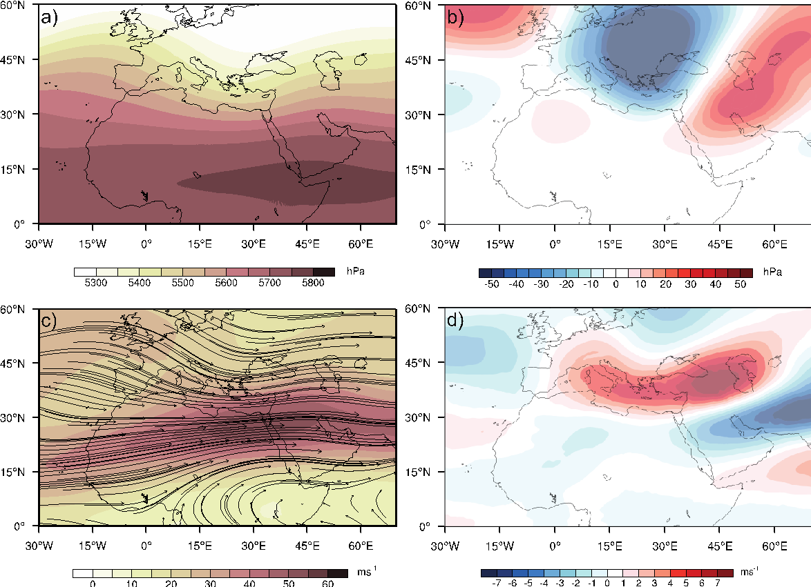
Fig . SP1 a) Daily mean 500 hPa geopotential heights for “AR days” in the winter season (DJF) for 1979–2019), b) daily mean 500 hPa geopotential heights deviations from the climatology of 1979–2019 for “AR days” in the winter season, c) and d) are same as “a” and “b” but for 200 hPa jet stream, respectively

