Viral Communities in Millipede Guts: Insights into Diversity and the Potential Role in Modulating the Microbiome
Julius E. Nweze^{1,2}, Johannes Schweichhart^{1,2}, Roey Angel^{1*}
¹Institute of Soil Biology and Biogeochemistry, Biology Centre CAS, České Budějovice, Czechia
²Department of Ecosystem Biology, Faculty of Science, University of South Bohemia in České Budějovice, Czechia
* Correspondence: roey.angel@bc.cas.cz

Supplementary Material

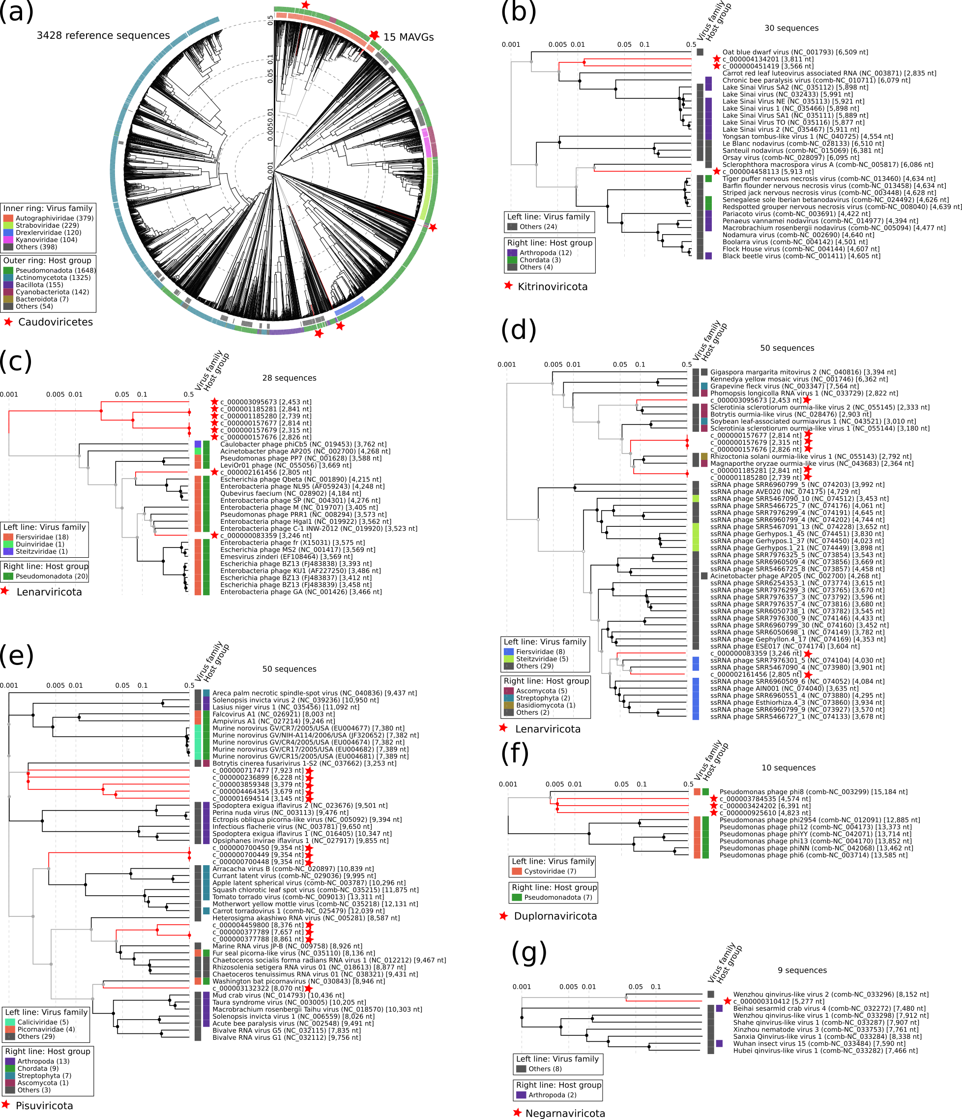
Supplementary Fig. 1. Proteomic tree of viral genomes in metatranscriptome from E. pulchripes. (a) Proteomic similarity in the dsDNA viruses between the metagenome-assembled viral genomes (MAVGs; 15) classified in the phylum Uroviricota (order Caudoviricetes) and related reference viral genomes. (b) Genome similarity in the ssRNA viruses between the MAVGs classified in the phylum Kitrinoviricota (3) and related reference viral genomes. (c) Genome similarity in the ssRNA viruses between the MAVGs classified in the phylum Lenarviricota (8), prokaryotic and (d) eukaryotic reference viral genomes. (e) Genome similarity in the ssRNA viruses between the MAVGs classified in the phylum Pisuviricota (12) and related eukaryotic reference viral genomes. (f) Genome similarity in the dsRNA viruses between the MAVGs classified in the phylum Duplornaviricota (3) and related prokaryotic reference viral genomes. (g) Genome similarity in the dsRNA viruses between the MAVGs classified in the phylum Negarnaviricota (1) and related eukaryotic reference viral genomes. See Fig. 2 and the Materials and Methods for how the tree was generated. The red stars represent each MAVG from our metatranscriptome.

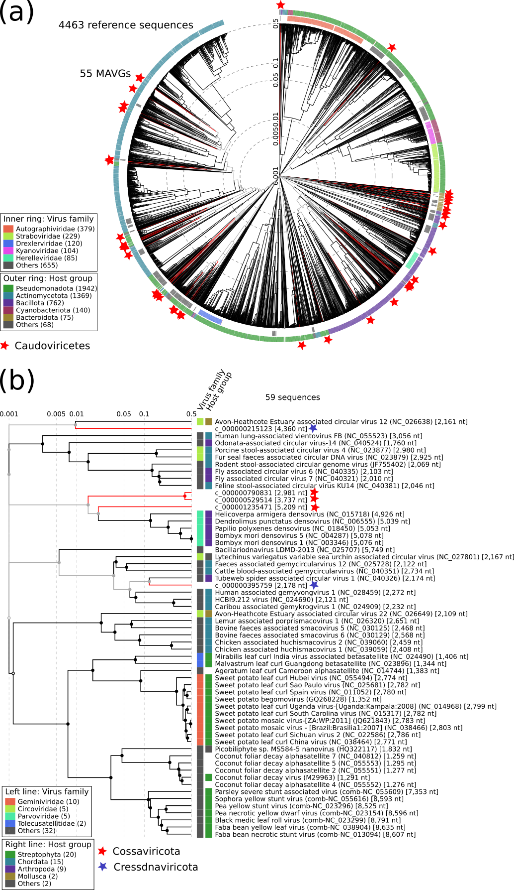
Supplementary Fig. 2. Proteomic tree of viral genomes in metagenome from G. connexa. (a) Genomic similarity in the dsDNA viruses between the metagenome-assembled viral genomes (55 MAVGs) classified in the phylum Uroviricota (order Caudoviricetes) and 4463 related reference viral genomes. (b) Genomic similarity in the ssDNA viruses between the MAVGs classified in the phyla Cossaviricota (3) and Cressdnaviricota (2) and related reference viral genomes. See Fig. 2 and the Materials and Methods for how the tree was generated. The red stars represent each MAVG from our metagenome.
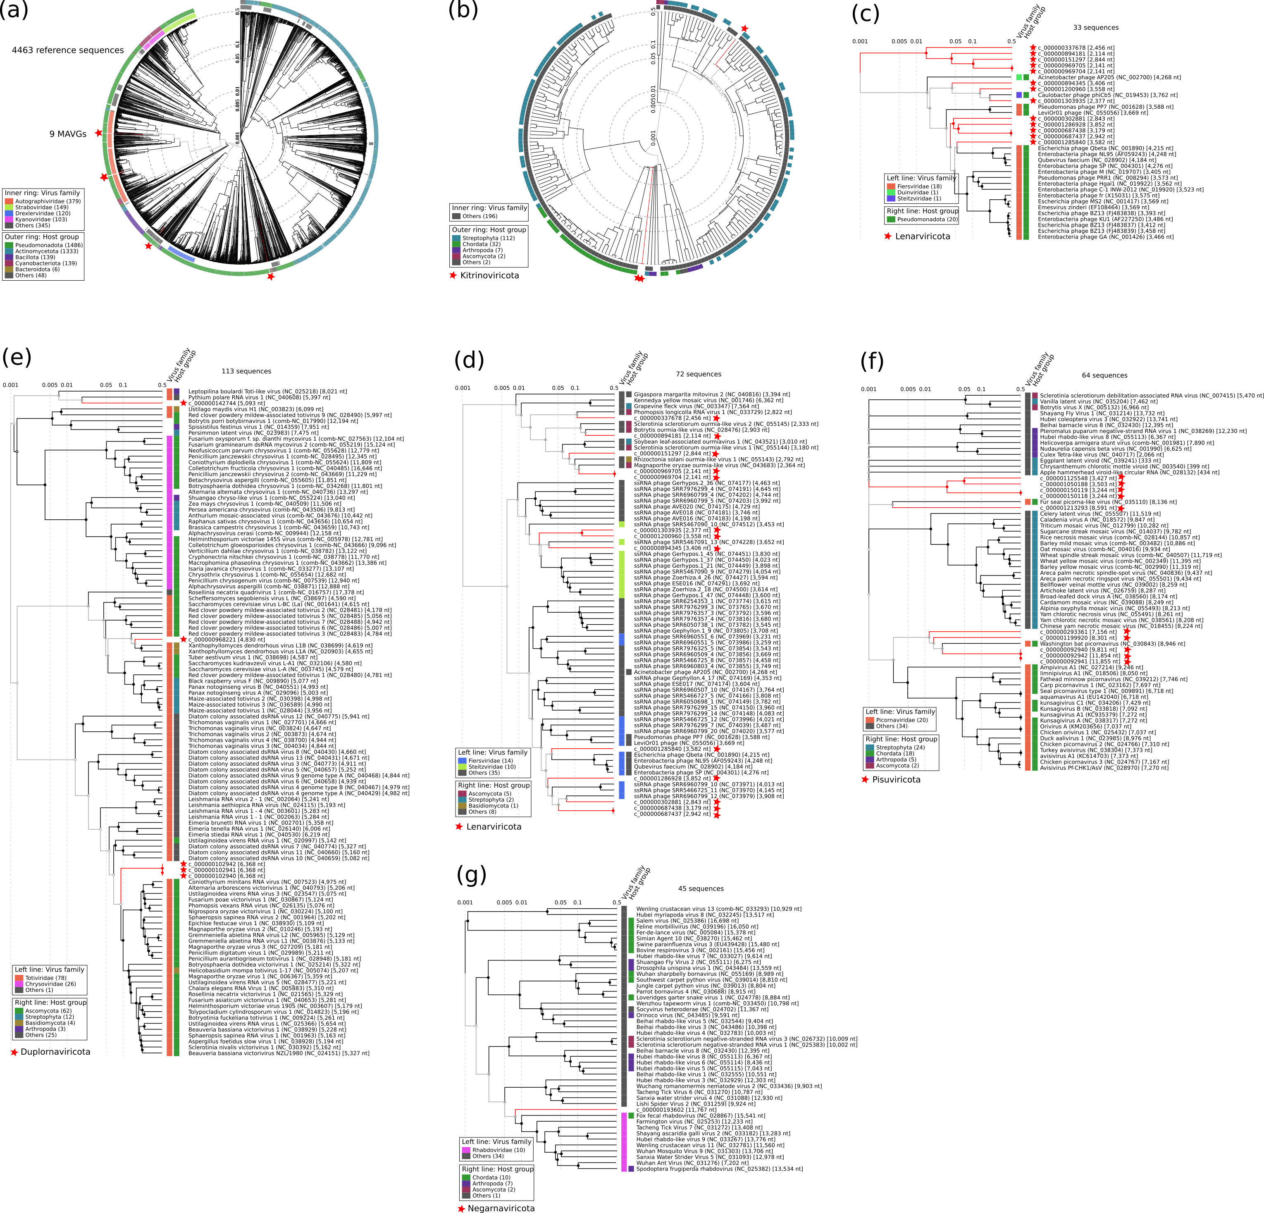
Supplementary Fig. 3. Proteomic tree of viral genomes in metatranscriptome from G. connexa. (a) Genomic similarity in the dsDNA viruses between the MAVGs classified in the phylum Uroviricota (9) and 4463 related reference viral genomes. (b) Genome similarity in the ssRNA viruses between the MAVGs classified in the phylum Kitrinoviricota (3) and 203 related reference viral genomes. (c) Genome similarity in the ssRNA viruses between the MAVGs classified in the phylum Lenarviricota (13) and 20 prokaryotic and (d) 59 eukaryotic reference viral genomes. (e) Genome similarity in the ssRNA viruses between the MAVGs classified in the phylum Duplornaviricota (5) and 108 related eukaryotic reference viral genomes. (f) Genome similarity in the dsRNA viruses between the MAVGs classified in the phylum Pisuviricota (10) and 54 related eukaryotic reference viral genomes. (g) Genome similarity in the dsRNA viruses between the MAVGs classified in the phylum Negarnaviricota (1) and 44 related eukaryotic reference viral genomes. See Fig. 2 and the Materials and Methods for how the tree was generated. The red stars represent each MAVG from our metatranscriptome.
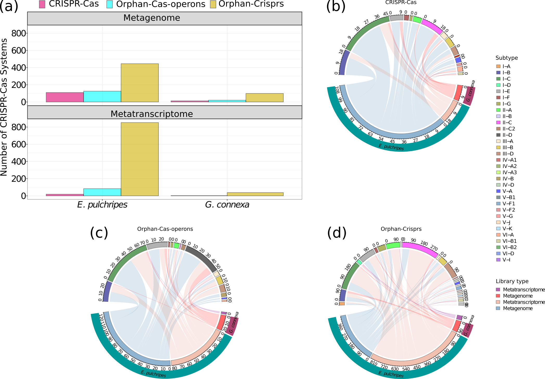

Supplementary Fig. 4. CRISPR-Cas loci and the associated genes in the metagenomic and metatranscriptomic libraries from the hindguts of E. pulchripes and G. connexa. (a) Total number of CRISPR-Cas loci, orphan Cas-genes and CRISPR arrays in both library types from the two millipede species. (b) The number of subtypes of CRISPR-Cas loci in both library types (lacking in the metatranscriptome from G. connexa). (c) The number of orphan cas-operons (those not present in CRISPR-Cas loci) and (d) orphan CRISPR arrays in both library type.
Supplementary Fig. 5. Arrangements and directions of the CRISPR-Cas systems identified in the metagenomes and metatranscriptomes from E. pulchripes and G. connexa. (a) The CRISPR-Cas systems in the metagenome and (b) metatranscriptome from E. pulchripes. (c) The CRISPR-Cas systems in the metagenome from G. connexa.

Supplementary Fig. 6. Arrangements and directions of the CRISPR-Cas systems identified in the MAGs from E. pulchripes and G. connexa. Each CRISPR-Cas system identified in our study was labelled with the specific phylum of the metagenome-assembled genomes (MAGs) from which it originated in each millipede species.
Supplementary Fig. 7. Arrow maps of the detected virus auxiliary metabolic genes (AMGs) from the metagenome-assembled viral genomes (MAVGs) recovered in metagenome from the hindgut of E. pulchripes.
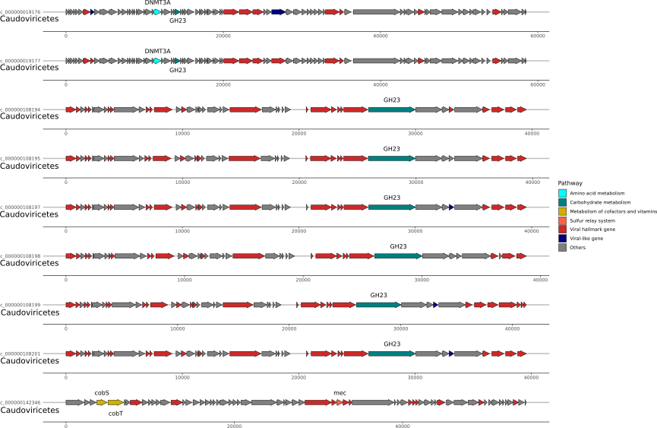
Supplementary Fig. 8. Arrow maps of the detected virus auxiliary metabolic genes (AMGs) from metagenome-assembled viral genomes (MAVGs) recovered in metatranscriptome from the hindgut of E. pulchripes.
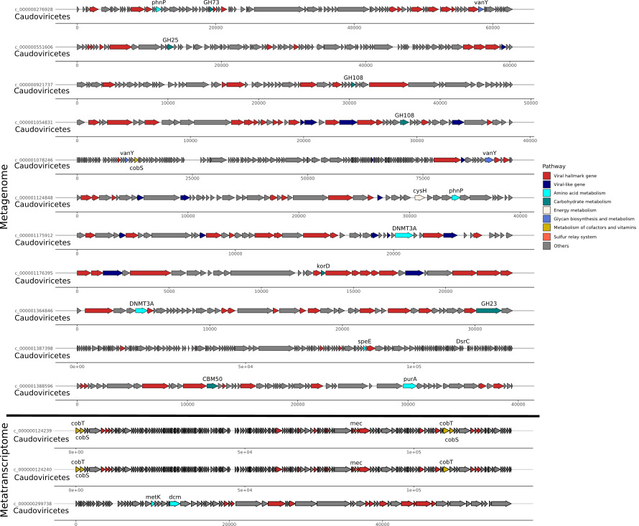
Supplementary Fig. 9. Arrow maps of the detected virus auxiliary metabolic genes (AMGs) from metagenome-assembled viral genomes (MAVGs) recovered in metagenome and metatranscriptome from the hindgut of G. connexa.

