Genetic or pharmacological GHSR blockade has sexually dimorphic effects in rodents on a high-fat diet
Andras H. Leko^{1,2*}, Adriana Gregory-Flores^{1,3*}, Renata C. N. Marchette^{3*}, Juan L. Gomez⁴, Janaina C.M. Vendruscolo³, Vez Repunte-Canonigo⁵, Vicky Chuong^{1,3}, Sara L. Deschaine¹, Kimberly Whiting^{1,3}, Shelley N. Jackson⁶, Maria Paula Cornejo⁷, Mario Perello⁷, Zhi-Bing You⁸, Michael Eckhaus⁹, Kim D. Janda¹⁰, Barry Zorman¹¹, Pavel Sumazin¹², George F. Koob³, Michael Michaelides⁴, Pietro P. Sanna⁵,
Leandro F. Vendruscolo^{12#}, Lorenzo Leggio^{1,6,13,14,15#}

SUPPLEMENT

MATERIAL AND METHODS

BEHAVIORAL ASSESSMENTS
Given that locomotion and anxiety-like behavior may affect feeding and the orexigenic actions of ghrelin, we tested GHSR-KO and WT rats in an open field test and a novelty-suppressed feeding test.

Open Field Test
The open field test under low light conditions (and small space) is commonly used to assess spontaneous activity and locomotion in rodents¹. We investigated the effects of HFD and GHSR deletion on locomotor activity after 40 weeks of ad libitum access to either chow or high-fat diet (HFD). Rats were habituated to the testing room for at least 1 h prior to the open field test. The order of testing was randomly selected based on genotype and diet assignments. Males and females were tested on separate days. Rats were placed in the center of a dark, gray small open field (40 x 40 x 50 cm) and ambulation was recorded for 5 min. The apparatus was cleaned with Labsan 256 CPQ (Sanitation Strategies LLC, Holt, MI) after each rat completed the task. The videos were analyzed for total distance moved using EthoVision tracking software (Noldus, Leesburg, VA, USA).

Novelty-Suppressed Feeding Test
This test is commonly used to assess anxiety-like behavior². After 18 weeks of ad libitum access to either chow or high-fat diet (HFD), rats were food deprived for 23 h prior to the test; water was available ad libitum during this time. The rats were habituated to an anteroom for at least 1 h and carried into the testing room at the beginning of the test. The order of testing was randomly selected based on genotype and diet assignments. Males and females were tested on separate days. Chow or HFD was placed in the center of a large (100 x 100 x 30 cm), white open field depending on the rats’ diet assignment (i.e., chow or HFD). Rats were placed in one of the corners facing the center of the open field. Latency to feed was recorded from the moment that the rat was placed in the open field until it began to bite into the food (i.e., not just sniffing or holding the food). At this point, the rat was removed from the apparatus and returned to its home cage. The maximum testing time was 10 min, when the rat was removed from the open field if it did not reach the food. The apparatus was cleaned with Labsan 256 CPQ (Sanitation Strategies LLC, Holt, MI) after each rat completed the test. After the test, food consumption in the home cage was recorded for 60 min to determine any differences in appetite between the groups in a low-stress environment (i.e., home cages), after which ad libitum access to chow or HFD was reinstated.

SMALL ANIMAL POSITRON EMISSION TOMOGRAPHY (PET)
Previous studies have used positron emission tomography (PET) with [¹⁸F] fluorodeoxyglucose (FDG) to measure the brain’s metabolic response to an array of food stimuli and obesity³. Here, we used small animal PET to measure brain glucose uptake 50 weeks after initiation of Chow or HFD. Six rats per group were selected at random and fasted overnight for 12 h prior to FDG administration.
The PET scans were adapted from a previously published protocol⁴. Briefly, the food was removed 1 h before the beginning of the dark cycle; the rats had ad libitum access to water. Acute food deprivation is necessary for PET with FDG because circulating glucose competes with FDG uptake. On the day of the scan, rats were injected with FDG (1 µCi/g/BW, i.p.) and allowed 30 min for uptake in their home-cages. The rats were then placed in a sealed anesthesia induction chamber and anesthetized with 4-5% isoflurane mixed with oxygen. Next, the anesthetized rats were placed in a prone position on the scanner bed. Glucose was measured via tail blood sample using a commercially available Aimstrip Plus blood glucose monitor (Germaine Laboratories, San Antonio, TX). Anesthesia was maintained with 2% isoflurane and rats were scanned for 20 min using a Mediso nanoScan PET/CT scanner. During the scan, the rats were monitored visually by the experimenter and scanner beds were equipped with respiratory and body temperature sensors. After the scan, rats were kept in a holding area for 24 h for FDG to decay. Rats were returned to their regular holding rooms in clean cages after radiotracer activity had completely decayed (measured via survey meter and activity counter).

LIVER HISTOLOGY
Liver tissue samples were sent to Histoserv Inc. (Germantown, Maryland) where tissue was paraffin processed and stained with hematoxylin-eosin⁵. The slides were then evaluated by a veterinary pathologist, using a qualitative lipidosis scoring to evaluate the lipid content of hepatocytes by microscopic analysis. Two livers were used from each group with the same genotype-sex-diet. Lipidosis was scored on an 8-point scale: 0 – negative, 1 – minimal, 2 – minimal to mild, 3 – mild, 4 – mild to moderate, 5 – moderate, 6 – moderate to severe, 7 – severe.

ENDOCRINE ASSAYS
To characterize the endocrine and metabolic profile of GHSR-KO and WT rats, we performed glucose tolerance and insulin tolerance tests. Blood levels of several hormones were also measured at the end of the experiments (terminal hormone analysis, described further below).
For endocrine assessments, tail blood collections were performed. Briefly, the experimenter gently held the rat to snip the tip of the tail and collect blood (~200 µl). The procedure was quick (less than 1 min) and anesthesia was not necessary. Hemostasis was achieved by gently drying the tail tip with paper towel. For multiple blood collections in a single day, the tail was only snipped once for the first collection. Subsequent collections were achieved by gently squeezing the tail from the base to the tip until blood flow was reestablished.

Glucose Tolerance Test
On week 51 after initiation of Chow or HFD, following a 12 h overnight food-deprivation, rats received an intraperitoneal (i.p.) injection of a 20% (w/v) glucose solution in saline (1 g/kg) 4-6 h into the light cycle. Glucose levels were measured at baseline and at 20-, 60- and 120-min post-glucose injection. Blood glucose was measured with a commercially available Aimstrip Plus blood glucose monitor (Germaine Laboratories, San Antonio, TX) at the time of the blood collection. Plasma insulin levels were measured at baseline and at 60 min post-glucose injection. Plasma insulin concentrations were analyzed using a commercial rat/mouse Insulin ELISA kit (EMD Millipore, Billerica, MA) and assayed in duplicates according to manufacturer instructions.

Insulin Tolerance Test
On week 52 after initiation of Chow or HFD, following a 12 h overnight food-deprivation, rats received an i.p. injection of insulin (1 U/kg) 4-6 h into the light cycle. Glucose levels were measured at baseline and at 20-, 60- and 120-min post-insulin injection. Blood glucose levels were measured as described above.

Terminal Hormone Analysis
At the time of the carcass analysis (see Methods in the main manuscript for additional details), blood was collected through cardiac puncture in EDTA coated Eppendorf tubes with or without the ghrelin inhibitor Pefabloc ® SC (Cat #11429876001, Millipore Sigma, Billerica, MA; 1mg/mL final concentration). Blood samples were immediately centrifuged at 2,000 x g for 15 min at 4°C. Plasma extracted from blood samples with ghrelin inhibitor Pefabloc® SC were treated with 5% (v/v) 1M HCl before storage at -80 °C. Plasma extracted from blood samples without ghrelin inhibitors were stored at -80 °C until assay. The various plasma hormone concentrations were analyzed using commercial rat/mouse ELISA kits for ghrelin (acylated form) and desacyl-ghrelin (ALPCO, Macedon, NY), insulin, leptin, and growth hormone (GH) ELISA kits (EMD Millipore, Billerica, MA), corticosterone and aldosterone ELISA kits (Abcam, Cambridge, MA), progesterone and testosterone ELISA kits (Cayman Chemical, Ann Harbor, MI), and a LEAP2 ELISA kit (MyBioSource, San Diego, CA). All samples were assayed in duplicates according to manufacturer instructions.

Gene expression and pathway analysis by RNA-seq
Gene expression was profiled by RNA-Seq. We used Gene Set Enrichment Analysis (GSEA) for pathway analysis⁶ in conjunction with genesets from the Molecular Signatures Database (MSigDB). Libraries were generated for next gen sequencing following the protocol recommended in the ScriptSeq v2 RNA-Seq Library Preparation Kit (Illumina), and uniquely barcoded with the ScriptSeq Index PCR Primers (Illumina) to generate ~30M 1x75 bp reads/sample. RNA-Seq reads were aligned and quantified to the RefSeq rat transcriptome (dated 2021-05-26) using RSEM (version 1.30)⁷ with Bowtie2⁸. Differential expression and log2 fold changes were calculated with DeSeq2⁹. Gene set enrichment calculations were completed using GSEA (v. 4.0.3)⁶ with statistics estimated by 10K gene set permutations and the log2 fold changes of the 8000 genes with lowest unadjusted p-values from DeSeq2. The Broad-UC San Diego Molecular Signatures Database (MsigDB v7.4) curated canonical pathway set was used (http://www.gsea-msigdb.org/gsea/index.jsp) , along with the v7.4 mapping to human orthologs.

Lipidomic analysis by mass spectrometry
From the tissue harvested during carcass analysis, brown adipose tissue (BAT) and white adipose tissue (WAT) samples were homogenized using a bead mill homogenizer (Bead Ruptor 12, Omni International, Kennesaw, GA). For homogenization, 500 µL of ice-cold water: ethanol was added per 10 mg of tissue. Two hundred and fifty µL of homogenate (5 mg of tissue) was placed in a glass extraction vial. Next, 1250 µL of chloroform/methanol (2:1, v/v) was added to the sample followed by 10 µL of the internal standard (triacylglycerol (TG) 30:0 at 8.5 mg/mL in chloroform/methanol [2:1, v/v]). Samples were sonicated for 10 min, and then vortexed for 1 h. Next, 250 µL of water was added to the sample. The resulting mixture was vortexed for 1 min and centrifuged at 15200 rpm at 4 °C for 10 min. The lower phase of the mixture (lipid/triacylglycerol phase) was collected and evaporated to dryness using nitrogen. The samples were re-suspended in 2.5 mL of chloroform/methanol (2:1, v/v) and stored at -80°C until mass analysis.
For mass spectrometry, 10 µL of the lipid extract was diluted in 990 µL of 10 mM of ammonium acetate in methanol. Samples were analyzed on an Orbitrap Velos (Thermo Fisher, San Jose, CA) coupled with an auto sampler (Ultimate 3000 HPLC, Thermo Fisher). Ten µL of the samples were injected in the instrument and analyzed in positive ion mode with the heated electrospray ionization (HESI) ion source. The instrument was set in Fourier transform mass spectrometry (FTMS) mode with a mass resolution of 100K.

PF-5190457 ADMINISTRATION IN C57BL/6J MICE AND GHSR-KO MICE
Experiments were performed in male (n=25) and female (n=19) C57BL6/J mice and GHSR-KO male mice¹⁰ (n=11) generated at the animal facility of the Multidisciplinary Institute of Cell Biology (IMBICE, National University of La Plata, Buenos Aires, Argentina). Mice were aged 12-20 weeks, weighed 20-27 g and fed with regular chow provided by Gepsa (Grupo Pilar, Argentina), which provided 2.5 kcal/g energy (weight composition: carbohydrates 28.8%, proteins 25.5%, fat 3.6%, fibers 27.4%, minerals 8.1%, and water 6.7%). All procedures were approved by the IACUC of the IMBICE (Approval number 10-01-22).
Ghrelin (Global Peptides, cat. PI‐G‐03) was dissolved in sterile artificial cerebrospinal fluid (aCSF, 300 pmol/uL) and prepared fresh each experimental day. PF-5190457 (Sigma, cat. PZ0270) was dissolved in dimethyl sulfoxide (DMSO) and diluted in aCSF to obtain a final concentration of DMSO lower than 5% v/v to avoid toxicity. One week before the experiment, anesthetized mice were stereotaxically implanted with a single indwelling guide cannula (P1 Technologies) into the lateral ventricle (placement coordinates: AP: −0.34 mm, ML: +1.00 mm and DV: −2.30 mm) and single-housed. Three days before the experiment, mice were daily icv‐injected with aCSF to acclimate them to handling.
During the ghrelin-induced food intake experiments, animals were housed with a limited amount of bedding to visualize chunks of pellets easily. On the experimental day, all food pellets were removed from the food hoppers and bedding was confirmed to be free of chow remains. Then, mice were first icv-injected with 2 µL of either vehicle (DMSO 5% v/v in aCSF) or PF-5190457 (100 pmol/mouse). 15 min after pre-treatment, mice were icv-injected with vehicle (aCSF) or ghrelin (20 pmol/mouse) and exposed to a pre-weighed chow pellet on the floor of the home cages. Chow pellets were weighed at 30-, 60- and 120-min after treatment using a calibrated scale (precision = 1 mg) and food intake was calculated by subtracting the weight of the remaining pellet to the initial weight. After the 120-min of acute food intake assessment, mice were left with a pre-weighed quantity of chow pellets to assess overnight food intake. Next morning (at 9.00 – 10.00 am), the remaining chow pellets were weighed to calculate overnight food consumption. A subset of animals were anesthetized and transcardially perfused with heparinized phosphate-saline buffer (PBS) and formalin (4% v/v in PBS) 120 min after ghrelin / vehicle treatment, and c-Fos immunostaining were conducted. These procedures were carried out as described earlier¹¹.
To assess the effect of icv. PF-590457 on HFD-induced binge-like eating in WT and GHSR-KO male mice, we used the following protocol. In the morning (9.00 – 10.00 am) of experimental day 1, chow pellets were removed from food hoppers and mice were icv-injected with 2 µL of either vehicle (DSMO 5% v/v in aCSF) or PF-5190457 (100 pmol/mouse). Fifteen-min after icv. administration, mice were exposed to a pre‐weighed pellet of HFD (Gepsa; HFD pellets provided 3.9 kcal/g energy and their percentage weight composition was: carbohydrates 22.5%, proteins 22.8%, fat 21.1%, fibers 23.0%, minerals 5.6% and water content 5.0%). Mice were left with access to the HFD pellet for 120-min and then HFD pellets were removed from home cages and chow was re‐added to the food hoppers. The same procedure was repeated during 4 consecutive days.

STATISTICAL ANALYSIS
All data are expressed as means and standard error of the mean (SEM). Data were analyzed using analysis of variance (ANOVA) with or without repeated measures (details are provided in the Results section). Mauchly’s test was used to assess the assumption of sphericity. If that was violated for the main effect of time, the degree of freedom was corrected using Greenhouse-Geisser estimate of sphericity. Post hoc comparisons were performed when appropriate using the Bonferroni test at repeated measures ANOVA, otherwise using Fisher’s LSD test. Statistical significance for all analyses was set at p < 0.05. GraphPad Prism 9.1.0 and SPSS were used for statistical analysis. Body weight, glucose tolerance, and insulin tolerance data from different genotypes in the same sex and on the same diet were also compared with each other to reflect the effect of GHSR deletion on body weight more precisely. 2-way repeated measures ANOVA (Time, Genotype) was used in addition to the initial 3-way repeated measures ANOVA (Time, Diet, Genotype).
For the small animal PET experiments, scans were reconstructed on software provided by Mediso. Scans were then co-registered with PMOD (Zürich, Switzerland) to an MRI rat template to ensure all scans are in the same coordinate space. Voxel-wise comparisons were made with Statistical Parametric Mapping (SPM12, London, UK) to assess whole brain between group differences in FDG uptake. A two-way (Genotype x Diet) ANOVA was used followed by post hoc comparisons to assess group differences. For each sex, diet groups were combined to compare how GHSR gene deletion altered FDG uptake. A two sample t-test was used to test both increases and decreases in FDG uptake between WT and GHSR gene deletion. Cluster plots (k = 100) show differences between subjects, with all statistical significance set at p = 0.05.
For the lipid assignment and lipidomic data analysis, a total of 43 triacylglycerols (TGs) were detected as [M+NH₄]⁺ mass peaks and assigned with a mass error < 6 ppm. Mass peaks for TGs were labeled as follows: species number equal the total carbon length and number of carbon double bonds of the acyl chains. R software (version 2.15.1) was used to annotate the data and report the peak intensities of TG species that were normalized with the peak intensity of the internal standard. All data were expressed as means and standard errors of the mean (SEM). A two-way (Genotype x Diet) ANOVA was used followed by Tukey’s multiple comparison test to assess group differences. Statistical significance for all analyses was set at p < 0.05. GraphPad Prism 8.0.1 was used for statistical analysis.

ANTI-GHRELIN VACCINE EXPERIMENT IN MALE WISTAR RATS
Animals
Given the results of the GHSR KO in diet-induced obesity (DIO), indicating an effect of HFD in male but not female rats (present study; see Results), we limited this experiment to male rats only. The rats were exposed to HFD only (no Chow condition was included). Sixteen adult male Wistar rats were obtained from Charles River (Kingston, New York, NY, USA). The rats weighed 250-275 g at the beginning of the study. All animals were single-housed and maintained under a 12 h/12 h light/dark cycle (lights off at 6:00PM) at 21ºC ± 2ºC with ad libitum access to food and water. All procedures were conducted per the National Institutes of Health Guide for the Care and Use of Laboratory Animals and were approved by the National Institute on Drug Abuse, Intramural Research Program, Animal Care and Use Committee.
Vaccine Preparation
The active Ghr1-TT-Alum-CpG ODN vaccine formulation for injection was composed of a 5:1:5 (v/v/v) mixture of A) Gherlin-Thr-Thr (Ghr1-TT) immunoconjugate (1.25 mg/ml in PBS), B) CpG oligodeoxynucleotides (ODN) 1826 (1.25 mg/ml in PBS), and C) Imject Alum (5 mg/ml in PBS). For each active injection, one aliquot each of Ghr1-TT, CpG ODN 1826, and Alum were diluted to the correct concentrations, then mixed together to form the vaccine formulation, and shaken at room temperature for 30 min. After shaking, the vaccine was stored on ice for no more than 1 h prior to injection. The control TT-Alum-CpG ODN 1826 vaccine formulation for injection was generated through the same procedure, with a 5:1:5 (v/v/v) mixture of TT (1.25 mg/mL in PBS), CpG ODN 1826 (1.25 mg/mL in PBS), and Imject Alum (5 mg/mL in PBS).
Vaccination Procedure
The rats were individually housed in the vivarium facility for 1 week prior to the initiation of study. Each rat was injected IP with 400 µL of vaccine formulation, delivering a dose of 250 µg Ghr1-TT, 50 µg CpG ODN 1826, and 1 mg of Alum per animal for each injection. The rats were injected with a priming dose on week 0, with boosts administered on weeks 3, 5, 8, 12 and 17. Tail bleeds were taken on weeks 4, 6, 9, 13 and 18. We recorded body weight and food intake throughout the experiment.
ELISA Test analysis for the assessment of the midpoint titer
Production of anti-ghrelin Ig was evaluated by ELISA. Microtiter plates (Costar 3690) were incubated with coating antigen Ghr1-BSA in PBS (5 μg/mL, 25 μL) (18 h, 37ºC). 5% Non-fat milk in PBS (30 min, 25ºC) was added to block non-specific binding. Rat sera were diluted 1:100 in 2% BSA in PBS then serially diluted across the plates (1:2) before incubation in a moist chamber (1 h, 37ºC). Plates were washed 10 times with H₂O before incubation with peroxidase-conjugated donkey anti-rat IgG (Jackson ImmunoResearch), mouse anti-rat IgM (bleeds 1 – 3), or goat anti-rat Ig (Southern Biotech, Inc.) in a moist chamber (30 min, 37ºC). The plates were further washed 10 times with H₂O before being developed with the TMB (3,3',5,5' tetramethylbenzidine dihydrochloride) substrate kit (Thermo Pierce) and the absorbance at 450 nm measured on a microplate reader (SpectraMax M2 Molecular Devices). Titers were calculated as the dilution corresponding to 50% of the maximum absorbance from a plot of the absorbance versus log(dilution) using GraphPad Prism 6.
Analysis of Antibody Binding Affinity by Surface Plasmon Resonance
Production of anti-Ghrelin Ig was evaluated by Surface Plasmon Resonance (SPR) methodology. A Biacore 3000 instrument equipped with a CM5 sensor chip (GE Healthcare) was
used for all the analyses. Reference flow cell 1 was immobilized with ~5,000 RU of BSA, and flow cell 2 was immobilized with ~5,000 RU of Ghr1-BSA using NHS/EDC chemistry according to the manufacturer's instruction. All assays were conducted at 25ºC with a flow rate of 30 μL/min, using HBS-EP+ buffer as running buffer. The surface was regenerated with 50 mM NaOH for 30 sec at 30 μL/min. All sera were titrated, and the concentration was normalized to give a response of ~100 RU in the assay. To determine the IC50 of rat full length ghrelin (rflGhre) for vaccinated sera, individual serum was incubated at RT for 1hr with various concentration of rflGhre, ranging from 1 μM-0.98 nM, then were passed over the flow cells. For control-generated sera, only the two highest concentration of rflGhre (1 and 0.5 μM) were used in competition assay. An anti-ghrelin control monoclonal antibody (JG4) was also used in IC50 determination as a positive control. IC50 were calculated using GraphPad Prism 6.
Diets
Rats were fed a HFD that was introduced 1 week following treatment with the priming dose on week 0 and consisted of 20% protein, 20% carbohydrate and 60% fat by kcal (Research Diets D12492, New Brunswick, NJ).
Novelty-Suppressed Feeding Test
This test is used to assess anxiety-like behavior² and was done on week 15 after the completion of the vaccination procedure. Rats were food deprived for 23 h with ad libitum access to water. Then, the rats were placed in an open field (100 x 100 x 30 cm) facing one of the corners and left to explore for 10 min. HFD pellets were placed in the center of the open field. Latency to feed was recorded from the moment the rat was placed in the open field until it began to consume the HFD, not just merely sniffing or holding the food. At this point, the rat was removed from the apparatus and returned to its home cage. Food consumption in the home cage was recorded over the next 60 min, after which ad libitum access HFD was reinstated.
Blood Glucose Concentrations
A razor blade was used to snip the tip of the tail (1 mm) to collect blood. The experimenter gently held the rat to snip the tip of the tail and collect blood. The procedure was quick (less than 2 min) and anesthesia was not necessary. Hemostasis was achieved by gently drying the tail tip with a paper towel. Blood glucose samples were collected on week 16 after completion of the vaccination procedure. Blood was collected within the 1st h after the start of the light cycle (lights on at 6:00AM) on separate days during fasting and satiated conditions. Blood glucose was measured with a commercially available Aimstrip Plus blood glucose monitor (Germaine Laboratories, San Antonio, TX).
Statistical Analysis
All data were expressed as means and standard errors of the mean (SEM). Data were analyzed using analysis of variance (ANOVA) with repeated measures and multiple unpaired t-test analysis. Mauchly’s test was used to assess the assumption of sphericity. If that was violated for the main effect of time, the degree of freedom was corrected using Greenhouse-Geisser estimate of sphericity. When appropriate, post hoc comparisons were performed using Bonferroni or Duncan’s tests for multiple comparisons. Statistical significance for all analyses was set at p ≤ 0.05. GraphPad Prism 9.0.1 was used for statistical analysis.

ANTI-GHRELIN VACCINE EXPERIMENT IN MALE AND FEMALE C57BL/6J MICE
Animals
Given the previous results in non-obese male mice¹² and the anti-ghrelin vaccine experiment in male rats exposed to HFD described here (see Supplemental Results above in this Supplement), we wondered whether species and/or sex differences could account for these differences. Therefore, we performed another anti-ghrelin vaccine experiment in male and female mice. Male (n = 16) and female (n = 16) C57BL/6J mice were obtained from Jackson’s Laboratory (Bar Harbor, ME, USA), and were 6 weeks-old upon arrival. All mice were single housed in standard cages and had ad libitum access to food and water. Mice were maintained in a temperature and humidity-controlled room with a 12h /12 h dark/light cycle (lights off 7:00AM).
Vaccine Preparation
Mice were treated with a Ghr1-CRM-Alum-CpG ODN vaccine. The Ghr1 peptide was conjugated to the carrier protein Diphtheria Toxoid mutant CRM 197, a non-toxic mutant used to make polysaccharides and haptens immunogenic, and to a Bovine Serum Albumin carrier for ELISA analysis. This step is necessary to ensure the immunogenicity of the Ghr1 hapten. The active vaccine formulation was prepared with a 5:1:5 (v/v/v) mixture of A) Ghr1-CRM immunoconjugate (1.25 mg/ml in PBS), B) CpG ODN 1826 (1.25 mg/ml in PBS), and C) Alhydrogel® (5 mg/ml in PBS). Once all components were combined, the active vaccine was shaken for 30 min at room temperature. The vaccine was kept on ice for no more than 1 h prior to injection. The sham vaccine was prepared the same as active vaccine, but instead formulated with a 5:1:5 (v/v/v) mixture of A) A genetically modified cross-reacting material (CRM) of diphtheria toxin carrier protein (1.25 mg/ml in PBS), B) CpG ODN 1826 (1.25 mg/ml in PBS), and C) Alhydrogel® (5 mg/ml in PBS).
Vaccination Procedure
Mice were habituated for 1 week upon arrival in the vivarium facility and prior to initiation of the study. Mice were treated with either active or sham vaccine intraperitoneally at a volume of 110 µL. Each dose delivered 50 µg of Ghr1-CRM or unconjugated CRM, 50 µg CpG ODN 1826, and 150 µg of Alhydrogel® per mouse. A priming dose was administered on week 0, followed by vaccine boosts on weeks 3, 5 and 8. Blood was collected from mice via the submandibular facial vein for determination of IgG response towards the vaccine. Bleeds were conducted one week following administration of vaccine boosts on weeks 4, 6 and 9. Blood was not centrifuged down to collect the sera, but was instead frozen at -20ºC as whole blood, which precluded the use of Biacore for affinity analysis. All blood was analyzed by ELISA to determine IgG titers, and IgM titers were examined for a select number of mice.
Diets
Mice were separated into two groups with ad libitum access to either regular chow or high-fat diet (HFD). HFD was introduced 1 week following treatment with the priming dose on week 0 and consisted of 20% protein, 20% carbohydrate and 60% fat by kcal (Research Diets D12492, New Brunswick, NJ). Chow and HFD intake and body weight was measured once per week.
Statistical Analysis
We analyzed regular chow and HFD separately. Weekly food consumption and body weight were analyzed by a three-way repeated measures ANOVA. Then, since no significant sex effects were identified, we combined male and female data to increase the power of the analysis and performed a two-way repeated measures ANOVA with treatment and time as independent factors. Mauchly’s test was used to assess the assumption of sphericity. If that was violated for the main effect of time, the degree of freedom was corrected using Greenhouse-Geisser estimate of sphericity. When appropriate (p < 0.05), Bonferroni post hoc test was used for comparisons.

RESULTS
BEHAVIORAL ASSESSMENTS
Open Field Test
The ANOVA did not reveal significant main effects of diet or genotype nor interactions in locomotion in either male (Supplemental Figure S1A) or female (Supplemental Figure S1B) rats as measured by distance travelled in the open field.
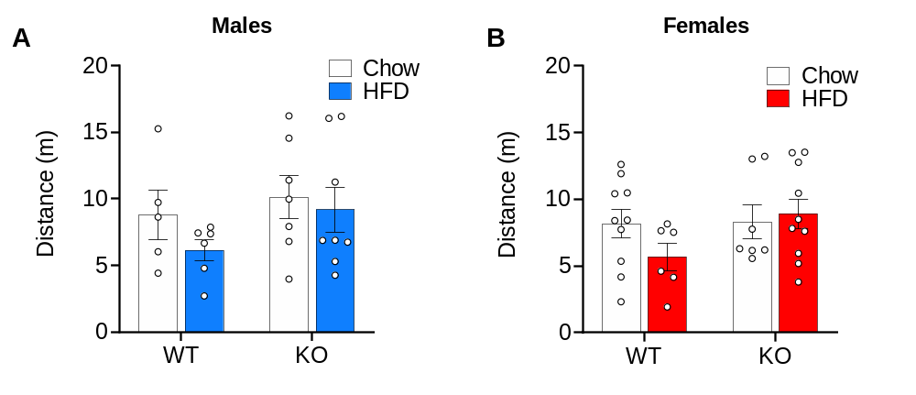
Supplemental Figure S1. No differences in locomotion between WT and GHSR-KO male and female rats fed with either HFD or chow. (A) There was no significant difference between WT and GHSR-KO male rats fed with either HFD or chow in distance travelled in the open field. WT: n = 5 Chow, n = 6 HFD. GHSR-KO: n = 7 Chow, n = 8 HFD. (B) There was no significant difference between WT and GHSR-KO female rats fed with either HFD or chow in distance travelled in the open field. WT: n = 10 Chow, n = 6 HFD. GHSR-KO: n = 7 Chow, n = 10 HFD.

Novelty-Suppressed Feeding Test
The ANOVA did not reveal main effects of genotype or diet, nor interactions between these two factors for the time to reach food in the novel (stressful) arena in males (Supplemental Figure S2A) or females (Supplemental Figure S2B). Moreover, there were no statistically significant differences in food consumption during 1 h in male rats upon return to the home-cage (low stress environment; Supplemental Figure S2C). However, there was a main effect of Diet (F_{1, 33} = 4.580, p < 0.05) on 1 h food consumption in the home-cage in female rats (Supplemental Figure S2D), indicating that HFD-fed female rats consumed less calories during 1 h after the novelty suppressed feeding test than chow-fed female rats, regardless of genotype.

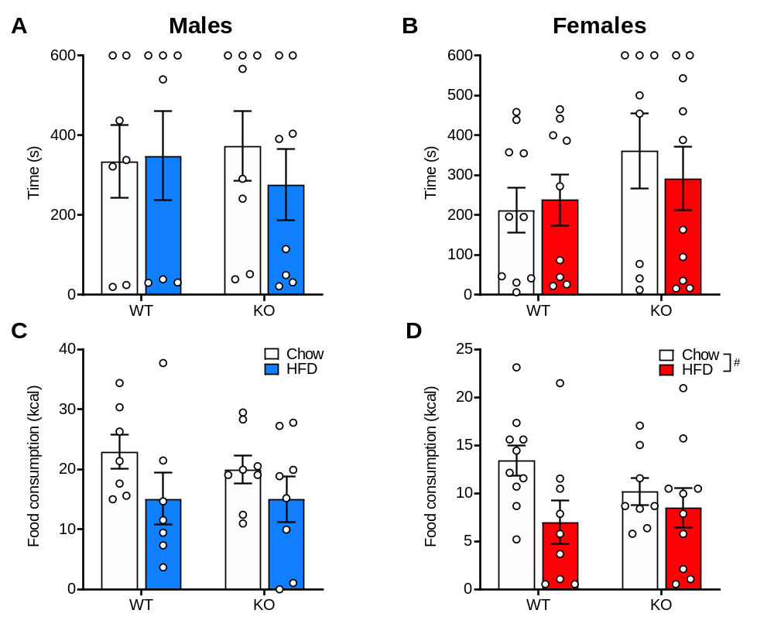
Supplemental Figure S2. GHSR deletion has no effect on novelty-suppressed feeding. (A) There was no significant difference in latency to feed in a novel arena between WT and GHSR-KO male rats, regardless of diet. (B) There was no significant difference in latency to feed in a novel arena between WT and GHSR-KO female rats, regardless of diet. (C) One hour food consumption in the home-cage did not differ between WT and GHSR-KO male rats. WT: n = 7 Chow, n = 7 HFD. GHSR-KO: n = 7 Chow, n = 8 HFD. (D) Overall, HFD-fed female rats consumed less calories during 1-hour food consumption in the familiar home-cage than chow-fed rats (#p < 0.05), regardless of genotype. WT: n = 10 Chow, n = 6 HFD. GHSR-KO: n = 7 Chow, n = 10 HFD.

CARCASS ANALYSIS
The 2-way ANOVA did not indicate any significant effects of Diet or Genotype on the percent of BAT weight, in both sexes (Supplemental Figure S3A-B). In males, we found a significant effect of Diet (F_{1, 24} = 88.06, p < 0.0001; HFD > Chow) and Genotype (F_{1, 24} = 6.489, p < 0.05; GHSR-KO < WT) for the percent of gonadal WAT weight (Supplemental Figure S3C), and a significant effect of Diet (F_{1, 29} = 6.907, p < 0.05; HFD > Chow) in females (Supplemental Figure S3D). The 2-way ANOVA indicated an effect of Diet (F_{1, 24} = 19.69, p < 0.001; HFD > Chow) on the percent of inguinal WAT weight in males, but not females (Supplemental Figure S3E-F). We did not find significant effects for gonadal/inguinal WAT ratio, in both sexes (Supplemental Figure S3G-H).
In males, there were no significant main effects or interactions of Diet and Genotype on nose-anus length, nor on percentage of adrenal glands in body weight (Supplemental Table 1). The 2-way ANOVA indicated a significant effect of Diet on spleen weight (F_{1, 24} = 10.96, p < 0.01; Chow > HFD).
The 2-way ANOVA showed an effect of Diet on the percentage of liver weight (F_{1, 24} = 179.7, p < 0.0001), indicating decreased liver weights in HFD-fed male rats compared with chow-fed male rats, regardless of genotype (Supplemental Table 1).
In female rats, the 2-way ANOVA indicated a similar difference in the percentage of liver weight, namely, the ratio of liver weight in the total body weight was higher in chow-fed animals, regardless of genotype (F_{1, 29} = 24.11, p < 0.0001). ANOVAs indicated no significant main effects or interactions of Diet and Genotype for nose-anus length, nor for the percentage of spleen weights, and adrenal gland weights (Supplemental Table 1).
Supplemental Figure S3. GHSR deletion results in less percentage of gonadal WAT in total body weight in male, but not female, rats. (A) GHSR knockout (KO) male rats and WT male rats fed with a HFD or a chow diet did not differ in relative BAT weight (% of body weight). WT chow: n = 6. GHSR-KO chow: n = 7. WT HFD: n = 7. GHSR-KO HFD: n = 8. (B) There were no genotype or diet effects in female rats on relative BAT weight. WT chow: n = 10. GHSR-KO chow: n = 7. WT HFD: n = 6. GHSR-KO HFD: n = 10. (C) WT male rats had more gonadal fat compared with GHSR-KO male rats (*p < 0.05). HFD-fed rats had more gonadal fat compared to chow-fed rats (####p < 0.0001) (D) Female rats that received HFD had a higher percentage of gonadal fat than the female rats fed a regular chow diet, regardless of genotype (#p < 0.05). (E) There was no genotype effect on the percentage of inguinal fat in male rats. HFD-fed males had more inguinal fat than chow-fed males, regardless of genotype (### p < 0.001). (F) There were no genotype or diet effects in female rats on relative inguinal fat weight. (G) We observed no effect of Diet or Genotype on gonadal/inguinal WAT ratio in males (H) There were no Genotype or Diet effects in female rats on gonadal/inguinal WAT ratio. Data are expressed as mean ± SEM, circles represent each individual rat.
Supplemental Table 1. Results of the carcass analysis on nose-anus length and on relative weights (% of body weight) of adrenal, spleen, and liver of wild-type (WT) or GHSR knock-out (KO) male and female rats fed with chow or a high-fat diet (HFD).

Treatment group | Nose-anus length  (cm) | Adrenal glands  (% of BW) | Spleen  (% of BW) | Liver  (% of BW)
Male WT Chow (6) | 28.4 ± 0.45 | 0.011 ± 0.0007 | 0.164 ± 0.009## | 2.651 ± 0.079####
Male GHSR-KO Chow (7) | 28.3 ± 0.34 | 0.012 ± 0.002 | 0.170 ± 0.020## | 2.519 ± 0.077####
Female WT Chow (10) | 23.2 ± 0.28 | 0.017 ± 0.001 | 0.167 ± 0.010 | 2.413 ± 0.104####
Female GHSR-KO Chow (7) | 23.1 ± 0.23 | 0.017 ± 0.002 | 0.163 ± 0.023 | 2.234 ± 0.085####
Male WT HFD (7) | 29.2 ± 0.44 | 0.008 ± 0.001 | 0.137 ± 0.010 | 1.706 ± 0.039
Male GHSR-KO HFD (8) | 29.0 ± 0.38 | 0.011 ± 0.001 | 0.114 ± 0.008 | 1.815 ± 0.049
Female WT HFD (6) | 23.4 ± 0.35 | 0.014 ± 0.003 | 0.166 ± 0.005 | 1.866 ± 0.122
Female GHSR-KO HFD (10) | 24.1 ± 0.29 | 0.011 ± 0.001 | 0.140 ± 0.011 | 1.836 ± 0.066
Data are presented as mean ± standard error of the mean (SEM). The number of samples tested are noted in parentheses. ##Difference from HFD-fed rats of the same sex, regardless of genotype (p < 0.01)
####Difference from HFD-fed rats of the same sex, regardless of genotype (p < 0.0001)

LIVER HISTOLOGY
Liver samples of HFD-fed male and female rats showed mild-to-severe lipidosis (scores 4-7), while those of chow-fed animals in both sexes showed either no sign or only mild-to-moderate lipidosis (scores 0-5). We did not observe any difference in lipidosis related to genotype or sex (Supplemental Figure S4).
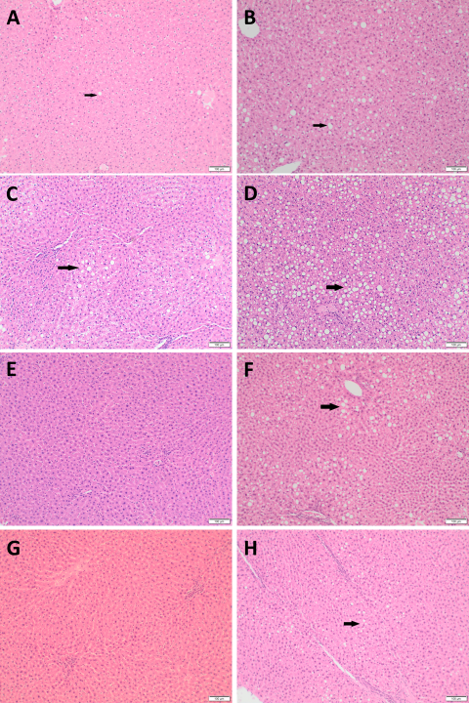
Supplemental Figure S4. Liver lipidosis on hematoxylin-eosin-stained liver slices. Arrows on the slices show the lipid accumulation. (A) WT male chow – minimal lipidosis. (B) WT male HFD – moderate lipidosis. (C) KO male chow – mild lipidosis. (D) KO male HFD – severe lipidosis. (E) WT female chow – no lipidosis. (F) WT female HFD – moderate lipidosis (G) KO female chow – no lipidosis (H) KO female HFD – moderate lipidosis

ENDOCRINE ASSAYS
Glucose Tolerance Test
A three-way repeated-measures (RM) ANOVA (Genotype x Diet x Time) only revealed a significant Time effect (F_{1.59, 38.15} = 26.31, p < 0.001) for glucose levels in male rats. Two-way RM ANOVAs in each diet group (Genotype x Time) also revealed only a Time effect (Chow: F_{1.347, 14.81} = 18.37, p < 0.001; HFD: F_{1.530, 19.88} = 13.60, p < 0.001). Post hoc comparisons indicated that blood glucose levels were higher at all timepoints compared with baseline in chow-fed and HFD animals (p < 0.01; Supplemental Figure S5A). Glucose levels at 120 min were lower than levels at 20 min (p < 0.05) in chow-fed animals, but not in HFD-fed (Supplemental Figure S5A). There were no significant main effects or interactions on insulin levels (Supplemental Figure S5B) in male rats.
In female rats, the three-way RM ANOVA also revealed a significant Time effect (F_{1.644, 46.04} = 18.757, p < 0.0001) for glucose levels. Two-way RM ANOVAs in each diet group (Genotype x Time) also indicated Time effect only (Chow: F_{1.157, 17.35} = 12.04, p < 0.01; HFD: F_{2.015, 26.19} = 8.259, p < 0.01). Post hoc comparisons indicated that blood glucose levels were higher at all time points compared with baseline in the chow-fed animals (p < 0.05), but only at 20 (p < 0.05) and 60 min (p < 0.01) in HFD-fed (Supplemental Figure S5C). Glucose levels at 120 min were lower than levels at 20 min (p < 0.05) in both diets (Supplemental Figure S5C). For insulin levels in female rats, the ANOVA also indicated a significant effect of Time (F_{1, 28} = 25.65, p < 0.0001; Supplemental Figure S5D), indicating that plasma insulin levels were higher at 60 min than at baseline, regardless of genotype.
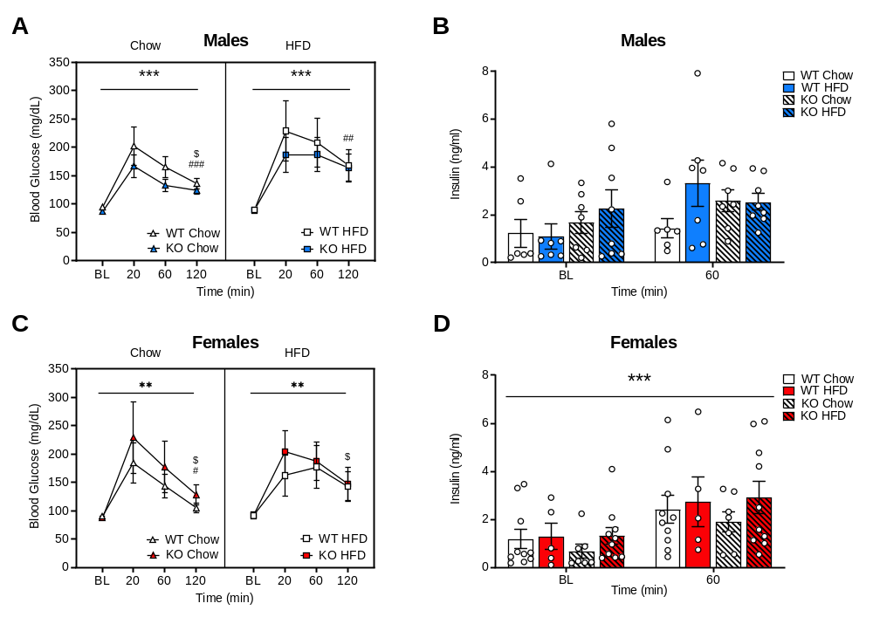
Supplemental Figure S5. Increased blood glucose levels in the glucose tolerance test in male and female rats, regardless of genotype. (A) Time had a significant effect on blood glucose levels in both diets, regardless of genotype (***p < 0.001). At 120 min, blood glucose levels of male rats, on chow or HFD, were higher than blood glucose levels at baseline (###p < 0.001, ##p < 0.01), and lower than at 20 min in the chow-fed only ($p < 0.05). (B) There was no significant difference between WT and GHSR-KO male rats fed chow or HFD in plasma insulin levels during glucose tolerance test. WT: n = 6 Chow, n = 7 HFD. GHSR-KO: n = 7 Chow, n = 8 HFD. (C) Time had a significant effect on blood glucose levels across all female groups (**p < 0.01). At 120 min, blood glucose levels of female rats were lower than blood glucose levels at 20 min in both diets ($p < 0.05) and higher than baseline in chow diet only (#p < 0.05). (D) Plasma insulin levels at 60 min were higher than at baseline across all female groups (***p < 0.001), regardless of genotype. WT: n = 10 Chow, n = 5 HFD. GHSR-KO: n = 7 Chow, n = 10 HFD.

Insulin Tolerance Test
A three-way RM ANOVA (Genotype x Diet x Time) indicated a significant Time effect (F_{2.616, 60.16} = 253.2, p < 0.001) and a significant interaction of Diet x Genotype (F_{1, 23} = 6.091, p < 0.05) in glucose levels in male rats. Two-way RM ANOVA (Genotype x Time) in chow-fed males indicated a Time effect only (F_{2.235, 22.35} = 113.4, p < 0.0001). In HFD-fed male rats, two-way RM ANOVA (Genotype x Time) revealed a significant effect of Time (F_{2.555, 33.21} = 144.9, p < 0.0001), and Genotype (F_{1, 13} = 6.640, p < 0.05; KO > WT). Post hoc analyses following the main effect of Time indicated that blood glucose levels at all timepoints were lower than baseline levels, in both diet groups (p < 0.001; Supplemental Figure S6A).
For females, the three-way RM ANOVA revealed a significant Time effect (F_{1.859, 53.90} = 92.94, p < 0.0001) for blood glucose levels, which were lower than baseline levels at all timepoints in chow-fed animals, and after 60 min in HFD-fed females, indicated by diet-specific two-way RM ANOVAs (Supplemental Figure S6B).
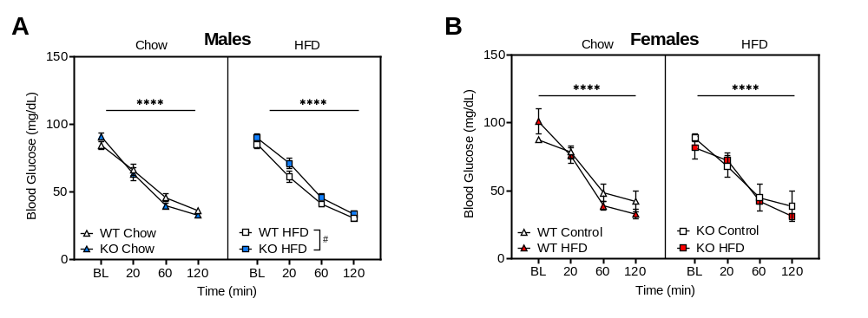
Supplemental Figure S6. Decreased blood glucose levels in the insulin tolerance test in male and female rats. (A) Blood glucose levels at all timepoints decreased from baseline across all male groups (****p < 0.0001). Blood glucose levels in GHSR-KO HFD-fed male rats were higher when compared to WT HFD-fed male rats (#p < 0.05). (B) Blood glucose levels at all timepoints decreased from baseline across all female groups (****p < 0.0001).

Terminal Hormone Analysis
For males, a two-way ANOVAs did not reveal significant main effects or interactions in plasma concentrations of ghrelin, desacyl-ghrelin, LEAP-2, corticosterone, insulin, GH, or testosterone at the terminal hormone analysis (after 52 weeks of ad libitum access to HFD or chow diet; Supplemental Figure S7A-F). A two-way ANOVA showed a significant Genotype x Diet interaction (F_{1, 24} = 9.814, p < 0.01) for progesterone concentrations. Post hoc test indicated increased levels of progesterone in GHSR-KO chow-fed male rats compared to the WT chow-fed (p < 0.01) and GHSR-KO HFD-fed groups (p < 0.05; Supplemental Figure S7G). A two-way ANOVA indicated a main effect of diet (F_{1, 24} = 7.592, p < 0.01; chow > HFD) for aldosterone levels (Supplemental Figure S7I), while we only observed a trend for a main effect of genotype (F_{1, 24} = 2.772, p = 0.109) with higher aldosterone in GHSR-KO animals compared to WT. Of note, the increased aldosterone levels are consistent with previous data from our lab; in fact, in the originally GHSR-KO cohort, whose characterization was reported in Zallar et al¹³, we also found that aldosterone was significantly higher in GHSR-KO rats (2094.32 ± 280.79 pg/ml) than in the WT rats (1231.36 ± 152.13 pg/ml; p < 0.05; unpublished data). The ANOVA indicated a main effect of diet (F_{1, 24} = 7.852, p < 0.01) for leptin levels, with HFD-fed male rats showing higher levels of leptin compared with chow-fed male rats (p < 0.05; Supplemental Figure S7J).
For females, two-way ANOVAs did not reveal significant main effects or interactions for plasma concentrations of ghrelin, desacyl-ghrelin, corticosterone, testosterone, insulin, LEAP2 or GH at the time of terminal hormone analysis (p’s > 0.05).
We were interested in the previously described¹⁴ differences of the ghrelin system between males and females, in relation to diet and genotype. When we compared hormones of the ghrelin system between males and females, a three-way ANOVA (Diet x Genotype x Sex) described a significant effect of Sex on LEAP-2 level (p < 0.0001). Males had higher LEAP-2 levels (Supplemental Figure S8C), while we did not detect significant main effects or interactions for ghrelin or desacyl-ghrelin levels (Supplemental Figure S8A-B).

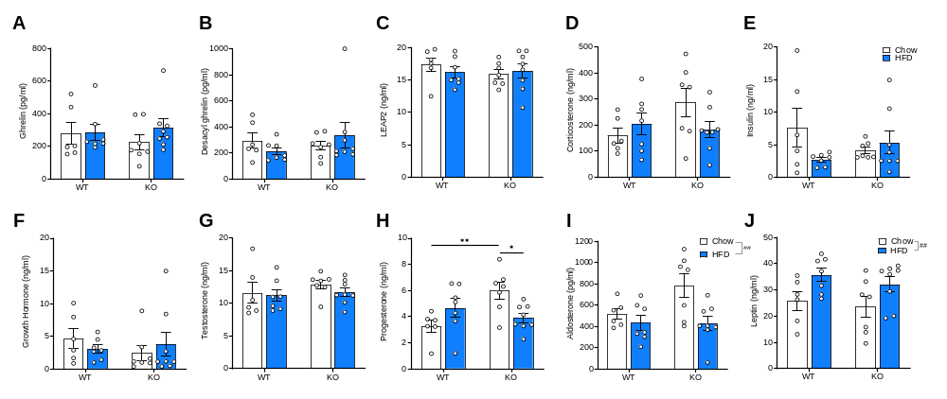
Supplemental Figure S7. Terminal hormone analysis - males. (A-G) There was no significant difference between WT and GHSR-KO male rats fed chow or HFD on plasma concentrations of ghrelin, desacyl-ghrelin, LEAP-2, corticosterone, insulin, GH, or testosterone. (H) GHSR-KO chow-fed male rats had higher levels of progesterone compared with WT chow-fed (**p < 0.01) and GHSR-KO HFD-fed groups (*p < 0.05). (I) Chow-fed male rats had higher levels of aldosterone compared with HFD-fed rats (##p < 0.01). (J) Leptin levels were significantly higher in HFD-fed male rats compared with chow-fed rats (##p < 0.01). WT: n = 6 Chow, n = 7 HFD. GHSR-KO: n = 7 Chow, n = 8 HFD. All data are expressed as mean ± SEM, circles represent each individual rat.

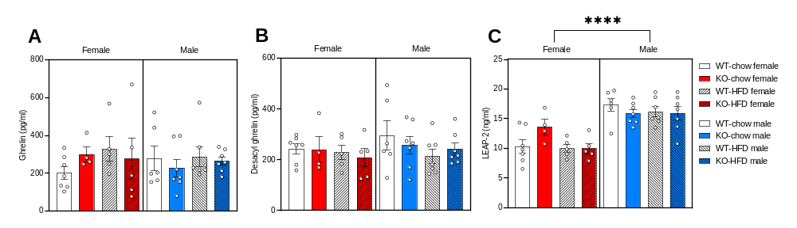
Supplemental Figure S8. Terminal hormone analysis – ghrelin system in males and females. (A-B) There was no significant difference regarding Sex, Diet, or Genotype in plasma concentrations of ghrelin or desacyl-ghrelin. (C) Males had higher LEAP-2 levels compared to females (****p < 0.0001). Males WT: n = 6 Chow, n = 7 HFD. Females WT: n = 7 Chow, n = 5 HFD. Males GHSR-KO: n = 7 Chow, n = 7 HFD. Females GHSR-KO: n = 4 Chow, n = 5 HFD. All data are expressed as mean ± SEM, circles represent each individual rat.

Gene expression and pathway analysis by RNA-seq
Comparisons of BAT gene expression in GHSR-KO and WT on the HFD or regular diet by GSEA are outlined in the Supplemental Tables S2-S6. The differential gene expression patterns in BAT are displayed in the Supplemental Figure S9, which complements Figure 5.
Supplemental Figure S9. Gene Set Enrichment Analysis (GSEA) pathway analysis of brown adipose tissue (BAT). (A) GSEA pathway analysis of the BAT of GHSR-KO rats on chow vs. WT rats on chow. Results indicate increased expression of TCA cycle and respiratory electron transport genes; fat and glucose metabolism genes, and BAT skeletal muscle-like gene program in GHSR-KO rats on chow vs. WT rats on chow and increased expression of extracellular matrix, integrins and collagen biosynthesis and modifying enzymes genes in WT rats. (B) HFD-induced greater upregulation of genesets representative of skeletal muscle-like genes in the BAT of GHSR-KO vs. WT rats is evident when gene expression in HFD-fed rats is normalized to gene expression in chow-fed rats. (C) Representative genesets differentially regulated in the BAT of WT rats on HFD vs. WT rats on chow suggest higher expression of TCA cycle and respiratory electron transport; fat metabolism gene, and muscle like charge transport pathways with the HFD. (D) For BAT, representative genesets differentially regulated in GHSR-KO rats on HFD vs. GHSR-KO on chow indicate that HFD primarily induced skeletal muscle-like genes in GHSR-KO rats. (Genesets shown have FWER p-values < 0.05; overlapping genesets not shown; complete list is in Supplemental Tables S2-5).

Lipidomic analysis by mass spectrometry
Analysis of lipid extracts of adipose tissue by mass spectrometry resulted in the assignment of 43 TG species. A total of 79 samples were analyzed consisting of 4 groups (WT chow, WT HFD, GHSR-KO chow, GHSR-KO HFD) for each sex and for each type of adipose tissue (BAT, WAT). All the groups consisted of an n = 5, except for female GHSR-KO chow WAT that had an n = 4. A two-way (Genotype x Diet) ANOVA was used, followed by Tukey’s multiple comparison tests to assess group differences for males and females and for BAT and WAT samples. These results are showed in Supplemental Table 11 (WAT) and Supplemental Table 12 (BAT). Genotype affected the TG profile of adipose tissue, but was highly localized for WAT samples in males, and was only observed for animals fed a chow diet. In every case of significance, an increase in the TG species was observed for GHSR-KO rats compared to WT rats. In WAT samples, 11 TG species (48:4, 52:4, 52:3, 54:7,54:6, 54:5, 58:5, 58:4, 60:7, 60:6, 60:5) were significantly increased in GHSR-KO males compared to WT males fed a chow diet. In BAT samples, 2 TG species (58:5 and 58:4) were significantly increased in GHSR-KO males compared with WT males fed with a chow diet, whereas in females fed with a chow diet only TG 50:4 was significantly increased in GHSR-KO compared with WT.
Diet greatly affected the TG profile of adipose tissue regardless of sex, genotype, and type of adipose tissue (See Supplemental Table 11 and Supplemental Table 12). In general, for a TG series with the same total number of carbons in the acyl chains, HFD leads to a higher number of TG species with 1-3 carbon double bonds (increase in saturation) and significant decrease in TG species with 3 < carbon double bonds (decrease in unsaturation). This trend was seen across all groups for a series of TG species (TG 52:4.TG 52:3, TG 52:2, Supplemental Figure S10A in male rats and Supplemental Figure S10B in female rats).
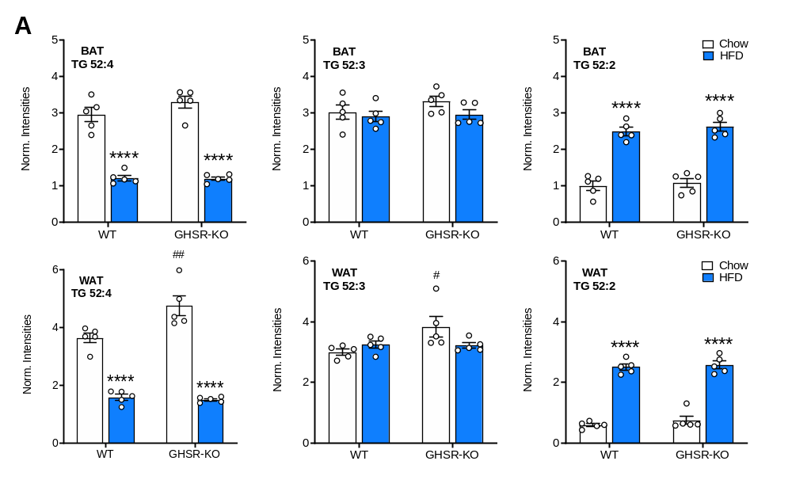
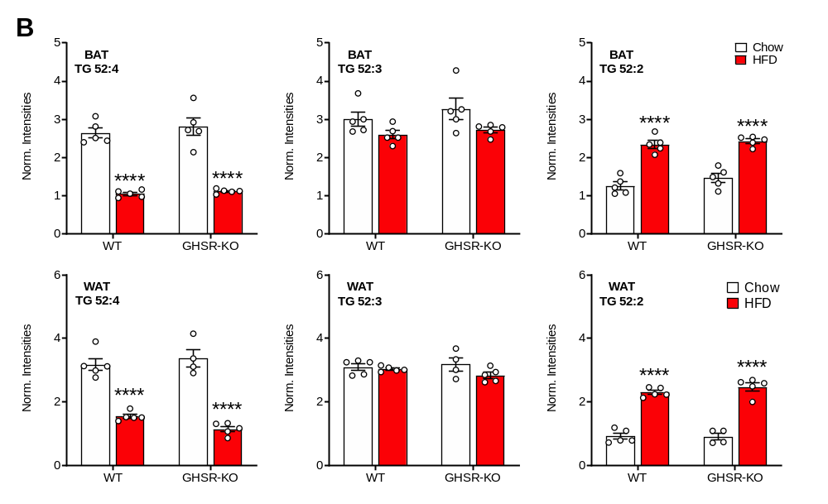
Supplemental Figure S10. Diet significantly changes TG species in adipose tissue based upon the level of saturation (number of carbon double bonds). Comparison of TG levels for TG 52:4, 52:3, and 52:2 from rats fed either a Chow or HFD for BAT and WAT for (A) males and (B) female rats. TG 52:4 was significantly decreased in animals fed HFD, TG 52:2 was significantly increased in animals fed HFD (****p < 0.0001). TG 52:4 and 52:3 in WAT samples for GHSR-KO male rats fed a Chow diet was significantly increased compared to WT male rats fed a Chow diet (##p < 0.01, #p < 0.05).

Supplemental Table 11. TG Species for WAT samples
Species | Males |  |  |  | Females
 | WT Chow (5) | WT HFD (5) | KO Chow (5) | KO HFD (5) | WT Chow (5) | WT HFD (5) | KO Chow (4) | KO HFD (5)
TG 40:2 | 0.006 ± 0.001 | 0.012 ± 0.001 (*) | 0.009 ± 0.001 | 0.011 ± 0.001 | 0.005 ± 0.001 | 0.012 ± 0.002 | 0.010 ± 0.003 | 0.008 ± 0.002
TG 44:2 | 0.011 ± 0.005 | 0.008 ± 0.001 | 0.018 ± 0.009 | 0.007 ± 0.0004 | 0.006 ± 0.001 | 0.012 ± 0.002 | 0.013 ± 0.007 | 0.008 ± 0.001
TG 46:3 | 0.024 ± 0.008 | 0.016 ± 0.001 | 0.034 ± 0.011 | 0.013 ± 0.001 | 0.013 ± 0.004 | 0.019 ± 0.002 | 0.020 ± 0.007 | 0.012 ± 0.001
TG 46:2 | 0.026 ± 0.005 | 0.029 ± 0.003 | 0.043 ± 0.007 | 0.024 ± 0.002 | 0.025 ± 0.008 | 0.034 ± 0.002 | 0.029 ± 0.008 | 0.024 ± 0.002
TG 46:1 | 0.016 ± 0.004 | 0.026 ± 0.003 | 0.026 ± 0.005 | 0.021 ± 0.001 | 0.018 ± 0.006 | 0.032 ± 0.002 | 0.024 ± 0.006 | 0.022 ± 0.002
TG 46:0 | 0.009 ± 0.003 | 0.012 ± 0.002 | 0.014 ± 0.003 | 0.010 ± 0.001 | 0.013 ± 0.002 | 0.016 ± 0.003 | 0.014 ± 0.002 | 0.013 ± 0.001
TG 48:4 | 0.041 ± 0.007 | 0.015 ± 0.002 (**) | 0.061 ± 0.005 (*) | 0.012 ± 0.002 (****) | 0.033 ± 0.012 | 0.017 ± 0.001 | 0.038 ± 0.009 | 0.011 ± 0.002
TG 48:3 | 0.113 ± 0.021 | 0.076 ± 0.009 | 0.159 ± 0.012 | 0.062 ± 0.006 (***) | 0.106 ± 0.044 | 0.083 ± 0.008 | 0.114 ± 0.022 | 0.048 ± 0.006
TG 48:2 | 0.185 ± 0.028 | 0.185 ± 0.018 | 0.265 ± 0.032 | 0.152 ± 0.008 (*) | 0.203 ± 0.049 | 0.200 ± 0.012 | 0.224 ± 0.038 | 0.137 ± 0.009
TG 48:1 | 0.112 ± 0.019 | 0.179 ± 0.018 | 0.162 ± 0.029 | 0.158 ± 0.005 | 0.127 ± 0.028 | 0.201 ± 0.010 | 0.152 ± 0.022 | 0.153 ± 0.006
TG 48:0 | 0.045 ± 0.009 | 0.056 ± 0.009 | 0.063 ± 0.016 | 0.056 ± 0.007 | 0.066 ± 0.008 | 0.072 ± 0.012 | 0.072 ± 0.011 | 0.075 ± 0.006
TG 50:5 | 0.088 ± 0.014 | 0.019 ± 0.003 (****) | 0.118 ± 0.007 | 0.014 ± 0.001 (****) | 0.074 ± 0.026 | 0.022 ± 0.002 | 0.081 ± 0.013 | 0.011 ± 0.002 (*)
TG 50:4 | 0.459 ± 0.066 | 0.180 ± 0.022 (***) | 0.611 ± 0.039 | 0.149 ± 0.014 (****) | 0.396 ± 0.123 | 0.190 ± 0.020 | 0.416 ± 0.053 | 0.109 ± 0.016 (*)
TG 50:3 | 0.930 ± 0.127 | 0.688 ± 0.060 | 1.242 ± 0.109 | 0.600 ± 0.032 (***) | 0.866 ± 0.235 | 0.692 ± 0.048 | 0.980 ± 0.124 | 0.444 ± 0.044
TG 50:2 | 1.004 ± 0.105 | 1.151 ± 0.075 | 1.370 ± 0.206 | 1.064 ± 0.026 | 1.191 ± 0.078 | 1.192 ± 0.027 | 1.275 ± 0.146 | 1.001 ± 0.034
TG 50:1 | 0.248 ± 0.022 | 0.639 ± 0.071 (***) | 0.334 ± 0.053 | 0.648 ± 0.058 (**) | 0.340 ± 0.039 | 0.711 ± 0.072 (**) | 0.346 ± 0.045 | 0.785 ± 0.058 (***)
TG 52:6 | 0.215 ± 0.033 | 0.027 ± 0.003 (****) | 0.284 ± 0.017 | 0.022 ± 0.002 (****) | 0.157 ± 0.049 | 0.033 ± 0.002 (*) | 0.178 ± 0.027 | 0.015 ± 0.004 (**)
TG 52:5 | 1.388 ± 0.177 | 0.336 ± 0.032 (****) | 1.790 ± 0.098 | 0.295 ± 0.018 (****) | 1.025 ± 0.226 | 0.344 ± 0.024 (*) | 1.164 ± 0.137 | 0.198 ± 0.031 (***)
TG 52:4 | 3.638 ± 0.171 | 1.590 ± 0.100 (****) | 4.744 ± 0.342 (**) | 1.506 ± 0.042 (****) | 3.182 ± 0.191 | 1.544 ± 0.065 (****) | 3.385 ± 0.272 | 1.148 ± 0.086 (****)
TG 52:3 | 3.008 ± 0.094 | 3.244 ± 0.117 | 3.842 ± 0.336 (*) | 3.218 ± 0.090 | 3.100 ± 0.103 | 3.034 ± 0.037 | 3.188 ± 0.207 | 2.842 ± 0.095
TG 52:2 | 0.598 ± 0.050 | 2.514 ± 0.100 (****) | 0.755 ± 0.139 | 2.584 ± 0.126 (****) | 0.915 ± 0.094 | 2.300 ± 0.064 (****) | 0.908 ± 0.105 | 2.478 ± 0.124 (****)
TG 54:7 | 0.528 ± 0.042 | 0.041 ± 0.005 (****) | 0.714 ± 0.057 (**) | 0.037 ± 0.002 (****) | 0.383 ± 0.046 | 0.052 ± 0.004 (****) | 0.415 ± 0.059 | 0.031 ± 0.005 (****)
TG 54:6 | 2.920 ± 0.136 | 0.404 ± 0.029 (****) | 3.844 ± 0.326 (**) | 0.399 ± 0.012 (****) | 2.018 ± 0.166 | 0.415 ± 0.015 (****) | 2.175 ± 0.188 | 0.303 ± 0.052 (****)
TG 54:5 | 4.362 ± 0.257 | 1.698 ± 0.081 (****) | 5.532 ± 0.464 (*) | 1.738 ± 0.052 (****) | 3.408 ± 0.178 | 1.534 ± 0.037 (****) | 3.548 ± 0.234 | 1.348 ± 0.094 (****)
TG 54:4 | 2.838 ± 0.186 | 3.320 ± 0.123 | 3.492 ± 0.318 | 3.474 ± 0.126 | 2.584 ± 0.102 | 2.796 ± 0.097 | 2.610 ± 0.168 | 2.772 ± 0.091
TG 54:3 | 0.524 ± 0.051 | 2.748 ± 0.092 (****) | 0.596 ± 0.082 | 2.942 ± 0.132 (****) | 0.710 ± 0.076 | 2.228 ± 0.063 (****) | 0.643 ± 0.089 | 2.412 ± 0.089 (****)
TG 56:8 | 0.192 ± 0.018 | 0.016 ± 0.003 (****) | 0.238 ± 0.036 | 0.017 ± 0.002 (****) | 0.113 ± 0.022 | 0.027 ± 0.003 (**) | 0.129 ± 0.022 | 0.013 ± 0.004 (***)
TG 56:7 | 0.268 ± 0.020 | 0.065 ± 0.010 (****) | 0.321 ± 0.041 | 0.067 ± 0.003 (****) | 0.177 ± 0.029 | 0.093 ± 0.011 (*) | 0.202 ± 0.024 | 0.060 ± 0.010 (**)
TG 56:6 | 0.209 ± 0.012 | 0.102 ± 0.015 (**) | 0.251 ± 0.031 | 0.111 ± 0.005 (***) | 0.147 ± 0.015 | 0.137 ± 0.016 | 0.171 ± 0.017 | 0.095 ± 0.013 (*)
TG 56:5 | 0.140 ± 0.008 | 0.104 ± 0.013 | 0.180 ± 0.020 | 0.115 ± 0.005 (*) | 0.103 ± 0.007 | 0.114 ± 0.009 | 0.115 ± 0.007 | 0.096 ± 0.010
TG 56:4 | 0.088 ± 0.004 | 0.111 ± 0.009 | 0.115 ± 0.012 | 0.119 ± 0.005 | 0.075 ± 0.004 | 0.100 ± 0.003 (**) | 0.077 ± 0.004 | 0.090 ± 0.006
TG 56:3 | 0.044 ± 0.001 | 0.081 ± 0.005 (***) | 0.064 ± 0.007 | 0.089 ± 0.005 (*) | 0.048 ± 0.002 | 0.071 ± 0.002 (***) | 0.047 ± 0.004 | 0.072 ± 0.004 (***)
TG 56:2 | 0.009 ± 0.0004 | 0.027 ± 0.003 (***) | 0.015 ± 0.002 | 0.031 ± 0.003 (***) | 0.012 ± 0.002 | 0.026 ± 0.003 (***) | 0.012 ± 0.001 | 0.032 ± 0.002 (****)
TG 58:8 | 0.072 ± 0.007 | 0.011 ± 0.003 (****) | 0.073 ± 0.009 | 0.012 ± 0.001 (****) | 0.037 ± 0.006 | 0.017 ± 0.003 (*) | 0.042 ± 0.005 | 0.011 ± 0.002 (**)
TG 58:7 | 0.054 ± 0.006 | 0.018 ± 0.004 (**) | 0.060 ± 0.008 | 0.020 ± 0.001 (***) | 0.032 ± 0.004 | 0.023 ± 0.005 | 0.036 ± 0.005 | 0.017 ± 0.003 (*)
TG 58:6 | 0.050 ± 0.004 | 0.020 ± 0.003 (***) | 0.065 ± 0.005 | 0.021 ± 0.001 (****) | 0.034 ± 0.006 | 0.023 ± 0.003 | 0.037 ± 0.004 | 0.016 ± 0.003 (*)
TG 58:5 | 0.090 ± 0.004 | 0.038 ± 0.003 (****) | 0.130 ± 0.009 (***) | 0.037 ± 0.001 (****) | 0.074 ± 0.006 | 0.037 ± 0.003 (****) | 0.077 ± 0.004 | 0.029 ± 0.003 (****)
TG 58:4 | 0.064 ± 0.002 | 0.079 ± 0.004 | 0.091 ± 0.007 (**) | 0.083 ± 0.003 | 0.065 ± 0.001 | 0.068 ± 0.003 | 0.065 ± 0.003 | 0.068 ± 0.003
TG 58:3 | 0.015 ± 0.0003 | 0.056 ± 0.004 (****) | 0.022 ± 0.002 | 0.060 ± 0.003 (****) | 0.022 ± 0.003 | 0.047 ± 0.003 (****) | 0.018 ± 0.003 | 0.056 ± 0.002 (****)
TG 60:7 | 0.055 ± 0.003 | 0.008 ± 0.001 (****) | 0.084 ± 0.008 (**) | 0.008 ± 0.0004 (****) | 0.036 ± 0.003 | 0.007 ± 0.0004 (****) | 0.038 ± 0.001 | 0.005 ± 0.001 (****)
TG 60:6 | 0.079 ± 0.006 | 0.031 ± 0.002 (***) | 0.114 ± 0.012 (**) | 0.033 ± 0.001 (****) | 0.060 ± 0.004 | 0.027 ± 0.001 (****) | 0.060 ± 0.004 | 0.023 ± 0.002 (****)
TG 60:5 | 0.043 ± 0.004 | 0.062 ± 0.004 (*) | 0.061 ± 0.005 (*) | 0.070 ± 0.002 | 0.041 ± 0.002 | 0.049 ± 0.003 | 0.039 ± 0.003 | 0.052 ± 0.002 (*)
TG 60:4 | 0.010 ± 0.001 | 0.047 ± 0.002 (****) | 0.016 ± 0.002 | 0.053 ± 0.002 (****) | 0.014 ± 0.002 | 0.036 ± 0.002 (****) | 0.011 ± 0.001 | 0.038 ± 0.002 (****)

Supplemental Table 11. Data are presented as mean ± standard error of the mean (SEM). The number of samples tested are noted in parentheses. Tukey’s Multiple Comparisons Test for Groups. ___ = Statistically lower value than chow diet counterparts of the same sex and genotype; ___ = Statistically higher value than chow diet counterparts of the same sex and genotype; ___ = Statistically higher value than WT counterparts of the same sex and diet; ___ = Statistically lower than WT counterparts of the same sex and diet. p value: *< 0.05, **< 0.01, ***< 0.001, ****< 0.0001. WT: wild type; KO: knockout; GHS-R: growth; HFD: high-fat diet paradigm.

Supplemental Table 12. TG Species for BAT samples
Species | Males |  |  |  | Females
 | WT Chow (5) | WT HFD (5) | KO Chow (5) | KO HFD (5) | WT Chow (5) | WT HFD (5) | KO Chow (4) | KO HFD (5)
TG 40:2 | 0.017 ± 0.003 | 0.018 ± 0.004 | 0.021 ± 0.004 | 0.019 ± 0.003 | 0.023 ± 0.004 | 0.021 ± 0.003 | 0.025 ± 0.003 | 0.016 ± 0.003
TG 44:2 | 0.010 ± 0.002 | 0.006 ± 0.001 | 0.011 ± 0.002 | 0.006 ± 0.0008 | 0.011 ± 0.001 | 0.007 ± 0.001 | 0.013 ± 0.001 | 0.007 ± 0.001 (*)
TG 46:3 | 0.016 ± 0.004 | 0.010 ± 0.001 | 0.018 ± 0.003 | 0.011 ± 0.001 | 0.013 ± 0.002 | 0.010± 0.001 | 0.017 ± 0.001 | 0.009 ± 0.0004 (**)
TG 46:2 | 0.048 ± 0.013 | 0.026 ± 0.002 | 0.049 ± 0.014 | 0.025 ± 0.002 | 0.048 ± 0.005 | 0.029 ± 0.004 | 0.062 ± 0.008 | 0.029 ± 0.003 (**)
TG 46:1 | 0.038 ± 0.014 | 0.024 ± 0.002 | 0.040 ± 0.014 | 0.024 ± 0.002 | 0.038 ± 0.006 | 0.030 ± 0.005 | 0.058 ± 0.009 | 0.028 ± 0.003 (*)
TG 46:0 | 0.021 ± 0.005 | 0.017 ± 0.001 | 0.022 ± 0.005 | 0.016 ± 0.002 | 0.034 ± 0.004 | 0.020 ± 0.002 | 0.048 ± 0.006 | 0.021 ± 0.002 (***)
TG 48:4 | 0.030 ± 0.006 | 0.010 ± 0.001 (*) | 0.035 ± 0.006 | 0.010 ± 0.001 (**) | 0.025 ± 0.002 | 0.009 ± 0.001 (****) | 0.030 ± 0.001 | 0.010 ± 0.001 (****)
TG 48:3 | 0.115 ± 0.030 | 0.053 ± 0.004 | 0.125 ± 0.034 | 0.046 ± 0.004 | 0.103 ± 0.012 | 0.050 ± 0.006 (**) | 0.135 ± 0.012 | 0.052 ± 0.004 (****)
TG 48:2 | 0.284 ± 0.064 | 0.163 ± 0.012 | 0.303 ± 0.072 | 0.159 ± 0.016 | 0.330 ± 0.027 | 0.181 ± 0.021 (**) | 0.429 ± 0.034 | 0.185 ± 0.019 (****)
TG 48:1 | 0.162 ± 0.042 | 0.166 ± 0.007 | 0.177 ± 0.047 | 0.165 ± 0.012 | 0.200 ± 0.025 | 0.187 ± 0.017 | 0.283 ± 0.033 | 0.191 ± 0.015
TG 48:0 | 0.064 ± 0.009 | 0.076 ± 0.003 | 0.070 ± 0.007 | 0.083 ± 0.005 | 0.101 ± 0.008 | 0.071 ± 0.004 | 0.128 ± 0.011 | 0.087 ± 0.003 (**)
TG 50:5 | 0.054 ± 0.009 | 0.012 ± 0.002 (***) | 0.059 ± 0.007 | 0.012 ± 0.001 (***) | 0.047 ± 0.003 | 0.013 ± 0.001 (****) | 0.053 ± 0.003 | 0.015 ± 0.001 (****)
TG 50:4 | 0.318 ± 0.046 | 0.113 ± 0.009 (**) | 0.358 ± 0.049 | 0.105 ± 0.009 (***) | 0.294 ± 0.014 | 0.100 ± 0.008 (****) | 0.342 ± 0.015 (*) | 0.110 ± 0.005 (****)
TG 50:3 | 0.759 ± 0.139 | 0.464 ± 0.033 | 0.847 ± 0.147 | 0.438 ± 0.028 | 0.733 ± 0.070 | 0.414 ± 0.028 (**) | 0.923 ± 0.075 | 0.430 ± 0.017 (****)
TG 50:2 | 1.251 ± 0.153 | 1.016 ± 0.043 | 1.396 ± 0.151 | 1.024 ± 0.058 | 1.482 ± 0.090 | 1.017 ± 0.049 (**) | 1.770 ± 0.112 | 1.053 ± 0.038 (****)
TG 50:1 | 0.347 ± 0.044 | 0.742 ± 0.018 (****) | 0.385 ± 0.048 | 0.795 ± 0.052 (****) | 0.521 ± 0.049 | 0.815± 0.039 (**) | 0.676 ± 0.069 | 0.832 ± 0.025
TG 52:6 | 0.100 ± 0.011 | 0.019 ± 0.002 (****) | 0.113 ± 0.008 | 0.017 ± 0.001 (****) | 0.076 ± 0.005 | 0.017 ± 0.001 (****) | 0.087 ± 0.008 | 0.020 ± 0.001 (****)
TG 52:5 | 0.726 ± 0.077 | 0.212 ± 0.018 (****) | 0.839 ± 0.052 | 0.196 ± 0.011 (****) | 0.616 ± 0.038 | 0.169 ± 0.008 (****) | 0.689 ± 0.070 | 0.189 ± 0.009 (****)
TG 52:4 | 2.956 ± 0.194 | 1.224 ± 0.074 (****) | 3.296 ± 0.166 | 1.206 ± 0.049 (****) | 2.648 ± 0.130 | 1.046 ± 0.041 (****) | 2.806 ± 0.229 | 1.114 ± 0.026 (****)
TG 52:3 | 3.028 ± 0.192 | 2.902 ± 0.143 | 3.316 ± 0.142 | 2.958 ± 0.134 | 3.004 ± 0.180 | 2.594 ± 0.106 | 3.278 ± 0.273 | 2.720 ± 0.069
TG 52:2 | 1.006 ± 0.128 | 2.494 ± 0.112 (****) | 1.091 ± 0.122 | 2.622 ± 0.128 (****) | 1.260 ± 0.100 | 2.344 ± 0.100 (****) | 1.464 ± 0.117 | 2.428 ± 0.058 (****)
TG 54:7 | 0.309 ± 0.026 | 0.034 ± 0.003 (****) | 0.354 ± 0.040 | 0.033 ± 0.002 (****) | 0.231 ± 0.014 | 0.030 ± 0.001 (****) | 0.242 ± 0.023 | 0.035 ± 0.001 (****)
TG 54:6 | 1.838 ± 0.157 | 0.350 ± 0.021 (****) | 2.138 ± 0.277 | 0.355 ± 0.010 (****) | 1.284 ± 0.076 | 0.293 ± 0.014 (****) | 1.288 ± 0.141 | 0.320 ± 0.009 (****)
TG 54:5 | 3.024 ± 0.204 | 1.430 ± 0.112 (***) | 3.456 ± 0.376 | 1.418 ± 0.046 (****) | 2.292 ± 0.141 | 1.111 ± 0.055 (***) | 2.332 ± 0.304 | 1.191 ± 0.051 (**)
TG 54:4 | 2.318 ± 0.111 | 2.828 ± 0.221 | 2.574 ± 0.190 | 2.848 ± 0.107 | 2.000 ± 0.136 | 2.224 ± 0.121 | 2.038 ± 0.271 | 2.370 ± 0.118
TG 54:3 | 0.741 ± 0.047 | 2.476 ± 0.186 (****) | 0.806 ± 0.045 | 2.584 ± 0.107 (****) | 0.778 ± 0.044 | 2.076 ± 0.113 (****) | 0.796 ± 0.080 | 2.158 ± 0.086 (****)
TG 56:8 | 0.144 ± 0.015 | 0.026 ± 0.004 (****) | 0.147 ± 0.021 | 0.026 ± 0.003 (****) | 0.098 ± 0.008 | 0.024 ± 0.001 (****) | 0.079 ± 0.012 | 0.031 ± 0.002 (**)
TG 56:7 | 0.223 ± 0.019 | 0.096 ± 0.014 (**) | 0.226 ± 0.028 | 0.098 ± 0.011 (**) | 0.165 ± 0.013 | 0.094 ± 0.004 (**) | 0.143 ± 0.021 | 0.116 ± 0.006
TG 56:6 | 0.183 ± 0.012 | 0.144 ± 0.016 | 0.193 ± 0.019 | 0.151 ± 0.016 | 0.159 ± 0.013 | 0.145 ± 0.008 | 0.133 ± 0.019 | 0.175 ± 0.008
TG 56:5 | 0.123 ± 0.007 | 0.133 ± 0.013 | 0.142 ± 0.010 | 0.142 ± 0.014 | 0.105 ± 0.007 | 0.131 ± 0.008 | 0.098 ± 0.011 | 0.149 ± 0.006 (**)
TG 56:4 | 0.090 ± 0.006 | 0.127 ± 0.010 (*) | 0.110 ± 0.004 | 0.133 ± 0.008 | 0.072 ± 0.004 | 0.108 ± 0.008 (**) | 0.084 ± 0.006 | 0.120 ± 0.003 (**)
TG 56:3 | 0.070 ± 0.007 | 0.105 ± 0.007 (**) | 0.087 ± 0.006 | 0.114 ± 0.007 | 0.067 ± 0.006 | 0.090 ± 0.008 | 0.084 ± 0.006 | 0.098 ± 0.002
TG 56:2 | 0.019 ± 0.002 | 0.048 ± 0.003(****) | 0.025 ± 0.003 | 0.055 ± 0.005 (****) | 0.022 ± 0.003 | 0.042 ± 0.003 (***) | 0.030 ± 0.003 | 0.044 ± 0.002 (*)
TG 58:8 | 0.057 ± 0.007 | 0.021 ± 0.004 (**) | 0.056 ± 0.010 | 0.020 ± 0.003 (**) | 0.036 ± 0.005 | 0.019 ± 0.001 (*) | 0.026 ± 0.004 | 0.026 ± 0.002
TG 58:7 | 0.048 ± 0.006 | 0.033 ± 0.007 | 0.049 ± 0.008 | 0.034 ± 0.006 | 0.034 ± 0.004 | 0.033 ± 0.003 | 0.026 ± 0.004 | 0.042 ± 0.003 (*)
TG 58:6 | 0.044 ± 0.003 | 0.031 ± 0.005 | 0.052 ± 0.004 | 0.032 ± 0.003 (*) | 0.031 ± 0.003 | 0.031 ± 0.002 | 0.030 ± 0.003 | 0.037 ± 0.002 (*)
TG 58:5 | 0.107 ± 0.007 | 0.049 ± 0.004 (****) | 0.135 ± 0.010 (*) | 0.050 ± 0.003 (****) | 0.074 ± 0.006 | 0.036 ± 0.002 (**) | 0.089 ± 0.010 | 0.041 ± 0.001 (***)
TG 58:4 | 0.095 ± 0.006 | 0.106 ± 0.009 | 0.122 ± 0.004 (*) | 0.110 ± 0.006 | 0.073 ± 0.008 | 0.073 ± 0.005 | 0.093 ± 0.010 | 0.084 ± 0.004
TG 58:3 | 0.030 ± 0.003 | 0.085 ± 0.006(****) | 0.039 ± 0.003 | 0.094 ± 0.006 (****) | 0.029 ± 0.004 | 0.063 ± 0.004 (****) | 0.040 ± 0.003 | 0.068 ± 0.003 (***)
TG 60:7 | 0.051 ± 0.006 | 0.010 ± 0.001 (**) | 0.072 ± 0.014 | 0.011 ± 0.0004 (***) | 0.026 ± 0.001 | 0.007 ± 0.001 (****) | 0.031 ± 0.004 | 0.009±0.0003(****)
TG 60:6 | 0.082 ± 0.004 | 0.040 ± 0.005 (*) | 0.106 ± 0.015 | 0.040 ± 0.002 (***) | 0.043 ± 0.003 | 0.024 ± 0.002 | 0.054 ± 0.009 | 0.028 ± 0.002 (**)
TG 60:5 | 0.056 ± 0.004 | 0.080 ± 0.009 | 0.070 ± 0.007 | 0.083 ± 0.004 | 0.035 ± 0.004 | 0.049 ± 0.004 | 0.044 ± 0.007 | 0.055 ± 0.005
TG 60:4 | 0.018 ± 0.001 | 0.066 ± 0.007(****) | 0.025 ± 0.002 | 0.072 ± 0.006 (****) | 0.015 ± 0.002 | 0.043 ± 0.004 (****) | 0.019 ± 0.002 | 0.046 ± 0.003 (****)

Supplemental Table 12. Data are presented as mean ± standard error of the mean (SEM). The number of samples tested are noted in parentheses. Tukey’s Multiple Comparisons Test for Groups. ___ = Statistically lower value than chow diet counterparts of the same sex and genotype; ___ = Statistically higher value than chow diet counterparts of the same sex and genotype; ___ = Statistically higher value than WT counterparts of the same sex and diet; ___ = Statistically lower than WT counterparts of the same sex and diet. p value: * < 0.05, **< 0.01, ***< 0.001, ****< 0.0001. WT: wild type; KO: knockout; GHS-R: growth; HFD: high-fat diet paradigm.

EFFECTS OF ICV. PF-5190457 ON GHRELIN-INDUCED NEURONAL ACTIVATION IN THE ARCUATE NUCLEUS AND OVERNIGHT FOOD INTAKE
We quantified the number of c-Fos immunoreactive (IR) cells in the hypothalamic arcuate nucleus (Arc) of male and female mice treated with icv. ghrelin and PF-5190457. A subset of mice were anesthetized and perfused 2 hours after treatment, at the end of the 2h food intake experiment. Ghrelin administration increased the number of c-Fos IR cells in both males (F_{1, 13} = 39.13, p < 0.0001, Supplemental Figure S11A) and females (F_{1, 13} = 48.32, p < 0.0001, Supplemental Figure S11B). We also detected significant ghrelin x PF-5190457 interactions in males (F_{1, 13} = 7.397, p < 0.05, Supplemental Figure S11A) and females (F_{1, 13} = 4.79, p < 0.05, Supplemental Figure S11B). Post hoc comparisons indicated that PF-5190457 pretreatment results in lower number c-Fos-IR cells in ghrelin-treated male (p < 0.01) and female mice (p < 0.05). Interestingly, PF-5190475 did not affect overnight food intake either in male or in female mice, compared to vehicle-treated animals (Supplemental Figure S11C-D).
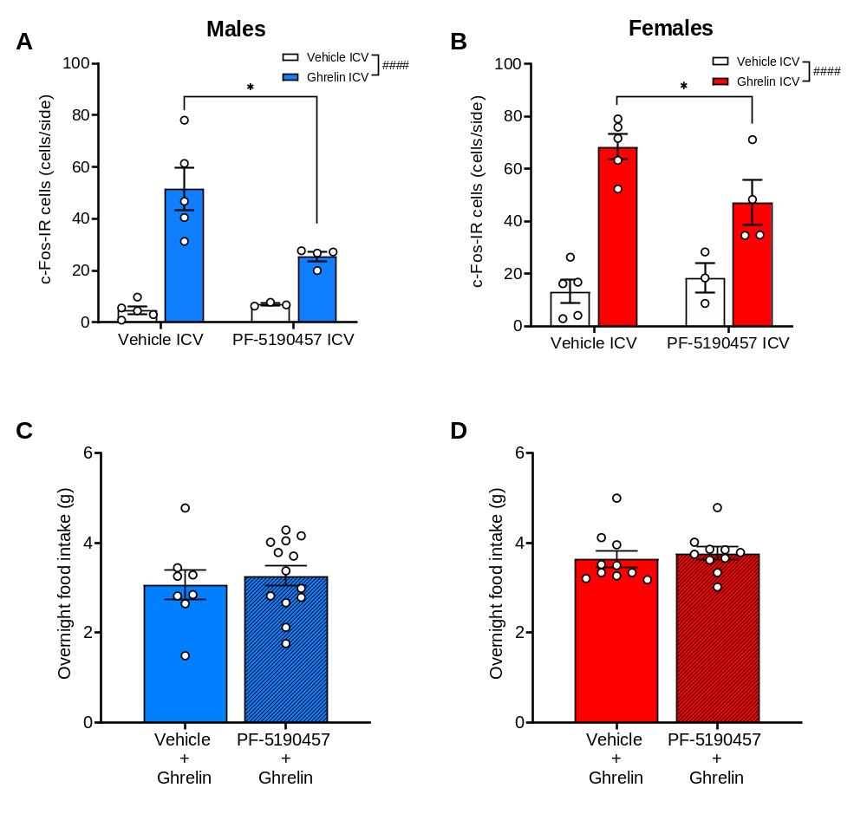
Supplemental Figure S11. PF-5190457 icv. administration attenuated the ghrelin-induced neuronal activation in the arcuate nucleus of the hypothalamus (Arc), but did not have any effect on overnight food intake. (A) In male mice, icv. ghrelin significantly increased the number of c-Fos IR cells in the Arc, regardless of vehicle / PF-5190457 pretreatment (####p < 0.0001), but PF-5190457 pretreatment resulted in lower numbers compared to the vehicle (*p < 0.05) (vehicle + vehicle: n = 5; PF-5190457 + vehicle: n = 3; ghrelin + vehicle: n = 5; ghrelin + PF-5190457: n = 4). (B) In female mice, icv. ghrelin significantly increased the number of c-Fos IR cells in the Arc, regardless of vehicle / PF-5190457 pretreatment (####p < 0.0001), but PF-5190457 pretreatment resulted in lower numbers compared to the vehicle (*p < 0.05) (vehicle + vehicle: n = 5; PF-5190457 + vehicle: n = 3; ghrelin + vehicle: n = 5; ghrelin + PF-5190457: n = 4). (C) PF-5190457 icv. administration did not affect overnight chow food intake in male mice (vehicle + ghrelin: n = 8; PF-5190457 + ghrelin: n = 13). (D) PF-5190457 icv. administration did not affect overnight chow food intake in female mice (vehicle + ghrelin: n = 10; PF-5190457 + ghrelin: n = 10).

ANTI-GHRELIN VACCINE EXPERIMENT IN MALE WISTAR RATS
Generation of Anti-Ghrelin Vaccine Immunization
For the active anti-ghrelin vaccine group, there was a modest escalation of IgG response following the first four doses, unfortunately titers also began to decrease within this immunization timeframe. Specifically, the IgG mid-point titer values obtained for bleeds 1, 2, 3, 4 and 5 were 907, 1185, 1942, 2865, and 1703, respectively (Supplemental Figure S12B). As expected, no antibody response was seen for the sham group (Supplemental Figure S12A). The average IgM titer for bleed 1 was 1088, which dropped, as expected, to 530 by bleed 2. Plasma ghrelin affinity (IC₅₀) of the antibody was also monitored, and only a modest affinity (≤ 1331 nM) was observed at bleed 3, which improved slightly by bleed 4 (≤ 311 nM) and 5 (≤ 476 nM; Supplemental Figure S13).
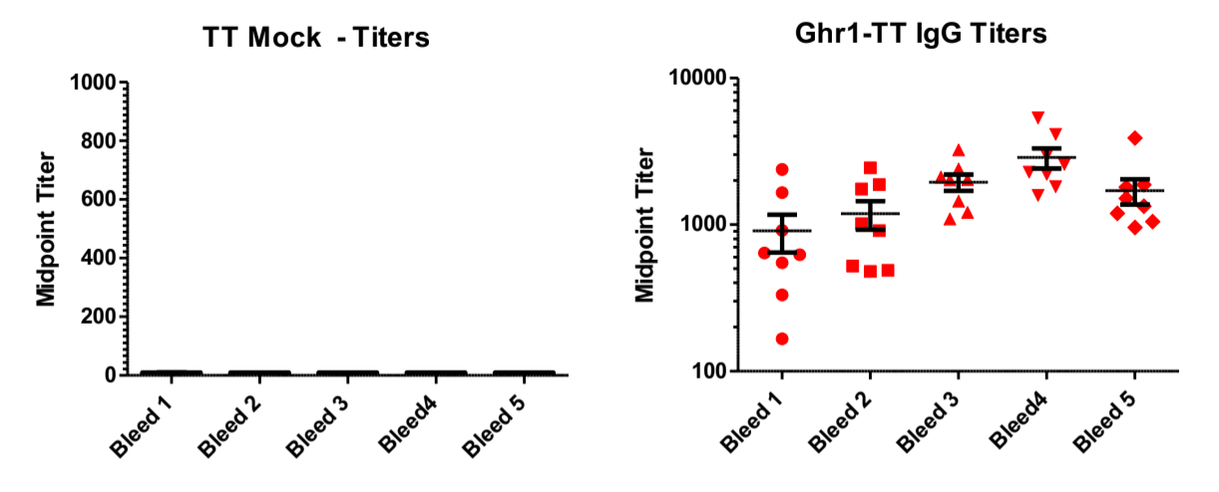
A
B
Supplemental Figure S12. Ghrelin (acyl-ghrelin) sequestering antibodies in active vaccine immunized male rats. (A) No antibody response was seen for Sham (TT Mock; n = 7) male rats. (B) Midpoint titers following each immunization boost for Active (Ghr1-TT; n = 8) vaccine in male rats.

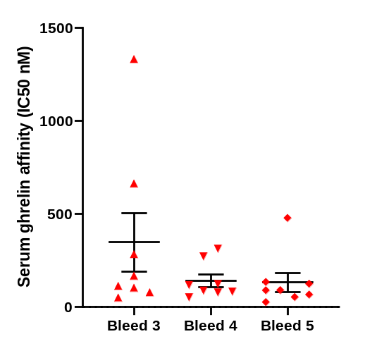
Supplemental Figure S13. Active vaccine immunization resulted in production of modest-affinity anti-ghrelin antibodies. Serum ghrelin affinity is shown as IC₅₀ concentration (nM). We could not calculate IC₅₀ by bleed 1 and 2, only from bleed 3(Ghr1-TT; n = 8) after active vaccine administration in male rats.

Body Weight
Body weight was recorded from weeks 0-21 starting at the priming dose. A two-way repeated measures ANOVA did not indicate a significant effect of vaccine treatment, but indicated a significant interaction between vaccine treatment and time (F _{(20, 260)} = 3.535, p < 0.0001) on body weight in male rats. Post hoc comparisons did not describe a significant difference between the body weight of vaccine and sham groups at any timepoint. The interaction was significant because of the slower increase in body weight in the sham group (Supplemental Figure S14).
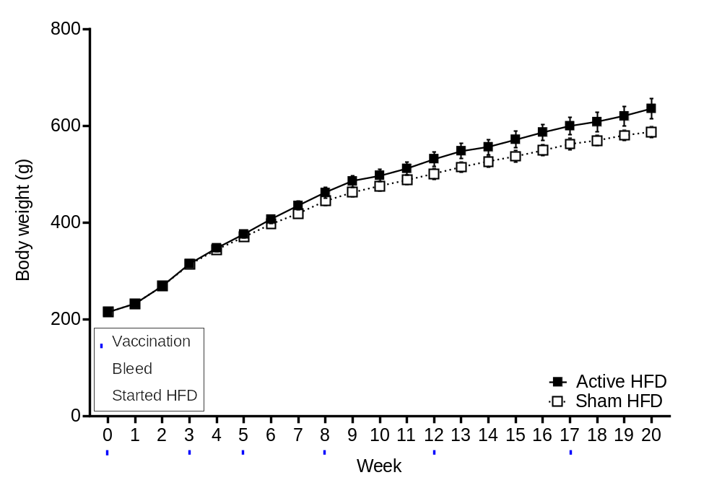
Supplemental Figure S14. Anti-ghrelin vaccine did not blunt body weight gain in actively immunized male rats. Thus, both groups increased their body weight during HFD. Time X Treatment interaction was significant (p < 0.0001), because the increment was lower in the sham treated group during the second half of HFD.

Food Consumption
One week after the vaccine priming dose, all rats started the HFD, which lasted 19 weeks (Supplemental Figure S15). A two-way repeated measures ANOVA revealed only a significant effect of time (F _{(1.617, 21.02)} = 48.22, p < 0.0001), but no effect of vaccine treatment nor Treatment X Time interaction.
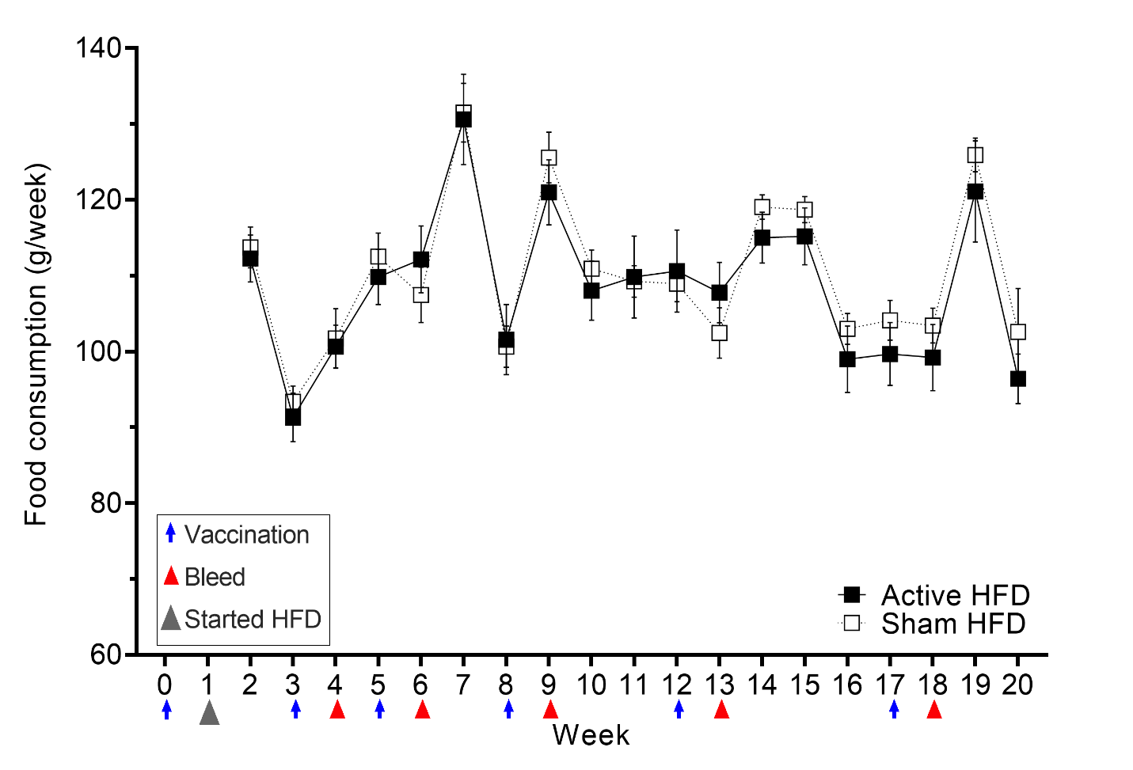
Supplemental Figure S15. Anti-ghrelin vaccine had no effect on weekly food intake. The effect of time was significant, but not the Treatment X Time interaction. Active vaccine immunized group (n = 8); sham group (n = 7).

Novelty-Suppressed Feeding Test
An unpaired t-test revealed no difference in latency to feed (Supplemental Figure S16A) between the active vaccine and sham groups. Similarly, no differences were found in caloric intake during the 1 h food consumption upon return to the home cage (Supplemental Figure S16B) between the active vaccine and sham groups.
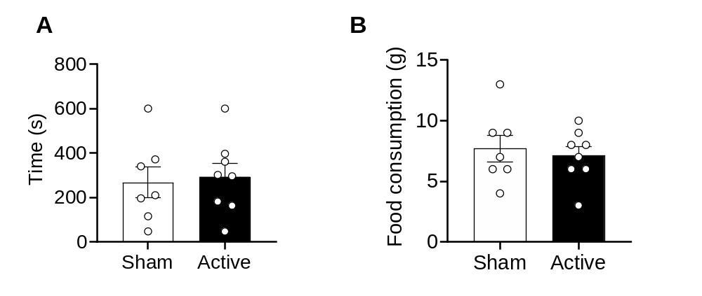
Supplemental Figure S16. Anti-ghrelin vaccine had no effect on suppressed feeding test. (A) There was no significant difference in latency to feed during the suppressed feeding test in active vaccine (n = 8) and sham (n = 7) groups. (B) 1 h food consumption in the home cage did not differ between active vaccine and sham groups.

Blood Glucose Concentrations
Student t-tests revealed no difference in blood glucose levels during satiety or fasting conditions between the active vaccine and sham groups (Supplemental Figure S17).
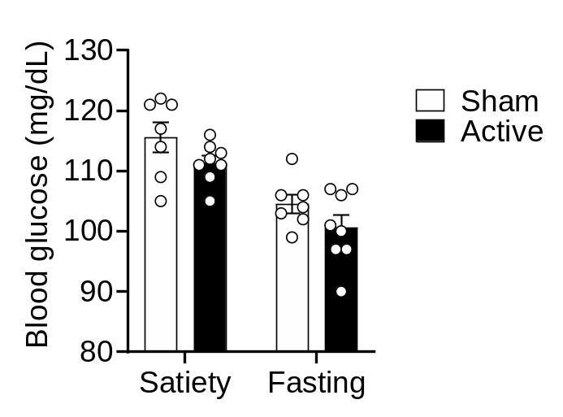
Figure S17. Anti-ghrelin vaccine had no effect on blood glucose concentrations on either satiety or fasting conditions. There were no significant differences in blood glucose levels of active vaccine (n = 8) and sham (n = 7) male rats during either satiety or fasting conditions.

ANTI-GHRELIN VACCINE EXPERIMENT IN MALE AND FEMALE C57BL/6J MICE
Generation of Anti-Ghrelin Vaccine Immunization
As expected, no antibody development was detected for the sham group (Supplemental Figure S18A). For the ghrelin-CRM vaccinated mice, the IgG mid-point titer values obtained for bleeds 1, 2, and 3 are 8,695, 12,187, and 10,035, respectively (Supplemental Figure S18B).
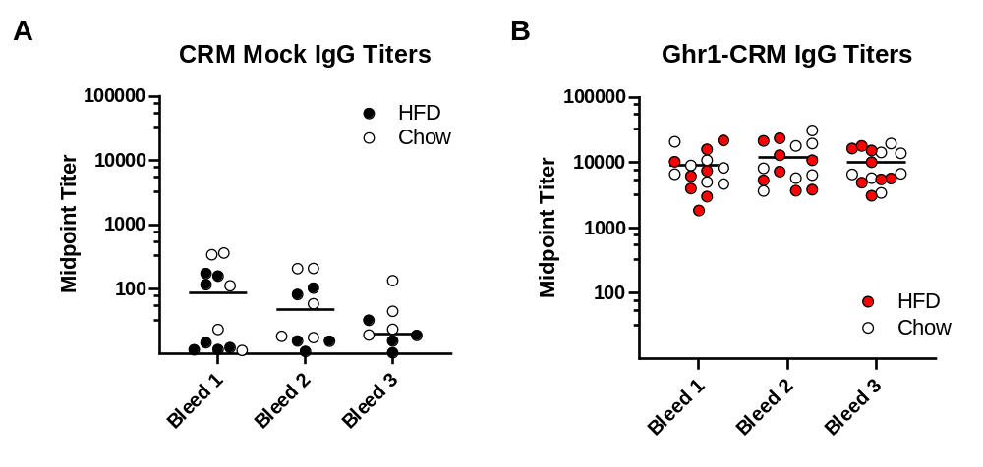
Supplemental Figure S18. Ghrelin (acyl-ghrelin) sequestering antibodies in active vaccine immunized mice. (A) No antibody development was seen for Sham (n = 16) mice, the average mid-point IgG titers for the mock vaccinated animals were under 200 for all 3 bleeds. (B) An immune response was detected with the active vaccine (n = 16) mice, as shown by midpoint titers following each immunization boost.

Body Weight
Body weight was recorded from weeks 0-21 starting at the priming dose. The 3-way ANOVA described no difference in body weight gain between the active vaccine and sham groups. Neither the main effect of treatment nor the Treatment x Diet, Treatment x Time, Treatment x Diet x Time interactions were significant. The effect of time (F_{1.805, 48.73} = 134.4, p < 0.0001) and diet (F_{1, 27} = 19.40, p = 0.0002), and their interaction (F_{20, 540} = 35.87, p < 0.0001) were significant, showing that body weight gain was increased in the HFD group compared to a chow diet, regardless of treatment (Supplemental Figure S19).
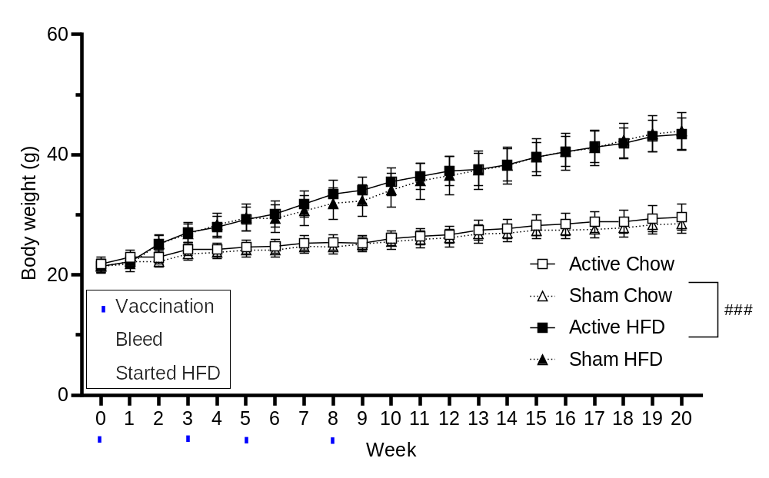
Supplemental Figure S19. Anti-ghrelin vaccine had no effect on body weight gain overtime. The active vaccine (n = 15) and sham groups (n = 16) both significantly gained weight both during HFD and the chow diet. The weight gain with HFD was significantly increased compared to the chow diet (###p = 0.0002).

Food Consumption
One week after the priming dose, mice were assigned a Chow or HFD paradigm that lasted 19 weeks. Two-way ANOVA did not show any difference in food intake between active vaccine and sham groups, neither with the chow diet nor with HFD (Supplemental Figure S20). Only the time effect was significant (chow diet: F_{2.067, 26.29} = 39.09, p < 0.0001; HFD: F_{4.531, 58.42} = 6.299, p = 0.0002).

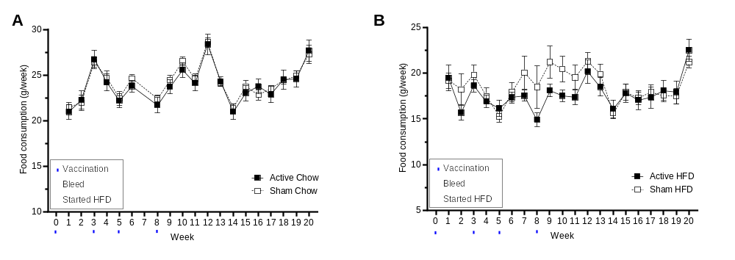
Supplemental Figure S20. Anti-ghrelin vaccine did not affect food consumption overtime. (A) Chow diet: There was no difference in food consumption between the active vaccine (n = 7) and sham groups (n = 8). The effect of time was significant (p < 0.0001) (B) HFD: There was no difference in food consumption between the active vaccine (n = 7) and sham groups (n = 8). The effect of time was significant (p = 0.0002).

REFERENCES
1 Gould, T. D., Dao, D. T. & Kovacsics, C. E. The open field test. Mood and anxiety related phenotypes in mice: Characterization using behavioral tests, 1-20 (2009).
2 Bodnoff, S. R., Suranyi-Cadotte, B., Aitken, D. H., Quirion, R. & Meaney, M. J. The effects of chronic antidepressant treatment in an animal model of anxiety. Psychopharmacology (Berl) 95, 298-302 (1988). https://doi.org:10.1007/bf00181937
3 Thanos, P. K. et al. Differences in response to food stimuli in a rat model of obesity: in-vivo assessment of brain glucose metabolism. Int J Obes (Lond) 32, 1171-1179 (2008). https://doi.org:10.1038/ijo.2008.50
4 Cai, N. S. et al. Opioid-galanin receptor heteromers mediate the dopaminergic effects of opioids. J Clin Invest 129, 2730-2744 (2019). https://doi.org:10.1172/jci126912
5 Fischer, A. H., Jacobson, K. A., Rose, J. & Zeller, R. Hematoxylin and eosin staining of tissue and cell sections. CSH Protoc 2008, pdb.prot4986 (2008). https://doi.org:10.1101/pdb.prot4986
6 Subramanian, A. et al. Gene set enrichment analysis: a knowledge-based approach for interpreting genome-wide expression profiles. Proc Natl Acad Sci U S A 102, 15545-15550 (2005). https://doi.org:10.1073/pnas.0506580102
7 Li, B. & Dewey, C. N. RSEM: accurate transcript quantification from RNA-Seq data with or without a reference genome. BMC Bioinformatics 12, 323 (2011). https://doi.org:10.1186/1471-2105-12-323
8 Langmead, B. & Salzberg, S. L. Fast gapped-read alignment with Bowtie 2. Nat Methods 9, 357-359 (2012). https://doi.org:10.1038/nmeth.1923
9 Love, M. I., Huber, W. & Anders, S. Moderated estimation of fold change and dispersion for RNA-seq data with DESeq2. Genome Biol 15, 550 (2014). https://doi.org:10.1186/s13059-014-0550-8
10 Zigman, J. M. et al. Mice lacking ghrelin receptors resist the development of diet-induced obesity. J Clin Invest 115, 3564-3572 (2005). https://doi.org:10.1172/jci26002
11 Cornejo, M. P. et al. Ghrelin treatment induces rapid and delayed increments of food intake: a heuristic model to explain ghrelin’s orexigenic effects. Cellular and Molecular Life Sciences 78, 6689-6708 (2021). https://doi.org:10.1007/s00018-021-03937-0
12 Wenthur, C. J., Gautam, R., Zhou, B., Vendruscolo, L. F., Leggio, L. & Janda, K. D. Ghrelin Receptor Influence on Cocaine Reward is Not Directly Dependent on Peripheral Acyl-Ghrelin. Sci Rep 9, 1841 (2019). https://doi.org:10.1038/s41598-019-38549-z
13 Zallar, L. J. et al. Development and initial characterization of a novel ghrelin receptor CRISPR/Cas9 knockout wistar rat model. Int J Obes (Lond) 43, 344-354 (2019). https://doi.org:10.1038/s41366-018-0013-5
14 Börchers, S. et al. From an Empty Stomach to Anxiolysis: Molecular and Behavioral Assessment of Sex Differences in the Ghrelin Axis of Rats. Front Endocrinol (Lausanne) 13, 901669 (2022). https://doi.org:10.3389/fendo.2022.901669

