Appendix 1. Extended methodology and rational for modelling approach
The primary purpose of this model is to facilitate the estimation of the probability of natural regeneration of tropical forests. The model is estimated/trained based on a sample of locations where natural regeneration did and did not occur. As such the dependent variable is binary. The suite of covariates selected represent a range of biophysical and socioeconomic variables (see Predictor Variables section in Methodology) that we anticipate are related to natural regeneration.

The statistical modelling and validation is based on a set of 6 million random points generated within the regeneration and non-regeneration spatial domains defined above, stratified so that each level of the dependent variable was equally represented but with no other form of spatial stratification. The former were sampled as spatially random points generated within the forest regeneration polygons using the ’sf’ library in R (function ’st sample’)¹. The latter were sampled as spatially random points within latitude limits of +/- 25 degrees using the ’random points GCS’ function in R, which accounts for the elliptical shape of Earth, and then discarding points falling outside of the target biomes (tropical and subtropical forest and savannah biomes), falling within excluded land cover categories (water, bare areas, urban areas, sparse vegetation; ESA
CCI Landcover for year 2000), or falling within the regeneration or forestry polygons delineated in the Fagan and colleagues 2022² dataset. These random points were then intersected with the geospatial covariate datasets (see Predictor Variables section in Methodology). Any records having NoData values for any of the covariates were removed, resulting in a final set of 5.8 million records. NoData values can arise due to mismatches in the coverage of datasets, such as along coastlines.
Several modelling frameworks could be adopted. We choose Random Forests (RF), a
classification tree machine-learning method, because of the high classification accuracies it commonly achieves while having lower risk of over-fitting compared to other potential
algorithms (e.g. LightGBM), and because it has previously been applied to developing spatial predictions of the potential for natural regeneration³. Although RF models are fairly robust to correlations among independent variables, having many strongly correlated variables in the model can result in the model being unduly influenced by those factors. It is good practice, therefore, to evaluate correlations among variables explicitly (calculate Pearson’s r correlation coefficients among all pairs of continuous variables) and either select a subset of any strongly correlated variables or use principal components analysis (PCA) to combine strongly correlated variables. We identified strong correlations among the 19 bioclimatic variables, which is expected as some of the variables are derived from others. Using PCA this dataset was reduced to 5 uncorrelated variables that capture 99.4% of the variation among the 19 variables (see Predictor Variables).

Although RF inherently includes ‘out-of-bag’ cross validation to reduce the potential for
over-fitting, we also validated the model against data that was not used to train the model. Training and validation datasets were drawn without replacement, with equal numbers of records for each level of the binary dependent variable, from the pool of 5.8 M records described above. RF models can take considerable time to fit with large datasets. To identify an appropriate sample we fit ten models to different random samples of 500,000 records, fit RF models to each one, and examined variance in the accuracy and variable importance (decrease in accuracy and the Gini coefficient) among the models. There is a stochastic component to RF models so some level of variation is expected. However, there was little variation in either the accuracy (mean: 0.886, range: 0.885 - 0.887) or the variable importance among these models. We therefore used a sample of 500,000 records for the variable selection process, which involves
fitting many RF models, and a sample of 1 million records to fit the final model.
Variable selection methods were used to identify a more parsimonious model and to reduce the computational burden associated with generating high-resolution predictions at a global scale. This was achieved using variable importance (mean decrease in accuracy metric) to rank the full set of variables, fitting a series of models of increasing complexity (adding one variable at a time in order of importance), and identifying the point at which the addition of further variables did not improve accuracy (Figure A1.1).

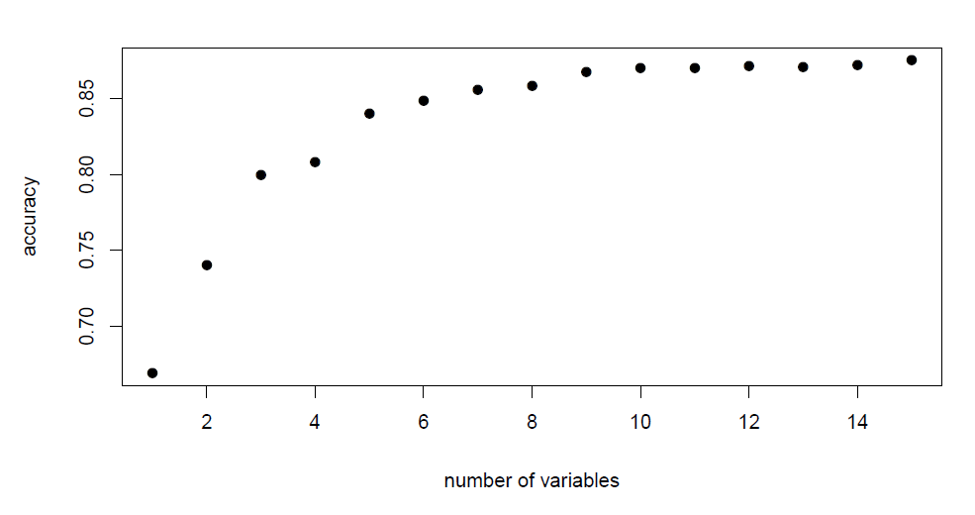
Figure A1.1. The change in model accuracy (y axis) among a set of increasingly complex models (x axis). Covariates were added sequentially in order of importance (mean decrease in accuracy metric) to identify the point at which the addition of any additional variables no longer improved model accuracy (here, ten variables).
We contrasted models that included both socioeconomic and biophysical variables to models that included biophysical variables alone. The accuracy of both models was similar (0.886 and 0.880 respectively). We based the spatial predictions on the model containing biophysical variables only for two reasons. First, identifying areas having biophysical conditions amenable to natural regeneration regardless of whether socioeconomic conditions are favourable to regeneration is most closely aligned with the intended use of the predictions to inform forest restoration planning. The premise of this rationale is that socioeconomic factors can be altered or mitigated using a variety of policy and management interventions (e.g. payments for ecosystem services, legislation governing land management, etc), while biophysical conditions are more difficult to alter. Hence, the focus of this analysis is on identifying areas where there is the
potential for natural regeneration if socioeconomic factors limiting regeneration are managed.
The second reason we favour the model with biophysical variables only is that it is difficult to make predictions using some socioeconomic variables. Specifically, we train our models based on recent historical natural regeneration using data from 2000, but make predictions of the potential for natural regeneration based on contemporary data from 2018. Although time-series of socioeconomic data are available there is often a trend in the data: in many areas there is a monotonic increase in factors such as population density and GDP. This is problematic as it can result in making model predictions based on data that fall outside of the range of values upon
which the model was based. This can result in substantial errors.
The ten top-ranked covariates in the biophysical model included local forest density; distance to nearest forest; two soil variables (soil organic carbon density and soil pH); four bioclimatic variables (the first four axes of a principal components analysis based on all 19 bioclimatic variables); land use/cover; and biome (Figure A1.2).
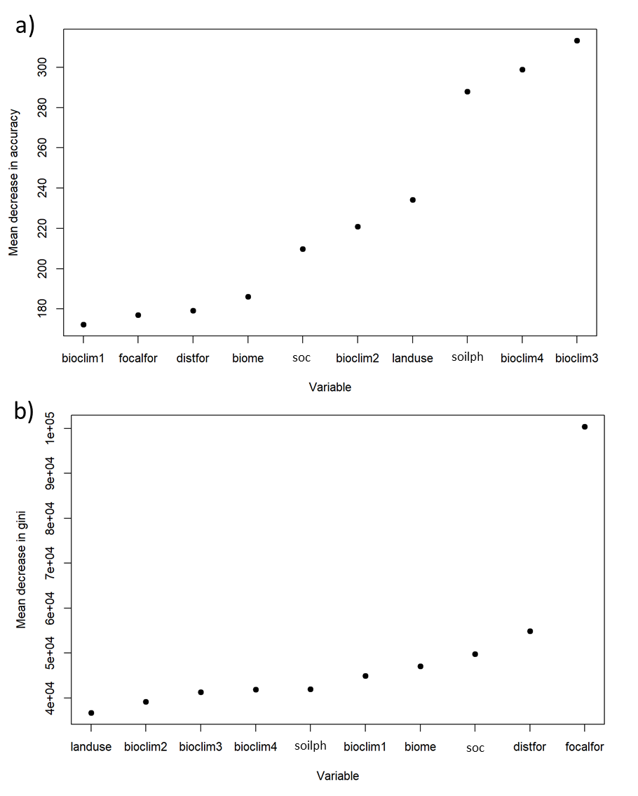
Figure A1.2. Variable importance plots for the model with ten biophysical variables. Mean decrease in accuracy (a) reflects the loss of accuracy that arises from the omission of a variable, whereas the Gini coefficient (b) reflects the contribution of a variable to the purity of the classification (how cleanly the levels of the dependent variable can be separated). Variables are: bioclim1, 2, 3, and 4 = bioclim principle component axes 1, 2, 3, and 4, biome = biome, distfor = distance to forest, focalfor = forest density, landuse = land use, soc = soil organic carbon content, soilph = soil pH.
Plots of each covariate against the predicted probability of natural regeneration (Figure A1.3) provide insight into the marginal effect of a variable on the class probability. The potential for natural regeneration as positively associated with forest density and soil organic carbon content, and negatively associated with distance to forest. There is a more complex relationship with soil pH and the relationship with the bioclimatic variables is more opaque because these variables are the axes of a principal components analysis representing combinations of all 19 original bioclimatic variables.
Predictions of the potential for natural regeneration were made using the spatial datasets representing the covariates in the final model. However, three of the variables were updated to reflect contemporary (2018) conditions: revised forest density and distance to forest covariates were derived from the Global Forest Watch 2018 tree cover dataset ⁴ at a 30m resolution, and the revised land user/cover dataset was derived from the combination of the 2015 ESA CCI dataset with the aforementioned tree cover data. The result of this process is a raster dataset with cell values in the range [0, 1], representing the probability of natural regeneration within that cell. These data are made available in the following forms: (i) 30m resolution binary predictions (2.3 GB), (ii) 30m resolution continuous probabilities expressed as a percentage and rounded to integers to reduce file size (9.3 GB), and (iii) an approximately 1 km resolution representing the proportion of each cell that has the potential for natural regeneration. The 30 m resolution data were tiled into 10 degree lat/lon tiles.
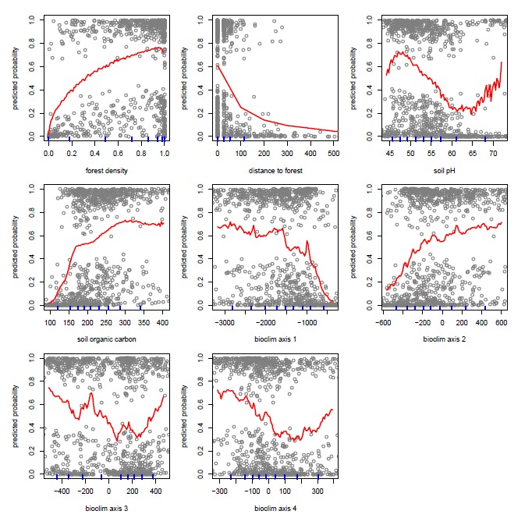
Figure A1.3. Plots indicating how each covariate (x axis) is related to the predicted probability of natural regeneration (y axis). Red lines are the mean predicted probability value calculated over a range of 100 intervals of the covariate. Open circles are a random sample of 1000 records from the training dataset to provide an indication of the distribution and variation in the data. The blue rug marks along the bottom of each plot represent the deciles of the distribution of values of that covariate. The covariate include: forest density in a 1km2 area, distance to nearest forest, soil pH (PHIHOX), soil organic carbon content (OCDENS), and four bioclimatic variables representing the first four axes of a principal components analysis based on 19 original bioclimatic variables (see Data Sources for details). The distance to nearest forest graph is plotted over a limited x axis range to improve legibility.
A limitation of our analysis is that the combination of datasets with different resolutions may degrade the quality of the predictions. While some of the key variables were mapped at a 30 m resolution (tree cover, distance to forest, and forest density), the best available data on soils, climate and land cover variables were mapped at coarser resolutions (Appendix 2). Of these, we speculate that the lack of land cover and land use data at the native 30 m resolution may prevent identifying important associations between opportunity cost (especially in the context of agricultural and pastoral production) and the potential for natural regeneration.
The majority of geoprocessing in this analysis used open source libraries in R and Python (the ‘osgeo’, ‘numpy’ and ‘multiprocessing’ Python packages ⁵, and the ‘sp’, ‘raster’ and ‘sf’ libraries in R ¹), with some additional processing and map-making in ESRI ArcGIS ⁶.
Validation
The validation points were divided into 16 0.5-km distance intervals based on the distance from each validation point to the nearest training point and accuracy was estimated within each interval to examine evidence for autocorrelation issues. Accuracy exceeded 95% for the points in the 0-0.5 km interval (Fig. A1.4a), declined to 81.4% in the 2.0-2.5 km interval, and then increased again. This pattern was driven by differences in the classification accuracy between the binary outcomes (from Fagan and colleagues 2022 – an observed historic subset of data) and variation in the relative frequency of the outcomes as a function of distance to training points (Fig. A1.4b). We therefore also quantified accuracy with balanced samples of outcomes in each distance interval using a bootstrapping approach (Fig. A1.4c). The bootstrapping was necessary because there are relatively few occurrences of certain outcomes in some intervals. For example, in the 6-8 km intervals where the frequency of regeneration samples is low (Fig. A1.4b), the bootstrapped accuracy estimates were based on only 5,000 samples. The estimates of model accuracy using this approach are lower (Fig. A1.4c) but never worse than 75%. Regardless of how accuracy was quantified, the model performed sufficiently well to be deemed useful for our application.
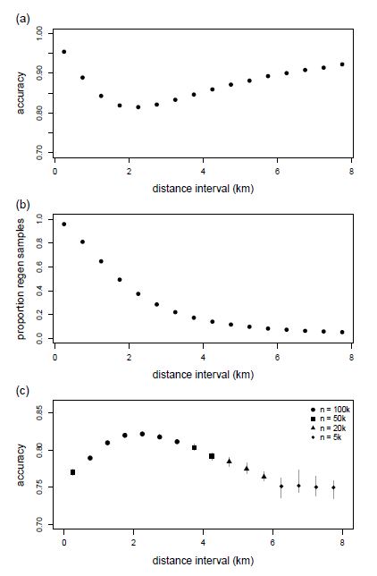
Figure A1.4. Model accuracy based on a random sample of 4.87 M points with equal number of regeneration and non-regeneration observations was 87.9%. To evaluate evidence of autocorrelation effects in this estimate accuracy was estimated in 16 0.5-km intervals between the training and validation points. (a) Accuracy was highest in the shortest distance interval, declined to 81.4% in the 2.0-2.5 km interval, and then increased. This pattern was driven by the combined effect of different accuracies for each outcomes (regeneration vs. non-regeneration) and the change in the relative frequency of each outcome as the distance interval increases (b). Accuracies were lower when forcing balanced samples in each interval and using a bootstrapping approach with 50 replicates of sampling with replacement. Sample sizes varied among intervals (c - see legend) because of the relative rarity of some outcomes at some distance-intervals (b). Vertical lines represent the range of accuracies among all 50 replicates.

References
1. Pebesma, E. & Bivand, R. Simple features for R: Standardized support for spatial vector data. Chapman and Hall/CRC (2023) doi:10.32614/rj-2018-009.
2. Fagan, M. E. et al. The expansion of tree plantations across tropical biomes. Nat. Sustain. 5, 681–688 (2022).
3. Crouzeilles, R. et al. Achieving cost‐effective landscape‐scale forest restoration through targeted natural regeneration. Conserv. Lett. 13, (2020).
4. Hansen, M. C. et al. High-resolution global maps of 21st-century forest cover change. Science 342, 850–853 (2013).
5. GDAL/OGR contributors. GDAL/OGR Geospatial Data Abstraction software Library. Open Source Geospatial Foundation (2023) doi:10.5281/zenodo.5884351.
6. ESRI. ArcGIS Desktop: Release 10.8. Redlands, CA: Environmental Systems Research Institute (2011).

