Supplementary Table S1 Logarithmic-fold changes of relative abundance estimates in soils with M. sieversii decline
OTUs | log2 fold change | IfcSE | stat | Padj | Phylum | Class, Oder, or Family
Bacteria
28186 | -3.95 | 0.85 | -4.64 | < 0.05 | Chloroflexi | Gitt-GS-136 Unclassified
11130 | -3.34 | 0.63 | -5.27 | < 0.01 | Actinobacteria | Thermoleophilia/ Gaiellales/ Gaiellaceae
20068 | -3.11 | 0.71 | -4.41 | < 0.05 | Gemmatimonadetes | Gemmatimonadetes Unclassified
25268 | -2.43 | 0.56 | -4.33 | < 0.05 | Actinobacteria | Thermoleophilia/ Gaiellales/ Gaiellaceae
347 | -2.20 | 0.50 | -4.40 | < 0.05 | Gemmatimonadetes | Gemmatimonadetes Unclassified
6119 | -2.02 | 0.46 | -4.40 | < 0.05 | Acidobacteria | [Chloracidobacteria]/ RB41
4585 | -1.85 | 0.39 | -4.81 | < 0.05 | Actinobacteria | MB-A2-108/ 0319-7L14
Fungi
72 | -4.73 | 1.42 | -3.34 | < 0.05 | Ascomycota | Sordariomycetes/ Sordariales/ Lasiosphaeriaceae Podospora
108 | -3.61 | 0.76 | -4.78 | < 0.01 | Ascomycota | Sordariomycetes/ Hypocreales Unclassified
39 | -2.81 | 0.82 | -3.43 | < 0.05 | Ascomycota | Dothideomycetes Unclassified
11 | -2.78 | 0.72 | -3.89 | < 0.01 | Ascomycota | Sordariomycetes/ Hypocreales/ Clavicipitaceae
44 | -1.97 | 0.62 | -3.15 | < 0.05 | Ascomycota | Sordariomycetes/ Hypocreales/ Clavicipitaceae
27 | -1.69 | 0.38 | -4.46 | < 0.01 | Ascomycota | Sordariomycetes/ Hypocreales/ Hypocreaceae
87 | -1.41 | 0.49 | -2.85 | < 0.05 | Ascomycota | Sordariomycetes/ Sordariales/ Lasiosphaeriaceae

Supplementary Table S2 Top ten connected OTUs in the networks based on samples from healthy and degraded M. sieversii soils (n = 15 for both healthy and degraded M. sieversii soils, respectively)
 | Phylum or Class | Class, Oder, or Family | Degree | Relative Recovery
Bacteria
Healthy M. sieversii | Actinobacteria | Thermoleophilia Unclassified | 53 | 0.49
 | Actinobacteria | Gaiellaceae | 51 | 0.27
 | Actinobacteria | Gaiellaceae | 51 | 0.05
 | Chloroflexi | Gitt-GS-136 Unclassified | 50 | 0.19
 | Actinobacteria | Pseudonocardiaceae | 49 | 0.36
 | Actinobacterias | Micromonosporaceae | 48 | 0.38
 | Actinobacteria | Solirubrobacteraceae | 46 | 0.13
 | Chloroflexi | JG30-KF-CM45 Unclassified | 45 | 0.10
 | Actinobacteria | Gaiellaceae | 45 | 0.04
 | Proteobacteria | Hyphomicrobiaceae | 45 | 0.04
Degenerated M. sieversii | Actinobacteria | Pseudonocardiaceae | 31 | 0.31
 | Actinobacteria | Geodermatophilaceae | 31 | 0.72
 | Crenarchaeota | Nitrososphaeraceae | 31 | 0.32
 | Actinobacteria | Micromonosporaceae | 30 | 0.38
 | Proteobacteria | Rhodospirillaceae | 30 | 0.07
 | Chloroflexi | JG30-KF-CM45 Unclassified | 30 | 0.15
 | Proteobacteria | Betaproteobacteria Unclassified | 28 | 0.12
 | Bacteroidetes | Chitinophagaceae | 27 | 0.10
 | Actinobacteria | Pseudonocardiaceae | 26 | 0.36
 | Crenarchaeota | Nitrososphaeraceae | 26 | 3.50
Fungi
Health M. sieversii | Ascomycota | Nectriaceae | 33 | 1.46
 | Ascomycota | Lasiosphaeriaceae | 32 | 0.18
 | Ascomycota | Nectriaceae | 30 | 0.47
 | Ascomycota | Staphylotrichum | 30 | 0.34
 | Ascomycota | Mycocentrospora | 29 | 0.74
 | Fungi | Unclassified | 29 | 0.87
 | Fungi | Unclassified | 29 | 1.51
 | Ascomycota | Nectriaceae | 28 | 1.02
 | Ascomycota | Unclassified | 23 | 0.14
 | Ascomycota | Lasiosphaeriaceae | 23 | 0.25
Degenerated M. sieversii | Ascomycota | Pleosporaceae | 17 | 0.05
 | Ascomycota | Trichocomaceae | 14 | 0.53
 | Ascomycota | Trichocomaceae | 12 | 0.27
 | Fungi | Unclassified | 12 | 0.04
 | Ascomycota | Herpotrichiellaceae | 12 | 0.01
 | Ascomycota | Helotiales unidentified | 11 | 0.28
 | Ascomycota/ | Orbiliomycetes unidentified | 10 | 0.10
 | Fungi | Unclassified | 10 | 1.51
 | Ascomycota | Hypocreaceae | 10 | 0.11
 | Zygomycota | Mortierellaceae | 10 | 0.31

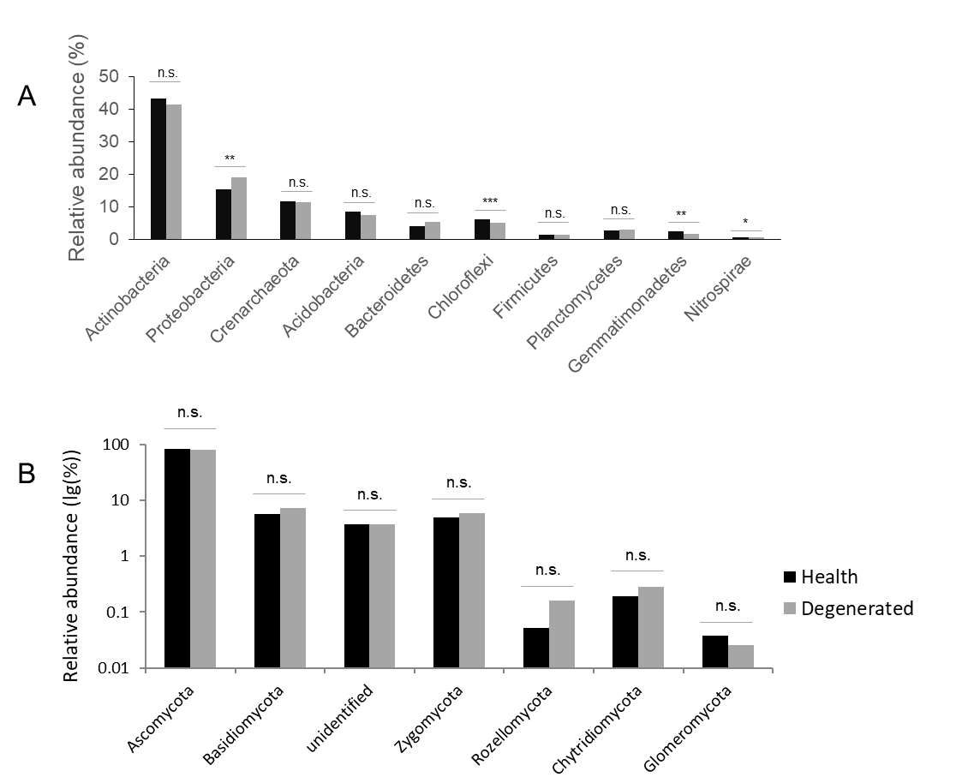
Supplementary Fig. S1 Changes in relative abundances of dominant microbial taxa. Only taxa with average relative abundance > 1% bacterial, and > 0.5% fungal phyla are shown. The relative abundance between M. sieversii categories were tested based on unpaired t test (Wilcoxon Mann-Whitney tests were used when test assumptions were not met; n.s., non-significant; *, P < 0.05; **, P < 0.01; ***, P < 0.001).

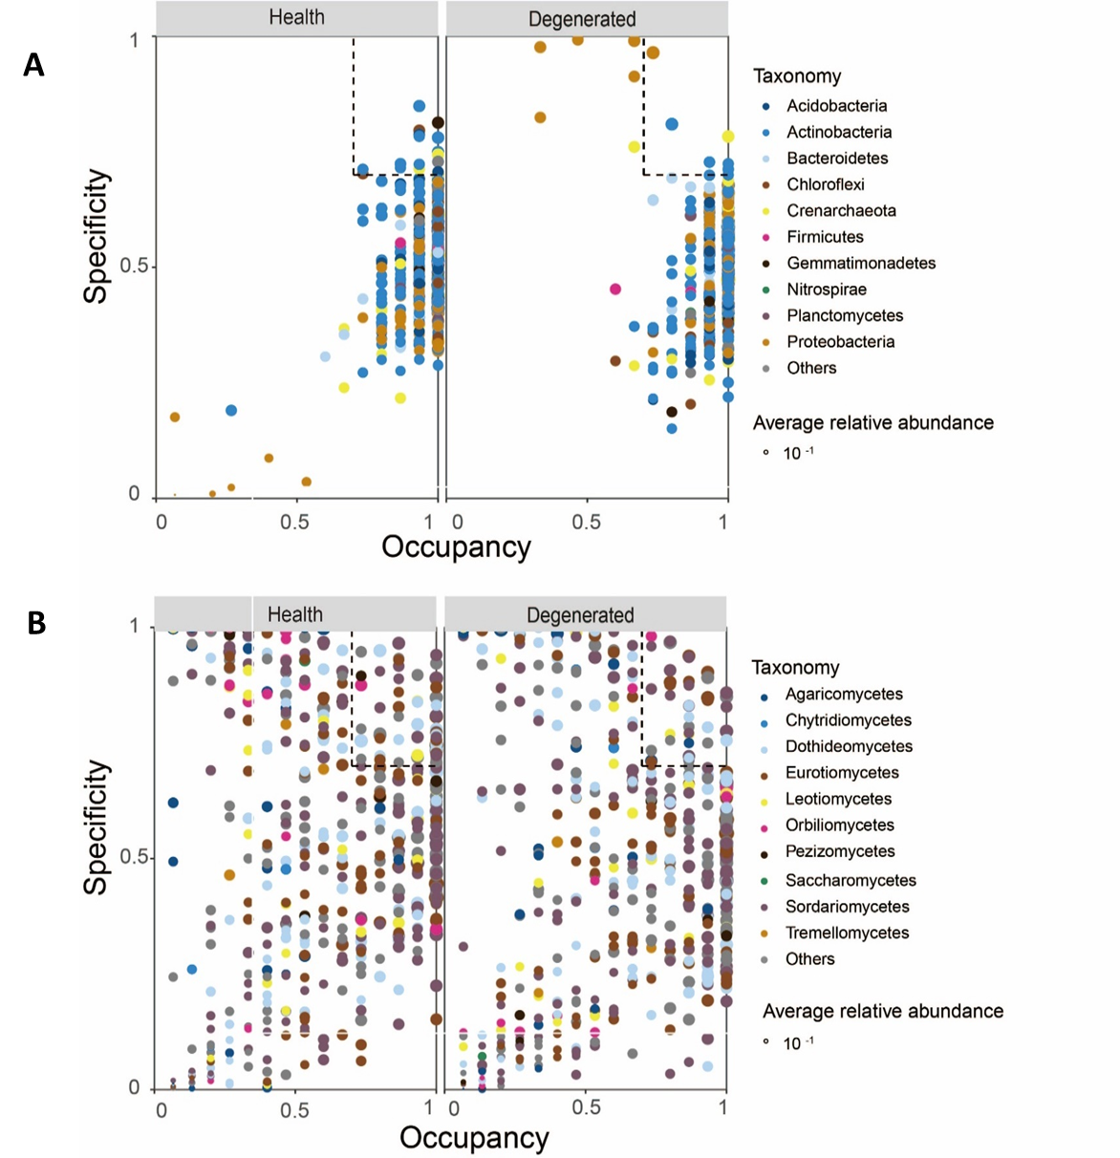
Supplementary Fig. S2 Indicator species and species assemblages characterizing M. sieversii decline. SPEC-OCCU plots show 500 most abundant bacterial (A) and fungal (B) OTUs in each M. sieversii category. The x-axis represents occupancy, i.e. how well an OTU is distributed across all 3 sites; and the y-axis represents specificity, i.e. whether they are also found in another M. sieversii category.

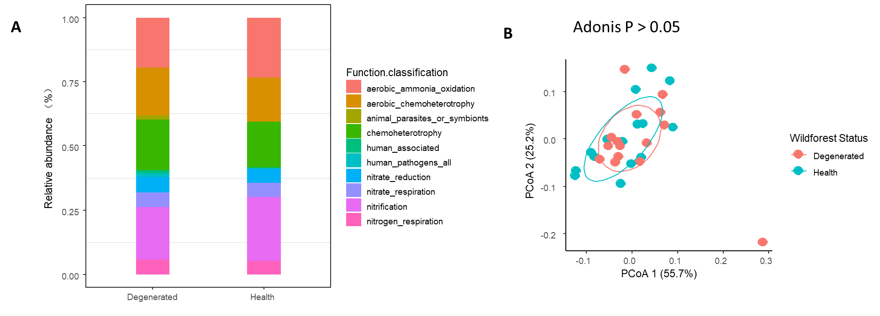
Supplementary Fig. S3 Potential functions of bacterial community with M. sieversii decline. A: Relative abundances of top ten of bacterial trophic groups that based on FAPROTAX predicted results; B: Principal coordinates analysis (PCoA) with Bray-Curtis distance showing the effects of M. sieversii decline on bacterial functional communities. In total, bacterial OTUs in wild fruit forest were categorized into 62 functional guilds of metabolic or other ecologically relevant functions, including carbon, nitrogen and other biogeochemical cycle process.

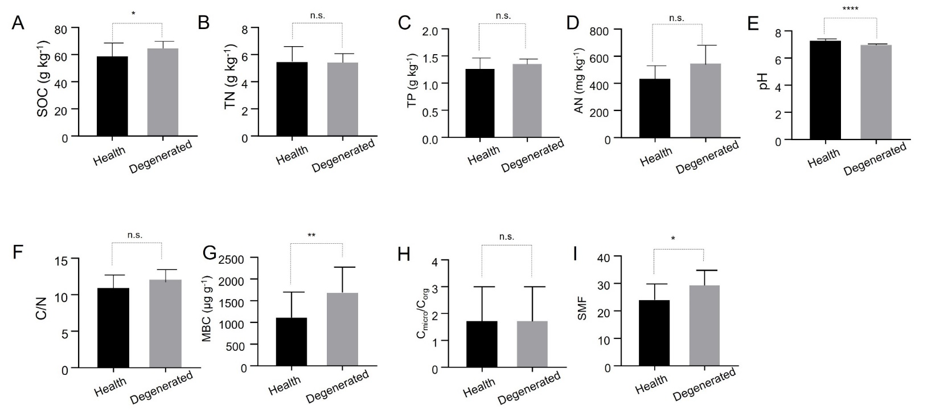
Supplementary Fig. S4 Bar chart of soil properties in the wild fruit forest. Soil multifunctionality was calculated based on SOC, TN and TP, microbial biomass C, AN and pH. SOC, TN, TP, and AN are good proxies of C, N, and P storage and also act as surrogates for C, N, and P availability in soils. AN are the fraction of the soil N pool that is more readily available for both plant and microbial uptake and are driven by N-cycling microorganisms. All components of soil physicochemical metrics were standardized by the Z-score transformation (Jucker & Coomes, 2012). SOC, TN, TP, and AN indicate soil organic matter, total nitrogen, total phosphorus and available nitrogen. MBC indicates microbial biomass carbon.

