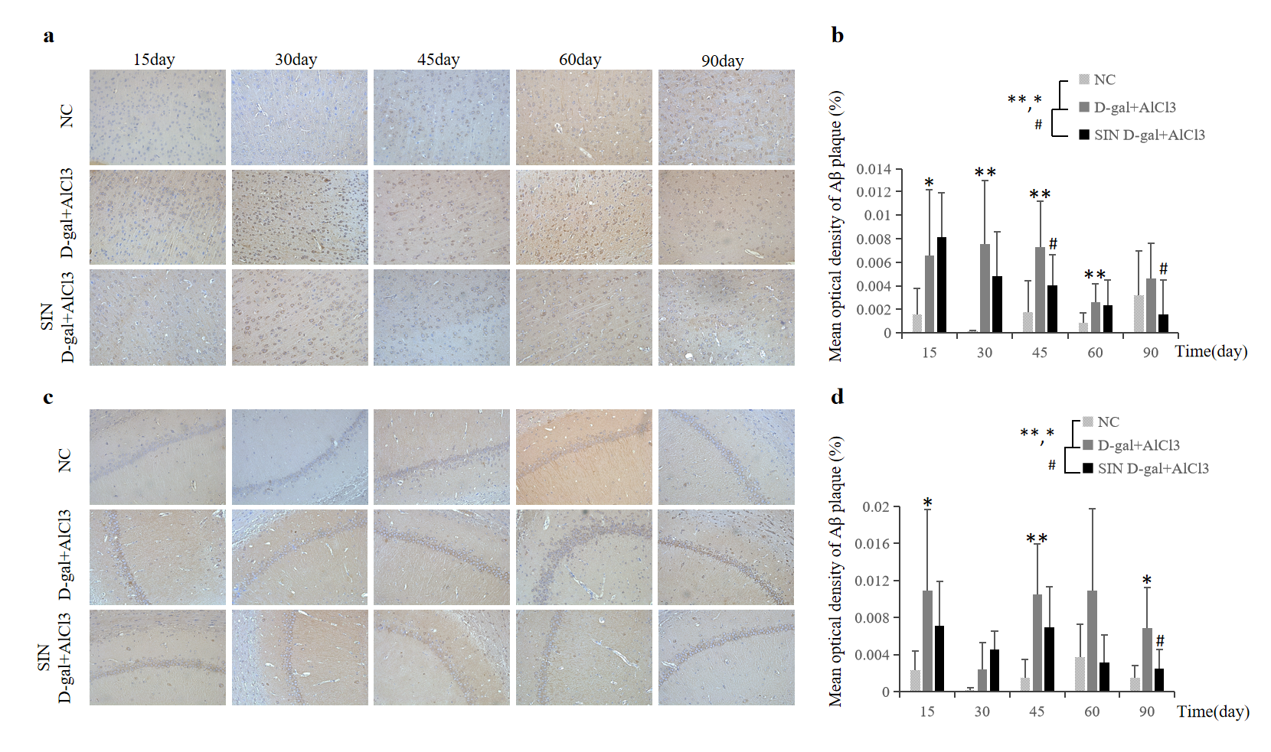Extended Data Fig. 1 | Aβ₄₂ immunostaining in the cerebral cortex and hippocampal CA3 region of chemical-induced rats. a, Photomicrograph of Aβ₄₂ immunostaining in the cerebral cortex of each group. Small and scattered Aβ₄₂ deposits (brown patches, originally ×200) appeared at every time point of model replication in the D-gal+AlCl₃ group. b, Histogram results of Aβ₄₂ positive expression in cerebral cortex indicated that its significant deposition in the D-gal+AlCl₃ group was from the 15th to the 60th day and the effect of schizandrin on it was on the 45th and 90th day. c, Photomicrograph of Aβ₄₂ immunostaining in the hippocampal CA3 region of each group. Small and scattered Aβ₄₂ deposits (brown patches, originally ×200) mainly gathered around neurons in the hippocampus of D-gal+AlCl₃ rats. d, Histogram results of Aβ₄₂₋positive expression in the hippocampal CA3 region. Significant positive Aβ₄₂ expression was detected in the D-gal+AlCl₃ group on the 15th, 45th and 90th days, and its suppression by schizandrin was suppressed in the SIN D-gal+AlCl₃ group on the 90th day. (*P<0.05; **P<0.01, compared with the NC group; #P<0.05, compared with the D-gal+AlCl₃ group).

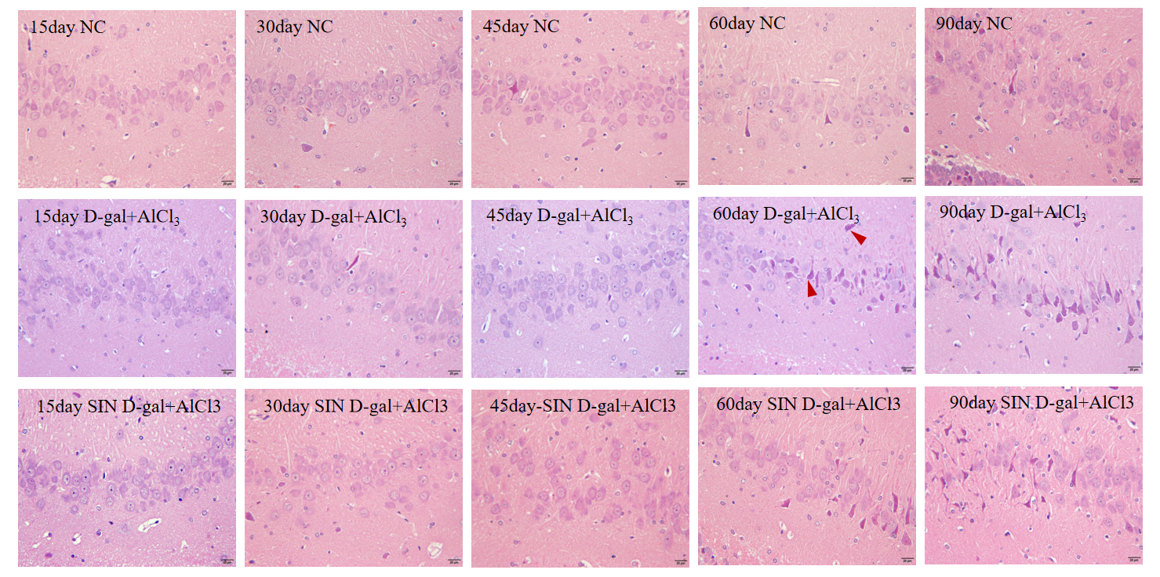
Extended Data Fig. 2 | Haematoxylin-eosin staining in the hippocampal CA3 region of chemical-induced rats. Disordered neuronal arrangement was detected in the D-gal+AlCl₃ group on the 45th day, and obvious nucleolar pyknosis (red triangle position, originally ×400) was found on the 60th day. In the SIN D-gal+AlCl₃ group, nucleolar pyknosis improved significantly on the 60th day and 90th day.
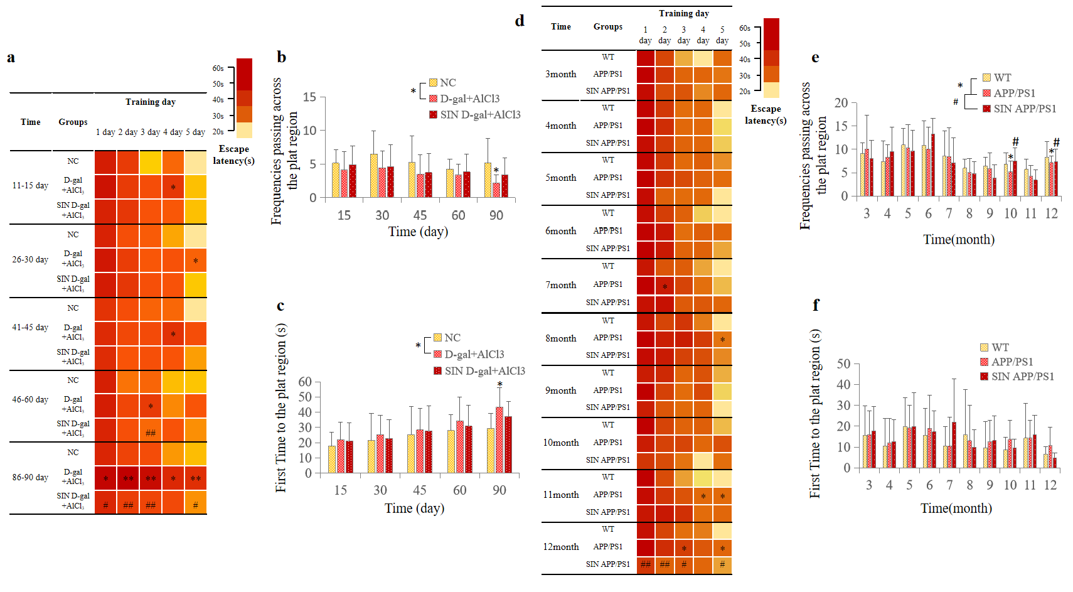

Extended Data Fig. 3 | Morris water maze test of learning and memory ability of chemically induced rats and APP/PS1 mice. a, Escape latency in the place navigation test: the escape latency in the D-gal+AlCl3 group was significantly prolonged from the 86th day to the 90th day, and there was a significant improvement in the SIN D-gal+AlCl3 group at the same time. b, Frequencies crossing the target quadrant in the spatial probe test: the frequencies in the D-gal+AlCl3 group were significantly decreased on the 90th day. c, Time spent crossing the platform: The time spent crossing the platform for the first time was notably prolonged in the D-gal+AlCl3 group on the 90th day. d, At the 12th month, the escape latency of rats in the APP/PS1 group was prolonged, and it was improved in the SIN APP/PS1 group. e, The number of platform crossings in the APP/PS1 group was obviously decreased at the 10th and 12th months, while that in the SIN APP/PS1 group was significantly increased. f, Although the trend of difference between the APP/PS1 group and the SIN APP/PS1 group occurred in the 10th and 12th months, there was no significant difference. (*P<0.05, **P<0.01, compared with the NC group; #P<0.05; ##P<0.01, compared with the APP/PS1 group)
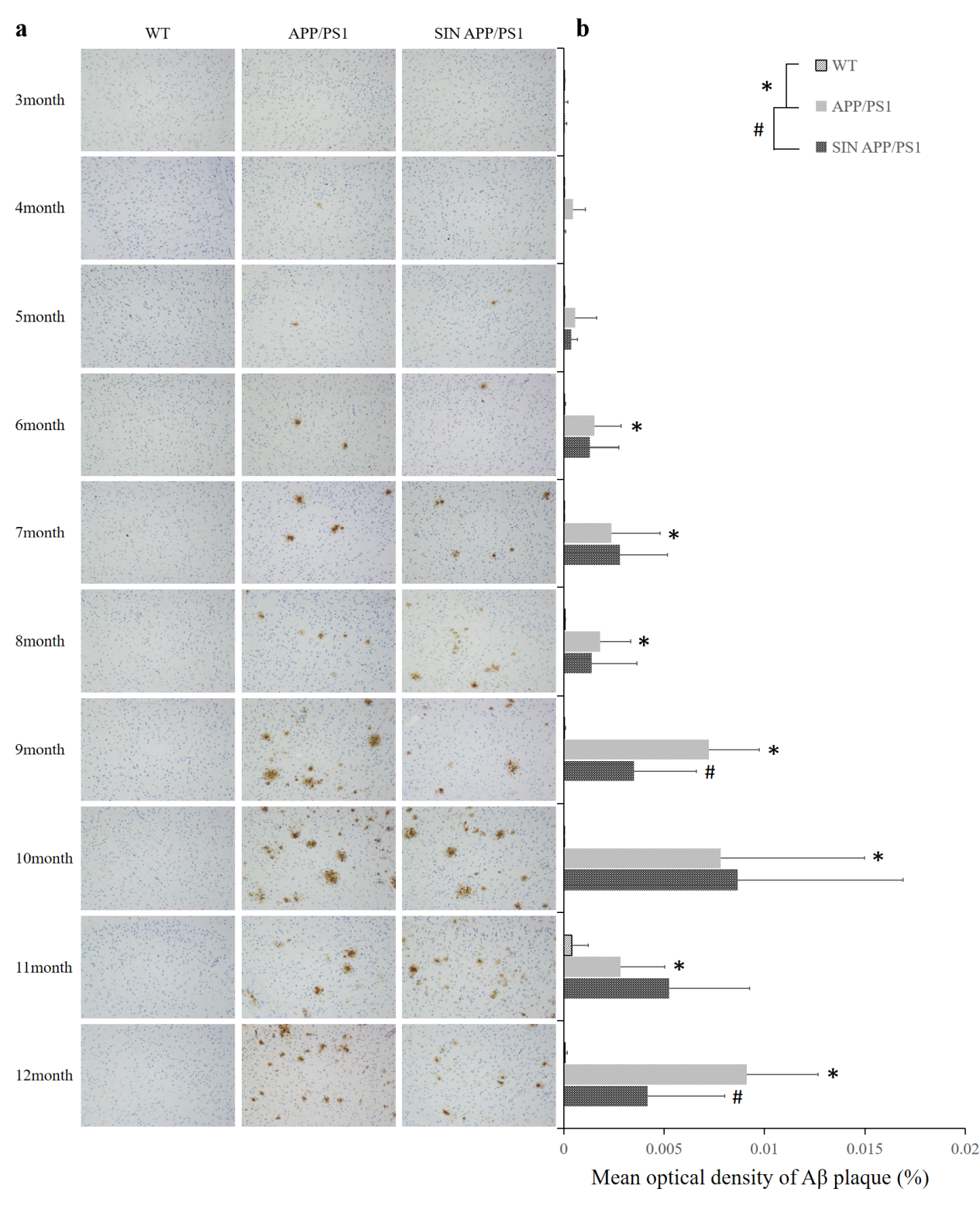Extended Data Fig. 4 | Aβ₄₂ immunostaining in the cerebral cortex of APP/PS1 mice. a, Obvious and compact Aβ₄₂ deposits (brown patches, originally ×200) appeared in the cerebral cortex of the APP/PS1 group at 6 months, and they gradually gathered on a larger scale with age in the APP/PS1 and SIN APP/PS1 groups. b, Histogram results of age-related Aβ₄₂ deposition helpfully clarify the significant differences between the APP/PS group and NC group from the 6th to the 12th month and the obvious downregulation of schizandrin at the 9th and 12th months. (*P<0.05, compared with the WT group; #P<0.05, compared with the APP/PS group)

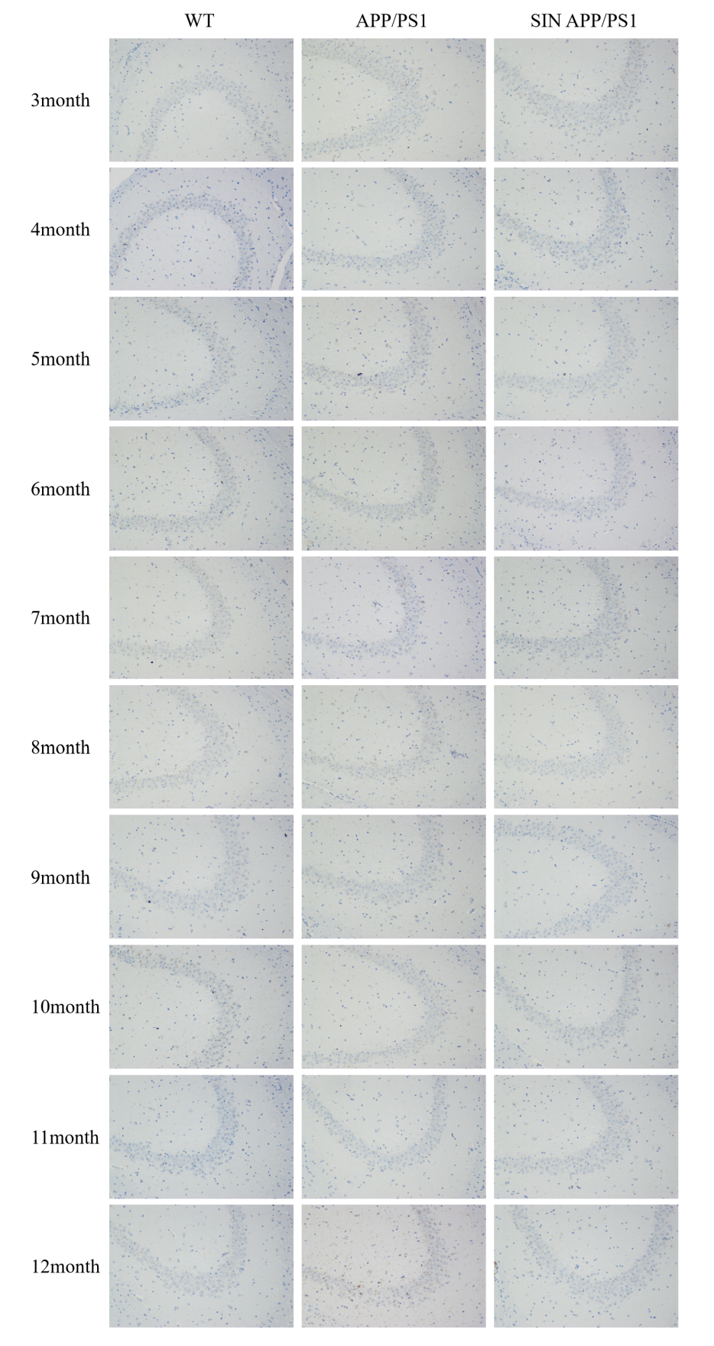
Extended Data Fig. 5 | Aβ₄₂ immunostaining in the hippocampal CA3 region of APP/PS1 mice. The Aβ₄₂ deposits (the brown patches, originally ×200) were unremarkable and were scattered in only small amounts in the hippocampal CA3 region of APP/PS1 mice at the 12th month.

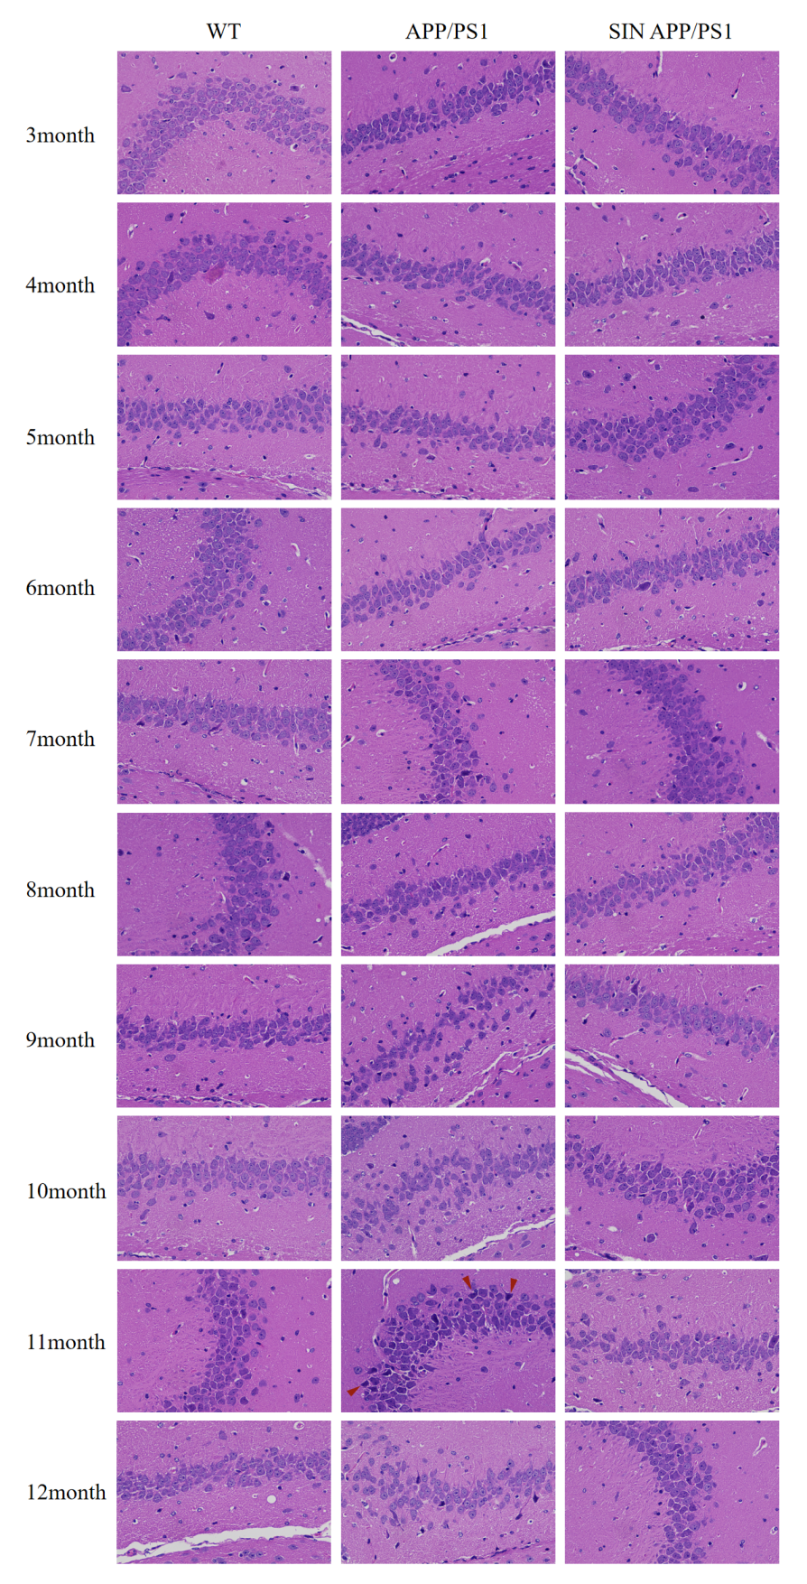
Extended Data Fig. 6 | Haematoxylin-eosin staining in the hippocampal CA3 region of APP/PS1 mice. The neuronal arrangement was disrupted in the hippocampal CA3 region of the APP/PS1 group from the 9th month, and more serious nucleolar pyknosis (red triangle position, originally ×400) was found at the 11th month. These pathological conditions were alleviated in the SIN APP/PS1 group.

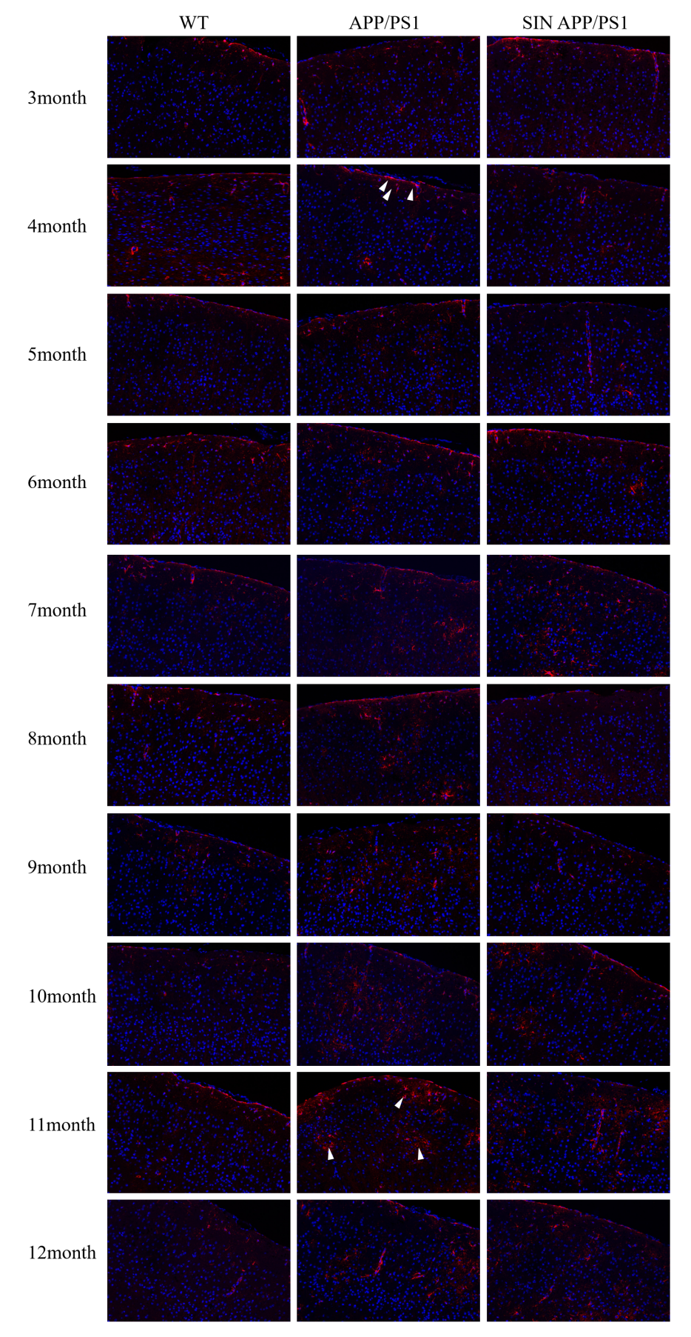
Extended Data Fig. 7 | Immunofluorescence staining in the cerebral cortex of APP/PS1 mice. Partial astrogliosis (white triangle position, originally ×200) was detected in the cortex of mice in the APP/PS1 group beginning at the 4th month, and a massive number of astrogliosis appeared at the 11th month. The condition of astrogliosis was improved in the SIN APP/PS1 group from the 8th to the 12th month (red area is proliferating astrocytes, and blue area is neuronal nuclei).
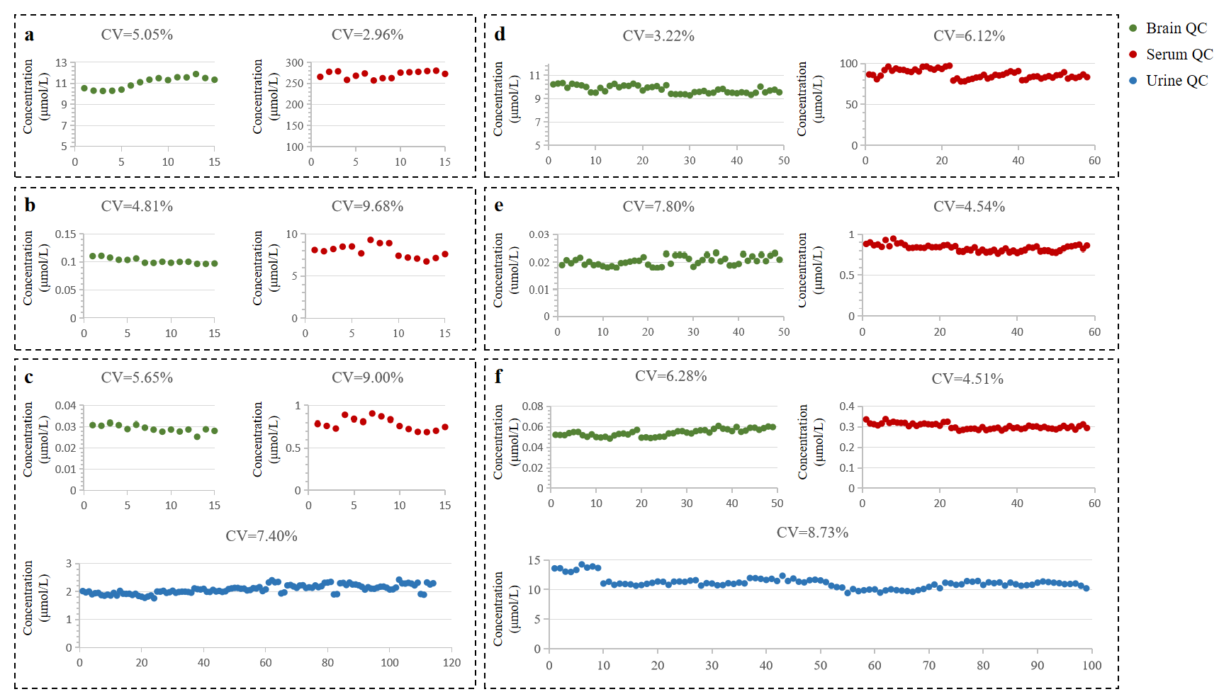
Extended Data Fig. 8 | QC monitoring during sample data collection. a, QC samples of tryptophan in chemically induced rat. b, QC samples of kynurenine in chemically induced rats. c, QC samples of xanthurenic acid in chemically induced rats. d, QC samples of tryptophan in APP/PS1 mice. e, QC samples of kynurenine in APP/PS1 mice. f, QC samples of xanthurenic acid in APP/PS1 mice. (The abscissa represents the quantity of QC, CV%≤20%).
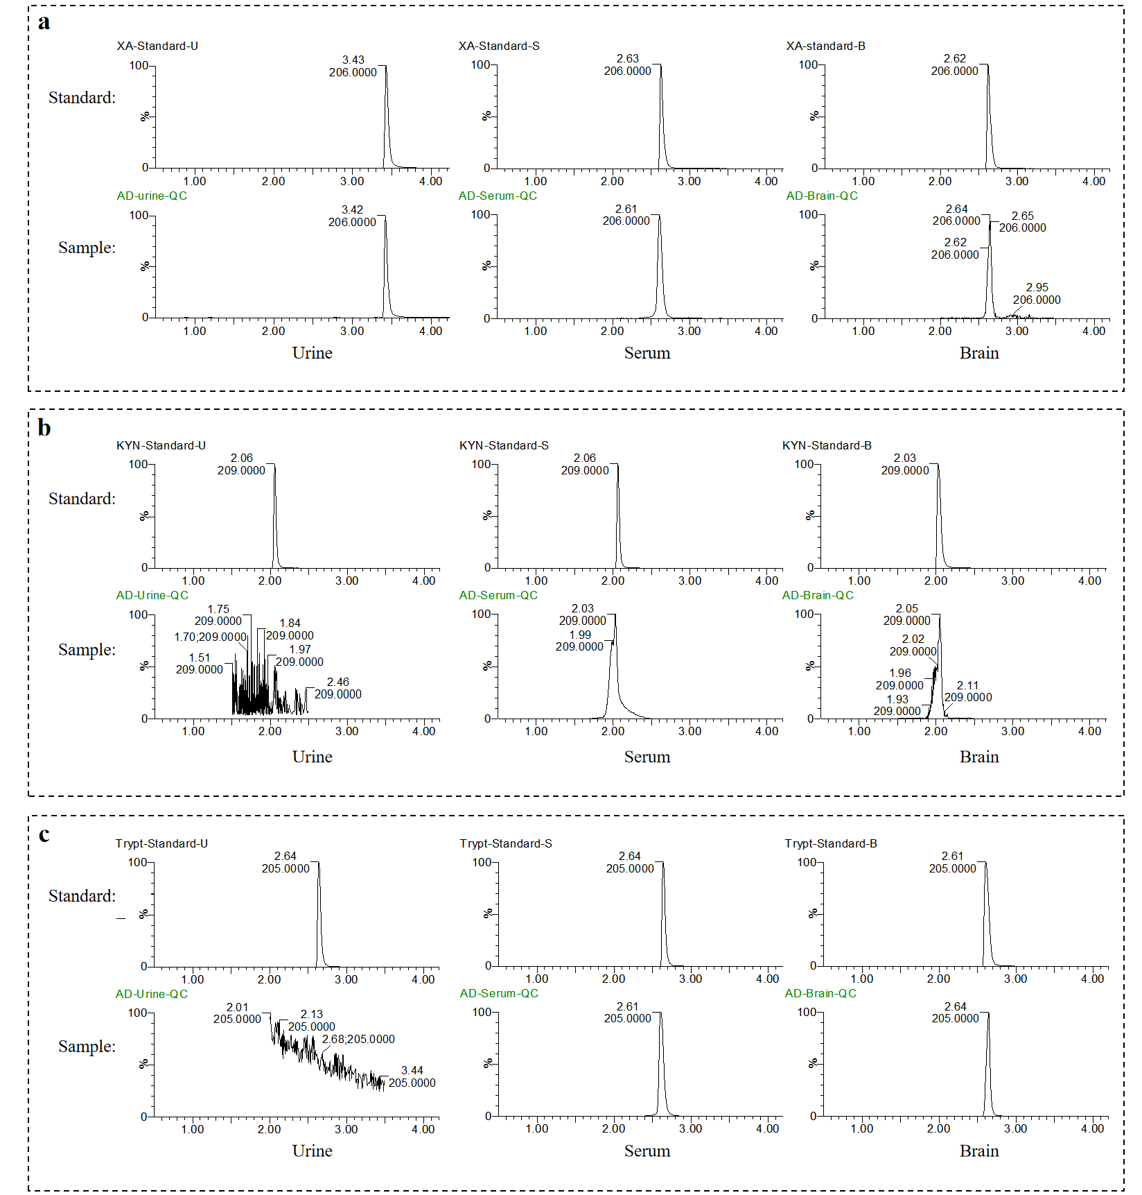

Extended Data Fig. 9 | Specificity of xanthurenic acid, kynurenine and tryptophan in different biological matrices under MRM mode. a, Specificity of xanthurenic acid in different biological matrices. b, Specificity of kynurenine in different biological matrices. c, Specificity of tryptophan in different biological matrices.

Table S1. Serum and brain sample elution conditions of liquid chromatography in the rat and mouse quantitative metabolism experiments.
Time | Flow Rate | A% | B% | Curve
Initial | 0.4 | 1 | 99 | 6
7.0 | 0.4 | 50 | 50 | 6
7.5 | 0.4 | 99 | 1 | 6
8.0 | 0.4 | 99 | 1 | 6
8.5 | 0.4 | 1 | 99 | 6
11.0 | 0.4 | 1 | 99 | 6

Table S2. Urine sample elution conditions of liquid chromatography in the rat and mouse quantitative metabolism experiments.
Time | Flow Rate | A% | B% | Curve
Initial | 0.4 | 1 | 99 | 6
2.5 | 0.4 | 11 | 89 | 6
4.5 | 0.4 | 21 | 79 | 6
7.0 | 0.4 | 40 | 60 | 6
8.5 | 0.4 | 99 | 1 | 6
10.5 | 0.4 | 99 | 1 | 6
10.6 | 0.4 | 1 | 99 | 6
13.0 | 0.4 | 1 | 99 | 6

Table S3. Mass spectrometry condition settings in the rat and mouse quantitative metabolomics experiments.
Settings/Biological Sample | Serum/Brain | Urine
Capillary | 3.00kV | 3.00kV
Cone | 35.00V | 40.00V
Extractor | 3.00V | 3.00V
RF | 0.10V | 0.10V
Source temprature | 110℃ | 120℃
Desolvation temprature | 400℃ | 400℃
Cone Gas Flow | 50.0L/Hour | 50.0L/Hour
Desolvation Gas Flow | 600L/Hour | 800L/Hour
Collision Gas Flow | 0.15mL/min | 0.15mL/min
LM1 Resolution | 8.50 | 8.50
HM1 Resolution | 15.00 | 15.00
Ion Energy 1 | 0.50 | 0.50
MS Mode Entrance | 50.0 | 50.0
MS Mode Collision Energy | 10.0 | 10.0
MS Mode Exit | 50.0 | 50.0
MSMS Mode Entrance | 1.00 | 1.00
MSMS Mode Collision Energy | 30.00 | 15.00
MSMS Mode Exit | 0.50 | 0.50
LM2 Resolution | 10.60 | 10.60
HM2 Resolution | 14.70 | 14.70
Ion Energy 2 | 0.90 | 2.00
Gain | 1.00 | 1.00
Multiplier | -507.36 | -507.36

Table S4. Optimized instrument settings in the MRM model
Biological sample | Analytes | Quantification transitions(m/z) | CV  (V) | CE  (eV) | Dwell  (secs) | PW  (secs)
 | Tryptophan | 205>146 | 22 | 16 | 0.061 | 19.2
Serum | Kynurenine | 209>192 | 28 | 14 | 0.061 | 25.2
 | Xanthurenic acid | 206>160 | 30 | 20 | 0.061 | 22.2
 | Tryptophan | 205>146 | 22 | 16 | 0.061 | 14.4
Brain | Kynurenine | 209>192 | 28 | 14 | 0.061 | 15.6
 | Xanthurenic acid | 206>160 | 30 | 20 | 0.061 | 15.0
Urine | Xanthurenic acid | 206>160 | 30 | 20 | 0.042 | 12.6
(Cone Voltage, CV; Collision Energy, CE; Dwell Time, DT; Peak Width, PW）

Table S5. Standard curve for determination of biological sample content
Model species | Biological Samples | Analytes | Standard curve | Correlation coefficient | Calibration range  (μmol/L)
Chemical-  induced rat | Urine | Xanthurenic acid | y = 6.0556x - 0.0857 | R² = 0.9998 | 6.340-0.198
Chemical-  induced rat | Serum | Xanthurenic acid | y = 3.9153x + 0.0184 | R² = 0.9990 | 3.170-0.025
Chemical-  induced rat | Serum | Kynurenine | y = 792.33x + 0.045 | R² = 0.9984 | 60.072-0.939
Chemical-  induced rat | Serum | Tryptophan | y = 1.7097x + 1.7063 | R² = 0.9991 | 293.988-6.890
Chemical-  induced rat | Brain | Xanthurenic acid | y = 2.8953x + 0.0006 | R²= 0.9976 | 0.198-0.003
Chemical-  induced rat | Brain | Kynurenine | y = 649.84x + 0.0004 | R²= 0.9999 | 1.877- 0.029
Chemical-  induced rat | Brain | Tryptophan | y = 1.2535x + 0.3014 | R²= 0.9989 | 97.996-1.531
APP/PS1 transgenic mouse | Urine | Xanthurenic acid | y = 2.3995x + 0.2192 | R²= 0.9996 | 50.722-0.793
APP/PS1 transgenic mouse | Serum | Xanthurenic acid | y = 3.0068x - 0.0004 | R²= 0.9999 | 2.097-0.008
APP/PS1 transgenic mouse | Serum | Kynurenine | y = 537.14x - 0.0023 | R²= 0.9999 | 7.509-0.029
APP/PS1 transgenic mouse | Serum | Tryptophan | y = 1.0984x + 1.5053 | R²= 0.9987 | 440.982-9.187
APP/PS1 transgenic mouse | Brain | Xanthurenic acid | y = 2.7536x + 0.004 | R²= 0.9991 | 0.524-0.004
APP/PS1 transgenic mouse | Brain | Kynurenine | y = 671.51x - 0.0006 | R²= 0.9997 | 0.939-0.004
APP/PS1 transgenic mouse | Brain | Tryptophan | y = 1.1186x + 0.618 | R²= 0.9971 | 146.994-1.148

Table S6. Investigation of the precision and accuracy of biological samples in a chemical-induced rat model (CV%≤20%)
Biological Samples | Analytes | Concentration | Within-day precision |  | Inter-day precision |  | Accuracy（％）
Biological Samples | Analytes | Concentration | Mean±SD | CV% | Mean±SD | CV% | Mean±SD | CV%
Urine | Xanthurenic acid (μmol/L) | High | 3.42±0.05 | 1.49 | 3.33±0.09 | 2.56 | 107.99±5.55 | 5.14
Urine | Xanthurenic acid (μmol/L) | Medium | 2.49±0.02 | 0.97 | 2.51±0.06 | 2.55 | 113.68±8.87 | 7.80
Urine | Xanthurenic acid (μmol/L) | Low | 2.08±0.03 | 1.61 | 2.05±0.02 | 1.08 | 101.67±11.36 | 11.17
Serum | Xanthurenic acid (nmol/L) | High | 1.20±0.02 | 1.77 | 1.23±0.03 | 2.28 | 113.69±3.82 | 3.36
Serum | Xanthurenic acid (nmol/L) | Medium | 0.80±0.01 | 0.84 | 0.79±0.01 | 1.48 | 115.52±8.09 | 7.00
Serum | Xanthurenic acid (nmol/L) | Low | 0.53±0.01 | 2.54 | 0.54±0.01 | 1.37 | 111.95±7.77 | 6.94
Serum | Kynurenine  (μmol/L) | High | 11.89±0.08 | 0.66 | 11.88±0.14 | 1.22 | 82.06±1.66 | 2.03
Serum | Kynurenine  (μmol/L) | Medium | 6.41±0.08 | 1.29 | 6.35±0.05 | 0.85 | 84.92±1.50 | 1.76
Serum | Kynurenine  (μmol/L) | Low | 3.53±0.08 | 2.16 | 3.60±0.08 | 2.16 | 88.66±3.88 | 4.38
Serum | Tryptophan  (μmol/L) | High | 448.29±8.6 | 1.92 | 441.68±3.80 | 0.86 | 95.93±1.90 | 1.98
Serum | Tryptophan  (μmol/L) | Medium | 300.81±6.06 | 2.01 | 304.39±5.15 | 1.69 | 91.62±1.96 | 2.14
Serum | Tryptophan  (μmol/L) | Low | 213.75±1.36 | 0.64 | 212.72±2.74 | 1.29 | 87.14±1.58 | 1.81
Brain | Xanthurenic acid (nmol/L) | High | 108.87±1.47 | 1.35 | 109.92±2.54 | 2.31 | 93.92±5.83 | 6.21
Brain | Xanthurenic acid (nmol/L) | Medium | 73.77±2.06 | 2.79 | 75.20±1.83 | 2.43 | 92.80±8.72 | 9.40
Brain | Xanthurenic acid (nmol/L) | Low | 61.39±1.08 | 1.76 | 62.62±1.19 | 1.91 | 102.61±12.48 | 12.16
Brain | Kynurenine  (μmol/L) | High | 0.60±0.01 | 1.32 | 0.56±0.03 | 6.13 | 112.49±7.21 | 6.41
Brain | Kynurenine  (μmol/L) | Medium | 0.33±0.01 | 4.10 | 0.33±0.02 | 5.30 | 109.60±6.51 | 5.94
Brain | Kynurenine  (μmol/L) | Low | 0.20±0.01 | 7.21 | 0.19±0.02 | 11.17 | 108.77±16.85 | 15.50
Brain | Tryptophan  (μmol/L) | High | 38.12±0.25 | 0.65 | 37.94±1.13 | 2.97 | 104.41±3.68 | 3.54
Brain | Tryptophan  (μmol/L) | Medium | 25.79±0.37 | 1.44 | 25.65±0.46 | 1.80 | 109.13±3.22 | 2.95
Brain | Tryptophan  (μmol/L) | Low | 19.63±0.20 | 1.03 | 19.71±0.37 | 1.90 | 115.53±6.23 | 5.39

Table S7. Investigation of the precision and accuracy of biological samples in the APP/PS1 transgenic mouse model (CV%≤20%)
Biological Samples | Analytes | Concentration | Within-day precision |  | Inter-day precision |  | Accuracy（％）
Biological Samples | Analytes | Concentration | Mean±SD | CV% | Mean±SD | CV% | Mean±SD | CV%
Urine | Xanthurenic acid (μmol/L) | High | 43.85±0.52 | 1.18 | 44.53±0.52 | 1.16 | 104.63±2.99 | 2.86
Urine | Xanthurenic acid (μmol/L) | Medium | 29.84±0.45 | 1.51 | 29.77±0.35 | 1.19 | 105.38±2.95 | 2.80
Urine | Xanthurenic acid (μmol/L) | Low | 22.00±0.19 | 0.87 | 22.25±0.22 | 0.97 | 112.86±5.33 | 4.73
Serum | Xanthurenic acid (μmol/L) | High | 0.80±0.02 | 2.18 | 0.82±0.02 | 2.37 | 87.59±3.41 | 3.89
Serum | Xanthurenic acid (μmol/L) | Medium | 0.43±0.01 | 1.19 | 0.43±0.01 | 2.16 | 97.33±4.98 | 5.12
Serum | Xanthurenic acid (μmol/L) | Low | 0.35±0.01 | 3.29 | 0.35±0.01 | 2.59 | 98.28±17.98 | 18.29
Serum | Kynurenine  (μmol/L) | High | 2.82±0.11 | 3.96 | 2.89±0.12 | 4.14 | 113.48±5.09 | 4.49
Serum | Kynurenine  (μmol/L) | Medium | 1.35±0.03 | 2.46 | 1.34±0.03 | 2.52 | 110.35±4.78 | 4.33
Serum | Kynurenine  (μmol/L) | Low | 1.02±0.04 | 4.28 | 1.00±0.04 | 3.73 | 109.16±18.95 | 17.36
Serum | Tryptophan  (μmol/L) | High | 218.28±5.23 | 2.39 | 219.00±5.86 | 2.68 | 101.07±3.49 | 3.45
Serum | Tryptophan  (μmol/L) | Medium | 109.19±2.56 | 2.35 | 110.33±3.09 | 2.80 | 99.05±6.65 | 6.71
Serum | Tryptophan  (μmol/L) | Low | 85.81±0.88 | 1.03 | 86.72±2.35 | 2.71 | 90.68±17.13 | 18.89
Brain | Xanthurenic acid (nmol/L) | High | 198.50±2.74 | 1.38 | 206.21±7.70 | 3.73 | 104.74±2.89 | 2.76
Brain | Xanthurenic acid (nmol/L) | Medium | 88.36±2.10 | 2.37 | 89.33±1.41 | 1.58 | 116.90±3.14 | 2.69
Brain | Xanthurenic acid (nmol/L) | Low | 56.88±0.97 | 1.71 | 57.80±1.01 | 1.75 | 106.43±19.72 | 18.53
Brain | Kynurenine  (nmol/L) | High | 180.91±6.71 | 3.71 | 181.51±10.21 | 5.63 | 80.75±6.08 | 7.52
Brain | Kynurenine  (nmol/L) | Medium | 67.41±2.78 | 4.13 | 69.76±1.45 | 2.07 | 92.40±6.44 | 6.97
Brain | Kynurenine  (nmol/L) | Low | 35.74±1.17 | 3.26 | 36.46±0.63 | 1.73 | 117.46±8.32 | 7.08
Brain | Tryptophan  (μmol/L) | High | 96.75±0.42 | 0.43 | 94.56±0.60 | 0.64 | 98.78±2.62 | 2.65
Brain | Tryptophan  (μmol/L) | Medium | 36.90±0.28 | 0.77 | 37.10±0.38 | 1.02 | 99.22±2.38 | 2.40
Brain | Tryptophan  (μmol/L) | Low | 21.15±0.44 | 2.06 | 21.20±0.12 | 0.57 | 105.66±11.79 | 11.16

Table S8. Investigation of the stability, LOQ and matrix effects of biological samples in chemical-induced rats and APP/PS1 transgenic mouse models (Stability%≤20%, Matrix effects%≤ ± 20%)
Model Species | Biological Samples | Analytes | Stability(%) | LOQ | Matrix effects（％）
Chemical-  induced rat | Urine | Xanthurenic acid | 1.66 | 0.53(μmol/L) | 1.46
Chemical-  induced rat | Serum | Xanthurenic acid | 1.72 | 5.82(nmol/L) | -5.96
Chemical-  induced rat | Serum | Kynurenine | 6.63 | 0.15(μmol/L) | -5.96
Chemical-  induced rat | Serum | Tryptophan | 1.22 | 11.52(μmol/L) | -5.96
Chemical-  induced rat | Brain | Xanthurenic acid | 7.04 | 13.66(nmol/L) | -2.95
Chemical-  induced rat | Brain | Kynurenine | 11.17 | 0.14(μmol/L) | -2.95
Chemical-  induced rat | Brain | Tryptophan | 1.88 | 4.37(μmol/L) | -2.95
APP/PS1 transgenic mouse | Urine | Xanthurenic acid | 1.40 | 0.45(μmol/L) | -6.91
APP/PS1 transgenic mouse | Serum | Xanthurenic acid | 3.37 | 0.01(μmol/L) | -9.42
APP/PS1 transgenic mouse | Serum | Kynurenine | 4.93 | 0.03(μmol/L) | -9.42
APP/PS1 transgenic mouse | Serum | Tryptophan | 3.79 | 5.07(μmol/L) | -9.42
APP/PS1 transgenic mouse | Brain | Xanthurenic acid | 1.64 | 0.30(nmol/L) | -9.22
APP/PS1 transgenic mouse | Brain | Kynurenine | 3.05 | 15.37(nmol/L) | -9.22
APP/PS1 transgenic mouse | Brain | Tryptophan | 1.64 | 0.35(μmol/L) | -9.22

