Supporting Information
Insights into the interactions between salt molecules: A combined experimental and computational study
Suganya Suresh ª, Saravanan Kandasamy ^{b}, Karthikeyan Ammasai ^{c}, and Kumaradhas Poomani ^{a*}

Computing details
Program(s) used to refine structure: SHELXL97 (Sheldrick, 1997); molecular graphics: ORTEP for Windows (Farrugia,2012); software used to prepare material for publication: WinGX publication routines (Farrugia,2012).

Table (S1): 2-amino 4-methoxy 6-methyl pyrimidine – 4-amino salicylic acid
Crystal data | F(000) = 616
C₁₃H₁₆N₄O₄ | D_{x} = 1.392 Mg m⁻³
M_{r} = 292.3 | Mo Kα radiation, λ = 0.71073 Å
Monoclinic, P2₁/n | Cell parameters from 6906 reflections
a = 8.8829 (2) Å | θ = 2.7–28.2°
b = 15.1248 (3) Å | μ = 0.11 mm⁻¹
c = 10.4933 (3) Å | T = 293 K
β = 98.392 (1)° | Block
V = 1394.70 (6) Å³ | 0.28 × 0.23 × 0.18 mm
Z = 4
Data collected
Bruker D8 Quest eco diffractometer | R_{int} = 0.019
8088 measured reflections | θ_{max} = 25.9°, θ_{min} = 2.7°
2690 independent reflections | h = -8→10
2573 reflections with I> 2s(I) | k = -18→17
Refinement | l = -12→12
Refinement on F²
Least-squares matrix: full | 1 restraints
R[F²> 2σ(F²)] = 0.051 | Primary atom site location: structure-invariant direct methods
wR(F²) = 0.126 | Secondary atom site location: difference Fourier map
S = 1.17 | Hydrogen site location: mixed
2690 reflections | w = 1/[σ²(F_{o}²) + (0.0578P)² + 0.2501P]  where P = (F_{o}² + 2F_{c}²)/3
228 parameters
H atoms treated by a mixture of independent and constrained refinement | ∆ρ_{max} = 0.19 e Å⁻³  ∆ρ_{min} = -0.14 e Å⁻³

Special details
Geometry:Allesds(expect the esd in the dihedral angle between two l.s planes) are estimated using the full convariance matrix. The cell esds are taken into account individually in the estimation of esds in distances, angles and torsion angles; correlations between esds in cell parameters are only used when they are defined by crystal symmetry. An approximate (isotropic) treatment of cell esds is used for estimating esds involving l.s. planes.
Table (S2): Fractional atomic coordinates and isotropic or equivalent isotropic displacement parameters (Å²)
Atom | x | y | z | U_{iso}*/U_{eq}
H8 | 0.557 (2) | 0.2155 (14) | 0.9816 (19) | 0.062 (6)*
H11 | 0.119 (2) | 0.3848 (12) | 0.8608 (16) | 0.043 (4)*
H4 | 0.509 (3) | 0.307 (2) | 0.678 (3) | 0.111 (9)*
H3 | 0.473 (2) | 0.5151 (13) | 0.8772 (19) | 0.058 (6)*
H3A | 0.882 (2) | 0.5480 (14) | 0.540 (2) | 0.059 (6)*
H13 | 0.646 (2) | 0.5910 (14) | 0.566 (2) | 0.067 (6)*
H4B | 0.463 (3) | 0.1857 (16) | 1.177 (2) | 0.066 (7)*
H3B | 0.984 (3) | 0.4953 (15) | 0.651 (2) | 0.065 (6)*
H4A | 0.314 (2) | 0.2248 (13) | 1.206 (2) | 0.054 (6)*
O2 | 0.16222 (13) | 0.41781 (8) | 0.63413 (11) | 0.0499 (3)
N2 | 0.80749 (15) | 0.47671 (9) | 0.80428 (12) | 0.0423 (3)
C12 | 0.31316 (17) | 0.33716 (10) | 0.79760 (14) | 0.0357 (4)
O1 | 0.70149 (14) | 0.43536 (9) | 0.98058 (11) | 0.0527 (4)
O3 | 0.37952 (14) | 0.36188 (9) | 0.59087 (11) | 0.0529 (4)
N1 | 0.65577 (15) | 0.56046 (9) | 0.64433 (13) | 0.0420 (3)
C13 | 0.28234 (18) | 0.37514 (11) | 0.66724 (15) | 0.0387 (4)
O4 | 0.54959 (14) | 0.27302 (10) | 0.75865 (13) | 0.0610 (4)
C11 | 0.21193 (18) | 0.35023 (11) | 0.88628 (15) | 0.0378 (4)
C4 | 0.69030 (19) | 0.47687 (11) | 0.86762 (15) | 0.0405 (4)
C9 | 0.36391 (18) | 0.26076 (11) | 1.04421 (15) | 0.0418 (4)
N3 | 0.90016 (19) | 0.52269 (12) | 0.62232 (16) | 0.0593 (5)
N4 | 0.3878 (2) | 0.22401 (13) | 1.16520 (16) | 0.0608 (5)
C10 | 0.23558 (18) | 0.31375 (11) | 1.00685 (15) | 0.0410 (4)
H10 | 0.1667 | 0.3241 | 1.0639 | 0.049*
C2 | 0.53537 (18) | 0.56017 (11) | 0.71129 (16) | 0.0403 (4)
C3 | 0.55101 (19) | 0.51842 (12) | 0.82589 (16) | 0.0445 (4)
C7 | 0.44378 (18) | 0.28625 (11) | 0.83790 (16) | 0.0411 (4)
C1 | 0.78794 (19) | 0.51967 (11) | 0.69082 (15) | 0.0419 (4)
C8 | 0.4677 (2) | 0.24902 (12) | 0.95922 (17) | 0.0470 (4)
C6 | 0.8393 (3) | 0.38770 (16) | 1.0263 (2) | 0.0688 (6)
H6A | 0.8568 | 0.3438 | 0.9639 | 0.103*
H6B | 0.8294 | 0.3594 | 1.1065 | 0.103*
H6C | 0.9234 | 0.4281 | 1.0388 | 0.103*
C5 | 0.3953 (2) | 0.60699 (14) | 0.65024 (19) | 0.0548 (5)
H5A | 0.3104 | 0.5889 | 0.6911 | 0.082*
H5B | 0.3758 | 0.5925 | 0.5603 | 0.082*
H5C | 0.4096 | 0.6697 | 0.6601 | 0.082*

Table (S3): Atomic displacement parameters (Å²)
Atom | U¹¹ | U²² | U³³ | U¹² | U¹³ | U²³
O2 | 0.0450 (7) | 0.0616 (8) | 0.0434 (7) | 0.0130 (6) | 0.0079 (5) | 0.0123 (6)
N2 | 0.0459 (8) | 0.0471 (8) | 0.0362 (7) | 0.0073 (6) | 0.0133 (6) | 0.0057 (6)
C12 | 0.0357 (8) | 0.0357 (8) | 0.0355 (8) | -0.0021 (6) | 0.0047 (6) | 0.0008 (6)
O1 | 0.0562 (7) | 0.0644 (8) | 0.0409 (7) | 0.0102 (6) | 0.0184 (6) | 0.0144 (6)
O3 | 0.0505 (7) | 0.0701 (9) | 0.0411 (7) | 0.0132 (6) | 0.0166 (5) | 0.0125 (6)
N1 | 0.0437 (8) | 0.0464 (8) | 0.0376 (7) | 0.0072 (6) | 0.0119 (6) | 0.0054 (6)
C13 | 0.0390 (8) | 0.0387 (8) | 0.0384 (8) | -0.0009 (7) | 0.0056 (6) | 0.0015 (7)
O4 | 0.0494 (7) | 0.0853 (10) | 0.0517 (8) | 0.0247 (7) | 0.0187 (6) | 0.0140 (7)
C11 | 0.0359 (8) | 0.0394 (9) | 0.0381 (8) | -0.0009 (7) | 0.0048 (6) | -0.0005 (6)
C4 | 0.0468 (9) | 0.0417 (9) | 0.0351 (8) | -0.0007 (7) | 0.0128 (7) | 0.0006 (7)
C9 | 0.0456 (9) | 0.0424 (9) | 0.0363 (8) | -0.0064 (7) | 0.0018 (7) | 0.0030 (7)
N3 | 0.0516 (9) | 0.0817 (13) | 0.0494 (9) | 0.0243 (9) | 0.0236 (7) | 0.0279 (9)
N4 | 0.0611 (11) | 0.0755 (12) | 0.0458 (9) | 0.0092 (9) | 0.0084 (8) | 0.0211 (8)
C10 | 0.0415 (9) | 0.0460 (9) | 0.0366 (8) | -0.0029 (7) | 0.0094 (7) | -0.0011 (7)
C2 | 0.0408 (8) | 0.0390 (8) | 0.0422 (9) | 0.0008 (7) | 0.0094 (7) | -0.0042 (7)
C3 | 0.0425 (9) | 0.0509 (10) | 0.0431 (9) | 0.0009 (7) | 0.0160 (7) | -0.0001 (7)
C7 | 0.0383 (8) | 0.0445 (9) | 0.0412 (9) | 0.0032 (7) | 0.0086 (7) | 0.0020 (7)
C1 | 0.0448 (9) | 0.0445 (9) | 0.0384 (8) | 0.0068 (7) | 0.0130 (7) | 0.0040 (7)
C8 | 0.0430 (9) | 0.0499 (10) | 0.0469 (10) | 0.0080 (8) | 0.0025 (7) | 0.0068 (8)
C6 | 0.0699 (13) | 0.0839 (15) | 0.0553 (12) | 0.0228 (11) | 0.0178 (10) | 0.0276 (11)
C5 | 0.0458 (10) | 0.0592 (12) | 0.0596 (11) | 0.0089 (8) | 0.0081 (8) | 0.0032 (9)

Table (S4): Geometric parameters (Å, º)
O2—C13 | 1.2521 (19) | C9—C10 | 1.402 (2)
N2—C4 | 1.314 (2) | N3—C1 | 1.312 (2)
N2—C1 | 1.345 (2) | N3—H3A | 0.94 (2)
C12—C11 | 1.399 (2) | N3—H3B | 0.87 (2)
C12—C7 | 1.405 (2) | N4—H4B | 0.88 (2)
C12—C13 | 1.472 (2) | N4—H4A | 0.83 (2)
O1—C4 | 1.3322 (19) | C10—H10 | 0.93
O1—C6 | 1.441 (2) | C2—C3 | 1.347 (2)
O3—C13 | 1.2765 (19) | C2—C5 | 1.493 (2)
N1—C1 | 1.353 (2) | C3—H3 | 0.94 (2)
N1—C2 | 1.363 (2) | C7—C8 | 1.380 (2)
N1—H13 | 0.94 (2) | C8—H8 | 0.94 (2)
O4—C7 | 1.3577 (19) | C6—H6A | 0.96
O4—H4 | 1.01 (3) | C6—H6B | 0.96
C11—C10 | 1.368 (2) | C6—H6C | 0.96
C11—H11 | 0.981 (18) | C5—H5A | 0.96
C4—C3 | 1.400 (2) | C5—H5B | 0.96
C9—N4 | 1.374 (2) | C5—H5C | 0.96
C9—C8 | 1.385 (2)
C4—N2—C1 | 115.93 (14) | C9—C10—H10 | 120.1
C11—C12—C7 | 117.38 (14) | C3—C2—N1 | 118.38 (15)
C11—C12—C13 | 120.83 (14) | C3—C2—C5 | 125.20 (15)
C7—C12—C13 | 121.79 (14) | N1—C2—C5 | 116.42 (15)
C4—O1—C6 | 118.77 (14) | C2—C3—C4 | 117.45 (15)
C1—N1—C2 | 121.18 (14) | C2—C3—H3 | 123.3 (12)
C1—N1—H13 | 120.2 (13) | C4—C3—H3 | 119.2 (12)
C2—N1—H13 | 118.6 (13) | O4—C7—C8 | 118.53 (15)
O2—C13—O3 | 122.26 (14) | O4—C7—C12 | 120.76 (14)
O2—C13—C12 | 119.63 (14) | C8—C7—C12 | 120.71 (15)
O3—C13—C12 | 118.10 (14) | N3—C1—N2 | 119.43 (15)
C7—O4—H4 | 104.1 (16) | N3—C1—N1 | 118.38 (15)
C10—C11—C12 | 122.08 (15) | N2—C1—N1 | 122.19 (14)
C10—C11—H11 | 118.5 (10) | C7—C8—C9 | 120.94 (16)
C12—C11—H11 | 119.4 (10) | C7—C8—H8 | 117.5 (12)
N2—C4—O1 | 119.17 (15) | C9—C8—H8 | 121.6 (12)
N2—C4—C3 | 124.88 (15) | O1—C6—H6A | 109.5
O1—C4—C3 | 115.96 (14) | O1—C6—H6B | 109.5
N4—C9—C8 | 121.03 (17) | H6A—C6—H6B | 109.5
N4—C9—C10 | 119.97 (17) | O1—C6—H6C | 109.5
C8—C9—C10 | 118.95 (15) | H6A—C6—H6C | 109.5
C1—N3—H3A | 118.4 (12) | H6B—C6—H6C | 109.5
C1—N3—H3B | 118.2 (14) | C2—C5—H5A | 109.5
H3A—N3—H3B | 122.9 (19) | C2—C5—H5B | 109.5
C9—N4—H4B | 114.4 (14) | H5A—C5—H5B | 109.5
C9—N4—H4A | 116.3 (14) | C2—C5—H5C | 109.5
H4B—N4—H4A | 125 (2) | H5A—C5—H5C | 109.5
C11—C10—C9 | 119.88 (15) | H5B—C5—H5C | 109.5
C11—C10—H10 | 120.1
C11—C12—C13—O2 | -1.8 (2) | C5—C2—C3—C4 | 179.16 (16)
C7—C12—C13—O2 | 177.82 (15) | N1—C4—C3—C2 | 1.1 (3)
C11—C12—C13—O3 | 179.25 (15) | O1—C4—C3—C2 | -179.28 (15)
C7—C12—C13—O3 | -1.1 (2) | C11—C12—C7—O4 | -177.92 (15)
C7—C12—C11—C10 | -1.4 (2) | C13—C12—C7—O4 | 2.4 (2)
C13—C12—C11—C10 | 178.20 (15) | C11—C12—C7—C8 | 1.7 (2)
C1—N2—C4—O1 | 179.81 (14) | C13—C12—C7—C8 | -177.93 (15)
C1—N2—C4—C3 | -0.5 (3) | C4—N2—C1—N3 | 179.71 (17)
C6—O1—C4—N2 | -3.2 (3) | C4—N2—C1—N1 | -0.1 (2)
C6—O1—C4—C3 | 177.10 (17) | C2—N1—C1—N3 | -179.58 (17)
C12—C11—C10—C9 | -0.6 (2) | C2—N1—C1—N2 | 0.3 (3)
N4—C9—C10—C11 | -179.95 (16) | O4—C7—C8—C9 | 179.68 (16)
C8—C9—C10—C11 | 2.3 (2) | C12—C7—C8—C9 | 0.0 (3)
C1—N1—C2—C3 | 0.3 (2) | N4—C9—C8—C7 | -179.76 (17)
C1—N1—C2—C5 | -179.75 (16) | C10—C9—C8—C7 | -2.1 (3)
N1—C2—C3—C4 | -0.9 (2)

Table (S5): 2-amino 4-methoxy 6-methyl pyrimidine – 5-chloro salicylic acid
Crystal data | F(000) = 324
C₁₃H₁₄N₃O₄Cl | D_{x} = 1.483 Mg m⁻³
M_{r} = 311.72 | Mo Ka radiation, l = 0.71076 Å
Triclinic, P¯1 | Cell parameters from 3294 reflections
a = 8.329 (6) Å | θ = 3.1–28.3°
b = 9.962 (8) Å | μ = 0.29 mm⁻¹
c = 9.998 (7) Å | T = 293 K
α = 111.66 (2)° | Block
β = 111.263 (13)° | 0.33 × 0.16 × 0.10 mm
γ = 94.052 (18)°
V = 698.1 (9) Å³
Z = 2
Data collection
Bruker D8 Quest Eco | R_{int} = 0.030
Absorption correction: multi-scan | θ_{max} = 28.3°, θ_{min} = 2.5°
9507 measured reflections | h = -11→11
3433 independent reflections | k = -13→13
2483 reflections with I> 2σ(I) | l = -13→13
Refinement
Refinement on F²
Least-squares matrix: full | 1 restraints
R[F²> 2σ(F²)] = 0.064 | Primary atom site location: structure-invariant direct methods
wR(F²) = 0.162 | Secondary atom site location: difference Fourier map
S = 1.08 | Hydrogen site location: mixed
3433 reflections | w = 1/[σ²(F_{o}²) + (0.0738P)² + 0.2537P]  where P = (F_{o}² + 2F_{c}²)/3
221 parameters
H atoms treated by a mixture of independent and constrained refinement | ∆ρ_{max} = 0.42 e Å⁻³  ∆ρ_{min} = -0.27 e Å⁻³

Special details
Geometry. All esds (except the esd in the dihedral angle between two l.s. planes) are estimated using the full covariance matrix. The cell esds are taken into account individually in the estimation of esds in distances, angles and torsion angles; correlations between esds in cell parameters are only used when they are defined by crystal symmetry. An approximate (isotropic) treatment of cell esds is used for estimating esds involving l.s. planes.
Table (S6): Fractional atomic coordinates and isotropic or equivalent isotropic displacement parameters (Å²)
 | x | y | z | U_{iso}*/U_{eq}
H9 | 0.526 (4) | 0.902 (3) | 0.910 (3) | 0.059 (8)*
H11 | 0.697 (4) | 0.677 (3) | 0.590 (3) | 0.049 (8)*
H3 | 1.176 (3) | 0.438 (3) | 0.092 (3) | 0.044 (7)*
H8 | 0.750 (4) | 1.120 (3) | 1.005 (3) | 0.048 (7)*
H13 | 1.074 (4) | 0.724 (3) | 0.438 (4) | 0.059 (8)*
H4 | 1.033 (5) | 1.111 (4) | 0.832 (4) | 0.077 (11)*
Cl1 | 0.42523 (9) | 0.62173 (8) | 0.68319 (10) | 0.0615 (3)
N1 | 1.1392 (2) | 0.7017 (2) | 0.3749 (2) | 0.0354 (5)
N2 | 1.3851 (2) | 0.7841 (2) | 0.3361 (2) | 0.0341 (4)
C4 | 1.3439 (3) | 0.6505 (3) | 0.2202 (3) | 0.0380 (5)
C12 | 0.8394 (3) | 0.8872 (3) | 0.7207 (3) | 0.0360 (5)
O3 | 1.0850 (2) | 0.9862 (2) | 0.6925 (2) | 0.0553 (5)
O2 | 0.9380 (3) | 0.7520 (2) | 0.5297 (2) | 0.0568 (5)
O1 | 1.4390 (2) | 0.61839 (19) | 0.1345 (2) | 0.0483 (5)
N3 | 1.3071 (3) | 0.9393 (2) | 0.5279 (2) | 0.0424 (5)
H3A | 1.3943 | 1.0097 | 0.5548 | 0.051*
H3B | 1.2388 | 0.9544 | 0.5764 | 0.051*
C3 | 1.2024 (3) | 0.5346 (3) | 0.1761 (3) | 0.0450 (6)
C2 | 1.1004 (3) | 0.5644 (3) | 0.2587 (3) | 0.0386 (5)
O4 | 0.9775 (3) | 1.1457 (2) | 0.8921 (3) | 0.0530 (5)
C13 | 0.9628 (3) | 0.8736 (3) | 0.6413 (3) | 0.0406 (6)
C1 | 1.2784 (3) | 0.8089 (2) | 0.4130 (3) | 0.0321 (5)
C11 | 0.7070 (3) | 0.7642 (3) | 0.6725 (3) | 0.0391 (6)
C10 | 0.5941 (3) | 0.7747 (3) | 0.7457 (3) | 0.0408 (6)
C7 | 0.8553 (3) | 1.0214 (3) | 0.8433 (3) | 0.0401 (6)
C8 | 0.7394 (4) | 1.0286 (3) | 0.9164 (4) | 0.0520 (7)
C5 | 0.9474 (4) | 0.4539 (3) | 0.2308 (4) | 0.0554 (7)
H5A | 0.9724 | 0.4364 | 0.3238 | 0.083*
H5B | 0.9286 | 0.3623 | 0.1425 | 0.083*
H5C | 0.8427 | 0.4919 | 0.2083 | 0.083*
C9 | 0.6111 (4) | 0.9056 (3) | 0.8679 (4) | 0.0529 (7)
C6 | 1.5901 (4) | 0.7267 (3) | 0.1751 (4) | 0.0539 (7)
H6A | 1.5546 | 0.8150 | 0.1701 | 0.081*
H6B | 1.6425 | 0.6880 | 0.1020 | 0.081*
H6C | 1.6750 | 0.7502 | 0.2807 | 0.081*

Table (S7): Atomic displacement parameters (Å²)
 | U¹¹ | U²² | U³³ | U¹² | U¹³ | U²³
Cl1 | 0.0509 (4) | 0.0591 (5) | 0.0830 (6) | 0.0011 (3) | 0.0410 (4) | 0.0283 (4)
N1 | 0.0358 (10) | 0.0348 (10) | 0.0385 (11) | 0.0022 (8) | 0.0238 (9) | 0.0117 (9)
N2 | 0.0324 (9) | 0.0351 (10) | 0.0371 (11) | 0.0058 (7) | 0.0210 (8) | 0.0118 (9)
C4 | 0.0383 (12) | 0.0388 (12) | 0.0415 (13) | 0.0087 (9) | 0.0238 (11) | 0.0148 (11)
C12 | 0.0364 (12) | 0.0413 (13) | 0.0388 (13) | 0.0106 (9) | 0.0225 (10) | 0.0188 (11)
O3 | 0.0514 (11) | 0.0548 (12) | 0.0598 (12) | -0.0031 (8) | 0.0364 (10) | 0.0145 (10)
O2 | 0.0606 (11) | 0.0522 (11) | 0.0616 (12) | 0.0024 (9) | 0.0472 (10) | 0.0092 (10)
O1 | 0.0524 (10) | 0.0436 (10) | 0.0495 (11) | 0.0061 (8) | 0.0370 (9) | 0.0061 (8)
N3 | 0.0412 (11) | 0.0359 (10) | 0.0466 (12) | -0.0031 (8) | 0.0304 (10) | 0.0043 (9)
C3 | 0.0505 (14) | 0.0340 (13) | 0.0473 (15) | 0.0026 (10) | 0.0282 (12) | 0.0076 (12)
C2 | 0.0395 (12) | 0.0335 (12) | 0.0412 (13) | 0.0023 (9) | 0.0195 (11) | 0.0129 (11)
O4 | 0.0582 (12) | 0.0372 (10) | 0.0613 (13) | 0.0039 (8) | 0.0333 (10) | 0.0116 (9)
C13 | 0.0399 (13) | 0.0461 (14) | 0.0413 (14) | 0.0065 (10) | 0.0248 (11) | 0.0171 (12)
C1 | 0.0322 (11) | 0.0336 (11) | 0.0338 (12) | 0.0055 (8) | 0.0180 (9) | 0.0143 (10)
C11 | 0.0427 (13) | 0.0369 (13) | 0.0417 (14) | 0.0078 (10) | 0.0265 (11) | 0.0126 (11)
C10 | 0.0387 (12) | 0.0428 (13) | 0.0506 (15) | 0.0084 (10) | 0.0266 (11) | 0.0224 (12)
C7 | 0.0427 (13) | 0.0388 (13) | 0.0428 (14) | 0.0099 (10) | 0.0220 (11) | 0.0175 (11)
C8 | 0.0658 (18) | 0.0435 (15) | 0.0551 (17) | 0.0177 (13) | 0.0427 (15) | 0.0116 (13)
C5 | 0.0552 (16) | 0.0378 (14) | 0.0685 (19) | -0.0056 (11) | 0.0352 (14) | 0.0115 (13)
C9 | 0.0592 (16) | 0.0543 (16) | 0.0637 (18) | 0.0174 (13) | 0.0463 (15) | 0.0234 (14)
C6 | 0.0512 (15) | 0.0532 (16) | 0.0588 (17) | 0.0066 (12) | 0.0394 (14) | 0.0104 (14)

Table (S8): Geometric parameters (Å, º)
Cl1—C10 | 1.746 (3) | C3—H3 | 0.96 (3)
N1—C2 | 1.348 (3) | C2—C5 | 1.494 (3)
N1—C1 | 1.354 (3) | O4—C7 | 1.350 (3)
N1—H13 | 0.95 (3) | O4—H4 | 0.87 (4)
N2—C4 | 1.319 (3) | C11—C10 | 1.374 (3)
N2—C1 | 1.353 (3) | C11—H11 | 0.92 (3)
C4—O1 | 1.338 (3) | C10—C9 | 1.373 (4)
C4—C3 | 1.404 (3) | C7—C8 | 1.398 (4)
C12—C11 | 1.392 (3) | C8—C9 | 1.371 (4)
C12—C7 | 1.399 (4) | C8—H8 | 0.98 (3)
C12—C13 | 1.496 (3) | C5—H5A | 0.9600
O3—C13 | 1.262 (3) | C5—H5B | 0.9600
O2—C13 | 1.247 (3) | C5—H5C | 0.9600
O1—C6 | 1.423 (3) | C9—H9 | 0.95 (3)
N3—C1 | 1.311 (3) | C6—H6A | 0.9600
N3—H3A | 0.8600 | C6—H6B | 0.9600
N3—H3B | 0.8600 | C6—H6C | 0.9600
C3—C2 | 1.362 (3)
C2—N1—C1 | 121.7 (2) | C10—C11—C12 | 120.2 (2)
C2—N1—H13 | 120.7 (19) | C10—C11—H11 | 121.7 (17)
C1—N1—H13 | 117.5 (19) | C12—C11—H11 | 118.1 (17)
C4—N2—C1 | 116.17 (19) | C9—C10—C11 | 120.7 (2)
N2—C4—O1 | 120.0 (2) | C9—C10—Cl1 | 118.95 (19)
N2—C4—C3 | 124.6 (2) | C11—C10—Cl1 | 120.3 (2)
O1—C4—C3 | 115.4 (2) | O4—C7—C8 | 118.7 (2)
C11—C12—C7 | 119.3 (2) | O4—C7—C12 | 122.1 (2)
C11—C12—C13 | 119.6 (2) | C8—C7—C12 | 119.2 (2)
C7—C12—C13 | 121.1 (2) | C9—C8—C7 | 120.4 (3)
C4—O1—C6 | 119.38 (19) | C9—C8—H8 | 118.6 (17)
C1—N3—H3A | 120.0 | C7—C8—H8 | 121.0 (17)
C1—N3—H3B | 120.0 | C2—C5—H5A | 109.5
H3A—N3—H3B | 120.0 | C2—C5—H5B | 109.5
C2—C3—C4 | 116.9 (2) | H5A—C5—H5B | 109.5
C2—C3—H3 | 120.2 (16) | C2—C5—H5C | 109.5
C4—C3—H3 | 122.8 (16) | H5A—C5—H5C | 109.5
N1—C2—C3 | 118.8 (2) | H5B—C5—H5C | 109.5
N1—C2—C5 | 116.9 (2) | C8—C9—C10 | 120.2 (2)
C3—C2—C5 | 124.4 (2) | C8—C9—H9 | 125.2 (18)
C7—O4—H4 | 100 (2) | C10—C9—H9 | 114.6 (18)
O2—C13—O3 | 124.7 (2) | O1—C6—H6A | 109.5
O2—C13—C12 | 117.8 (2) | O1—C6—H6B | 109.5
O3—C13—C12 | 117.5 (2) | H6A—C6—H6B | 109.5
N3—C1—N2 | 120.42 (19) | O1—C6—H6C | 109.5
N3—C1—N1 | 117.8 (2) | H6A—C6—H6C | 109.5
N2—C1—N1 | 121.8 (2) | H6B—C6—H6C | 109.5
C1—N2—C4—O1 | 177.7 (2) | C2—N1—C1—N3 | -179.8 (2)
C1—N2—C4—C3 | -1.8 (4) | C2—N1—C1—N2 | 0.4 (4)
N2—C4—O1—C6 | 3.4 (4) | C7—C12—C11—C10 | -0.5 (4)
C3—C4—O1—C6 | -177.1 (2) | C13—C12—C11—C10 | 179.3 (2)
N2—C4—C3—C2 | 0.9 (4) | C12—C11—C10—C9 | -0.7 (4)
O1—C4—C3—C2 | -178.7 (2) | C12—C11—C10—Cl1 | 178.82 (19)
C1—N1—C2—C3 | -1.4 (4) | C11—C12—C7—O4 | -177.9 (2)
C1—N1—C2—C5 | 178.0 (2) | C13—C12—C7—O4 | 2.3 (4)
C4—C3—C2—N1 | 0.8 (4) | C11—C12—C7—C8 | 0.9 (4)
C4—C3—C2—C5 | -178.5 (3) | C13—C12—C7—C8 | -178.8 (3)
C11—C12—C13—O2 | 2.4 (4) | O4—C7—C8—C9 | 178.6 (3)
C7—C12—C13—O2 | -177.9 (2) | C12—C7—C8—C9 | -0.3 (4)
C11—C12—C13—O3 | -177.5 (2) | C7—C8—C9—C10 | -0.8 (5)
C7—C12—C13—O3 | 2.2 (4) | C11—C10—C9—C8 | 1.3 (5)
C4—N2—C1—N3 | -178.7 (2) | Cl1—C10—C9—C8 | -178.2 (2)
C4—N2—C1—N1 | 1.2 (3)

Table (S9) : Acidity of complexes 2A4M6MP base and aromatic carboxylic acids.

Compounds | pKa | ∆pKa | Crystalline form
4-amino salicylic acid (4ASA) | 3.68 | 2.09 | Salt
5-chloro salicylic acid (5CLSA) | 2.59 | 3.18 | Salt
* The pKa value of 2-amino 4-methoxy 6-methyl pyrimidine (2A4M6MP) is 5.77, which was
calculated using ChemAxon calculator, Marvin 15.2.16.0 (http://www.chemaxon.com)

Table (S10): Interaction Energies (kJ/mol) of Salt-I
R is the distance between molecular centroids (mean atomic position) in Å.

Total energies, only reported for two benchmarked energy models, are the sum of the
four energy components, scaled appropriately (see the scale factor table below)
--------------------------------------------------------------------------------

 | N | Symop | R | Electron Density | E_ele | E_pol | E_dis | E_rep | E_tot
 | 0 | - | 4.32 | B3LYP/6-31G(d,p) | -5.6 | -4.9 | -29.6 | 15.8 | -25.5
 | 0 | - | 7.59 | B3LYP/6-31G(d,p) | 0.6 | -0.7 | -6.5 | 1.9 | -4.4
 | 0 | - | 9.51 | B3LYP/6-31G(d,p) | -3.0 | -0.3 | -0.6 | 0.0 | -4.0
 | 0 | -x, -y, -z | 6.06 | B3LYP/6-31G(d,p) | -9.0 | -4.8 | -19.0 | 29.7 | -11.4
 | 0 | - | 7.10 | B3LYP/6-31G(d,p) | -96.8 | -22.6 | -16.1 | 130.1 | -52.7
 | 0 | - | 6.47 | B3LYP/6-31G(d,p) | -41.0 | -8.9 | -15.4 | 40.2 | -38.5
 | 0 | - | 11.27 | B3LYP/6-31G(d,p) | 0.7 | -0.1 | -0.2 | 0.0 | 0.6
 | 0 | -x, -y, -z | 6.39 | B3LYP/6-31G(d,p) | -9.0 | -2.0 | -14.1 | 4.5 | -20.5
 | 0 | x, y, z | 8.88 | B3LYP/6-31G(d,p) | 0.6 | -0.3 | -2.0 | 0.2 | -1.2
 | 0 | - | 6.95 | B3LYP/6-31G(d,p) | -7.0 | -4.1 | -10.6 | 3.6 | -17.4
 | 0 | -x+1/2, y+1/2, -z+1/2 | 10.82 | B3LYP/6-31G(d,p) | -0.3 | -0.0 | -0.3 | 0.0 | -0.6
 | 0 | - | 4.82 | B3LYP/6-31G(d,p) | -1.4 | -3.7 | -26.3 | 13.8 | -18.5
 | 0 | - | 6.67 | B3LYP/6-31G(d,p) | 3.3 | -0.9 | -13.0 | 9.8 | -2.4
 | 0 | -x+1/2, y+1/2, -z+1/2 | 7.68 | B3LYP/6-31G(d,p) | -1.7 | -0.3 | -2.0 | 0.1 | -3.8
 | 0 | x+1/2, -y+1/2, z+1/2 | 10.67 | B3LYP/6-31G(d,p) | 0.0 | -0.0 | -0.2 | 0.0 | -0.2
 | 0 | x+1/2, -y+1/2, z+1/2 | 10.01 | B3LYP/6-31G(d,p) | 0.7 | -0.0 | -0.4 | 0.0 | 0.3
 | 0 | - | 6.48 | B3LYP/6-31G(d,p) | 14.1 | -2.2 | -7.8 | 2.5 | 8.0
 | 0 | -x, -y, -z | 8.67 | B3LYP/6-31G(d,p) | 10.9 | -2.3 | -6.4 | 3.2 | 6.2
 | 0 | - | 10.87 | B3LYP/6-31G(d,p) | 1.8 | -0.3 | -0.4 | 0.0 | 1.3
 | 0 | x+1/2, -y+1/2, z+1/2 | 9.75 | B3LYP/6-31G(d,p) | 0.9 | -0.1 | -0.5 | 0.0 | 0.4
 | 0 | - | 10.87 | B3LYP/6-31G(d,p) | 0.7 | -0.1 | -0.3 | 0.0 | 0.3
 | 0 | -x+1/2, y+1/2, -z+1/2 | 12.30 | B3LYP/6-31G(d,p) | 0.3 | -0.0 | -0.1 | 0.0 | 0.2
 | 0 | - | 10.55 | B3LYP/6-31G(d,p) | -2.7 | -0.3 | -0.5 | 0.0 | -3.5
 | 0 | -x, -y, -z | 6.62 | B3LYP/6-31G(d,p) | -4.3 | -1.4 | -11.0 | 5.3 | -11.9
 | 0 | -x, -y, -z | 13.69 | B3LYP/6-31G(d,p) | 0.2 | -0.0 | -0.1 | 0.0 | 0.2
 | 0 | - | 12.38 | B3LYP/6-31G(d,p) | -0.4 | -0.0 | -0.1 | 0.0 | -0.5
 | 0 | x+1/2, -y+1/2, z+1/2 | 10.43 | B3LYP/6-31G(d,p) | -0.3 | -0.1 | -0.3 | 0.0 | -0.6
 | 0 | - | 12.32 | B3LYP/6-31G(d,p) | 2.6 | -0.1 | -0.1 | 0.0 | 2.5
 | 0 | x, y, z | 10.49 | B3LYP/6-31G(d,p) | -1.9 | -0.1 | -0.4 | 0.0 | -2.4
 | 0 | - | 10.28 | B3LYP/6-31G(d,p) | -1.2 | -0.1 | -0.4 | 0.0 | -1.7
 | 0 | - | 11.50 | B3LYP/6-31G(d,p) | 1.9 | -0.1 | -0.1 | 0.0 | 1.9
 | 0 | -x, -y, -z | 12.82 | B3LYP/6-31G(d,p) | -0.5 | -0.0 | -0.1 | 0.0 | -0.6
 | 0 | - | 12.16 | B3LYP/6-31G(d,p) | 1.1 | -0.2 | -0.2 | 0.0 | 0.9
 | 0 | - | 14.60 | B3LYP/6-31G(d,p) | -0.8 | -0.0 | -0.0 | 0.0 | -0.9
 | 0 | x+1/2, -y+1/2, z+1/2 | 15.63 | B3LYP/6-31G(d,p) | 0.2 | -0.0 | -0.0 | 0.0 | 0.2
 | 0 | - | 13.89 | B3LYP/6-31G(d,p) | -1.7 | -0.0 | -0.0 | 0.0 | -1.9
 | 0 | - | 12.97 | B3LYP/6-31G(d,p) | -1.1 | -0.1 | -0.1 | 0.0 | -1.3
 | 0 | - | 12.80 | B3LYP/6-31G(d,p) | 0.3 | -0.0 | -0.1 | 0.0 | 0.2
 | 0 | x+1/2, -y+1/2, z+1/2 | 16.89 | B3LYP/6-31G(d,p) | -0.2 | -0.0 | -0.0 | 0.0 | -0.2
 | 0 | -x+1/2, y+1/2, -z+1/2 | 15.39 | B3LYP/6-31G(d,p) | 0.4 | -0.0 | -0.0 | 0.0 | 0.4
 | 0 | -x+1/2, y+1/2, -z+1/2 | 14.76 | B3LYP/6-31G(d,p) | -0.3 | -0.0 | -0.0 | 0.0 | -0.4
 | 0 | -x+1/2, y+1/2, -z+1/2 | 13.67 | B3LYP/6-31G(d,p) | 0.2 | -0.0 | -0.1 | 0.0 | 0.1
 | 0 | - | 11.88 | B3LYP/6-31G(d,p) | -2.5 | -0.2 | -0.2 | 0.0 | -2.9
 | 0 | - | 12.09 | B3LYP/6-31G(d,p) | -0.9 | -0.0 | -0.1 | 0.0 | -1.0
 | 0 | - | 17.71 | B3LYP/6-31G(d,p) | 0.4 | -0.0 | -0.0 | 0.0 | 0.5
 | 0 | - | 14.31 | B3LYP/6-31G(d,p) | 0.5 | -0.0 | -0.0 | 0.0 | 0.5
 | 0 | - | 12.50 | B3LYP/6-31G(d,p) | 1.3 | -0.1 | -0.1 | 0.0 | 1.2
 | 0 | - | 17.10 | B3LYP/6-31G(d,p) | 0.5 | -0.0 | -0.0 | 0.0 | 0.5
 | 1 | - | 4.32 | B3LYP/6-31G(d,p) | -5.6 | -4.9 | -29.6 | 15.8 | -25.5
 | 2 | x+1/2, -y+1/2, z+1/2 | 6.65 | B3LYP/6-31G(d,p) | -10.8 | -8.2 | -16.2 | 17.1 | -21.1
 | 1 | - | 4.82 | B3LYP/6-31G(d,p) | -1.4 | -3.7 | -26.3 | 13.8 | -18.5
 | 1 | -x, -y, -z | 9.86 | B3LYP/6-31G(d,p) | 6.6 | -0.5 | -0.5 | 0.0 | 6.2
 | 2 | x, y, z | 8.88 | B3LYP/6-31G(d,p) | 6.6 | -0.3 | -0.7 | 0.0 | 6.2
 | 2 | x+1/2, -y+1/2, z+1/2 | 7.60 | B3LYP/6-31G(d,p) | -12.3 | -3.6 | -8.5 | 8.1 | -18.1
 | 1 | - | 7.10 | B3LYP/6-31G(d,p) | -96.8 | -22.6 | -16.1 | 130.1 | -52.7
 | 1 | - | 6.47 | B3LYP/6-31G(d,p) | -41.0 | -8.9 | -15.4 | 40.2 | -38.5
 | 1 | - | 6.67 | B3LYP/6-31G(d,p) | 3.3 | -0.9 | -13.0 | 9.8 | -2.4
 | 1 | -x, -y, -z | 6.86 | B3LYP/6-31G(d,p) | -7.6 | -0.4 | -1.5 | 0.0 | -9.6
 | 2 | -x+1/2, y+1/2, -z+1/2 | 7.95 | B3LYP/6-31G(d,p) | -9.3 | -0.7 | -1.1 | 0.0 | -11.3
 | 1 | - | 6.48 | B3LYP/6-31G(d,p) | 14.1 | -2.2 | -7.8 | 2.5 | 8.0
 | 1 | - | 6.95 | B3LYP/6-31G(d,p) | -7.0 | -4.1 | -10.6 | 3.6 | -17.4
 | 1 | - | 9.51 | B3LYP/6-31G(d,p) | -3.0 | -0.3 | -0.6 | 0.0 | -4.0
 | 1 | -x+1/2, y+1/2, -z+1/2 | 10.79 | B3LYP/6-31G(d,p) | -2.7 | -0.1 | -0.2 | 0.0 | -3.1
 | 1 | - | 11.85 | B3LYP/6-31G(d,p) | -1.5 | -0.1 | -0.1 | 0.0 | -1.8
 | 1 | -x, -y, -z | 10.45 | B3LYP/6-31G(d,p) | 8.7 | -0.6 | -0.5 | 0.0 | 8.4
 | 1 | - | 7.59 | B3LYP/6-31G(d,p) | 0.6 | -0.7 | -6.5 | 1.9 | -4.4
 | 1 | - | 13.16 | B3LYP/6-31G(d,p) | -0.9 | -0.0 | -0.1 | 0.0 | -1.0
 | 1 | - | 11.85 | B3LYP/6-31G(d,p) | 0.1 | -0.1 | -0.1 | 0.0 | 0.0
 | 1 | -x, -y, -z | 9.29 | B3LYP/6-31G(d,p) | -7.1 | -0.3 | -0.6 | 0.0 | -8.3
 | 1 | - | 10.55 | B3LYP/6-31G(d,p) | -2.7 | -0.3 | -0.5 | 0.0 | -3.5
 | 1 | - | 12.38 | B3LYP/6-31G(d,p) | -0.4 | -0.0 | -0.1 | 0.0 | -0.5
 | 1 | -x+1/2, y+1/2, -z+1/2 | 12.76 | B3LYP/6-31G(d,p) | -0.5 | -0.1 | -0.1 | 0.0 | -0.6
 | 1 | - | 9.28 | B3LYP/6-31G(d,p) | 2.3 | -0.1 | -0.4 | 0.0 | 2.0
 | 1 | - | 10.87 | B3LYP/6-31G(d,p) | 0.7 | -0.1 | -0.3 | 0.0 | 0.3
 | 1 | - | 11.50 | B3LYP/6-31G(d,p) | 1.9 | -0.1 | -0.1 | 0.0 | 1.9
 | 1 | - | 11.39 | B3LYP/6-31G(d,p) | 0.9 | -0.1 | -0.1 | 0.0 | 0.8
 | 1 | - | 14.48 | B3LYP/6-31G(d,p) | 0.2 | -0.0 | -0.0 | 0.0 | 0.1
 | 2 | x, y, z | 10.49 | B3LYP/6-31G(d,p) | -7.7 | -0.7 | -0.7 | 0.0 | -9.2
 | 1 | - | 12.32 | B3LYP/6-31G(d,p) | 2.6 | -0.1 | -0.1 | 0.0 | 2.5
 | 1 | - | 11.44 | B3LYP/6-31G(d,p) | -1.8 | -0.0 | -0.1 | 0.0 | -2.1
 | 1 | - | 10.87 | B3LYP/6-31G(d,p) | 1.8 | -0.3 | -0.4 | 0.0 | 1.3
 | 1 | - | 11.27 | B3LYP/6-31G(d,p) | 0.7 | -0.1 | -0.2 | 0.0 | 0.6
 | 1 | - | 10.28 | B3LYP/6-31G(d,p) | -1.2 | -0.1 | -0.4 | 0.0 | -1.7
 | 2 | x, y, z | 12.72 | B3LYP/6-31G(d,p) | -0.4 | -0.1 | -0.1 | 0.0 | -0.6
 | 1 | - | 12.09 | B3LYP/6-31G(d,p) | -0.9 | -0.0 | -0.1 | 0.0 | -1.0
 | 1 | -x+1/2, y+1/2, -z+1/2 | 17.04 | B3LYP/6-31G(d,p) | 0.8 | -0.0 | -0.0 | 0.0 | 0.8
 | 1 | -x+1/2, y+1/2, -z+1/2 | 14.49 | B3LYP/6-31G(d,p) | 1.9 | -0.0 | -0.0 | 0.0 | 2.0
 | 1 | x+1/2, -y+1/2, z+1/2 | 15.14 | B3LYP/6-31G(d,p) | 0.4 | -0.0 | -0.0 | 0.0 | 0.4
 | 1 | - | 12.80 | B3LYP/6-31G(d,p) | 0.3 | -0.0 | -0.1 | 0.0 | 0.2
 | 1 | - | 11.88 | B3LYP/6-31G(d,p) | -2.5 | -0.2 | -0.2 | 0.0 | -2.9
 | 1 | - | 12.97 | B3LYP/6-31G(d,p) | -1.1 | -0.1 | -0.1 | 0.0 | -1.3
 | 1 | - | 13.89 | B3LYP/6-31G(d,p) | -1.7 | -0.0 | -0.0 | 0.0 | -1.9
 | 1 | -x+1/2, y+1/2, -z+1/2 | 11.69 | B3LYP/6-31G(d,p) | 1.3 | -0.2 | -0.2 | 0.0 | 1.0
 | 1 | x+1/2, -y+1/2, z+1/2 | 13.72 | B3LYP/6-31G(d,p) | 1.2 | -0.0 | -0.0 | 0.0 | 1.3
 | 2 | x, y, z | 14.70 | B3LYP/6-31G(d,p) | -1.0 | -0.0 | -0.0 | 0.0 | -1.1
 | 2 | -x+1/2, y+1/2, -z+1/2 | 12.95 | B3LYP/6-31G(d,p) | -2.6 | -0.0 | -0.1 | 0.0 | -2.8

Energy Model | k_ele | k_pol | k_disp | k_rep
CE-HF ... HF/3-21G electron densities | 1.019 | 0.651 | 0.901 | 0.811
CE-B3LYP ... B3LYP/6-31G(d,p) electron densities | 1.057 | 0.740 | 0.871 | 0.618

Table (S11): Interaction Energies (kJ/mol) of Salt-II
R is the distance between molecular centroids (mean atomic position) in Å.

Total energies, only reported for two benchmarked energy models, are the sum of the
four energy components, scaled appropriately (see the scale factor table below)
--------------------------------------------------------------------------------

 | N | Symop | R | Electron Density | E_ele | E_pol | E_dis | E_rep | E_tot
 | 1 | - | 7.17 | B3LYP/6-31G(d,p) | -96.0 | -19.6 | -16.1 | 151.9 | -36.2
 | 0 | -x, -y, -z | 5.50 | B3LYP/6-31G(d,p) | -0.9 | -0.8 | -19.0 | 7.6 | -13.4
 | 0 | - | 7.79 | B3LYP/6-31G(d,p) | -0.5 | -2.2 | -9.6 | 9.9 | -4.4
 | 0 | -x, -y, -z | 8.71 | B3LYP/6-31G(d,p) | -2.2 | -2.7 | -3.5 | 0.7 | -7.0
 | 0 | - | 4.70 | B3LYP/6-31G(d,p) | -14.3 | -3.3 | -29.5 | 15.8 | -33.5
 | 0 | - | 9.70 | B3LYP/6-31G(d,p) | -1.2 | -0.2 | -4.8 | 4.8 | -2.7
 | 0 | - | 7.17 | B3LYP/6-31G(d,p) | -96.0 | -2.6 | -16.1 | 151.9 | -23.6
 | 0 | x, y, z | 8.33 | B3LYP/6-31G(d,p) | -0.5 | -0.5 | -5.4 | 1.7 | -4.5
 | 0 | - | 8.45 | B3LYP/6-31G(d,p) | -1.5 | -1.5 | -5.0 | 1.2 | -6.2
 | 0 | -x, -y, -z | 7.86 | B3LYP/6-31G(d,p) | 3.0 | -1.1 | -8.7 | 4.6 | -2.4
 | 0 | - | 4.41 | B3LYP/6-31G(d,p) | -0.8 | -1.1 | -26.4 | 15.8 | -14.8
 | 0 | - | 5.27 | B3LYP/6-31G(d,p) | -8.1 | -2.2 | -20.3 | 12.8 | -19.9
 | 0 | - | 9.10 | B3LYP/6-31G(d,p) | 0.2 | -1.1 | -5.1 | 2.2 | -3.7
 | 0 | -x, -y, -z | 6.13 | B3LYP/6-31G(d,p) | -65.2 | -19.0 | -29.8 | 65.9 | -68.3
 | 1 | -x, -y, -z | 7.82 | B3LYP/6-31G(d,p) | 9.1 | -2.7 | -10.3 | 7.8 | 3.4
 | 1 | -x, -y, -z | 6.90 | B3LYP/6-31G(d,p) | -7.2 | -0.8 | -9.8 | 10.2 | -10.4
 | 2 | x, y, z | 11.21 | B3LYP/6-31G(d,p) | 0.1 | -0.1 | -0.2 | 0.0 | -0.2
 | 1 | - | 7.79 | B3LYP/6-31G(d,p) | -0.5 | -1.1 | -9.6 | 9.9 | -3.7
 | 1 | - | 5.27 | B3LYP/6-31G(d,p) | -8.1 | -2.2 | -20.3 | 12.8 | -19.9
 | 1 | - | 9.70 | B3LYP/6-31G(d,p) | -1.2 | -0.2 | -4.8 | 4.8 | -2.7
 | 1 | - | 9.10 | B3LYP/6-31G(d,p) | 0.2 | -1.1 | -5.1 | 2.2 | -3.7
 | 1 | -x, -y, -z | 8.30 | B3LYP/6-31G(d,p) | 1.5 | -1.5 | -3.3 | 0.3 | -2.2
 | 1 | -x, -y, -z | 9.09 | B3LYP/6-31G(d,p) | -1.0 | -0.3 | -0.6 | 0.0 | -1.8
 | 1 | - | 4.41 | B3LYP/6-31G(d,p) | -0.8 | -3.1 | -26.4 | 15.8 | -16.3
 | 1 | - | 4.70 | B3LYP/6-31G(d,p) | -14.3 | -3.3 | -29.5 | 15.8 | -33.5
 | 2 | x, y, z | 8.33 | B3LYP/6-31G(d,p) | -3.2 | -0.9 | -2.8 | 0.1 | -6.5
 | 1 | -x, -y, -z | 4.91 | B3LYP/6-31G(d,p) | -9.7 | -2.6 | -27.1 | 11.7 | -28.5
 | 1 | -x, -y, -z | 15.20 | B3LYP/6-31G(d,p) | 2.1 | -0.0 | -0.0 | 0.0 | 2.1
 | 1 | - | 9.52 | B3LYP/6-31G(d,p) | 2.4 | -0.2 | -0.5 | 0.0 | 2.0
 | 1 | x, y, z | 10.00 | B3LYP/6-31G(d,p) | -0.7 | -0.1 | -0.3 | 0.0 | -1.1
 | 1 | - | 14.90 | B3LYP/6-31G(d,p) | -1.1 | -0.0 | -0.0 | 0.0 | -1.2
 | 1 | -x, -y, -z | 6.76 | B3LYP/6-31G(d,p) | -3.1 | -0.2 | -1.6 | 0.0 | -4.8
 | 1 | - | 6.56 | B3LYP/6-31G(d,p) | 1.4 | -0.3 | -1.9 | 0.0 | -0.3
 | 1 | - | 10.01 | B3LYP/6-31G(d,p) | 1.2 | -0.1 | -0.3 | 0.0 | 0.9
 | 1 | - | 9.26 | B3LYP/6-31G(d,p) | 3.8 | -0.5 | -1.1 | 0.0 | 2.7
 | 1 | - | 8.45 | B3LYP/6-31G(d,p) | -1.5 | -0.5 | -5.0 | 1.2 | -5.5
 | 1 | - | 10.72 | B3LYP/6-31G(d,p) | 1.5 | -0.1 | -0.3 | 0.0 | 1.2
 | 2 | x, y, z | 9.96 | B3LYP/6-31G(d,p) | 1.8 | -0.0 | -0.3 | 0.0 | 1.6
 | 2 | x, y, z | 12.53 | B3LYP/6-31G(d,p) | -0.2 | -0.0 | -0.2 | 0.0 | -0.4
 | 1 | - | 11.94 | B3LYP/6-31G(d,p) | 0.9 | -0.0 | -0.2 | 0.0 | 0.8
 | 1 | - | 12.60 | B3LYP/6-31G(d,p) | 0.1 | -0.0 | -0.1 | 0.0 | 0.0
 | 1 | x, y, z | 15.16 | B3LYP/6-31G(d,p) | -1.4 | -0.0 | -0.0 | 0.0 | -1.5
 | 1 | - | 10.04 | B3LYP/6-31G(d,p) | -2.1 | -0.1 | -0.5 | 0.0 | -2.8
 | 1 | x, y, z | 16.35 | B3LYP/6-31G(d,p) | -0.8 | -0.0 | -0.0 | 0.0 | -0.8
 | 1 | -x, -y, -z | 11.21 | B3LYP/6-31G(d,p) | -0.9 | -0.1 | -0.2 | 0.0 | -1.1
 | 1 | - | 9.27 | B3LYP/6-31G(d,p) | -1.7 | -0.1 | -0.5 | 0.0 | -2.3
 | 1 | - | 17.37 | B3LYP/6-31G(d,p) | -0.1 | -0.0 | -0.0 | 0.0 | -0.1
 | 1 | - | 16.80 | B3LYP/6-31G(d,p) | 0.2 | -0.0 | -0.0 | 0.0 | 0.1
 | 2 | x, y, z | 11.09 | B3LYP/6-31G(d,p) | 1.5 | -0.0 | -0.2 | 0.0 | 1.4
 | 1 | - | 17.13 | B3LYP/6-31G(d,p) | -0.9 | -0.0 | -0.0 | 0.0 | -0.9
 | 1 | - | 14.49 | B3LYP/6-31G(d,p) | 0.4 | -0.0 | -0.0 | 0.0 | 0.4
 | 1 | -x, -y, -z | 12.30 | B3LYP/6-31G(d,p) | 0.3 | -0.0 | -0.2 | 0.0 | 0.1
 | 1 | -x, -y, -z | 15.01 | B3LYP/6-31G(d,p) | -0.3 | -0.0 | -0.0 | 0.0 | -0.4
 | 2 | x, y, z | 18.80 | B3LYP/6-31G(d,p) | -0.3 | -0.0 | -0.0 | 0.0 | -0.4
 | 1 | - | 13.91 | B3LYP/6-31G(d,p) | -0.8 | -0.0 | -0.1 | 0.0 | -0.9
 | 1 | -x, -y, -z | 11.63 | B3LYP/6-31G(d,p) | -1.6 | -0.0 | -0.2 | 0.0 | -1.9
 | 1 | - | 12.62 | B3LYP/6-31G(d,p) | 0.9 | -0.0 | -0.2 | 0.0 | 0.7
 | 1 | - | 13.76 | B3LYP/6-31G(d,p) | -0.2 | -0.0 | -0.0 | 0.0 | -0.2
 | 1 | - | 14.97 | B3LYP/6-31G(d,p) | 1.2 | -0.0 | -0.0 | 0.0 | 1.2
 | 1 | - | 14.68 | B3LYP/6-31G(d,p) | -0.4 | -0.0 | -0.0 | 0.0 | -0.5
 | 1 | - | 14.95 | B3LYP/6-31G(d,p) | 1.0 | -0.0 | -0.0 | 0.0 | 1.0
 | 1 | - | 14.88 | B3LYP/6-31G(d,p) | 0.0 | -0.0 | -0.0 | 0.0 | 0.0
 | 1 | -x, -y, -z | 16.89 | B3LYP/6-31G(d,p) | -0.4 | -0.0 | -0.0 | 0.0 | -0.4
 | 1 | - | 15.45 | B3LYP/6-31G(d,p) | -0.3 | -0.0 | -0.0 | 0.0 | -0.4
 | 1 | - | 24.48 | B3LYP/6-31G(d,p) | -0.1 | -0.0 | -0.0 | 0.0 | -0.1
 | 1 | x, y, z | 22.32 | B3LYP/6-31G(d,p) | -0.4 | -0.0 | -0.0 | 0.0 | -0.5

Energy Model | k_ele | k_pol | k_disp | k_rep
CE-HF ... HF/3-21G electron densities | 1.019 | 0.651 | 0.901 | 0.811
CE-B3LYP ... B3LYP/6-31G(d,p) electron densities | 1.057 | 0.740 | 0.871 | 0.618

Table(S12) : Topological properties of salt I (1st row) and II (2nd row)
bonds | rho | del2rho
C2-C3 | 2.283 | -24.492
 | 2.223 | -23.213
C3-C4 | 2.091 | -21.417
 | 2.074 | -20.992
C5-C2 | 1.735 | -15.147
 | 1.731 | -15.077
C7-C12 | 2.07 | -20.485
 | 2.099 | -21.05
C7-C8 | 2.158 | -22.311
 | 2.1 | -21.273
C8-C9 | 2.122 | -21.428
 | 2.156 | -22.112
C9-C10 | 2.066 | -20.572
 | 2.181 | -22.783
C10-C11 | 2.176 | -22.421
 | 2.165 | -22.198
C11-C12 | 2.059 | -20.198
 | 2.081 | -20.562
C12-C13 | 1.854 | -17.024
 | 1.785 | -15.843
C1-N1 | 2.228 | -24.023
 | 2.233 | -24.41
C2-N1 | 2.124 | -19.74
 | 2.177 | -19.133
C1-N2 | 2.326 | -26.348
 | 2.295 | -25.561
C4-N2 | 2.452 | -27.332
 | 2.425 | -27.058
C1-N3 | 2.441 | -27.461
 | 2.432 | -27.008
N4-C9 | 2.089 | -21.651
 | - | -
C4-O1 | 2.093 | -10.067
 | 2.07 | -10.709
C6-O1 | 1.545 | -3.969
 | 1.598 | -2.723
C13-O2 | 2.555 | -10.365
 | 2.56 | -8.302
C13-O3 | 2.388 | -9.885
 | 2.492 | -10.543
C7-O4 | 1.991 | -11.744
 | 2.025 | -11.455
C10-Cl1 | - | -
 | 1.321 | -7.05
C3-H3 | 2.575 | -41.019
 | 2.466 | -38.068
C5-H5A | 2.442 | -36.817
 | 2.443 | -36.969
C5-H5B | 2.428 | -36.455
 | 2.445 | -36.881
C5-H5C | 2.453 | -37.266
 | 2.435 | -36.708
C6-H6A | 2.509 | -39.247
 | 2.513 | -39.334
C6-H6B | 2.513 | -39.563
 | 2.514 | -39.564
C6-H6C | 2.519 | -39.536
 | 2.51 | -39.245
C8-H8 | 2.526 | -39.186
 | 2.367 | -35.372
C9-H9 | - | -
 | 2.523 | -39.871
C10-H10 | 2.592 | -40.734
 | - | -
C11-H11 | 2.385 | -36.097
 | 2.695 | -44.873
O2-H3A | 0.207 | 2.514
 | - | -
O3-H3B | - | -
 | 0.162 | 2.244
O3-H13 | 0.267 | 3.146
 | - | -
O2-H13 | - | -
 | 0.343 | 3.676
H4-O3 | 0.426 | 3.78
 | 0.32 | 3.969
O4-H4 | 2.125 | -49.829
 | 3.124 | -90.162
H13-N1 | 2.725 | -69.288
 | 2.61 | -64.943
H3A-N3 | 2.702 | -66.798
 | 3.342 | -88.004
N3-H3B | 3.28 | -85.224
 | 3.325 | -91.496
N4-H4A | 3.567 | -95.364
 | - | -
H4B-N4 | 3.167 | -76.645
 | - | -

Figure (S13):Molecular packing view of along (a) a-axis (b) b- axis (c) c-axis for salt ( I & II )
SALT I | SALT II
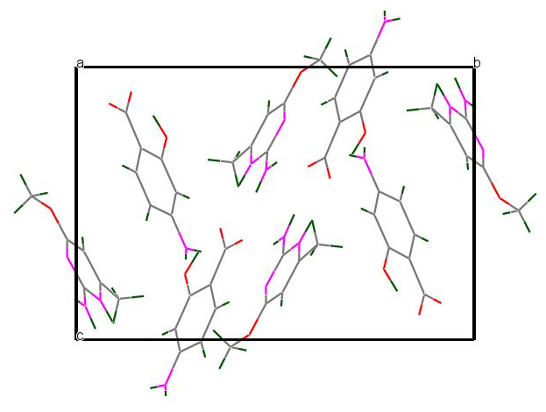 | 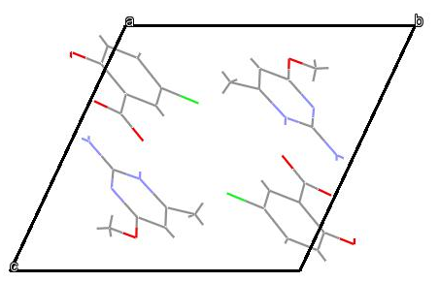
(a)
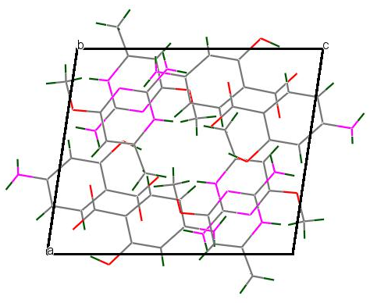 | 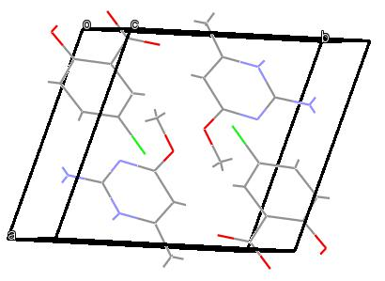
(b)
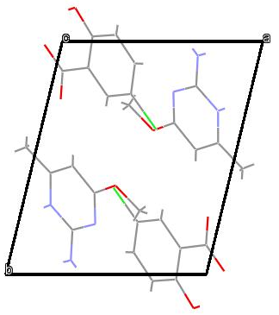 | 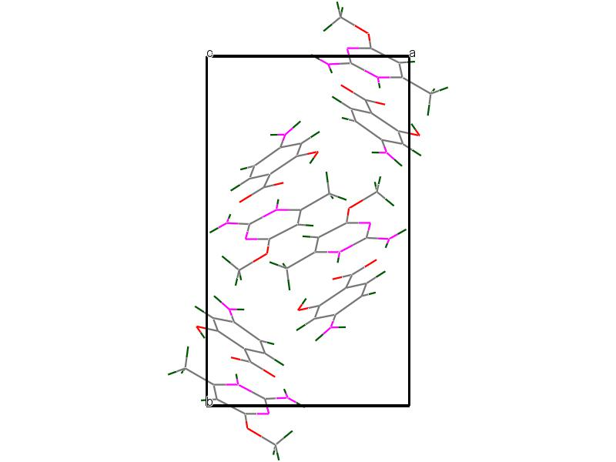
(c)

Figure (S14): Hydrogen bonding in the crystal of salt (I) showing the $R_{2}^{2}$(8) and centrosymmetric $R_{4}^{2}$(8) ring motifs.(salt – I)

Figure (S15): A view of supramolecular chain formed in (I) via N−H···O interactions with dashed lines representing hydrogen bonds. (salt – I)
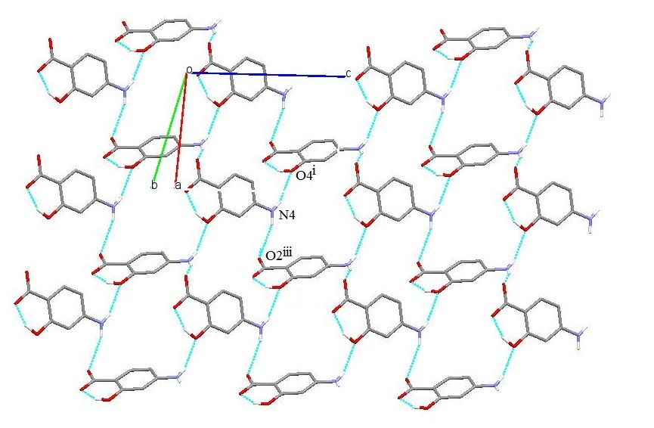
Figure S16: A molecular packing view of the supramolecular sheet. (salt – I)
Figure S17: A view of the supramolecular structures. (salt – I)
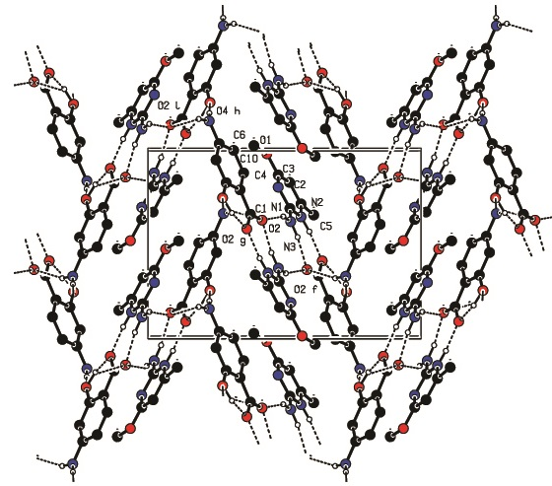

Figure (S18) : A molecular packing view of the cyclic heterotetramer. (salt – I)
Figure (S19): A view of the C−H···π stacking interactions. (salt – I)
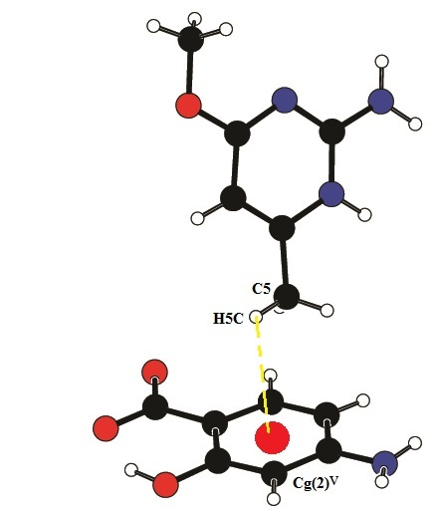

Figure (S20): A molecular packing view of linear heterotetramer. (salt – II)
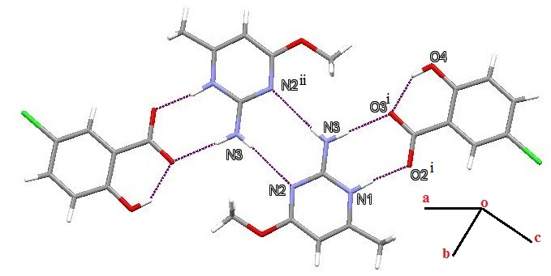

Figure (S21): A view of the supramolecular chain formed in (II) via N−H···N interactions in different planes. (salt – II)
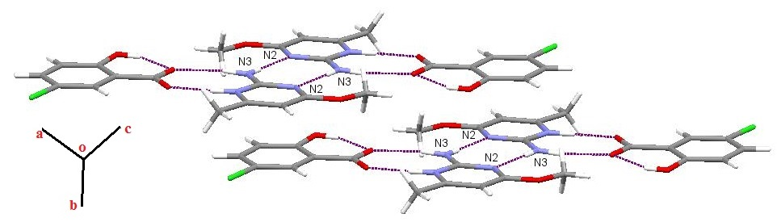

Figure (S22): A view of the C−Cl···π stacking interactions (salt – II)
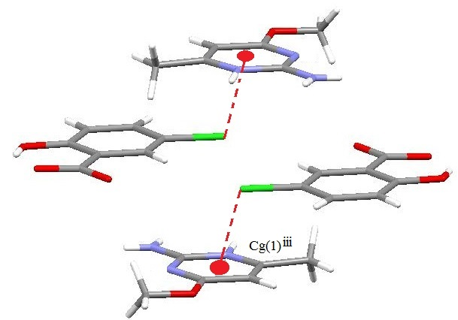

Figure (S23): Showing the dipole moment vector orientation of the salt (I & II) molecules. The origin is at the center of mass of the molecule.

Figure (S24): Three dimensional Hirshfeld surface of Salt (I) & (II): (a) di, (b) de (c) curvedness (d) shape index
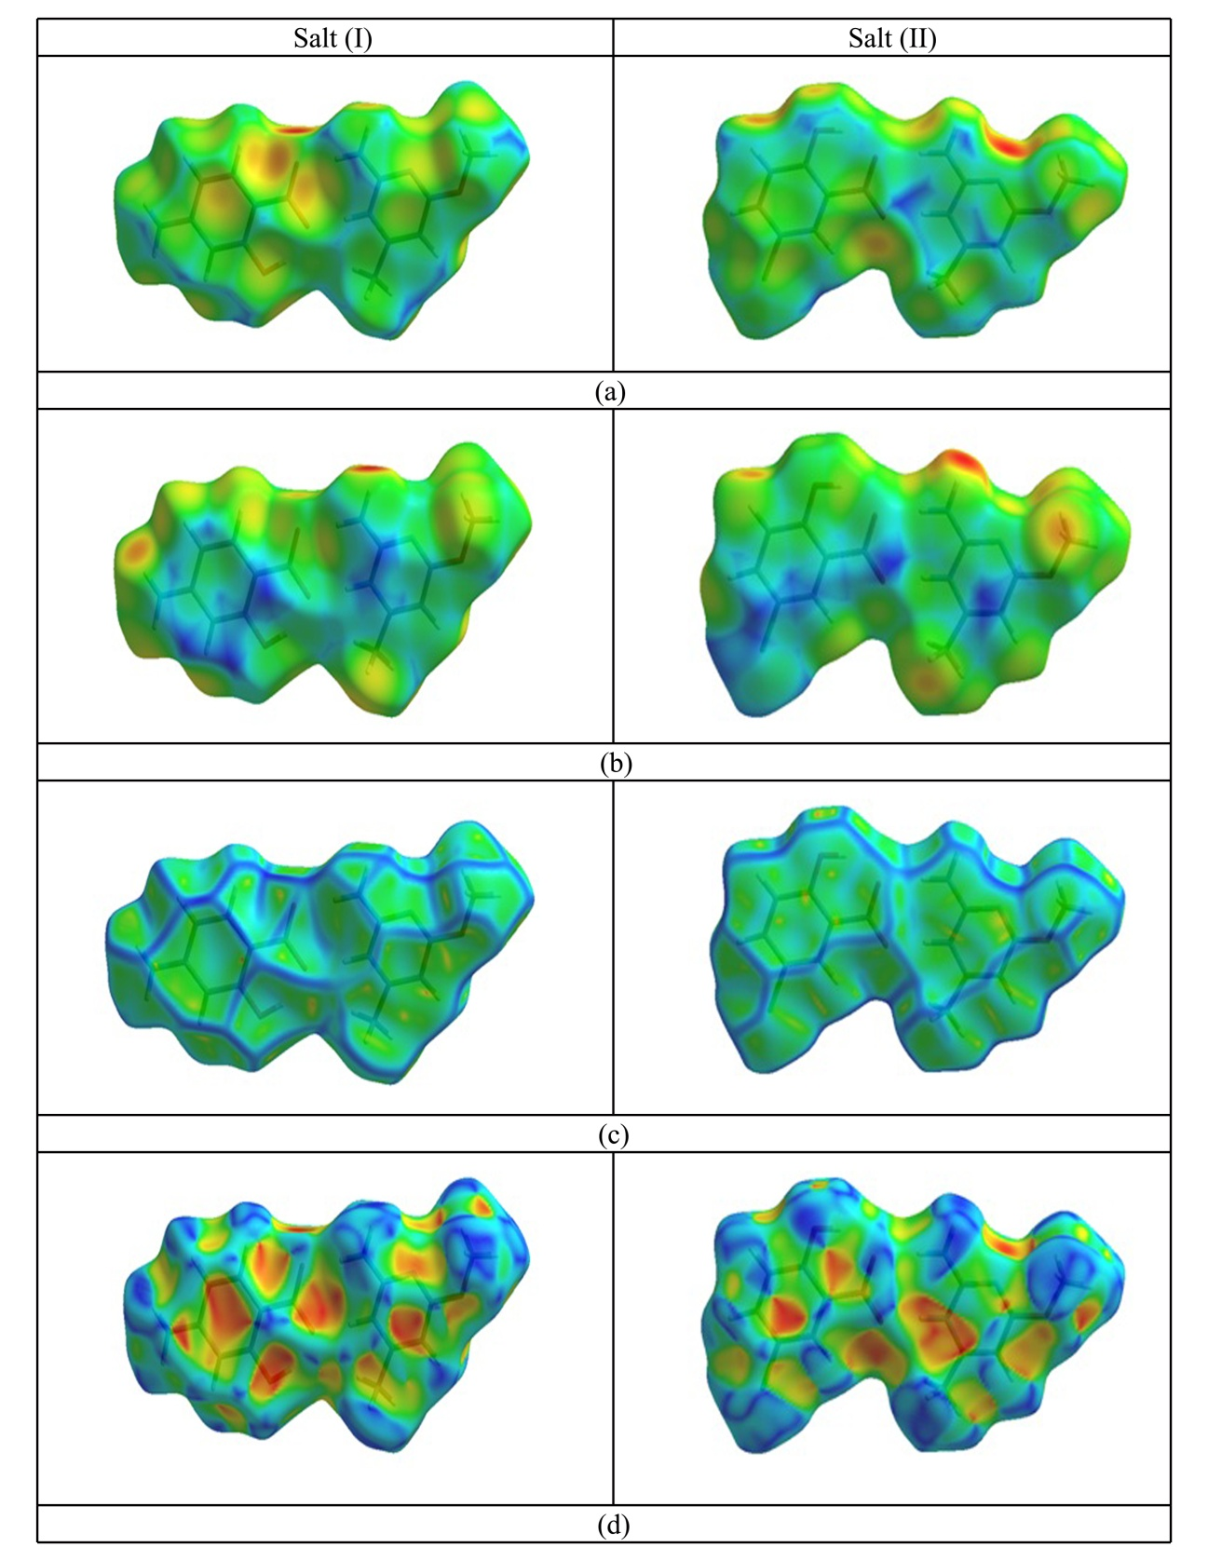

Figure (S25) The overall plot of the reduced density gradient versus the electron density times the sign of the second Hessian eigenvalue.

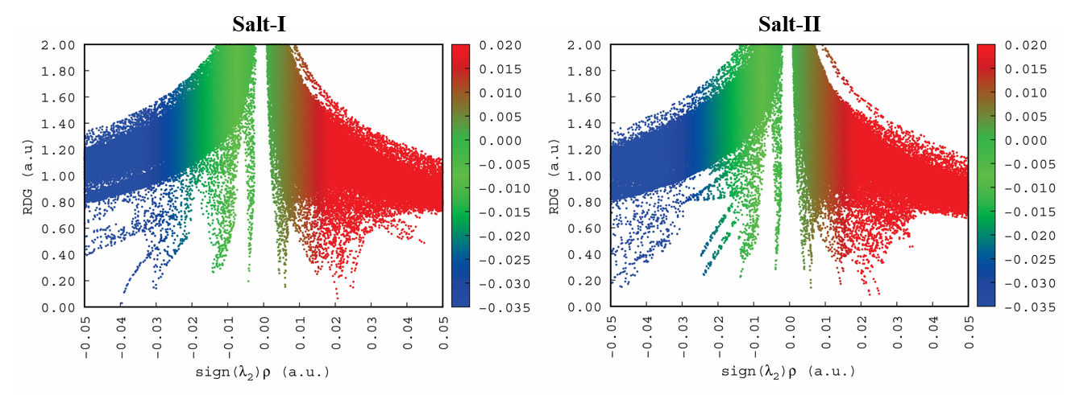Salt-I
Counterpoise corrected energy = -1025.015290987964
BSSE energy = 0.004536300468
sum of monomers = -1024.846532788945
complexation energy = -108.74 kcal/mole (raw)
complexation energy = -105.90 kcal/mole (corrected)

Salt-II
Counterpoise corrected energy = -1429.312889110770
BSSE energy = 0.001566736969
sum of monomers = -1429.131205986360
complexation energy = -114.99 kcal/mole (raw)
complexation energy = -114.01 kcal/mole (corrected)

