Supporting Information

Intriguing Type-II g-GeC/AlN Bilayer Heterostructure for Photocatalytic Water Decomposition and Hydrogen Production
Naim Ferdous¹, Md. Sherajul Islam^{1,2,*}, Md. Shahabul Alam¹, Md. Yasir Zamil¹, Jeshurun Biney¹, Sareh Vatani¹, Jeongwon Park^{1,3}
¹Department of Electrical & Biomedical Engineering, University of Nevada, Reno, NV 89557, USA.
²Department of Electrical & Electronic Engineering, Khulna University of Engineering and Technology, Khulna-9203, Bangladesh.
³School of Electrical Engineering and Computer Science, University of Ottawa, Ottawa, ON K1N6N5, Canada.

*Corresponding Author’s Email: sheraj_kuet@eee.kuet.ac.bd (Md. Sherajul Islam)

Text S1. Structural and electronic properties of GeC and AlN monolayer
After geometry optimization, the lattice constant of the freestanding GeC monolayer is calculated as 3.26 Å while the Ge-C bond length is 1.88 Å. The values agree well with the earlier theoretical and experimental studies^{1–3}. On the other hand, the geometry-optimized lattice constant and the Al-N bond length of the freestanding AlN monolayer are obtained as 3.13 Å and 1.81 Å, respectively, which are also in close agreement with previous works. The electronic band structures of the pristine GeC layer and monolayer AlN are represented in Figure S1, with their optimized structures shown in the offset. Freestanding layered GeC is a semiconductor with a direct band gap of 2.07 eV. The valence band maximum (VBM) and the conduction band minimum (CBM) are located in the high symmetry K point. The result aligns closely with the work of Ji et al.² (Direct band gap of 2.08 eV) and Yang et al.⁴ (2.07 eV band gap). The VBM of the GeC layer comes mainly from the C-p_{z} orbit, while the CBM is dominated by the Ge-p_{z} orbit⁵. In addition, freestanding monolayer AlN also reveals semiconducting properties with an indirect band gap of 2.91 eV. CBM is located in the $Γ$ point, while the VBM is in the K point. This result also corresponds well with the literature^{6–8}. N-p_{z} orbital dominates in the VBM of the freestanding AlN layer while the CBM comes from the Al-s and N-s orbitals⁷.

Stacking Configuration | Optimized lattice Constant ($Å)$ | Binding energy (meV$/Å$²) | Optimized interlayer distance ($Å)$ | Band gap (calculated with PBE-GGA in eV) | VBM Position | CBM Position
XX | 3.198 | -2.47 | 3.82 | 1.853 | K Point | K Point
XX′ | 3.255 | -45.16 | 2.43 | 2.834 | $Γ-K$ route | $M$point
XY | 3.203 | -22.5 | 3.13 | 2.099 | K Point | $Γ$ point
XY′ | 3.199 | -10.72 | 3.45 | 1.793 | K point | K point
XZ | 3.205 | -13.3 | 3.05 | 2.052 | $Γ-K$ route | K point
XZ′ | 3.198 | -3.77 | 3.68 | 1.946 | K point | K point
Table S1: Geometry optimized lattice constant, binding energy per interface area, optimized interlayer distance (h_{o}), calculated electronic band gap and the valence band maximum (VBM) and conduction band minimum (CBM) positions of the six configurations of the GeC/AlN vdW heterostructure.

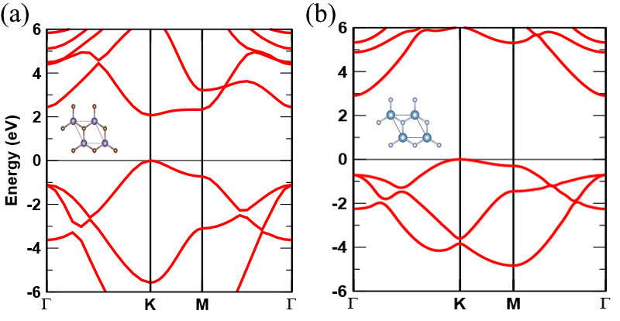
Figure S1: Electronic band diagram of (a) GeC monolayer and (b) free standing AlN layer. The valence band maximum is set to the zero value of energy. The insets show the top views of the GeC and AlN monolayers.

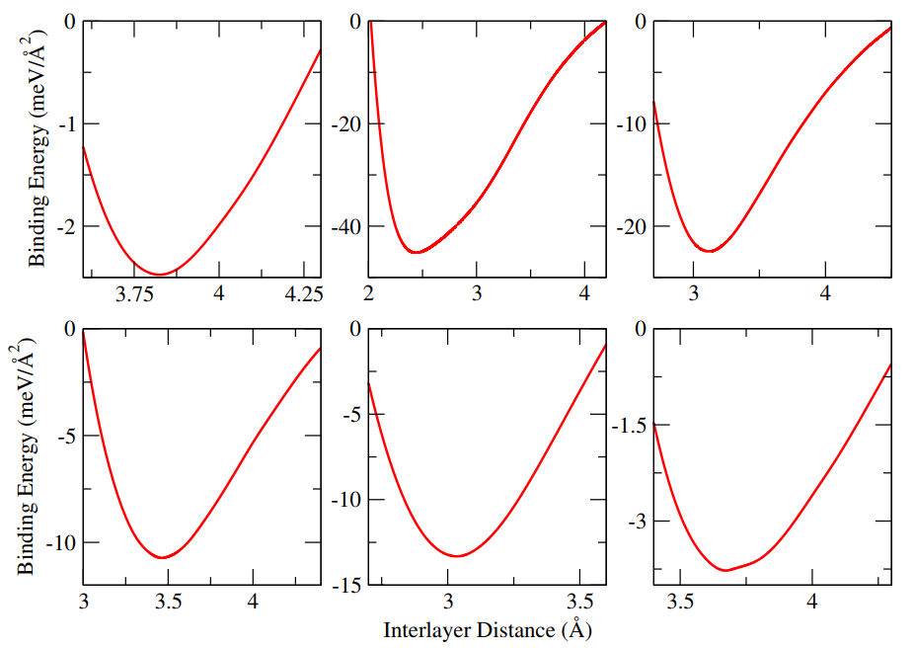
(a)
(b)
(c)
(d)
(e)
(f)

Figure S2: Binding energy as a function of interlayer distance for the six structural configurations of the GeC/AlN bilayer heterostructure (a) XX, (b) XX′, (c) XY, (d) XY′, (e) XZ, and (f) XZ′.

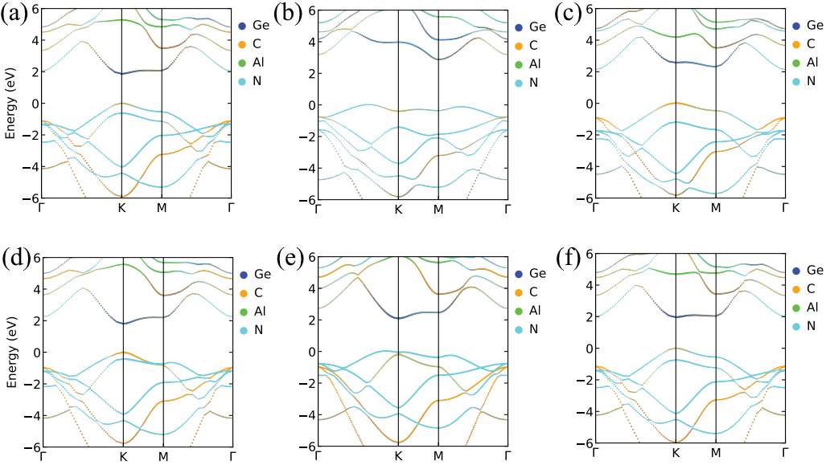
Figure S3: Atom projected band structures of the six structural configurations of the GeC/AlN bilayer heterostructure (a) XX, (b) XX′, (c) XY, (d) XY′, (e) XZ, and (f) XZ′. The blue, cyber yellow, green and sky-blue colors refer to the contribution from Ge, C, Al and N atoms, respectively.

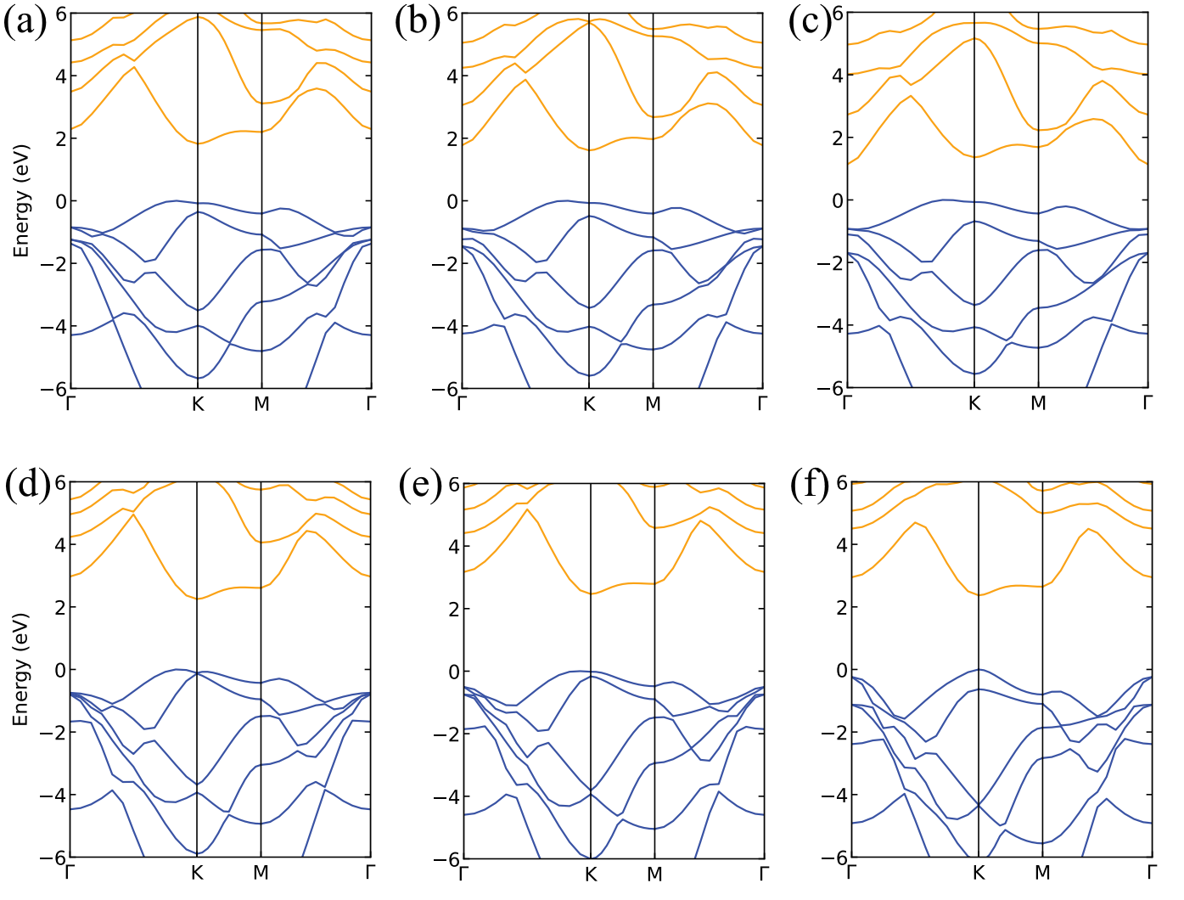
Figure S4: Electronic band diagram of the GeC/AlN bilayer heterostructure under varying percentage of strain (a) +2% Strain (b) +4% Strain (c) +6% Strain (d) -2% Strain (e) -4% Strain (f) -6% Strain.

References:
1. Xu, Z., Li, Y., Li, C. & Liu, Z. Tunable electronic and optical behaviors of two-dimensional germanium carbide. Appl. Surf. Sci. 367, 19–25 (2016).
2. Ji, Y., Dong, H., Hou, T. & Li, Y. Monolayer graphitic germanium carbide (g-GeC): The promising cathode catalyst for fuel cell and lithium-oxygen battery applications. J. Mater. Chem. A 6, 2212–2218 (2018).
3. Wu, X., Zhang, W., Yan, L. & Luo, R. The deposition and optical properties of Ge1-xCx thin film and infrared multilayer antireflection coatings. Thin Solid Films 516, 3189–3195 (2008).
4. Yang, J. et al. High-Performance p-type 2D FET Based on Monolayer GeC with High Hole Mobility: A DFT-NEGF Study. 8, 2200388(1–8) (2022).
5. Fan, X., Jiang, J., Li, R. & Mi, W. Half-metallicity and magnetic anisotropy in transition-metal-atom- doped graphitic germanium carbide (g-Gec) monolayers. J. Phys. Chem. C (2021) doi:10.1021/acs.jpcc.1c04139.
6. Şahin, H. et al. Monolayer honeycomb structures of group-IV elements and III-V binary compounds: First-principles calculations. Phys. Rev. B - Condens. Matter Mater. Phys. 80, (2009).
7. Wang, S. et al. First-principles calculations of aluminium nitride monolayer with chemical functionalization. Appl. Surf. Sci. 481, 1549–1553 (2019).
8. Zamil, M. Y., Islam, M. S., Stampfl, C. & Park, J. Tribo-Piezoelectricity in Group III Nitride Bilayers: A Density Functional Theory Investigation. ACS Appl. Mater. Interfaces (2022) doi:10.1021/acsami.2c00855.

