Supplementary material to:

A crisis of lake hypoxia in the Anthropocene: The long-term effects of climate and nutrients
Laura M. V. Soares¹, Jean-Philippe Jenny¹, Olivia Desgué-Itier¹, Cécilia Barouillet¹, Damien Bouffard², Céline Casenave³, Isabelle Domaizon¹, Victor Frossard¹, Nelson G. Hairston Jr. ⁴, Andrea Lami⁵, Bruno J. Lemaire⁶, Gaël Many⁷, Marie-Elodie Perga⁷, Georges-Marie Saulnier⁸, Fréderic Soulignac⁹, Brigitte Vinçon-Leite¹⁰

Historical reconstruction of model inflow forcing data
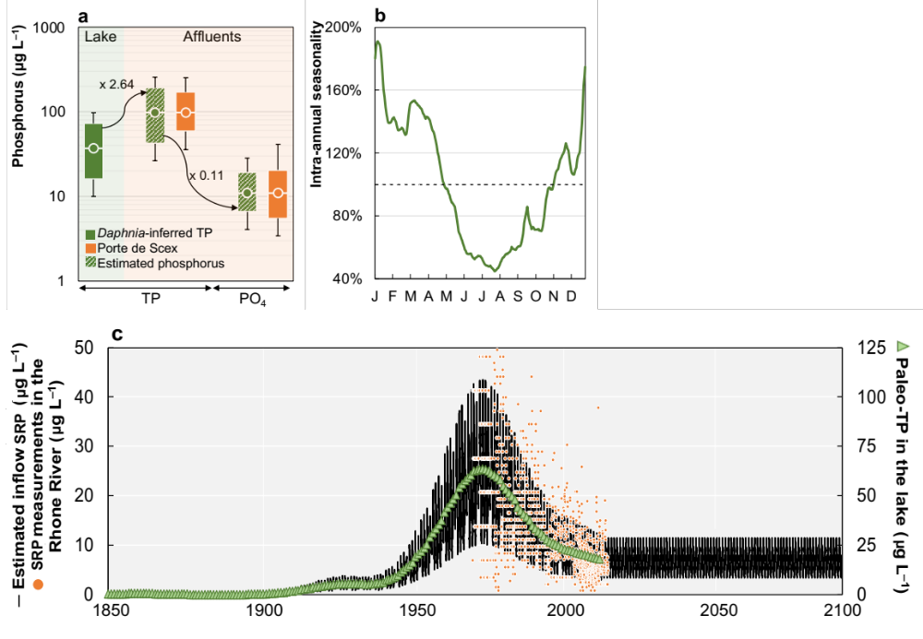
Fig. S1 | Reconstruction of long-term daily inputs of phosphorus into Lake Geneva from 1850 to 2100. a) Conversion of annual paleolimnological TP records in the lake into SRP in the tributaries (see “Methods”); b) Synthetic intra-annual seasonality of SRP in the tributaries (Porte de Scex monitoring station); c) Daily soluble reactive phosphorus input into the lake.

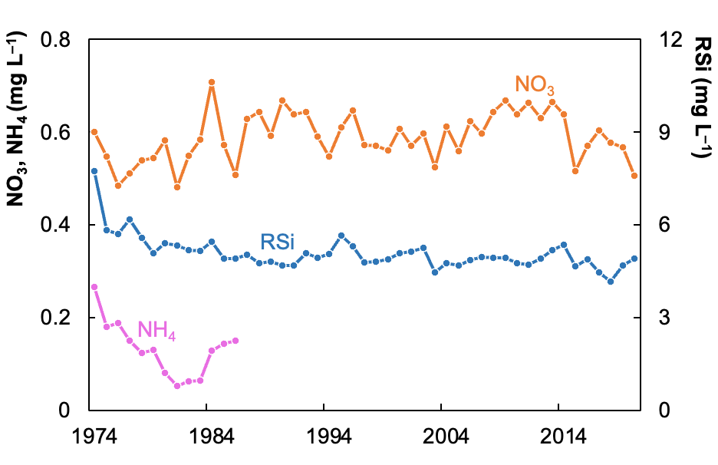
Fig. S2 | Mean annual concentrations of nitrate (NO₃), ammonium (NH₄), and silicate (RSi) measured in the Rhone River from 1974 to 2020¹.

Fourteen input variables were included in the inflow file: discharge, temperature, salinity, DO, soluble reactive phosphorus (SRP), dissolved organic phosphorus (DOP), particulate organic phosphorus (POP), ammonium (NH₄), nitrate (NO₃), dissolved organic nitrogen (DON), particulate organic nitrogen (PON), reactive silica (SiO₂), dissolved organic carbon (DOC), and particulate organic carbon (POC). Except for the phosphorus inputs, their long-term trends were estimated following common procedures found in the literature based on field measurements. A complete description of each of these methods is provided below and is summarized in Fig. S3 and Table S1.
Inflow and outflow discharge
Daily inflow discharge into Lake Geneva was estimated based on long-term monitoring of the outflow discharge, comprising 102 years of measurements¹. Monthly outflow discharges in the Rhone River from 1919 to 2020 were linearly interpolated to obtain a daily time series. The mean daily outflow over the period was computed and replicated from 1850 to 2100. Like most large natural alpine lakes, the level in Lake Geneva is regulated by several valves installed at its outlet. Indeed, since 1884, Lake Geneva’s level is regulated within limits compatible with its multiple uses: lake elevation can vary from 371.70 m to 372.30 m through the operation of a dam; during floods or heavy rains, fluctuations can occur and increase the level by about 30 cm². In face of a small variation representing only 0.3% relative to its maximum water depth, it was assumed that inflow discharges were equal to outflow discharges for the 1850–2100 period. This assumption was tested against weekly measurements of the inflow Rhone River from 1974 to 2020 multiplied by a correction factor of 1.33 to account for the contribution of the other affluents
(RMSE = 66 m³ s^{–1}; RRMSE = 10%). In addition, inflow and outflow discharges were neglected in previous modeling applications in Lake Geneva^{3,4} with no compromise of the thermal dynamics simulation by this assumption. Hence, all lake inflows were entered as input to the model as a single combined inflow.
Inflow salinity, temperature and dissolved oxygen concentration
Weekly measurements of chloride from 1974 to 2020 were linearly interpolated to obtain a daily time series; then, the mean daily chloride over the period was computed and replicated from 1850 to 2100. As the Rhone River contributes to approximately 75% of the total inflow discharge, a scaling factor of 1.33 was applied to consider the contribution of chloride in the remaining tributaries. The salinity content ($S$, pss) was calculated from chloride (${Cl}^{-}$, mg L^{–1}) as:
$S=0.0018066{×Cl}^{-}$ (1)
Daily inflow water temperature during 1850–2100 period was estimated by the air2stream model as a function of air temperature and inflow discharge⁵. A comparison of estimated water temperature against weekly measurements in the Rhone River from 1974 to 2020 presented an RMSE of 0.66 °C and an RRMSE of 7.5%. Daily inflow oxygen concentration was estimated as a function of water temperature assuming 100% saturation at the inflow^{6,7} as:
$DO=exp\left(7.71-1.31ln\left(T+45.93\right)\right)$ (2)
where $DO$ is dissolved oxygen at saturation in mg L^{–1} and T is water temperature in ºC.
The estimated inflow DO concentration was compared against weekly measurements in the Rhone River from 1974 to 2020 and a correction factor of 0.95 was applied for a closer match with field conditions. Performance metrics (RMSE = 0.56 mg L^{–1}; RRMSE = 12%) attested to the agreement between estimations and measurements. As both water temperature and dissolved oxygen were estimated from air temperature, they were calculated for the three different future climatic projections (SSP1-RCP2.6, SSP3-RCP7.0, and SSP5-RCP8.5).
Inflow nutrients
Daily ammonium, nitrate, and reactive silica concentrations in the inflows were derived by linear interpolation between weekly samples in the Rhone River from 1974 to 2020 (for ammonium, data were available from 1974 to 1986). This method has been used in other model applications^{8,9} but potentially underestimates the effect of storm events that may not be captured by routine monitoring. A scaling factor of 1.33 was applied to consider the contribution of nutrient inflows in the remaining tributaries. The mean daily concentrations over the period were computed and replicated from 1850 to 2100.
Inflow organic matter
Daily total and dissolved organic carbon in the inflows were derived by linear interpolation between weekly samples in the Rhone River from 1974 to 2020. A scaling factor of 1.33 was applied to consider the contribution of nutrient inflows in the remaining tributaries and the mean daily concentrations over the period were computed and replicated from 1850 to 2100. Particulate organic carbon was estimated as:
$POC=TOC-DOC$ (3)
In the absence of field measurements on organic nitrogen, they were calculated from inorganic nutrient concentrations and were divided into dissolved (D) and particulate (P) fractions as:
$DON or PON={ \left(TN-{NH}_{4}-{NO}_{3}\right)}/2$ (4)
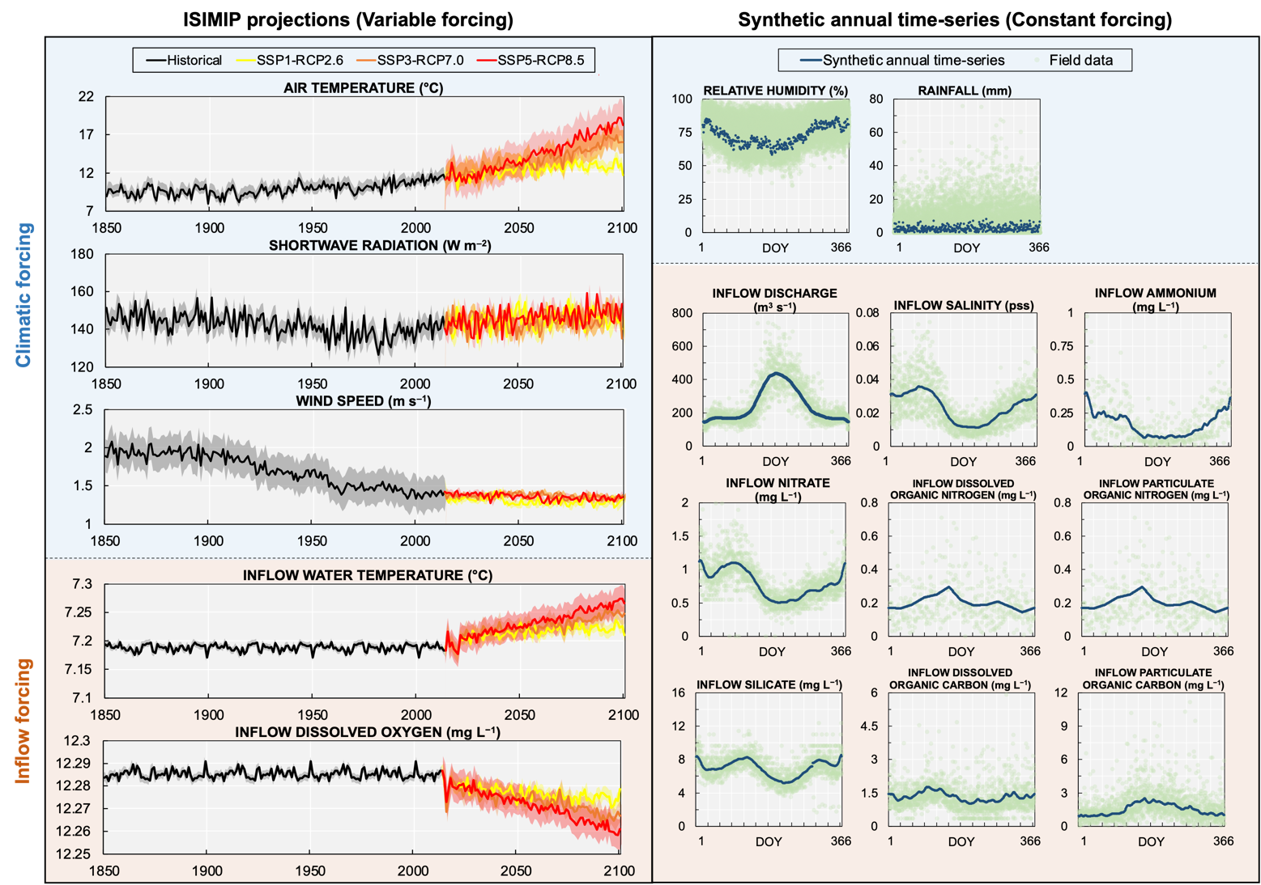
Fig. S3 | Input inflow forcing data to the GLM-AED2 model applied to Lake Geneva from 1850 to 2100. a) inflow and outflow discharge, b) salinity, c) water temperature, d) dissolved oxygen, e) ammonium, f) nitrate, g) silicate, h) dissolved organic carbon, i) particulate organic carbon, and j) dissolved and particulate organic nitrogen.

Table S1. Methods applied for long-term reconstructions of model forcing data for the historical simulations and future projections.
Driver | Historical reconstruction | Future projections
Inflow discharge  Outflow discharge | Inflow discharge was assumed equal to outflow discharge in face of a small lake level variation (0.3%). Linear interpolation of monthly outflow discharges. Replication of daily means each year for 1850–2014 period. | To isolate the effects of future climatic forcing directly on the lake, it was kept constant. Adoption of the replicated daily means for 2015–2100 period.
Inflow salinity | Linear interpolation of monthly chloride. Application of a scaling factor of 1.33 to account for the contribution of the remaining tributaries. Salinity was determined using the relationship:  salinity (ppt) = 0.0018066 $×$ Cl– (mg/L)  Replication of daily means each year for 1850–2014 period.
Inflow temperature | Estimated by the air2stream model as a function of air temperature and inflow discharge for 1850–2100 period.
Inflow oxygen | Estimated as a function of water temperature assuming 100% saturation at the inflow for 1850–2100 period as:  $DO=exp\left(7.71-1.31ln\left(T+45.93\right)\right)$
Inflow ammonium  Inflow nitrate  Inflow reactive silica  Inflow dissolved organic carbon  Inflow total organic carbon  Inflow total nitrogen | Linear interpolation between weekly measurements. A scaling factor of 1.33 was applied to consider the contribution of mass inflows in the remaining tributaries. Replication of daily means each year for 1850–2014 period. | Replication of daily means each year for 2015–2100 period.
Inflow particulate organic carbon | Calculated as:  $$POC=TOC-DOC$$
Inflow dissolved organic nitrogen  Inflow particulate organic nitrogen | Calculated from total and inorganic nitrogen concentrations as:  $DON or PON={ \left(TN-{NH}_{4}-{NO}_{3}\right)}/2$

Model calibration and validation
The modelling procedure followed well-defined standard techniques, i.e. calibration based on field measurements over a representative time period and validation against an independent dataset¹⁰. The GLM-AED2 model was calibrated for a 10-year period from 1st January 1992 to 31st December 2001 using all available measurements over the vertical profile of the water column. In the context of the present approach of coupling lake modelling and paleolimnological data, we selected the variables that contain long-term paleolimnological records as focal state variables for the calibration and validation procedures: dissolved oxygen, chlorophyll-a, and total organic carbon (TOC) (as well as water temperature that was previously calibrated⁴). Initial model parameter values and their typical ranges were derived from default values in the literature¹¹. Lake-specific calibration (Table S2) focused on parameters related to (1) oxygen and phosphorus flux at the sediment-water interface: sediment flux of oxygen and phosphorus (Fsed_oxy, Fsed_frp), half-saturation concentration controlling flux of oxygen and phopshorus (Ksed_oxy, Ksed_frp), Arrhenius temperature multiplier for sediment phosphorus flux (theta_sed_frp); (2) rates of organic matter: Arrhenius temperature multiplier for mineralization (theta_minerl), mineralization rate of dissolved organic matter (Rdom), hydrolysis rate of particulate organic matter (Rpoc_hydrol, Rpon_hydrol, Rpop_hydrol); and (3) phytoplankton growth and mortality: maximum growth rate (Rgrowth), standard, maximum and optimum temperatures (T_std, T_opt, T_max), specific attenuation coefficient (KePHY), half-saturation constant for light limitation of growth (I_K), respiration/metabolic loss rate (R_resp), Arrhenius temperature multiplier for phytoplankton respiration (theta_resp), fraction of primary production lost to exudation (f_pr), fraction of metabolic loss that is true respiration and dissolved organic matter (k_fres and k_fdom). We used a general set of parameters to represent nitrate, ammonium, and silicate because they were not the focus of this analysis.
A combination of manual and automatic calibration techniques was applied to improve the reproducibility of the magnitude, seasonal patterns, and peak timing for the selected variables. First, parameter values were manually changed to improve overall dynamics and behavior and to limit the parameter space range; then, in a second calibration step, the optimization algorithm CMA-ES (covariance matrix adaptation evolution strategy¹²) was used to minimize the fit criteria RMSE (root mean square error) between observed and simulated data. In face of the integrative aspect of the present study, model outputs of DO, chl-a, and TOC were compared to field measurements for integrated layers of epilimnion (0–30 m) and deep hypolimnion (270–300 m) instead of discrete depths. The model parameters were calibrated iteratively and fixed for the next calibration step in the following order: dissolved oxygen, total organic carbon, and chlorophyll-a. Calibration was run for 300 iterations for each variable. This calibration approach was done in accordance with other aquatic ecosystem modelling studies^{13–15}.
The calibrated parameters were validated against the remaining field data for 1957–1991 and 2002–2020 periods. We used time periods prior and after to the calibration period for validation to stress test the model by applying it at periods with different ecological characteristics.
Table S2. The selected AED parameters, their initial value, typical range, and calibrated value.
Symbol | Description | Initial value | Range | Assigned value
Oxygen
Fsed_oxy | Sedimentation flux for dissolved oxygen at 20 °C (mmol m⁻² d⁻¹) | −6 | −300 – 300 | −40.0
Ksed_oxy | Half-saturation oxygen concentration controlling oxygen flux (mmol m⁻³) | 20 | 20 – 100 | 100
Phosphorus
Fsed_frp | Sedimentation flux for filterable reactive phosphorus at 20 °C (mmol m⁻² d⁻¹) | 0.125 | −30 – 30 | 0.001
Ksed_frp | Half-saturation concentration controlling filterable reactive phosphorus flux (mmol m⁻³) | 20 | 20 – 100 | 20
theta_sed_frp | Arrhenius temperature multiplier for sediment filterable reactive phosphorus flux | 1.08 | 1.0 – 1.2 | 1.001458
Organic matter
Rdom_minerl | Mineralization rate of dissolved organic matter at 20 °C (d⁻¹) | 0.01 | 0.0001 – 0.5 | 0.002
Rpoc_hydol | Hydrolysis rate of particulate organic carbon at 20 °C (d⁻¹) | 0.01 | 0.0001 – 0.5 | 0.03
Rpon_hydol | Hydrolysis rate of particulate organic nitrogen at 20 °C (d⁻¹) | 0.01 | 0.0001 – 0.5 | 0.008
Rpop_hydol | Hydrolysis rate of particulate organic phosphorus at 20 °C (d⁻¹) | 0.01 | 0.0001 – 0.5 | 0.0009
theta_minerl | Arrhenius temperature multiplier for mineralization | 1.08 | 1.0 – 1.2 | 1.012966
Phytoplankton
R_growth | Phytoplankton maximum growth rate at 20 °C (d⁻¹) | 3.1 | 0.6 – 4.0 | 1.9
theta_std | Standard temperature (°C) | 18.0 | 15.0 – 24.0 | 18.0
theta_opt | Optimum temperature (°C) | 28.0 | 9.0 – 30.0 | 21.0
theta_max | Maximum temperature (°C) | 39.0 | 18.0 – 40.0 | 32.0
KePHY | Specific attenuation coefficient (mmol m⁻³ m⁻¹) | 0.00408 | 0.0001 – 0.005 | 0.00408
I_K | Half-saturation constant for light limitation of growth (W m⁻²) | 100 | 10 – 100 | 100
R_resp | Phytoplankton maximum respiration rate at 20 °C (d⁻¹) | 0.02 | 0.01 – 0.20 | 0.075
theta_resp | Arrhenius temperature multiplier for respiration | 1.08 | 1.0 – 1.2 | 1.2
f_pr | Fraction of primary production lost to exudation | 0.025 | 0.002 – 0.1 | 0.075
k_fres | Fraction of metabolic loss that is true respiration | 0.1 | 0.1 – 0.6 | 0.6
k_fdom | Fraction of metabolic loss that is dissolved organic matter | 0.3 | 0.05 – 0.3 | 0.3

Model performance
Seven goodness-of-fit metrics were calculated as follows to quantify the difference between field measurements and modelling results: root mean square error (RMSE), relative root mean square error (RRMSE), mean absolute error (MAE), normalized mean absolute error (NMAE), coefficient of determination (R²), bias, and Nash-Sutcliffe efficiency (NSE).
$RMSE= \sqrt{\frac{1}{n}\sum_{i=1}^{n}{{\left(S_{i}-O_{i}\right)}^{2}}}$ (5)
$RRMSE=\frac{RMSE}{\left|\max\left(O\right)-min⁡(O)\right|}$ (6)
$MAE=\frac{1}{n}\sum_{i=1}^{n}{\left|S_{i}-O_{i}\right|}$ (7)
$NMAE=\frac{1}{n}\sum_{i=1}^{n}{\frac{\left|S_{i}-O_{i}\right|}{O_{i}}}$ (8)
$R^{2}=\frac{{\left[\sum_{i=1}^{n}{\left(S_{i}-\overline{S}\right)\left(O_{i}-\overline{O}\right)}\right]}^{2}}{\left[\sum_{i=1}^{n}{{\left(S_{i}-\overline{S}\right)}^{2}}\sum_{i=1}^{n}{{\left(O_{i}-\overline{O}\right)}^{2}}\right]}$ (9)
$BIAS=\frac{1}{n}\sum_{i=1}^{n}{\left(S_{i}-O_{i}\right)}$ (10)
$NSE=1-\frac{\sum_{i=1}^{n}{{\left(S_{i}-O_{i}\right)}^{2}}}{\sum_{i=1}^{n}{{\left(O_{i}-\overline{O}\right)}^{2}}}$ (11)
where O and S are depth-averaged observed measurements and simulated data in the epilimnion (0–30 m) and deep hypolimnion (270–300 m); $\overline{S}$ and $\overline{O}$ are their average value; and n is the length of O and S which fits the number of field campaigns over the period. Appropriate levels of confidence in the model's performance are generally established as RMSE lower than 3 mg L^{–1} for DO and RRMSE lower than 50% for TOC and lower than 100% for Chl-a¹⁶.
The mean absolute error of simulated dissolved oxygen was 1.33 mg L^{–1} and 2.14 mg L^{–1} in the epilimnion and deep hypolimnion, respectively, over the complete period of simulation with available field measurements for comparison (1957–2020; Table S3). The average fits were also better in the epilimnion compared to the hypolimnion for the simulated TOC concentrations, which achieved a MAE of 0.23 mg L^{–1} and 0.52 mg L^{–1} for epi- and deep hypolimnion, respectively. The model predicted chlorophyll-a with good precision as evident in MAE of 2.56 µg L^{–1} for the epilimnion. The results demonstrate that the model simulation of the focal state variables was within the range of concentrations of field measurements both in the epi- and the deep hypolimnion from 1957 to 2020, whereas the model captured a smaller variability in DO in the epilimnion and had a systematic tendency to underestimate TOC concentrations in the bottom (Fig. S4).
Table S3 | Performance metrics of modelled dissolved oxygen, total organic carbon, and chlorophyll-a concentrations against field measurements in epilimnion and hypolimnion over calibration, validation, and complete period of simulation with available field measurements for comparison. RMSE: root mean square error, RRMSE: relative root mean square error, MAE: mean absolute error, NMAE: normalized mean absolute error, R²: coefficient of determination, bias, NSE: Nash-Sutcliffe efficiency.
 | Calibration | Validation | Complete |  | Calibration | Validation | Complete
 | DO epilimnion |  |  |  | DO hypolimnion
RMSE (mg L^{–1}) | 1.78 | 1.57 | 1.60 |  | 2.08 | 2.90 | 2.75
RRMSE | 0.33 | 0.23 | 0.24 |  | 0.31 | 0.27 | 0.26
MAE (mg L^{–1}) | 1.49 | 1.30 | 1.33 |  | 1.55 | 2.23 | 2.14
NMAE | 0.16 | 0.13 | 0.14 |  | 0.36 | 0.58 | 0.60
R² | 0.12 | 0.04 | 0.05 |  | 0.35 | 0.001 | 0.02
Bias (mg L^{–1}) | 1.11 | 0.67 | 0.74 |  | -0.43 | 0.34 | 0.33
NSE | -1.64 | -8.49 | -1.08 |  | -0.65 | -4.64 | -0.68
 | TOC epilimnion |  |  |  | TOC hypolimnion
RMSE (mg L^{–1}) | 0.29 | 0.30 | 0.30 |  | 0.71 | 0.56 | 0.60
RRMSE | 0.14 | 0.17 | 0.14 |  | 0.42 | 0.28 | 0.30
MAE (mg L^{–1}) | 0.22 | 0.24 | 0.23 |  | 0.64 | 0.48 | 0.52
NMAE | 0.19 | 0.23 | 0.22 |  | 0.66 | 0.60 | 0.61
R² | 0.16 | 0.16 | 0.17 |  | 0.16 | 0.009 | 0.03
Bias (mg L^{–1}) | -0.04 | -0.04 | -0.04 |  | -0.64 | -0.43 | -0.49
NSE | -0.66 | -0.58 | 0.28 |  | -11.07 | -6.28 | -5.63
 | Chl-a epilimnion
RMSE (µg L^{–1}) | 3.85 | 3.32 | 3.44
RRMSE | 0.23 | 0.16 | 0.16
MAE (µg L^{–1}) | 2.88 | 2.36 | 2.56
NMAE | 0.80 | 0.78 | 0.78
R² | 0.02 | 0.08 | 0.06
Bias (µg L^{–1}) | -0.36 | -0.21 | -0.11
NSE | -0.30 | -0.22 | -0.41

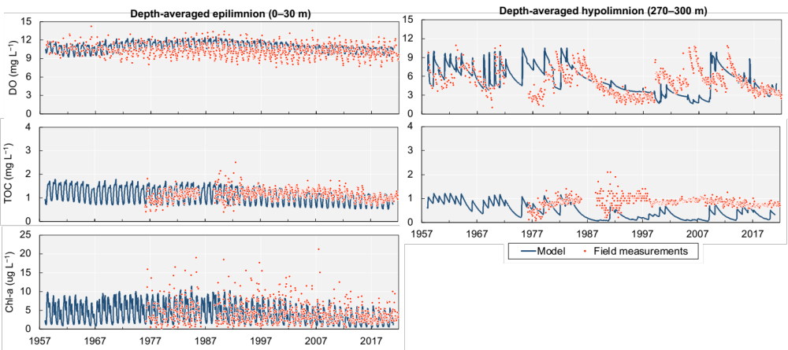
Fig. S4 | Focal state variables in depth-averaged epilimnion (0–30 m depth) and deep hypolimnion (270–300 m depth) modelled by GLM-AED2 in blue line and field measurements in red dots from the complete period of available data (1957–2020).
The model errors in this study were relatively high compared to other studies that performed short-term simulations. The reason for this result is that many of the former model studies has covered shorter time scales¹⁷ and systems that have not undergone such high nutrient variability (TP from 10 to 90 µg L^{–1}), which somewhat eases the ability to capture ecosystem dynamics. We can conclude that our simplified approach resulted in the inability of the model to fully capture short-term processes accurately. As the selection of performance metrics is highly dependent on the model's purpose, in this case, the traditional commonly applied metrics for short-term model performance assessment are considered unsuited for evaluating the ability of the model to capture long-term processes. In this manner, a complimentary analysis was implemented to quantitatively assess the model performance in replicating DO dynamics in the deep hypolimnion at long-term scales, the focus of the present study.
Cumulative distribution functions (CDF) of model concentrations and field measurements were assessed to describe the distribution of oxygen concentration in the deep hypolimnion, indicating a good agreement of the frequency of occurrence of a certain concentration value
(Fig. S5a). In addition, interpolated simulated and observed quantiles reveal a coefficient of determination as high as 0.993 (Fig S5b). Those results corroborate the understanding that, although the model is not suitable for representing certain short-term processes, the model performance is acceptable for representing processes at the decadal scale. For instance, the model correctly predicted reoccurring long-term patterns of dissolved oxygen in the bottom of the lake, such as the decadal DO replenishment after complete mixing events followed by consumption under well-established thermal stratification (Fig. S6).
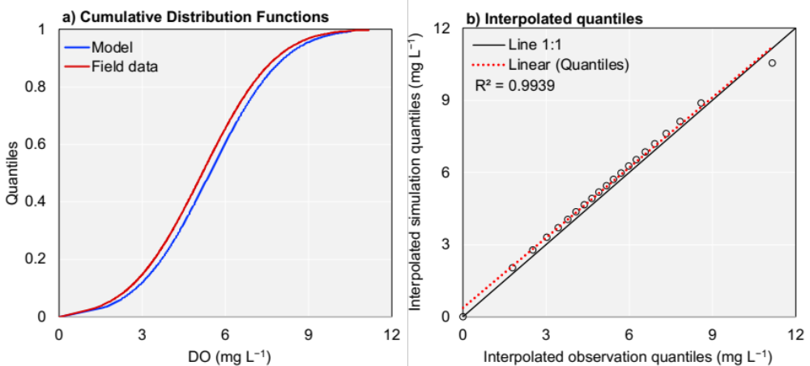
Fig. S5 | Complementary model performance analysis for dissolved oxygen concentration in the deep hypolimnion: a) Cumulative distribution functions of model concentrations and field measurements. b) Correlation between interpolated simulated and observed quantiles.
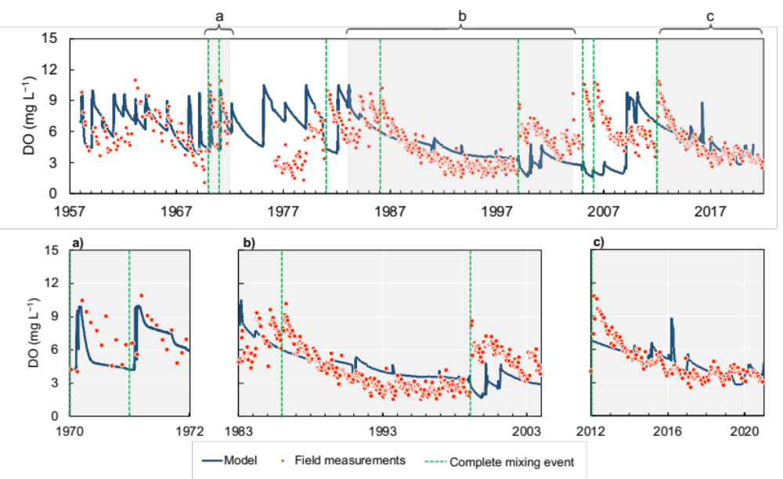
Fig. S6 | Dissolved oxygen simulation (blue line) against field measurements (red dots) in the depth-averaged deep hypolimnion (270–300 m depth) from 1957 to 2020. Events of complete mixing (Gaillard et al., 2022) are represented by green lines.
The timing of DO replenishment in the deep hypolimnion was not always captured. Discrepancies between model results and observed data were attributed mostly to the inability of the hydrodynamic module to reproduce the timing of deep mixing by using ISIMIP climatic projections, instead of meteorological time series from a close station, as DO dynamics at the bottom of the lake are strongly associated with the occurrence of stochastic deep mixing events. Nevertheless, the coupled GLM-AED2 model was able to capture important long-term transitions in hypolimnetic DO of Lake Geneva at a decadal scale. Finally, the ability of the GLM-AED2 model to replicate deep oxygen in Lake Geneva over seasonal, decadal, and centennial temporal scales is summarized in Fig. S7.
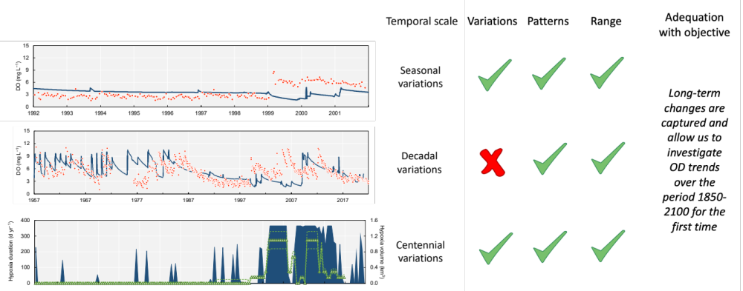
Fig. S7 | Summary of GLM-AED2 model ability to replicate deep oxygen in Lake Geneva over seasonal, decadal, and centennial temporal scales. The green signs indicate that the oxygen dynamics are well simulated.

Future simulation of deep hypoxia
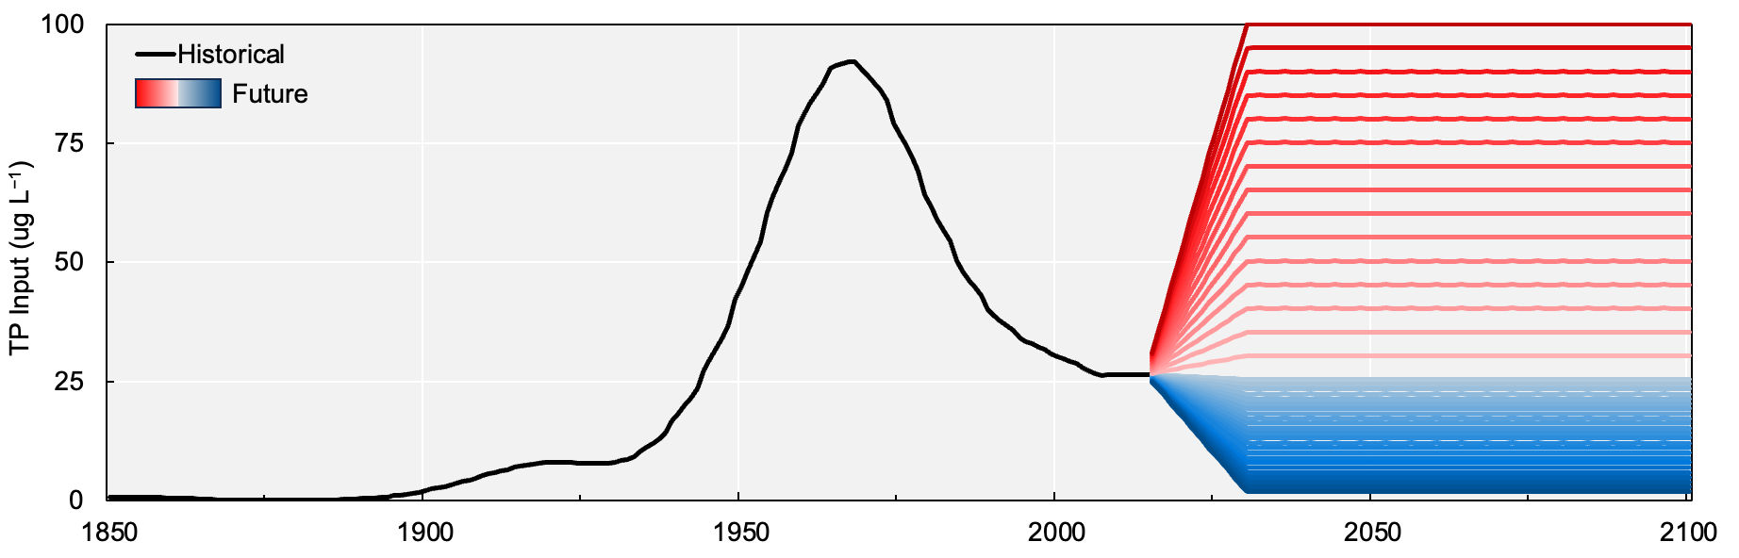
Fig. S8 | Fictional future scenarios of phosphorus input load for varying it to represent different management strategies from 2020 to 2100. Phosphorus input load in 2019 gradually increase or decrease until 2030, when the average annual value was assumed constant up to 2100. The minimum and maximum phosphorus input loads were between 2 and 100 µg L^{–1}, respectively, to cover the entire range of loads based on the historical condition. The step sizes between the minimum and maximum phosphorus input load varied, with a step size of 1 µg L^{–1} between 2 and 25 µg L^{–1} and a step size of 5 µg L^{–1} between 25 and 100 µg L^{–1}.

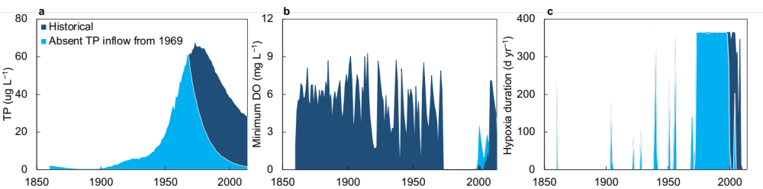
Fig. S9 | Investigating the temporal inertia of the lake and its effects on intensity and duration of hypoxia in Lake Geneva by setting phosphorus input load as absent from 1969 (year of the peak of TP input load) based on modelled a) TP concentration in the lake, which started to decrease also in 1969 and took 52 years to reach near-0 µg L^{–1} in 2020, b) minimum oxygen concentration, and c) hypoxia duration over the historical period (1850–2020).
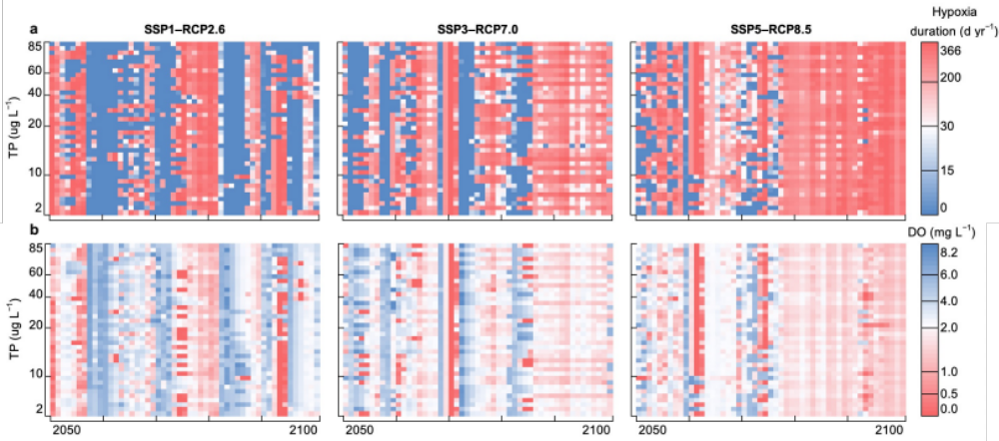
Fig. S10 | Future projected changes of a) hypoxia duration and b) minimum oxygen concentration under future climatic forcing (SSP1–RCP2.6, SSP3–RCP7.0, and SSP5–RCP8.5) and prospective scenarios of phosphorus input load over 2050–2100 period.
Fig. S11 | Elucidating shifts in hypoxia duration and annual minimum oxygen concentration throughout the water column from natural conditions, i.e. pre-1950 (blue dots and area) to a) nutrient-altered condition, i.e., from 1950 to 2020 (yellow dots and area) and b) climate-altered condition, i.e., from 2050 to 2100, for the SSP5–RCP8.5 scenario (red dots and area). c) Conceptual diagram of hypoxia state transition.
References
1. Eawag & FOEN. NADUF - National long-term surveillance of Swiss rivers (2022-1) (Version 2022-1) [Data set]. (2022) doi:https://doi.org/10.25678/00069G.
2. Jalinoux, R., Pasquini, F. & SILA. Comment et pourquoi le niveau des lacs est-il régulé ? in Le tour des grands lacs alpins naturels en 80 questions (eds. Montuelle, B. & Clemens, A.) (2015).
3. Schwefel, R., Gaudard, A., Wüest, A. & Bouffard, D. Effects of climate change on deepwater oxygen and winter mixing in a deep lake (Lake Geneva): Comparing observational findings and modeling. Water Resour Res 52, 8811–8826 (2016).
4. Desgué-Itier, O. et al. Past and future climate change effects on the thermal regime and oxygen solubility of four peri-alpine lakes. Hydrol Earth Syst Sci 27, 837–859 (2023).
5. Toffolon, M. & Piccolroaz, S. A hybrid model for river water temperature as a function of air temperature and discharge. Environmental Research Letters 10, (2015).
6. Jones, H. F. E. et al. Modelling interactive effects of multiple disturbances on a coastal lake ecosystem: Implications for management. J Environ Manage 207, 444–455 (2018).
7. Calamita, E. et al. Sixty years since the creation of Lake Kariba: Thermal and oxygen dynamics in the riverine and lacustrine sub-basins. PLoS One 14, 1–22 (2019).
8. Burger, D. F., Hamilton, D. P. & Pilditch, C. A. Modelling the relative importance of internal and external nutrient loads on water column nutrient concentrations and phytoplankton biomass in a shallow polymictic lake. Ecol Modell 211, 411–423 (2008).
9. Özkundakci, D., Hamilton, D. P. & Trolle, D. Modelling the response of a highly eutrophic lake to reductions in external and internal nutrient loading. N Z J Mar Freshwater Res 45, 165–185 (2011).
10. Hipsey, M. R. et al. A system of metrics for the assessment and improvement of aquatic ecosystem models. Environmental Modelling and Software 128, (2020).
11. Hipsey, M. R. Modelling Aquatic Eco-Dynamics: Overview of the AED modular simulation platform. Preprint at (2022).
12. Hansen, N. The CMA Evolution Strategy: A Tutorial. https://arxiv.org/abs/1604.00772 (2016).
13. Fenocchi, A. et al. Applicability of a one-dimensional coupled ecological-hydrodynamic numerical model to future projections in a very deep large lake (Lake Maggiore, Northern Italy/Southern Switzerland). Ecol Modell 392, 38–51 (2019).
14. Ladwig, R. et al. Lake thermal structure drives interannual variability in summer anoxia dynamics in a eutrophic lake over 37 years. Hydrol Earth Syst Sci 25, 1009–1032 (2021).
15. Mi, C. et al. Ensemble warming projections in Germany’s largest drinking water reservoir and potential adaptation strategies. Science of the Total Environment 748, 141366 (2020).
16. Soulignac, F. et al. Contribution of 3D coupled hydrodynamic-ecological modeling to assess the representativeness of a sampling protocol for lake water quality assessment. Knowl Manag Aquat Ecosyst 42 (2019) doi:10.1051/kmae/2019034.
17. Soares, L. M. V. & Calijuri, M. do C. Deterministic modelling of freshwater lakes and reservoirs: Current trends and recent progress. Environmental Modelling and Software vol. 144 Preprint at https://doi.org/10.1016/j.envsoft.2021.105143 (2021).

