Figure S1: Showing the increase in zone of inhibition by Gentamycin (G), Tetracycline (T) and kanamycin (K) against staphylococcus aureus MTCC 3160 when treated with volatile of mustard oil and garlic mustard oil macerate. The experiment was done in triplicate.
Table S1: Zone of inhibition by different antibiotics against S. aureus MTCC 3160 when exposed to vapour of different samples.
Sample | Gentamycin | Tetracycline | Kanamycin
Control | 25.5±0.5 | 36.00±0.00 | 24.00±0.00
Mustard oil | 34±0.00 | 48.00±0.00 | 33.5±0.5
Garlic mustard oil macerate | 36±0.00 | 50.00±0.00 | 34.5±0.5

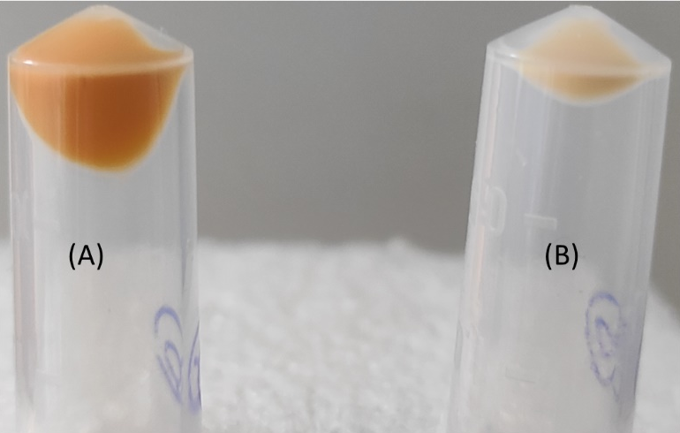

Figure S2: Representing staphyloxanthin inhibition by the GMM volatile (B) compared to the mustard oil volatile (A).

Figure S3: HPLC chromatogram of garlic mustard oil macerate (GMM) and mustard oil (MO).
Figure S4: Liquid chromatogram of garlic mustard oil macerate (GMM) during LCMS analysis.

Figure S5: Molecular docking analysis: Representation of 3D Orientation of crtM with AITC and 2D representation of interaction of AITC with specific amino acid of crtM.

Figure S6: Molecular docking analysis: Representation of 3D Orientation of crtM with dithiin and 2D representation of interaction of dithiin with specific amino acid of crtM.

Figure S7: Molecular docking analysis: Representation of 3D Orientation of crtM with sinigrin and 2D representation of interaction of sinigrin with specific amino acid of crtM.

Figure S8: Molecular docking analysis: Representation of 3D Orientation of crtM with allicin and 2D representation of interaction of allicin with specific amino acid of crtM.

Figure S9: Molecular docking analysis: Representation of 3D Orientation of crtM with ajoene and 2D representation of interaction of ajoene with specific amino acid of crtM.

