Supplementary information_ Taking a shortcut: evidence of path integration in fish (Sibeaux, Newport, Green, Engelmann & Burt de Perera)
Table S1: Experimental setup. Cichlids Group 1 experienced displacement Lateral first and a Diagonal displacement, two weeks after. Group 2 experienced a Diagonal displacement first and a Lateral displacement two weeks after.
Weekday | Day | Fish | Group | Displacement | Day | Fish | Group | Displacement | Day | Fish | Group | Displacement | Day | Fish | Group | Displacement
Sunday | 1 |  |  |  | 30 |  |  |  | 59 |  |  |  | 86
Monday | 2 | C6 | 1 | Lateral | 31 | C11 | 1 | Lateral | 60 | C21 | 1 | Lateral | 87 | C31* | 1 | Lateral
Tuesday | 3 | C7 | 1 | Lateral | 32 | C12 | 1 | Lateral | 61 | C22 | 1 | Lateral | 88 | C32 | 1 | Lateral
Wednesday | 4 | C8 | 1 | Lateral | 33 | C13 | 1 | Lateral | 62 | C23 | 1 | Lateral | 89 | C33 | 1 | Lateral
Thursday | 5 | C9 | 1 | Lateral | 34 | C14 | 1 | Lateral | 63 | C24 | 1 | Lateral | 90 | C34 | 1 | Lateral
Friday | 6 | C10 | 1 | Lateral | 35 | C15 | 1 | Lateral | 64 | C25 | 1 | Lateral | 91 | C35* | 1 | Lateral
Saturday | 7 |  |  |  | 36 |  |  |  | 65 |  |  |  | 92
Sunday | 8 |  |  |  | 37 |  |  |  | 66 |  |  |  | 93
Monday | 9 | C1 | 2 | Diagonal | 38 | C16 | 2 | Diagonal | 67 | C26 | 2 | Diagonal | 94 | C36 | 2 | Diagonal
Tuesday | 10 | C2 | 2 | Diagonal | 39 | C17 | 2 | Diagonal | 68 | C27 | 2 | Diagonal | 95 | C37 | 2 | Diagonal
Wednesday | 11 | C3 | 2 | Diagonal | 40 | C18 | 2 | Diagonal | 69 | C28 | 2 | Diagonal | 96 | C38 | 2 | Diagonal
Thursday | 12 | C4 | 2 | Diagonal | 41 | C19 | 2 | Diagonal | 70 | C29 | 2 | Diagonal | 97 | C39d** | 2 | Diagonal
Friday | 13 | C5 | 2 | Diagonal | 42 | C20 | 2 | Diagonal | 71 | C30 | 2 | Diagonal | 98 | C40 | 2 | Diagonal
Saturday | 14 |  |  |  | 43 |  |  |  | 72 |  |  |  | 99
Sunday | 15 |  |  |  | 44 |  |  |  | 73 |  |  |  | 100
Monday | 16 | C6 | 1 | Diagonal | 45 | C11 | 1 | Diagonal | 74 | C21 | 1 | Diagonal | 101 | C31 | 2 | Diagonal
Tuesday | 17 | C7 | 1 | Diagonal | 46 | C12 | 1 | Diagonal | 75 | C22 | 1 | Diagonal | 102 | C32 | 1 | Diagonal
Wednesday | 18 | C8 | 1 | Diagonal | 47 | C13 | 1 | Diagonal | 76 | C23 | 1 | Diagonal | 103 | C33 | 1 | Diagonal
Thursday | 19 | C9 | 1 | Diagonal | 48 | C14 | 1 | Diagonal | 77 | C24 | 1 | Diagonal | 104 | C34 | 1 | Diagonal
Friday | 20 | C10 | 1 | Diagonal | 49 | C15 | 1 | Diagonal | 78 | C25 | 1 | Diagonal | 105 | C35 | 2 | Diagonal
Saturday | 21 |  |  |  | 50 |  |  |  | 79 |  |  |  | 106
Sunday | 22 |  |  |  | 51 |  |  |  | 80 |  |  |  | 107
Monday | 23 | C1 | 2 | Lateral | 52 | C16 | 2 | Lateral | 81 | C26 | 2 | Lateral | 108 | C36 | 2 | Lateral
Tuesday | 24 | C2 | 2 | Lateral | 53 | C17 | 2 | Lateral | 82 | C27 | 2 | Lateral | 109 | C37 | 2 | Lateral
Wednesday | 25 | C3 | 2 | Lateral | 54 | C18 | 2 | Lateral | 83 | C28 | 2 | Lateral | 110 | C38 | 2 | Lateral
Thursday | 26 | C4 | 2 | Lateral | 55 | C19 | 2 | Lateral | 84 | C29 | 2 | Lateral | 111 | C39 | 1 | Lateral
Friday | 27 | C5 | 2 | Lateral | 56 | C20 | 2 | Lateral | 85 | C30 | 2 | Lateral | 112 | C40 | 2 | Lateral
 |  |  |  |  |  |  |  |  |  |  |  |  | 113
 |  |  |  |  |  |  |  |  |  |  |  |  | 114
 |  |  |  |  |  |  |  |  |  |  |  |  | 115 | C31 | 2 | Lateral
 |  |  |  |  |  |  |  |  |  |  |  |  | 116 | C35 | 2 | Lateral
 |  |  |  |  |  |  |  |  |  |  |  |  | 117 | C39 | 1 | Diagonal
* Building work in the lab next door could have alter the fish behaviour; ** individual C39d died between the two sessions
Table S2: Average distance between the fish trajectory and the model trajectories and between fish trajectories and the randomly generated model trajectories. The smallest average distance between the fish trajectory and one of the three model trajectories is in bold.
 | Fish | Distance to PI (mean±SD) |  |  | Distance to AC (mean±SD) |  |  |  | Distance to RR (mean±SD) |  |  | Average ± SD_{uniform} 10000 Random
 | 1D | 58.93 | ± | 35.40ª |  | 92.22 | ± | 45.10^{b} | 50.25 | ± | 55.31^{c} | 61.14 | ± | 26.19
Diagonal displacement | 3D | 47.02 | ± | 36.12ª |  | 89.33 | ± | 40.14^{b} | 52.45 | ± | 30.70^{c} | 61.89 | ± | 22.58
Diagonal displacement | 4D | 67.47 | ± | 45.94ª |  | 82.01 | ± | 39.98^{b} | 62.12 | ± | 55.98^{c} | 59.44 | ± | 27.99
Diagonal displacement | 6D | 73.81 | ± | 43.12ª |  | 69.98 | ± | 41.43^{b} | 52.43 | ± | 41.52^{c} | 60.68 | ± | 33.81
Diagonal displacement | 10D | 122.30 | ± | 73.69ª |  | 21.51 | ± | 12.28^{b} | 124.74 | ± | 82.66ª | 79.92 | ± | 37.00
Diagonal displacement | 12D | 98.82 | ± | 49.91ª |  | 46.49 | ± | 33.39^{b} | 70.94 | ± | 36.51^{c} | 65.29 | ± | 35.67
Diagonal displacement | 14D | 44.24 | ± | 24.74ª |  | 75.10 | ± | 40.07^{b} | 12.03 | ± | 7.84^{c} | 41.70 | ± | 19.25
Diagonal displacement | 18D | 43.44 | ± | 22.59ª |  | 33.07 | ± | 10.30^{b} | 22.08 | ± | 12.48^{c} | 30.17 | ± | 14.34
Diagonal displacement | 20D | 31.61 | ± | 16.19ª |  | 64.08 | ± | 35.98^{b} | 10.57 | ± | 8.16^{c} | 34.77 | ± | 15.72
Diagonal displacement | 21D | 27.37 | ± | 13.60ª |  | 111.53 | ± | 51.88^{b} | 65.41 | ± | 18.88^{c} | 67.17 | ± | 35.74
Diagonal displacement | 22D | 13.64 | ± | 11.17ª |  | 94.68 | ± | 48.88^{b} | 32.42 | ± | 11.22^{c} | 45.40 | ± | 24.35
Diagonal displacement | 25D | 18.99 | ± | 11.45ª |  | 59.82 | ± | 36.75^{b} | 14.15 | ± | 5.13^{c} | 30.06 | ± | 15.22
Diagonal displacement | 26D | 52.64 | ± | 30.21ª |  | 8.22 | ± | 3.30^{b} | 37.91 | ± | 22.61^{c} | 35.22 | ± | 15.52
Diagonal displacement | 29D | 94.53 | ± | 64.50ª |  | 58.40 | ± | 31.70^{b} | 86.35 | ± | 69.25^{c} | 64.69 | ± | 35.53
Diagonal displacement | 31D | 29.23 | ± | 10.72ª |  | 87.10 | ± | 58.09^{b} | 49.71 | ± | 27.99^{c} | 62.21 | ± | 33.24
Diagonal displacement | 33D | 110.14 | ± | 50.00ª |  | 61.92 | ± | 37.75^{b} | 88.53 | ± | 60.21^{c} | 76.58 | ± | 38.99
Diagonal displacement | 35D | 44.00 | ± | 27.90ª |  | 84.52 | ± | 50.39^{b} | 49.40 | ± | 39.43^{c} | 59.62 | ± | 27.49
Diagonal displacement | 39D | 77.05 | ± | 45.15ª |  | 79.82 | ± | 44.72ª | 56.76 | ± | 56.97 ^{b} | 61.73 | ± | 31.94
Diagonal displacement | Mean Diagonal D | 58.62 | ± | 49.44 |  | 67.77 | ± | 47.31 | 52.13 | ± | 51.11 | 55.43 | ± | 42.73
Lateral displacement | 1L | 80.58 | ± | 38.37 ª |  | 45.42 | ± | 22.23 ^{b} | 57.88 | ± | 45.67 ^{c} | 63.74 | ± | 32.61
Lateral displacement | 3L | 166.55 | ± | 79.77 ª |  | 64.09 | ± | 26.41 ^{b} | 161.17 | ± | 66.68 ª | 114.85 | ± | 45.90
Lateral displacement | 4L | 84.39 | ± | 56.42ª |  | 38.85 | ± | 11.99^{b} | 85.50 | ± | 54.05ª | 60.94 | ± | 31.86
Lateral displacement | 5L | 12.95 | ± | 5.36 ª |  | 43.80 | ± | 17.90 ^{b} | 21.36 | ± | 7.08 ^{c} | 30.68 | ± | 14.87
Lateral displacement | 6L | 48.54 | ± | 16.25 ª |  | 68.84 | ± | 54.71 ^{b} | 31.15 | ± | 15.82 ^{c} | 61.16 | ± | 22.18
Lateral displacement | 15L | 60.36 | ± | 34.85 ª |  | 63.04 | ± | 36.37 ª | 46.90 | ± | 50.53 ^{b} | 60.26 | ± | 32.87
Lateral displacement | 16L | 19.93 | ± | 10.66 ª |  | 57.99 | ± | 15.15 ^{b} | 39.06 | ± | 7.06 ^{c} | 41.52 | ± | 15.00
Lateral displacement | 18L | 25.86 | ± | 14.50 ª |  | 97.03 | ± | 54.38 ^{b} | 41.53 | ± | 22.72 ^{c} | 67.10 | ± | 34.66
Lateral displacement | 19L | 18.98 | ± | 11.13 ª |  | 100.10 | ± | 66.30 ^{b} | 51.08 | ± | 19.32 ^{c} | 67.88 | ± | 32.33
Lateral displacement | 21L | 36.98 | ± | 21.38 ª |  | 93.43 | ± | 54.03 ^{b} | 70.71 | ± | 40.91 ^{c} | 63.51 | ± | 29.34
Lateral displacement | 22L | 73.06 | ± | 52.54 ª |  | 49.51 | ± | 24.93 ^{b} | 52.84 | ± | 29.92 ^{c} | 63.79 | ± | 18.59
Lateral displacement | 26L | 55.06 | ± | 31.61 ª |  | 68.60 | ± | 34.33 ^{b} | 68.83 | ± | 41.29 ^{b} | 63.08 | ± | 16.66
Lateral displacement | 27L | 42.34 | ± | 22.52 ª |  | 78.78 | ± | 42.36 ^{b} | 60.69 | ± | 43.31 ^{c} | 62.66 | ± | 23.33
Lateral displacement | 29L | 110.17 | ± | 81.24 ª |  | 58.10 | ± | 31.31 ^{b} | 174.36 | ± | 102.01^{c} | 83.72 | ± | 23.48
Lateral displacement | 31L | 106.11 | ± | 62.18 ª |  | 14.45 | ± | 6.15 ^{b} | 103.61 | ± | 44.04 ª | 69.22 | ± | 39.03
Lateral displacement | 33L | 90.17 | ± | 58.25 ª |  | 24.84 | ± | 11.37 ^{b} | 85.12 | ± | 68.00 ^{c} | 62.92 | ± | 31.86
Lateral displacement | 34L | 45.05 | ± | 10.41 ª |  | 83.11 | ± | 25.39 ^{b} | 36.47 | ± | 9.66 ^{c} | 66.25 | ± | 27.12
Lateral displacement | 35L | 30.32 | ± | 10.18 ª |  | 71.80 | ± | 31.58 ^{b} | 38.15 | ± | 17.71 ^{c} | 54.10 | ± | 22.12
Lateral displacement | 39L | 8.60 | ± | 6.03 ª |  | 46.55 | ± | 30.24 ^{b} | 24.30 | ± | 15.16 ^{c} | 31.41 | ± | 16.19
Lateral displacement | Mean Lateral D | 57.31 | ± | 56.46 |  | 62.75 | ± | 42.72 | 64.73 | ± | 60.28 | 62.57 | ± | 53.77
PI= Path Integration, AC=Allothetic cues, RR= Route recapitulation. For each fish, different letters indicate that the distance between the fish trajectory and the models (PI, AC and RR) were significant different. Each line shows the result of a single linear mixed model (package glmmTMB) with distance as the response variable and model as the explanatory variable. Model was also added as a random intercept. We used the packages “multcomp” to adjust p-values (Holm-Bonferroni correction) and “DHARMa” for model validation. The distance to the 10000 randomly generated models followed a uniform distribution. Therefore, the standard deviation for uniform distribution was calculated as SD_{uniform} =(b-a)/sqrt (12), where [a,b] is the interval over which the continuous uniform distribution is defined.
Table S3: Fish subpopulations. a) Total number of trials tested fish from each population (each fish was tested twice, therefore Trial tests is the number of fish in each population x 2) and the number of fish that actually entered and exited the reward chamber giving us data to analysed. B) The number of fish from each population that followed either Path integration (PI), Allothetic cues (AC), Route recapitulation (RR) or showed random movements.

 | Population
 | b | c | d | e | f | g
a) Total
Trial tests | 8 | 14 | 2 | 8 | 32 | 16
Gave us data | 5 | 5 | 2 | 2 | 16 | 7
b) Following strategy
PI | 1 | 1 |  |  | 4 | 2
AC |  |  | 1 | 1 | 3 | 1
RR | 1 | 1 |  |  | 2 | 1
Random | 3 | 3 | 1 | 1 | 7 | 3

Testing the effect of subpopulation on individual’s chosen strategy was not possible with the multinomial mixed effects regression (“mblogit” function, mclogit package; Elff, 2022), detailed in the methods paragraph “Testing the effect of age, speed, trial number and displacement on chosen strategy” due to convergence problems arising from the unequal numbers of individuals sampled from each of the subpopulations

Table S4: Effect of fish age, swimming speed, the test trial number or the displacement on the navigational strategy chosen. The results in bold indicate the significant p-values.
contrast | Fixed effects |  |  | β coefficient | SE | z ratio | P
PI-AC | Age |  |  | -0.10 | 0.13 | -0.78 | 1.000
PI-RR |  |  |  | -0.03 | 0.12 | -0.25 | 1.000
PI-Random |  |  |  | -0.47 | 0.15 | -3.11 | 0.011
AC-RR |  |  |  | 0.07 | 0.13 | 0.55 | 1.000
AC-Random |  |  |  | -0.37 | 0.16 | -2.34 | 0.077
RR-Random |  |  |  | -0.44 | 0.17 | -2.59 | 0.048
PI-AC | Swimming Speed |  |  | -0.10 | 0.13 | -0.78 | 1.000
PI-RR |  |  |  | -0.03 | 0.12 | -0.25 | 1.000
PI-Random |  |  |  | -0.47 | 0.15 | -3.11 | 0.011
AC-RR |  |  |  | 0.07 | 0.13 | 0.55 | 1.000
AC-Random |  |  |  | -0.37 | 0.16 | -2.34 | 0.077
RR-Random |  |  |  | -0.44 | 0.17 | -2.59 | 0.048
PI-AC | Displacement |  | Diagonal | -0.08 | 0.09 | -0.91 | 1.000
PI-RR |  |  | Diagonal | -0.11 | 0.11 | -0.92 | 1.000
PI-Random |  |  | Diagonal | -0.68 | 0.15 | -4.55 | <0.001
AC-RR |  |  | Diagonal | -0.02 | 0.14 | -0.14 | 1.000
AC-Random |  |  | Diagonal | -0.60 | 0.19 | -3.16 | 0.008
RR-Random |  |  | Diagonal | -0.57 | 0.23 | -2.55 | 0.043
PI-AC |  |  | Lateral | -0.11 | 0.21 | -0.53 | 1.000
PI-RR |  |  | Lateral | 0.05 | 0.17 | 0.29 | 1.000
PI-Random |  |  | Lateral | -0.26 | 0.23 | -1.16 | 1.000
AC-RR |  |  | Lateral | 0.16 | 0.18 | 0.88 | 1.000
AC-Random |  |  | Lateral | -0.15 | 0.24 | -0.62 | 1.000
RR-Random |  |  | Lateral | -0.31 | 0.21 | -1.48 | 0.826
PI-AC | Trial | First |  | -0.16 | 0.12 | -1.36 | 0.521
PI-RR | Trial |  |  | -0.15 | 0.14 | -1.08 | 0.563
PI-Random | Trial |  |  | -0.63 | 0.17 | -3.76 | 0.001
AC-RR | Trial |  |  | 0.02 | 0.20 | 0.08 | 0.934
AC-Random | Trial |  |  | -0.46 | 0.24 | -1.89 | 0.297
RR-Random | Trial |  |  | -0.48 | 0.27 | -1.75 | 0.322
PI-AC | Trial | Later |  | -0.03 | 0.20 | -0.16 | 1.000
PI-RR | Trial |  |  | 0.09 | 0.16 | 0.57 | 1.000
PI-Random | Trial |  |  | -0.32 | 0.23 | -1.39 | 0.674
AC-RR | Trial |  |  | 0.12 | 0.14 | 0.91 | 1.000
AC-Random | Trial |  |  | -0.28 | 0.19 | -1.50 | 0.674
RR-Random | Trial |  |  | -0.41 | 0.17 | -2.45 | 0.085
Pairwise contrast on multinomial regression probabilities with fish identity included as random effect. The results for age and speed were averaged over the levels of displacement and test trial number, the results for displacement was averaged over the levels of test trial number and the results of test trial number was averaged over the levels of displacement. All p-values were adjusted with the Holm-Bonferroni method. β is the coefficient which estimates the strength of the effect, SE is the standard error and Z is an effect size. Random effect= fish ID: n=24. Model null deviance variance=102.6, residual deviance= 73.8.The current version of mblogit package does not allow to obtain contrasts for the intercept and the random effect but information on the full model can be found on the R code (Dryad data).

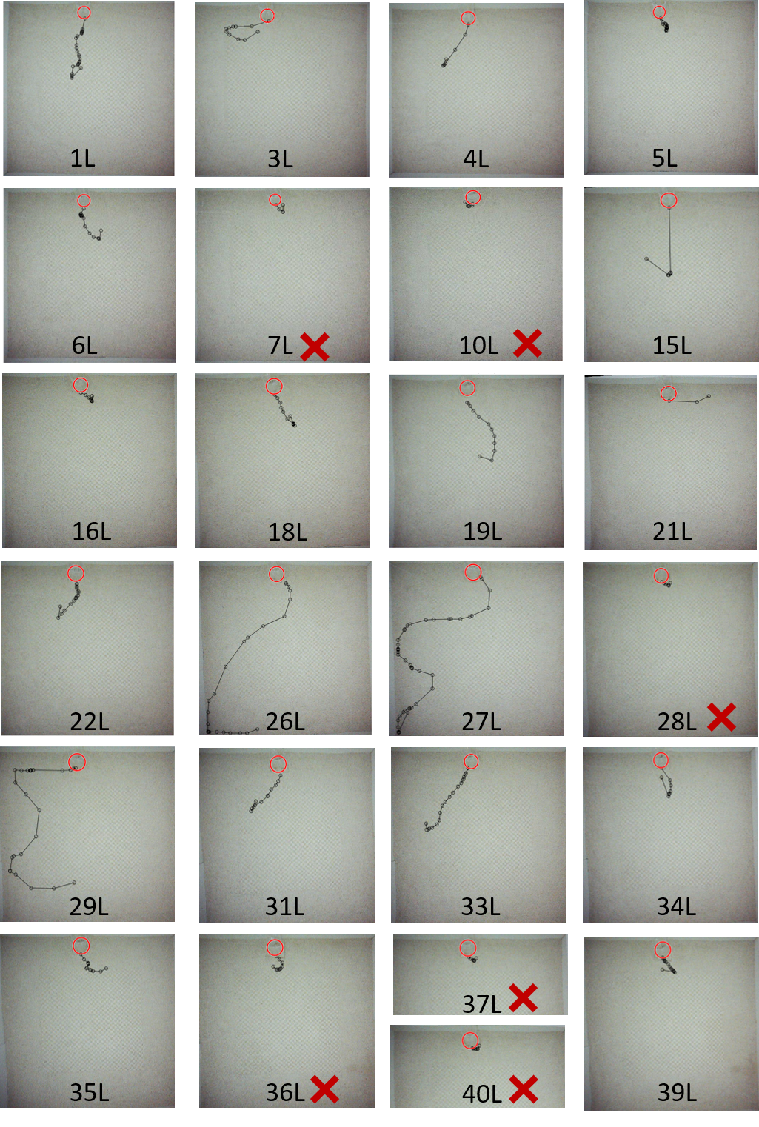
Figure S1a: Individual trajectories after Lateral displacement. The red circles indicate the chamber position after displacement. The fish position was collected every second (black dots) and we stopped analysing trajectories when the fish direction oriented toward the origin (chamber). This last position (toward origin) is represented on the following pictures but was not taking into account for the trajectory analysis. The red cross indicates the trial that were discarded (Distance from origin is shorter than the chamber diameter).
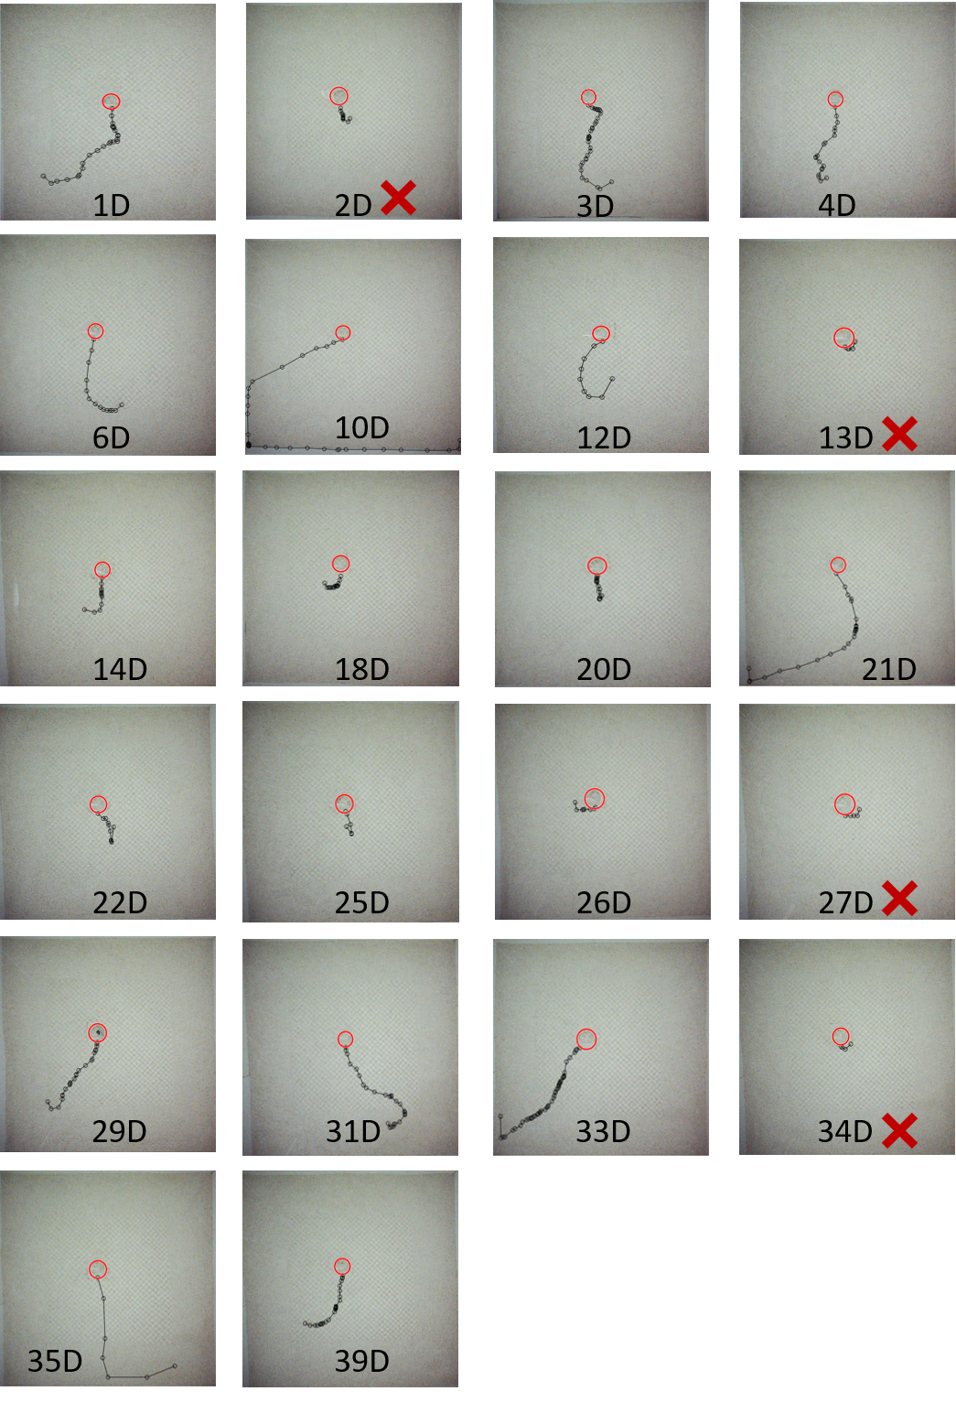
Figure S1b: Individual trajectories after Lateral displacement. The red circles indicate the chamber position after displacement. The fish position was collected every second (black circle) and we stopped analysing trajectories when the fish direction oriented toward the origin (chamber). This last position is represented on the following pictures but was not taking into account for the trajectory analysis. The red cross indicates the trial that were discarded (Distance from origin is shorter than the chamber diameter).
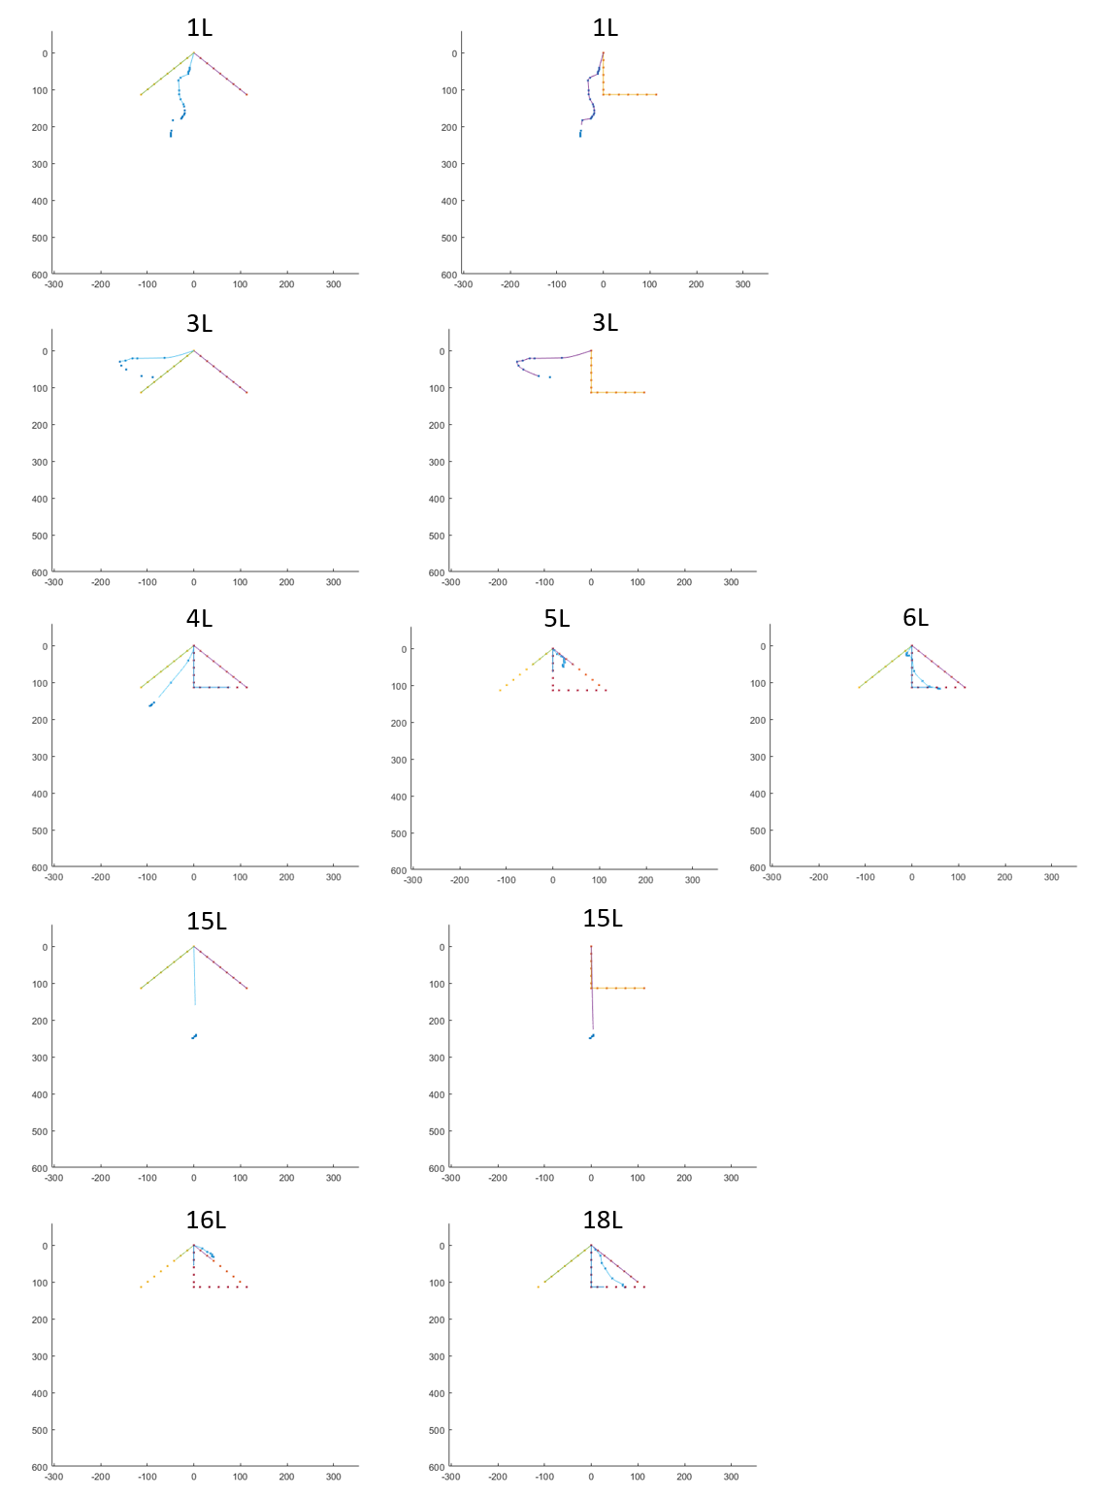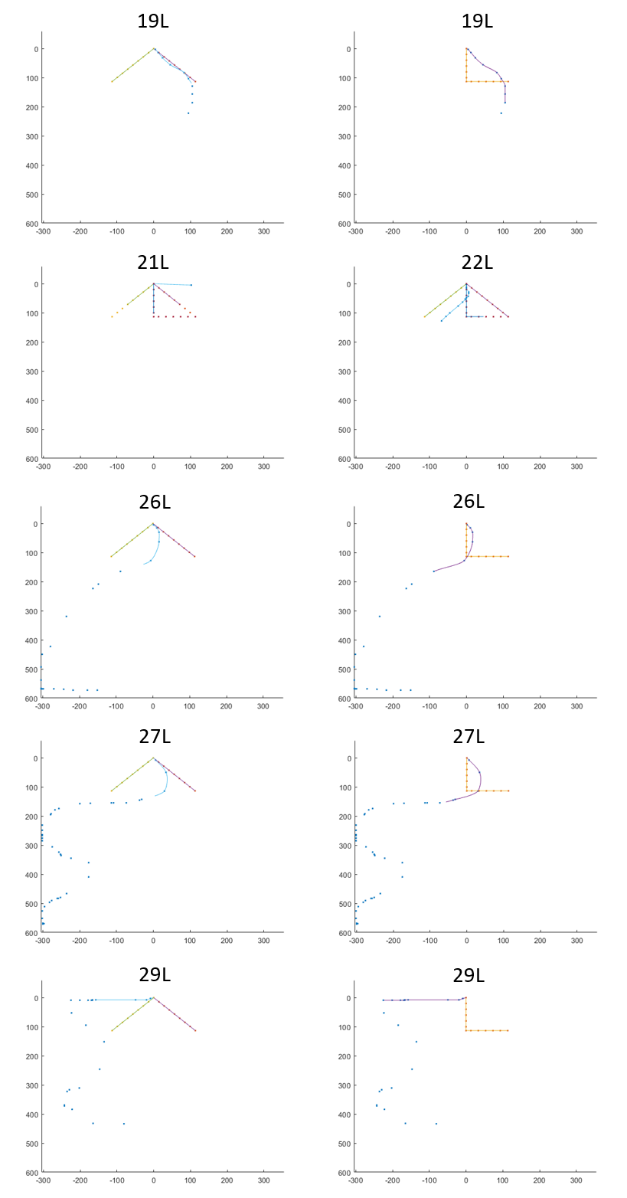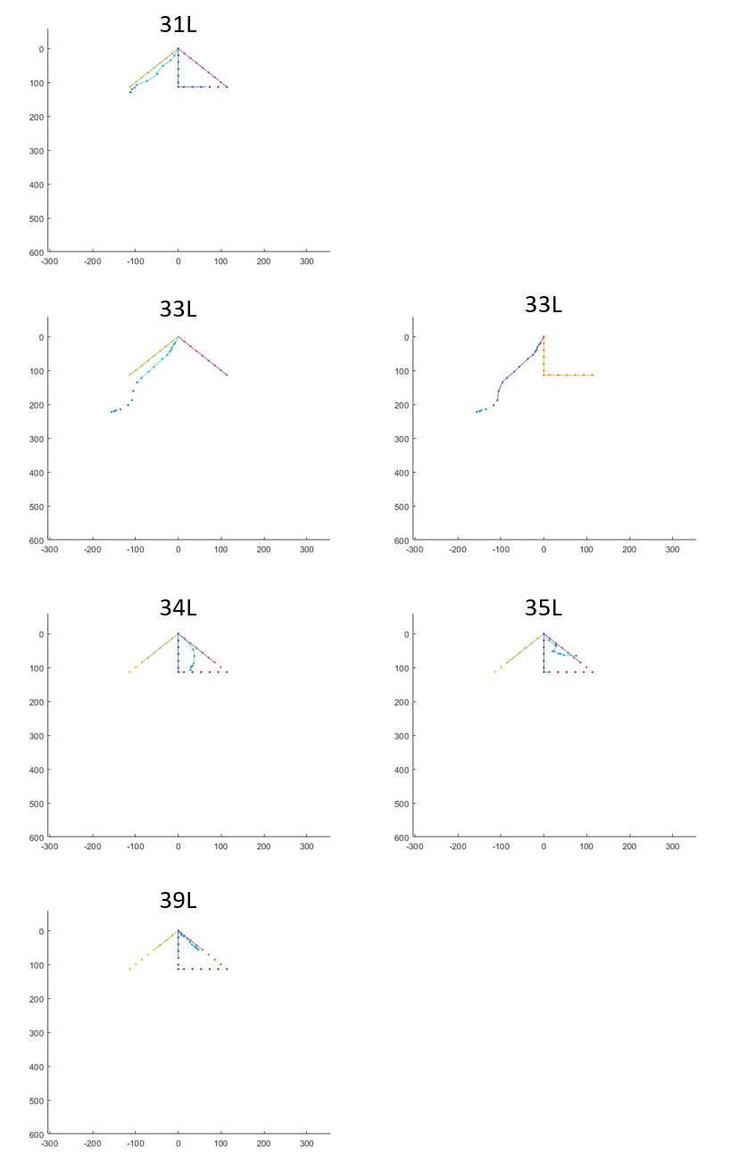
Figure S2a: Fish and model trajectories interpolation. The sinuous path represents the fish trajectory after lateral displacement, the straight line going down right represent the PI trajectory model, the straight line going down left represent the AC trajectory model, the L shaped path represent the RR trajectory. Dots represent the fish position (coordinates) taken very second or the model coordinate. Lines represent the cropped trajectories implemented with 1000 points.

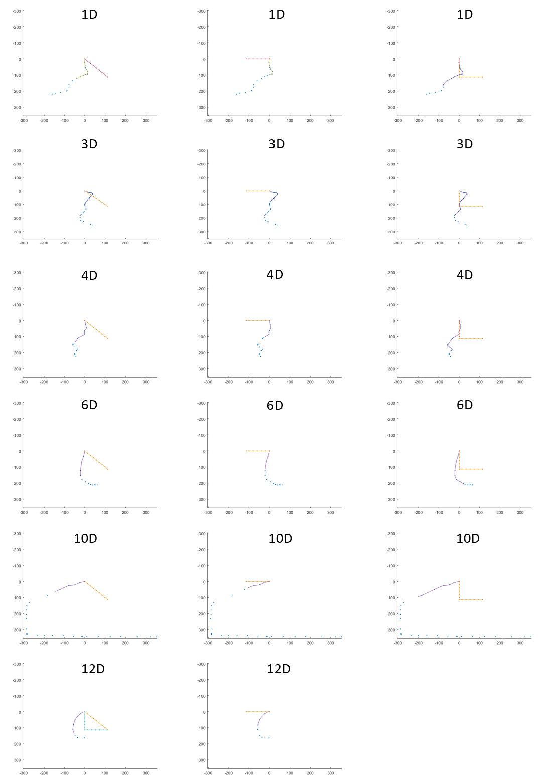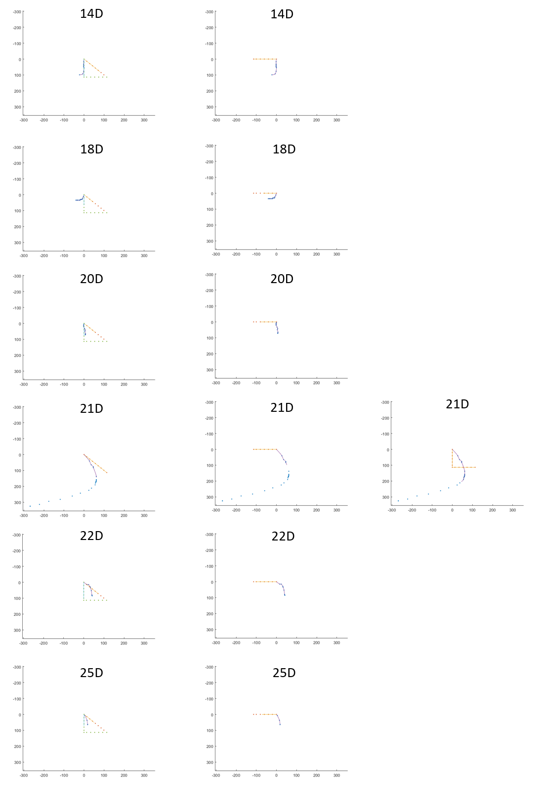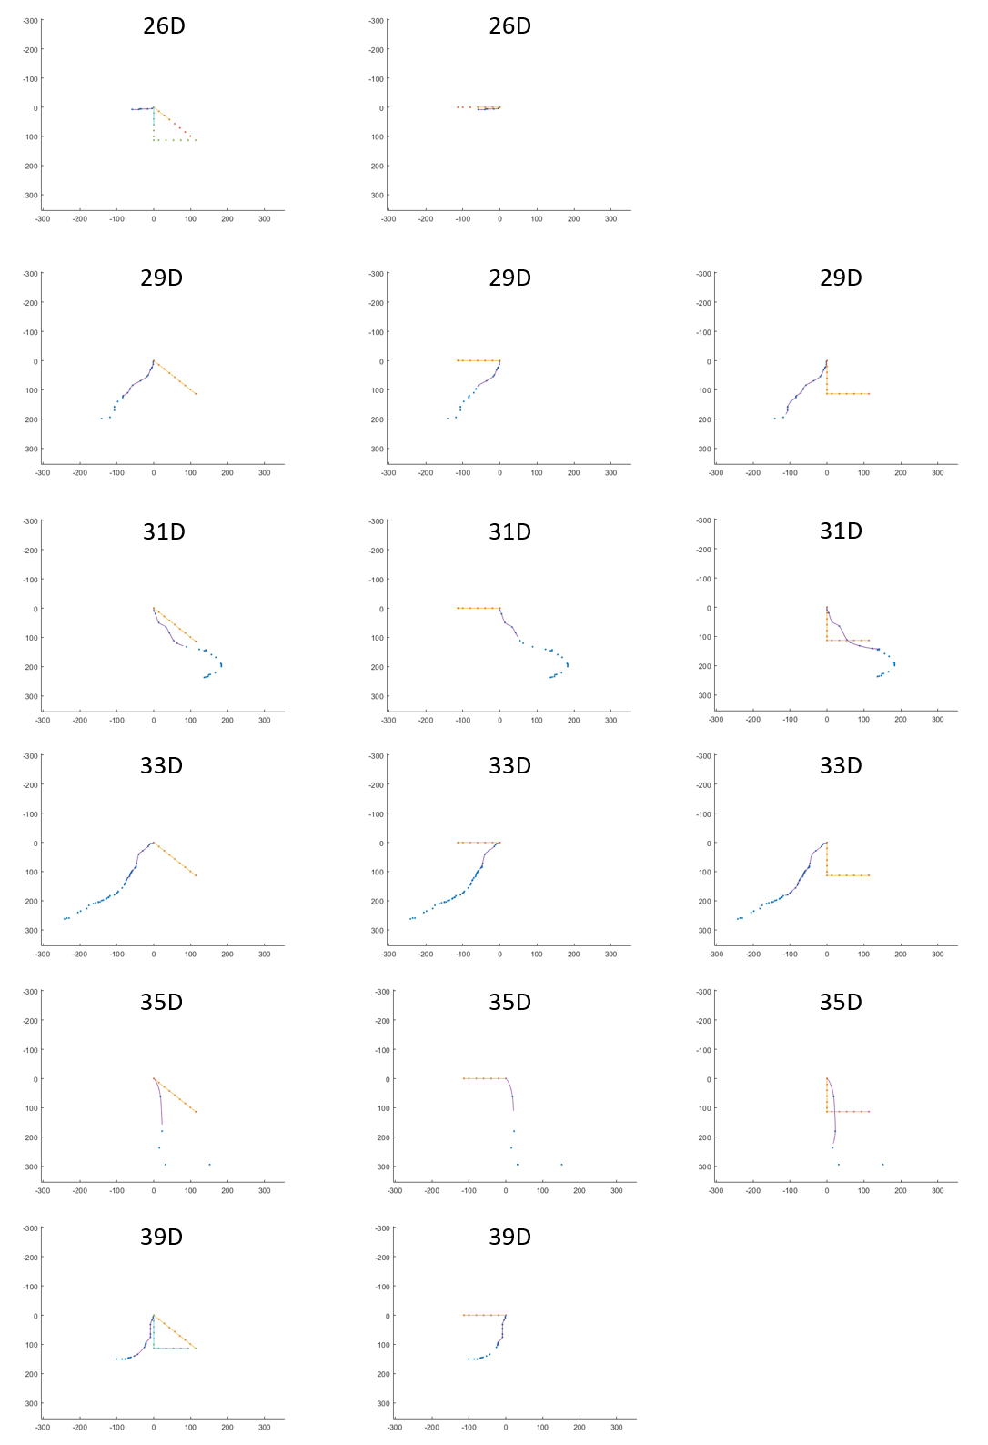
Figure S2b: Fish and model trajectories interpolation. The sinuous path represents the fish trajectory after diagonal displacement, the straight line going down right represent the PI trajectory model, the straight line going down left represent the AC trajectory model, the L shaped path represent the RR trajectory. Dots represent the fish position (coordinates) taken very second or the model coordinate. Lines represent the cropped trajectories implemented with 1000 points.
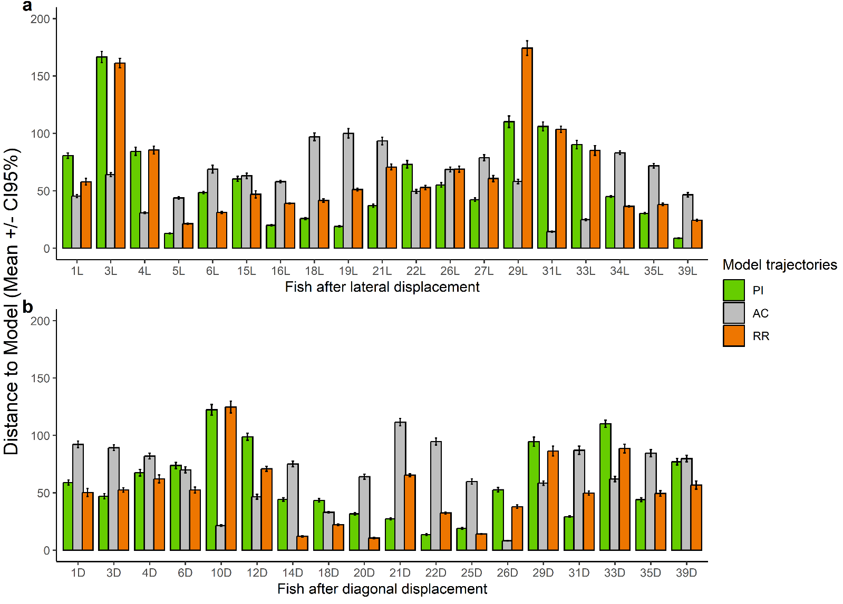
Figure S3: Average distance ± CI_{95%} between the fish trajectories and the model trajectories after a) lateral displacement or b) diagonal displacement. The average distances were calculated over the 10000 interpolated data points from the fish trajectory and each of the model trajectories. PI= Path integration, AC= Allothetic cues, RR=Route recapitulation.

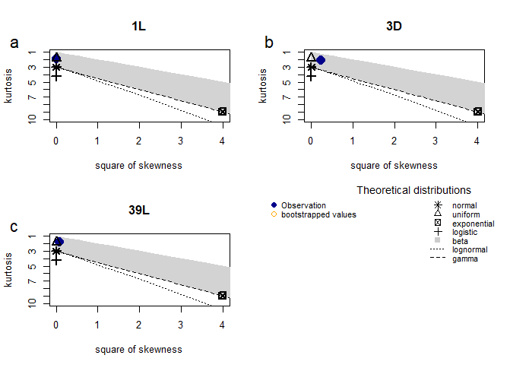
Figure S4: Cullen and Frey figures showing the distribution of the distance between the fish 1L (S4a), 3D (S4b) and 39L (S4c) trajectories and the 10000 randomly generated trajectories.

