Supplementary figure 1
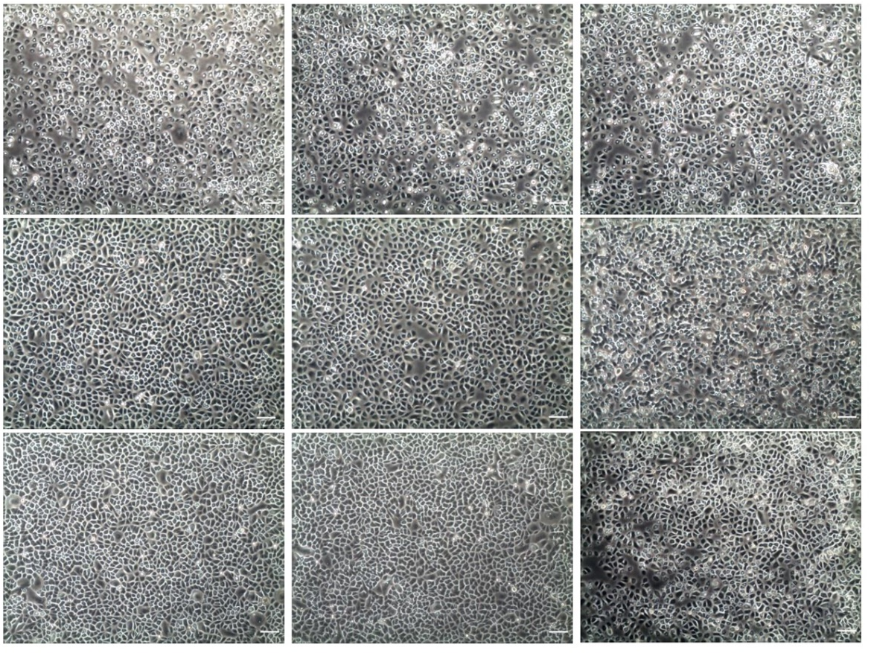

Supplementary table 1. Primer sets used in PCR
Target gene | Primer (5' – 3')
Human – occludin | F: - AAGAGTTGACAGTCCCATGGCATA -
Human – occludin | R: - AGGCTGCCTGAAGTCATCCAC -
Human – claudin 1 | F: - GGGCAGATCCAGTGCAAAG -
Human – claudin 1 | R: - GGATGCCAACCACCATCAAG -
Human – claudin 4 | F: - CCAGAGCCATATAACTGCTCAACC -
Human – claudin 4 | R: - CAAGTGTGAGCAGACCAGTTCC -
Human – ZO-1 | F: - GACCAATAGCTGATGTTGCCAGAG -
Human – ZO-1 | R: - TGCAGGCGAATAATGCCAGA -
Human – cofilin | F: - CCAGATAAGGACTGCCGCTATG -
Human – cofilin | R: - TCGTAGCAGTTTGCTTGCAATTC -
Human – ATP2C1 | F: - CAATGGATGTTCAGCAGCTTTCA -
Human – ATP2C1 | R: - AGTCTGGCCCATCGCAACTC -
Human – GAPDH | F: - GAAGGGCAAGGACACCATTA -
Human – GAPDH | R: - GGGCTCACTTTTTCTGATGC -

