Supplementary

Table S.1, 2 and 3 tabulate the cell viability in terms of cell numbers After 1 day incubation MTT tests in favor of three laser wavelength (808nm, 660nm, 450nm) at various exposure time 30sec., 90sec., 3min., 6min., and 12min. (is related to Figure1). Note that each value is multiplied by 25000 cells.

Table S. 1
Cell viability in terms of cell numbers at 808 nm for various exposure time.
Exposure time/ No. | Control | 30 Sec. | 90 Sec. | 3 min. | 6 min. | 12 min.
1 | 0.614 | 0.658 | 0.724 | 0.631 | 0.708 | 0.731
2 | 0.612 | 0.650 | 0.710 | 0.628 | 0.685 | 0.696
3 | 0.643 | 0.634 | 0.740 | 0.710 | 0.703 | 0.734

Table S. 2
Cell viability in terms of cell numbers at 660 nm for various exposure time.
Exposure time/ No. | Control | 30 Sec. | 90 Sec. | 3 min. | 6 min. | 12 min.
1 | 0.614 | 0.676 | 0.712 | 0.782 | 0.715 | 0.802
2 | 0.612 | 0.733 | 0.701 | 0.746 | 0.778 | 0.739
3 | 0.643 | 0.758 | 0.747 | 0.776 | 0.756 | 0.815

Table S. 3
Cell viability in terms of cell numbers at 450 nm for various exposure time.
No./ Exposure time | Control | 30 Sec. | 90 Sec. | 3 min. | 6 min. | 12 min.
1 | 0.614 | 0.733 | 0.739 | 0.733 | 0.739 | 0.701
2 | 0.612 | 0.681 | 0.703 | 0.701 | 0.750 | 0.670
3 | 0.643 | 0.706 | 0.703 | 0.731 | 0.722 | 0.660

Table S.4, 5 and 6 tabulate the cell viability in terms of cell numbers After 4 days incubation MTT tests in favor of three laser wavelength (808nm, 660nm, 450nm) at various exposure time 30sec., 90sec., 3min., 6min., and 12min. (is related to Figure1). Note that each value is multiplied by 25000 cells.

Table S. 4
Cell viability in terms of cell numbers at 808 nm for various exposure time.
Exposure time/ No. | Control | 30 Sec. | 90 Sec. | 3 min. | 6 min. | 12 min.
1 | 0.520 | 0.606 | 0.609 | 0.622 | 0.533 | 0.622
2 | 0.530 | 0.606 | 0.679 | 0.584 | 0.500 | 0.582
3 | 0.515 | 0.596 | 0.656 | 0.621 | 0.534 | 0.633
4 | 0.545 | 0.579 | 0.686 | 0.493 | 0.494 | 0.599
5 | 0.554 | 0.590 | 0.691 | 0.521 | 0.520 | 0.654
6 | 0.554 | 0.577 | 0.651 | 0.488 | 0.513 | 0.603

Table S. 5
Cell viability in terms of cell numbers at 660 nm for various exposure time.
Exposure time/ No. | Control | 30 Sec. | 90 Sec. | 3 min. | 6 min. | 12 min.
1 | 0.52 | 0.645 | 0.577 | 0.69 | 0.665 | 0.689
2 | 0.53 | 0.616 | 0.543 | 0.688 | 0.669 | 0.626
3 | 0.515 | 0.664 | 0.568 | 0.687 | 0.670 | 0.691
4 | 0.545 | 0.589 | 0.576 | 0.565 | 0.641 | 0.636
5 | 0.554 | 0.610 | 0.613 | 0.565 | 0.618 | 0.666
6 | 0.554 | 0.585 | 0.592 | 0.563 | 0.621 | 0.683

Table S. 6
Cell viability in terms of cell numbers at 450 nm for various exposure time.
Exposure time/ No. | Control | 30 Sec. | 90 Sec. | 3 min. | 6 min. | 12 min.
1 | 0.52 | 0.607 | 0.649 | 0.618 | 0.634 | 0.577
2 | 0.53 | 0.557 | 0.626 | 0.607 | 0.614 | 0.567
3 | 0.515 | 0.598 | 0.662 | 0.641 | 0.638 | 0.585
4 | 0.545 | 0.575 | 0.645 | 0.604 | 0.571 | 0.555
5 | 0.554 | 0.597 | 0.653 | 0.640 | 0.611 | 0.618
6 | 0.554 | 0.575 | 0.626 | 0.606 | 0.583 | 0.561

Table S.7, 8 and 9 list the number of cells under laser activation at 660 nm for 12 minutes in favor of (a) one, (b) four, and (c) seven days of incubation for various groups (is related to Figure 3). Note that each value is multiplied by 25000 cells.
S. 7) Initially only a single round of PMB by laser however, the laser exposure is carried out once every day. S. 8) Number of cells available after 1,4 and 7 days of incubation + daily laser exposure (single round per day). S. 9) Similar laser treatment two rounds per day.

Table S. 7a
Number of PC12 cells under laser activation at 660 nm for 12 minutes in favor of one day of incubation.
No. | Control | Control+ Laser | UT cR-39 | UT CR-39 +Laser
1 | 0.710 | 0.773 | 0.844 | 0.873
2 | 0.701 | 0.75 | 0.834 | 0.877
3 | 0.724 | 0.759 | 0.820 | 0.923

Table S. 7b
Number of PC12 cells under laser activation at 660 nm for 12 minutes in favor of four day of incubation.
No. | Control | Control+ Laser | UT cR-39 | UT CR-39 +Laser
1 | 0.624 | 0.693 | 0.795 | 0.872
2 | 0.621 | 0.658 | 0.777 | 0.888
3 | 0.633 | 0.643 | 0.788 | 0.910

Table S. 7c
Number of cells PC12 under laser activation at 660 nm for 12 minutes in favor of seven day of incubation.
No. | Control | Control+ Laser | UT cR-39 | UT CR-39 +Laser
1 | 0.432 | 0.462 | 0.511 | 0.687
2 | 0.431 | 0.480 | 0.520 | 0.683
3 | 0.450 | 0.492 | 0.520 | 0.670

Table S. 8a
Number of PC12 cells under laser activation at 660 nm for 12 minutes in favor of one day of incubation.
No. | control | control+ laser | UT CR-39 +laser
1 | 0.720 | 0.763 | 0.873
2 | 0.712 | 0.758 | 0.867
3 | 0.724 | 0.749 | 0.893

Table S. 8b
Number of PC12 cells under laser activation at 660 nm for 12 minutes in favor of four day of incubation.
No. | control | control+ laser | UT CR-39 +laser
1 | 0.633 | 0.020 | 0.030
2 | 0.621 | 0.028 | 0.020
3 | 0.602 | 0.021 | 0.021

Table S. 8c
Number of PC12 cells under laser activation at 660 nm for 12 minutes in favor of seven day of incubation.
No. | Control | Control+ Laser | UT CR-39 +Laser
1 | 0.422 | 0.032 | 0.037
2 | 0.410 | 0.028 | 0.023
3 | 0.450 | 0.022 | 0.017

Table S. 9a
Number of PC12 cells under laser activation at 660 nm for 12 minutes in favor of one day of incubation.
No. | control | control+ laser | UT CR-39 +Laser
1 | 0.730 | 0.263 | 0.273
2 | 0.702 | 0.258 | 0.367
3 | 0.704 | 0.249 | 0.213

Table S. 9b
Number of PC12 cells under laser activation at 660 nm for 12 minutes in favor of four day of incubation.
No. | Control | Control+ Laser | UT CR-39 +Laser
1 | 0.643 | 0.012 | 0.014
2 | 0.631 | 0.010 | 0.010
3 | 0.622 | 0.013 | 0.011

Table S. 9c
Number of PC12 cells under laser activation at 660 nm for 12 minutes in favor of seven day of incubation.
No. | Control | Control+ Laser |  | UT CR-39 +Laser
1 | 0.472 | 0.012 | 0.017
2 | 0.460 | 0.018 | 0.010
3 | 0.450 | 0.002 | 0.017

Table S.10
PC12 cell numbers (is related to Fig 4).
No. | Control | Control+ Laser | Untreated | UT CR-39 | UT CR-39+Laser
1 | 80170 | 98947 | 102000 | 231543 | 245000
2 | 81941 | 101031 | 99390 | 226700 | 243720
3 | 78871 | 102315 | 103780 | 219300 | 261500

Table S.11
The number of neurons expressing MAP2 in a quantitative way (is related to Fig6).
No. | Control | Control+ Laser |  | UT CR-39 |  | UT CR-39+Laser
1 | 274 | 387 | 634 |  | 579
2 | 93 | 503 | 549 |  | 691
3 | 118 | 219 | 430 |  | 750
4 | 186 | 234 | 601 |  | 706
5 | 215 | 178 | 580 |  | 870

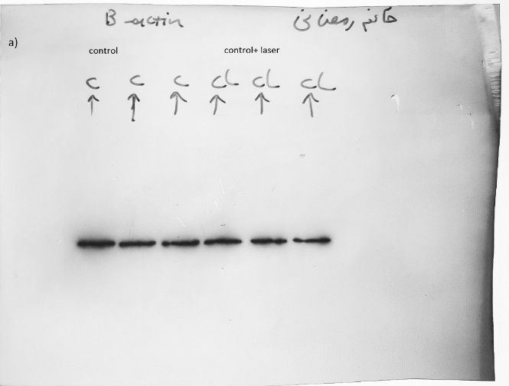 | 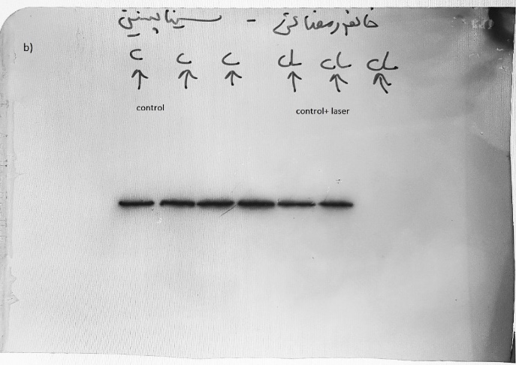
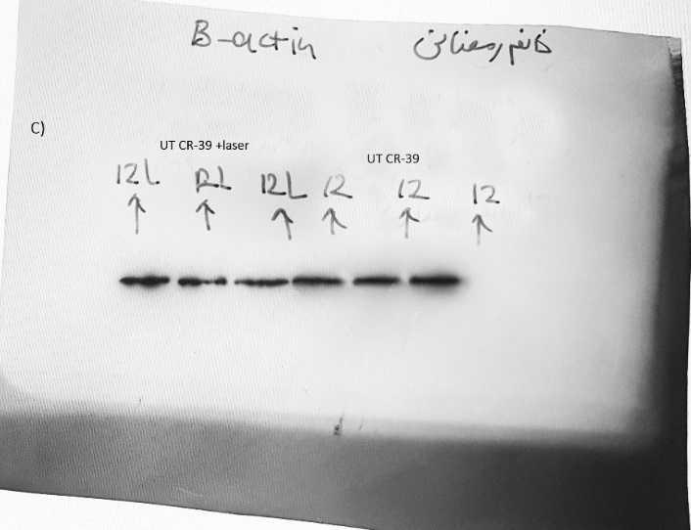 | 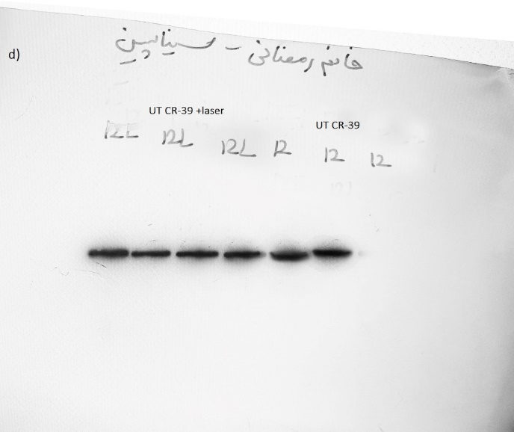
Fig S.1 Original Western blot band images. Note that all samples were tested with tree repetitions a) Beta- actin band for control and control+ laser b) Synapsin1 band for control and control+ laser c) Beta- actin band for UT CR-39 and UT CR-39 + laser d) Synapin1 band for UT CR-39 and UT CR-39 + laser. Regarding the images of Western blot given in Fig.7a, a band was cut for each group in comparison. The short name was used (12 stands for UT CR-39, 12L: UT CR39+ Laser, C: Control, CL: Control+ laser). The original bands are shown in Fig S.1 of supplementary. The dividing lines come from the original bands.

