Volume of the Dentate Gyrus/CA4 Hippocampal Subfield Mediates the Interplay between Sleep Quality and Depressive Symptoms Supplementary Materials

Supplementary tableS1. Correlational results for both the left and right hippocampal subfields with sleep quality.

 | Left DG | Left CA1 | Left CA3 | Left CA4 | Left molecular layer | Left subiculum | Left presubiculum | Left tail | Left HATA | Left parasubiculum | Left fimbria | Left fissure
PSQI | -0.087（<0.001） | -0.079  (0.002) | -0.080  (0.001) | -0.084  (<0.001) | -0.075  (0.003) | -0.055  (0.028) | -0.050  (0.046) | -0.037  (0.141) | 0.066(0.009) | -0.015  (0.539) | -0.018  (0.469) | -0.012  (0.640)
 | Right DG | Right CA1 | Right CA3 | Right CA4 | Right molecular layer | Right subiculum | Right presubiculum | Right tail | Right HATA | Right parasubiculum | Right fimbria | Right fissure
PSQI | -0.080  （0.001） | -0.038  (0.131) | -0.086  （<0.001） | -0.082  (0.001) | -0.053  (0.035) | -0.027  (0.282) | 0.003  (0.918) | -0.046  (0.068) | -0.025  (0.324) | -0.027  (0.287) | -0.018  (0.484) | 0.012  (0.632)
Note. CA, cornu ammonis; PSQI, Pittsburgh Sleep Quality Index; HATA, hippocampus- amygdala-transition-area.

Supplementary tableS2. Correlational results for all the hippocampal subfields with both sleep quality and depressive symptoms.
 | DG | CA1 | CA3 | CA4 | molecular layer | subiculum | presubiculum | tail | HATA | parasubiculum | fimbria | fissure
PSQI | -0.088  (<0.001) | -0.061  (0.015) | -0.089  (<0.001) | -0.088  (<0.001) | -0.067  (0.008) | -0.044  (0.081) | -0.026  (0.301) | -0.044  (0.082) | -0.049  (0.049) | -0.024  (0.346) | -0.020  (0.423) | 0.001  (0.980)
SDS | -0.088  (<0.001) | -0.076  (0.002) | -0.073  (0.004) | -0.083  (<0.001) | -0.069  (0.006) | -0.034  (0.168) | -0.046  (0.065) | -0.041  (0.104) | -0.072  (0.004) | -0.006  (0.825) | -0.016  (0.521) | -0.046  (0.065)
Note. CA, cornu ammonis; PSQI, Pittsburgh Sleep Quality Index; HATA, hippocampus- amygdala-transition-area.

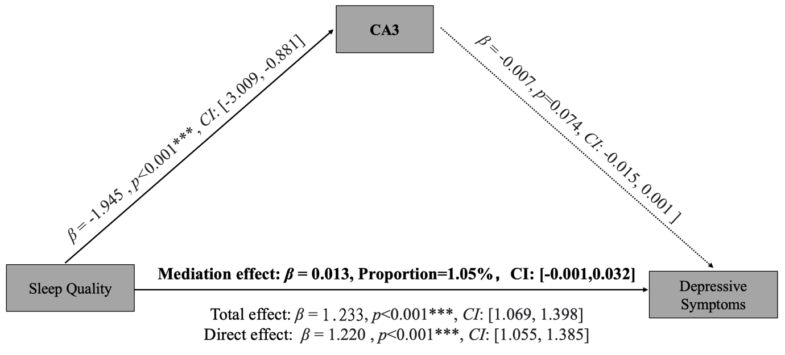

Supplementary figure 1. volume of hippocampal subfield CA-3 did not mediate the association between poor sleep quality and self-reported depression. The volume of hippocampal subfield CA-3 was selected as ﻿mediation variable. The total score of SDS was used as the dependent variable and the total score of PSQI was determined as the independent variable. Age, sex, handedness, BMI, and family income were included as covariates to rule out confounding when performing mediation analysis. DG, dentate gyrus; CA, cornu ammonis; PSQI, Pittsburgh Sleep Quality Index; SDS, Self-rating Depression Scale; CI, confidant interval.

