Supporting information
Exonuclease-III assisted the target recycling coupling with hybridization chain reaction for sensitive mecA gene analysis by using PGM

Table S1. Sequences of oligonucleotides used as probes in this work.
Title | Sequences (5’-3’)
biotin-H1 | biotin-AGA ACG TGC CGA GGA AGT ACC CTC GGC ACG TTC TGC TGA TGG
biotin-H2 | biotin-GGT ACT TCC TaCG GCA CGT TCT CCA TCA GCA GAA CGT GCC GAG
H probe | NH₂-AGA ACG TGC CGA GGA AGT ACC GTA CCA TTG CAA GGT ACT TCC AAT GAC GCT ATG ATC CCA AT
mecA | ATT GGG ATC ATA GCG TCA TT

Table S2. A brief comparison of the proposed approach with other methods.
Title | Mechanism | LOD | Signal mode | Detection target | Instrument to read results | Ref
The method | Exo-III assisted signal cycle and HCR | 2 CFU/mL | Glucose | mecA | PGM
DNA circuit | Exo-III and DNAzyme-mediated signal amplification | 1 fM | Fluorescent signal | mecA | Fluorescent landscape photometer | ¹
Fluorescence biosensor | Exo-III-assisted  cascade signal amplification strategy | 2.4 fM | Fluorescent signal | mecA | Fluorescent landscape photometer | ²
HCR based method-1 | HCR and nicking enzyme | 120 CFU/mL | Fluorescent signal | DNA sequence | Fluorescent landscape photometer | ³
HCR based method-2 | Enzyme-free HCR-based signal amplification strategy | 400 CFU/mL | Fluorescent signal | DNA sequence | Fluorescent landscape photometer | ⁴
HCR, hybridization chain reaction; LOD, limit of detection; Exo-III, exonuclease-III;

Supplemented experimental section
Genomic DNA Extraction
The ready-to-use DNA mini kit from Stratec Molecular GmbH Berlin, Germany, was used to separate bacterial DNA from MRSA strains. The genomic DNA of MRSA strains was purified using the bacterial DNA purification mini kit (Stratec Molecular, Berlin, Germany) following the manufacturer’s protocol, and stored at −20 ◦C.
DNA Quantification
The eluted genomic DNA was quantified by measuring UV absorption using a NanoDrop spectrophotometer (BioRad, Hercules, CA, USA). The DNA samples were kept at −20 ◦C for future analysis.
Gene amplification
The genomic DNA was further subjected to multiplex PCR amplification to detect mecA genes. The multiplex PCR amplification was carried out using a Bio-Rad thermal cycler. PCR was carried out in 50 µL reaction mixtures, 25 µL Quick-Load 2X power Taq Master Mix applied with 1 µL reverse primer (1 µM) and 1 µL (1 µM) forward primer and genomic DNA (30 ng/µL). Sterile distilled water was added to bring the total volume to 50 µL. The negative control comprised just the Quick-Load 2X power Taq Master Mix, primers, and sterile water. The conditions of the gradient multiplex PCR (30 cycles) used in this study are as follows: denaturation at 95 ◦C for 30 s, annealing at 55–61 ◦C for 30 s, and eventually elongation at 72 ◦C for 30 s. After the optimization of the annealing temperature, a conventional multiplex PCR was carried out using the same conditions of 95 ◦C for 30 s, followed by annealing at 60 ◦C for 30 s, and eventually elongation at 72 ◦C for 30 s.

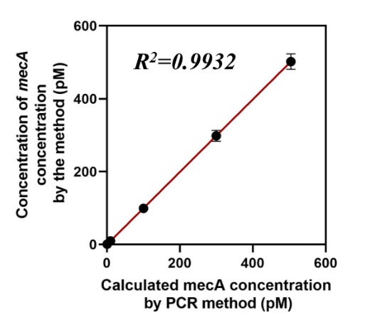
Fig. S1. Analysis of serum samples containing the mecA gene at different concentrations.

Ref
1. Pan, J.; Bao, D.; Bao, E.; Chen, J., A hairpin probe-mediated DNA circuit for the detection of the mecA gene of Staphylococcus aureus based on exonuclease III and DNAzyme-mediated signal amplification. Analyst 2021, 146 (11), 3673-3678.
2. Li, Q.; Zhou, D.; Pan, J.; Liu, Z.; Chen, J., Ultrasensitive and simple fluorescence biosensor for detection of the mecA gene of Staphylococcus aureus by using an exonuclease III-assisted cascade signal amplification strategy. Analyst 2018, 143 (23), 5670-5675.
3. Zhang, C.; Luo, Z.; Wu, M.; Ning, W.; Tian, Z.; Duan, Y.; Li, Y., A highly sensitive fluorescence biosensor for detection of Staphylococcus aureus based on HCR-mediated three-way DNA junction nicking enzyme assisted signal amplification. Analyst 2021, 146 (21), 6528-6536.
4. Tang, J.; Wang, Z.; Zhou, J.; Lu, Q.; Deng, L., Enzyme-free hybridization chain reaction-based signal amplification strategy for the sensitive detection of Staphylococcus aureus. Spectrochim Acta A Mol Biomol Spectrosc 2019, 215, 41-47.

