Supplementary Material
Table S1. TCGA 33 cancer cohorts and their abbreviations.
Cancer full name | Abbreviation | Cancer full name | Abbreviation
Adrenocortical carcinoma | ACC | Lung adenocarcinoma | LUAD
Bladder Urothelial Carcinoma | BLCA | Lung squamous cell carcinoma | LUSC
Breast invasive carcinoma | BRCA | Mesothelioma | MESO
Cervical squamous cell carcinoma and endocervical adenocarcinoma | CESC | Ovarian serous cystadenocarcinoma | OV
Cholangiocarcinoma | CHOL | Pancreatic adenocarcinoma | PAAD
Colon adenocarcinoma | COAD | Pheochromocytoma and Paraganglioma | PCPG
Lymphoid Neoplasm Diffuse Large B-cell Lymphoma | DLBC | Prostate adenocarcinoma | PRAD
Esophageal carcinoma | ESCA | Rectum adenocarcinoma | READ
Glioblastoma multiforme | GBM | Sarcoma | SARC
Head and Neck squamous cell carcinoma | HNSC | Skin Cutaneous Melanoma | SKCM
Kidney Chromophobe | KICH | Stomach adenocarcinoma | STAD
Kidney renal clear cell carcinoma | KIRC | Testicular Germ Cell Tumors | TGCT
Kidney renal papillary cell carcinoma | KIRP | Thyroid carcinoma | THCA
Acute Myeloid Leukemia | LAML | Thymoma | THYM
Brain Lower Grade Glioma | LGG | Uterine Corpus Endometrial Carcinoma | UCEC
Liver hepatocellular carcinoma | LIHC | Uterine Carcinosarcoma | UCS
Uveal Melanoma | UVM

Figure S1. Correlation analysis between ANO family and six immune subtypes.
(a) The medium expression level of ANO family in C1-C6 immune subtypes.
(b-d) Boxplot showing expression differences of ANO family in different immune subtypes with tumor of LIHC, BRCA and SARC, respectively.
(***: p < 0.001; **: p < 0.01; *: p<0.05; LIHC: Liver hepatocellular carcinoma, BRCA: Breast invasive carcinoma, SARC: Sarcoma).
Figure S2. Three examples showing the correlation between ANO family and stemness indices, stromal scores, immune scores, estimate scores and tumor purity.
(LIHC: liver hepatocellular carcinoma; COAD: colorectal adenocarcinoma; HNSC: head and neck squamous carcinoma)
Figure S3. Correlation between ANO family and drug sensivity.
Scatter plots showing correlation between ANO family and many compounds. (Vertical axis means drug activity Z score in Cellminer database and horizontal axis stand for expression level of each ANO member)
Figure S4. Protein-protein network, correlation analysis and alteration in ANO family.
(a) The protein-protein interaction network, ANO1, ANO8 among the center stage.
(b) Correlation heatmap. Intense correlations were seen between ANO4 and ANO5, ANO7L1 and ANO9, both with a Pearson coefficient of 0.35.
(c) Oncoprint showing the alteration of ANO family. ANO1, ANO2 took up the top roll with a mutation frequency of 7% and 4% respectively.
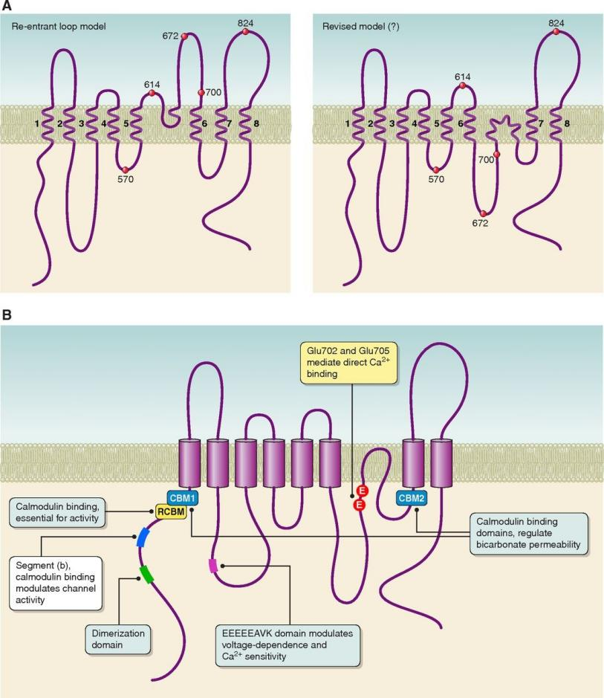
Figure S5. The speculative mechanism diagram of ANO family.
(a) The structure of ANO family proteins.
(b) As data from exoRBase has confirmed the exosome expression of ANO family in several cancer tissues, it can be speculated that all ANO members can act as exosome themselves to mediated downstream signal transduction.

