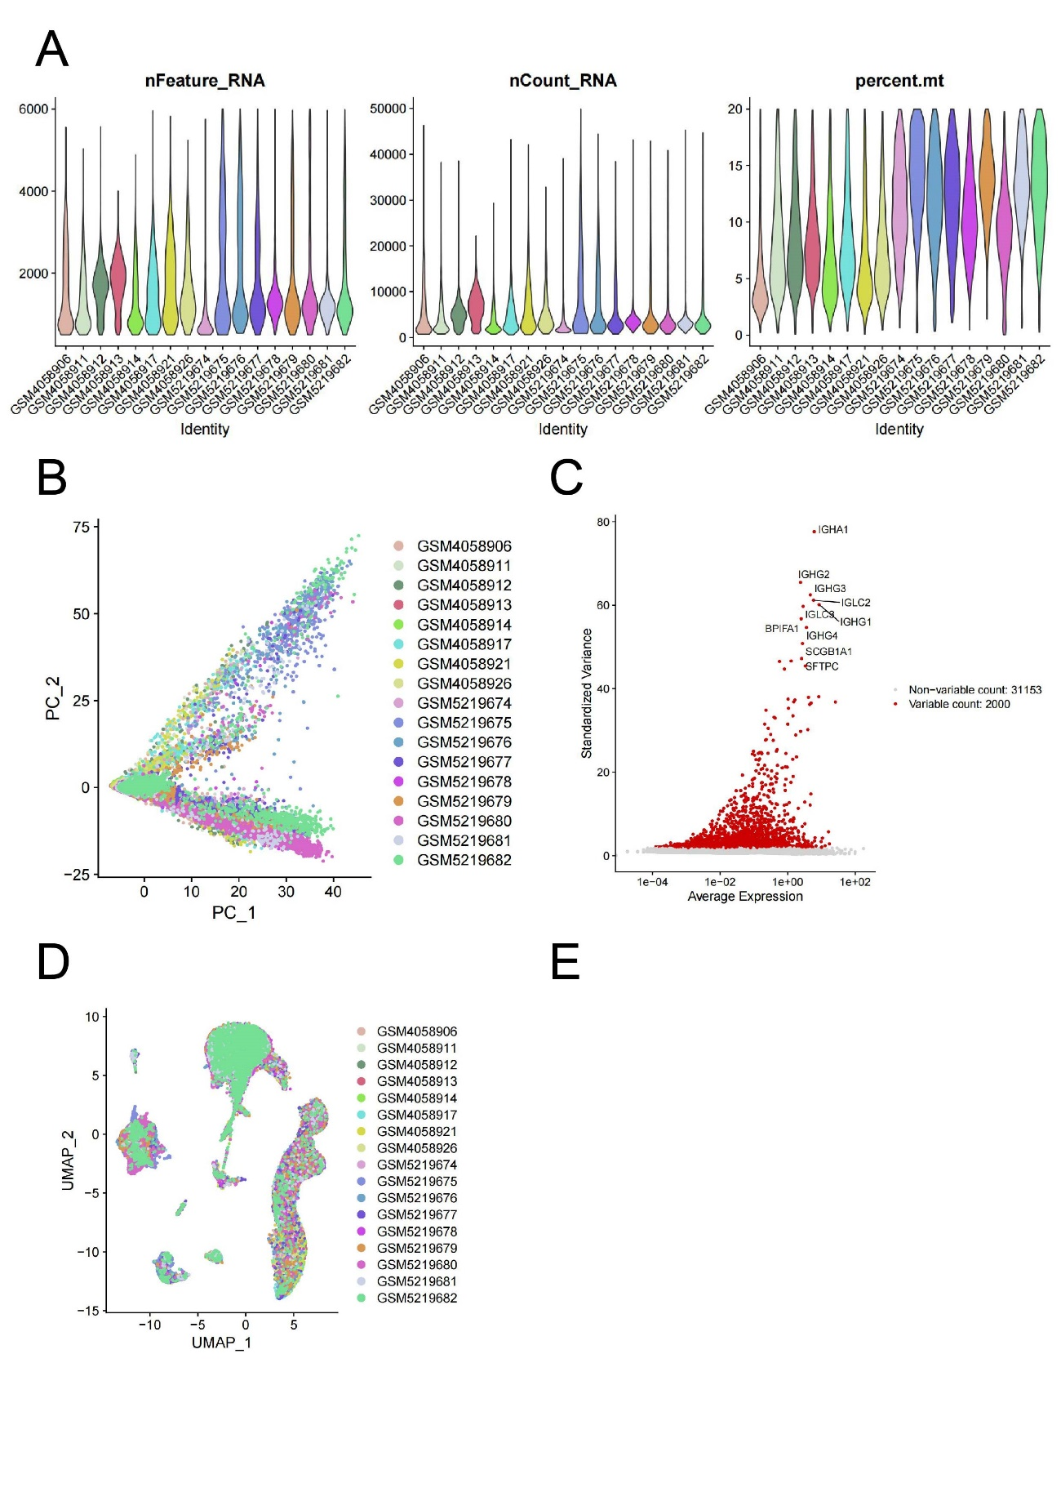
Supplementary Figs. 1 Preprocessing of single-cell data. (A) The criteria of retaining cell (B) PCA analysis (C) Scatter plots showing high variable genes. (D) UMAP plot of 50000+ cells from 9 LUAD sample and 8 healthy lung sample, colored by different samples.

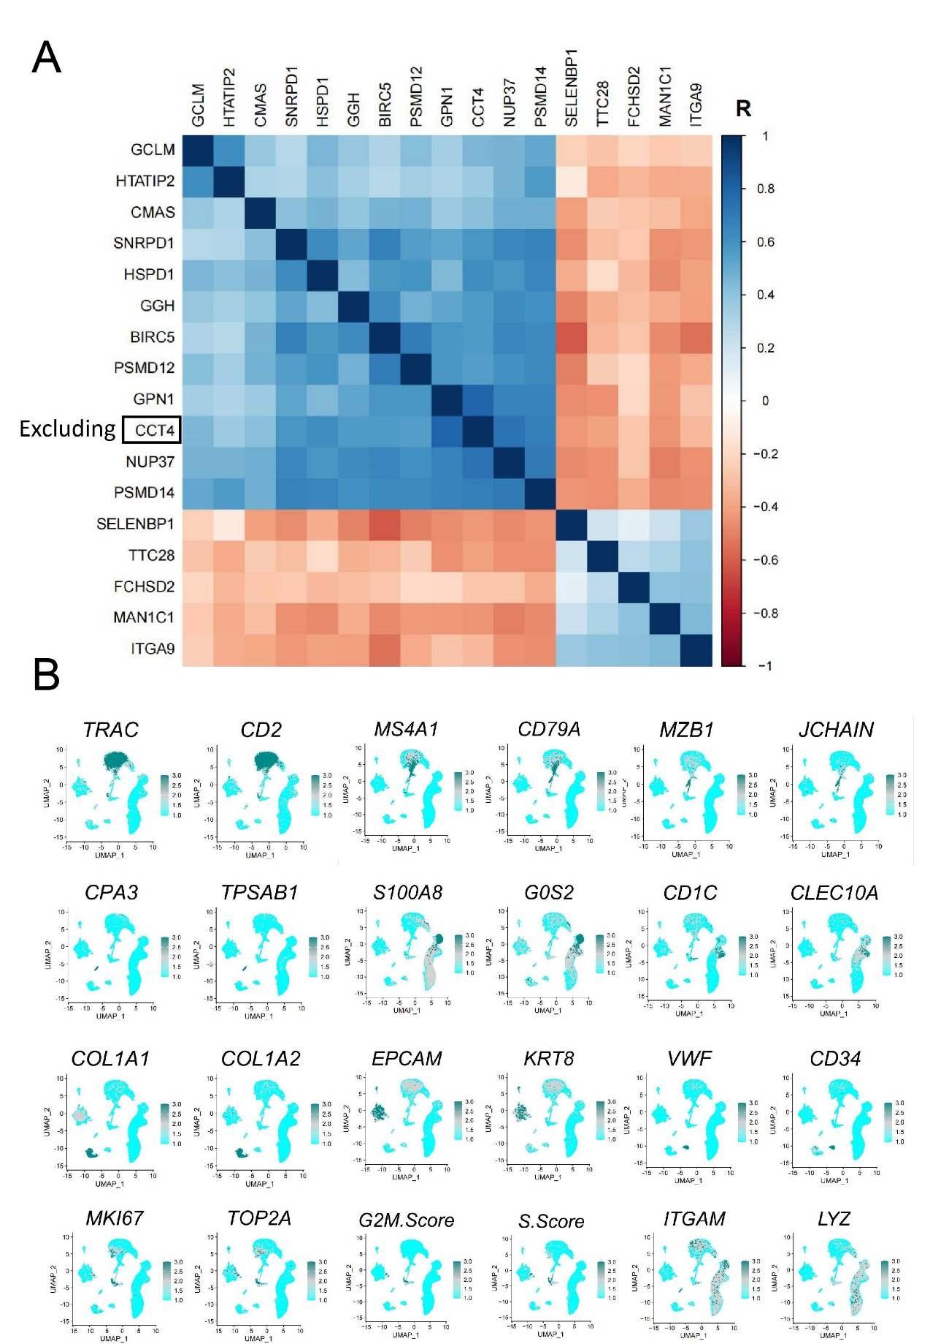
Supplementary Figs. 2 Correlation between prognosis-related genes and marker gene. (A) Heatmap showing correlation coefficient among prognosis-related genes (B) UMAP showing the expression of marker genes in LUAD.

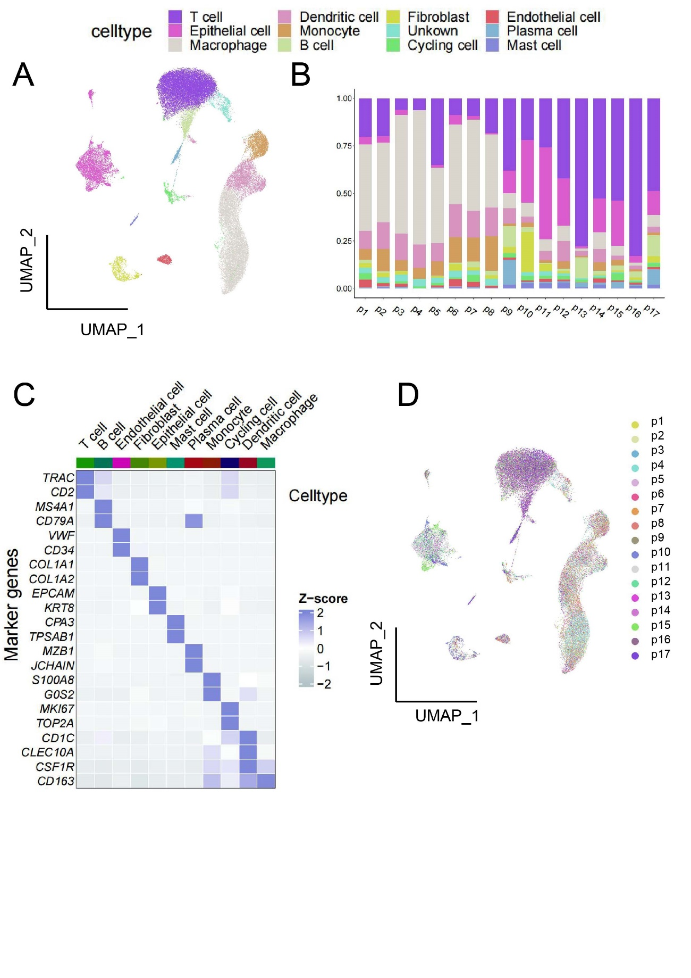
Supplementary Figs. 3 Cell clustering and annotation. (A) UMAP plot of 50000+ cells from 9 LUAD samples and 8 healthy lung samples, colored by 12 major cell types including cycling and undefined cells. (B) Cell composition of different samples. (C) Heatmap of canonical markers of 11 major cell types. (D) UMAP plot of 50000+ cells from 9 LUAD samples and 8 healthy lung samples, colored by different samples.

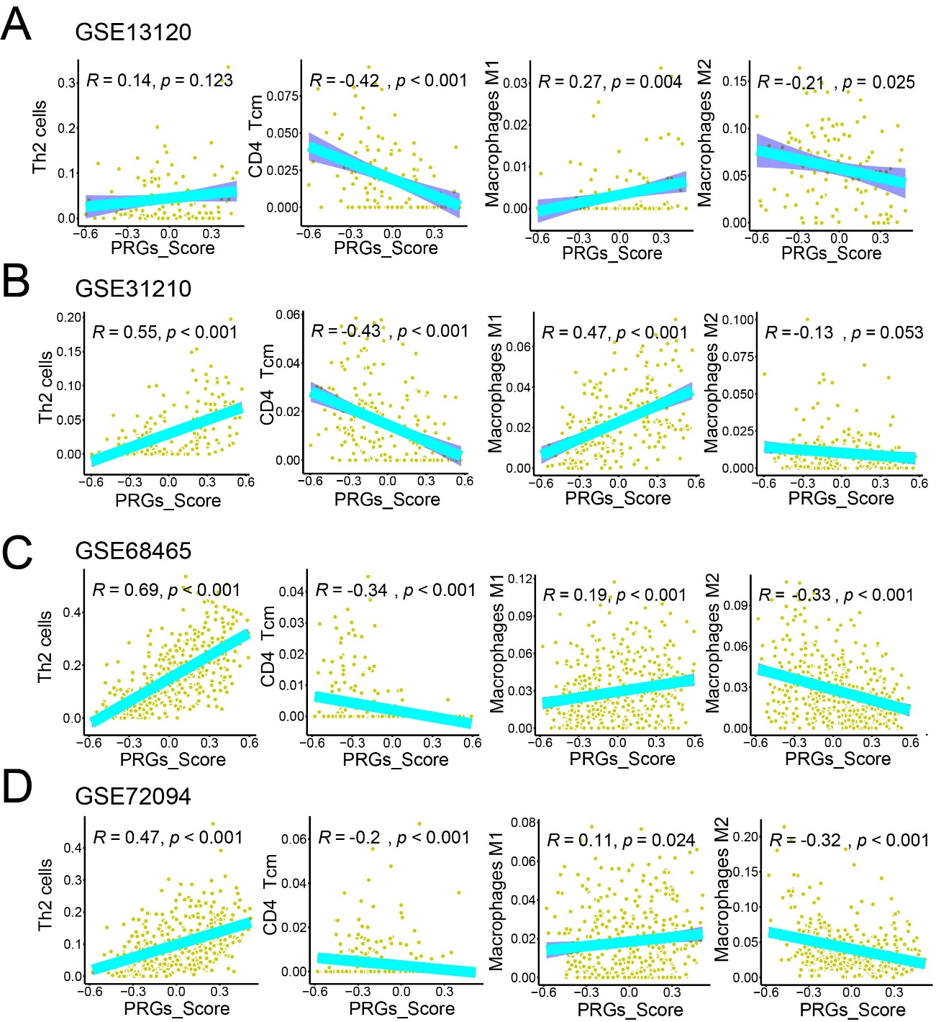
Supplementary Figs. 4 Correlation between PRGs and the cell composition in different LUAD samples. (A-D) Scatter plot showing the correlation between PRGs and cell composition in LUAD cohorts, including GSE13120 (A), GSE31210 (B), GSE68465 (C), and GSE72094 (D).

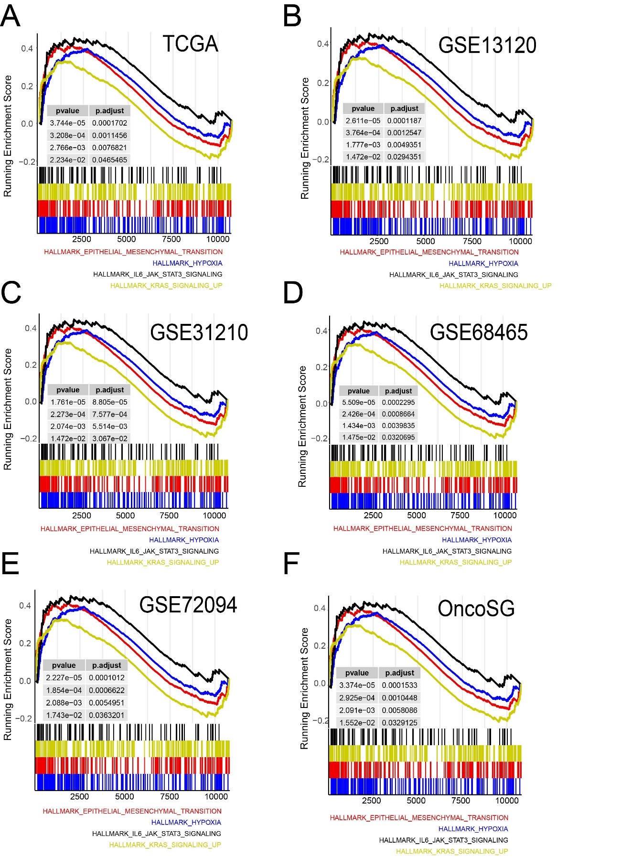
Supplementary Figs. 5 GSEA analysis. (A-F) GSEA analysis between HPGS groups and LGPS groups in LUAD cohorts of TCGA (A), GSE13120 (B), GSE31210 (C), GSE68465 (D), GSE72094 (E), and OncoSG (F).

