Supplemental files
Inter-species root interaction can shift feedback effect of arbuscular mycorrhizal fungi from neutral to positive or negative

Methods
Changwu Research Station, located in the southern part of the Loess Plateau, is characterized by a warm temperate subhumid continental climate. At this field research station, stands of R. pseudoacacia monoculture, P. orientalis monoculture, and of a 50:50 mixture of these tree species had been established on the native grassland in 2003 to control soil erosion, when the “Grain for Green” project was implemented. In November 2013, the soil of three field plots of each of the three afforestation types and of three nearby native grassland sites with no history of tree plantation had been sampled to describe the AM fungal communities (three R. pseudoacacia monocultures, three P. orientalis monocultures, three R. pseudoacacia × P. orientalis mixtures, and three nearby native grassland stands). The study showed AM fungi from native grasslands and from tree-planted area significantly differed (Fig. S1). And in particular, the relative abundances of Glomus and Rhizophagus were slightly lower in native grasslands than in R. pseudoacacia × P. orientalis mixture. The methods used to describe the communities and the AM community data were published earlier (Chen et al., 2018b).
In 2017, the soil of nearby native grassland and R. pseudoacacia × P. orientalis were collected according to Chen et al. (2018), and were treated as Native-AM inoculum and Remodeled-AM inoculum.
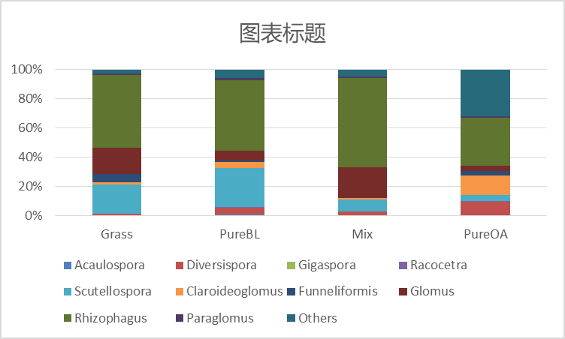
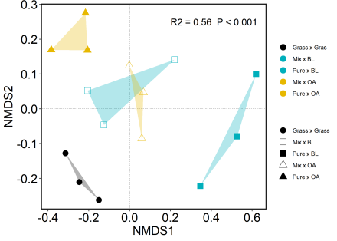
Fig. S1 AM fungi composition and relative abundance in grassland (Grass), Robinia pseudoacacia monoculture (PureBL), Platycladus orientalis monoculture (PureOA) and the mixture of R. pseudoacacia and P. orientalis (Mix). The NMDs was made on Bray-Curtis dissimilarities of OTUs with 97% similarity (left). Bar plot showed relative abundance of the genus of AM fungi (right).
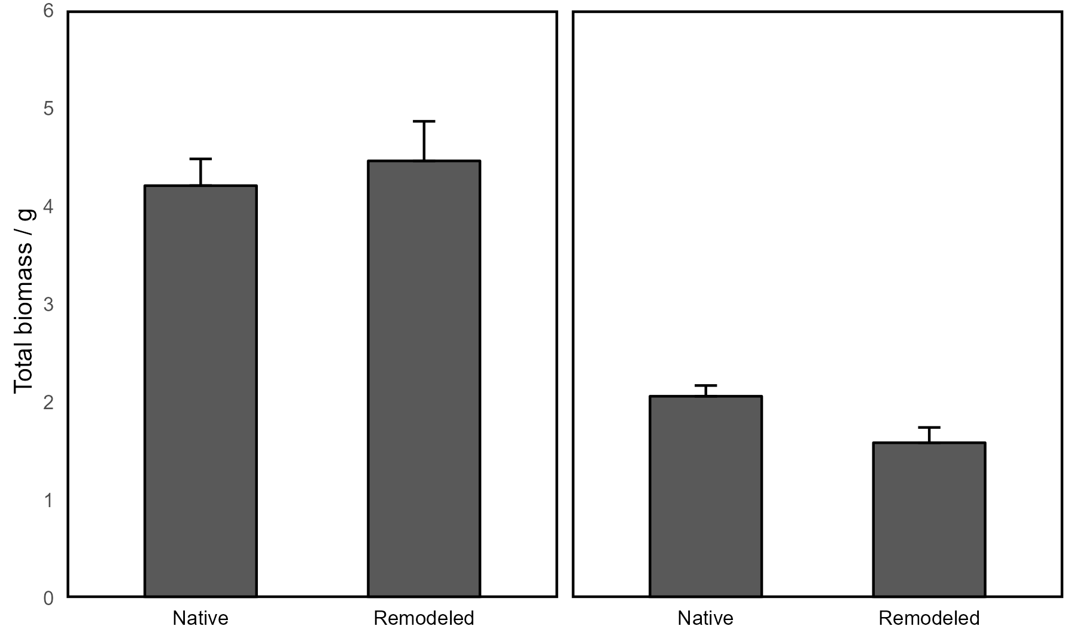
Fig. S2 Total biomass (g plant⁻¹) of R. pseudoacacia (left) and P. orientalis (right) inoculated with Native- and Remodeled-AM inoculum. Different lowercase letters indicate significant differences among AM inoculum with t-test (p < 0.05).
R. pseudoacacia
P. orientalis
a
a
a
b
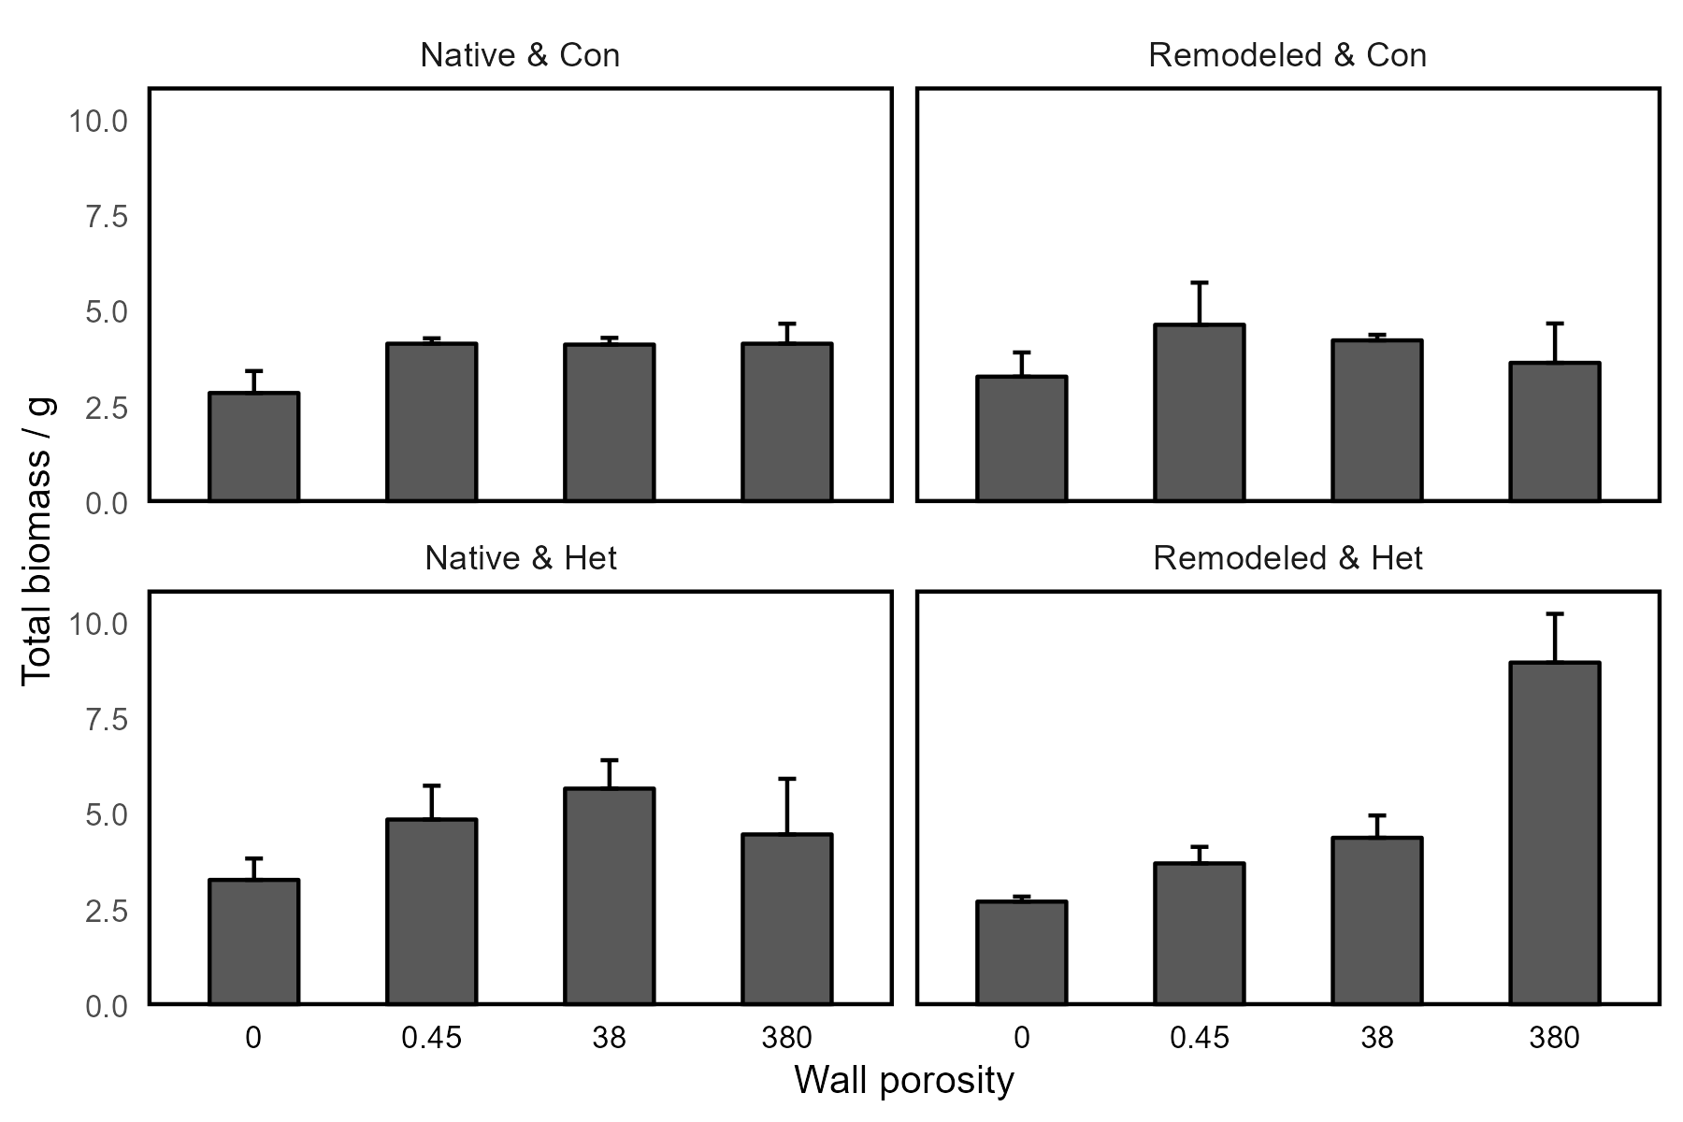
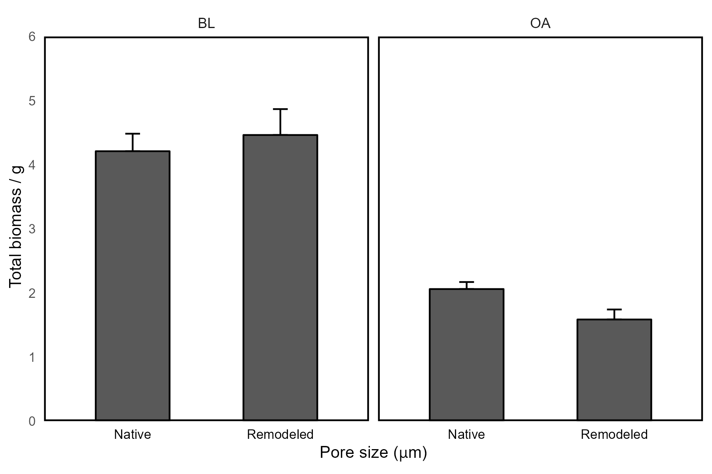
Fig. S3 Total biomass (mean ± se) of R. pseudoacacia grown with different wall porosity treatments under different AM & neighbor plants (Native & Con: plants inoculated with native AM fungi with conspecific neighbor plants, Native & Het: plants inoculated with native AM fungi with heterospecific neighbor plants, Remodeled & Con: plants inoculated with remodeled AM fungi with conspecific neighbor plants, Remodeled & Het: plants inoculated with native AM fungi with heterospecific plants). Bars with different lowercase letters denote a significant difference between pore size treatments according to Tukey’ s test at a significance level of p < 0.05.
b
a
b
b
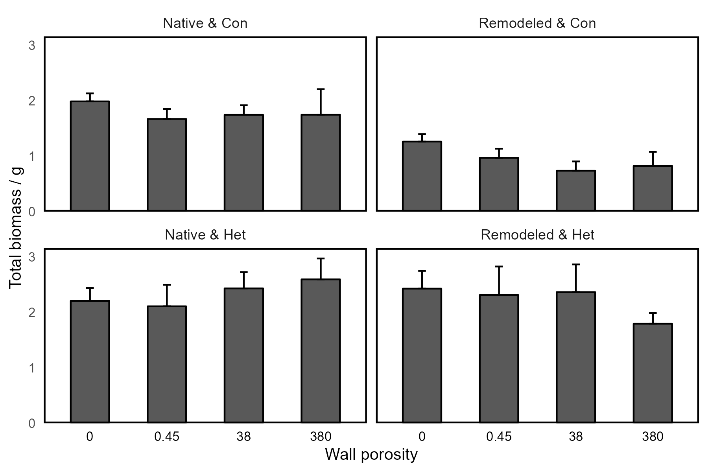
Fig. S4 Total biomass (mean ± se) of P. orientalis grown with different pore size treatments under different AM & neighbor plants (Native & Con: plants inoculated with native AM fungi with conspecific neighbor plants, Native & Het: plants inoculated with native AM fungi with heterospecific neighbor plants, Remodeled & Con: plants inoculated with remodeled AM fungi with conspecific neighbor plants, Remodeled & Het: plants inoculated with native AM fungi with heterospecific plants).

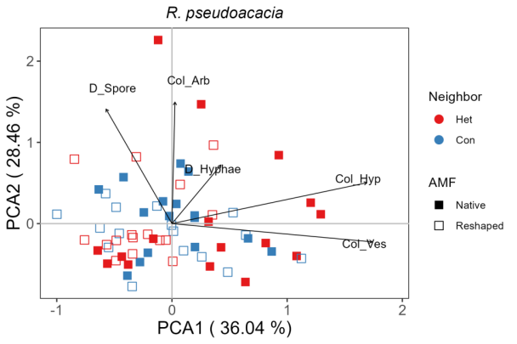
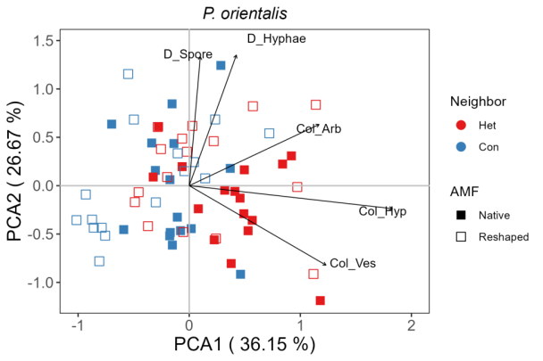
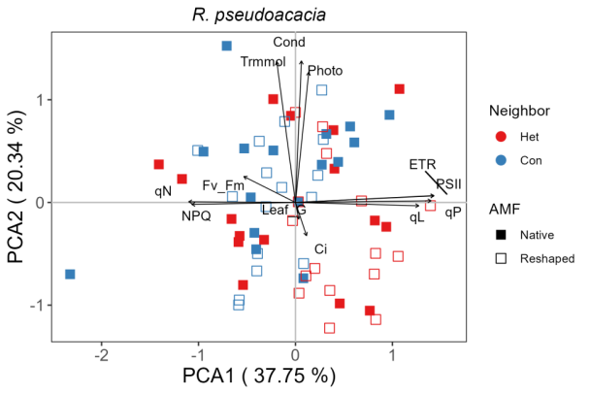
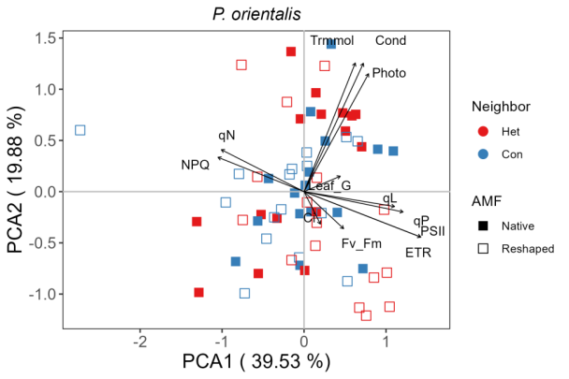
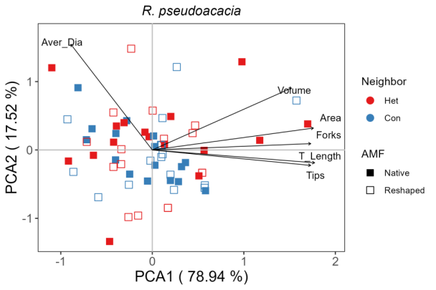
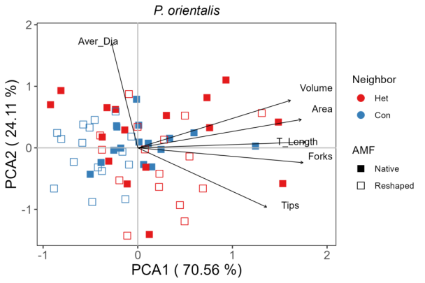
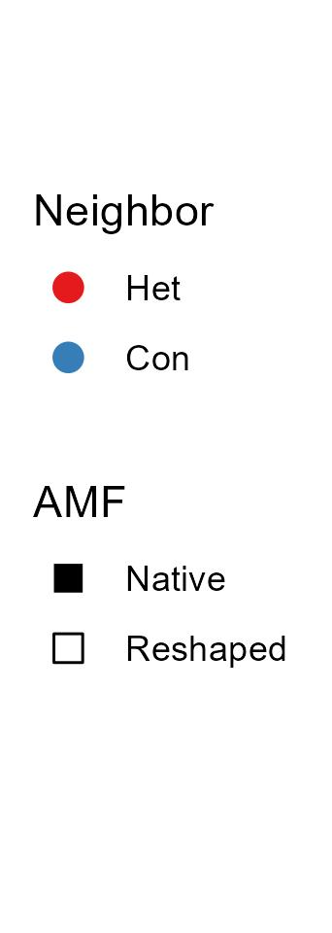
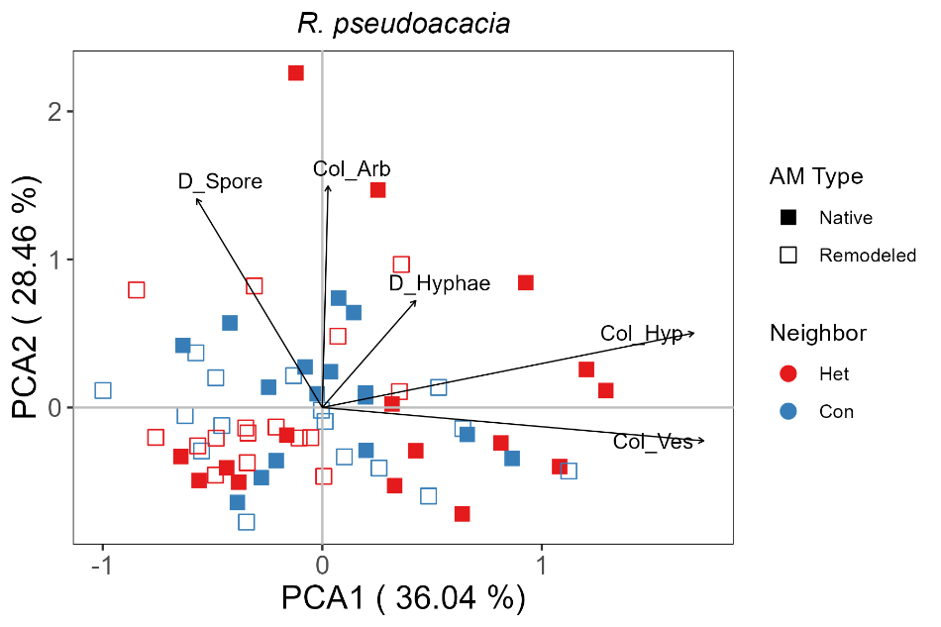
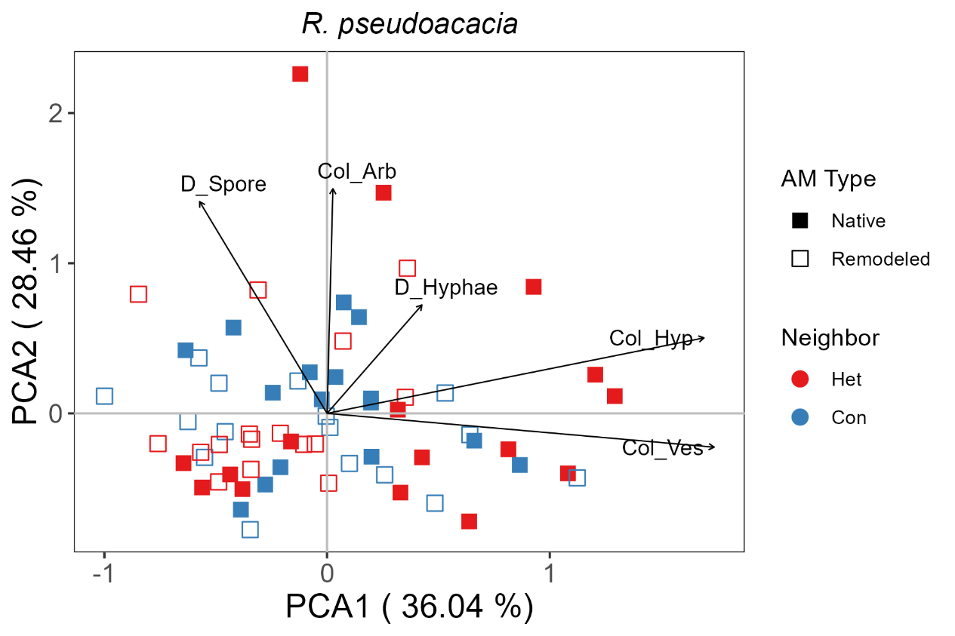
Fig. S5 Multivariate space of AM fungal colonization (top), photosynthetic (median) and root morphology (bottom) characteristics of R. pseudoacacia and P. orientalis with conspecific (Con) or heterospecific (Het) neighbor trees and different AM types.
AM colonization
AM colonization
Photosynthesis
Photosynthesis
Root morphology
Root morphology
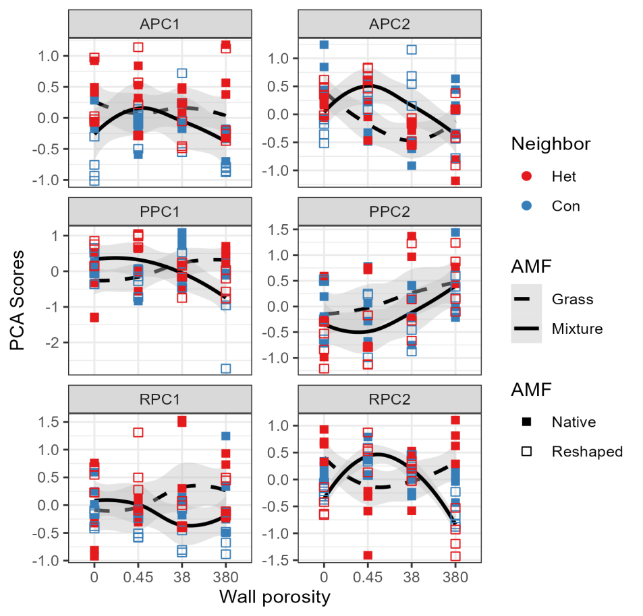
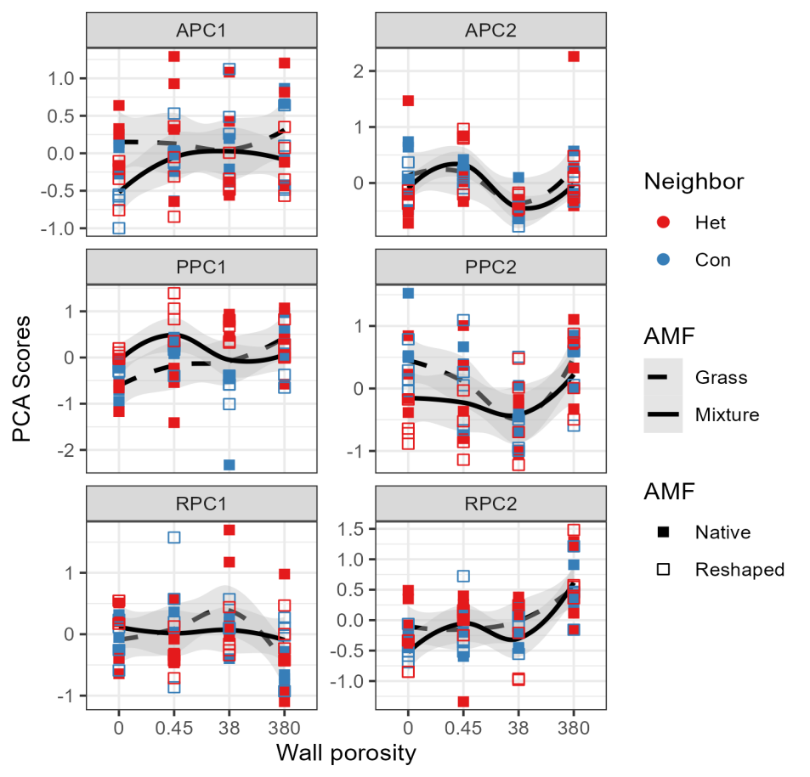


Fig. S6 Effect of wall porosities on photosynthesis, root morphology, and root colonization.of R. pseudoacacia and conspecific (Con) or heterospecific (Het) neighbor trees under different AM community type. These characteristics showed different patterns of response to the gradient of wall porosity. Solid or dashed lines represent LOESS fits of remodeled- or native-AM treatments and grey areas denote the 95% confidence intervals.
P. orientalis
P. orientalis
R. pseudoacacia
R. pseudoacacia

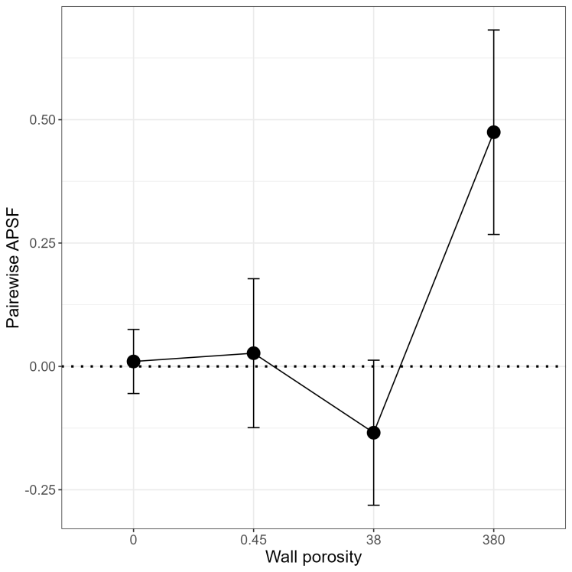
*
Fig. S7 The Mean pairwise feedback effects values (pairwise APSF) of plants grown under different wall porosities. Asterisks adjacent to dots represent significant differences in pairwise APSF when plants were grown with native vs. remodeled AM inoculum based on one-sample t-test.

Table S1. AM fungal colonization (mean ± se) for R. pseudoacacia and three-way ANOVA results for the effects of AM type, neighbor plant, belowground interaction and their interaction.
AMF | Neighbor |  | Pore size | D_Spore | D_Hyphae | Col_Hyp | Col_Arb | Col_Ves
Native | conspecific |  | 0 | 1.91±0.7 | 11.8±1.8 | 44.4±4.7 | 1.11±0.6 | 25.5±3.2
Native |  |  | 0.45 | 1.99±0.4 | 8.08±0.6 | 45.1±5.7 | 1.62±0.4 | 17.0±2.4
Native |  |  | 38 | 1.35±0.4 | 3.42±0.2 | 49.5±6.5 | 0.75±0.2 | 22.66±4.4
Native |  |  | 380 | 1.91±0.4 | 6.8±1.8 | 55.7±8.3 | 1.16±0.3 | 33.51±9.1
Native | heterospecific |  | 0 | 1.68±0.9 | 5.32±0.5 | 65.3±9.1 | 1.15±1.1 | 27.87±3.4
Native |  |  | 0.45 | 1.46±0.1 | 12.5±2.7 | 60.5±14.3 | 0.92±0.9 | 33.1±9.0
Native |  |  | 38 | 1.03±0.1 | 3.74±0.9 | 56.4±12 | 0.36±0.1 | 25.7±10.7
Native |  |  | 380 | 1.97±0.3 | 5.22±0.3 | 64.5±13.5 | 3.54±3.1 | 34.2±12.3
Remodeled | conspecific |  | 0 | 2.44±0.5 | 4.62±0.6 | 26.1±4.0 | 0.88±0.3 | 10.7±2.4
Remodeled |  |  | 0.45 | 1.51±0.1 | 9.9±0.8 | 54.6±4.6 | 0.8±0.37 | 21.3±3.3
Remodeled |  |  | 38 | 0.27±0.1 | 4.7±0.5 | 58.4±11 | 0.83±0.2 | 31.7±8.4
Remodeled |  |  | 380 | 1.62±0.5 | 8.8±0.9 | 40.7±6.6 | 0.4±0.14 | 24.8±7.3
Remodeled | heterospecific |  | 0 | 1.47±0.2 | 6.28±0.9 | 34.3±7.2 | 0.55±0.4 | 15.7±3.7
Remodeled |  |  | 0.45 | 2.47±0.5 | 8.61±1.7 | 56.1±11.8 | 2.3±0.8 | 10.4±2.2
Remodeled |  |  | 38 | 1.07±0.2 | 5.71±1.6 | 34.2±3.8 | 0.86±0.3 | 15.5±3.7
Remodeled |  |  | 380 | 1.75±0.1 | 3.85±0.7 | 55.6±12.1 | 1.66±0.9 | 16.2±3.1
Three-way ANOVA
AM Type(A) |  |  |  | 0.00 | 1.77 | 5.71* | 0.08 | 9.02**
Neighbor(N) |  |  |  | 0.05 | 3.35 | 1.90 | 0.34 | 0.08
Interaction level (BIL) |  |  |  | 6.77*** | 15.41*** | 1.71 | 1.90 | 0.62
A×N  A×BIL  N×BIL |  |  |  | 1.48 | 0.46 | 1.77 | 2.02 | 3.67*
 |  |  |  | 1.56 | 5.72** | 1.62 | 1.42 | 0.90
 |  |  |  | 1.22 | 4.89** | 1.43 | 1.47 | 0.83
A×N×BIL |  |  |  | 0.79 | 8.53*** | 0.61 | 1.46 | 1.59
*, **, *** indicate significance level (p values <0.05, <0.01 and <0.001, respectively)

Table S2. AM fungal colonization (mean ± se) for P. orientalis and three-way ANOVA results for the effects of AM itype, neighbor plant, belowground interaction and their interaction.
AMF | Neighbor |  | Pore size | D_Spore | D_Hyphae | Col_Hyp | Col_Arb | Col_Ves
Native | conspecific |  | 0 | 2.35±0.2 | 7.63±1.7 | 54.3±6.3 | 23.3±2.4 | 12.4±2.2
Native |  |  | 0.45 | 0.99±0.3 | 4.17±0.3 | 48.8±5.2 | 6.43±1.0 | 17.1±3.11
Native |  |  | 38 | 0.4±0.14 | 3.6±0.17 | 56.8±4.8 | 19.9±2.4 | 16.4±3.2
Native |  |  | 380 | 2.0±0.47 | 5.06±0.38 | 39.0±5.0 | 17.3±3.5 | 6.88±1.6
Native | heterospecific |  | 0 | 1.23±0.5 | 5.1±1.16 | 71.8±7.7 | 45.6±14 | 8.87±3.26
Native |  |  | 0.45 | 1.4±0.16 | 7.51±0.87 | 62.4±8.8 | 19.2±4.0 | 23.6±6.1
Native |  |  | 38 | 1.23±0.4 | 2.88±0.76 | 66.7±2.5 | 35.2±8.1 | 15.9±3.8
Native |  |  | 380 | 1.52±0.4 | 1.98±0.79 | 71.9±10.6 | 25.4±6.2 | 26.1±7.8
Remodeled | conspecific |  | 0 | 2.44±0.5 | 4.6±0.6 | 26.1±4.0 | 0.88±0.3 | 10.7±2.4
Remodeled |  |  | 0.45 | 1.3±0.37 | 2.56±0.2 | 28.1±6.0 | 7.2±2.97 | 6.15±2.88
Remodeled |  |  | 38 | 2.4±0.27 | 6.2±0.99 | 43.3±5.1 | 11.3±6.3 | 19.7±4.6
Remodeled |  |  | 380 | 2.0±0.24 | 7.3±0.65 | 52.9±9.9 | 31.8±8.2 | 9.05±3.95
Remodeled | heterospecific |  | 0 | 1.8±0.19 | 5.7±1.06 | 56.6±8.33 | 38.2±6.5 | 12.6±4.9
Remodeled |  |  | 0.45 | 2.3±0.18 | 6.16±0.08 | 61.9±12.8 | 47.4±8.8 | 9.38±3.4
Remodeled |  |  | 38 | 0.79±0.1 | 3.59±0.38 | 48.3±7.1 | 23.2±2.3 | 9.66±3.3
Remodeled |  |  | 380 | 1.82±0.2 | 3.71±0.92 | 58.3±11.2 | 13.3±5.2 | 20.6±12.1
Three-way ANOVA
AM Type(A) |  |  |  | 2.90 | 0.02 | 9.86** | 0.48 | 6.58*
Neighbor(N) |  |  |  | 0.00 | 0.44 | 23.43*** | 29.74*** | 3.47
Interaction level (BIL) |  |  |  | 4.02* | 9.04*** | 0.67 | 4.59** | 2.62
A×N  A×BIL  N×BIL |  |  |  | 0.38 | 1.43 | 0.00 | 0.20 | 1.01
 |  |  |  | 6.76*** | 5.49** | 0.90 | 4.52** | 0.43
 |  |  |  | 0.9 | 4.24** | 2.71* | 3.57* | 2.89*
A×N×BIL |  |  |  | 9.4*** | 9.23*** | 0.50 | 2.48 | 2.39
*, **, *** indicate significance level (p values <0.05, <0.01 and <0.001, respectively)

Table S3. Results of principal component analysis of initial plant variables of R. pseudoacacia..
PCA scores | Variable | Correlation | Cumulative (%)
APC1 | Col_T | 0.9***
APC1 | Col_Ves | 0.92***
APC1 | Col_Hyp | 0.9*** | 36.04
APC2 | D_Spore | 0.75***
APC2 | D_Hyphae | 0.38**
APC2 | Col_Arb | 0.79*** | 28.46
PPC1 | PSII | 0.96***
PPC1 | NPQ | -0.72***
PPC1 | qN | -0.73***
PPC1 | qP | 0.91***
PPC1 | qL | 0.81***
PPC1 | ETR | 0.96*** | 37.75
PPC2 | Photo | 0.8***
PPC2 | Cond | 0.95***
PPC2 | Trmmol | 0.93*** | 20.34
RPC1 | T_Length | 0.99***
RPC1 | Area | 0.98***
RPC1 | Volume | 0.84***
RPC1 | Tips | 0.96***
RPC1 | Forks | 0.96*** | 78.94
RPC2 | Aver_Dia | 0.86*** | 17.52

Table S4. Results of principal component analysis of initial plant variables of P. orientalis.
PCA scores | Variable | Correlation | Cumulative (%)
APC1 | Col_Arb | 0.58***
APC1 | Col_T | 0.95***
APC1 | Col_Ves | 0.63***
APC1 | Col_Hyp | 0.96*** | 36.15
APC2 | D_Spore | 0.75***
APC2 | D_Hyphae | 0.7*** | 26.67
PPC1 | PSII | 0.9***
PPC1 | NPQ | -0.78***
PPC1 | qN | -0.73***
PPC1 | qP | 0.7***
PPC1 | qL | 0.64***
PPC1 | ETR | 0.9*** | 39.53
PPC2 | Photo | 0.74***
PPC2 | Cond | 0.83***
PPC2 | Trmmol | 0.84*** | 19.88
RPC1 | T_Length | 0.97***
RPC1 | Area | 0.93***
RPC1 | Volume | 0.84***
RPC1 | Tips | 0.79***
RPC1 | Forks | 0.96*** | 70.56
RPC2 | Aver_Dia | 0.94*** | 24.11

Table S5. The PCA scores of datasets of AM fungi, photosynthesis and root morphology for R. pseudoacacia and three-way ANOVA results for the effects of AM type, neighbor plant, blowground interaction and their interaction.
AMF | Neighbor | Pore size | APC1 | APC2 | PPC1 | PPC2 | RPC1 | RPC2
Native | conspecific | 0 | 0.034±0.11 | 0.24±0.28 | -0.55±0.16 | 0.71±0.25 | 0.096±0.16 | 0.3±0.067
Native | conspecific | 0.45 | -0.22±0.15 | 0.22±0.073 | 0.29±0.079 | 0.15±0.29 | -0.25±0.14 | 0.13±0.17
Native | conspecific | 38 | -0.05±0.15 | -0.3±0.15 | -0.84±0.47 | -0.38±0.12 | -0.028±0.15 | 0.22±0.16
Native | conspecific | 380 | 0.26±0.3 | 0.08±0.21 | 0.51±0.21 | 0.57±0.13 | 0.62±0.12 | -0.45±0.16
Native | heterospecific | 0 | 0.26±0.16 | 0.0089±0.5 | -0.54±0.19 | 0.044±0.29 | 0.081±0.26 | -0.096±0.2
Native | heterospecific | 0.45 | 0.47±0.42 | 0.16±0.25 | -0.54±0.25 | 0.037±0.39 | 0.072±0.23 | 0.17±0.4
Native | heterospecific | 38 | 0.14±0.38 | -0.42±0.049 | 0.7±0.1 | -0.59±0.21 | -0.74±0.42 | -0.2±0.064
Native | heterospecific | 380 | 0.37±0.39 | 0.47±0.61 | 0.27±0.35 | 0.44±0.26 | 0.36±0.47 | -0.61±0.37
Remodeled | conspecific | 0 | -0.69±0.11 | 0.034±0.14 | -0.19±0.056 | 0.27±0.18 | 0.12±0.19 | 0.46±0.14
Remodeled | conspecific | 0.45 | 0.1±0.15 | 0.06±0.071 | 0.07±0.18 | 0.16±0.29 | -0.37±0.5 | 0.12±0.28
Remodeled | conspecific | 38 | 0.38±0.3 | -0.55±0.085 | -0.61±0.11 | -0.42±0.32 | -0.22±0.12 | 0.13±0.15
Remodeled | conspecific | 380 | -0.05±0.27 | -0.099±0.11 | -0.15±0.21 | 0.17±0.26 | 0.14±0.27 | -0.49±0.28
Remodeled | heterospecific | 0 | -0.35±0.14 | -0.23±0.051 | 0.1±0.04 | -0.57±0.12 | -0.36±0.11 | 0.59±0.15
Remodeled | heterospecific | 0.45 | -0.21±0.25 | 0.59±0.27 | 0.73±0.2 | -0.52±0.22 | 0.34±0.18 | -0.011±0.092
Remodeled | heterospecific | 38 | -0.33±0.12 | -0.32±0.079 | 0.49±0.12 | -0.32±0.35 | 0.079±0.18 | 0.48±0.3
Remodeled | heterospecific | 380 | -0.12±0.21 | 0.048±0.16 | 0.27±0.18 | 0.26±0.34 | 0.046±0.19 | -0.74±0.25
Three-way ANOVA
AM Type(A) |  |  | 6.562* | 0.883 | 2.825 | 3.431 | 0.171 | 1.385
Neighbor(N) |  |  | 0.216 | 0.379 | 12.214** | 5.362* | 0.052 | 0.874
Interaction level(BIL) |  |  | 1.078 | 5.219** | 4.898** | 6.281** | 2.767* | 12.139***
A×N |  |  | 3.985* | 0.467 | 5.571* | 0.049 | 1.098 | 1.321
A×BIL |  |  | 1.292 | 0.587 | 3.817* | 1 | 1.445 | 1.384
N×BIL |  |  | 0.91 | 0.907 | 9.29*** | 1.693 | 1.955 | 0.124
A×N×BIL |  |  | 1.188 | 0.567 | 3.66* | 0.574 | 1.380 | 1.043
*, **, *** indicate significance level (p values <0.05, <0.01 and <0.001, respectively)

Table S6. The PCA scores of datasets of AM fungi, photosynthesis and root morphology for P. orientalis and three-way ANOVA results for the effects of AM type, neighbor plant, blowground interaction and their interaction.
AMF | Neighbor | Pore size | APC1 | APC2 | PPC1 | PPC2 | RPC1 | RPC2
Native | conspecific | 0 | 0.09±0.14 | 0.68±0.23 | 0.058±0.056 | 0.035±0.24 | -0.16±0.17 | -0.16±0.081
Native | conspecific | 0.45 | -0.21±0.13 | -0.43±0.035 | -0.33±0.22 | 0.0068±0.28 | 0.029±0.07 | -0.4±0.15
Native | conspecific | 38 | 0.014±0.15 | -0.63±0.1 | 0.55±0.3 | -0.02±0.27 | 0.089±0.12 | 0.21±0.069
Native | conspecific | 380 | -0.38±0.11 | 0.32±0.13 | 0.16±0.1 | 0.17±0.37 | -0.21±0.39 | 0.071±0.13
Native | heterospecific | 0 | 0.44±0.2 | 0.15±0.077 | -0.58±0.41 | -0.17±0.32 | 0.32±0.38 | -0.65±0.12
Native | heterospecific | 0.45 | 0.35±0.24 | 0.081±0.23 | 0.018±0.2 | -0.044±0.41 | 0.053±0.099 | 0.63±0.27
Native | heterospecific | 38 | 0.31±0.097 | -0.3±0.092 | -0.13±0.14 | 0.53±0.37 | -0.74±0.47 | -0.13±0.25
Native | heterospecific | 380 | 0.45±0.31 | -0.57±0.28 | 0.52±0.091 | 0.47±0.068 | -0.32±0.3 | -0.71±0.17
Remodeled | conspecific | 0 | -0.75±0.16 | -0.28±0.095 | 0.18±0.22 | 0.03±0.26 | 0.26±0.08 | 0.26±0.068
Remodeled | conspecific | 0.45 | -0.1±0.14 | 0.33±0.13 | -0.29±0.16 | -0.16±0.26 | 0.48±0.082 | -0.34±0.1
Remodeled | conspecific | 38 | 0.09±0.27 | 0.63±0.21 | 0.089±0.2 | -0.42±0.21 | 0.55±0.18 | -0.26±0.069
Remodeled | conspecific | 380 | -0.83±0.021 | -0.5±0.096 | -1±0.51 | 0.14±0.096 | 0.54±0.16 | 0.65±0.15
Remodeled | heterospecific | 0 | 0.23±0.25 | 0.36±0.14 | 0.37±0.19 | -0.59±0.18 | -0.42±0.12 | 0.46±0.12
Remodeled | heterospecific | 0.45 | 0.41±0.3 | 0.68±0.091 | 0.87±0.088 | -0.79±0.19 | -0.5±0.3 | -0.52±0.15
Remodeled | heterospecific | 38 | -0.19±0.17 | -0.32±0.12 | -0.15±0.23 | 0.21±0.38 | 0.18±0.12 | -0.12±0.091
Remodeled | heterospecific | 380 | 0.074±0.35 | -0.22±0.28 | -0.33±0.19 | 0.58±0.34 | -0.16±0.18 | 1±0.19
Three-way ANOVA
AM Type(A) |  |  | 6.626* | 4.509* | 0.321 | 3.304 | 3.812* | 14.858***
Neighbor(N) |  |  | 25.044*** | 0.152 | 1.592 | 0.137 | 11.325** | 0.007
Interaction level (BIL) |  |  | 1.398 | 8.048*** | 0.95 | 3.579* | 0.045 | 5.928**
A×N |  |  | 0.009 | 1.946 | 6.434* | 0.473 | 5.956* | 3.486
A×BIL |  |  | 1.655 | 11.713*** | 9.168*** | 0.587 | 2.953* | 29.314***
N×BIL |  |  | 3.085* | 4.661** | 5.99** | 3.17* | 0.807 | 3.82*
A×N×BIL |  |  | 1.421 | 13.135*** | 0.287 | 0.408 | 2.396 | 11.972***
*, **, *** indicate significance level (p values <0.05, <0.01 and <0.001, respectively)

