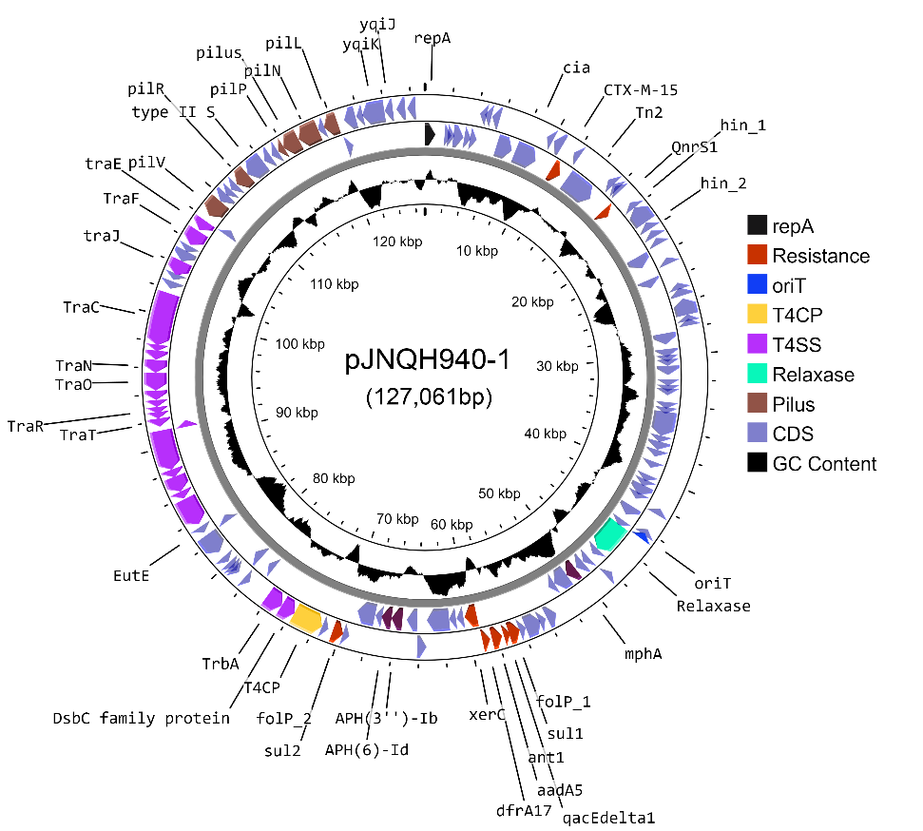
Figure S1. A circle map of the bla_{CTX-M15}-bearing IncB/O/K/Z type plasmid pJNQH940-1 in strain JNQH940. Open reading frames (ORFs) of pJNQH940-1 are shown as the outermost ring, with plasmid replicons, transconjugation elements (T4CP, T4SS, oriT, relaxase), type IV pilus system and antimicrobial resistance genes highlighted.

