Leucobacter edaphi sp. nov., isolated from chromium containing chemical plant soil
Antonie van Leeuwenhoek Journal of Microbiology
Bijun Zheng^{1.2.} Zhe Xu^{1.2} Li Yang^{1.2} Guangyang Jiang^{1.2} Jia Chen^{1.2} Yichen Yang^{1.2} Yongqiang Tian ^{1.2*}
1 Sichuan University, College of Biomass Science and Engineering, Chengdu, 610065, PR China
2 Key Laboratory of Leather Chemistry and Engineering (Sichuan University), Ministry of Education, Chengdu 610065, PR China
* Correspondence: yqtian@scu.edu.cn
Tel/Fax: +86-28-85405237 E-mail: yqtian@scu.edu.cn
Address: No.24 South Section 1, firs-ring Road, Chengdu, China.
Running title: Leucobacter edaphi sp. nov., isolated from chromium containing chemical plant soil
Keywords: chromium soil; Leucobacter; Leucobacter edaphi; novel species

Tables
Supplementary Table S1. Genome features of strains CSA2^{T} and reference strains.
Strains:1. L. edaphi CSA2^{T}; 2. L. chromiireducens subsp. solipictus TAN 31504^{T}; 3. L. chromiireducens subsp. chromiireducens L-1^{T}. NA: no data avilable
Features | 1 | 2 | 3
Basic Genome features (NCBI annotations)
Genome size (Mb) | 2.6 | 3.5 | 3.22
DNA G+C content (mol%) | 68.7 | 68.9 | 67.0
Scaffold number | NA | 11 | NA
Contig number | 11 | 13 | 6
Scaffold N50 (bp) | NA | 451461 | NA
Contig N50 (bp) | 623960 | 422159 | 623960
Protein | 2336 | 3046 | 2803
rRNA | 3 | 3 | 4
tRNA | 46 | 54 | 47
Other RNA | 3 | 3 | 3
Gene | 2409 | 3156 | 2897
Pseudogene | 21 | 50 | 40
Subsystem Feature Counts (RAST annotations)
Resistance to chromium compounds | 1 | 1 | 2
Sulfur Metabolism | 5 | 10 | 8
Cobalt-zinc-cadmium resistance | 2 | 4 | 2
Supplementary Table S1 (Continued)
Features | 1 | 2 | 3
Cooper homeostasis | 7 | 11 | 9
Secondary Metabolism-Auxin biosynthesis | 7 | 6 | 5
Gram-Negative cell wall components | 4 | 3 | 4
Amino acids and derivatives | 247 | 311 | 301
Carbohydrates | 98 | 117 | 117
Protein metabolism | 138 | 150 | 152
Cofactors, Vitamins, Prosthetic Groups, Pigments | 101 | 87 | 117
Respiration | 29 | 31 | 25
Membrane Transport | 33 | 40 | 43

Figure legends
Supplementary Fig. S1 Neighbor-Joining tree showing the phylogenetic position of strain CSA2^{T} based on 16S rRNA gene sequence. Bootstrap values, based on 1000 replicates (≥ 50% Shown), are indicated at the branching points. Bar, 0.005 substitutions per nucleotide position. GenBank accession number are given in parentheses. Subtercola boreus K300^{T} was used as the outgroup
Supplementary Fig. S2 Minimum-Evolution tree showing the phylogenetic position of strain CSA2^{T} based on 16S rRNA gene sequences. Bootstrap values, based on 1000 replicates (≥ 50% Shown), are indicated at the branching points. Bar, 0.005 substitutions per nucleotide position. GenBank accession numbers are given in parentheses. Subtercola boreus K300^{T} was used as the outgroup
Supplementary Fig. S3 Genome circos plot of strain CSA2T. Genomic data was obtained from NCBI (https://www.ncbi.nlm.nih.gov/), and the visualization was performed using CGview (https://cgview.ca/). The meanings attributed to the various elements of the genome circos plot, from the outermost to the innermost circle, are as follows: 1-2, Purple color represents forward/reverse strand open reading frame; 3, Forward strand RNA et al. The legend illustrates the specific RNA species represented by the corresponding color blocks; 4, Contigs (blue and yellow); 5, Reverse strand RNA et al. 6, GC content (black); 7, GC Skew (green and purple represents GC Skew + and -, respectively)
Supplementary Fig. S4 Comparative genome circos plot of strain CSA2^{T} vs reference strains. Genomic data was obtained from NCBI (https://www.ncbi.nlm.nih.gov/), and the visualization was performed using BRIG (http://sourceforge.net/projects/brig). Starting from the center and expanding outwards, rings 1 to 3 depict the genomic size, GC content, and GC skew, respectively. rings 4-6 denote the genotypic differences compared with L. edaphi CSA2^{T}, L. chromiireducens subsp. chromiireducens L-1^{T} and L. chromiireducens subsp. solipictus TAN 31504^{T}
Supplementary Fig. S5 CSA2^{T} hexavalent chromium (i.e., Cr(Ⅵ)) tolerance and reduction tests. OD₆₀₀ indicate bacteria concentration in liquid medium. Test was performed in TSB medium, 30℃, pH 7.2, 48h. Strain CSA2^{T} could grow well in medium containing Cr(Ⅵ) from 50mg/L to 300mg/L, but its growth was markedly inhibited at 400mg/L and 600mg/L. The Cr(Ⅵ) of 50mg/L and 100mg/L had a weak stress ability to strain CSA2^{T}, the strain grew rapidly, reaching stationary phase or even decline phase after 48h, corresponding to a low OD₆₀₀ value. The Cr(Ⅵ) of 150mg/L, 200mg/L and 300mg/L had a strong stress ability to strain CSA2^{T}, the strain grew slowly, reaching logarithmic phase after 48h, corresponding to a high OD₆₀₀ value. The Cr(Ⅵ) of 400mg/L and 600mg/L had a stronger stress ability to strain CSA2^{T}, the strain grew very slowly, and the number of reproduction was still very low after 48h, corresponding to a lower OD₆₀₀ value
Supplementary Fig. S6 Venn diagram and bar graph generated by Orthovenn 3 show the distribution of shared and unique gene clusters of strains L. edaphi CSA2^{T}, L. chromiireducens subsp. chromiireducens L-1^{T} and L. chromiireducens subsp. solipictus 31504^{T}. Venn diagrams representing the distribution of core homologous, shared and unique clusters in all three species. Bar graph showing cumulative clusters of homologous genes found in each species. Bar chart showing cumulative core, shared and distinct clusters for all species.
Supplementary Fig. S7 Transmission electron microscope micrograph of strain CSA2^{T} after growing on TSB medium at 30℃ for 36h. Bar, 0.5μm
Supplementary Fig. S8 Scanning electron microscope micrograph of strain CSA2^{T} after growing on TSB medium at 30℃ for 36h. Bar, 1.0μm
Supplementary Fig. S9 Fatty acid analysis chromatograms of CSA2^{T} and refence strains.All strains were grown on TSB medium at 30℃ for 36h prior to fatty acid analysis by GC-MS (Trace DSQ Ⅱ; Thermo Fisher). Fatty acid types represented by the letters: A: anteiso-C_{15:0}, B: iso-C_{16:0}, C: C_{16:0}, D: anteiso-C_{17:0}, E: iso-C_{17:0}
Supplementary Fig. S10 Two-dimensional thin-layer chromatograms of the compositions of total polar lipid of CSA2^{T} and reference strains. (a): L. chromiireducens subsp. chromiireducens L-1^{T} (b): L. chromiireducens subsp. solipictus TAN 31504^{T} (c): L. edaphi CSA2^{T}. All strains were grown on TSB medium at 30℃ for 36h prior to extracted polar lipids and separated by two-dimensional silica gel H plates. Phosphomolybdic acid reagent was used for color development. Solvent systems: (I) chloroform-methanol-water (65:25:4, v/v/v); (II) chloroform- glacial acetic acid-methanol-water (80:18:12:5, v/v/v/v). DPG: diphosphatidylglycerol; PG: phosphatidylglycerol; GL: unidentified glycolipid, L: unidentified lipid; PL: unidentified phospholipid
Supplementary Fig. S1
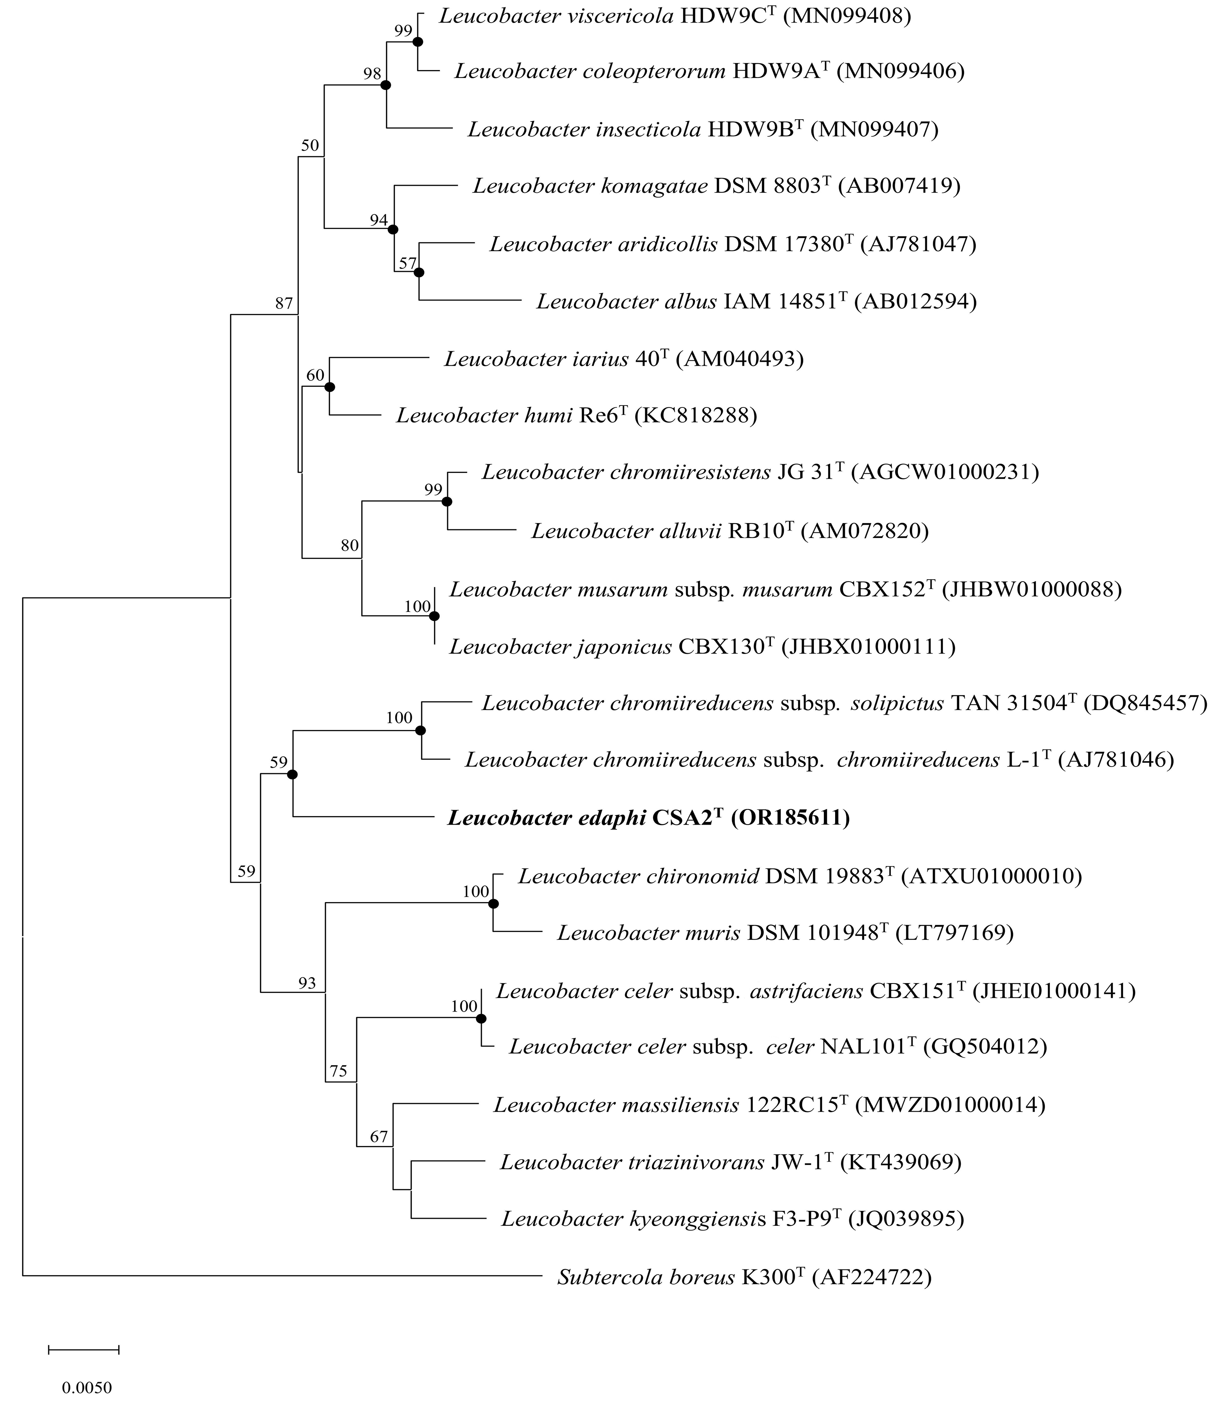
Supplementary Fig. S2
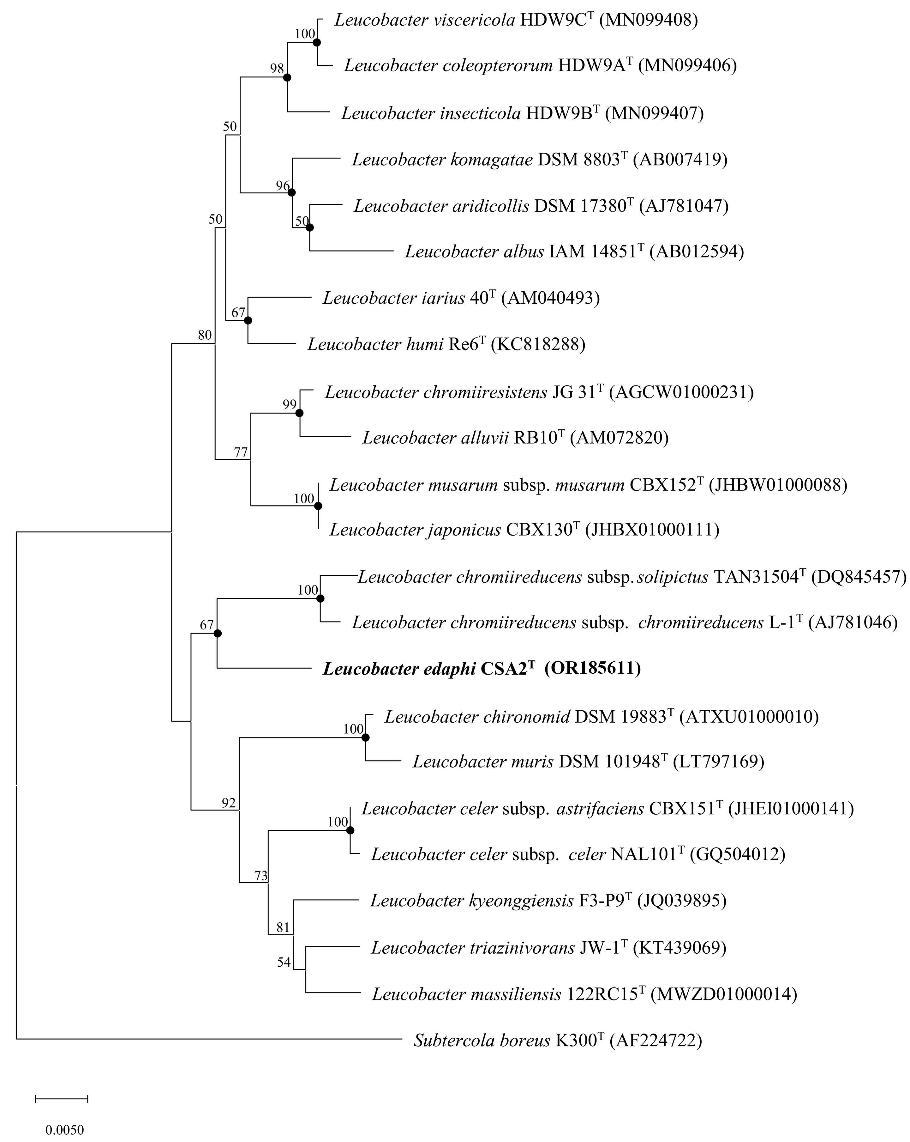
Supplementary Fig. S3
Supplementary Fig. S4
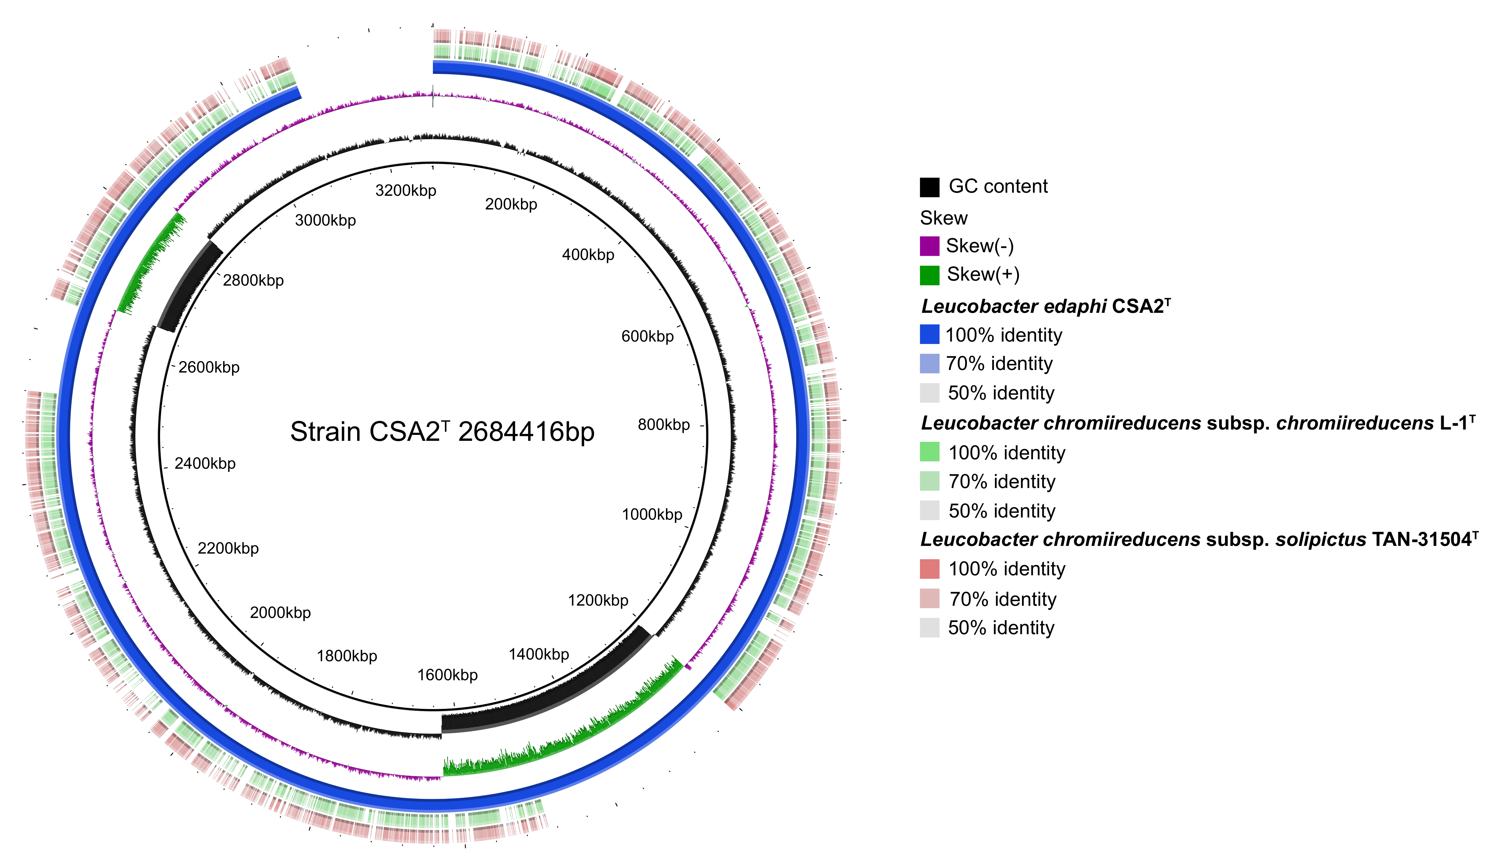

Supplementary Fig. S5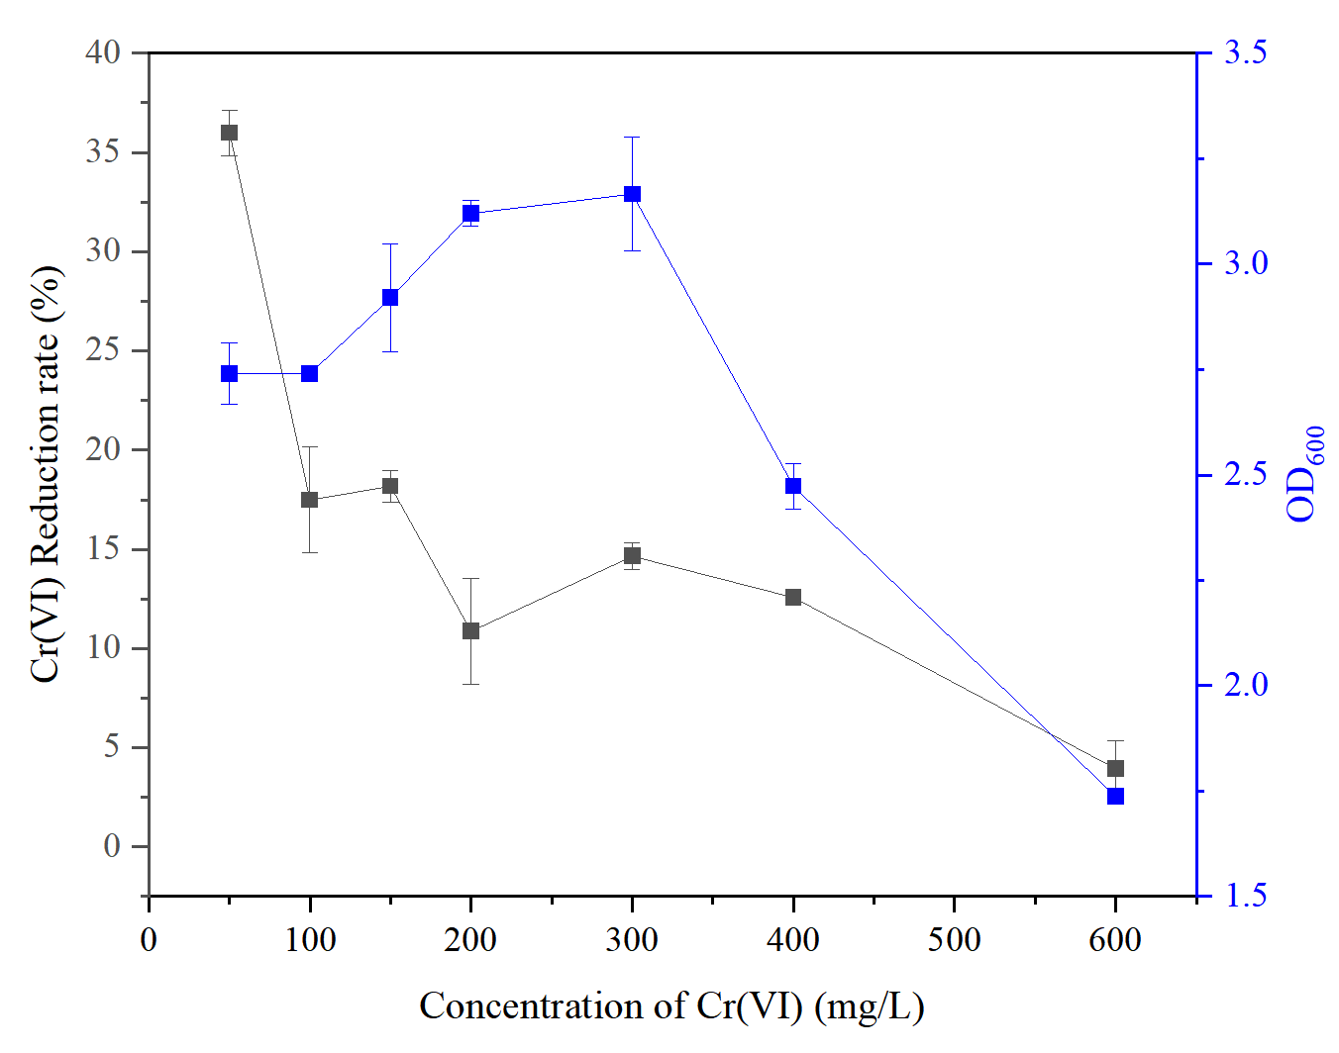
Supplementary Fig. S6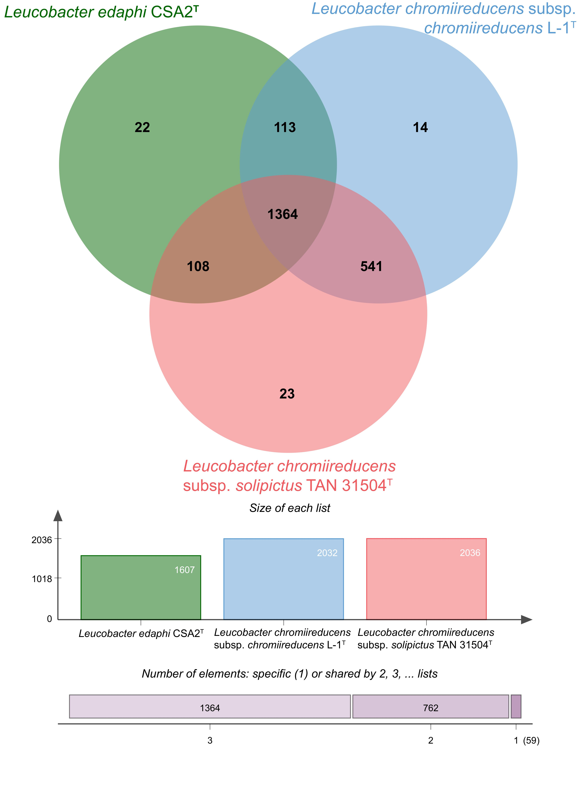
Supplementary Fig. S7
Supplementary Fig. S8
Supplementary Fig. S9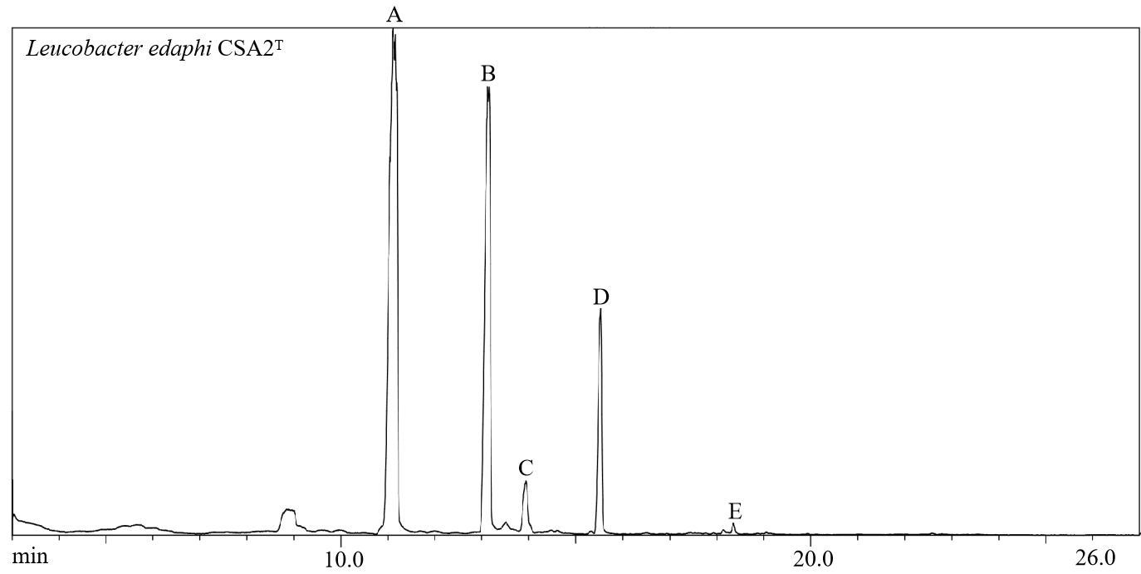
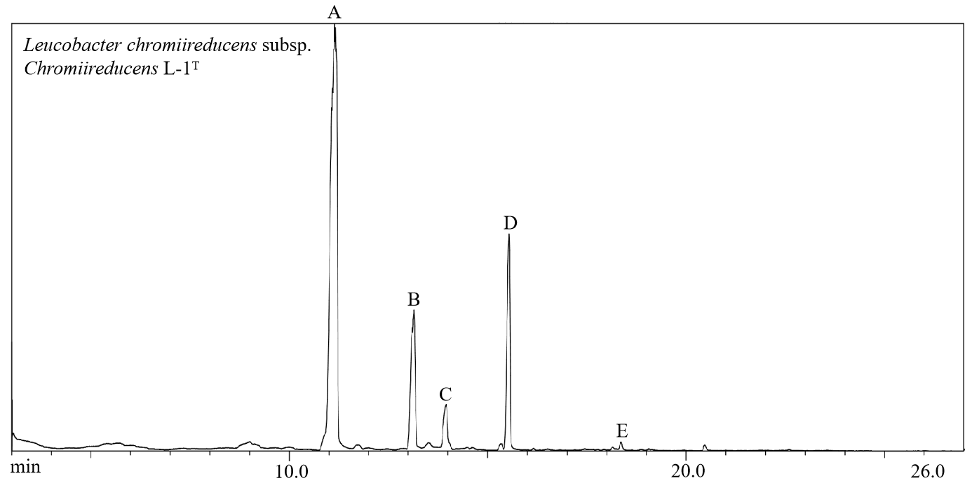
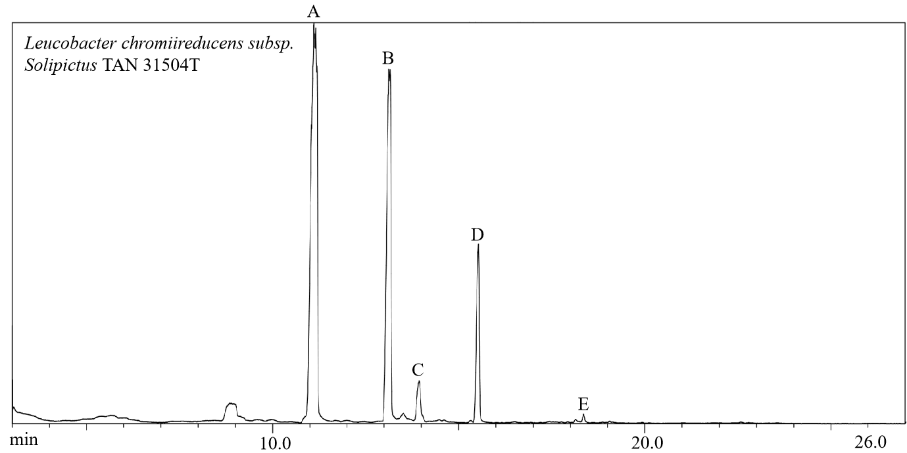
Supplementary Fig. S10
