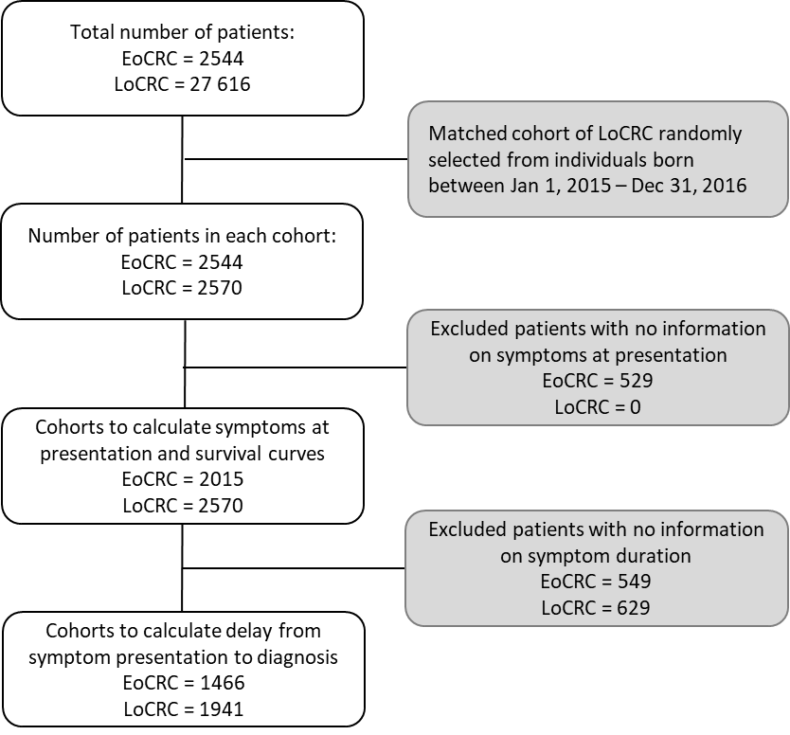
Supplemental Figure 1. Consort diagram of subset cohort of patients younger than 50 (EoCRC) and 50 years or older (LoCRC) with colorectal cancer.

Characteristics | LoCRC (subset) |  | LoCRC (all) |  | p value
Characteristics | n | % | n | % | p value
Sex
Male | 1474 | 57.4 | 15979 | 57.9 | 0.63
Female | 1096 | 42.6 | 11637 | 42.1 | 0.63
Median age at diagnosis (min-max) | 69 (50-104) |  | 66 (50-104) |  | 0.23
Diagnosis date
1990-1994 | 0 | 0.0 | 2126 | 8.5 | <0.0001
1995-1999 | 0 | 0.0 | 2906 | 11.6 | <0.0001
2000-2004 | 0 | 0.0 | 4629 | 18.5 | <0.0001
2005-2009 | 0 | 0.0 | 5881 | 23.5 | <0.0001
2010-2014 | 1 | 0.0 | 6906 | 27.5 | <0.0001
2015-2017 | 2569 | 100.0 | 2624 | 10.5 | <0.0001
Clinical stage
0 | 5 | 0.2 | 62 | 0.2 | <0.0001
1 | 83 | 3.2 | 610 | 2.4 | <0.0001
2 | 736 | 28.6 | 7609 | 30.3 | <0.0001
3 | 1087 | 42.3 | 9897 | 39.5 | <0.0001
4 | 609 | 23.7 | 6030 | 24.1 | <0.0001
Unknown | 50 | 1.9 | 864 | 3.4 | <0.0001
Histology
Adenocarcinoma | 2523 | 98.2 | 24679 | 98.4 | 0.33
Mucinous cell | 120 | 4.7 | 1478 | 6.0 | 0.33
Signet cell | 21 | 0.8 | 150 | 0.6 | 0.33
Other | 47 | 1.8 | 393 | 1.6 | 0.33

Supplemental Table 1. Demographic characteristics of all individuals ≥ 50yo and a matched subset of the ≥50 yo cohort (LoCRC).

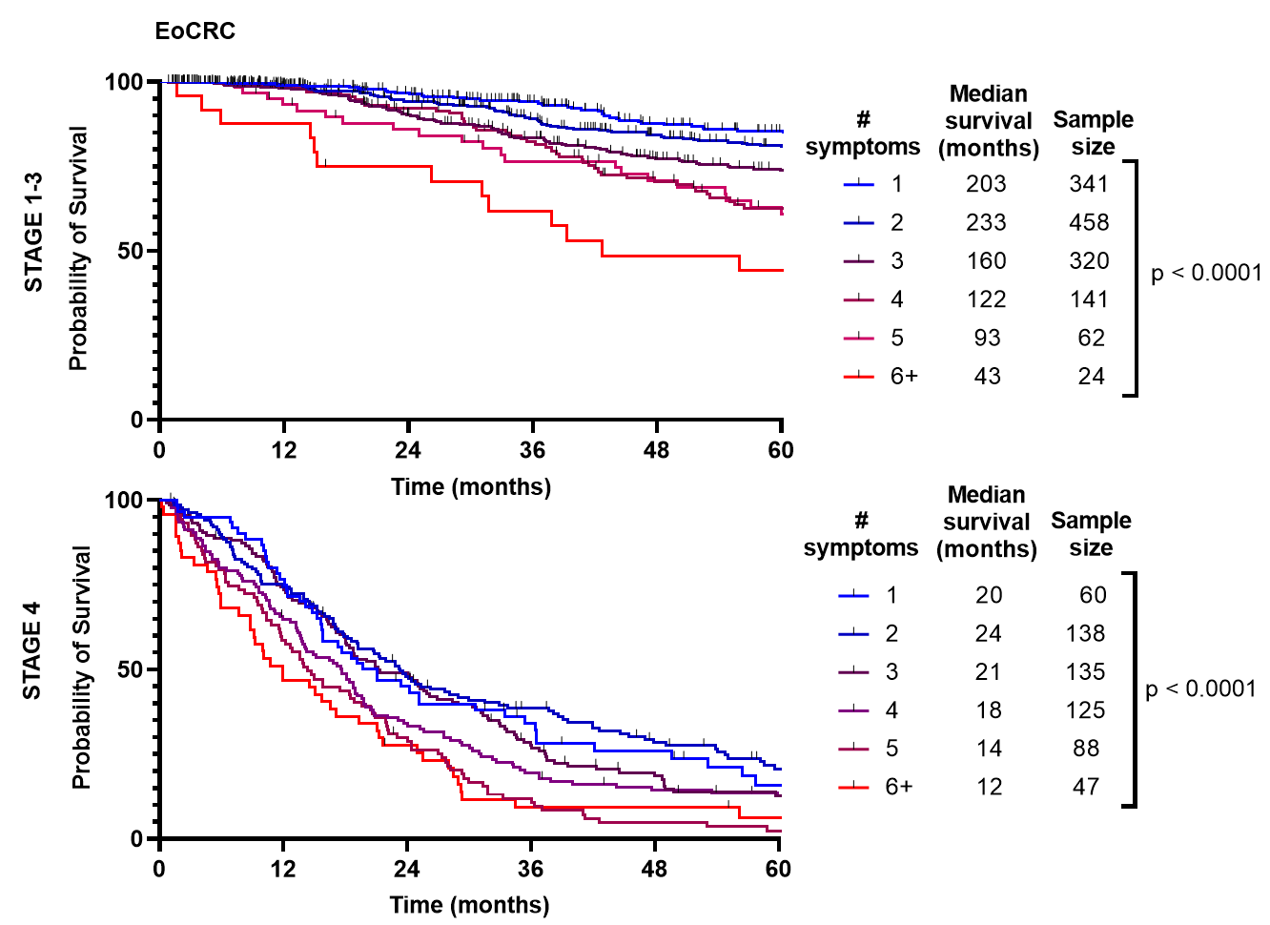

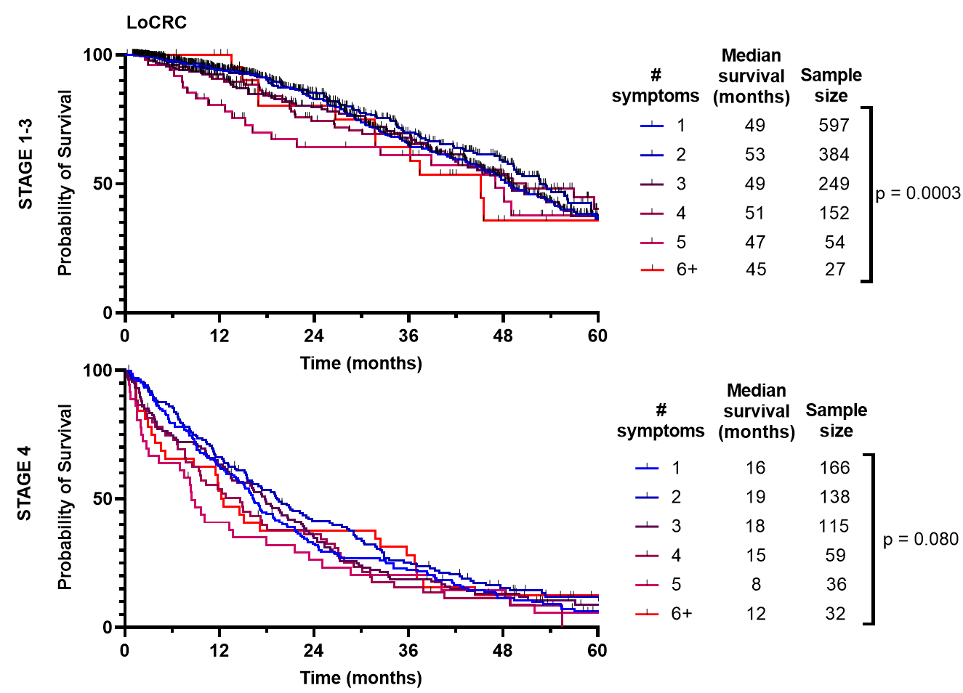
Supplemental Figure 2. Survival of patients with early-onset (patients under 50) and late-onset (patients 50 years or older) with colorectal cancer by number of symptoms at presentation, separated by stage of CRC at presentation. Kaplan Meyer curves for EoCRC and LoCRC from Figure 3 are divided by either stage 1-3 or stage 4 CRC. Stage 0 and undefined stage excluded.

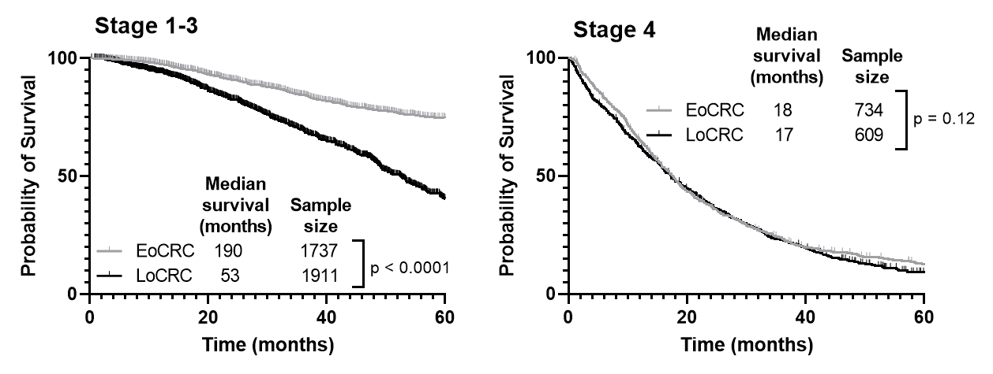
Supplemental Figure 3. Median survival of patients younger than 50 (EoCRC) and 50 years or older (LoCRC) by stage of cancer at presentation. Kaplan Meyer curves of all EoCRC and LoCRC divided by Stage 1-3 and Stage 4 excluding stage 0 and undefined stage.

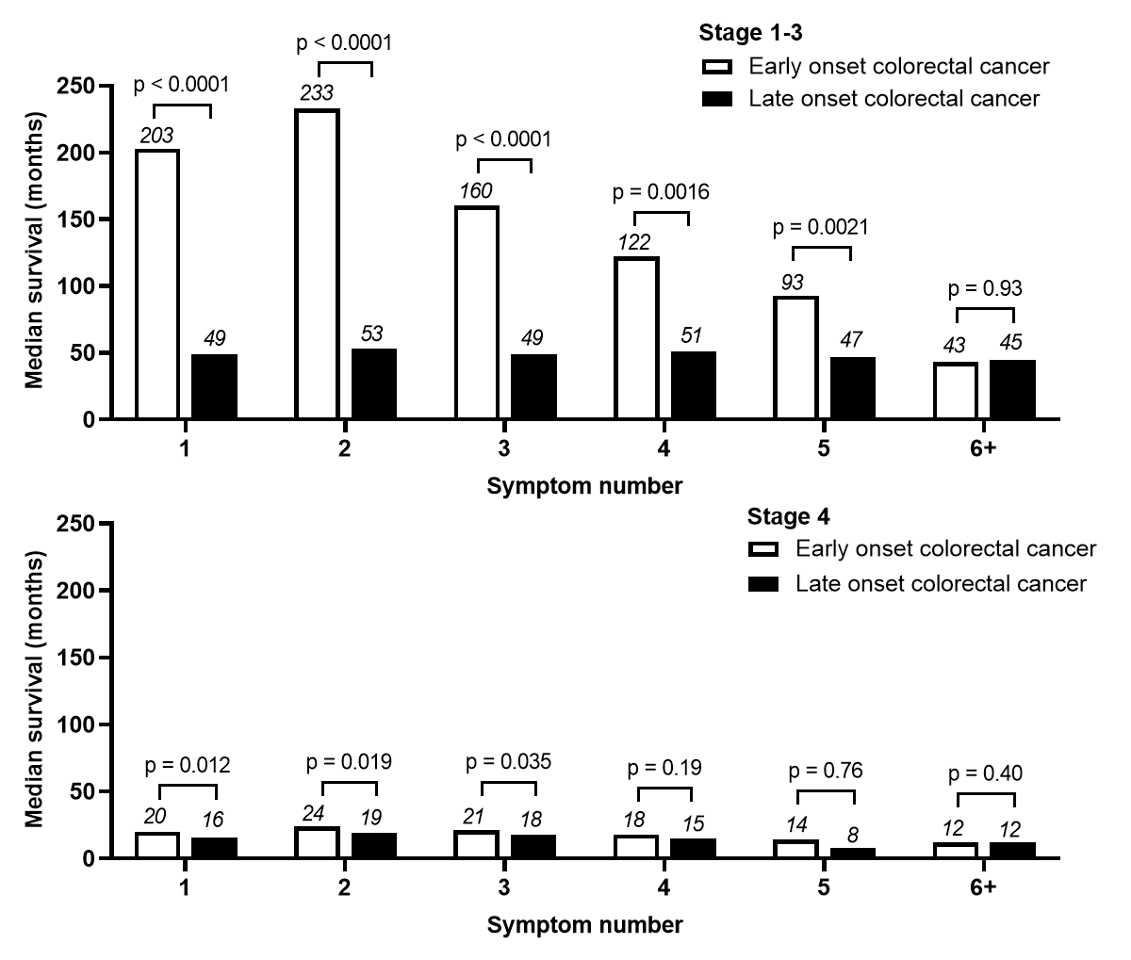
Supplemental Figure 4. Median survival of patients younger than 50 (EoCRC) and 50 years or older (LoCRC) by symptom number at presentation and stage of diagnosis of colorectal cancer. Median survival calculated from Kaplan Meyer curves in Supplementary Figure 2, and p-value summarizes log-rank comparisons.

Variable | HR (95% CI) | P
Age<50 | 0.87 (0.78-0.96) | 0.008
Stage
Stage 1 | 0.12 (0.066-0.23) | <0.0001
Stage 2 | 0.11 (0.090-0.13) | <0.001
Stage 3 | 0.25 (0.23-0.28) | <0.001
Stage 4 | Reference
Total Number of Symptoms
0 | Reference
1 | 1.48 (1.12-1.95) | 0.006
2 | 1.36 (1.027-1.80) | 0.032
3 | 1.68 (1.27-2.23) | <0.0001
4 | 1.93 (1.44-2.58) | <0.0001
5 | 2.51 (1.84-3.43) | <0.0001
6 | 2.36 (1.63-3.42) | <0.0001
7 | 2.31 (1.46-3.68) | <0.0001
8 | 9.02 (3.27-24.88) | <0.0001
9 | 5.20 (0.72-37.58) | 0.1

Supplemental Table 2. Multivariate analysis of the listed variables controlling for age, diagnosis era, stage at diagnosis, number of symptoms and duration of symptoms (categorical as 0-90, 91-180 and 181+ days). A total of 3344 patients with all available values were analyzed using a Cox-proportional hazard model.

