Supplemental for “Single-cell RNA sequencing reveals the cellular and molecular heterogeneity of treatment-naïve primary osteosarcoma in dogs”

Running title: Canine osteosarcoma scRNA-seq atlas

Dylan T. Ammons^{a*}, Leone S. Hopkins^{b}, Kathryn E. Croniseª, Jade Kurihara^{b}, Daniel P. Regan^{a,b}, and Steven Dow^{a,b*}
Department of ªMicrobiology, Immunology and Pathology; ^{b}Flint Animal Cancer Center, Department of Clinical Sciences; Colorado State University, Fort Collins, CO, USA

*Corresponding authors:
Dylan T. Ammons, Department of Microbiology, Immunology and Pathology, College of Veterinary Medicine and Biomedical Sciences, Colorado State University, Fort Collins, CO 80523; e-mail: dylan.ammons@colostate.edu
Steven Dow, Flint Animal Cancer Center, Department of Clinical Sciences, College of Veterinary Medicine and Biomedical Sciences, Colorado State University, Fort Collins, CO 80523; e-mail: steven.dow@colostate.edu

Supplemental data file descriptions:
Supplemental Data 1: Results of all pseudobulk contrasts presented in the manuscript in long data format. The contrast is indicated in the column “gs_base” and the “log2FoldChange” column direction is based on term1_VS_term2 as defined in the “gs_base” column.
Supplemental Data 2/3: Results of FindMarkers() on the T cell (Data 2) and myeloid (Data 3) subsets joined with the surfaceome database with “Surfaceome.Label” corresponding to the classification and “Surfaceome.Label.Source” indicating the method in which the prediction was made.
Supplemental Data 4-6: Datasets used to generate the plots in Figure 9b (Data 4), 9c (Data 5), and 9d (Data 6).
Supplemental Data 7: Results of FindMarkers() for all 41 cell types joined with the surfaceome database with “Surfaceome.Label” corresponding to the classification and “Surfaceome.Label.Source” indicating the method in which the prediction was made.

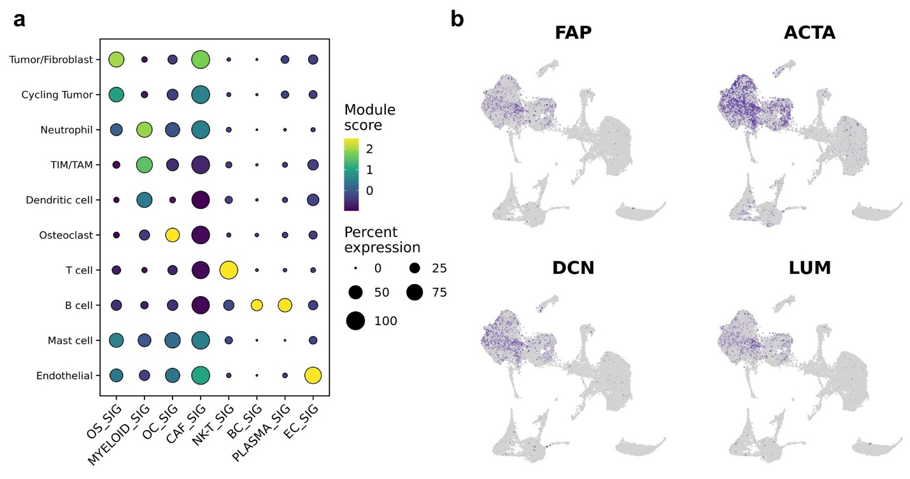
Supplemental figure 1: (a) Dot plot depicting the scaled module score of gene lists used to identify cell populations in human osteosarcoma datasets. (b) Feature plots depicting the log normalized counts of fibroblast related genes.

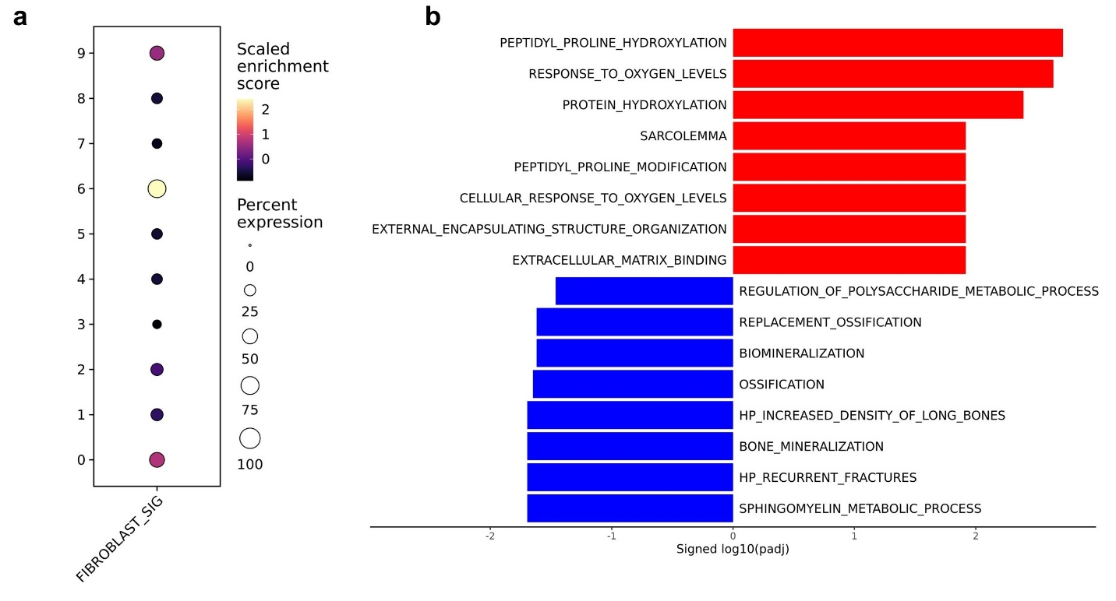
Supplemental figure 2: (a) Dot plot depicting the scaled module score of a fibroblast gene list. (b) Bar chart depicting the results of gene set enrichment analysis from the differential gene expression analysis of hypoxic osteoblasts (c4) versus non-hypoxic osteoblasts (c0, c1, c2) in Figure 2e.

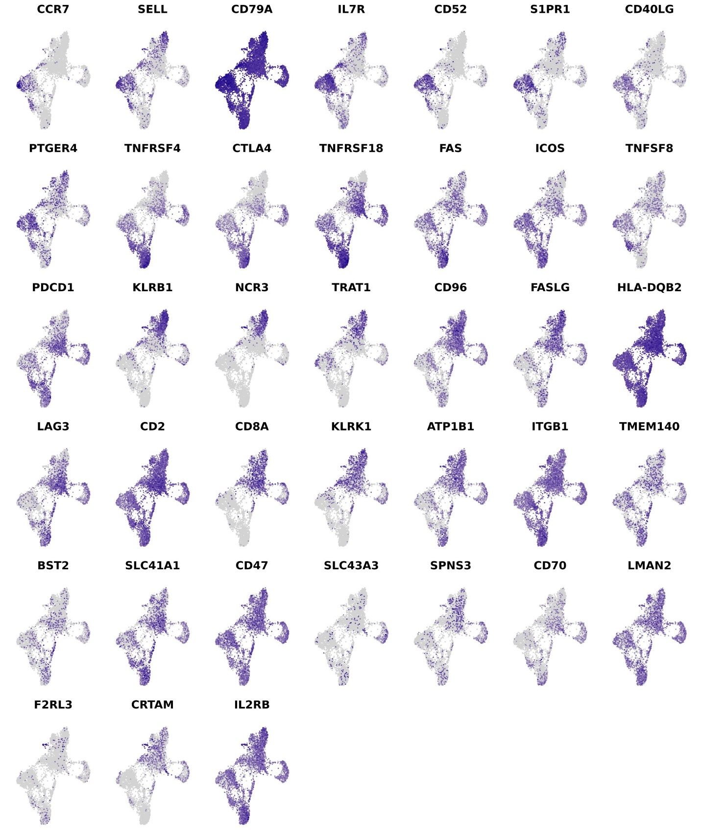
Supplemental figure 3: Feature plots depicting the log normalized counts of features in T cells presented in the surface marker screen heatmap in Figure 3g.

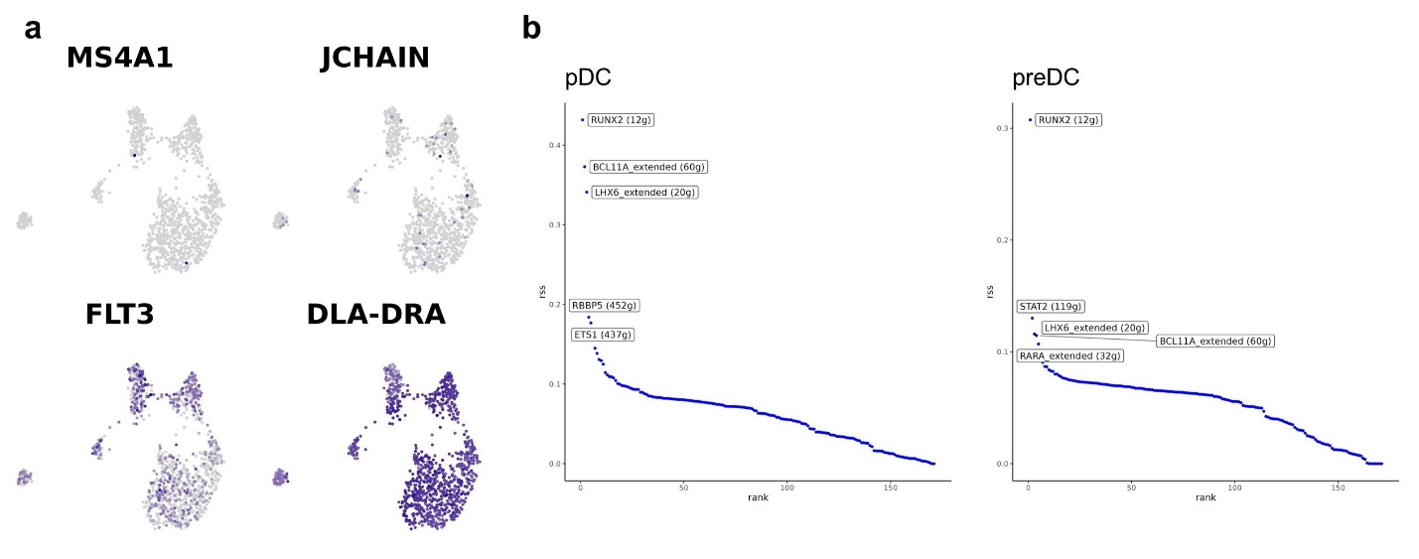
Supplemental figure 4: (a) Feature plots depicting the log normalized counts of B cell and dendritic cell associated features. presented in the surface marker screen heatmap in Figure 3g. (b) Scatter plots depicting regulon enrichment score for active transcription factors in plasmacytoid dendritic cells (pDC) and precursor dendritic cells (preDC), as determined using SCENIC. The parenthetic number in the label indicates the number of genes associated with the regulon.

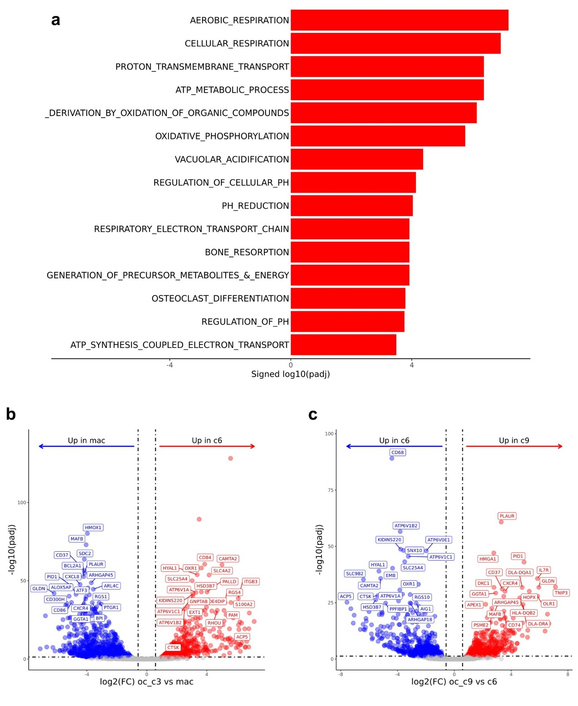
Supplemental figure 5: (a) Bar chart depicting the results of gene set enrichment analysis from the differential gene expression analysis Mature OC (c6) versus macrophage (c0, c1, c2, and c3) in Figure 6d. Volcano plot depicting the results of differential gene expression analysis between (b) CD320⁺ OC versus macrophage (c0, c1, c2, and c3) (x-axis) and (c) CD320⁺ OCs versus Mature OC (y-axis).
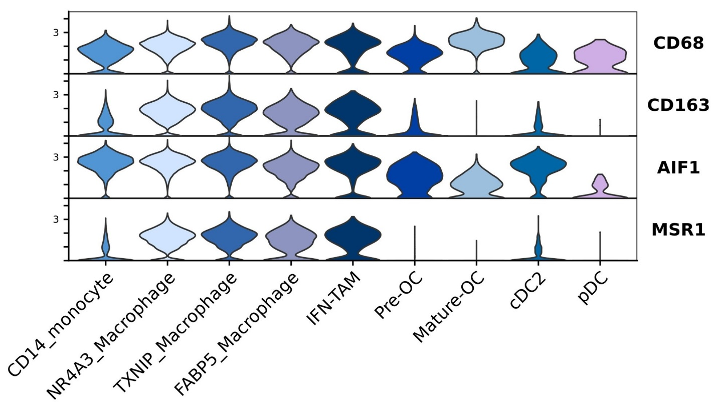
Supplemental figure 6: Violin plots of four immunohistochemistry (IHC) macrophage markers widely used to evaluate macrophage infiltrates in canine and human osteosarcoma. The human data is presented here.
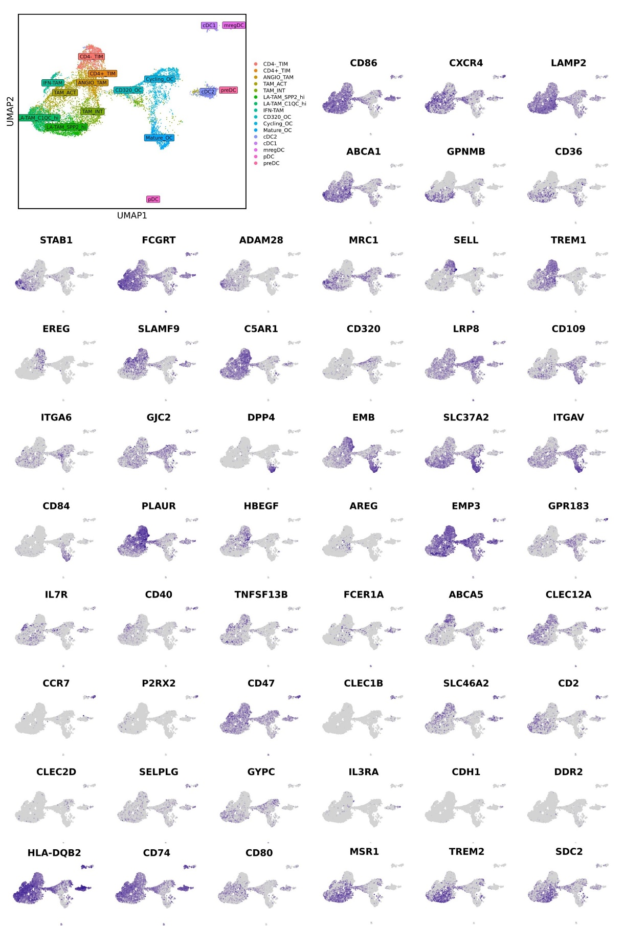Supplemental figure 7: Feature plots depicting the log normalized counts of features in myeloid cells presented in the surface marker screen heatmap in Figure 7b.

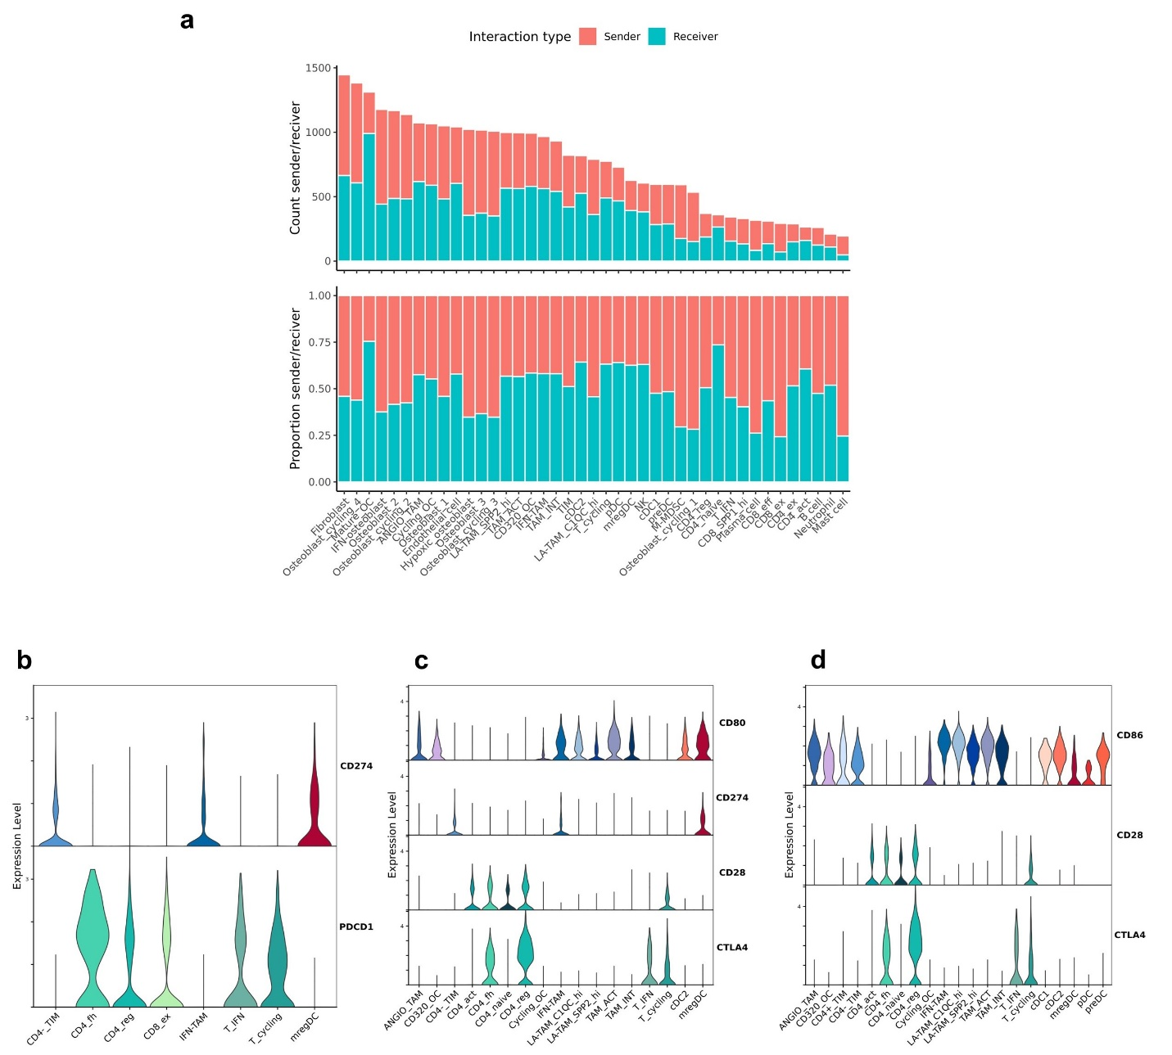
Supplemental figure 8: (a) Bar chart depicting the number of CellChat inferred interactions (top) and the percentage interactions in which a cell type is predicted to be sending or receiving an interaction (bottom). Violin plots of features included in the CellChat PDL1 network (b), CD80 network (c), and CD86 network (d).
Percent immune cells |  |  |  | Percent all cells
Cell type | Average | Range |  | Cell type | Average | Range
CD4_naive | 1.15 | 0.4-1.77 |  | CD4_naive | 0.77 | 0.28-1.65
CD4_act | 5.6 | 1.54-12.89 |  | CD4_act | 3.74 | 0.58-7.89
CD4_reg | 4.89 | 1.63-10.55 |  | CD4_reg | 2.96 | 0.98-6.46
CD4_fh | 1.76 | 0.08-4.63 |  | CD4_fh | 1.12 | 0.05-2.83
CD8_eff | 4.89 | 2.46-9.8 |  | CD8_eff | 3.5 | 1.08-9.11
CD8_ex | 8.73 | 1.97-15.77 |  | CD8_ex | 5.65 | 1.18-9.66
CD8_SPP1_hi | 1.36 | 0.49-2.34 |  | CD8_SPP1_hi | 0.81 | 0.45-1.43
T_IFN | 1.07 | 0.08-1.91 |  | T_IFN | 0.68 | 0.05-1.35
T_cycling | 3.04 | 0.79-5.68 |  | T_cycling | 1.89 | 0.47-3.41
NK | 0.28 | 0.06-0.9 |  | NK | 0.18 | 0.02-0.55

Supplemental table 1: Percent composition of each T cell cluster as a percentage of total immune cells and percentage of total cells (osteoclasts were included as an immune cell in the calculation). The data are plotted in Figure 3f.

Pro-inflammatory | AZIN1 | CD38 | CD86 | CXCL10 | FPR2 | GPR18 | IL12B | IL18
 | IRF5 | NFKBIZ | NOS2 | PTGS2 | TLR4 | TNF
Anti-inflammatory | ALOX15 | ARG1 | CHIL3 | CHIL4 | EGR2 | IL10 | IRF4 | KLF4
 | MRC1 | MYC | SOCS2 | TGM2

Supplemental table 2: Gene lists used to complete module scoring of “Pro-inflammatory” and “anti-inflammatory” gene signatures in Figure 5e.

Percent immune cells |  |  |  | Percent all cells
Cell type | Average | Range |  | Cell type | Average | Range
CD4-_TIM | 4.36 | 0.91-7.23 |  | CD4-_TIM | 2.81 | 0.64-5.62
CD4+_TIM | 0.91 | 0.23-1.53 |  | CD4+_TIM | 0.56 | 0.17-0.94
ANGIO_TAM | 2.77 | 1.04-5.78 |  | ANGIO_TAM | 1.6 | 0.83-3.47
TAM_ACT | 7.58 | 2.5-16.21 |  | TAM_ACT | 4.7 | 1.95-11.48
TAM_INT | 5.54 | 0.65-10.88 |  | TAM_INT | 3.36 | 0.4-7.7
LA-TAM_SPP2_hi | 5.7 | 1.71-7.83 |  | LA-TAM_SPP2_hi | 3.37 | 1.59-4.94
LA-TAM_C1QC_hi | 4.81 | 1.47-6.41 |  | LA-TAM_C1QC_hi | 2.85 | 1.36-4.54
IFN-TAM | 1.43 | 0.43-3.22 |  | IFN-TAM | 0.87 | 0.4-2.28
CD320_OC | 1.37 | 0.4-2.59 |  | CD320_OC | 0.79 | 0.24-1.56
Cycling_OC | 5.52 | 1.62-9.04 |  | Cycling_OC | 3.2 | 1.5-5.43
Mature_OC | 2.87 | 0.4-9.45 |  | Mature_OC | 1.41 | 0.37-3.54
cDC2 | 3.63 | 2.11-6.47 |  | cDC2 | 2.16 | 1.46-3.88
cDC1 | 0.98 | 0.17-3.08 |  | cDC1 | 0.6 | 0.12-1.85
mregDC | 0.93 | 0.2-2.6 |  | mregDC | 0.6 | 0.14-1.56
pDC | 0.36 | 0.1-0.65 |  | pDC | 0.23 | 0.06-0.43
preDC | 0.26 | 0.03-0.44 |  | preDC | 0.16 | 0.02-0.31

Supplemental table 3: Percent composition of each myeloid cluster as a percentage of total immune cells and percentage of total cells (osteoclasts were included as an immune cell in the calculation). The data are plotted in Figure 7c.
Immune | SPP1 | CD45 | CCL | SELPLG | CD86 | SELL
 | FASLG | FLT3 | PD-L1 | CD96 | CD23 | OSM
 | THY1 | ADGRE5 | SEMA4 | CD40 | CSF | PARs
 | IL1 | CD80 | MPZ | CD22 | CADM | BAFF
 | IL16
Immune-related | GALECTIN | FN1 | THBS | LAMININ | SEMA7 | CLEC
 | ICAM | NRG | NOTCH | HSPG | NECTIN | BAG
 | RESISTIN | VISFATIN
Non-immune | COLLAGEN | APP | PTN | VEGF | BSP | PECAM1
 | APRIL | JAM | CDH1 | ESAM | VWF | PERIOSTIN
 | ANGPT | GAS | CALCR | TENASCIN | CDH5 | PDGF
 | IGF | FGF | CDH | NCAM

Supplemental table 4: Breakdown of the 61 significant CellChat networks into three subdivided networks: “immune”, “immune-related”, and “non-immune”.

