Supplement:

B
A
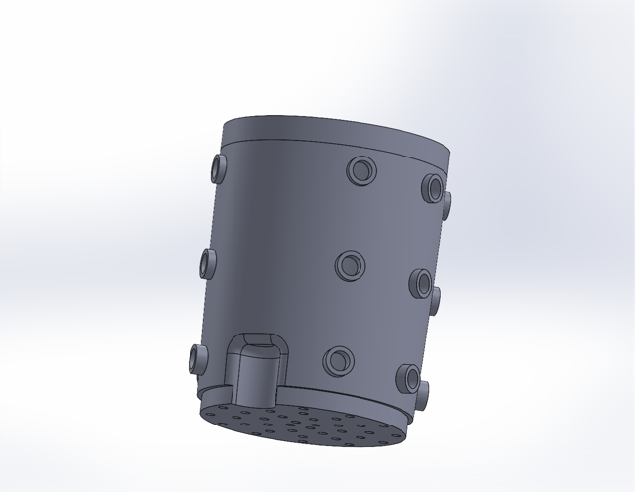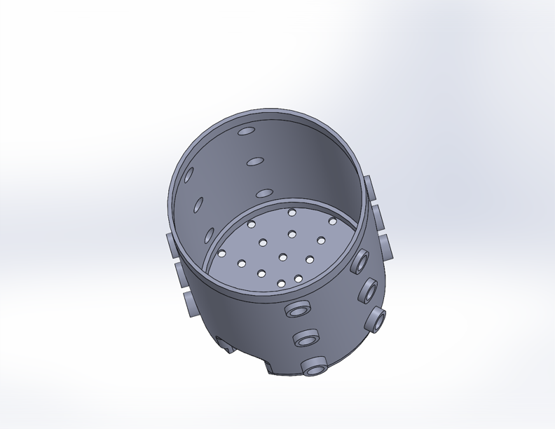

Supplemental Figure 1. CAD drawing of 3D printed pots showing sampling ports along the side A) side view and B) top view the perforated bottom that allows for root formation and self-watering from a reservoir.

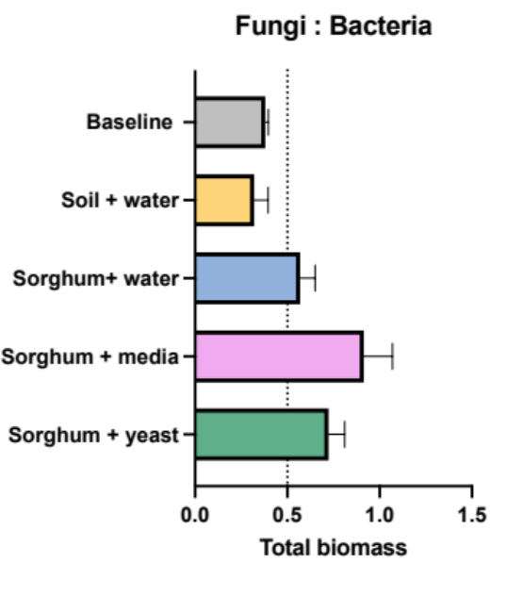

Supplemental Figure 2. Ratios of fungal biomass to bacterial biomass by phospholipid fatty acid (PFLA) analysis by Gas Chromatography (GC) of microbial composition of soils at baseline and 30 days post amendment.

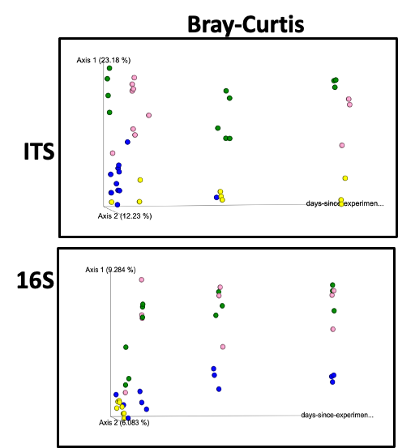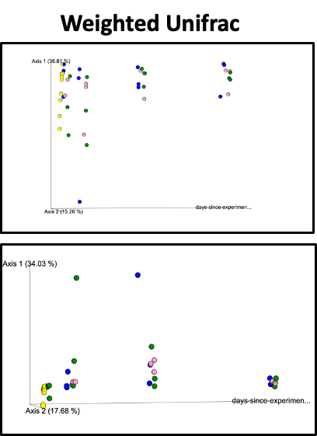
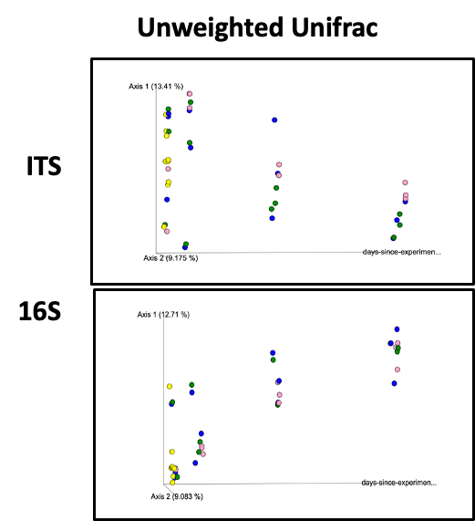

Supplemental Figure 3. Beta-diversity of samples over time course. Principal coordinate 1, principal coordinate 2, and days since the experiment start to visualize how these samples changed over time.

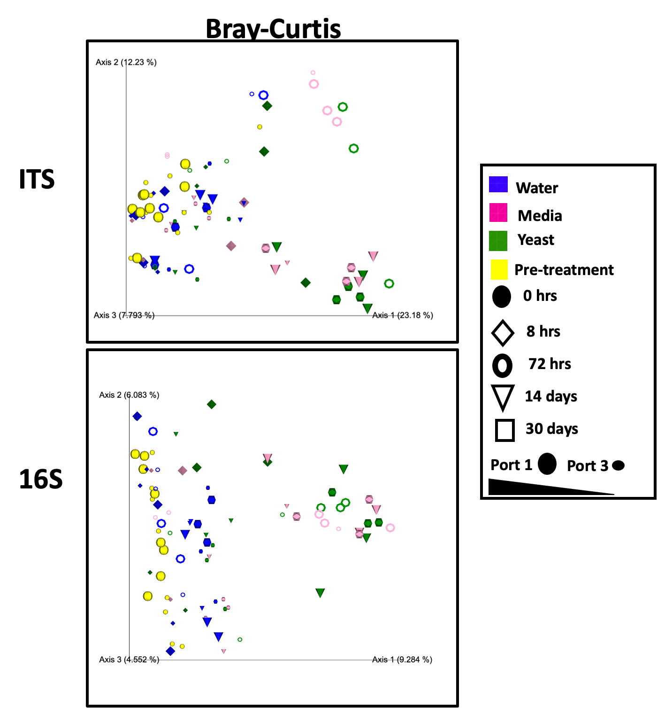

Supplemental Figure 4. Beta-diversity as a function of treatment (color) time (shape) and strata (scale) of soil mycobiome (top) and bacteriome (bottom) with Bray-Curtis distance matrix.

