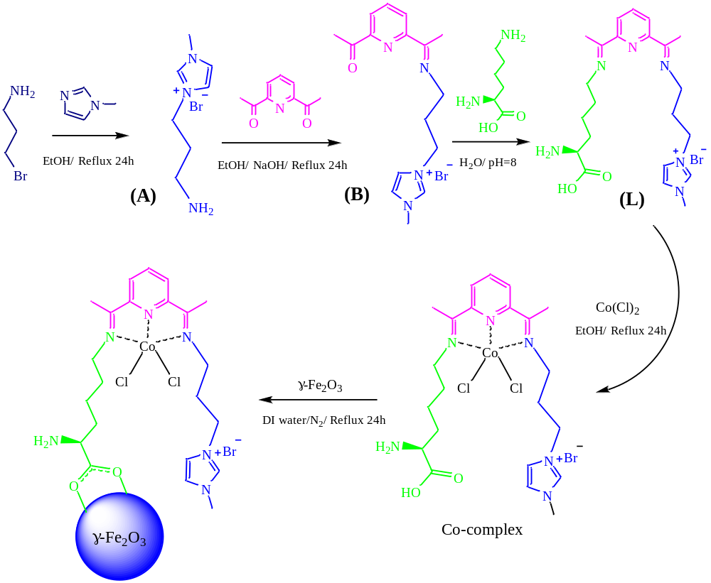
Scheme 1. The sequence of events in the preparation of the L-Co (II)-γ-Fe₂O₃ catalyst
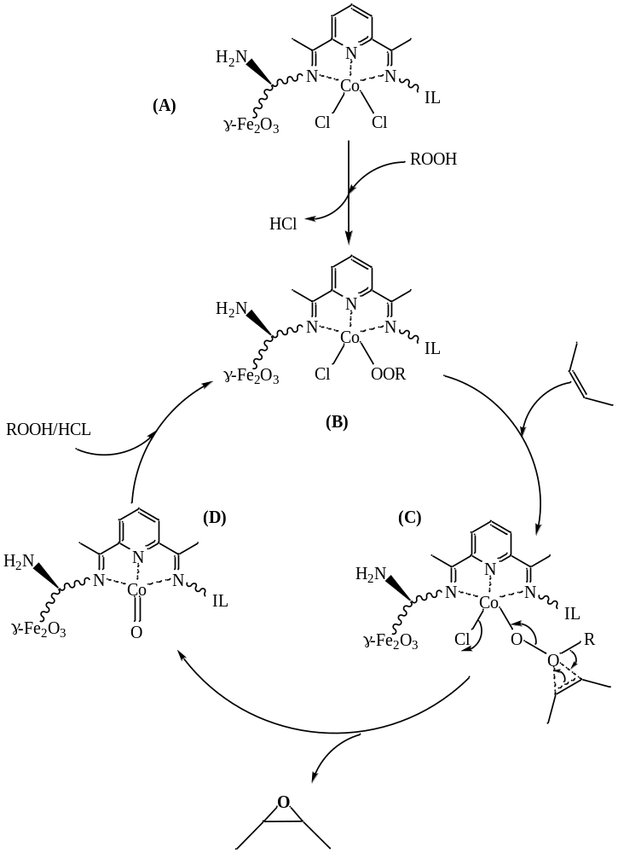

Scheme 2. Proposed mechanism for epoxidation of alkenes in the presence of L-Co (II) -γ-Fe₂O₃ catalyst

