Extended data figures 1-9

Extended Data Fig. 1: Examples showing common types of greenhouses in: a, Heilongjiang, northern China; b, Shandong, eastern China; c, Hainan, southern China; d, Xianyang, central China; e, Odense, Denmark; f, Almeria, Spain. The first row shows field photos, the second to fourth rows show true color composites of PlanetScope, Sentinel-2 and Landsat images from 2019. The example in c illustrates the seasonal mulching activities for low tunnel that was excluded from PlanetScope imagery and therefore not mapped in our study.
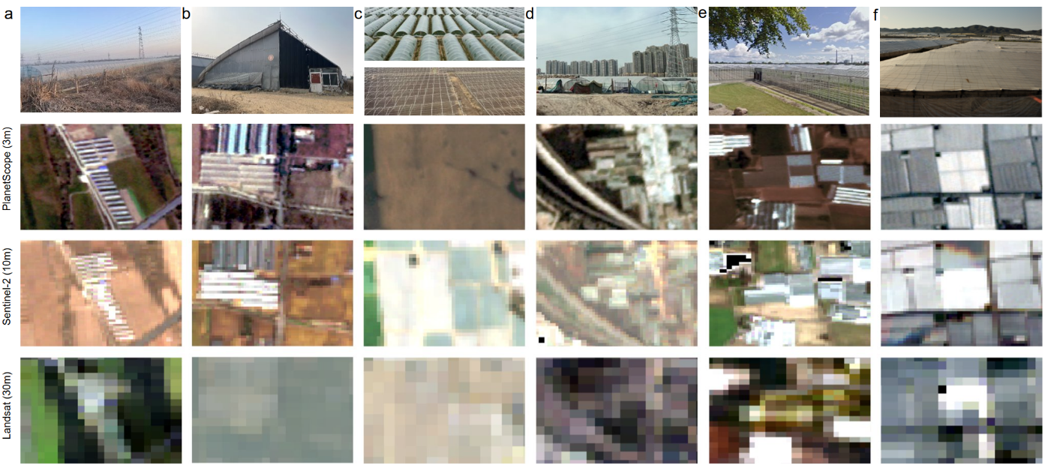
Extended Data Fig. 2: Example of the largest major greenhouse cultivation cluster (Weifang, China), defined by 1 km grids of significant (p-value < 0.05) greenhouse cultivation percentage cover. A zoom-in (orange area) on a 8x8 km grid structure, shows the details of the 3 m predictions.
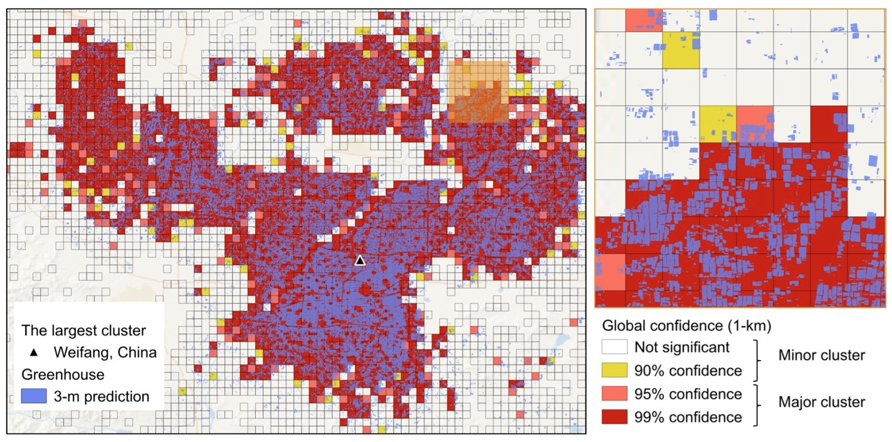

Extended Data Fig. 3: Examples showing the determination of starting year using Earth Timelapse. a, True color composites of Landsat images from 1988 to 1999; the year 1990 (in red color) was the starting year for the significant cluster of Weifang, China (36.7123N, 118.747E). b, The year of 2006 was the starting year for the significant cluster of Lake Chapala, Mexico (19.885N, -102.207E). The criterion is to identify the first occurrence of visible patterns of semi-transparent whitish features.
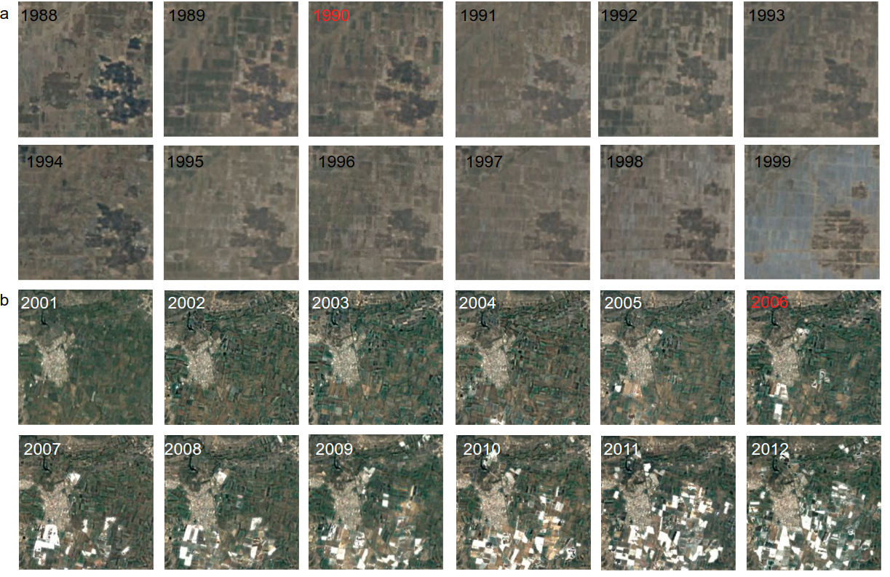
Extended Data Fig. 4: Full collection of trajectories of areal expansion during 1984-2021 for the largest clusters of the top five greenhouse cultivation countries. From top to bottom rows are Weifang, China; Almeria, Spain; Bari, Italy; Antalya, Turkey; and Chapala, Mexico.

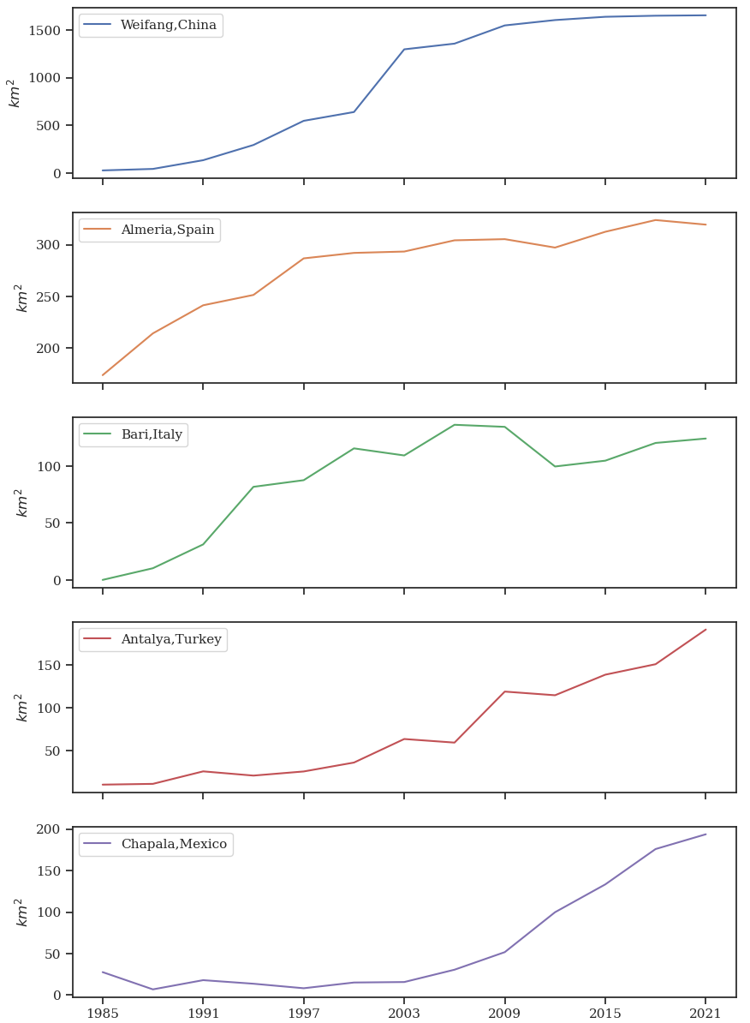

Extended Data Fig. 5: Top importers of three types of vegetables. a, Tomato from exporters (E) of Spain, Mexico, China, Turkey and Italy to its top importers (I); b, Cucumber from exporters (E) of Spain, Mexico, China, and Turkey to its top importers; c, Pepper from exporters (E) of Spain, Mexico, China, and Turkey to its top importers. The percentage of export weight to each of the total vegetable production weight is shown on the secondary y-axis as a dashed line.
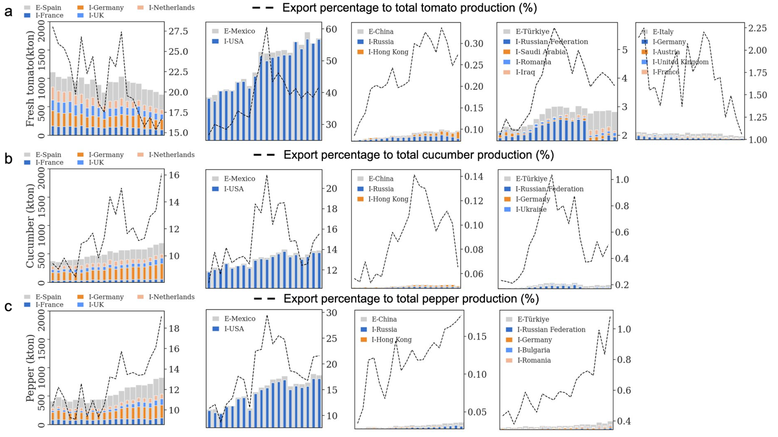

Extended Data Fig. 6: Domestic production of four types of vegetables (GP: green pepper, CG: cucumber, EP: eggplant, TM: tomato) in five countries. a, Spain; b, Mexico; c, China; d, Turkey; and e, Italy.

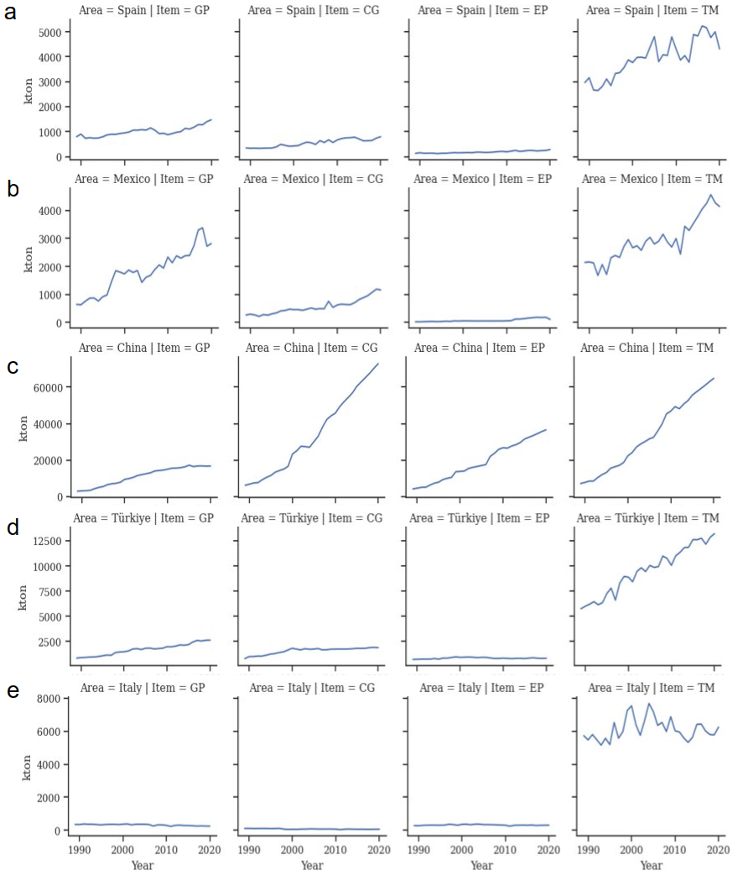
Extended Data Fig. 7: a, Incidence rate of greenhouse cultivation in cropland areas. b, nighttime light brightness (unitless), and c, elevation at county level in China.
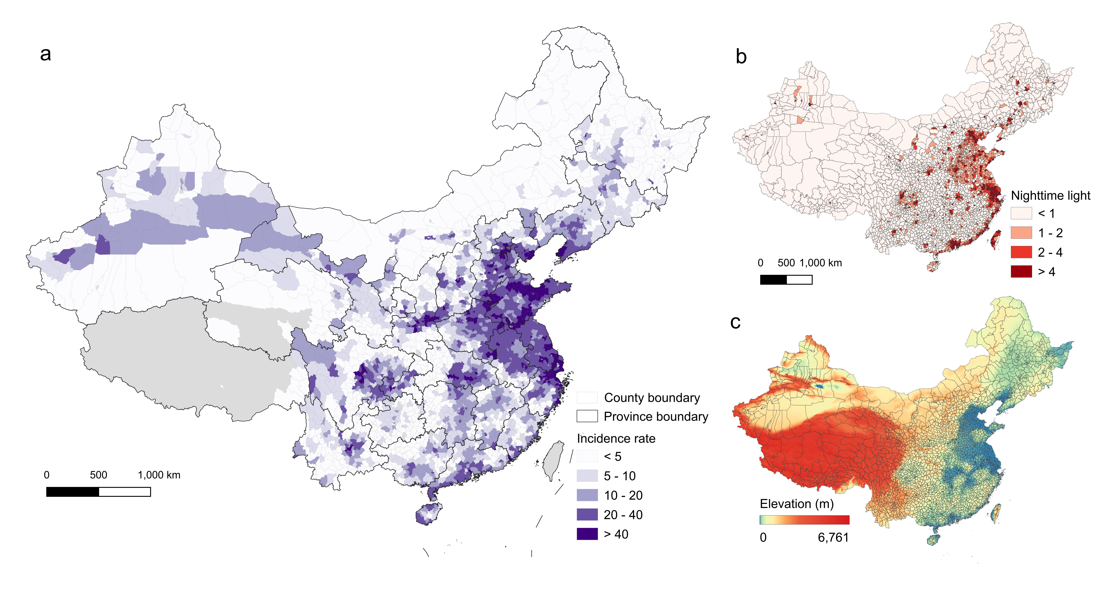

Extended Data Fig. 8 National level budget on poverty alleviation and the poverty headcount rate in China from 2013 to 2020.
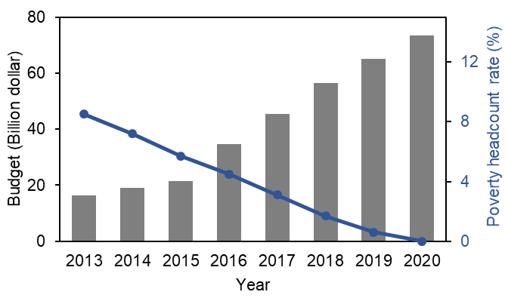

Extended Data Fig. 9 Schematic workflow of global input data preparation, the deep learning models and subsequent analysis. Human settlements are defined by the global urban footprint⁵.

