Supplementary information

Previously undetected small-scale greenhouses are an unknown environmental threat

Xiaoye Tongª, Xiaoxin Zhangª, Rasmus Fensholtª, Peter Rosendal Dau Jensenª, Sizhuo Liª, Marianne Nylandsted Larsenª, Florian Reinerª, Feng Tian^{b}, Martin Brandtª

a Department of Geosciences and Natural Resource Management, University of Copenhagen, Copenhagen, Denmark
b School of Remote Sensing and Information Engineering, Wuhan University, Wuhan, China

Supplementary Figures 1-3 Supplementary Table 1-6
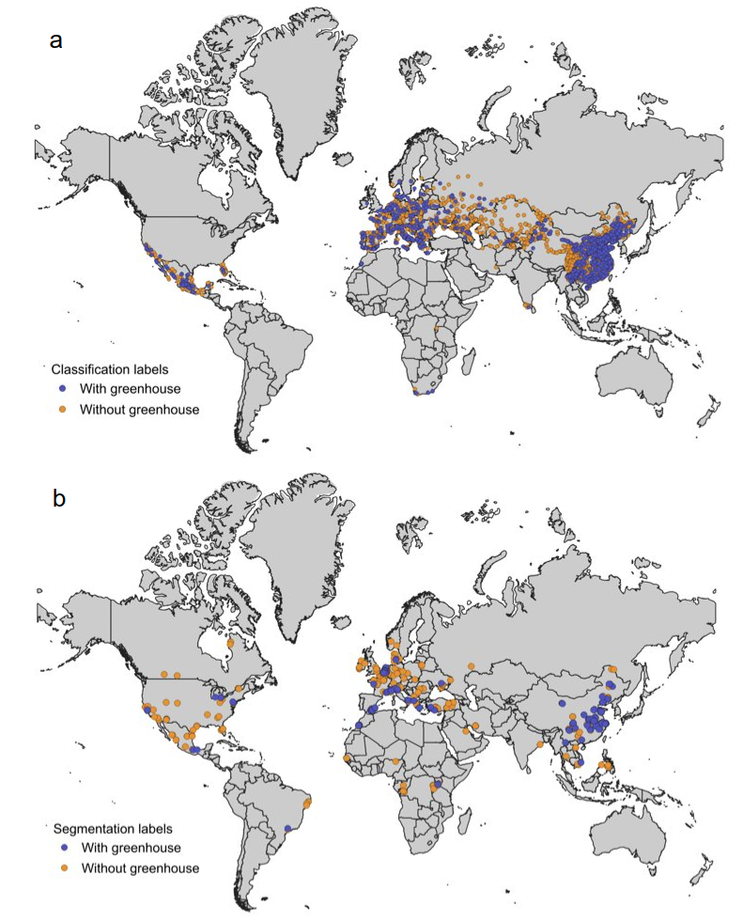

Supplementary Fig. 1 | Location of labelling sites with or without greenhouse cultivation used for training the a., classification model (with greenhouse: 1753, without: 2113) and b., segmentation model (with greenhouse: 323, without: 361).
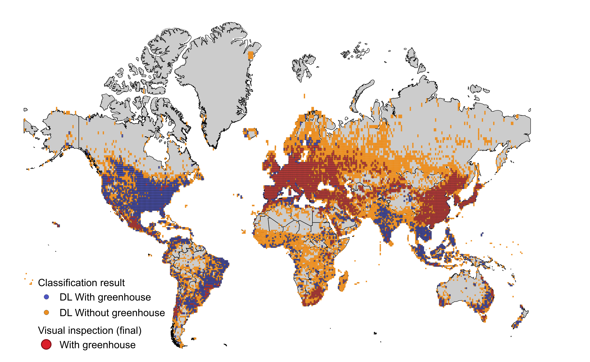
Supplementary Fig. 2 | The 1-degree tiles with (5502 tiles) or without (6925 tiles) greenhouse cultivation as predicted by the classification model. By visual inspection of the 5502 tiles, 2673 tiles were subsequently selected for further mapping of greenhouse cultivation at a resolution of 3 m.
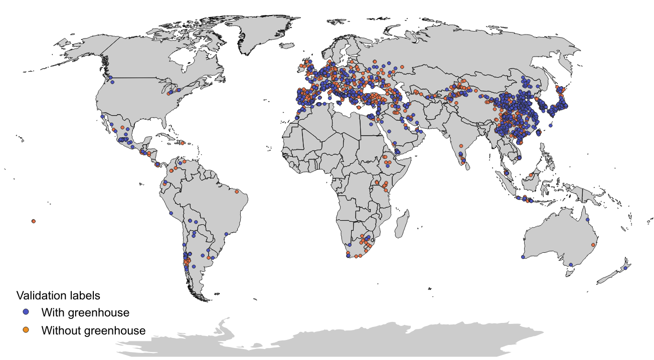

Supplementary Fig. 3 | Distribution of 1500 1-km grid cells for global validation of greenhouse cultivation as predicted from the segmentation model.

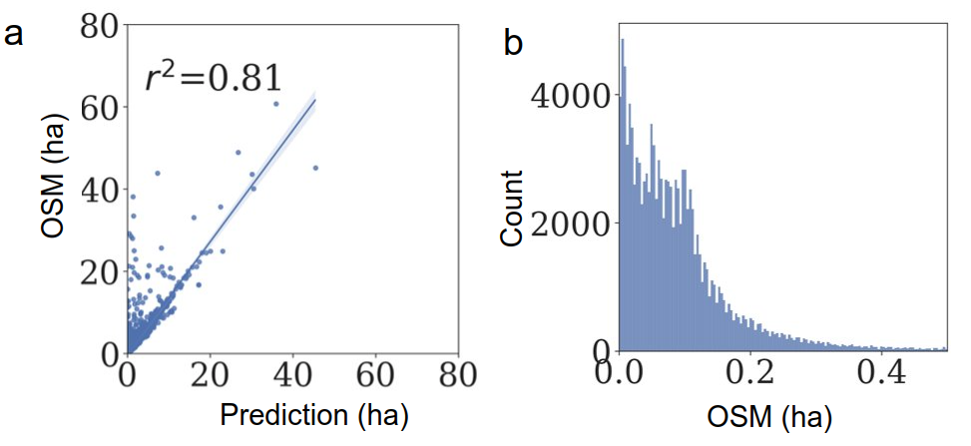
Supplementary Fig. 4 | Cross validation between OpenStreetMap (OSM) greenhouse labels and the PlanetScope-derived 3 m map. a, Scatterplot between the size of OSM greenhouses (n = 81785) and the size extracted from PlanetScope 3 m predictions, b, The histogram of OSM greenhouses by size that has not been mapped from PlanetScope 3 m predictions (n = 124719).

Supplementary Table 1 | Statistics of the accuracy evaluation of greenhouse cultivation for 1500 1 x 1 km² grid cells.

Area range (ha) | Precision | Recall | f1-score | Number of labels
< 0.1 | 0.31 | 1.00 | 0.47 | 160
0.1 - 0.5 | 0.45 | 1.00 | 0.62 | 494
0.5 - 1 | 0.62 | 1.00 | 0.77 | 175
1 - 10 | 0.85 | 1.00 | 0.92 | 556
10 - 50 | 0.98 | 1.00 | 0.99 | 106
> 50 | 1.00 | 1.00 | 1.00 | 9

Supplementary Table 2 | Statistics of the performance of the trained PlanetScope classification model when evaluated on testing datasets.
 | Recall | Precision | F1 Score | Accuracy
Test Score | 0.879 | 0.837 | 0.857 | 0.871

Supplementary Table 3 | Statistics of the performance of the trained Planetscope segmentation model when evaluated on testing datasets.
 | Recall | Precision | F1 Score | MIoU
Test Score | 0.916 | 0.939 | 0.927 | 0.867

Supplementary Table 4 | Information on the starting year of the emergence of the largest 65 major clusters. Note: Major cluster #id 60 as a seasonal greenhouse cluster was not visible from annual Landsat time series and thus has no reported starting year.
id | ADM2_NAME | ADM0_NAME | ADM1_NAME | Coverage (ha) | Coverage(km2) | Year_inspector#1 | Year_inspector#2 | Inspection_difference | Elevation (m) | Aridity_index (*10000) | lon | lat | If_seasonal
1 | Turfan | China | Xinjiang Uygur Zizhiqu | 224486.1 | 22.4 | 2000 | 2003 | -3 | -52.4 | 108.2 | 42.87 | 89.202
2 | Wuhu | China | Anhui Sheng | 288696.0 | 28.9 | 1994 | 1994 | 0 | 7.1 | 9274.5 | 31.412 | 118.261
3 | Weifang | China | Shandong Sheng | 82155.5 | 821.6 | 1990 | 1989 | 1 | 44.9 | 4612.9 | 36.842 | 118.699
4 | Ningbo | China | Zhejiang Sheng | 208684.4 | 20.9 | 2002 | 2003 | -1 | 4.9 | 9366.0 | 30.204 | 121.346
5 | Matera | Italy | Basilicata | 336620.3 | 33.7 | 1984 | 1984 | 0 | 40.6 | 4539.4 | 40.525 | 16.867
6 | Qujing | China | Yunnan Sheng | 767681.2 | 76.8 | 2013 | 2012 | 1 | 1860.2 | 7613.4 | 25.006 | 103.708
7 | Southern District | Israel | Southern District | 192925.9 | 19.3 | 1984 | 1984 | 0 | -13.8 | 617.3 | 31.252 | 34.424
8 | Almeria | Spain | Andalucia | 3511691.8 | 351.2 | 1970 | 1970 | 0 | 142.2 | 1674.0 | 36.75 | -2.727
9 | Latina | Italy | Lazio | 498121.1 | 49.8 | 1984 | 1984 | 0 | 23.2 | 7013.8 | 41.293 | 13.101
10 | Kashgar | China | Xinjiang Uygur Zizhiqu | 201737.8 | 20.2 | 2005 | 2005 | 0 | 1208.9 | 447.0 | 39.472 | 76.907 | 1
11 | Taroudannt | Morocco | Souss - Massa | 533378.2 | 53.3 | 1998 | 1984 | 14 | 188.7 | 1124.3 | 30.47 | -9.071
12 | Huelva | Spain | Andalucia | 981304.9 | 98.1 | 1984 | 1990 | -6 | 64.1 | 2944.9 | 37.186 | -6.868
13 | Kinitra | Morocco | Gharb - Chrarda - Bini Hssen | 330459.8 | 33.0 | 1988 | 1987 | 1 | 22.4 | 3693.7 | 34.634 | -6.37
14 | Heze | China | Shandong Sheng | 190904.4 | 19.1 | 1997 | 1997 | 0 | 49.2 | 4534.4 | 35.146 | 115.681
15 | Shenyang | China | Liaoning Sheng | 351880.7 | 35.2 | 1995 | 1996 | -1 | 24.9 | 4987.1 | 41.908 | 122.951
16 | Jinan | China | Shandong Sheng | 690043.9 | 69.0 | 1990 | 1995 | -5 | 19.6 | 4179.6 | 37.138 | 117.263
17 | Weinan | China | Shaanxi Sheng | 2192092.5 | 219.2 | 2006 | 2004 | 2 | 368.4 | 4079.5 | 34.85 | 110.085
18 | Chtouka-Ait Baha | Morocco | Souss - Massa | 1454975.8 | 145.5 | 1988 | 1986 | 2 | 97.1 | 1003.0 | 30.202 | -9.464
19 | Ragusa | Italy | Sicilia | 257822.1 | 25.8 | 1984 | 1984 | 0 | 70.4 | 2898.7 | 36.819 | 14.497
20 | Zuid-holland | Netherlands | Zuid-holland | 701411.4 | 70.1 | 1970 | 1970 | 0 | -2.9 | 11443.6 | 51.985 | 4.227
21 | Yuncheng | China | Shanxi Sheng | 874659.9 | 87.5 | 2014 | 2014 | 0 | 377.3 | 3777.8 | 35.014 | 110.633
22 | Nantong | China | Jiangsu Sheng | 483747.5 | 48.4 | 2013 | 2010 | 3 | 3.7 | 8431.6 | 32.07 | 121.169 | 1
23 | Anyang | China | Henan Sheng | 317000.6 | 31.7 | 2002 | 2000 | 2 | 55.1 | 3937.0 | 35.914 | 114.78
24 | Tai'an | China | Shandong Sheng | 372539.8 | 37.3 | 1995 | 1995 | 0 | 134.6 | 4984.4 | 35.924 | 117.25
25 | Hainan | China | Hainan Sheng | 631797.2 | 63.2 | 2015 | 2013 | 2 | 19.4 | 7232.2 | 18.531 | 108.858
26 | Hohhot | China | Nei Mongol Zizhiqu | 236366.9 | 23.6 | 2008 | 2008 | 0 | 1095.6 | 2059.9 | 40.7 | 111.811
27 | Xuzhou | China | Jiangsu Sheng | 297332.7 | 29.7 | 2008 | 2008 | 0 | 29.1 | 4981.3 | 34.559 | 118.189
28 | Wuzhong | China | Ningxia Huizu Zizhiqu | 204785.3 | 20.5 | 1998 | 2004 | -6 | 1220.5 | 1417.4 | 37.523 | 105.304
29 | Bayin'gholin Mongol | China | Xinjiang Uygur Zizhiqu | 467286.3 | 46.7 | 1994 | 1995 | -1 | 940.0 | 442.2 | 41.729 | 86.073
30 | Qingdao | China | Shandong Sheng | 928281.5 | 92.8 | 1985 | 1993 | -8 | 37.2 | 5083.7 | 36.669 | 120.188
31 | Kunming | China | Yunnan Sheng | 1788398.7 | 178.8 | 2000 | 2001 | -1 | 1898.1 | 7128.5 | 25.299 | 103.086
32 | Liaocheng | China | Shandong Sheng | 2773076.6 | 277.3 | 1996 | 1996 | 0 | 38.7 | 3946.4 | 36.164 | 115.525
33 | Manavgat | Turkey | Antalya | 853178.4 | 85.3 | 1999 | 1998 | 1 | 43.4 | 4575.7 | 36.983 | 30.79
34 | Yinchuan | China | Ningxia Huizu Zizhiqu | 407065.3 | 40.7 | 2000 | 2000 | 0 | 1112.9 | 1259.8 | 38.467 | 106.379
35 | Chifeng | China | Nei Mongol Zizhiqu | 507075.2 | 50.7 | 2002 | 2002 | 0 | 705.7 | 2944.7 | 41.71 | 118.926
36 | Tangshan | China | Hebei Sheng | 981560.8 | 98.2 | 1997 | 1997 | 0 | 8.0 | 4299.3 | 39.438 | 118.84
37 | Yancheng | China | Jiangsu Sheng | 318041.2 | 31.8 | 2002 | 2004 | -2 | 1.1 | 7604.0 | 32.74 | 120.749 | 1
38 | Linyi | China | Shandong Sheng | 1066218.1 | 106.6 | 1995 | 1995 | 0 | 80.0 | 5480.8 | 34.832 | 117.926
39 | Granada | Spain | Andalucia | 281957.7 | 28.2 | 1984 | 1984 | 0 | 197.6 | 2325.6 | 36.72 | -3.461
40 | Dalian | China | Liaoning Sheng | 324737.2 | 32.5 | 1995 | 1995 | 0 | 33.4 | 5141.7 | 39.236 | 121.731
41 | Jiaxing | China | Zhejiang Sheng | 271675.5 | 27.2 | 1997 | 2003 | -6 | 5.4 | 8714.5 | 30.769 | 120.886
42 | Anamur | Turkey | Icel | 193730.6 | 19.4 | 1988 | 1988 | 0 | 65.7 | 3885.3 | 36.102 | 32.864
43 | Bari | Italy | Puglia | 892509.8 | 89.3 | 1989 | 1984 | 5 | 161.2 | 4033.5 | 40.993 | 16.989
44 | Hengshui | China | Hebei Sheng | 728858.7 | 72.9 | 2004 | 1999 | 5 | 19.6 | 2845.1 | 38.169 | 115.713
45 | Salerno | Italy | Campania | 560866.1 | 56.1 | 1987 | 1984 | 3 | 24.3 | 8106.5 | 40.587 | 14.919
46 | Anshan | China | Liaoning Sheng | 280785.9 | 28.1 | 1999 | 2000 | -1 | 8.0 | 4983.1 | 41.036 | 122.513
47 | Shanghai Shi | China | Shanghai Shi | 231178.9 | 23.1 | 2001 | 2001 | 0 | 3.5 | 7947.8 | 30.944 | 121.824
48 | Baoding | China | Hebei Sheng | 218169.4 | 21.8 | 2003 | 2006 | -3 | 26.5 | 3318.9 | 38.639 | 115.521
49 | Caltanissetta | Italy | Sicilia | 429256.2 | 42.9 | 1984 | 1984 | 0 | 94.4 | 2745.8 | 36.96 | 14.446
50 | Xishuangbanna Dai | China | Yunnan Sheng | 195361.9 | 19.5 | 2009 | 2009 | 0 | 1150.4 | 10209.8 | 22.017 | 100.261
51 | Jinzhou | China | Liaoning Sheng | 664348.3 | 66.4 | 1992 | 1993 | -1 | 15.9 | 4106.4 | 41.5 | 121.914
52 | Cheju-do | Republic of Korea | Cheju-do | 241609.6 | 24.2 | 1986 | 1986 | 0 | 88.6 | 14514.3 | 33.291 | 126.698
53 | Cangzhou | China | Hebei Sheng | 339002.9 | 33.9 | 1990 | 1990 | 0 | 8.9 | 3098.8 | 38.538 | 116.724
54 | Wuwei | China | Gansu Sheng | 309403.9 | 30.9 | 1994 | 2000 | -6 | 1538.2 | 1129.3 | 37.96 | 102.715
55 | Yantai | China | Shandong Sheng | 231171.2 | 23.1 | 1990 | 1992 | -2 | 28.4 | 4961.3 | 36.916 | 120.754
56 | Murcia | Spain | Regin de Murcia | 654134.7 | 65.4 | 1984 | 1984 | 0 | 209.3 | 1757.1 | 37.844 | -0.846
57 | Aksu | China | Xinjiang Uygur Zizhiqu | 390478.0 | 39.0 | 2000 | 1998 | 2 | 1004.2 | 567.9 | 41.449 | 83.223
58 | Liangshan Yi | China | Sichuan Sheng | 466167.4 | 46.6 | 2008 | 2008 | 0 | 1538.1 | 6772.3 | 27.932 | 102.173
59 | Honghe Hani and Yi | China | Yunnan Sheng | 519695.3 | 52.0 | 2003 | 2007 | -4 | 1416.9 | 7642.5 | 23.735 | 102.88
60 | Buldan | Turkey | Denizli | 462806.1 | 46.3 |  |  | 0 | 227.1 | 3498.4 | 38.26 | 28.707 | 1
61 | Langfang | China | Hebei Sheng | 329189.7 | 32.9 | 1997 | 1997 | 0 | 16.0 | 3792.4 | 39.254 | 116.413
62 | Beijing Shi | China | Beijing Shi | 529475.7 | 52.9 | 2000 | 2000 | 0 | 37.2 | 3929.3 | 39.615 | 116.346
63 | Tianjin Shi | China | Tianjin Shi | 384440.6 | 38.4 | 1994 | 1994 | 0 | 8.3 | 3732.2 | 39.66 | 116.921
64 | StateM | Mexico |  | 153775.8 | 15.4 | 2006 | 1989 | 17 | 2194.0 | 7272.0 | 18.96 | -99.68
66 | Lake Chapala | Mexico |  | 269000.0 | 26.9 | 2006 | 2001 | 5 | 1711.0 | 4696.0 | 19.889 | -102.179
67 | Zamora | Mexico |  | 180606.4 | 18.1 | 2006 | 2004 | 2 | 1563.0 | 4212.0 | 20 | -102.31
 |  |  |  |  |  |  | Averaged_difference | 0.17
Supplementary Table 5 | Statistics of the performance of the trained Landsat segmentation model when evaluated on testing datasets.
 | Recall | Precision | F1 Score
Test Score | 0.791 | 0.981 | 0.875

Supplementary Table 6 | Statistics of the accuracy evaluation of greenhouse cultivation from Landsat three-year composites for the largest cluster in the top 5 countries of greenhouse cultivation coverage.
Epoch | Precision | Recall | f1-score | Country
1985 | 0.00 | 0.00 | 0.00 | China-Weifang
1988 | 0.00 | 0.00 | 0.00 | China-Weifang
1991 | 0.00 | 0.00 | 0.00 | China-Weifang
1994 | 0.00 | 0.00 | 0.00 | China-Weifang
1997 | 0.75 | 0.75 | 0.75 | China-Weifang
2000 | 1.00 | 1.00 | 1.00 | China-Weifang
2003 | 0.63 | 0.83 | 0.71 | China-Weifang
2006 | 1.00 | 1.00 | 1.00 | China-Weifang
2009 | 0.75 | 1.00 | 0.86 | China-Weifang
2012 | 0.50 | 0.50 | 0.50 | China-Weifang
2015 | 0.67 | 0.50 | 0.57 | China-Weifang
2018 | 0.83 | 0.63 | 0.71 | China-Weifang
2021 | 0.83 | 1.00 | 0.91 | China-Weifang
All | 0.81 | 0.79 | 0.80 | China-Weifang
1985 | 1.00 | 1.00 | 1.00 | Spain-Almeria
1988 | 1.00 | 1.00 | 1.00 | Spain-Almeria
1991 | 1.00 | 1.00 | 1.00 | Spain-Almeria
1994 | 1.00 | 0.91 | 0.95 | Spain-Almeria
1997 | 0.92 | 0.85 | 0.88 | Spain-Almeria
2000 | 0.93 | 0.93 | 0.93 | Spain-Almeria
2003 | 1.00 | 1.00 | 1.00 | Spain-Almeria
2006 | 0.92 | 1.00 | 0.96 | Spain-Almeria
2009 | 1.00 | 1.00 | 1.00 | Spain-Almeria
2012 | 0.93 | 1.00 | 0.96 | Spain-Almeria
2015 | 0.93 | 1.00 | 0.97 | Spain-Almeria
2018 | 0.81 | 1.00 | 0.90 | Spain-Almeria
2021 | 0.92 | 1.00 | 0.96 | Spain-Almeria
All | 0.94 | 0.97 | 0.95 | Spain-Almeria
1985 | 0.00 | 0.00 | 0.00 | Italy-Bari
1988 | 0.00 | 0.00 | 0.00 | Italy-Bari
1991 | 0.50 | 1.00 | 0.67 | Italy-Bari
1994 | 0.50 | 0.67 | 0.57 | Italy-Bari
1997 | 1.00 | 1.00 | 1.00 | Italy-Bari
2000 | 0.75 | 1.00 | 0.86 | Italy-Bari
2003 | 0.50 | 0.50 | 0.50 | Italy-Bari
2006 | 0.86 | 0.50 | 0.63 | Italy-Bari
2009 | 1.00 | 1.00 | 1.00 | Italy-Bari
2012 | 1.00 | 1.00 | 1.00 | Italy-Bari
2015 | 1.00 | 1.00 | 1.00 | Italy-Bari
2018 | 1.00 | 1.00 | 1.00 | Italy-Bari
2021 | 0.80 | 0.80 | 0.80 | Italy-Bari
All | 0.79 | 0.83 | 0.81 | Italy-Bari
1985 | 0.00 | 0.00 | 0.00 | Turkey-Antalya
1988 | 1.00 | 0.40 | 0.57 | Turkey-Antalya
1991 | 1.00 | 0.80 | 0.89 | Turkey-Antalya
1994 | 1.00 | 0.67 | 0.80 | Turkey-Antalya
1997 | 1.00 | 0.86 | 0.92 | Turkey-Antalya
2000 | 1.00 | 0.88 | 0.93 | Turkey-Antalya
2003 | 1.00 | 1.00 | 1.00 | Turkey-Antalya
2006 | 1.00 | 1.00 | 1.00 | Turkey-Antalya
2009 | 1.00 | 1.00 | 1.00 | Turkey-Antalya
2012 | 1.00 | 1.00 | 1.00 | Turkey-Antalya
2015 | 1.00 | 1.00 | 1.00 | Turkey-Antalya
2018 | 0.86 | 1.00 | 0.92 | Turkey-Antalya
2021 | 0.88 | 1.00 | 0.93 | Turkey-Antalya
All | 0.97 | 0.84 | 0.90 | Turkey-Antalya
1985 | 0.00 | 0.00 | 0.00 | Mexico-Chapala
1988 | 0.00 | 0.00 | 0.00 | Mexico-Chapala
1991 | 0.00 | 0.00 | 0.00 | Mexico-Chapala
1994 | 0.00 | 0.00 | 0.00 | Mexico-Chapala
1997 | 0.00 | 0.00 | 0.00 | Mexico-Chapala
2000 | 0.00 | 0.00 | 0.00 | Mexico-Chapala
2003 | 0.00 | 0.00 | 0.00 | Mexico-Chapala
2006 | 0.75 | 0.75 | 0.75 | Mexico-Chapala
2009 | 1.00 | 1.00 | 1.00 | Mexico-Chapala
2012 | 1.00 | 1.00 | 1.00 | Mexico-Chapala
2015 | 1.00 | 1.00 | 1.00 | Mexico-Chapala
2018 | 1.00 | 0.92 | 0.96 | Mexico-Chapala
2021 | 1.00 | 1.00 | 1.00 | Mexico-Chapala
All | 0.94 | 0.91 | 0.93 | Mexico-Chapala

