Charge transfer complex mediated conversion of CO₂ to CO fuel
Xuebo Cao*, Kai Wang, Mingming Chu, Yuanyuan Wu, Xingtian Zhang, Zhen Yan

College of Biological, Chemical Sciences and Engineering, Jiaxing University, Jiaxing, Zhejiang 314001, China
*Corresponding author. Email: xbcao@zjxu.edu.cn

Contents:
Supplementary Movie 1 | Movie shows the violent combustion of the CO product.
Supplementary Table 1 | A summary of various advanced electrochemical systems for the conversion of CO₂ to CO.
Supplementary Table 2 | A summary of various advanced photochemical systems for the conversion of CO₂ to CO.
Supplementary Table 3 | Structural formula for molecular ion or the fragments identified in Fig. S4.
Supplementary Table 4 | Structural formular for the compounds identified in Fig. S8.
Supplementary Table 5 | Selected standard potentials of CO₂R.
Supplementary Fig. 1 | Time-dependent UV-vis absorption spectra of the [Cu^{I}∙∙∙NMI•‒] solution.
Supplementary Fig. 2 | Air-assisted oxidization experiment for [Cu^{I}∙∙∙NMI•‒] solution.
Supplementary Fig. 3 | Stability studies of the [Cu^{I}∙∙∙NMI•‒] solution.
Supplementary Fig. 4 | The time-off-flight mass spectrum of the [Cu^{I}∙∙∙NMI•‒] solution.
Supplementary Fig. 5 | Schematic illustration of time‒dependent in-situ ATR-IR studies.
Supplementary Fig. 6 | ATR-IR results of the [Cu^{I}∙∙∙NMI•‒] system.
Supplementary Fig. 7 | CO₂ absorption capacities for the [Cu^{I}∙∙∙NMI•‒] system.
Supplementary Fig. 8 | The time-off-flight mass spectrum of the system with CO_{2.}
Supplementary Fig. 9 | EPR spectrum for the [Cu^{I}∙∙∙NMI•‒] solution saturated by CO_{2.}
Supplementary Fig. 10 | [Cu^{I}∙∙∙NMI•‒] as the mediator for electrocatalytic CO₂R.
Supplementary Fig. 11 | Representative GC signals of CO₂ feed and the converted CO.
Supplementary Fig. 12 | Analysis of the gaseous product using GC equipped with TCD.
Supplementary Fig. 13 | In-situ ATR−IR absorption spectroscopy study of the CO₂R.
Supplementary Fig. 14 | Isotope tracer study using ¹³CO₂ as the feedstock.
Supplementary Fig. 15 | Representative photograph of the reaction system.
Supplementary Fig. 16 | ¹H-NMR spectroscopy studies of the reduction system.
Supplementary Fig. 17 | ¹³C–NMR spectroscopy studies of the reduction system.
Supplementary Fig. 18 | SEM image of the white colloid.
Supplementary Fig. 19 | XPS characterization of the white colloid.
Supplementary Fig. 20 | PXRD characterizations of the white colloid.
Supplementary Fig. 21 | Pressure of the CO₂ reactant and the CO product.
Supplementary Fig. 22 | PXRD characterization of the red solid.
Supplementary Fig. 23 | Electrochemical regeneration of the reaction system.
Supplementary Fig. 24 | ¹H-NMR and ¹³C-NMR spectroscopy studies of the regenerated NMI.
Supplementary Fig. 25 | Flow reduction of CO₂ to CO in the bubbling reactor.

Supplementary Table 1 | A summary of various advanced electrochemical systems for the conversion of CO₂ to CO.
Catalytic Electrode  (area)ª |  | Electrolyte | Current  (mA·cm⁻²) | Cathodic Potential  or Cell Voltage (V) | CO Faradaic  efficiency | CO₂ flow rate (SCCM)ª | Conversion of CO₂ (R)^{b} | CO evolution rate  (v_{m}, mmol min⁻¹)^{b} | Refs
 | CoPc + phenol  （4 cm²） | KOH  (1 mol L⁻¹) | 200 | 2.52 (E_{cell}) | 88% | 100 | 5.19 % | 0.219 | [1]
 | Ni-NCB  （100 cm²） | KHCO₃  (1 mol L⁻¹) | 73.8 | 2.46 (E_{cell}) | 102.4% | 500 | 11.33 % | 2.33 | [2]
 | Fe³⁺–N–C  （1 cm²） | KHCO₃  (0.5 mol L⁻¹) | 94 (j_{co}) | -0.45 | 90% | 40 | 1.79% | 0.0292 | [3]
 | NiPc-OMe-MDE  (0.95cm²) | KHCO₃  (1 mol L⁻¹) | 400 | -0.69 | 99.1% | 20 | 14.3% | 0.117 | [4]
 | Zn^{δ+}-NC  (2.25 cm²) | KOH  (1 mol L⁻¹) | 1000 | 7 | 98% | 55 | 30.5% | 0.686 | [5]
 | Ni₂/NC  （1 cm²） | KHCO₃  (1 mol L⁻¹) | 150 | 1.25 | 94.3% | 20 | 5.39% | 0.044 | [6]
 | Ni-N₄/C-NH₂  （1 cm²） | KHCO₃  (1 mol L⁻¹) | 447.6 | -1 | 85% | 30 | 9.66% | 0.118 | [7]
 | Au/PE  (10 cm²) | KHCO₃  (0.5 mol L⁻¹) | 25.5 (j_{co}) | -0.6 | 92% | 50 | 3.89% | 0.0793 | [8]
 | Cu-APC  （0.5 cm²） | NaHCO₃  (0.2 mol L⁻¹) | 8.6 (j_{co}) | -0.78 | 92% | 20 | 0.164% | 1.34×10⁻³ | [9]
 | NPCA900  （1 cm²） | [Bmim]PF₆/MeCN | 143.6 | -2.4 (vs. Ag/Ag⁺) | 99.1% | 20 | 5.42 % | 0.0442 | [10]
 | Mn-C₃N₄/CNT  （1 cm²） | [Bmim]PF₄ | 29.7 (j_{co}) | -0.73 | 90.9% | NA | 9.23 | 9.23×10⁻³ | [11]
 | CoTAP-cov  （1 cm²） | KHCO₃  (0.5 mol L⁻¹) | 25.4 | -1.35 | 100% | 5 | 3.87% | 7.9×10⁻³ | [12]
 | Zn-N₃-C  （1 cm²） | KHCO₃  (0.1 mol L⁻¹) | 6.64 (j_{co}) | -0.65 | 95.6% | 10 | 0.506% | 2.06×10⁻³ | [13]
 | NiFe-DASC  （1 cm²） | KHCO₃  (0.5 mol L⁻¹) | 50.4 | -0.8 | 94.5% | 10 | 3.63% | 0.0148 | [14]
 | DNG-SAFe  （1cm²​） | KHCO₃  (1 mol L⁻¹) | 46.2(j_{co}) | -0.79 | 89% | 30 | 1.17% | 0.0144 | [15]
 | AgNPS/GDE  （1 cm²​） | CsOH  (3 mol L⁻¹) | 866 (j_{co}) | 3 (E_{cell}) | 98% | 17 | 36% | 0.269 | [16]
ª CoPc = cobalt phthalocyanine; NCB = N-doped carbon black; NiPc-OMe-MDE = methoxy-substituted NiPc molecularly dispersed electrocatalysts (MDEs); PE = polyethylene; APC = atom-pair catalysts; NPCA = N, P-co-doped carbon aerogels; g-C₃N₄/CNT = graphitic carbon nitride on carbon nanotube; CoTAP-cov = Covalent ligation of Co tetrakis-(4-aminophenyl) porphyrin on CNTs; DASC = diatomic site catalyst; DNG-SAFe = single-atom Fe–N₄ sites; AgNPS/GDE = Ag Nanoparticles/Gas diffusion electrode; SCCM = Standard Cubic Centimetre per Minute.
^{b} Single-pass conversion rate (R) of CO₂ was acquired using based on the data reported in the literatures. At first, the molar conversion rate CO₂ to CO (i.e., CO evolution rate v_{m}, in mol s⁻¹ for calculation or mmol mim⁻¹ for the Table) can be calculated in accordance with Equations 1 and 2:
FE = (m⋅n⋅F)/(I⋅t) = (v_{m}⋅n⋅F)/I (1)
v_{m} = (FE⋅I)/(n⋅F) (2)
where FE is the Faraday efficiency, m is the molar number (mol) of CO generated, n is the number of electrons exchanged (2 mol⁻¹ for the conversion of CO₂ to CO), F is Faraday’s constant (F = 96485 C mol⁻¹), I is the current (Ampere, A), and t is the time (s).
Using v_{m}, the volume conversion rate of CO₂ (V’_{CO2}, m³ s⁻¹) in the electrolytic cell is obtained in accordance with Equations 3 and 4
p⋅V’_{CO2} = v_{m}⋅R⋅T (3)
V’_{CO2} = (v_{m}⋅R⋅T)/p (4)
where p is the atmospheric pressure in Pa, R the ideal gas constant of 8.314 J mol⁻¹ K⁻¹, and T the temperature in K.
Thus, the single pass conversion of CO₂ (R) is obtained in accordance with Equation 5
R = V’_{CO2}/V_{CO2} (5)
where V_{CO2} is the flow rate (m³ s⁻¹) of CO₂ feed to the electrolytic cell.

Supplementary Table 2 | A summary of various advanced photochemical systems for the conversion of CO₂ to CO
Photocatalystª | Reaction medium | Light source | CO evolution rate (mmol/min)^{b} | Ref
(CoZn) (0.025 μM) | [Ru(phen)₃] (PF₆)₂, TEOA in H₂O/CH₃CN | LED light (450 nm, 100 mW·cm⁻²) | 1.35×10⁻⁵ | [17]¹⁷
NC@NiCo₂O₄ (1 mg) | [Ru(bpy^{p)})₃]Cl₂·6H₂O, TEOA in H₂O/CH₃CN | 300W Xe lamp (λ> 420 nm) | 4.37×10⁻⁴ | [18]¹⁸
CTU/TiO₂ (0.1 g) | H₂O | 300 W Xe lamp (λ> 300 nm) | 5.22×10⁻⁵ | [19]¹⁹
Ni(TPA/TEG) (1mg) | [Ru(bpy) ₃]Cl₂·6H₂O, TEOA in H₂O / CH₃CN | 300W Xe lamp (λ> 420 nm) | 4.43×10⁻⁴ | [20]²⁰
TRP (15 mg) | NaHCO₃ (1.36 g) H₂SO₄ (2 M, 10 mL) | 300 W Xenon lamp (λ> 400 nm) | 1.22×10⁻⁴ | [21]²¹
Co₃O₄ (10 mg) | Ru(bpy)₃]Cl₂·6H₂O, TEOA in H₂O/CH₃CN | 300W Xe lamp (λ> 420 nm) | 3.34×10⁻⁴ | [22]²²
[Co₂(OH)L](ClO₄)₃ (0.025 μM) | [Ru(phen) ₃](PF₆)₂, TEOA in H₂O/CH₃CN | LED light (450 nm) | 3.52×10⁻⁵ | [23]²³
BCN (50 mg) | H₂O / CH₃CN, TEOA, CoCl₂, 2, 2-bipyridine | 300W Xe lamp (λ> 420 nm) | 7.92×10⁻⁵ | [24]²⁴
HR-CN (30 mg) | Co(bpy) ₃Cl₂, TEOA | visible light (λ>420 nm) | 1.48×10⁻⁴ | [25]²⁵
IrP/TiO₂/ReP (10 mg) | BIH In DMF/H₂O | 450 W Xe lamp (λ> 500 nm) | 6.96×10⁻⁵ | [26]²⁶
CsPbBr₃/GO (4 mg) | Ethyl acetate | 100 W Xe lamp (150 mW cm⁻²) | 1.58×10⁻⁶ | [27]²⁷
CsPbBr₃ (4 mg) | Ethyl acetate/H₂O | 300 W Xe lamp (100 mW cm⁻²) | 2.87×10⁻⁷ | [28]²⁸
Coqpy@mpg-C₃N₄ (6 mg) | BIH and PhOH | Visible light (λ > 400 nm) | 7.98×10⁻⁷ | [29]²⁹
Cu/crystalline g-C₃N₄ (25 mg) | H₂O | 300W Xe lamp (λ> 420 nm) | 5.14×10⁻⁵ | [30]³⁰
Ni-PCD@TD-CO (1 mg) | [Ru(bpy)₃]Cl₂, TEOA in H₂O/CH₃CN | visible light (λ>420 nm) | 7.98×10⁻⁶ | [31]³¹
2D-Ni₂TCPE (1 mg) | [Ru(bpy)₃]Cl₂·6H₂O, TEOA in H₂O/CH₃CN | Visible light (λ>420 nm) | 6.96×10⁻⁵ | [32]³²
CN/Bi₉O_{7.5}S₆ (1 mg) | H₂O | 300W Xe lamp (λ> 420 nm) | 6.18×10⁻⁷ | [33]³³
CsPbBr₃/CTF-1-Ni (1 mg) | Ethyl acetate | 300-W Xe lamp (λ>400 nm) | 1.44×10⁻⁶ | [34]³⁴
CdSQD/NC (1 mg) | Co(bpy)₃²⁺ MeCN/H₂O | 300-W Xe lamp (λ> 420 nm) | 8.7×10⁻⁵ | [35]³⁵
CDT-DCDA-490 (1 mg) | NaHCO₃ solution/ cyclohexene | 300-W Xe lamp (λ> 420 nm) | 7.08×10⁻⁷ | [36]³⁶
BUT-110-50%-Co (1 mg) | H₂O/TEOA | 300-W Xe lamp 320-780 nm | 1.07×10⁻⁷ | [37]³⁷
Au-NC@UiO-68-NHC (1 mg) | MeCN/CH₃OH | 300-W Xe lamp | 2.57×10⁻⁶ | [38]³⁸
ª CTU = Cu (II) tetra(4-carboxylphenyl) porphyrin (CuTCPP) into UiO-66 MOF; TPA/TEG = terephthalic acid/triethylene glycol; TPR = treated rape pollen; L¹ = N[(CH₂)₂NHCH₂ (m-C₆H₄CH₂NH(CH₂) ₂] ₃); BCN = boron carbon nitride; HR-CN = g-C₃N₄ with a helical rodlike morphology; Coqpy@mpg = Co−quaterpyridine molecular complex to semiconductive mesoporous graphitic; Ni-PCD@TD-COF = a covalent organic framework hosting metalloporphyrin-based carbon dots; TCPE = 1,1,2,2-tetra (4-carboxylphenyl)ethylene); CTF = two-dimensional (2D) covalent triazine frameworks; CdSQD/NC = N-doped carbon (NC) supported CdS quantum dots; CDT-DCDA = phenyl-group-linked tri-s-triazine polymer semiconductor; BUT-110 = Zr₆O₄(OH)₁₀(NDIDB)_{1.5}(DCPP)_{1.5}(H₂O)₆; NHC = N-heterocyclic carbenes; TEMOA = Triethanolamine; bpy = 2,2-bipyridine; BIH = a sacrificial electron donor; DMF = N,N-Dimethylformamide; LED = Light-emitting diode.
^{b} CO evolution rates were available in the literatures.
Supplementary Fig. 1 | Time-dependent UV-vis absorption spectra of the brown solution. The solution for UV-vis absorption spectroscopy measurements was prepared by mixing copper powder (0.01 g) and NMI (1 mL) in a sealed quartz cuvette with an optical path of 1 mm. After shaking two minutes, the cuvette was placed in the UV-vis absorption spectrometer and the spectra were acquired at the time of 5, 10, 20, 30, 40, 50, 60, 80, and 100 minutes.

Supplementary Fig. 2 | (a) A air-assisted oxidization experiment was designed to identify the presence of soluble charge transfer complex [Cu^{I}∙∙∙NMI•‒]. If there were copper species in the brown solution, a colour change would be observed because of the transformation of Cu⁺ to Cu²⁺. So, the light brown supernatant was extract through a 0.22 μm pore sized syringe filter (to exclude the interference of Cu⁰ particles) and transferred to an open colorimeter tube. As expected, with the exposure of the solution to air, a colour change from brown to blue, a characteristic colour for Cu²⁺ ions, did occur. Ten hours later, the solution was grown by fine blue crystallites. (b) A magnified image clearly shows blue crystallites in the solution. The inset shows the photography of the crystallites taken with an optical microscope. (c) X-ray diffraction (XRD) patterns of the blue crystallites (black line) and the complex Cu(NMI)₃CO₃ reported in the reference³⁹ (blue line). (d) Structure of the complex Cu(NMI)₃CO₃.
According to the results, it can be concluded that: (1) copper powder indeed dissolve in NMI and form soluble [Cu^{I}∙∙∙NMI•‒]; (2) [Cu^{I}∙∙∙NMI•‒] can capture ambient CO₂ and thereby transform to Cu(NMI)₃CO₃ complex with the aid of the oxygen in air through the following equation (Eq. 6).
[Cu^{I}∙∙∙NMI•‒] + 2NMI + CO₂ + 1/2O₂ → Cu(NMI)₃CO₃ (6)

Supplementary Fig. 3 | Stability studies of the [Cu^{I}∙∙∙NMI•‒] system. (a) Photograph of freshly prepared [Cu^{I}∙∙∙NMI•‒] solution. (b) Photograph of [Cu^{I}∙∙∙NMI•‒] solution stored over one year. (c) UV-vis absorption spectra of freshly prepared [Cu^{I}∙∙∙NMI•‒] and [Cu^{I}∙∙∙NMI•‒] stored over one year. As seen, the two systems show almost identical colour and spectra, which demonstrates that the solution can keep unchanged in the sealed reagent bottle.

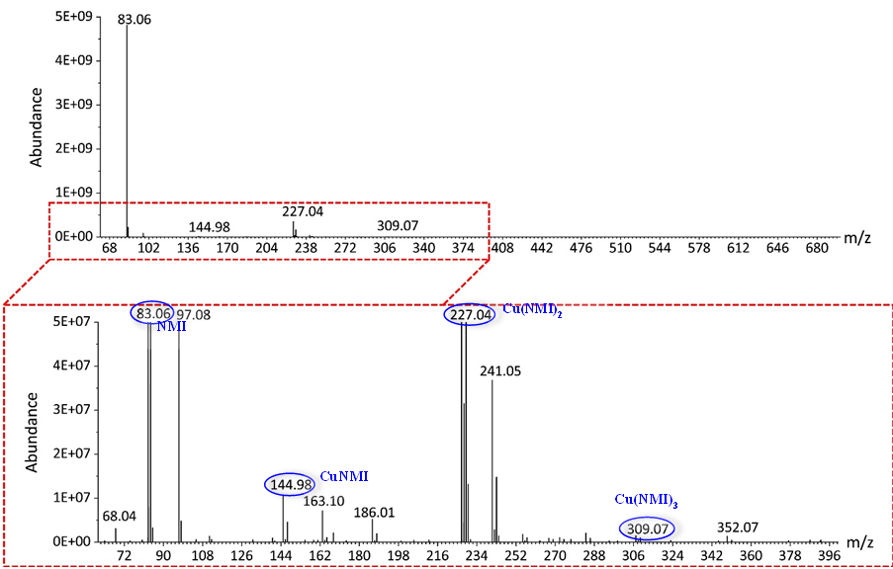
Supplementary Fig. 4 | The time-off-flight mass spectrum of the [Cu^{I}∙∙∙NMI•‒] solution. m/z denotes mass to charge ratio. Molecular ion or the fragments of NMI (m/z = 83.06), Cu(NMI) (m/z = 144.98), Cu(NMI)₂ (m/z = 227.04), and Cu(NMI)₃ (m/z = 309.07) are identified. Their structural formula are shown in Supplementary Table 3 below.

Supplementary Table 3 | Structural formula for molecular ion or the fragments identified in Supplementary Fig. 4.

 | Structural formula | MS(ESI) m/z:  (found) | Formula Weight  (calculated)
I | 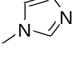 | 83.06 | 82.05
I-a | 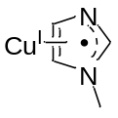 | 144.98 | 144.98
II-a | 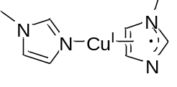 | 227.04 | 227.04
III-a | 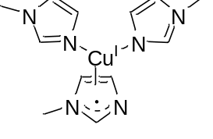 | 309.07 | 309.09

Supplementary Fig. 5 | Schematic illustration of the setup for studying the interactions between CO₂ and [Cu^{I}∙∙∙NMI•‒] solution with time‒dependent in-situ attenuated total reflection infrared (ATR-IR) absorption spectrometer. The [Cu^{I}∙∙∙NMI•‒] solution prepared by 10 mL of NMI and 0.05 g of copper powder was added to the flask, followed by the injection of 5 mL of CO₂ (purity 99.999%). ATR–IR spectra of the system were acquired in real time, as shown in Supplementary Fig. 6. For a comparison, the interaction of CO₂ with individual NMI was also studied by the ATR–IR absorption spectrometer.

Supplementary Fig. 6 | (a, c) ATR-IR spectra of the [Cu^{I}∙∙∙NMI•‒] system and individual NMI upon the interaction with CO₂. (b, d) Absorbances at the wavenumber of 2336 cm⁻¹ for [Cu^{I}∙∙∙NMI•‒] and individual NMI upon the interaction with CO₂.
For the [Cu^{I}∙∙∙NMI•‒] system (a), when CO₂ was injected into the flask at the 500th second in the experiment, a band at 2336 cm⁻¹ attributed to the asymmetric stretching vibration of CO₂ is developed. The intensity of the 2336 cm⁻¹ band is rapidly increased and approaches a platform (absorption saturation) within 370 seconds (c). As a Lewis base, individual NMI is also effective in absorbing Lewis acidic CO₂ molecules. Consequently, when CO₂ is injected into the flask at the 280th second in the experiment, a characteristic IR absorption band of CO₂ at 2336 cm⁻¹ yields (b). This band takes ca. 490 seconds to approach a platform (d). As seen, the [Cu^{I}∙∙∙NMI•‒] system exhibits a relatively short saturation absorption time towards CO₂ than the single NMI system. This phenomenon can be interpreted by the fact that the anionic radical NMI•‒ in the [Cu^{I}∙∙∙NMI•‒] system is a potent nucleophile to attract Lewis acidic CO₂ molecule.

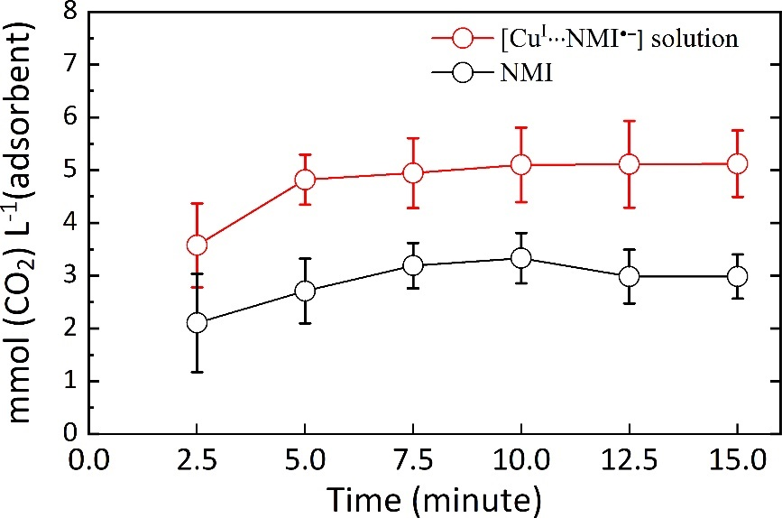
Supplementary Fig. 7 | CO₂ absorption capacities for the [Cu^{I}∙∙∙NMI•‒] system (red circle) and single NMI system (black circle). The experiments for quantitatively determining CO₂ absorption capacities were conducted in parallel with time‒dependent in-situ ATR-IR measurements, as demonstrated in Supplementary Figs. 5, 6.
In details, 5 mL of CO₂ was injected into the flask filled by 10 mL NMI or 10 mL [Cu^{I}∙∙∙NMI•‒] solution. The solution was stirred to promote the absorption of CO₂. After that, CO₂ remained in the headspace of the flask was analysed every 2.5 min interval using gas chromatography (GC). 100 microlitres of the gas phase was injected into the GC column (5A molecular sieve) using a gastight syringe. The gas concentration was averaged over five measurements. The gas chromatograph was equipped with a flame ionization detector (FID) and a methanizer. The methanation reactor can convert CO and CO₂ to CH₄ for detection. The results show that the [Cu^{I}∙∙∙NMI•‒] solution shows an absorption capacity of ca. 5 mmol L⁻¹, almost two folds that of single NMI system.

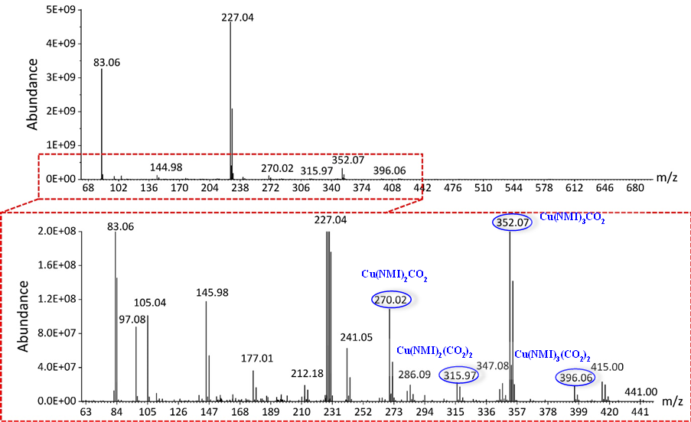
Supplementary Fig. 8 | The time-off-flight mass spectrum of the [Cu^{I}∙∙∙NMI•‒] solution upon the interaction with CO₂. New fragments were identified in the spectrum. They can be assigned to Cu(NMI)₂CO₂ (m/z = 270.02), Cu(NMI)₂(CO₂)₂ (m/z = 315.97), Cu(NMI)₃CO₂ (m/z = 352.07), and Cu(NMI)₃(CO₂)₂ (m/z = 396.06). Structural formula of these compounds are shown in Supplementary Table 4 below.
Supplementary Table 4 | Structural formular for the compounds identified in Supplementary Fig. 8.

 | Structural formula | MS(ESI) m/z:  （found） | Formula Weight  (calculated)
II-b | 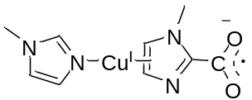 | 270.02 | 270.02
II-c | 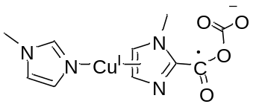 | 315.97 | 315.01
III-b | 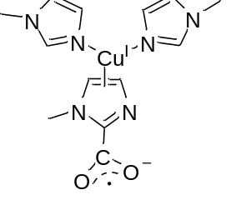 | 352.07 | 352.07
III-c | 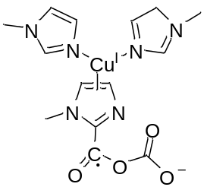 | 396.06 | 396.06

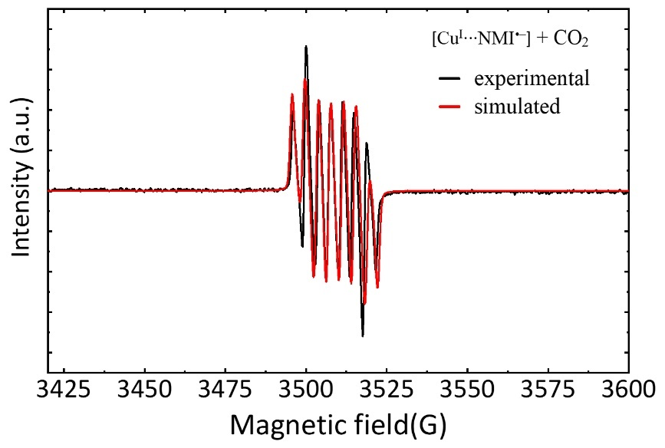
Supplementary Fig. 9 | EPR spectrum for the [Cu^{I}∙∙∙NMI•‒] solution saturated by CO₂.

Supplementary Fig. 10 | [Cu^{I}∙∙∙NMI•‒] as the mediator for electrocatalytic CO₂R. (a) Experimental set for studying electrocatalytic reduction of CO₂. The cathode compartment was filled by [Cu^{I}∙∙∙NMI•‒] solution (acting as both mediator and catholyte). CO₂ was continuously purged through the cathode compartment at 20 standard cubic centimetre per minute (sccm). The anode compartment was filled by 0.1 mol L⁻¹ KOH solution (anolyte). Cathode and anode compartments were separated by proton exchange membrane (PEM). Glassy carbon, ruthenium–coated titanium mesh, and Ag/AgCl were used as the working electrode (WE), counter electrode (CE), and reference electrode (RE), respectively. After the CO₂ passed through the cathode, it was allowed to directly enter the gas sampling loop of the GC for online gaseous analysis. (b) The schematic shows the details of the electrolytic cell. (c) GC measurements showed that CO (retention time ca. 0.7 min) could be detected when a cell voltage of 1.4 V was applied. The fraction of CO in the outlet gas is positively dependent on the cell voltage. (d) Relationships of CO production rate and single pass conversion with the applied cell voltage.

Supplementary Table 5 | Selected standard potentials of CO₂R (V vs. SHE) at 1.0 atm and 25 ºC^{40,41}.
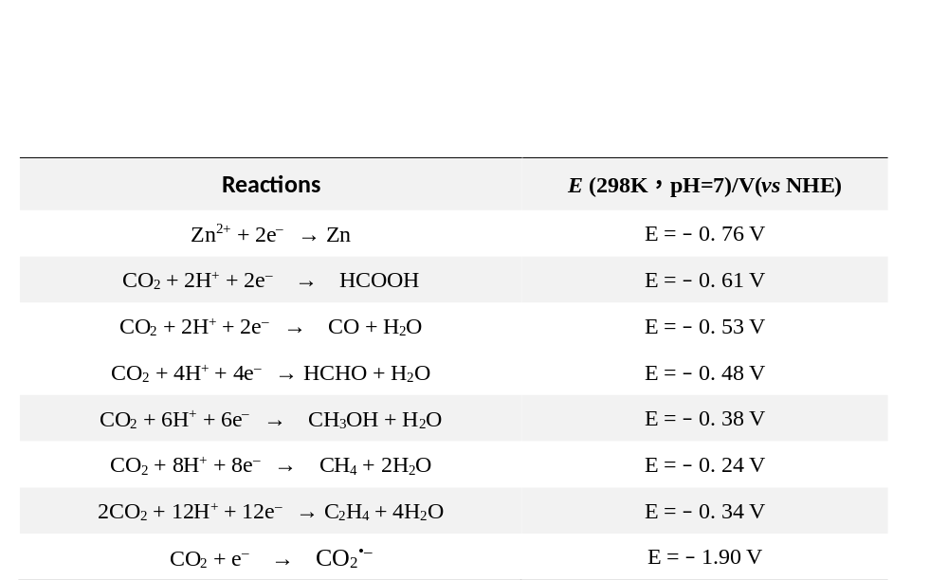

Supplementary Fig. 11 | Representative GC signals of CO₂ feed (green line) and the converted CO (red line) in the experiments. For the aim of validating the accuracy of the GC signals, standard CO₂ and CO samples were tested and the GC curves (black lines) were recorded for comparisons. Calibration of the gas chromatograph was done using calibration gases with 2000 to 500000 parts per million (ppm) CO or CO₂ balanced in nitrogen. The product concentrations were averaged over five measurements.

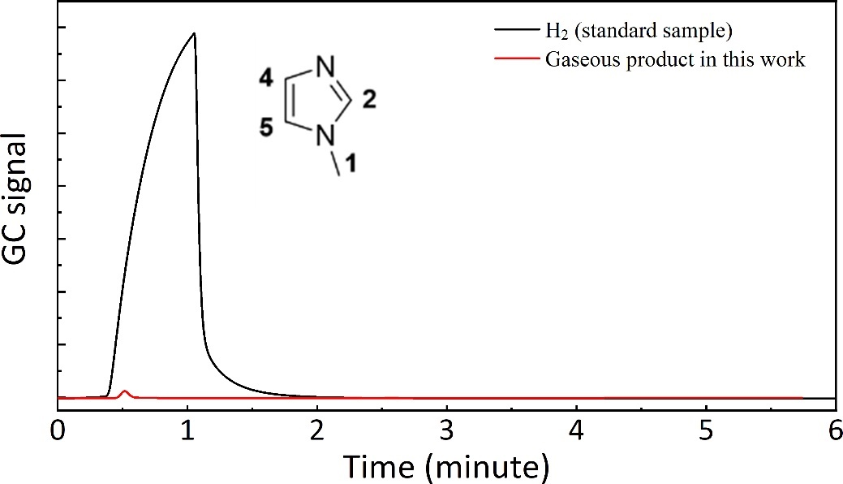
Supplementary Fig. 12 | Analysis of the gaseous product using gas chromatograph equipped with a thermal conductivity detector (TCD). Black and red lines correspond to the GC curves of standard H₂ sample and the gaseous product, respectively. The comparison reveals that a small amount of H₂ was generated in the process of CO₂R. This is because C2 hydrogen (See the inset) in the imidazole ring of NMI is weakly acidic (pka =6.88), which can react with Zn to yield H₂.
Calibration of the gas chromatograph was done using calibration gases with 1%, 10%, and 50% hydrogen balanced in nitrogen and 100% hydrogen. The product concentrations were averaged over five measurements.

Supplementary Fig. 13 | In-situ ATR−IR absorption spectroscopy study of the CO₂R using Zn as the reducing agent and [Cu^{I}∙∙∙NMI•‒] solution as the mediator. The experiment was conducted in the setup shown in Supplementary Fig. 5.

Supplementary Fig. 14 | Isotope tracer study using ¹³CO₂ as the feedstock. In the mass chromatograms of the gaseous product, the m/z value of 29 is assigned to ¹³CO (m/z = 29). The characteristic mass fragment ¹³C (m/z = 13) from ¹³CO was also observed. The m/z value of 32 was assigned to O₂ molecule. The m/z value of 28 is assigned to N₂ (carrier gas: m/z = 28), rather than the ¹²CO (m/z = 28) molecule. This presumption is supported by the fact that the found m/z value of 14 is consistent with the fragment of N and the mass spectroscopy signal of ¹²C (m/z = 12) was not observed.

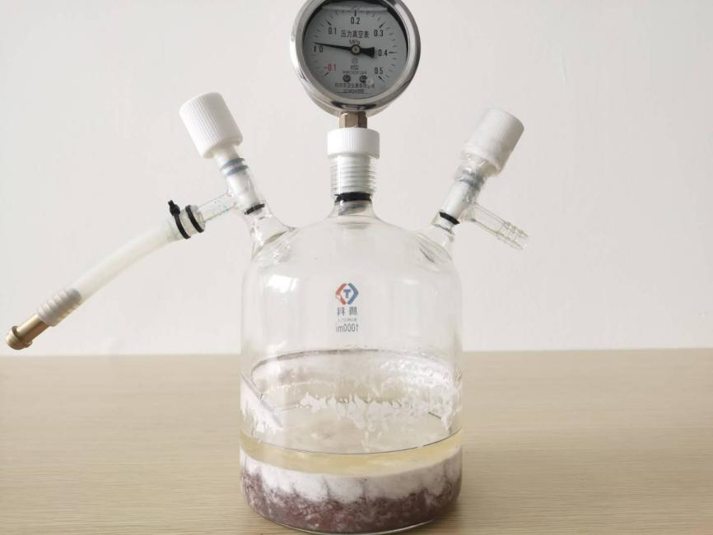
Supplementary Fig. 15 | Representative photograph of the reaction system. This system had been used for the conversion of CO₂ to CO three times (namely thee cycles). After that, it is clearly seen that grey Zn was consumed and what left in the reactor were wite colloid, red solid, and transparent liquid.

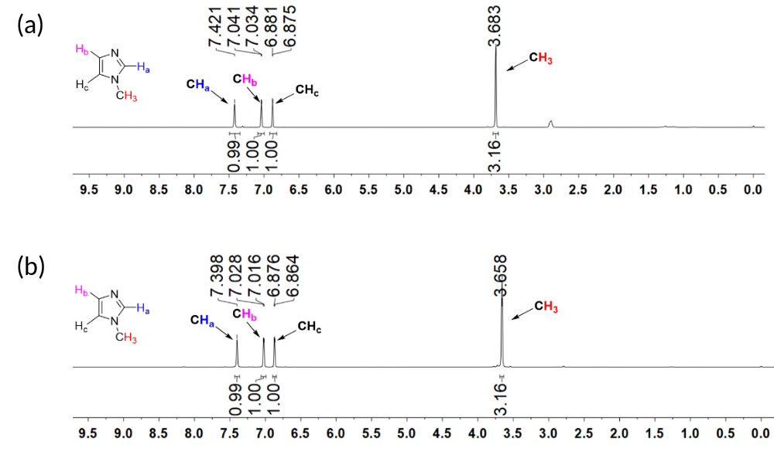
Supplementary Fig. 16 | ¹H nuclear magnetic resonance (¹H-NMR) spectroscopy studies of pure NMI (a) and the transparent supernatant shown in Supplementary Fig. 15 (b). As seen, the ¹H–NMR spectrum of the supernatant is identical to that of pure NMI. That is, possible liquid products such as formate and oxalate were not formed, which demonstrate that CO₂R mediated by [Cu^{I}∙∙∙NMI•‒] exhibits high selectivity.

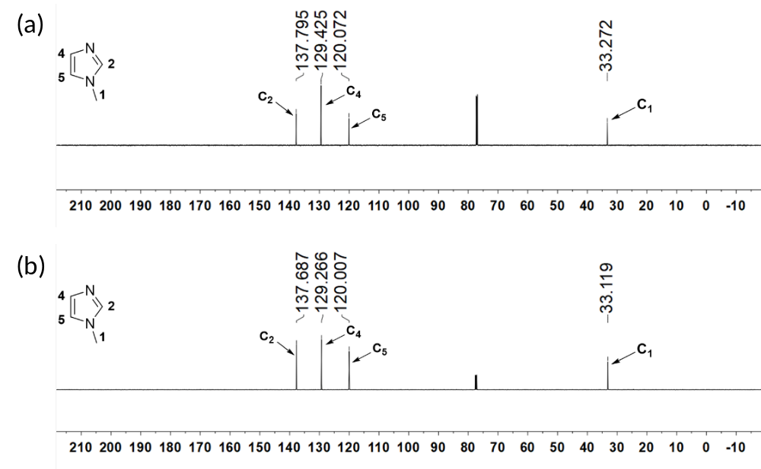
Supplementary Fig. 17 | ¹³C–NMR spectroscopy studies of pure NMI (a) and the transparent supernatant shown in Supplementary Fig. 15 (b). As seen, the ¹³C–NMR spectrum of the supernatant is also identical to that pure NMI, consistent with the ¹H–NMR result shown in Supplementary Fig. 16.

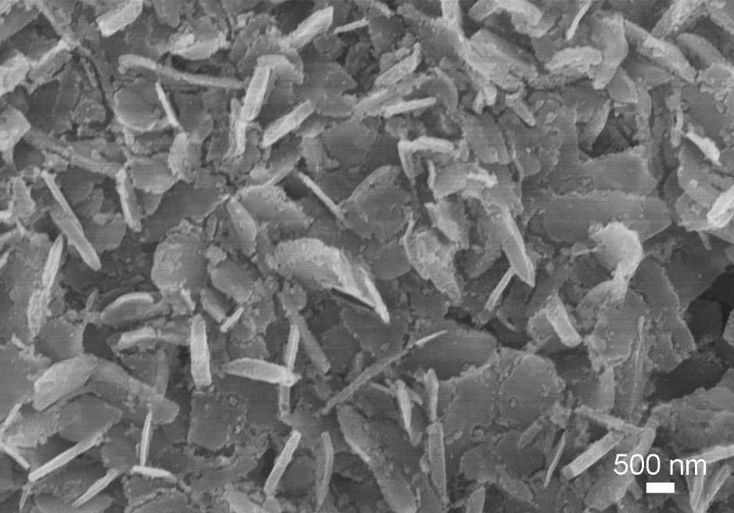

Supplementary Fig. 18 | Scanning electron microscopy (SEM) image of the white colloid.

Supplementary Fig. 19 | X−ray photoelectron spectroscopy (XPS) characterizations of the white colloid. (a) The survey spectrum demonstrates that the colloid is a non−cupreous compound, as learn from the absence of Cu 2p peak at ca. 950 eV. The compound consists of Zn, O, N, and C elements. (b-d) High-resolution XPS spectra of (b) C1s, (c) O 1s, and (d) N 1s. The high-resolution XPS spectra suggests that Zn²⁺ ion, CO₃²⁻ ion, and NMI are the constitutional units of the white colloid.

Supplementary Fig. 20 | (a) Powder X−ray diffraction (PXRD) pattern of the white colloid (Top) and the XRD pattern given in Ref. S39 (Down). (b) Structure of the complex Zn(NMI)₂CO₃.

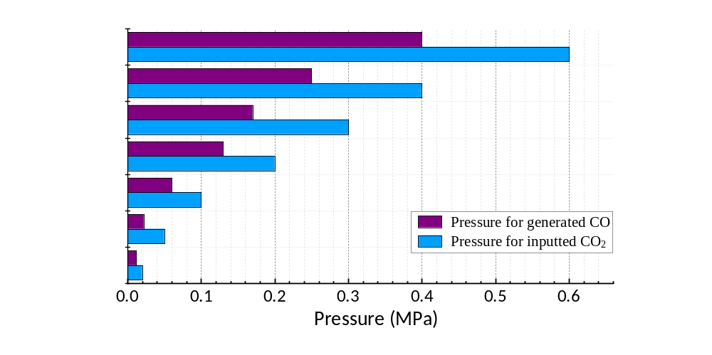
Supplementary Fig. 21 | Relationship between the pressure of CO₂ inputted into the reactor and the pressure of CO generated. It is always observed that the pressure of CO is approximately half that of CO₂ feed.

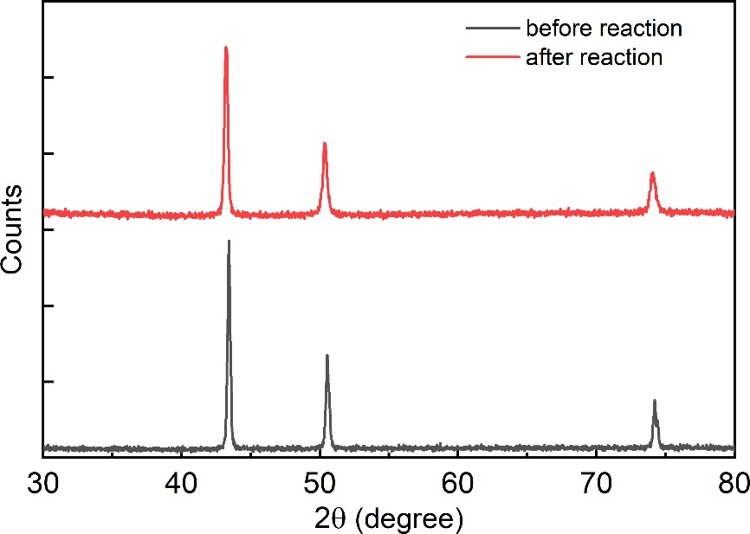

Supplementary Fig. 22 | PXRD patterns of the copper powder used for CO₂R reaction (black line) and the red solid shown in Supplementary Fig. 15 (red line). PXRD results demonstrate that copper maintains the zero valent state and is non-consumable in the process of CO₂R reaction.

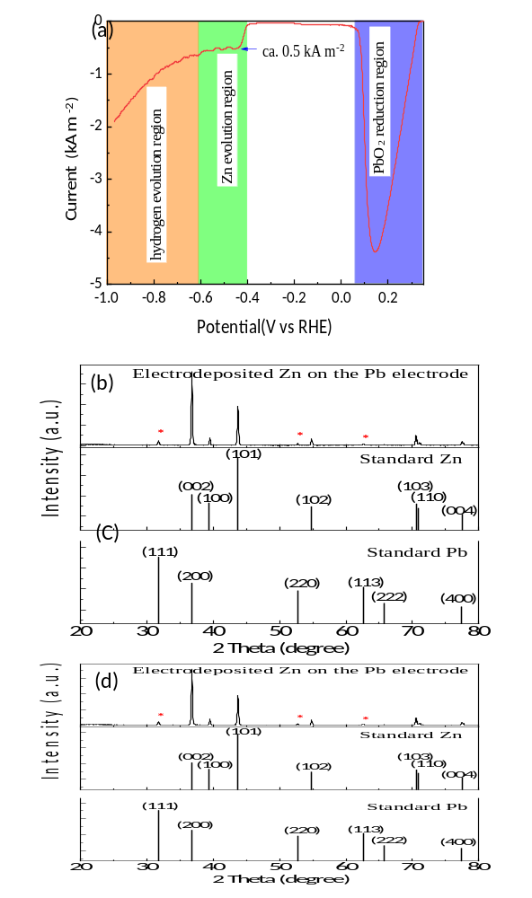
Supplementary Fig. 23 | (a) Linear sweep voltammetry (LSV) of Zn(CO₃)(NMI)₂ dissolved in 0.1 mol L⁻¹ KOH solution. Lead cathode with a high overpotential for hydrogen evolution reaction was used as the work electrode. Platinum wire and Ag/AgCl were used as the counter electrode and reference electrode, respectively. The LSV was scanned at a rate of 5 mV s⁻¹ at room temperature. In the violet region, the cathode current is associated with the reduction of oxidized layer (PbO₂) of the lead electrode. In the green region, the cathode current is attributed to the reduction of Zn²⁺ ions. It can begin to observe a layer of metal plating on the surface of the lead electrode. The cathode current reached 0.5 kA m⁻² (or 50 mA cm⁻² at the potential of -0.45 V vs RHE). In the orange region, gas bubbles were formed on the lead electrode and accordingly, the cathode current can be associated with the hydrogen evolution reaction. (b) XRD pattern of the electrochemically reduced Zn. The asterisks (⁕) denote the signals from the lead electrode. (c) XRD pattern for standard Zn. (d) XRD pattern for standard lead.

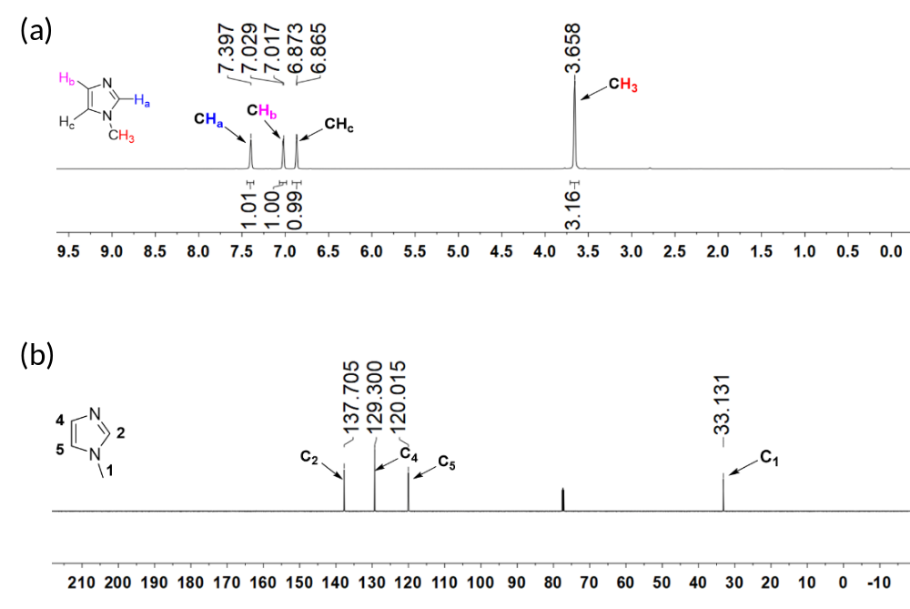
Supplementary Fig. 24 | (a) ¹H-NMR and (b) ¹³C-NMR spectroscopy studies of NMI released to the electrolyte after the electrolysis. Prior to the measurements, NMI was extracted from the electrolyte (0.1 mol L⁻¹ KOH solution) by ethyl acetate. Ethyl acetate in the extractive liquid was then allowed to volatilize. The remained liquid was collected for the NMR spectroscopy characterizations. The recorded ¹H–NMR spectrum (a) is identical to those shown in Supplementary Fig. 16. The recorded ¹³C–NMR spectrum (b) is identical to those shown in Supplementary Fig. 17. Both the results demonstrate that NMI is regenerative through the electrolysis of the complex Zn(CO₃)(NMI)₂.

Supplementary Fig. 25 | Flow reduction of CO₂ to CO with the customized bubbling reactor. (a) Schematic of the bubbling reactor. The reactor was constructed of 10 gas washing bottles connected in series. Each bottle (volume 10 mL) was placed by 2 mL NMI, 0.1 g Cu, and 1 g Zn. (b) Photograph of the bubbling reactor. (c) GC signals at various CO₂ flow rates (5~100 SCCM). (d) Dependence of CO fraction in the off–gas on CO₂ flow rate. (e) Continuous production of nearly pure CO at 10 SCCM CO₂ and ca. 86% CO at 30 SCCM CO₂.

Supplemental References
1 Ren, S. et al. Molecular electrocatalysts can mediate fast, selective CO₂ reduction in a flow cell. Science 365, 367-369 (2019).
2 Zheng, T. et al. Large-scale and highly selective CO₂ electrocatalytic reduction on nickel single-atom catalyst. Joule 3, 265-278 (2019).
3 Gu, J., Hsu, C.-S., Bai, L., Chen, H. M. & Hu, X. Atomically dispersed Fe³⁺ sites catalyze efficient CO₂ electroreduction to CO. Science 364, 1091-1094 (2019).
4 Zhang, X. et al. Molecular engineering of dispersed nickel phthalocyanines on carbon nanotubes for selective CO₂ reduction. Nat. Energy 5, 684-692 (2020).
5 Li, S. et al. Low‐Valence Zn^{δ+}(0< δ< 2) Single‐Atom Material as Highly Efficient Electrocatalyst for CO₂ Reduction. Angew. Chem. Int. Ed. 60, 22826-22832 (2021).
6 Ding, T. et al. Atomically precise dinuclear site active toward electrocatalytic CO₂ reduction. J. Am. Chem. Soc. 143, 11317-11324 (2021).
7 Chen, Z. et al. Amination strategy to boost the CO₂ electroreduction current density of M–N/C single-atom catalysts to the industrial application level. Energy Environ. Sci. 14, 2349-2356 (2021).
8 Li, J. et al. Efficient electrocatalytic CO₂ reduction on a three-phase interface. Nat. Catal. 1, 592-600 (2018).
9 Jiao, J. et al. Copper atom-pair catalyst anchored on alloy nanowires for selective and efficient electrochemical reduction of CO₂. Nat. chem. 11, 222-228 (2019).
10 Chen, C. et al. Boosting CO₂ electroreduction on N, P‐co‐doped carbon aerogels. Angew. Chem. Int. Ed. 132, 11216-11222 (2020).
11 Feng, J. et al. A Mn-N₃ single-atom catalyst embedded in graphitic carbon nitride for efficient CO₂ electroreduction. Nat. Commun. 11, 1-8 (2020).
12 Gu, S., Marianov, A. N. & Jiang, Y. Covalent grafting of cobalt aminoporphyrin-based electrocatalyst onto carbon nanotubes for excellent activity in CO₂ reduction. Appl. Catal. B: Environ. 300, 120750 (2022).
13 Zhang, Y., Jiao, L., Yang, W., Xie, C. & Jiang, H. L. Rational Fabrication of Low‐Coordinate Single‐Atom Ni Electrocatalysts by MOFs for Highly Selective CO₂ Reduction. Angew. Chem. Int. Ed. 60, 7607-7611 (2021).
14 Zeng, Z. et al. Orbital coupling of hetero-diatomic nickel-iron site for bifunctional electrocatalysis of CO₂ reduction and oxygen evolution. Nat. Commun. 12, 1-11 (2021).
15 Ni, W. et al. Electroreduction of carbon dioxide driven by the intrinsic defects in the carbon plane of a single Fe–N₄ site. Adv. Mater. 33, 2003238 (2021).
16 Bhargava, S. S. et al. System design rules for intensifying the electrochemical reduction of CO₂ to CO on Ag nanoparticles. ChemElectroChem 7, 2001-2011 (2020).
17 Ouyang, T. et al. Dinuclear Metal Synergistic Catalysis Boosts Photochemical CO₂‐to‐CO Conversion. Angew. Chem. Int. Ed. 57, 16480-16485 (2018).
18 Wang, S., Guan, B. Y. & Lou, X. W. D. Rationally designed hierarchical N-doped carbon@ NiCo₂O₄ double-shelled nanoboxes for enhanced visible light CO₂ reduction. Energy Environ. Sci. 11, 306-310 (2018).
19 Wang, L. et al. In-situ incorporation of Copper (II) porphyrin functionalized zirconium MOF and TiO₂ for efficient photocatalytic CO₂ reduction. Sci. Bull. 64, 926-933 (2019).
20 Niu, K. et al. A spongy nickel-organic CO₂ reduction photocatalyst for nearly 100% selective CO production. Sci. Adv. 3, e1700921 (2017).
21 Jiang, Z. et al. Nature-based catalyst for visible-light-driven photocatalytic CO₂ reduction. Energy Environ. Sci. 11, 2382-2389 (2018).
22 Gao, C. et al. Co₃O₄ Hexagonal Platelets with Controllable Facets Enabling Highly Efficient Visible‐Light Photocatalytic Reduction of CO₂. Adv. Mater. 28, 6485-6490 (2016).
23 Ouyang, T., Huang, H. H., Wang, J. W., Zhong, D. C. & Lu, T. B. A dinuclear cobalt cryptate as a homogeneous photocatalyst for highly selective and efficient visible‐light driven CO₂ reduction to CO in CH₃CN/H₂O solution. Angew. Chem. Int. Ed. 129, 756-761 (2017).
24 Huang, C. et al. Carbon-doped BN nanosheets for metal-free photoredox catalysis. Nat. Commun. 6, 1-7 (2015).
25 Zheng, Y., Lin, L., Ye, X., Guo, F. & Wang, X. Helical graphitic carbon nitrides with photocatalytic and optical activities. Angew. Chem. Int. Ed. 126, 12120-12124 (2014).
26 Kim, P. S. et al. Organometallic Iridium (III) Complex Sensitized Ternary Hybrid Photocatalyst for CO₂ to CO Conversion. Chem. Eur. J. 25, 13609-13623 (2019).
27 Xu, Y.-F. et al. A CsPbBr₃ perovskite quantum dot/graphene oxide composite for photocatalytic CO₂ reduction. J. Am. Chem. Soc. 139, 5660-5663 (2017).
28 Hou, J. et al. Inorganic colloidal perovskite quantum dots for robust solar CO₂ reduction. Chem. Eur. J. 23, 9481-9485 (2017).
29 Ma, B. et al. Efficient visible-light-driven CO₂ reduction by a cobalt molecular catalyst covalently linked to mesoporous carbon nitride. J. Am. Chem. Soc. 142, 6188-6195 (2020).
30 Li, Y., Li, B., Zhang, D., Cheng, L. & Xiang, Q. Crystalline carbon nitride supported copper single atoms for photocatalytic CO₂ reduction with nearly 100% CO selectivity. ACS nano 14, 10552-10561 (2020).
31 Zhong, H. et al. Covalent organic framework hosting metalloporphyrin‐based carbon dots for visible‐light‐driven selective CO₂ reduction. Adv. Funct. Mater. 30, 2002654 (2020).
32 Zheng, H. L. et al. Photochemical In Situ Exfoliation of Metal–Organic Frameworks for Enhanced Visible‐Light‐Driven CO₂ Reduction. Angew. Chem. Int. Ed. 59, 23588-23592 (2020).
33 Li, J. et al. Van der Waals heterojunction for selective visible-light-driven photocatalytic CO₂ reduction. Appl. Catal. B: Environ. 284, 119733 (2021).
34 Wang, Q. et al. Coupling CsPbBr₃ Quantum Dots with Covalent Triazine Frameworks for Visible‐Light‐Driven CO₂ Reduction. ChemSusChem 14, 1131-1139 (2021).
35 Wang, F. et al. Ordered macroporous carbonous frameworks implanted with CdS quantum dots for efficient photocatalytic CO₂ reduction. Adv. Mater. 33, 2102690 (2021).
36 Zhen, W., Sun, J., Ning, X., Shi, X. & Xue, C. Polymeric carbon nitride with internal np homojunctions for efficient photocatalytic CO₂ reduction coupled with cyclohexene oxidation. Applied Catalysis B: Environmental 298, 120568 (2021).
37 Kong, X. J. et al. In Situ Porphyrin Substitution in a Zr (IV)‐MOF for Stability Enhancement and Photocatalytic CO₂ Reduction. Small, 2005357 (2021).
38 Jiang, Y. et al. N‐Heterocyclic Carbene‐Stabilized Gold Nanoclusters in a Metal‐Organic Framework for Photocatalytic CO₂ Reduction. Angew. Chem. Int. Ed. (2021).
39 Vaid, T. P., Kelley, S. P. & Rogers, R. D. Metal carbonate complexes formed through the capture of ambient O₂ and CO₂ by elemental metals in 1-methylimidazole: molecular Cu(CO₃)(MeIm)₃ and polymeric M(CO₃)(MeIm)₂·2H₂O (M= Co, Zn). Dalton T. 46, 8920-8923 (2017).
40 Li, K., An, X., Park, K. H., Khraisheh, M. & Tang, J. A critical review of CO₂ photoconversion: Catalysts and reactors. Catal. Today 224, 3-12 (2014).
41 Kubacka, A., Fernandez-Garcia, M. & Colon, G. Advanced nanoarchitectures for solar photocatalytic applications. Chem. Rev. 112, 1555-1614 (2012).

