New strains of Trichoderma with potential for biocontrol and plant growth promotion improve early soybean growth and development

Rodrigo Mattos Silva Galeano^{1,2}, João Victor Souza Ribeiro^{1,2} , Samanta Monção Silva^{1,2}, Ana Lorena de Oliveira Simas^{1,2}, Nelciele Cavalieri de Alencar Guimarães^{1,2}, Douglas Chodi Masui^{1,2}, Bianca Obes Corrêa³, Giovana Cristina Giannesi^{1,2}, Sebastião Ferreira de Lima⁴, Marivaine da Silva Brasil^{1,5}, Fabiana Fonseca Zanoelo^{*1,2}

¹ Programa Multicêntrico de Pós-Graduação em Bioquímica e Biologia Molecular, Universidade Federal de Mato Grosso do Sul, Campo Grande, MS, Brazil
² Laboratório de Bioquímica Geral e Microrganismos, Universidade Federal de Mato Grosso do Sul, Campo Grande, MS, Brazil
³ Universidade Anhanguera - Uniderp, Campo Grande, MS, Brazil
⁴ Universidade Federal de Mato Grosso do Sul, Campus Chapadão do Sul, Chapadão do Sul, MS, Brazil
⁵ Laboratório de Microbiologia, Universidade Federal de Mato Grosso do Sul, Campus do Pantanal, Corumbá, MS, Brazil

* Corresponding author: F. F. Zanoelo. E-mail address: fabiana.zanoelo@ufms.br

Supplementary Information

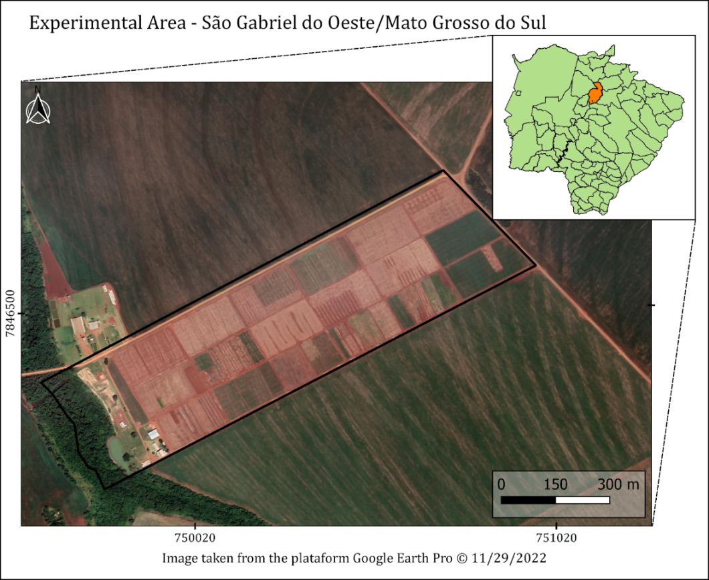
Fig. S1 Collection area of 15 soybean rhizospheric soil samples in an experimental farm in São Gabriel do Oeste, MS, Brazil (19°46’07”S 54°61’60”W)

Table S1 Pesticides used in this study. The concentration of agrochemicals added to the culture medium are presented following the recommended dose by the manufacturers and considering a spray tank of 200 L.
Commercial name | Pesticide class | Active ingredient | Concentration | Recommended  dose | Concentration
Atrazine | Herbicide | Atrazine | 500 g/L | 4.5 L/ha | 22.5 mL/L
Glint | Herbicide | Haloxyfop-P-methyl | 125 g/L | 0.45 L/ha | 2.25 mL/L
ZAPP QI 620 | Herbicide | Glyphosate  (N-[phosphonomethyl]glycine) | 620 g/L | 2.0 L/ha | 10 mL/L
G-ammonium | Herbicide | Glufosinate ammonium salt | 200 g/L | 2.0 L/ha | 10 mL/L
Curbix | Insecticide | Etiprole | 200 g/L | 0.25 L/ha | 1.25 mL/L
Unizebe | Fungicide | Mancozebe | 750 g/kg | 2,0 kg/ha | 10 g/L

Table S2 Antagonism activity of Trichoderma spp. against the phytopathogens M. phaseolina, Fusarium sp., and S. sclerotiorum
Isolates | Medium | Inhibition of mycelial growth (% ± SD)
Isolates | Medium | M. phaseolina | Fusarium sp. | S. sclerotiorum
GT-1  GT-2 | DOC2  PDA | 59.3 ± 0.6  55.2 ± 4.6 | 76.1 ± 1.7  71.5 ± 6.4 | 63.0 ± 1.7  n.d.
GT-3 | PDA | 60.4 ± 1.3 | 75.9 ± 1.7 | n.d.
GT-4 | PDA | 68.5 ± 1.7 | 77.0 ± 0.6 | 76.1 ± 3.4
GT-5 | TSM | 54.3 ± 3.1 | 77.0 ± 0.3 | n.d.
GT-6 | PDA | 53.2 ± 2.3 | 74.8 ± 2.6 | n.d.
GT-7 | PDA | 70.0 ± 1.1 | 84.4 ± 3.9 | 75.6 ± 1.1
GT-8 | PDA | 52.9 ± 1.2 | 77.0 ± 1.3 | 80.9 ± 2.6
GT-9 | PDA | 55.7 ± 2.6 | 82.2 ± 5.9 | 58.9 ± 2.2
GT-10 | PDA | 57.0 ± 1.3 | 81.5 ± 6.4 | 60.0 ± 1.1
GT-11 | PDA | 48.6 ± 0.6 | n.d. | n.d.
GT-12 | PDA | 72.6 ± 0.6 | 80.7 ± 2.8 | 77.4 ± 0.9
GT-13 | PDA | 54.3 ± 2.5 | 73.7 ± 3.6 | n.d.
GT-14 | PDA | 50.7 ± 2.8 | 74.8 ± 2,8 | n.d.
GT-15 | PDA | 45.6 ± 4.8 | 73.7 ± 3.7 | n.d.
GT-16 | PDA | 66.3 ± 0.6 | 84.1 ± 4.5 | n.d.
GT-17 | PDA | 55.0 ± 1.5 | 75.6 ± 2.2 | n.d.
GT-18 | PDA | 46.5 ± 1.3 | n.d. | n.d.
GT-19 | PDA | 68.2 ± 1.3 | 84.8 ± 3.9 | 75.8 ± 1.2
GT-20 | PDA | 55.2 ± 2.8 | 73.0 ± 4.5 | n.d.
GT-21 | DOC2 | 55.7 ± 2.6 | 86.3 ± 2.3 | 65.2 ± 1.8
GT-22 | PDA | 65.4 ± 1.4 | 76.7 ± 1.9 | 66.3 ± 1.2
GT-23 | PDA | 45.9 ± 0.6 | n.d. | n.d.
GT-24 | PDA | 50.0 ± 2.2 | 73.7 ± 3.9 | n.d.
GT-25 | PDA | 51.9 ± 0.7 | 74.8 ± 2.8 | n.d.
GT-26 | PDA | 58.2 ± 2.6 | 73.7 ± 4.2 | 70.2 ± 0.3
GT-27 | PDA | 58.7 ± 1.4 | 78.1 ± 1.7 | 65.0 ± 0.6
GT-28 | PDA | 66.5 ± 2.1 | 81.1 ± 7.3 | 74.9 ± 0.9
GT-29 | PDA | 68.0 ± 0.9 | 77.4 ± 0.6 | 64.6 ± 2.7
GT-30 | PDA | 49.3 ± 4.0 | n.d. | n.d.
GT-31 | PDA | 66.3 ± 2.6 | 83.7 ± 5.0 | 74.1 ± 4.8
GT-32 | PDA | 65.6 ± 1.1 | 79.5 ± 1.5 | 75.7 ± 4.2
GT-33 | DOC2 | 54.4 ± 1.1 | 76.3 ± 1.7 | 70.0 ± 1.9
GT-34 | PDA | 61.9 ± 0.6 | 76.5 ± 1.4 | n.d.
GT-35 | PDA | 53.3 ± 1.1 | 75.6 ± 1.9 | n.d.
GT-36 | PDA | 56.7 ± 1,1 | 72.2 ± 5.1 | 60.4 ± 2.6
GT-37 | PDA | 58.9 ± 1.1 | 75.9 ± 2.3 | n.d.
GT-38 | PDA | 71.5 ± 3.6 | 80.4 ± 2.3 | 75.2 ± 3.1
GT-39 | PDA | 47.2 ± 2.5 | n.d. | n.d.
GT-40 | PDA | 58.2 ± 1.3 | 75.2 ± 2.8 | n.d.
GT-41 | PDA | 58.1 ± 0.8 | 81.9 ± 6.1 | 63.1 ± 0.6
GT-42 | PDA | 54.8 ± 1.3 | 77.4 ± 0.6 | 64.9 ± 4.2
GT-43 | PDA | 46.3 ± 0.6 | n.d. | n.d.
GT-44 | PDA | 64.8 ± 0.6 | 71.1 ± 5.9 | n.d.
GT-45 | DOC2 | 59.1 ± 1.2 | 82.0 ± 5.9 | 56.5 ± 0.3
GT-46 | DOC2 | 55.5 ± 2.1 | 77.0 ± 1.3 | n.d.
GT-47 | TSM | 55.0 ± 0.6 | 75.6 ± 1.9 | n.d.
GT-48 | TSM | 54.3 ± 3.1 | 77.0 ± 0.6 | n.d.
GT-49 | TSM | 54.4 ± 1.1 | 76.3 ± 1.7 | 70.0 ± 1.9
GT-50 | TSM | 55.3 ± 0.3 | 87.4 ± 1.3 | n.d.
GT-51 | TSM | 49.7 ± 0.9 | 61.5 ± 5.6 | n.d.
GT-52 | TSM | 55.2 ± 0.6 | 74.8 ± 1.3 | n.d.
GT-53 | TSM | 59.1 ± 0.9 | 74.4 ± 3.3. | n.d.
GT-54 | TSM | 59.6 ± 1.3 | 73.0 ± 0.6 | 57.2 ± 1.5
GT-55 | TSM | 54.1 ± 2.4 | 74.6 ± 2.9 | n.d.
GT-56 | TSM | 56.7 ± 1.1 | 78.2 ± 0.6 | n.d.
GT-57 | TSM | 57.4 ± 0.6 | 84.8 ± 3.9 | n.d.
GT-58 | TSM | 63.9 ± 1.5 | 76.3 ± 1.7 | n.d.
GT-59 | TSM | 57.4 ± 0.6 | 73.7 ± 3.9 | 63.0 ± 2.8
GT-60 | RBA | 55.9 ± 0.6 | 70.0 ± 2.2 | 59.8 ± 1.4
GT-61 | RBA | 57.4 ± 2.3 | 79.6 ± 8.2 | n.d.
GT-62 | RBA | 60.0 ± 2.2 | 88.5 ± 0.6 | 71.4 ± 2.3
GT-63 | RBA | 52.3 ± 2.9 | 86.3 ± 2.3 | n.d.
GT-64 | RBA | 53.3 ± 1.1 | 77.0 ± 0.6 | n.d.
GT-65 | RBA | 53.0 ± 1.3 | 73.9 ± 2.6 | n.d.
GT-66 | RBA | 57.6 ± 0.9 | 80.4 ± 7.4 | n.d.
The values presented in the table represent means with ± standard deviation (SD) obtained from a triplicate experiment
n.d.: not determined

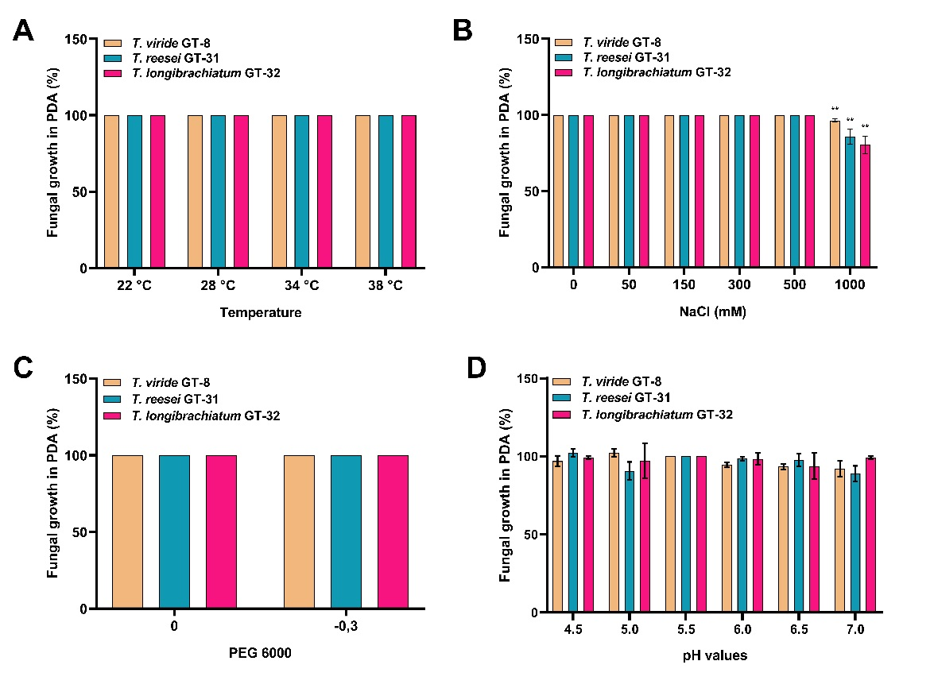
Fig. S2 Growth of Trichoderma spp. in PDA medium after 7 days under different conditions of (A) temperature (B) salinity, (C) drought by PEG 6000, and (D) pH. Asterisks represent significant differences from the control treatment (**, p-value < 0.01) as determined by Tukey's test

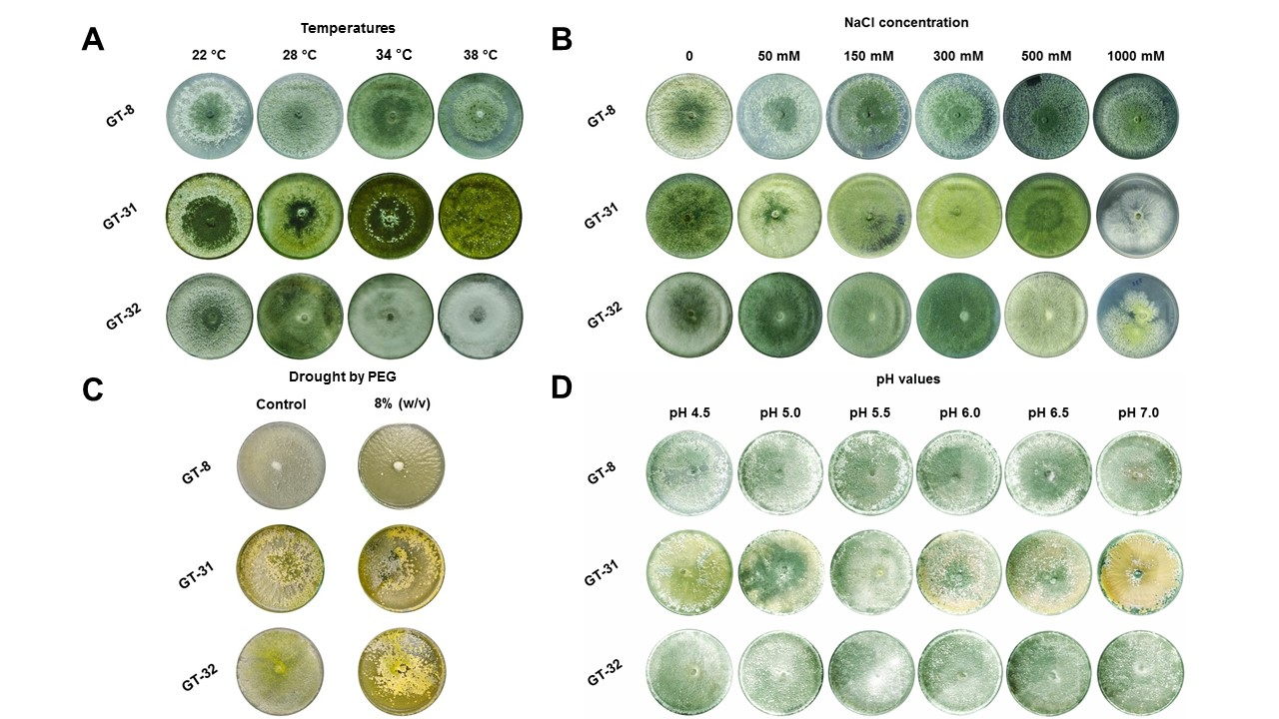
Fig. S3 Growth of Trichoderma spp. in Petri plates containing PDA medium after 7 days under different conditions of (A) temperature (B) salinity, (C) drought by PEG 6000, and (D) pH

