Supplementary Material
Increasing precipitation deteriorates the progress of pesticide reduction policy: a case study in the Yellow River
Zewei Guo ª, Wei Ouyang ^{a, b *}, Tulcan, Roberto Xavier Supe ª, Chunye Lin ª, Mengchang He ª
ª State Key Laboratory of Water Environment Simulation, School of Environment, Beijing Normal University, Beijing 100875, China
^{b} Advanced Interdisciplinary Institute of Environment and Ecology, Beijing Normal University, Zhuhai, 519087, China
Number of Pages: 26
Number of Tables: 3
Number of Figures: 4

Method
The comprehensive water inflow coefficient λ.
Table list
Table S1. The geographical coordinates of the sampling sites
Table S2 Optimized UPLC - MS/MS parameters of atrazine and its, surrogates, and internal standards.
Table S3 Calibration equations, linear ranges and performances (R², MDLs, MQLs) of the target chemicals and the surrogate in surface water (ng/L), SPM (ng/L), and surface sediment (ng/g) samples.
Table. S4 Global atrazine concentration in the water.

Figure list
Fig. S1 Extracted ion chromatograms (EIC) of the atrazine, the surrogate desethylatrazine-¹³C, and the internal standard atrazine-¹³C in the samples, respectively.
Fig. S2 Annual spatial distribution of parameters related to comprehensive water inflow coefficient, including (A) sub-basin classify, (B) retain index, (C) precipitation index, (D) runoff index, (E) subsurface water index, and (F) terrain index.
Fig. S3 Atrazine occurrence in China before and after reduction policy. The red point indicates level of atrazine in Yellow River Watershed (YRW).
Fig. S4 Estimated atrazine concentration in the water of the Yellow River Watershed

The comprehensive water inflow coefficient λ.
The generation, migration, and transformation of pollutants are mainly determined by precipitation, slope, surface/underground runoff, and watershed interception. Therefore, different water inflow coefficients λ for each sub-basin are used to comprehensively consider the process of pollutants inflow into the aquatic environments¹. A comprehensive water inflow coefficients method is established based on five indicators: precipitation, slope, surface runoff, subsurface infiltration, interception.
$$λ=α×β×TI×LI×RI$$
where α, β, TI, LI, and RI represent the precipitation index, terrain index, transport index, leaching index, and retain index, respectively. Among them, transport index, leaching index, and retain index have been normalized.
- The equation of rainfall driving factor α is as follows:
$$α=α_{t}×α_{s}=\frac{L}{\overline{L}}×\frac{R_{j}}{\overline{R}}=\frac{f_{(r)}}{f_{(\overline{r})}}×\frac{R_{j}}{\overline{R}}$$
where α is the rainfall driving factor, determined by the dual effects of the temporal non-uniformity impact factor α_{t} and the spatial non-uniformity impact factor α_{s}, where α_{t} is the driving factor of inter-annual rainfall variability and α_{s} is the driving factor of spatial distribution of rainfall. L is the loads of agricultural diffuse pollution entering water per year, L̅ is the average annual loads of agricultural diffuse pollution entering water, R_{j} is the average annual rainfall in sub-basin j, R̅ is the multi-year average annual rainfall in the Yellow River Watershed, r̅ is the average annual rainfall in the entire watershed, and f(r) is the amount of agricultural diffuse pollution entering water per year.
According to Cai et al.², the precipitation and diffuse pollutants load data in the Yellow River Watershed, the correlation between the annual average precipitation r and the total nitrogen annual water inflow was established. The regression equation is as follows:
L_{TN} = 5.2558 r² + 26584r - 1000000 (R² = 0.2531)
r represents the annual average precipitation (mm), and L_{TN} represents the total nitrogen discharge into the river (kg). Therefore, the formula for calculating the rainfall driving factor is obtained as:
$$α_{TN}=\frac{5.2558 r^{2}+ 26584 r- 1000000}{5.2558{ \overline{r}}^{2} + 26584 \overline{r}- 1000000}×\frac{R_{j}}{\overline{R}}$$
- The terrain driving factor β is defined as:
$$β=\frac{L(θ_{j})}{L(θ)}=\frac{cθ_{j}^{d}}{c{\overline{θ}}_{j}^{d}}=\frac{θ_{j}^{d}}{{\overline{θ}}^{d}}$$
where θ_{j} is the slope of the spatial unit in the watershed, L is the annual input of diffuse pollutants, $\overline{θ}$ is the average slope of the sub-basin, and c and d are constants.
- Transport Index (TI).
The relationship between rainfall and runoff can be expressed as:
$$\frac{F}{S}=\frac{Q}{(P-I_{α})}$$
where F is the initial abstraction (mm) at the start of runoff, S is the maximum potential retention after which all rainfall becomes runoff (mm), Q is the actual amount of runoff generated (mm) from a single rainfall event, P is the total rainfall (mm), and I_{α} is the initial abstraction (mm) before runoff begins.
$$Q=\left\{\begin{aligned}{\frac{(P-I_{α})}{\left(P-I_{α}\right)+S}}^{2}, P>I_{α} \\ 0, P<I_{α} \end{aligned}\right.$$
where P is a variable obtained from the field monitoring. S is the retention parameter, which is related to the underlying surface factors. It presents spatial differences with different soils, land use, management measures, and slopes, and temporal differences with changes in soil moisture content. To calculate S, the Curve Number (CN) parameter is introduced³, and the relationship between S and CN is given by:
$S=\frac{25400}{CN}-254$,
where CN is a dimensionless parameter that reflects the characteristics of the underlying surface of the watershed, with a numerical range of 1-100. A higher value indicates a poorer water storage capacity of the underlying surface. The initial abstraction of rainfall, I_{a}, is typically approximated as 0.2S based on the empirical equation⁴, so the equation becomes:
$$Q=\left\{\begin{aligned}{\frac{(R_{day}-0.2S)}{R_{day}+0.8S}}^{2}, P>I_{α} \\ 0, P<I_{α} \end{aligned}\right.$$
The sub-basins were delineated using ArcGIS 10.2 software based on a 90 m resolution digital elevation model (DEM), resulting in a total of 52 sub-basins in the Yellow River Watershed.
${CN}_{3}={CN}_{2}×exp⁡[0.00673×\left(100-{CN}_{2}\right)]$,
$${CN}_{2S}=\frac{{CN}_{3}-{CN}_{2}}{3}\left[1-2\exp\left(-13.86slp\right)\right]+{CN}_{2}$$
where slp is the average slope of each sub-basin.
(4) The leaching index
The actual infiltration capacity of soil water in the watershed is determined by the rainfall spatial Distribution Index (PI) and seasonal distribution index (SI), where the PI index characterizes the maximum theoretical rainfall that can be used for infiltration in the sub-watershed (mm), and the SI index characterizes the impact of seasonal variation in rainfall on soil moisture infiltration (dimensionless)⁵. The calculation formula is as follows:
$$LI=PI·SI$$
$$=\frac{prec-0.4(\frac{25400}{CN}-254)}{prec+0.6(\frac{25400}{CN}-254)}×\sqrt[3]{2×\frac{prec(ls)}{prec}}$$
where prec and prec (ls) represent the annual rainfall (mm) and the total rainfall (mm) during the non-flood season (November to May of the following year), respectively
(5) The retain index (RI) is constructed to represent the likelihood of pollutants being intercepted by vegetation buffer strips during the migration process to water bodies¹. The calculation formula is as follows:
$$RI=ln\left(\frac{\sum_{DA=1}^{N}{T_{{DA}_{i}}}}{\tan{B_{{DA}_{i}}}}\right)$$
where DA represents the vegetation type, ∑T_{DA}__{i} is the accumulated interception efficiency of forests and grasslands, and B_{DA}__{i} is the average slope.
Reference
(1) Hu, Q.; Guo, H.; Wang, Y.; Zhang, Y.; Li, Z.; Fu, Z.; Lu, W. Estimation of Agricultural Non-Point Source Pollution Loads Based on Improved Export Coefficient Model. Beijing Daxue Xuebao (Ziran Kexue Ban)/Acta Sci. Nat. Univ. Pekin. 2021, 57 (4), 739–748. https://doi.org/10.13209/j.0479-8023.2021.049.
(2) Cai, M.; Li, H.; Zhuang, Y.; Wang, Q. Application of Modified Export Coefficient Method in Polluting Load Estimation of Non-Point Source Pollution. J. Hydraul. Eng. 2004, 7, 40–45.
(3) Quansah, J. E.; Engel, B. A.; Chaubey, I. Tillage Practicses Usage in Early Warning Prediction of Atrazine Pollution. Am. Soc. Agric. Biol. Eng. 2008, 51 (4), 1311–1321.
(4) Hu, J.; Ma, J.; Nie, C.; Xue, L.; Zhang, Y.; Ni, F.; Deng, Y.; Liu, J.; Zhou, D.; Li, L.; Wang, Z. Attribution Analysis of Runoff Change in Min-Tuo River Basin Based on SWAT Model Simulations, China. Sci. Rep. 2020, 10 (1), 1–16. https://doi.org/10.1038/s41598-020-59659-z.
(5) Blanchard, P. E.; Lerch, R. N. Watershed Vulnerability to Losses of Agricultural Chemicals: Interactions of Chemistry, Hydrology, and Land-Use. Environ. Sci. Technol. 2000, 34 (16), 3315–3322. https://doi.org/10.1021/es991115+.

Table S1. The geographical coordinates of the sampling sites
Site | Lon | Lat | Type
LJX | 103.0846 | 35.76318 | Main stream
SPT | 105.2307 | 37.48605 | Main stream
YC | 106.4118 | 38.35767 | Main stream
BYGL | 107.032 | 40.31105 | Main stream
SHHK | 108.7755 | 40.61455 | Main stream
HFC | 111.1956 | 39.22355 | Main stream
WB | 110.7258 | 37.44767 | Main stream
LM | 110.5884 | 35.67768 | Main stream
TG | 110.2833 | 34.64658 | Main stream
HSR | 103.348 | 36.12306 | Tributary
TR | 103.5328 | 35.82066 | Tributary
FR | 110.4714 | 35.34409 | Tributary
WR | 110.1192 | 34.66187 | Tributary

Table S2 Optimized UPLC - MS/MS parameters of atrazine and its, surrogates, and internal standards.
Chemical | MRM (Q1/Q3, Da) | DP (V) | CE (eV)
Atrazine | 216/103.9 | 90 | 40
 | 216/132.1 | 90 | 28
Desethylatrazine-¹³C | 191/105.9 | 70 | 31
 | 191/149 | 68 | 22
Atrazine-¹³C | 223.9/110 | 80 | 37
 | 223.9/182 | 79 | 24
DP: Declustering Potential; CE: Collision Energy.

Table S3 Calibration equations, linear ranges and performances (R², MDLs, MQLs) of the target chemicals and the surrogate in surface water (ng/L), SPM (ng/L), and surface sediment (ng/g) samples.
Chemical | Calibration equation | Linear range | R² | MDL | MQL
ATR | y = 0.2748x+0.0009 | 0.25-200 | 0.9995 | 0.11 | 0.42
Desethylatrazine-¹³C | y = 37138x+5022 | 0.25-200 | 0.9999
MQL: Method quantification limits; MDL: Method detection limits. The MDL was calculated based on three times of signal-to-noise ratio of blanks. The MQL was calculated based on ten times of signal-to noise ratio of blanks. The internal standard Atrazine-¹³C was used to calibrate the equipment error excluding the surrogate DEA-¹³C.

Table. S4 Global atrazine concentration in the water.
Continent | Country | Year | Location | Concentrationª | Reference
Asia Pacific | China | 2016 | Yangtze River | 191.4  (21-1726) | ⁶
Asia Pacific | China | 2019 | Shandong | (70-1120) | ⁷
Asia Pacific | China | 2019 | Shandong | (10-740) | ⁷
Asia Pacific | China | 2009 | Jiangsu | (ND-170) | ⁸
Asia Pacific | China | 2009 | Jiangsu | 210  (ND - 420) | ⁸
Asia Pacific | China | 2009 | Shandong | 40  (40-50) | ⁸
Asia Pacific | China | 2009 | Hebei | (5-590) | ⁹
Asia Pacific | China | 2017 | Wuhan | 80  (40-180) | ¹⁰
Asia Pacific | China | 2013 | Hebei | 960 | ¹¹
Asia Pacific | China | 2018 | Guangxi | 127  (74-585) | ¹²
Asia Pacific | China | 2014 | Zhejiang | 193.6  (21.3-614) | ¹³
Asia Pacific | China | 2019 | Shandong | 154.8  (10.5-551.5) | ¹⁴
Asia Pacific | China | 2013 | Henan | 578  (320-960) | ¹¹
Asia Pacific | China | 2000 | Beijing | (600-750) | ¹⁵
Asia Pacific | China | 2018 | Liaoning | 23.3  (8.7-64.8) | ¹⁶
Asia Pacific | China | 2019 | Zhejiang | 23.9  (2.4-69.6) | ¹⁷
Asia Pacific | China | 2019 | Shandong | 99.1  (4.2-195.9) | ¹⁴
Asia Pacific | China | 2001 | Liaoning | 9700  (4520-17500) | ¹⁸
Asia Pacific | China | 2012 | Anhui | 9  (1-18.3) | ¹⁹
Asia Pacific | China | 2014 | Shanghai | 15  (6-20) | ²⁰
Asia Pacific | China | 2018 | Shandong | 28.3  (9-174) | ²¹
Asia Pacific | China | 2013 | Tianjin | 17.3  (9.7-25.2) | ²²
Asia Pacific | China | 2012 | Shandong | 31.3  (6.8-83) | ²³
Asia Pacific | China | 2019 | Liaoning | 63.7  (31.5-97.6) | ²⁴
Asia Pacific | China | 2018 | Jiangsu | 352  (19-1190) | ²⁵
Asia Pacific | China | 2014 | China | 289.3  (7-1289.5) | ²⁶
Asia Pacific | China | 2014 | Heilongjiang | 844.9 | ²⁶
Asia Pacific | China | 2014 | Heilongjiang | 606.5 | ²⁶
Asia Pacific | China | 2014 | Jiangsu | 352.4 | ²⁶
Asia Pacific | China | 2014 | Jiangsu | 247.1 | ²⁶
Asia Pacific | China | 2014 | Guangdong | 45.7 | ²⁶
Asia Pacific | China | 2014 | Henan | 10.9 | ²⁶
Asia Pacific | China | 2014 | Jiangsu | 70.8 | ²⁶
Asia Pacific | China | 2014 | Ningxia | 135.6 | ²⁶
Asia Pacific | China | 2019 | Shandong | 0.2  (0.1-0.5) | ¹⁴
Asia Pacific | Korea | 2010 | Seoul | 0.4  (nd - 1) | ²⁷
Asia Pacific | Saudi Arabia | 2016 | Jeddah | 2.2  (na-2200) | ²⁸
Asia Pacific | Serbia | 2011 | Danube River | 104  (3-188) | ²⁹
Asia Pacific | Serbia | 2011 | Danube River | 20 | ²⁹
Asia Pacific | Thailand | 2014 | Mondego River | (25-150) | ³⁰
Asia Pacific | Thailand | 2014 | Mondego River | (nd - 87) | ³⁰
Asia Pacific | Thailand | 2007 | Mae Sa watershed | 50  (na - 800) | ³¹
Asia Pacific | Iran | 2020 | Iran | 24.9  (20.5-33.1) | ³²
Asia Pacific | Kazakhstan | 2015 | Kazakhstan | 1.2  (1.1-1.2) | ³³
Asia Pacific | Myanmar | 2016 | Myanmar | 950  (700-2900) | ³⁴
Asia Pacific | Vietnam | 2019 | Vietnam | 10.9  (3.9-21.2) | ³⁵
Asia Pacific | Indonesia | 2021 | Indonesia | 7.3  (4.4-9.6) | ³⁶
Asia Pacific | Korea | 2011 | Korea | 0.4  (0.1-1) | ²⁷
Asia Pacific | Australia | 2006 | Burdekin | (na-1648) | ³⁷
Asia Pacific | Australia | 2007 | Burdekin | (na-3838) | ³⁷
Asia Pacific | Australia | 2008 | Burdekin | (na-8750) | ³⁷
Asia Pacific | Australia | 2009 | Burdekin | (na-11066) | ³⁷
Asia Pacific | Australia | 2005 | Burdekin | (na-3925) | ³⁷
Asia Pacific | Australia | 2010 | Great Barrier Reef | 965.5  (20-12580) | ³⁸
South Asia | India | 2017 | India | 52  (10-90) | ³⁹
North America | USA | 2001 | Mississippi River | 4945  (50-9840) | ⁴⁰
North America | USA | 2004 | Florida | (0.9-108) | ⁴¹
North America | USA | 2016 | Georgia | (na-1650) | ⁴²
North America | USA | 2014 | Georgia | 19.0  (5-49) | ⁴²
North America | USA | 2013 | Rocky Mountain | (na-12) | ⁴³
North America | USA | 2004 | Maryland | 170 | ⁴⁴
North America | USA | 2004 | Indiana | 350 | ⁴⁴
North America | USA | 1990 | Midwestern USA | 230  (na-3100) | ⁴⁵
North America | USA | 1995 | Chesapeake Bay | 420  (46-3100) | ⁴⁶
North America | USA | 1995 | Susquehanna River | 81 | ⁴⁶
North America | USA | 1995 | Susquehanna River | 160 | ⁴⁶
North America | USA | 1995 | Susquehanna River | 61 | ⁴⁶
North America | USA | 2016 | Louisiana | 33  (3.3-104) | ⁴⁷
North America | USA | 1995 | USA | 28  (1-2600) | ⁴⁰
North America | USA | 2003 | USA | 21  (1-1930) | ⁴⁰
North America | USA | 2013 | Beasley Lake | 1836  (132-3539) | ⁴⁸
North America | USA | 1993 | Nevada | 190  (80-700) | ⁴⁹
North America | USA | 1994 | Nebraska | 1766  (860-3010) | ⁵⁰
North America | USA | 1994 | Nebraska | 905  (150-2110) | ⁵⁰
North America | USA | 2006 | Salt River Basin | 797  (29-149000) | ⁵¹
North America | USA | 1997 | Midwestern USA | 170  (na-1500) | ⁵²
North America | USA | 1991 | Illinois | 290  (na-1810) | ⁵³
North America | USA | 2000 | Illinois | 110  (na-140) | ⁵³
North America | USA | 2001 | Indiana | 1150 | ⁵⁴
North America | USA | 2003 | Indiana | 880 | ⁵⁴
North America | USA | 2005 | Superior Lake | 5500  (5100-6000) | ⁵⁵
North America | USA | 2001 | Virginia | 2006  (590-6570) | ⁵⁶
North America | USA | 1985 | Pennsylvania | 101  (17-540) | ⁵⁷
North America | USA | 1985 | Pennsylvania | 240  (13-1110) | ⁵⁷
North America | USA | 2003 | Florida | 33  (10-56) | ⁴¹
North America | USA | 1999 | Florida | 18.8  (7.9-29) | ⁴¹
North America | USA | 1997 | Florida | 24.5  (1-48) | ⁴¹
North America | USA | 2001 | Florida | 205  (9.9-400) | ⁴¹
North America | USA | 1986 | Pennsylvania | 155 | ⁵⁸
North America | USA | 1987 | Pennsylvania | 36 | ⁵⁸
North America | USA | 1991 | Nebraska | 270  (na-960) | ⁵⁹
North America | USA | 1993 | Indiana | 2134  (80-7640) | ⁶⁰
North America | USA | 2001 | Indiana | 3838  (290-8560) | ⁶¹
North America | USA | 1992 | Walnut Watershed | 280  (200-350) | ⁶²
North America | USA | 1992 | Iowa | 471  (100-1410) | ⁶³
North America | USA | 1998 | Iowa and Missouri | (3800-6300) | ⁶⁴
North America | USA | 1994 | Iowa and Missouri | 500  (20-1390) | ⁵
North America | USA | 1994 | Iowa and Missouri | 200  (20-1540) | ⁵
North America | USA | 1999 | Virginia | 1130  (na-2160) | ⁶⁵
North America | Canada | 2017 | St. Lawrence River | 29  (4-666) | ⁶⁶
North America | Canada | 2013 | Grand River | 11  (na-29) | ⁶⁷
North America | Canada | 2014 | British Columbia | 300  (100-600) | ⁶⁸
North America | Canada | 2003 | British Columbia | 80  (10 - 510) | ⁶⁸
North America | Canada | 2004 | British Columbia | 200  (100 - 300) | ⁶⁸
North America | Canada | 1994 | Quebec | 80  (20-300) | ⁶⁹
North America | Canada | 1991 | Ontario | 355  (320-390) | ⁷⁰
North America | Canada | 2010 | Ontario | 580  (480-750) | ⁷¹
North America | Canada | 1995 | Humber river | 174  (40-540) | ⁷²
North America | Canada | 2002 | Humber river | 50  (na-3600) | ⁷³
North America | Canada | 2002 | Humber river mouth | 50  (na-1100) | ⁷³
North America | Canada | 2002 | West Don river | (na-140) | ⁷³
North America | Canada | 1994 | Quebec | 881  (150-2280) | ⁷⁴
Latin America | Argentina | 2012 | Argentina | 1020  (640 - 1400) | ⁷⁵
Latin America | Argentina | 2015 | Argentina | 40  (0.02 - 135) | ⁷⁶
Latin America | Argentina | 2015 | Argentina | 60  (13-152) | ⁷⁶
Latin America | Argentina | 2015 | Argentina | 386  (38-2179) | ⁷⁷
Latin America | Brazil | 2016 | Brazil | 1400 | ⁷⁸
Latin America | Brazil | 2014 | Brazil | 19  (5-49) | ⁷⁹
Latin America | Brazil | 2015 | Brazil | (250-9300) | ⁸⁰
Latin America | Brazil | 2015 | Brazil | (600-2700) | ⁸⁰
Latin America | Brazil | 2015 | Brazil | (190-630) | ⁸⁰
Latin America | Chile | 2016 | Chile | 45 | ⁸¹
Latin America | Mexico | 2019 | Mexico | 204  (6-402) | ⁸²
Latin America | Venezuela | 2010 | Venezuela | 1020  (50-1990) | ⁸³
Latin America | Mexico | 2019 | Mexico | 2  (2-7) | ⁸⁴
Latin America | Colombia | 2021 | Colombia | 575  (10-1830) | ⁸⁵
Africa | Nigeria | 2016 | Nigeria | 9  (3-80) | ⁸⁶
Africa | Cameroon | 2015 | Cameroon | 23  (20-27) | ⁸⁷
Africa | South Africa | 1991 | Eastern Transvaal | 1370  (730-15000) | ⁸⁸
Africa | South Africa | 2020 | Camps Bay | 2  (0.8-4.2) | ⁸⁹
Africa | Egypt | 2018 | Egypt | 55  (50-60) | ⁹⁰
Africa | eSwatini | 2018 | eSwatini | 22  (0.1-636) | ⁹¹
Africa | South Africa | 2019 | South Africa | 161  (10-812) | ⁹²
Africa | Sudan | 2017 | Sudan | 39  (5-134) | ⁹³
Africa | Zimbabwe | 2019 | Zimbabwe | 62 | ⁹⁴
Africa | Cameroon | 2015 | Cameroon | 139  (19-461) | ⁸⁷
Africa | Morocco | 2019 | Morocco | 19 | ⁹⁵
Africa | Senegal | 2018 | Senegal | 102 | ⁹⁶
Africa | Burkina Faso | 2016 | Burkina Faso | 15 | ⁹⁷
Africa | Tanzania | 2015 | Tanzania | 60 | ⁹⁸
Europe | Egypt | 1991 | Nile Delta | 1.0 | ⁹⁹
Europe | Spain | 1992 | Tarragona | 800 | ¹⁰⁰
Europe | England | 1997 | Thames Estuary | 109 | ¹⁰¹
Europe | France | 1996 | Vannetin river | 1050 | ¹⁰²
Europe | France | 2016 | European Alps | 0.2 | ¹⁰³
Europe | France | 2007 | Brittany | 14 | ¹⁰⁴
Europe | Greece | 2012 | Louros | 13 | ¹⁰⁵
Europe | Greece | 1991 | Thermaikos Gulf | 100  (50-150) | ⁹⁹
Europe | Greece | 1991 | Amvrakikos Gulf | 425  (50-800) | ⁹⁹
Europe | Italy | 2005 | Sacca di Goro lagoon | (2-8) | ¹⁰⁶
Europe | Italy | 2010 | Baltic Estuary | 1.6  (1.7-2.1) | ¹⁰⁷
Europe | Portugal | 2015 | Arade estuary | (2-3) | ¹⁰⁸
Europe | Portugal | 2017 | Portugal Estuaries | (na-16.5) | ¹⁰⁹
Europe | Portugal | 2012 | Guadiana River | 8.2  (na-18.61) | ¹¹⁰
Europe | Portugal | 2017 | Mediterranean Sea | (na-16.5) | ¹⁰⁹
Europe | Portugal | 2017 | Mediterranean Sea | (na-35.3) | ¹⁰⁹
Europe | Portugal | 2014 | Mondego Estuary | 88  (25-150) | ³⁰
Europe | Scotland | 2014 | North East Scotland | (na-2.7) | ¹¹¹
Europe | Scotland | 2014 | Ugie river | 1.4  (0.3-2.7) | ¹¹¹
Europe | Spain | 2009 | The Llobregat | 0.2  (0.04-0.4) | ¹¹²
Europe | Spain | 2009 | The Llobregat | 0.3  (0.02-3.1) | ¹¹²
Europe | Spain | 2009 | The Llobregat | 0.2  (0.02-0.5) | ¹¹²
Europe | Spain | 2009 | The Llobregat | 1.1  (0.2-7.2) | ¹¹³
Europe | Spain | 2003 | Western Mediterranean Sea | 82  (12 - 170) | ¹¹⁴
Europe | Spain | 2015 | Catalonia | 1.1  (0.03-3.8) | ¹¹⁵
Europe | Spain | 2010 | Mina Pública Aigües Terrasa | 1.3  (1.1-1.6) | ¹¹³
Europe | Spain | 2010 | Sant Joan Despí | 2  (1.5-2.7) | ¹¹³
Europe | Spain | 2010 | Anoia | 0.9 | ¹¹³
Europe | Spain | 1991 | Ebro Delta | 29  (1-57) | ⁹⁹
Europe | Spain | 1996 | Ebro Delta | 142 | ¹⁰⁰
Europe | Spain | 1997 | Ebro Delta | 175 | ¹⁰⁰
Europe | Switzerland | 1992 | Switzerland | 231  (1-460) | ¹⁰⁰
Europe | Switzerland | 1996 | Switzerland | 3500  (1000-6000) | ¹⁰⁰
Middle East | Turkey | 2011 | Dardanelles | (na-33) | ¹¹⁶
Europe | Germany | 2011 | Lower Rhine | 59  (20-95) | ¹¹⁷
Europe | Russia | 1994 | Russia | 41  (23-110) | ¹¹⁸
Europe | Poland | 2003 | Poland | 420  (332-508) | ¹¹⁹
Europe | Czech | 2011 | Czech | 7.4  (1.1-41) | ¹²⁰
Europe | Austria | 1995 | Austria | 127  (41-242) | ¹²¹
Europe | Croatia | 2015 | Croatia | 2.6  (0.7-7) | ¹²²
ª Concentration mean (minimum – maximum), ng/L; na: not reported; nd: not detected

References
(1) Hu, Q.; Guo, H.; Wang, Y.; Zhang, Y.; Li, Z.; Fu, Z.; Lu, W. Estimation of Agricultural Non-Point Source Pollution Loads Based on Improved Export Coefficient Model. Beijing Daxue Xuebao (Ziran Kexue Ban)/Acta Sci. Nat. Univ. Pekin. 2021, 57 (4), 739–748. https://doi.org/10.13209/j.0479-8023.2021.049.
(2) Cai, M.; Li, H.; Zhuang, Y.; Wang, Q. Application of Modified Export Coefficient Method in Polluting Load Estimation of Non-Point Source Pollution. J. Hydraul. Eng. 2004, 7, 40–45.
(3) Quansah, J. E.; Engel, B. A.; Chaubey, I. Tillage Practicses Usage in Early Warning Prediction of Atrazine Pollution. Am. Soc. Agric. Biol. Eng. 2008, 51 (4), 1311–1321.
(4) Hu, J.; Ma, J.; Nie, C.; Xue, L.; Zhang, Y.; Ni, F.; Deng, Y.; Liu, J.; Zhou, D.; Li, L.; Wang, Z. Attribution Analysis of Runoff Change in Min-Tuo River Basin Based on SWAT Model Simulations, China. Sci. Rep. 2020, 10 (1), 1–16. https://doi.org/10.1038/s41598-020-59659-z.
(5) Blanchard, P. E.; Lerch, R. N. Watershed Vulnerability to Losses of Agricultural Chemicals: Interactions of Chemistry, Hydrology, and Land-Use. Environ. Sci. Technol. 2000, 34 (16), 3315–3322. https://doi.org/10.1021/es991115+.
(6) Peng, Y.; Fang, W.; Krauss, M.; Brack, W.; Wang, Z.; Li, F.; Zhang, X. Screening Hundreds of Emerging Organic Pollutants (EOPs) in Surface Water from the Yangtze River Delta (YRD): Occurrence, Distribution, Ecological Risk. Environ. Pollut. 2018, 241, 484–493. https://doi.org/10.1016/j.envpol.2018.05.061.
(7) Sun, X.; Liu, F.; Shan, R.; Fan, Y. Spatiotemporal Distributions of Cu, Zn, Metribuzin, Atrazine, and Their Transformation Products in the Surface Water of a Small Plain Stream in Eastern China. Environ. Monit. Assess. 2019, 191 (7). https://doi.org/10.1007/s10661-019-7556-3.
(8) Han, F.; Chen, J.; Jiang, Z.; Ji, W.; Xu, L.; Chen, L.; Li, X.; Zhou, C. Investigation of VOCs and SVOCs in Surface Water Source in Jiangsu，Zhejiang，Shandong Province，China. J. Environ. Health 2011, 28 (10), 890–894. https://doi.org/10.16241/j.cnki.1001-5914.2011.10.021.
(9) Heeb, F.; Singer, H.; Pernet-Coudrier, B.; Qi, W.; Liu, H.; Longrée, P.; Müller, B.; Berg, M. Organic Micropollutants in Rivers Downstream of the Megacity Beijing: Sources and Mass Fluxes in a Large-Scale Wastewater Irrigation System. Environ. Sci. Technol. 2012, 46 (16), 8680–8688. https://doi.org/10.1021/es301912q.
(10) Sun, S.; Chen, Y.; Lin, Y.; An, D. Occurrence, Spatial Distribution, and Seasonal Variation of Emerging Trace Organic Pollutants in Source Water for Shanghai, China. Sci. Total Environ. 2018, 639, 1–7. https://doi.org/10.1016/j.scitotenv.2018.05.089.
(11) Brauns, B.; Jakobsen, R.; Song, X.; Bjerg, P. L. Pesticide Use in the Wheat-Maize Double Cropping Systems of the North China Plain: Assessment, Field Study, and Implications. Sci. Total Environ. 2018, 616–617, 1307–1316. https://doi.org/10.1016/j.scitotenv.2017.10.187.
(12) Li, H.; Feng, Y.; Li, X.; Zeng, D. Analytical Confirmation of Various Herbicides in Drinking Water Resources in Sugarcane Production Regions of Guangxi, China. Bull. Environ. Contam. Toxicol. 2018, 100 (6), 815–820. https://doi.org/10.1007/s00128-018-2324-6.
(13) Ta, N.; Feng, J.; Sun, C.; Zhou, F. Determination of Atrazine in Water of Taihu Meiliang Bay by Capillary Gas Chromatography. J. Chem. Inf. Model. 2005, 27 (8), 634–636.
(14) Guo, Z.; Ouyang, W.; Tulcan, R. X. S.; Lin, C.; He, M.; Wang, B.; Xin, M. Spatiotemporal Partition Dynamics of Typical Herbicides at a Turbid River Estuary. Mar. Pollut. Bull. 2022, 182 (April), 113946. https://doi.org/10.1016/j.marpolbul.2022.113946.
(15) Ren, J.; Jiang, K.; Zhou, H. The Concentration and Source of Atrazine Residue in Water of Guanting Reservoir. Environ. Sci. 2002, 23 (1), 126–128.
(16) Xie, H.; Wang, X.; Chen, J.; Li, X.; Jia, G.; Zou, Y.; Zhang, Y.; Cui, Y. Occurrence, Distribution and Ecological Risks of Antibiotics and Pesticides in Coastal Waters around Liaodong Peninsula, China. Sci. Total Environ. 2019, 656, 946–951. https://doi.org/10.1016/j.scitotenv.2018.11.449.
(17) Xue, Y.; Zhang, Z. M.; Zhang, R. R.; Li, Y. Q.; Sun, A. L.; Shi, X. Z.; Chen, J.; Song, S. Aquaculture-Derived Distribution, Partitioning, Migration, and Transformation of Atrazine and Its Metabolites in Seawater, Sediment, and Organisms from a Typical Semi-Closed Mariculture Bay. Environ. Pollut. 2021, 271. https://doi.org/10.1016/j.envpol.2020.116362.
(18) Yang, D.; He, Y.; Wang, H. Environmental Characteristics of the Atrazine in the Waters in East Liaohe River Basin. Environ. Sci. 2005, 26 (3), 203–208.
(19) Qi, W.; Müller, B.; Pernet-Coudrier, B.; Singer, H.; Liu, H.; Qu, J.; Berg, M. Organic Micropollutants in the Yangtze River: Seasonal Occurrence and Annual Loads. Sci. Total Environ. 2014, 472, 789–799. https://doi.org/10.1016/j.scitotenv.2013.11.019.
(20) Xu, C.; Chen, L.; You, L.; Xu, Z.; Ren, L. F.; Yew-Hoong Gin, K.; He, Y.; Kai, W. Occurrence, Impact Variables and Potential Risk of PPCPs and Pesticides in a Drinking Water Reservoir and Related Drinking Water Treatment Plants in the Yangtze Estuary. Environ. Sci. Process. Impacts 2018, 20 (7), 1030–1045. https://doi.org/10.1039/c8em00029h.
(21) Ouyang, W.; Zhang, Y.; Gu, X.; Tysklind, M.; Lin, C.; Wang, B.; Xin, M. Occurrence, Transportation, and Distribution Difference of Typical Herbicides from Estuary to Bay. Environ. Int. 2019, 130 (June), 104858. https://doi.org/10.1016/j.envint.2019.05.052.
(22) Ren, C.; Tian, X.; Zhang, H.; Liu, Y.; Sun, Y.; Xu, Y.; Gong, X.; Wang, M. Determination of Triazine Herbicides in Seawater Using Solid Phase Extraction-UPLC-/MS/MS. J. Chinese Mass Spectrom. Soc. 2013, 34 (6), 353–361.
(23) Xu, Y.; Huihui Liu; Ren, C.; Sun, Y.; Li, F.; Ren, B.; Deng, X.; Zhang, H.; Wang, M. Distributions of the Triazine Herbicides in the Surface Seawater of Laizhou Bay. Prog. Fish. Sci. 2014, 35 (3), 34–39.
(24) Du, J.; Hu, C.; Xie, H.; Tian, J.; Li, A.; Xie, Q.; Jinghao Wu; Song, L. Concentration Levels and Potential Ecological Risks of Current Use Pesticides in the Surface Seawater of Typical Liaoning Sea Areas. Environ. Sci. 2021, 42 (4), 1772–1780. https://doi.org/10.13227/j.hjkx.202008125.
(25) Chen, X.; Qian, Z.; Zhu, H.; Kong, J.; Feng, J.; Xian, Q. Contamination Status of Four Herbicides in Jiuli River from the West Bank of Wangyu River. Environ. Monit. Forewarning 2019, 11 (6), 36–46.
(26) Xu, X.; Li, C.; Sun, J.; Wang, H.; Wang, D.; Song, H.; Wang, Z. Residue Characteristics and Ecological Risk Assessment of Twenty-Nine Pesticides in Surface Water of Major River-Basin in China. Asian J. Ecotoxicol. 2016, 11 (2), 347–354. https://doi.org/10.7524/AJE.1673.
(27) Ryu, J.; Yoon, Y.; Oh, J. Occurrence of Endocrine Disrupting Compounds and Pharmaceuticals in 11 WWTPs in Seoul, Korea. KSCE J. Civ. Eng. 2011, 15 (1), 57–64. https://doi.org/10.1007/s12205-011-0913-6.
(28) Ali, A. M.; Rønning, H. T.; Al Arif, W. M.; Kallenborn, R.; Kallenborn, R. Occurrence of Pharmaceuticals and Personal Care Products in Effluent-Dominated Saudi Arabian Coastal Waters of the Red Sea. Chemosphere 2017, 175, 505–513. https://doi.org/10.1016/j.chemosphere.2017.02.095.
(29) Antić, N.; Radišić, M.; Radović, T.; Vasiljević, T.; Grujić, S.; Petković, A.; Dimkić, M.; Laušević, M. Pesticide Residues in the Danube River Basin in Serbia - a Survey during 2009-2011. Clean - Soil, Air, Water 2015, 43 (2), 197–204. https://doi.org/10.1002/clen.201200360.
(30) Rodrigues, E. T.; Alpendurada, M. F.; Ramos, F.; Pardal, M. Â. Environmental and Human Health Risk Indicators for Agricultural Pesticides in Estuaries. Ecotoxicol. Environ. Saf. 2018, 150 (December 2017), 224–231. https://doi.org/10.1016/j.ecoenv.2017.12.047.
(31) Sangchan, W.; Bannwarth, M.; Ingwersen, J.; Hugenschmidt, C.; Schwadorf, K.; Thavornyutikarn, P.; Pansombat, K.; Streck, T. Monitoring and Risk Assessment of Pesticides in a Tropical River of an Agricultural Watershed in Northern Thailand. Environ. Monit. Assess. 2014, 186 (2), 1083–1099. https://doi.org/10.1007/s10661-013-3440-8.
(32) Almasi, H.; Takdastan, A.; Jaafarzadeh, N.; Babaei, A. A.; Tahmasebi Birgani, Y.; Cheraghian, B.; Saki, A.; Jorfi, S. Spatial Distribution, Ecological and Health Risk Assessment and Source Identification of Atrazine in Shadegan International Wetland, Iran. Mar. Pollut. Bull. 2020, 160 (August), 111569. https://doi.org/10.1016/j.marpolbul.2020.111569.
(33) Snow, D. D.; Chakraborty, P.; Uralbekov, B.; Satybaldiev, B.; Sallach, J. B.; Thornton Hampton, L. M.; Jeffries, M.; Kolok, A. S.; Bartelt-Hunt, S. B. Legacy and Current Pesticide Residues in Syr Darya, Kazakhstan: Contamination Status, Seasonal Variation and Preliminary Ecological Risk Assessment. Water Res. 2020, 184. https://doi.org/10.1016/j.watres.2020.116141.
(34) Iwai, C. B.; Khaung, T.; Prasopsuk, J.; Ravindran, B. Environmental Risk Assessment of Floating Gardens in Inle Lake, Myanmar. Urban Clim. 2022, 44 (June), 101194. https://doi.org/10.1016/j.uclim.2022.101194.
(35) Wan, Y.; Tran, T. M.; Nguyen, V. T.; Wang, A.; Wang, J.; Kannan, K. Neonicotinoids, Fipronil, Chlorpyrifos, Carbendazim, Chlorotriazines, Chlorophenoxy Herbicides, Bentazon, and Selected Pesticide Transformation Products in Surface Water and Drinking Water from Northern Vietnam. Sci. Total Environ. 2021, 750, 141507. https://doi.org/10.1016/j.scitotenv.2020.141507.
(36) Laude, S.; Mahfudz; Fathurrahman; Samuddin, S.; Rahim, A.; Darwis. Effect of Atrazine and Green Fertilizer (Tithonia Diversifolia) on Weed Growth and Corn Productivity. IOP Conf. Ser. Earth Environ. Sci. 2021, 681 (1). https://doi.org/10.1088/1755-1315/681/1/012044.
(37) Davis, A. M.; Lewis, S. E.; Bainbridge, Z. T.; Glendenning, L.; Turner, R. D. R.; Brodie, J. E. Dynamics of Herbicide Transport and Partitioning under Event Flow Conditions in the Lower Burdekin Region, Australia. Mar. Pollut. Bull. 2012, 65 (4–9), 182–193. https://doi.org/10.1016/j.marpolbul.2011.08.025.
(38) Smith, R.; Middlebrook, R.; Turner, R.; Huggins, R.; Vardy, S.; Warne, M. Large-Scale Pesticide Monitoring across Great Barrier Reef Catchments - Paddock to Reef Integrated Monitoring, Modelling and Reporting Program. Mar. Pollut. Bull. 2012, 65 (4–9), 117–127. https://doi.org/10.1016/j.marpolbul.2011.08.010.
(39) Chaubey, J.; Singh, S. K.; Singh, S.; Arora, H. Assessment of the Impact of Pesticide Usage in Groundwater Aquifer of an Agriculturally Dominated Area in North West India. Water Pract. Technol. 2020, 15 (2), 327–342. https://doi.org/10.2166/wpt.2020.017.
(40) Bexfield, L. M. Decadal-Scale Changes of Pesticides in Ground Water of the United States, 1993-2003. J. Environ. Qual. 2008, 37 (S5), S-226-S-239. https://doi.org/10.2134/jeq2007.0054.
(41) Harman-Fetcho, J. A.; Hapeman, C. J.; McConnell, L. L.; Potter, T. L.; Rice, C. P.; Sadeghi, A. M.; Smith, R. D.; Bialek, K.; Sefton, K. A.; Schaffer, B. A.; Curry, R. Pesticide Occurrence in Selected South Florida Canals and Biscayne Bay during High Agricultural Activity. J. Agric. Food Chem. 2005, 53 (15), 6040–6048. https://doi.org/10.1021/jf047803g.
(42) Glinski, D. A.; Purucker, S. T.; Van Meter, R. J.; Black, M. C.; Henderson, W. M. Analysis of Pesticides in Surface Water, Stemflow, and Throughfall in an Agricultural Area in South Georgia, USA. Chemosphere 2018, 209, 496–507. https://doi.org/10.1016/j.chemosphere.2018.06.116.
(43) Battaglin, W. A.; Bradley, P. M.; Iwanowicz, L.; Journey, C. A.; Walsh, H. L.; Blazer, V. S. Pharmaceuticals, Hormones, Pesticides, and Other Bioactive Contaminants in Water, Sediment, and Tissue from Rocky Mountain National Park, 2012–2013. Sci. Total Environ. 2018, 643, 651–673. https://doi.org/10.1016/j.scitotenv.2018.06.150.
(44) Alvarez, D. A.; Cranor, W. L.; Perkins, S. D.; Clark, R. C.; Smith, S. B. Chemical and Toxicologic Assessment of Organic Contaminants in Surface Water Using Passive Samplers. J. Environ. Qual. 2008, 37 (3), 1024–1033. https://doi.org/10.2134/jeq2006.0463.
(45) Michael Thurman, E.; Meyer, M. T.; Mills, M. S.; Pomes, M. L.; Goolsby, D. A.; Kolpln, D. W. A Reconnaissance Study of Herbicides and Their Metabolites in Surface Water of the Midwestern United States Using Immunoassay and Gas Chromatography/Mass Spectrometry. Environ. Sci. Technol. 1992, 26 (12), 2440–2447. https://doi.org/10.1021/es00036a016.
(46) Harman‐Fetcho, J. A.; McConnell, L. L.; Baker, J. E. Agricultural Pesticides in the Patuxent River, a Tributary of the Chesapeake Bay. J. Environ. Qual. 1999, 28 (3), 928–938. https://doi.org/10.2134/jeq1999.00472425002800030025x.
(47) Callicott, K.; Hooper-Bùi, L. An Investigation of Environmental Concentrations of Atrazine, Chlorothalonil, and Fipronil in a Mississippi River-Influenced Marsh in Southern Louisiana. Microchem. J. 2019, 146 (July 2018), 1241–1248. https://doi.org/10.1016/j.microc.2019.01.060.
(48) Lizotte, R.; Locke, M.; Bingner, R.; Steinriede, R. W.; Smith, S. Effectiveness of Integrated Best Management Practices on Mitigation of Atrazine and Metolachlor in an Agricultural Lake Watershed. Bull. Environ. Contam. Toxicol. 2017, 98 (4), 447–453. https://doi.org/10.1007/s00128-016-2020-3.
(49) Shipitalo, M. J.; Edwards, W. M.; Owens, L. B. Herbicide Losses in Runoff from Conservation-Tilled Watersheds in a Corn-Soybean Rotation. Soil Sci. Soc. Am. J. 1997, 61 (1), 267–272. https://doi.org/10.2136/sssaj1997.03615995006100010038x.
(50) Ma, L.; Spalding, R. F. Herbicide Persistence and Mobility in Recharge Lake Watershed in York, Nebraska. J. Environ. Qual. 1997, 26 (1), 115–125. https://doi.org/10.2134/jeq1997.00472425002600010018x.
(51) Lerch, R. N.; Sadler, E. J.; Sudduth, K. A.; Baffaut, C.; Kitchen, N. R. Herbicide Transport in Goodwater Creek ExperimentalWatershed: I. Long-Term Research on Atrazine. J. Am. Water Resour. Assoc. 2011, 47 (2), 209–223. https://doi.org/10.1111/j.1752-1688.2010.00503.x.
(52) Battaglin, W. A.; Thurman, E. M.; Kalkhoff, S. J.; Porter, S. D. Herbicides and Transformation Products in Surface Waters of the Midwestern United States. J. Am. Water Resour. Assoc. 2003, 39 (4), 743–756. https://doi.org/10.1111/j.1752-1688.2003.tb04402.x.
(53) Mills, P. C.; Kolpin, D. W.; Scribner, E. A.; Thurman, E. M. Herbicides and Degradates in Shallow Aquifers of Illinois: Spatial and Temporal Trends. J. Am. Water Resour. Assoc. 2005, 41 (3), 537–547. https://doi.org/10.1111/j.1752-1688.2005.tb03753.x.
(54) Larose, M.; Heathman, G. C.; Norton, L. D.; Engel, B. Hydrologic and Atrazine Simulation of the Cedar Creek Watershed Using the SWAT Model. J. Environ. Qual. 2007, 36 (2), 521–531. https://doi.org/10.2134/jeq2006.0154.
(55) Kurt-Karakus, P. B.; Muir, D. C. G.; Bidleman, T. F.; Small, J.; Backus, S.; Dove, A. Metolachlor and Atrazine in the Great Lakes. Environ. Sci. Technol. 2010, 44 (12), 4678–4684. https://doi.org/10.1021/es100549v.
(56) Stueber, A. M.; Criss, R. E. Origin and Transport of Dissolved Chemicals in a Karst Watershed, Southwestern Illinois. J. Am. Water Resour. Assoc. 2005, 41 (2), 267–290. https://doi.org/10.1111/j.1752-1688.2005.tb03734.x.
(57) Pionke, H. B.; Glotfelty, D. E.; Lucas, A. D.; Urban, J. B. Pesticide Contamination of Groundwaters in the Mahantango Creek Watershed. J. Environ. Qual. 1988, 17 (1), 76–84. https://doi.org/10.2134/jeq1988.00472425001700010011x.
(58) H.B.Pionke; D.W.Glotfelty. Contamination of Groundwater by Atrazine and Selected Metabolites. Chemosphere 1990, 21 (6), 813–822.
(59) Spalding, R. F.; Snow, D. D.; Cassada, D. A.; Burbach, M. E. Study of Pesticide Occurrence in Two Closely Spaced Lakes in Northeastern Nebraska. J. Environ. Qual. 1994, 23 (3), 571–578. https://doi.org/10.2134/jeq1994.00472425002300030024x.
(60) Homes, M. J.; Frankenberger, J. R.; Engel, B. A. Susceptibility of Indiana Watersheds to Herbicide Contamination. J. Am. Water Resour. Assoc. 2001, 37 (4), 987–1000. https://doi.org/10.1111/j.1752-1688.2001.tb05527.x.
(61) Quansah, J. E.; Engel, B. A.; Chaubey, I. Tillage Practices Usage in Early Warning Prediction of Atrazine Pollution. Am. Soc. Agric. Biol. Eng. 2008, 51 (4), 1311–1321.
(62) Schilling, K. E.; Thompson, C. A. Walnut Creek Watershed Monitoring Project, Iowa: Monitoring Water Quality in Response to Prairie Restoration. J. Am. Water Resour. Assoc. 2000, 36 (5), 1101–1114. https://doi.org/10.1111/j.1752-1688.2000.tb05713.x.
(63) Jaynes, D. B.; Hatfield, J. L.; Meek, D. W. Water Quality in Walnut Creek Watershed: Herbicides and Nitrate in Surface Waters. J. Environ. Qual. 1999, 28 (1), 45–59. https://doi.org/10.2134/jeq1999.00472425002800010005x.
(64) Lerch, R. N.; Blanchard, P. E. Watershed Vulnerability to Herbicide Transport in Northern Missouri and Southern Iowa Streams. Environ. Sci. Technol. 2003, 37 (24), 5518–5527. https://doi.org/10.1021/es030431s.
(65) Shukla, S.; Mostaghimi, S.; Lovern, S. B.; McClellan, P. W. Impact of Agrichemical Facility Best Management Practices on Runoff Water Quality. Trans. Am. Soc. Agric. Eng. 2001, 44 (6), 1661–1672. https://doi.org/10.13031/2013.7042.
(66) Montiel-León, J. M.; Munoz, G.; Vo Duy, S.; Do, D. T.; Vaudreuil, M. A.; Goeury, K.; Guillemette, F.; Amyot, M.; Sauvé, S. Widespread Occurrence and Spatial Distribution of Glyphosate, Atrazine, and Neonicotinoids Pesticides in the St. Lawrence and Tributary Rivers. Environ. Pollut. 2019, 250, 29–39. https://doi.org/10.1016/j.envpol.2019.03.125.
(67) Couperus, N. P.; Pagsuyoin, S. A.; Bragg, L. M.; Servos, M. R. Occurrence, Distribution, and Sources of Antimicrobials in a Mixed-Use Watershed. Sci. Total Environ. 2016, 541, 1581–1591. https://doi.org/10.1016/j.scitotenv.2015.09.086.
(68) Wan, M.; Kuo, J. N.; McPherson, B.; Pasternak, J. Agricultural Pesticide Residues in Farm Ditches of the Lower Fraser Valley, British Columbia, Canada. J. Environ. Sci. Heal. - Part B Pestic. Food Contam. Agric. Wastes 2006, 41 (5), 647–669. https://doi.org/10.1080/03601230600701817.
(69) Laroche, A.-M.; Gallichand, J. Analysis of Pesticide Residues in Surface and Groundwater of a Small Watershed. 1995, 38 (1994), 1731–1736.
(70) Ng, H. Y. F.; Clegg, S. B. Atrazine and Metolachlor Losses in Runoff Events from an Agricultural Watershed: The Importance of Runoff Components. Sci. Total Environ. 1997, 193 (3), 215–228. https://doi.org/10.1016/S0048-9697(96)05342-9.
(71) Metcalfe, C. D.; Sultana, T.; Li, H.; Helm, P. A. Current-Use Pesticides in Urban Watersheds and Receiving Waters of Western Lake Ontario Measured Using Polar Organic Chemical Integrative Samplers (POCIS). J. Great Lakes Res. 2016, 42 (6), 1432–1442. https://doi.org/10.1016/j.jglr.2016.08.004.
(72) House, W. A.; Leach, D.; Long, J. L. A.; Cranwell, P.; Smith, C.; Bharwaj, L.; Meharg, A.; Ryland, G.; Orr, D. O.; Wright, J. Micro-Organic Compounds in the Humber Rivers. Sci. Total Environ. 1997, 194–195 (96), 357–371. https://doi.org/10.1016/S0048-9697(96)05375-2.
(73) Struger, J.; Fletcher, T. Occurrence of Lawn Care and Agricultural Pesticides in the Don River and Humber River Watersheds (1998-2002). J. Great Lakes Res. 2007, 33 (4), 887–905. https://doi.org/10.3394/0380-1330(2007)33[887:OOLCAA]2.0.CO;2.
(74) Lapp, P.; Madramootoo, C. A.; Enright, P.; Papineau, F.; Perrone, J. Water Quality of an Intensive Agricultural Watershed in Quebec. J. Am. Water Resour. Assoc. 1998, 34 (2), 427–437. https://doi.org/10.1111/j.1752-1688.1998.tb04146.x.
(75) De Gerónimo, E.; Aparicio, V. C.; Bárbaro, S.; Portocarrero, R.; Jaime, S.; Costa, J. L. Presence of Pesticides in Surface Water from Four Sub-Basins in Argentina. Chemosphere 2014, 107, 423–431. https://doi.org/10.1016/j.chemosphere.2014.01.039.
(76) Pérez, D. J.; Iturburu, F. G.; Calderon, G.; Oyesqui, L. A. E.; De Gerónimo, E.; Aparicio, V. C. Ecological Risk Assessment of Current-Use Pesticides and Biocides in Soils, Sediments and Surface Water of a Mixed Land-Use Basin of the Pampas Region, Argentina. Chemosphere 2021, 263. https://doi.org/10.1016/j.chemosphere.2020.128061.
(77) Corcoran, S.; Metcalfe, C. D.; Sultana, T.; Amé, M. V.; Menone, M. L. Pesticides in Surface Waters in Argentina Monitored Using Polar Organic Chemical Integrative Samplers. Bull. Environ. Contam. Toxicol. 2020, 104 (1), 21–26. https://doi.org/10.1007/s00128-019-02758-z.
(78) Barizon, R. R. M.; Figueiredo, R. de O.; de Souza Dutra, D. R. C.; Regitano, J. B.; Ferracini, V. L. Pesticides in the Surface Waters of the Camanducaia River Watershed, Brazil. J. Environ. Sci. Heal. - Part B Pestic. Food Contam. Agric. Wastes 2020, 55 (3), 283–292. https://doi.org/10.1080/03601234.2019.1693835.
(79) Caldas, S. S.; Arias, J. L. O.; Rombaldi, C.; Mello, L. L.; Cerqueira, M. B. R.; Martins, A. F.; Primel, E. G. Occurrence of Pesticides and PPCPs in Surface and Drinking Water in Southern Brazil: Data on 4-Year Monitoring. J. Braz. Chem. Soc. 2019, 30 (1), 71–80. https://doi.org/10.21577/0103-5053.20180154.
(80) Albuquerque, A. F.; Ribeiro, J. S.; Kummrow, F.; Nogueira, A. J. A.; Montagner, C. C.; Umbuzeiro, G. A. Pesticides in Brazilian Freshwaters: A Critical Review. Environ. Sci. Process. Impacts 2016, 18 (7), 779–787. https://doi.org/10.1039/c6em00268d.
(81) Climent, M. J.; Herrero-Hernández, E.; Sánchez-Martín, M. J.; Rodríguez-Cruz, M. S.; Pedreros, P.; Urrutia, R. Residues of Pesticides and Some Metabolites in Dissolved and Particulate Phase in Surface Stream Water of Cachapoal River Basin, Central Chile. Environ. Pollut. 2019, 251, 90–101. https://doi.org/10.1016/j.envpol.2019.04.117.
(82) Lagunas-Basave, B.; Brito-Hernández, A.; Saldarriaga-Noreña, H. A.; Romero-Aguilar, M.; Vergara-Sánchez, J.; Moeller-Chávez, G. E.; Díaz-Torres, J. de J.; Rosales-Rivera, M.; Murillo-Tovar, M. A. Occurrence and Risk Assessment of Atrazine and Diuron in Well and Surface Water of a Cornfield Rural Region. Water (Switzerland) 2022, 14 (22), 1–14. https://doi.org/10.3390/w14223790.
(83) Molina-Morales, Y.; Flores-Garcia, M.; Balza-Quintero, A.; Benitez-Diaz, P.; Miranda-Contreras, L. Levels of Pesticides in Superficial Waters in an Agricultural Region of Merida State, Venezuela, between 2008 and 2010. Rev. Int. Contam. Ambient. 2012, 28 (4), 289-301 WE-Science Citation Index Expanded (SCI-.
(84) Moeder, M.; Carranza-Diaz, O.; López-Angulo, G.; Vega-Aviña, R.; Chávez-Durán, F. A.; Jomaa, S.; Winkler, U.; Schrader, S.; Reemtsma, T.; Delgado-Vargas, F. Potential of Vegetated Ditches to Manage Organic Pollutants Derived from Agricultural Runoff and Domestic Sewage: A Case Study in Sinaloa (Mexico). Sci. Total Environ. 2017, 598, 1106–1115. https://doi.org/10.1016/j.scitotenv.2017.04.149.
(85) Salahshoor, Z.; Ho, K.; Hsu, S.; Hossain, A. H.; Trauth, K.; Lin, C.; Fidalgo, M. Detection of Atrazine and Its Metabolites in Natural Water Samples Using Photonic Molecularly Imprinted Sensors. molecules 2022, 27 (16), 5075.
(86) Owagboriaye, F.; Oladunjoye, R.; Aina, S.; Adekunle, O.; Salisu, T.; Adenekan, A.; Abesin, O.; Oguntubo, J.; Fafioye, O.; Dedeke, G.; Lawal, O. Outcome of the First Survey of Atrazine in Drinking Water from Ijebu-North, South-West, Nigeria: Human Health Risk and Neurotoxicological Implications. Toxicol. Reports 2022, 9 (May), 1347–1356. https://doi.org/10.1016/j.toxrep.2022.06.012.
(87) Branchet, P.; Cadot, E.; Fenet, H.; Sebag, D.; Ngatcha, B. N.; Borrell-Estupina, V.; Ngoupayou, J. R. N.; Kengne, I.; Braun, J. J.; Gonzalez, C. Polar Pesticide Contamination of an Urban and Peri-Urban Tropical Watershed Affected by Agricultural Activities (Yaoundé, Center Region, Cameroon). Environ. Sci. Pollut. Res. 2018, 25 (18), 17690–17715. https://doi.org/10.1007/s11356-018-1798-4.
(88) Pick, F. E.; van Dyk, L. P.; Botha, E. Atrazine in Ground and Surface Water in Maize Production Areas of the Transvaal, South Africa. Chemosphere 1992, 25 (3), 335–341. https://doi.org/10.1016/0045-6535(92)90550-B.
(89) Ojemaye, C. Y.; Onwordi, C. T.; Pampanin, D. M.; Sydnes, M. O.; Petrik, L. Herbicides in Camps Bay (Cape Town, South Africa), Supplemented. Sci. Total Environ. 2021, 778, 146057. https://doi.org/10.1016/j.scitotenv.2021.146057.
(90) Eissa, F.; Al-Sisi, M.; Ghanem, K. Occurrence, Human Health, and Ecotoxicological Risk Assessment of Pesticides in Surface Waters of the River Nile’s Rosetta Branch, Egypt. Environ. Sci. Pollut. Res. 2021, 28 (39), 55511–55525. https://doi.org/10.1007/s11356-021-14911-5.
(91) Msibi, S. S.; Chen, C. Y.; Chang, C. P.; Chen, C. J.; Chiang, S. Y.; Wu, K. Y. High Pesticide Inhalation Exposure from Multiple Spraying Sources amongst Applicators in Eswatini, Southern Africa. Pest Manag. Sci. 2021, 77 (10), 4303–4312. https://doi.org/10.1002/ps.6459.
(92) Farounbi, A. I.; Ngqwala, N. P. Occurrence of Selected Endocrine Disrupting Compounds in the Eastern Cape Province of South Africa. Environ. Sci. Pollut. Res. 2020, 27 (14), 17268–17279. https://doi.org/10.1007/s11356-020-08082-y.
(93) Abdelbagi, A. O.; Ismail, R. E. A.; Ishag, A. E. S. A.; Hammad, A. M. A. Pesticide Residues in Eggplant Fruit from Khartoum State, Sudan. J. Heal. Pollut. 2020, 10 (25), 1–11. https://doi.org/10.5696/2156-9614-10.25.200304.
(94) Basopo, N.; Muzvidziwa, A. Assessment of the Effects of Atrazine, Dichlorodiphenyltrichloroethane, and Dimethoate on Freshwater Fish (Oreochromis Mossambicus): A Case Study of the A2 Farmlands in Chiredzi, in the Southeastern Part of Zimbabwe. Environ. Sci. Pollut. Res. 2020, 27 (1), 579–586. https://doi.org/10.1007/s11356-019-06569-x.
(95) Sarti, O.; Otal, E.; Morillo, J.; Ouassini, A. Integrated Assessment of Groundwater Quality beneath the Rural Area of R’mel, Northwest of Morocco. Groundw. Sustain. Dev. 2021, 14 (March). https://doi.org/10.1016/j.gsd.2021.100620.
(96) Halstead, N. T.; Hoover, C. M.; Arakala, A.; Civitello, D. J.; De Leo, G. A.; Gambhir, M.; Johnson, S. A.; Jouanard, N.; Loerns, K. A.; McMahon, T. A.; Ndione, R. A.; Nguyen, K.; Raffel, T. R.; Remais, J. V.; Riveau, G.; Sokolow, S. H.; Rohr, J. R. Agrochemicals Increase Risk of Human Schistosomiasis by Supporting Higher Densities of Intermediate Hosts. Nat. Commun. 2018, 9 (1). https://doi.org/10.1038/s41467-018-03189-w.
(97) Lehmann, E.; Fargues, M.; Nfon Dibié, J. J.; Konaté, Y.; de Alencastro, L. F. Assessment of Water Resource Contamination by Pesticides in Vegetable-Producing Areas in Burkina Faso. Environ. Sci. Pollut. Res. 2018, 25 (4), 3681–3694. https://doi.org/10.1007/s11356-017-0665-z.
(98) Nascimento, A. F.; Pires, F. R.; Chagas, K.; Procópio, S. de O.; Oliveira, M. A.; Cargnelutti Filho, A.; Belo, A. F.; Egreja Filho, F. B. Risk of Soil Recontamination Due to Using Eleusine Coracana and Panicum Maximum Straw After Phytoremediation of Picloram. Int. J. Phytoremediation 2015, 17 (4), 313–321. https://doi.org/10.1080/15226514.2014.909775.
(99) Readman, J. W.; Albanis, T. A.; Barcelo, D.; Galassi, S.; Tronczynski, J.; Gabrielides, G. P. Herbicide Contamination of Mediterranean Estuarine Waters: Results from a MED POL Pilot Survey. Mar. Pollut. Bull. 1993, 26 (11), 613–619. https://doi.org/https://doi.org/10.1016/0025-326X(93)90500-J.
(100) Ferrer, I.; Hennion, M. C.; Barceló, D. Immunosorbents Coupled On-Line with Liquid Chromatography/Atmospheric Pressure Chemical Ionization/Mass Spectrometry for the Part per Trillion Level Determination of Pesticides in Sediments and Natural Waters Using Low Preconcentration Volumes. Anal. Chem. 1997, 69 (22), 4508–4514. https://doi.org/10.1021/ac970843h.
(101) Power, M.; Attrill, M. J.; Thomas, R. M. Trends in Agricultural Pesticide (Atrazine, Lindane, Simazine) Concentrations in the Thames Estuary. Environ. Pollut. 1999, 104 (1), 31–39. https://doi.org/10.1016/S0269-7491(98)00158-4.
(102) Irace-Guigand, S.; Aaron, J. J.; Scribe, P.; Barcelo, D. A Comparison of the Environmental Impact of Pesticide Multiresidues and Their Occurrence in River Waters Surveyed by Liquid Chromatography Coupled in Tandem with UV Diode Array Detection and Mass Spectrometry. Chemosphere 2004, 55 (7), 973–981. https://doi.org/10.1016/j.chemosphere.2003.12.007.
(103) Rizzi, C.; Finizio, A.; Maggi, V.; Villa, S. Spatial-Temporal Analysis and Risk Characterisation of Pesticides in Alpine Glacial Streams. Environ. Pollut. 2019, 248, 659–666. https://doi.org/10.1016/j.envpol.2019.02.067.
(104) Caquet1, T.; Roucaute1, M.; Mazzella, N.; Delmas2, F.; Madigou, C.; Farcy, E.; Burgeot, T.; Allenou, J.-P.; Gabellec4, R.; 1. Risk Assessment of Herbicides and Booster Biocides along Estuarine Continuums in the Bay of Vilaine Area (Brittany, France) Th. Environ. Sci. Pollut. Res. 2013, 20 (2), 651–666.
(105) Kapsi, M.; Tsoutsi, C.; Paschalidou, A.; Albanis, T. Environmental Monitoring and Risk Assessment of Pesticide Residues in Surface Waters of the Louros River (N.W. Greece). Sci. Total Environ. 2019, 650, 2188–2198. https://doi.org/10.1016/j.scitotenv.2018.09.185.
(106) Carafa, R.; Marinov, D.; Dueri, S.; Wollgast, J.; Ligthart, J.; Canuti, E.; Viaroli, P.; Zaldívar, J. M. A 3D Hydrodynamic Fate and Transport Model for Herbicides in Sacca Di Goro Coastal Lagoon (Northern Adriatic). Mar. Pollut. Bull. 2006, 52 (10), 1231–1248. https://doi.org/10.1016/j.marpolbul.2006.02.025.
(107) Nödler, K.; Licha, T.; Voutsa, D. Twenty Years Later - Atrazine Concentrations in Selected Coastal Waters of the Mediterranean and the Baltic Sea. Mar. Pollut. Bull. 2013, 70 (1–2), 112–118. https://doi.org/10.1016/j.marpolbul.2013.02.018.
(108) Gonzalez-Rey, M.; Tapie, N.; Le Menach, K.; Dévier, M. H.; Budzinski, H.; Bebianno, M. J. Occurrence of Pharmaceutical Compounds and Pesticides in Aquatic Systems. Mar. Pollut. Bull. 2015, 96 (1–2), 384–400. https://doi.org/10.1016/j.marpolbul.2015.04.029.
(109) Sousa, J. C. G.; Barbosa, M. O.; Ribeiro, A. R. L.; Ratola, N.; Pereira, M. F. R.; Silva, A. M. T. Distribution of Micropollutants in Estuarine and Sea Water along the Portuguese Coast. Mar. Pollut. Bull. 2020, 154 (May 2019), 111120. https://doi.org/10.1016/j.marpolbul.2020.111120.
(110) Palma, P.; Köck-Schulmeyer, M.; Alvarenga, P.; Ledo, L.; Barbosa, I. R.; López de Alda, M.; Barceló, D. Risk Assessment of Pesticides Detected in Surface Water of the Alqueva Reservoir (Guadiana Basin, Southern of Portugal). Sci. Total Environ. 2014, 488–489 (1), 208–219. https://doi.org/10.1016/j.scitotenv.2014.04.088.
(111) Cui, S.; Hough, R.; Yates, K.; Osprey, M.; Kerr, C.; Cooper, P.; Coull, M.; Zhang, Z. Effects of Season and Sediment-Water Exchange Processes on the Partitioning of Pesticides in the Catchment Environment: Implications for Pesticides Monitoring. Sci. Total Environ. 2020, 698, 134228. https://doi.org/10.1016/j.scitotenv.2019.134228.
(112) Proia, L.; Osorio, V.; Soley, S.; Köck-Schulmeyer, M.; Pérez, S.; Barceló, D.; Romaní, A. M.; Sabater, S. Effects of Pesticides and Pharmaceuticals on Biofilms in a Highly Impacted River. Environ. Pollut. 2013, 178, 220–228. https://doi.org/10.1016/j.envpol.2013.02.022.
(113) Köck-Schulmeyer, M.; Ginebreda, A.; González, S.; Cortina, J. L.; de Alda, M. L.; Barceló, D. Analysis of the Occurrence and Risk Assessment of Polar Pesticides in the Llobregat River Basin (NE Spain). Chemosphere 2012, 86 (1), 8–16. https://doi.org/10.1016/j.chemosphere.2011.08.034.
(114) Gómez-Gutiérrez, A. I.; Jover, E.; Bodineau, L.; Albaigés, J.; Bayona, J. M. Organic Contaminant Loads into the Western Mediterranean Sea: Estimate of Ebro River Inputs. Chemosphere 2006, 65 (2), 224–236. https://doi.org/10.1016/j.chemosphere.2006.02.058.
(115) Köck-Schulmeyer, M.; Postigo, C.; Farré, M.; Barceló, D.; López de Alda, M. Medium to Highly Polar Pesticides in Seawater: Analysis and Fate in Coastal Areas of Catalonia (NE Spain). Chemosphere 2019, 215, 515–523. https://doi.org/10.1016/j.chemosphere.2018.10.049.
(116) Nödler, K.; Voutsa, D.; Licha, T. Polar Organic Micropollutants in the Coastal Environment of Different Marine Systems. Mar. Pollut. Bull. 2014, 85 (1), 50–59. https://doi.org/10.1016/j.marpolbul.2014.06.024.
(117) Vonberg, D.; Vanderborght, J.; Cremer, N.; Pütz, T.; Herbst, M.; Vereecken, H. 20 Years of Long-Term Atrazine Monitoring in a Shallow Aquifer in Western Germany. Water Res. 2014, 50. https://doi.org/10.1016/j.watres.2013.10.032.
(118) Boyd-Boland, A. A.; Magdic, S.; Pawliszyn, J. B. Simultaneous Determination of 60 Pesticides in Water Using Solid-Phase Microextraction and Gas Chromatography-Mass Spectrometry. Analyst 1996, 121 (7), 929–938. https://doi.org/10.1039/an9962100929.
(119) Badach, H.; Nazimek, T.; Kamińska, I. A. Pesticide Content in Drinking Water Samples Collected from Orchard Areas in Central Poland. Ann. Agric. Environ. Med. 2007, 14 (1), 109–114.
(120) Černoch, I.; Fránek, M.; Diblíková, I.; Hilscherová, K.; Randák, T.; Ocelka, T.; Bláha, L. Determination of Atrazine in Surface Waters by Combination of POCIS Passive Sampling and ELISA Detection. J. Environ. Monit. 2011, 13 (9), 2582–2587. https://doi.org/10.1039/c1em10112a.
(121) Pestizide, R.; Fliebgewassern, O. Pesticides in Austrian Running Waters - a Country-Wide Overview. 1997, 25 (5), 233–241.
(122) Hrelja, I.; Stipaničev, D.; Repec, S.; Perčin, A.; Mesić, M.; Šestak, I.; Zgorelec, Ž. Comprehensive Analysis of Nitrates, Sulphates and Agrochemicals in Leachates from an Intensive Agriculture Area-A Case Study in Croatia. J. Cent. Eur. Agric. 2022, 23 (1), 138–153. https://doi.org/10.5513/JCEA01/23.1.3361.

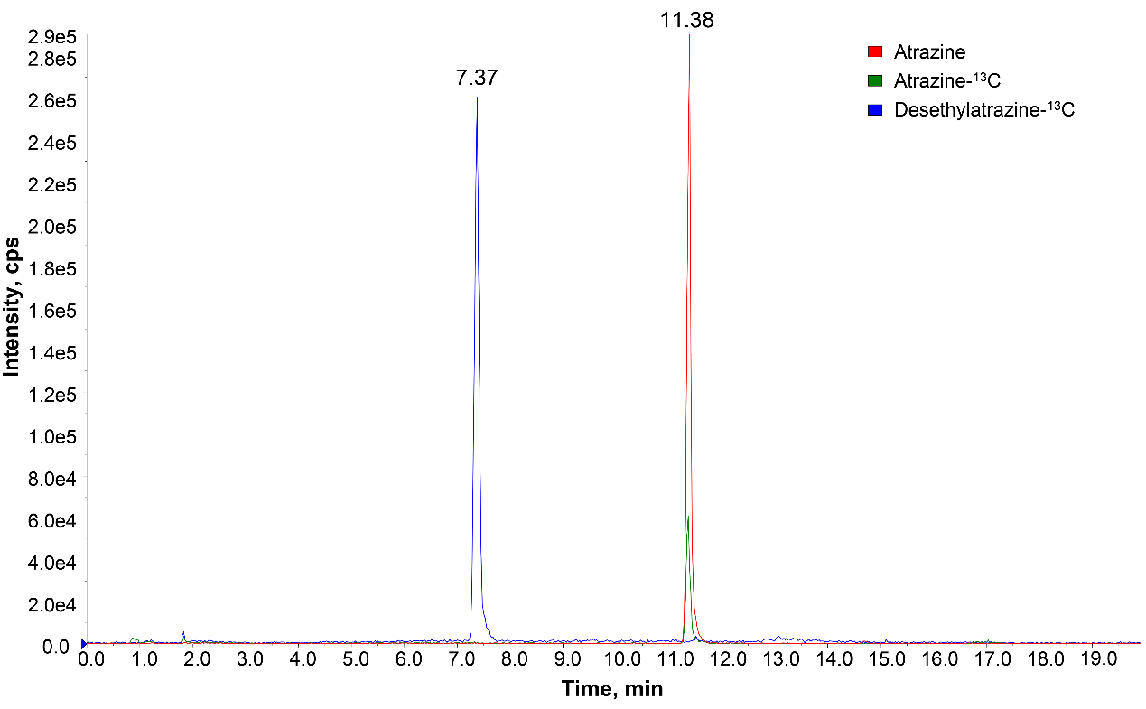

Fig. S1 Extracted ion chromatograms (EIC) of the atrazine, the surrogate desethylatrazine-¹³C, and the internal standard atrazine-¹³C in the samples, respectively.

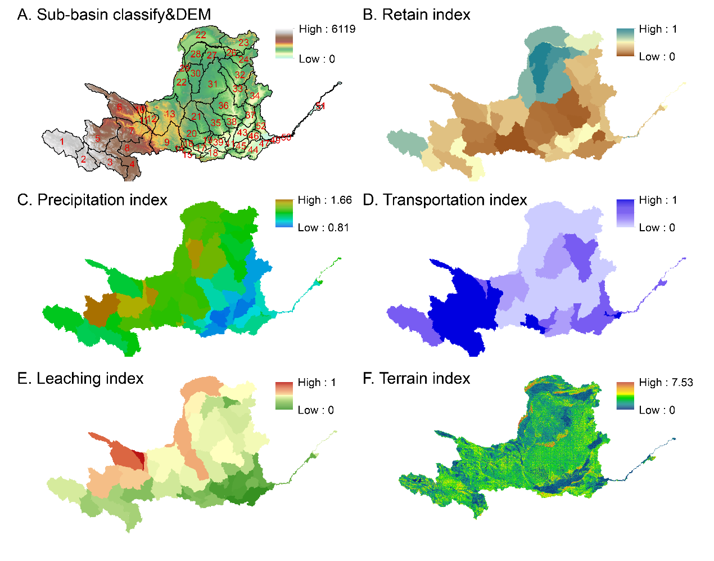

Fig. S2 Annual spatial distribution of parameters related to comprehensive water inflow coefficient, including (A) sub-basin classify, (B) retain index, (C) precipitation index, (D) runoff index, (E) subsurface water index, and (F) terrain index.
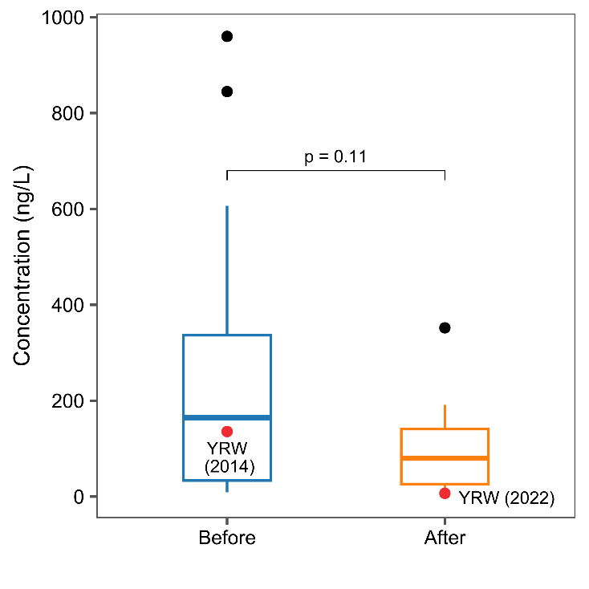

Fig. S3 Atrazine occurrence in China before and after reduction policy. The red point indicates level of atrazine in Yellow River Watershed (YRW).
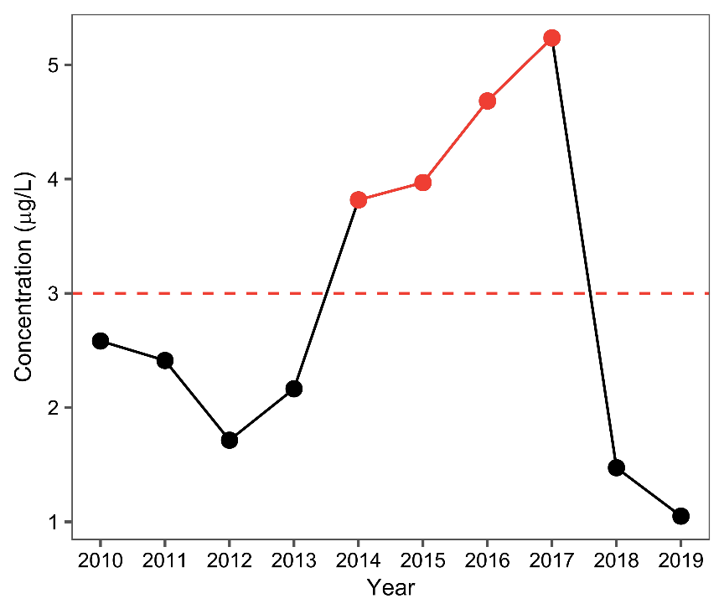

Fig. S4 Estimated atrazine concentration in the water of the Yellow River Watershed

