Supplementary Information
Selective and sensitive detection of hazardous 2,4,6-trinitrophenol (TNP) in water by an amine and azine functionalized metal-organic framework
Manpreet Kaur ª, Ashok Kumar Malik ^{a,*}
ª Department of Chemistry, Punjabi University, Patiala-147002, Punjab, India
*Corresponding author: malik_chem2002@yahoo.co.uk(A.K.M.)

Supporting Information
HOMO LUMO energy levels of NEs/L and LOD calculations.

Table S1. HOMO LUMO energy levels of commonly studies nitro explosive molecules determined using theoretical calculations.
Sr. No. | Ligand/Analyte | E_{HOMO} (eV) | E_{LUMO} (eV) | ΔE (eV)
1 | L | -7.055 | -2.805 | -4.250
2 | H₂ata | -8.228 | 1.702 | -9.930
3 | 2-NP | -9.464 | -1.880 | -7.584
4 | 1,3-DNB | -8.620 | -3.316 | -5.303
5 | TNP | -8.408 | -4.051 | -4.357
6 | 2,4-DNT | -8.306 | -3.160 | -5.145
7 | 2,6-DNT | -8.100 | -3.025 | -5.075
8 | 2,4-DNP | -7.881 | -3.009 | -4.871
9 | NB | -7.823 | -2.630 | -5.192
10 | 4-NT | -7.574 | -2.509 | -5.065
11 | 2-NT | -7.489 | -2.485 | -5.003
12 | 3-NT | -7.480 | -2.556 | -4.924
13 | 4-NP | -7.142 | -2.420 | -4.721

Section S1: Calculation of Limit of detection (LOD) for TNP
The 22.91 mg of TNP was dissolved in 50 ml of distilled water to make a 2 mM aqueous TNP solution. This solution was used in the PL emission studies. Furthermore, 10 ml of a 2 mM aqueous TNP solution was diluted with water to achieve a 2 μM, i.e., 22.91 μg TNP in 50 ml solution. This diluted 2 μM aqueous TNP solution was utilized in another set of PL emission experiments to determine LOD.
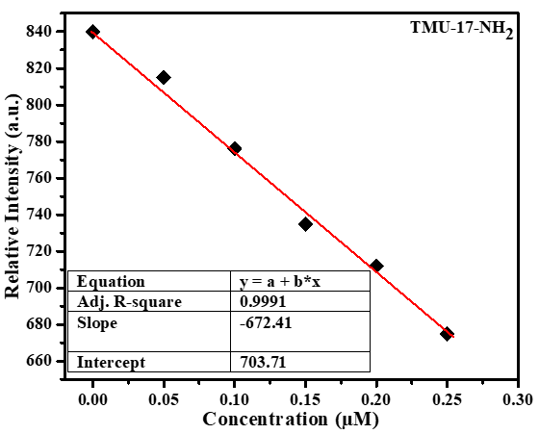
Figure S1. Linear region of PL emission intensity for TMU-17-NH₂ in water upon incremental addition of TNP.
In a typical LOD experiment, an incremental amount of 2 μM aqueous TNP solution in the volume range of 0.0 L to 250 L was introduced to the TMU-17-NH₂ water suspension (2 mg of MOF dispersed in 2 ml water). The intensity of the fluorescence recorded for each incremental addition of aqueous TNP solution was plotted against the rising concentration of TNP. The slop of the resulting curve was determined to be 672.41 µM TMU-17-NH₂. The standard deviation (σ) in the TMU-17-NH₂ LOD determination was derived from five blank measurements for each MOF. LOD = 3/m is determined using an earlier report ^{S1}, and the results are given below:
Blank Readings |  | TMU-17-NH₂
#1 | Fluorescence Intensity (a.u.) | 846
#2 | Fluorescence Intensity (a.u.) | 852
#3 | Fluorescence Intensity (a.u.) | 851
#4 | Fluorescence Intensity (a.u.) | 843
#5 | Fluorescence Intensity (a.u.) | 867
Standard deviation (σ) |  | 9.257429
Slope (m) |  | 672.41 µM
Detection limit (3σ/m) |  | 0.04130 µM or 9.4 ppb

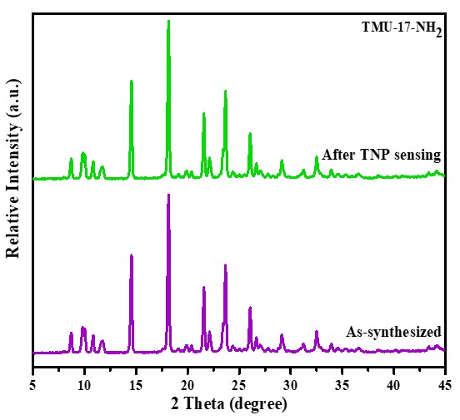
Figure S2. PXRD patterns of TMU-17-NH₂: comparison between the as-synthesized vs. after the TNP sensing.

References
S1. B. Parmar, Y. Rachuri, K.K. Bisht, R. Laiya, E. Suresh, Mechanochemical and conventional synthesis of Zn (II)/Cd (II) luminescent coordination polymers: dual sensing probe for selective detection of chromate anions and TNP in aqueous phase, Inorganic chemistry 56(5) (2017) 2627-2638.

