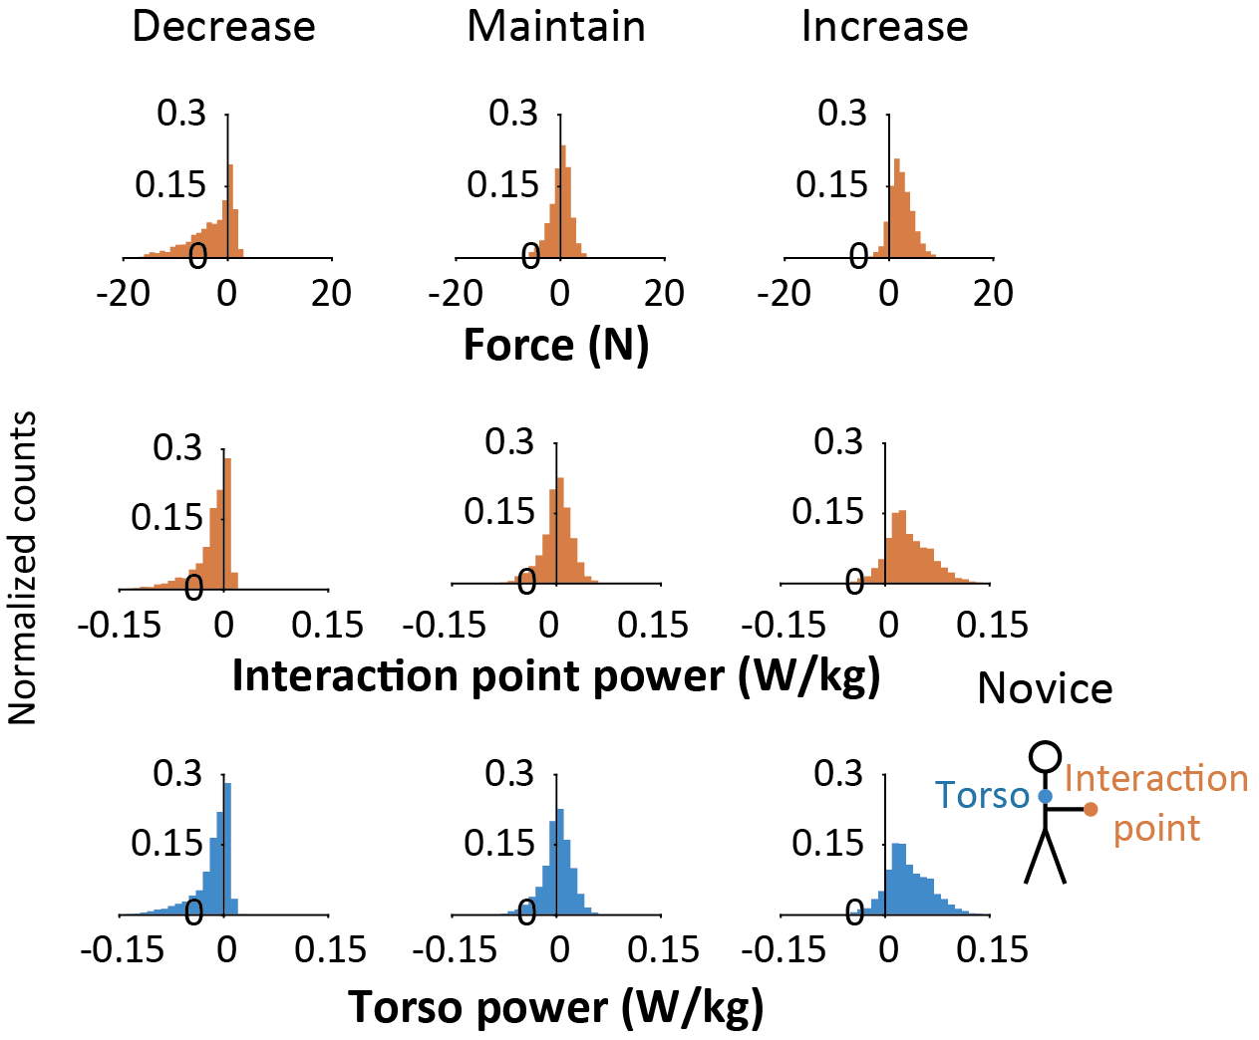
Supplementary figure S1: Histograms of interaction force, power at the interaction point, and power at the novice's torso. Values calculated at the interaction point are in orange and at the torso in blue. Data from all time samples, trials, and participants (n = 8) are included. Columns correspond to backleading conditions.

