Supplementary information
One-pot, degradable, silica nanocarriers with encapsulated oligonucleotides for mitochondrial specific delivery
Chloe Trayford¹, Alissa Wilhalm^{1,2}, Pamela Habibovic¹, Hubert Smeets², Florence van Tienen^{2*} and Sabine van Rijt^{1*}
¹MERLN Institute for Technology-Inspired Regenerative Medicine, Maastricht University, P.O. Box 616, 6200 MD Maastricht, the Netherlands
²Department of Toxicogenomics, Maastricht University, PO Box 616
6200 MD, Maastricht, The Netherlands

* Shared last and corresponding authors:
Sabine van Rijt, PhD
Associate Professor
Department of Instructive Biomaterials Engineering
MERLN Institute for Technology-Inspired Regenerative Medicine, Maastricht University
E-mail: s.vanrijt@maastrichtuniversity.nl

Florence van Tienen, PhD
Assistant Professor
Department of Toxicogenomics
School for Mental Health and Neuroscience, Maastricht University
E-mail: florence​.​vantienen​@​​maastricht​university​.​nl

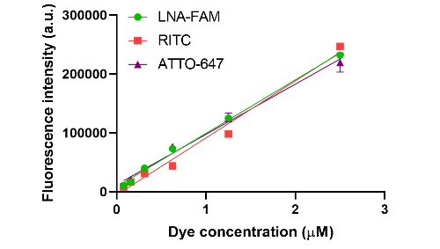
Fig S1. Rhodamine b isothiocyanate (RITC), Fluorescein locked nucleic acid (LNA-FAM) and ATTO-647 standard curves for the determination of LNA-FAM, RITC and ATTO-647 concentration in HSN and LP.
Fig S2. a) Surface charge of functionalized LPs where LP_{C} = -0.1 ± 5.6 mV (grey), LP_{D}= 8.9 ± 4.9 mV (light brown), LP_{SH} = 23.2 ± 4.7 mV (light purple). Statistical significance of is determined compared to LP_{C} where * = p < 0.0001. b) Fluorescence of LP_{SH} after incubation with amine reactive FITC and thiol reactive ATTO-647-Maleimide.

Analog | Sequence 5’ to 3’
DNA-LNA mixmer | GG[+G] TT[+T] GG[+T] AA[+G] AT[+G] GC[+A] GG
PNA | TGG CAG GGC CCG
DNA | GGG TTT GGT AAG ATG GCA GG-C3
Table S1. Oligonucleotide options to block the m.3243A>G mutation and stop amplification. The location of the mutation is indicated in red.

Fig S3. TEM images of HSN incorporated with different oligonucleotides showing effects on morphology where a) HSN(DNA) and b) HSN(PNA). Scale bars are 200 nm.
Fig S4. Size and fluorescence characterization of HSN(LNA). a) Size analysis of 30 particles by ImageJ where HSN (light green)= 82.5 ± 6.3 nm and LP (pink)= 117.9 ± 6.6 nm b) Concentration of RITC in 100 µg of NP as determined by fluorescence analysis where RITC is 0.4 ± 0.04 µM or 0.6 ± 0.08 µM in HSN(LNA) (light green) and LP(LNA) (pink), respectively.
Fig S5. Incorporation of LNA inside the hollow core of HSN(LNA-FAM). Incorporation was determined by a) ratio of pellet: supernatant LNA-FAM fluorescence in HSN(LNA-FAM) at each of 3 washes with absolute ethanol and b) corresponding surface charges of HSN pellets at each wash. Error bars are derived from technical triplicates.
Fig S6. LNA-FAM content per mg of LP_{C} and LP by UV absorption analysis.
Fig S7. Zeta potential analysis of MITO-porter and TPP functionalized HSN and LP where HSN_{M}=green, HSN_{TPP}=dark green, LP_{M}= red and LP_{TPP}= dark red. MITO-porter and TPP functionalization significantly increased the surface charge of HSN and LP where * = p<0.0001.
Fig S8. Fluorescence imaging of fluorescent MITO-porter functionalized HSN and LP showing co-localization of the substituted fluorescein DOPE; 18:1 (Δ9-Cis) PE (DOPE) with RITC NP fluorescence. NP were coated with MITO-porter by hydration of the lipid film, washed three times and deposited on a plasmalysed microscopy cover slip. Where green= 18:1 (Δ9-Cis) PE (DOPE) red= HSN or LP and orange= merged channels. Scale bars are 50 μm.
Fig S9. TEM images of uranyl acetate stained HSN_{M} and LP_{M} where a) HSN_{M} and b) LP_{M}. Scale bar is 100nm.

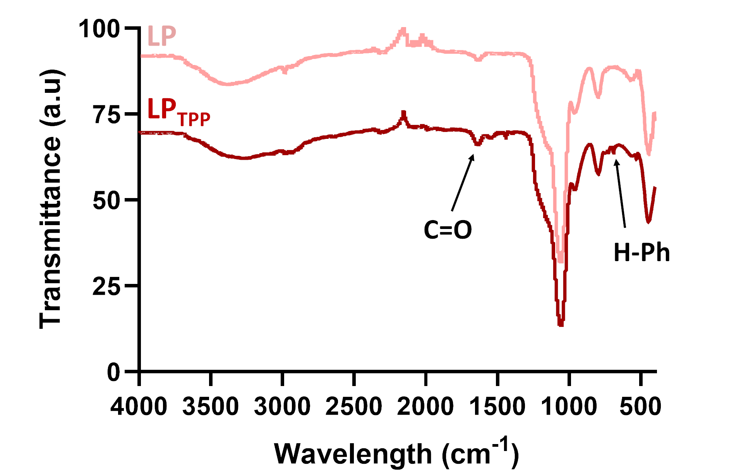
Fig S10. FTIR spectrum of LPs and LP_{TPP} to show successful TPP conjugation on the NP surface where LP= pink and LP_{TPP}= dark red. Characteristic peaks referring to the amide bonds or phenyl groups of conjugated TPP are indicted by arrows.
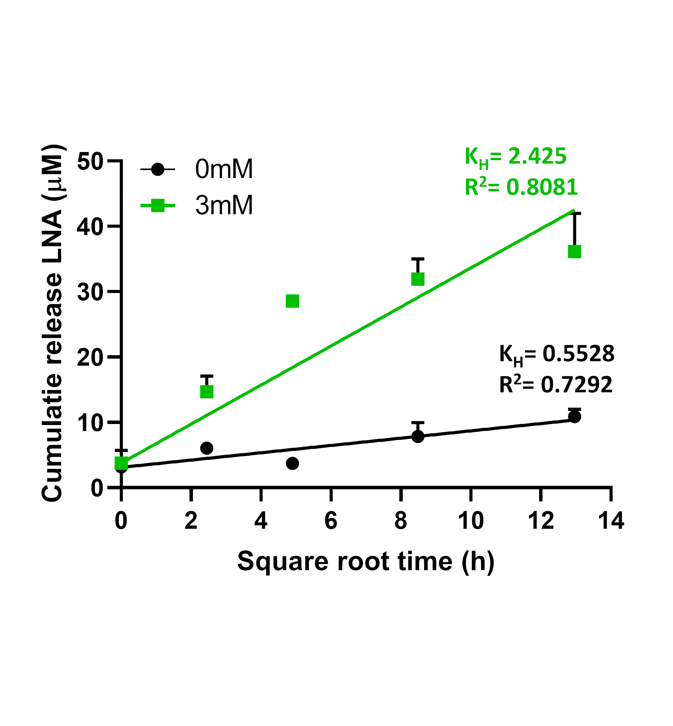
Fig S11. LNA release profiles of HSN(LNA)_{TPP} fitted to the Higuchi model. Where HSN(LNA)_{TPP} dispersed in PBS = black and HSN(LNA)_{TPP} dispersed in PBS with 3mM GSH = green. The Higuchi dissolution constant K_{H} and the coefficient of determination R² are given above the fittings.
Fig S12. TEM images showing GSH catalyzed degradation of HSN(LNA)_{M} over a 14 d period. A 50 µL aliquot from a stock of HSN(LNA)_{M} stirred at 37°C in PBS or in PBS with 3 mM GSH was collected and imaged at each timepoint. HSN(LNA)_{M} degradation was only obvious at 7 and 14 d for the 3 mM GSH condition. Scale bars are 200 nm.
Fig S13. Fluorescence imaging of 80% mutated mesangioblast cells (M32) labelled with un-functionalized, MITO-porter and TPP functionalized HSN and LP. Images show intracellular distribution. M32 were exposed to NPs at 100 μg/mL and images were taken 24 h post labelling where blue= nucleus, red= actin and pink= NP. Scale bars are 50 μm.
Fig S14. TEM images showing endosomal localization of MITO-porter or TPP functionalized HSN and LP. 80% mutated mesangioblasts (M32) were incubated with NP at 100 μg/mL then fixed, sectioned, stained and imaged after 24 h exposure. While LP_{TPP} and HSN_{TPP} were mostly observed to escape endosomes, LP_{M} and HSN_{M} are contained within them. Arrow indicate nanoparticle clusters. Scale bars are 500 nm.

