Supplementary material for
Data-driven identification of predictive risk biomarkers for subgroups of osteoarthritis using an interpretable machine learning framework: a UK biobank study

Sup Fig. 1

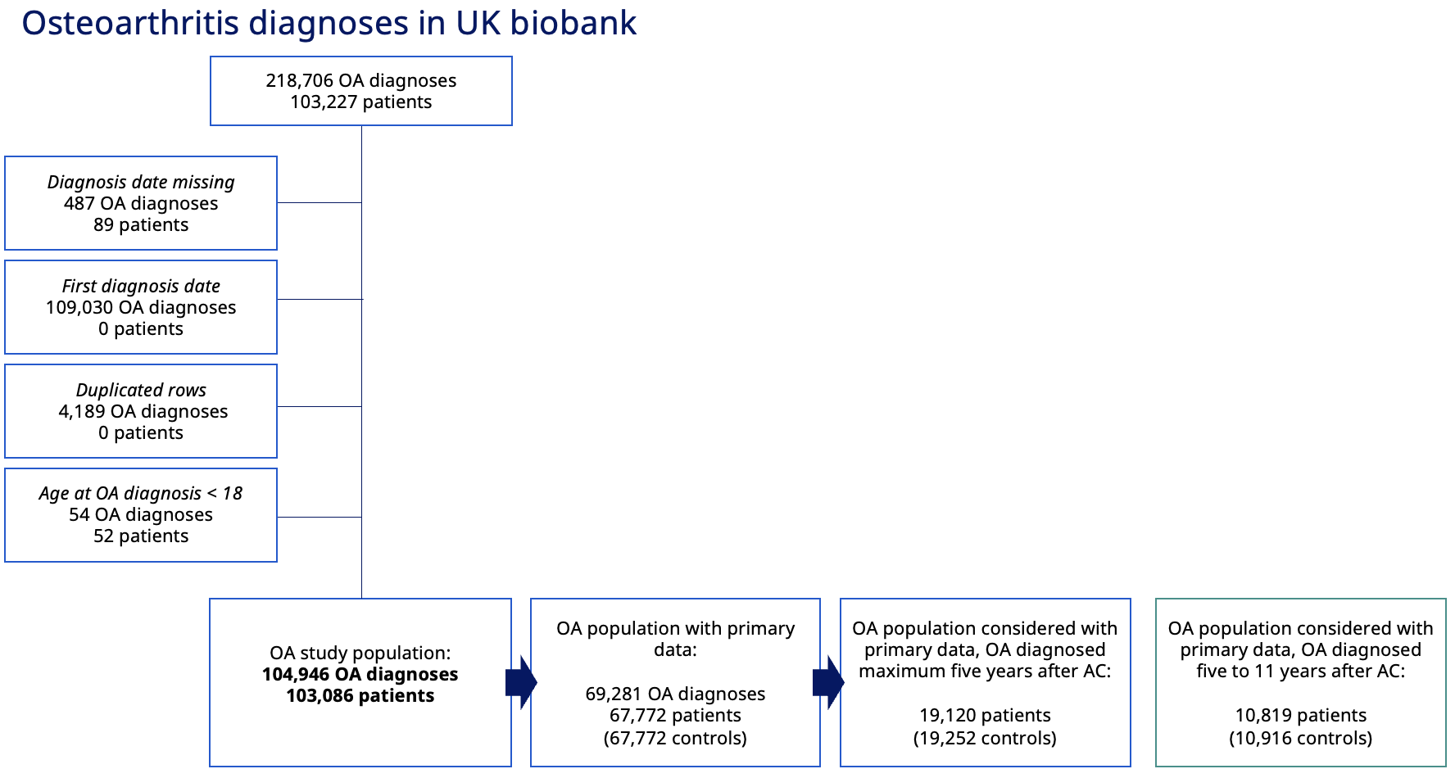
Supplementary Figure 1:OA patient filtering and timeline. Study population of OA in UK biobank. Clinical codes of OA were mined in primary care (read2/read3 (CTV3)) and secondary care (ICD-9/ICD-10) data. Any trauma-induced and nonsense OA diagnoses codes were excluded for identification of OA diagnoses and patients.

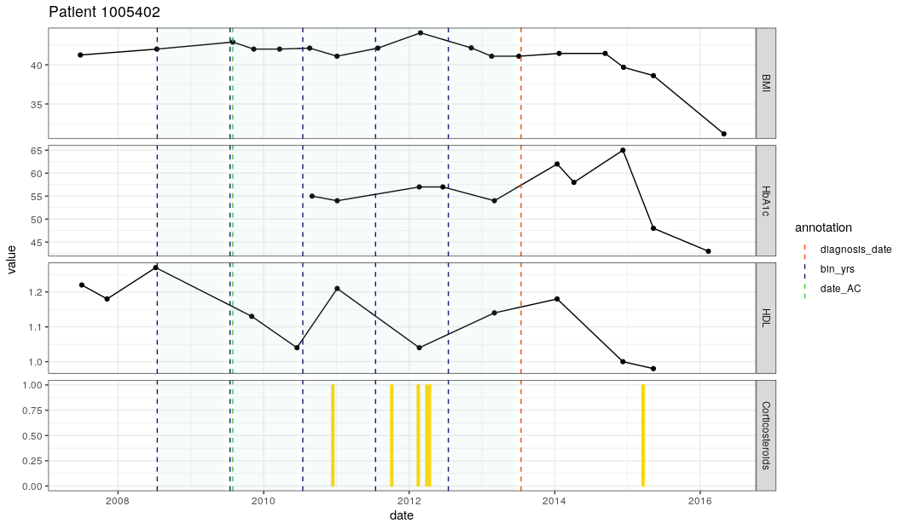
Sup Fig. 2
OA diagnosis
Yearly time points prior to OA diagnosis
UKB assessment centre
Medication prescription
Date
Biomarker Value
Yearly data capture windows
OA patient example

Supplementary Figure 2: Yearly binning of longitudinal patient data Longitudinal patient data was captured from primary care GP data and is shown for an example patient with OA. Date of UK Biobank (UKB) assessment centre is shown with the green dotted line and is required to be no more than 5 years prior to the date of OA diagnosis, shown by the red dotted line. In the 5 years prior to OA diagnosis, 5 yearly data capture windows are established (shown by blue dotted lines and blue shaded regions). For clinical biomarkers, the average value in each yearly data capture window is extracted. For drug prescriptions, a binary value (0/1) is assigned for each data capture window, reflecting whether a drug had been prescribed in this yearly time-period (indicated by a yellow bar). Longitudinal data extractions were then used as input features to the XGBoost models.

Sup Fig. 3
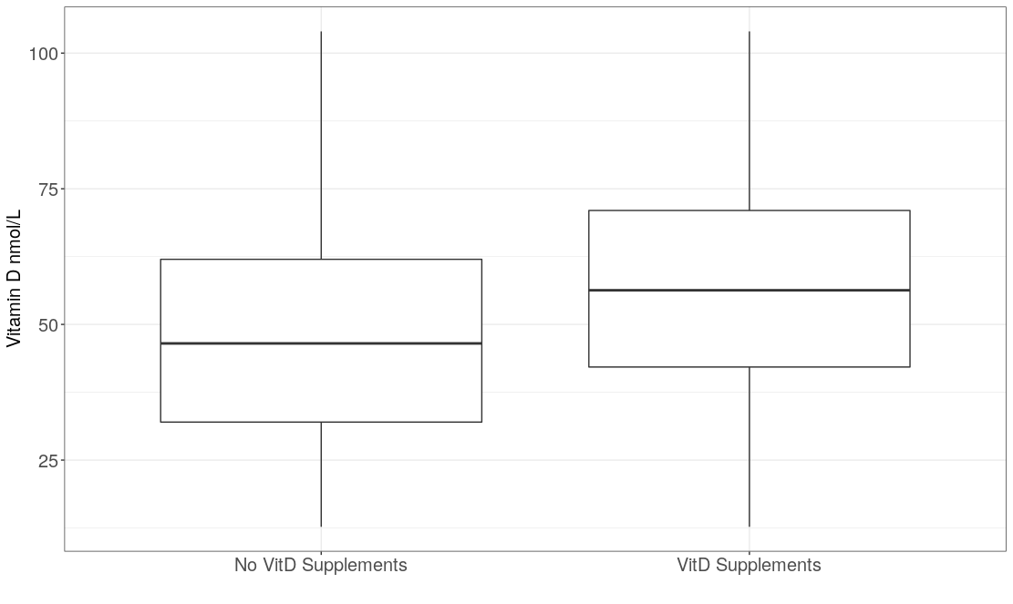
a)

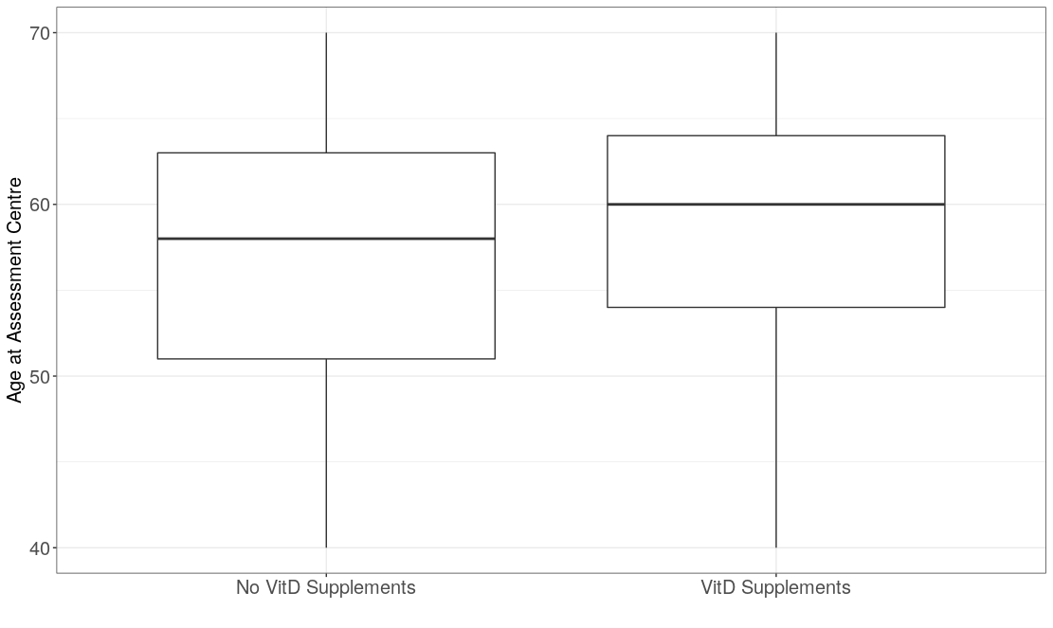
b)

Supplementary Figure 3: Vitamin D supplements Cases of OA and controls segregated by those who report taking vitamin D supplements and those who do not report taking vitamin D supplements at assessment centre. (a) their associated vitamin D levels at assessment centre (P-value < 2.2e-16 in two-sided t.test) (b) their age at assessment centre (P-value < 2.2e-16 in two-sided t.test).

Sup Fig. 4
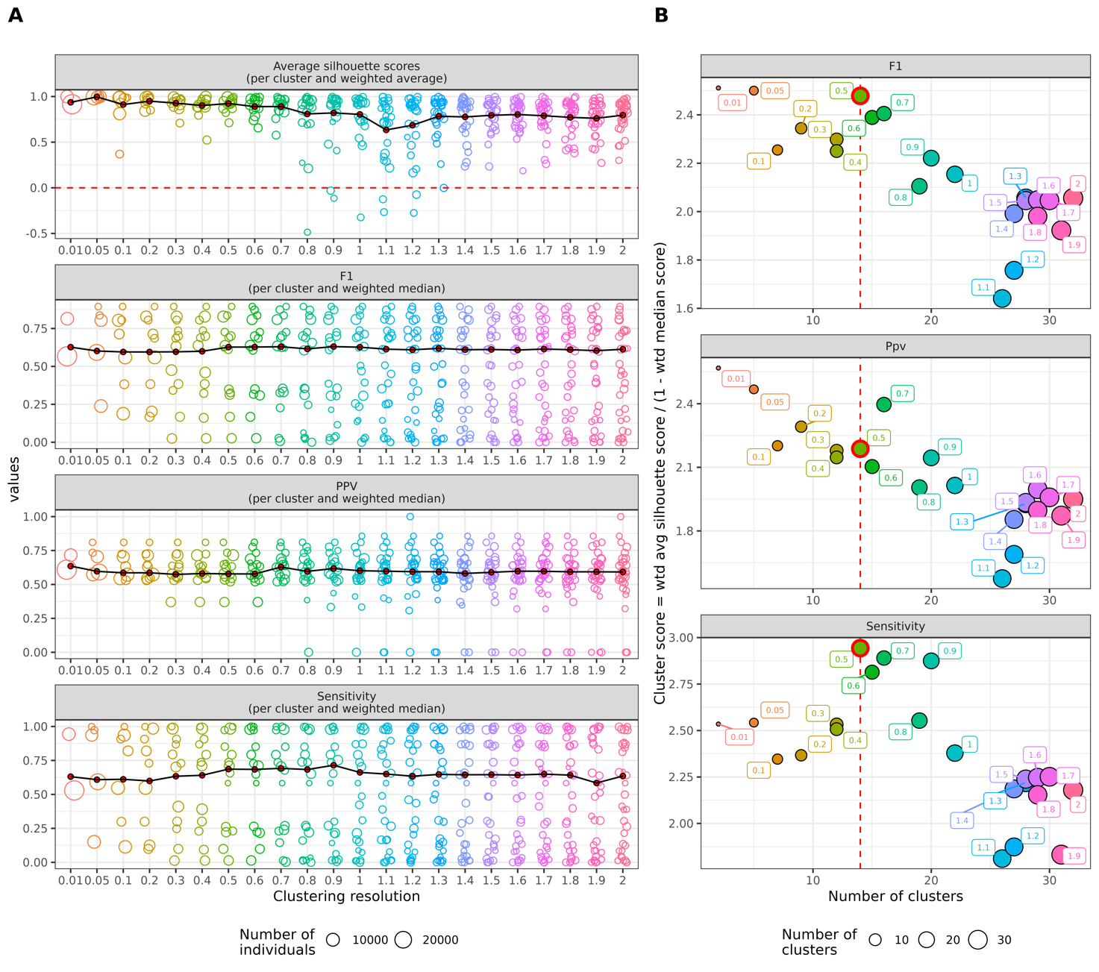
Supplementary Figure 4: Clustering resolution optimisation. A. Silhouette scores (cluster robustness) as well as F1/Precision/Recall were determined for each cluster at various clustering resolution, and the weighted mean and medians (respectively) calculated per resolution. B. A cluster score was defined to integrate the silhouette scores and prediction metrics per resolution to determine which resolution leads to an optimisation of the number of high-quality clusters and clusters with good predictive value. Colours and labels indicate the clustering resolution. The red dotted line indicates the chosen cluster resolution (resolution = 0.5, 14 clusters).

Sup Fig. 5
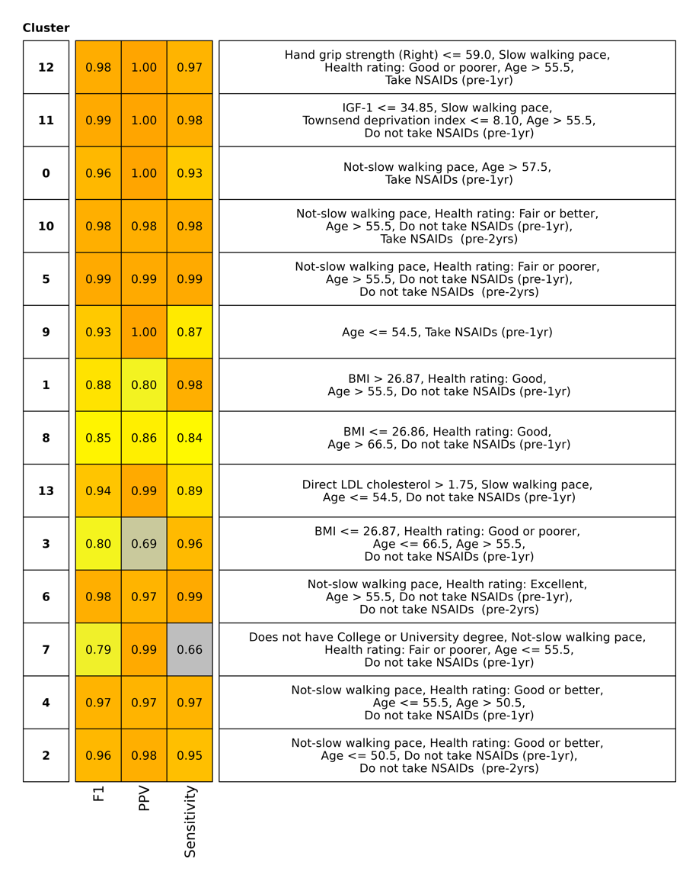
Supplementary figure 5: Cluster rules performance. Out-of-bag performance values (F1/precision/recall) for each cluster. These values indicate how accurately each set of rules attribute individuals to each cluster.

Sup Fig. 6
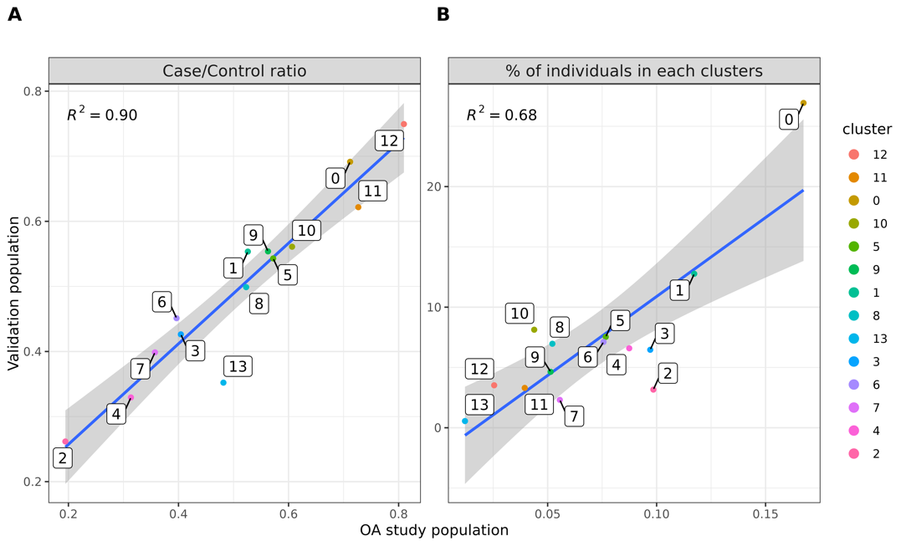
Supplementary figure 6: Correlation between OA study and validation populations.

Sup Fig. 7
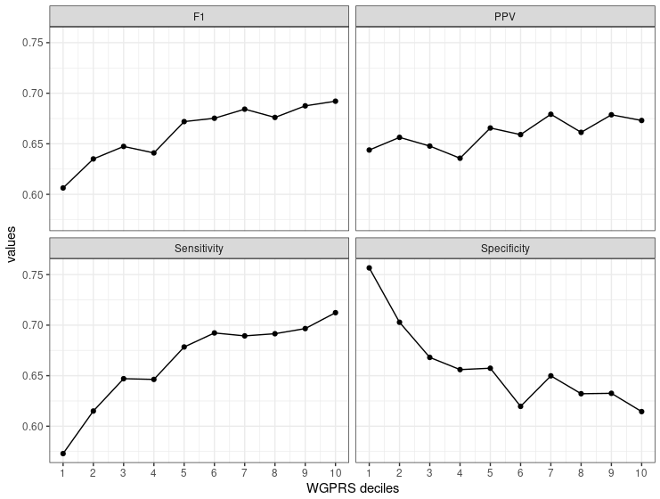
Supplementary Figure 7: Predictive performance of the OA WGPRS XGBoost model, ranked by WGPRS decile.

Sup Fig. 8
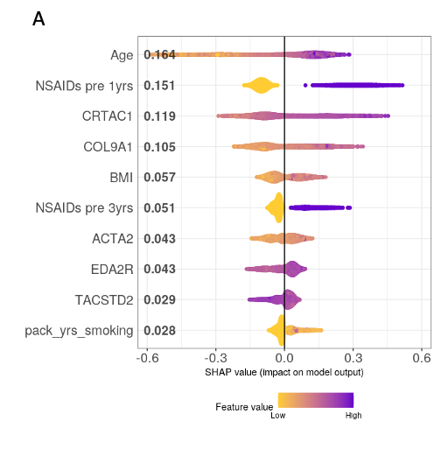
Supplementary Figure 8: SHAP beeswarm plot for ClinPro model trained on 1461 proteins and clinical features as given in Clin model. The ClinPro model had ROC-AUC 0.70.

Sup Fig. 9
Supplementary Figure 9: SHAP dependence plots between age and top five proteins including P-value from glm.anova.
NSAIDs prescriptions one year before OA diagnosis/proxy date have significant interaction dependencies with COL9A1 (P<2e-16), ACTA2(P=2.8e-4), EDA2R (P<2e-16), TACSTD2 (P=2.8e-5) (plots not shown). BMI had significant interaction dependencies with CRTAC1 (P=6e-4), ACTA2 (P=0.01), EDA2R (P<2e-16) and TACSTD2 (P=1.6e-9).

Sup Table 1

Supplementary Table 1: Robustness and stability of Clin model across 100 random model initialisations (cross-validation splits and model parameters). To test stability of the model, the labels of OA cases and controls were randomly permuted and tested with the same 100 model initialisations.
 | ROC-AUC | Sensitivity | PPV | Specificity | NPV
Robustness of Clin model across 100 model initialisations | 0.72 (0.72 - 0.72) | 0.67 (0.67 – 0.67) | 0.65 (0.65 – 0.66) | 0.65 (0.65 – 0.65) | 0.66 (0.66 – 0.66)
Clin model across 100 model initialisations on permuted outcome label | 0.50 (0.50 – 0.51) | 0.49 (0.49 – 0.49) | 0.50 (0.50 – 0.50) | 0.51 (0.51 – 0.51) | 0.50 (0.50 – 0.50)

Sup Table 2
Supplementary Table 2: Sensitivity analysis of ROC-AUC performance of multi-omics subset of individuals without any omics features included. Other clinical features included in the Multi-omics OA risk biomarkers models are included.
ClinSNP | ClinGRS (proxy) | ClinGRS (noproxy) | ClinPath (proxy) | ClinPath (noproxy) | ClinMet | ClinPro
0.73 (0.72 – 0.73) | 0.72 (0.71 – 0.72) | 0.72 (0.71 – 0.72) | 0.72 (0.71 – 0.72) | 0.72 (0.71 – 0.72) | 0.72 (0.71 – 0.73) | 0.69 (0.65 – 0.73)

Sup Table 3
Supplementary Table 3: ClinWGPRS, ClinGRS and ClinPath models where genetic features are adjusted with 10 principal components of population substructure and batch corrected.
 | ClinWGPRS | ClinGRS (proxy) | ClinGRS (noproxy) | ClinPath (proxy) | ClinPath (noproxy)
ROC-AUC | 0.72 (0.72 – 0.73) | 0.72 (0.71 – 0.72) | 0.72 (0.71 – 0.72) | 0.72 (0.71 – 0.72) | 0.72 (0.71 – 0.72)
Ranking of features | WGPRS (ranked 9th most important feature) | TGFB1, GDF5, CAMKV | GDF5, TGFB1 ANKRD13D | TGF beta signaling pathway, adipocyte signaling pathway, cytokine-cytokine receptor interaction | TGF beta signaling pathway, Leishmania infection

